08

**Fall**

**Abstract book**

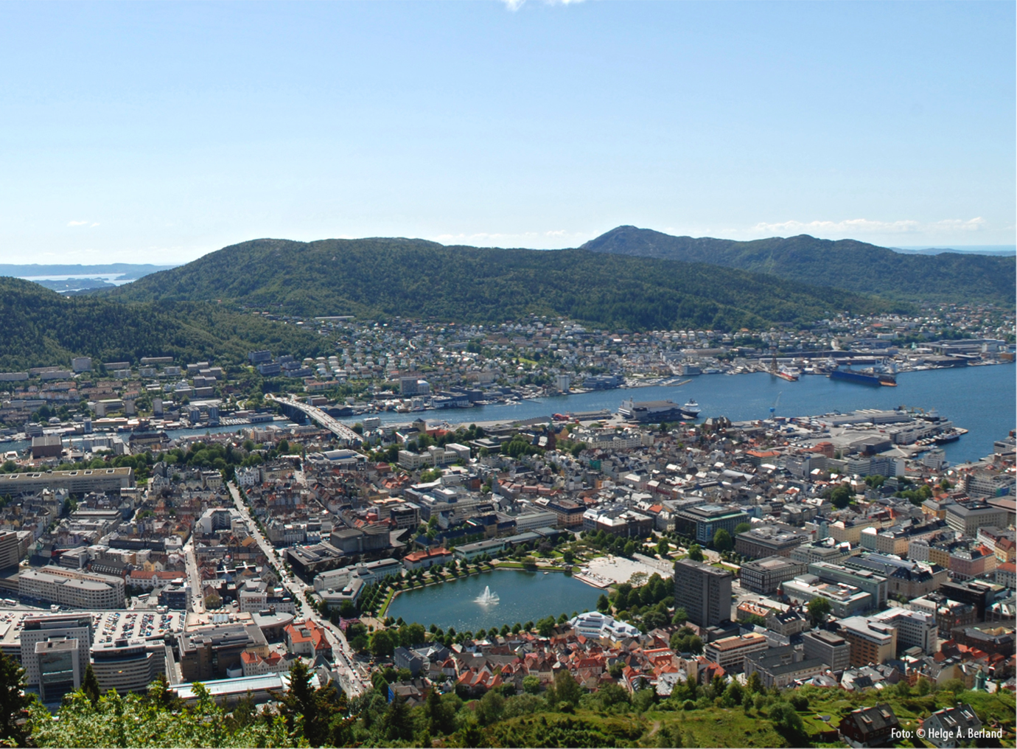

/Users/mblnr/Dropbox/ISQBP2016/Material for conference/Logos/isqbp_final.pdf

**2016 PRESIDENT’S MEETING**

Grand Hotel Terminus, Bergen, Norway, 19-22 June

*Scientific Committee*

|  |  |
| --- | --- |
| Nathalie Reuter (University of Bergen, Norway) | nathalie.reuter@uib.no |
| Bjørn Olav Bransdal (Arctic University Tromsø, Norway) | bjorn-olav.brandsdal@uit.no |
| Michele Cascella (University of Oslo, Norway) | michele.cascella@kjemi.uio.no |

*Organizing Committee*

|  |  |
| --- | --- |
| Pierre Bedoucha (University of Bergen, Norway) | pierre.bedoucha@uib.no |
| Qaiser Waheed (University of Bergen, Norway) | qaiser.waheed@uib.no |
|  |  |
|  |  |
|  |  |
|  |  |
|  |  |
|  |  |

Macintosh HD:Users:pierrebedoucha:Dropbox:ISQBP2016:Material for conference:Logos:UiBmerke_grayscaleV8.pdf

Abstracts

Table of Contents

Abstracts