Automatic calibration of a multi-sensors system

# Introduction:

I propose a mathematical and algorithm framework to solve the problem of automatic calibration of a multi sensors system. A multi sensor system is a system composed of several sensors (cameras, lidars, radars, GPS, IMU, …) that constitute a solid. A set S of sensors form a solid if:

$$∀ t ∈TimeRange, ∀ X_{1}∈S, ∀X_{2}∈S \vec{\frac{dX_{1}X_{2}}{dt}}= \vec{0}$$

The aim is to find the relative orientation and position for each couple of sensor:

$$R_{s1}^{s2}, T_{s1}^{s2}$$

That map points expressed in $s_{1}$ coordinate system into $s_{2}$ coordinate system:

$$X_{s2}= R_{s1}^{s2}* X_{s1}+ T_{s1}^{s2}$$

# Example:

Let's suppose you have the following system composed of a GPS / IMU and a lidar:

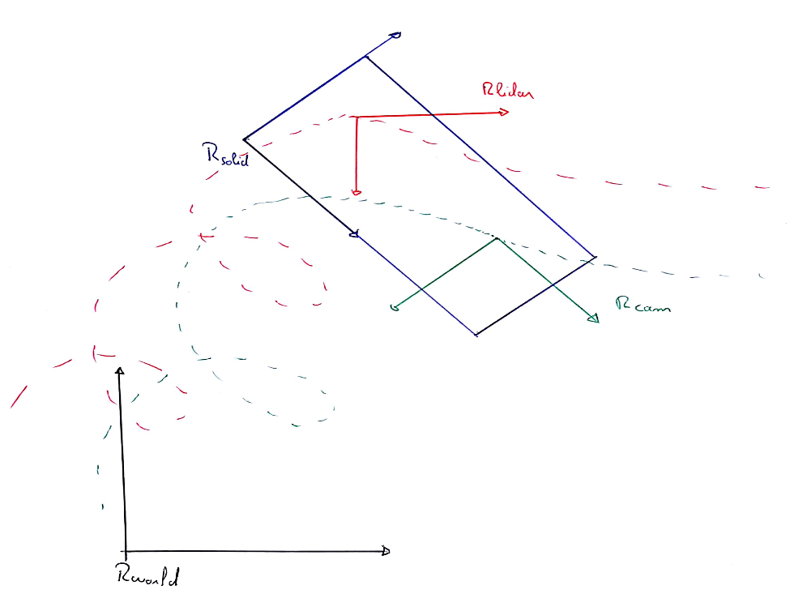

Notations:

$R(t)$: Orientation of the solid over the time in the world reference frame $T(t)$ 
: Position of the solid in the world reference frame $\tilde{T}$ 
 : Position of the IMU in the solid reference frame $R^{*}$ 
 : Orientation of the lidar in the IMU reference frame $T^{*}$ 
: Position of the lidar in the IMU reference frame

We suppose that we have access to the IMU orientation and position in the world reference frame over the time and the lidar orientation and position in the lidar reference frame at time t0 (obtained using a slam algorithm for instance).

The idea is to express the theory orientation and position of the sensors according to the parameters ($R^{*}, T^{*}, \tilde{T}$) and see how we can infer them using the input data

Let’s X be a physical 3D points. $X_{s}$ will be the $R^{3}$ vector representing the coordinates of X in the s reference frame.

$X_{world}=R\left(t\right)* X_{solid}+T(t)$ (1)

$X_{solid}= X_{IMU}+ \tilde{T}$ (2)

Using (1) and (2) we have

$X_{world}=R\left(t\right){* X}_{IMU}+T\left(t\right)+R\left(t\right)* \tilde{T}$ (3)

Thus:

$$R_{IMU}^{world}(t)=R\left(t\right) \\ T_{IMU}^{world}\left(t\right)=T\left(t\right)+R\left(t\right)* \tilde{T}$$

The trajectory of the IMU forms a kind of cycloid around the trajectory of the solid

Now, we will retrieve $R_{lidar}^{lidar0}, T_{lidar}^{lidar0}$ which represents the orientation and position of the lidar in the lidar reference frame at time t0. To do that we will map the frame from the lidar to the world and then to the lidar at time t0.

$X_{IMU}= R^{*}* X_{lidar}+ T^{*}$ (4)

Using (1), (2) and (4) we have:

$X_{world}=R\left(t\right)* R^{*}* X_{lidar}+R\left(t\right)*\left(T^{*}+ \tilde{T}\right)+T(t)$ (5)

Now, we will express X in lidar reference frame at time t0

$X_{solid0}= R_{0}^{T}RR^{*}X_{lidar}+ R_{0}^{T}R\left(T^{*}+\tilde{T}\right)+ R_{0}^{T}T- R_{0}^{T}T_{0}$ (6)

$X_{IMU0}= R_{0}^{T}RR^{*}X_{lidar}+ R_{0}^{T}R\left(T^{*}+\tilde{T}\right)+ R_{0}^{T}T- R_{0}^{T}T_{0}- \tilde{T}$ (7)

$X_{lidar0}= {R^{*T}R}_{0}^{T}RR^{*}X_{lidar}+ {R^{*T}R}_{0}^{T}R\left(T^{*}+\tilde{T}\right)+ {R^{*T}R}_{0}^{T}T- {R^{*T}R}_{0}^{T}T_{0}- R^{*T}\tilde{T}- R^{*T}T^{*}$ (8)

Thus:

$$R_{lidar}^{lidar0}= {R^{*T}R}_{0}^{T}RR^{*}$$

$$T_{lidar}^{lidar0}=\left(R^{*T}R_{0}^{T}R-R^{*T}\right)\left(\tilde{T}+T^{*}\right)+ R^{*T}R_{0}^{T}(T- T_{0)}$$

Using these equations we can derives two constraints on the relative orientation and the position:

$$\left(I\right):R\left(t\right)* R^{*}- R_{0}^{T}R^{*}R_{lidar}^{lidar0}={M*R^{*}= 0}_{R^{9}}$$

$$\left(II\right): \left(R^{*T}R_{0}^{T}R-R^{*T}\right)\left(\tilde{T}+T^{*}\right)+ R^{*T}R_{0}^{T}\left(X_{IMU}-R\tilde{T}- X_{IMU0}+ R_{0}\tilde{T}\right)- T_{lidar}^{lidar0}=0_{R^{3}}$$

Hence, using (I) it is possible to get the parameter $R^{*}$

We define:

$$G: \begin{matrix}R^{3} & → & R^{9}\sim M_{3, 3}(R) \\ Θ=(φ, θ, ψ) & → & R_{ψ(t)}*R_{θ\left(t\right)}*R_{φ(t)}\end{matrix}$$

With,

$R_{ψ(t)}= \left[\begin{matrix}cos⁡(ψ\left(t\right)) & \begin{matrix}-sin⁡(ψ\left(t\right)) & 0\end{matrix} \\ \begin{matrix}sin⁡(ψ\left(t\right)) \\ 0\end{matrix} & \begin{matrix}\begin{matrix}\cos\left(ψ\left(t\right)\right) & 0\end{matrix} \\ \begin{matrix}0 & 1\end{matrix}\end{matrix}\end{matrix}\right]$ (I.8)

$R_{θ\left(t\right)}= \left[\begin{matrix}cos⁡(θ\left(t\right)) & \begin{matrix}0 & sin⁡(θ\left(t\right))\end{matrix} \\ \begin{matrix}0 \\ -sin⁡(θ\left(t\right))\end{matrix} & \begin{matrix}\begin{matrix}1 & 0\end{matrix} \\ \begin{matrix}0 & cos⁡(θ\left(t\right))\end{matrix}\end{matrix}\end{matrix}\right]$ (I.9)

${ R}_{φ(t)}= \left[\begin{matrix}1 & \begin{matrix}0 & 0\end{matrix} \\ \begin{matrix}0 \\ 0\end{matrix} & \begin{matrix}\begin{matrix}cos⁡(φ\left(t\right)) & -sin⁡(φ\left(t\right))\end{matrix} \\ \begin{matrix}\sin\left(φ\left(t\right)\right) & cos⁡(φ\left(t\right))\end{matrix}\end{matrix}\end{matrix}\right]$ (I.10)

For each time entry ti we define:

$$F_{i}: \begin{matrix}R^{3} & → & R^{9} \\ Θ= (φ, θ, ψ) & → & M*G(Θ)\end{matrix}$$

And we want to find $Θ$ that minimize:

$$\sum_{i∈samples}{{\left\|F_{i}(Θ)\right\|}^{2}}$$

It is a non linear least square cost function. A solution can be approximated using a levenberg marquardt algorithm.

Just a few word about the jacobian of $F_{i}$ at the point $Θ$

$F_{i}$ is the composition of the function G and the function H: $X→ M_{i}*X$. Hence, the jacobian of Fi is:

$$J_{Fi}\left(Θ\right)= J_{Hi}\left(G\left(Θ\right)\right)* J_{G}(Θ)$$

With:

$$J_{Hi}\left(G\left(Θ\right)\right)= M_{i}$$

And

$$J_{G}\left(Θ\right)=$$