|  |
| --- |
| ENSTA Bretagne |
| UV5.4 Status Report |
| Pierre Jacquot – SPID/ROB |

|  |
| --- |
|  |

Supervised by :

* Pierre Bosser
* Nathalie Debèse
* Denis Legris

Summary

Introduction 3

Context 3

1. Pre-processing 4

1.1 Point Cloud Artifacts 4

1.2 Normal Estimation 5

2. Surface Function 7

2.1 Signed Distance Function (4) 8

. References 10

Figure 1 - Graphical representation of the different forms of point cloud artifacts (3) 4

Figure 2 - Part of the Kereon scan. The white points on the right of the windows are considered as noise, and are created by the laser going throught the window 4

Figure 3 - missing data on Kéréon scan 5

# Introduction

Computers are constantly increasing in term of power, efficiency and capacity. This quick evolution allow us to manage more and more data at the same time. This ability to deal with a large amount of data permit now to deal with what we called cloud points. This cloud point are the results of laser scans, and basically contain a collection of data, each containing the coordinates and sometimes the color of what the laser has scanned. This ability to represent our world using cloud points have many application. We can for example use this to recreate architectural site, or to recreate an environment in prevision of a future operation(1) or even into the biomedical field.

However when we talk about recreating a monument, or an object using data cloud, this also mean that we have to create a 3D version of this model. To do so we have to do a surface reconstruction of the object or monument. This surface reconstruction imply to link each point, in a logical way with each other in order to obtain an accurate 3D reproduction of the desired object.

As you can imagine such a task imply many pre-requisites. Among them we first need to understand how the 3D points cloud has been acquired, what king of object we want to reconstruct (an exterior, an interior, a simple object?). Linking a points cloud also need pre-treatment, so we can obtain the most accurate representation. We’ll therefore need to clear the cloud point of any noise or misplace points and simplify it if it contains too many points, so we can have a light mesh (a mesh is a collection of vertices, edges and faces that defines a shape (2). Here it will be the final 3D representation of the building we’re trying to recreate). Furthermore linking the points between them is not trivial as there is not necessary a right order to do it, and the computer certainly don’t know in advance which order will be the best. We will have to recreate the surface in an implicit way. Therefore, the goal of this status report is to explain step by step how to reconstruct the surface of a cloud point, by pointing out in a chronological way the best methods pre-process the point cloud and reconstruct its surfaces. You’ll find in the following sections an explanation of the most used and robust methods to do so.

# Context

This project is collaboration between les Phares et Balise (a department of le parc marin d’Iroise) and the ENSTA Bretagne. Les Phares et Balises are currently trying to put forward some of the lighthouses of the Finistère’s coast. These lighthouses are for most of them too far away from the coast and despite their strong cultural interest cannot be visited. To tackle this issue, les phares et balises have organized several laser scans of these lighthouses so that people could visit them. The main idea is to present a 3D representation of these lighthouses (focusing on the lighthouse of Kereon) during the Brest 2016 festival. As meshing a cloud point is not trivial they ask for the ENSTA Bretagne expertise to create a 3D mesh of the lighthouse of Kereon.

# 1. Pre-processing

Recreating a mesh from a raw cloud point is not trivial and need a good understanding on the data we’re using and on the challenges we’ll have to face. Therefore, we’ll be focusing on this next part on the first obstacle will have to overcome before meshing our cloud point. Thus we will talk about artefacts that can appear in your raw data, (mostly because of the scan quality), (3), the sampling of the cloud point and the normal associated with each point (4). Each of this part will be a determinant factors in the surface reconstruction method.

## 1.1 Point Cloud Artifacts

Laser scanning an area often comes with many non-wanted features appearing in the point cloud. These unwanted features are called artifacts. The most impactful on the surface reconstruction are: the sampling density, the noise, the outliers, the misalignment and the missing data. All of these artifacts will be explained in the next parts and we’ll be dealt with later, during the surface reconstruction part.

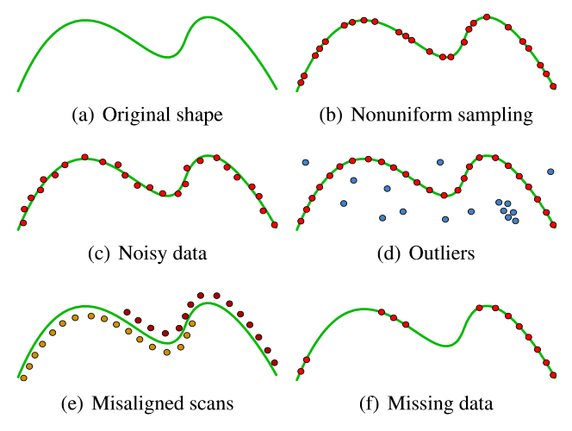

Figure 1 - Graphical representation of the different forms of point cloud artifacts (3)

**Non uniform sampling:**

Non uniform sampling is visible on figure 1(b). This king of artefacts is in majority due to the positioning of the scanner regarding the object or scene we are scanning. Other factors impacting point sampling are the orientation of the scanner and also the shape of the objects we are scanning. A good way to tackle this issue is to scan an object multiple time, and with various angle in order to have the right amount of point.

**Noise:**

One of the most common artefact. Noise is due to many factors, including the sensor of the scanner, the distance and orientation of the surface scanned, the inner characteristic of the surface scanned. For example reflective surfaces are a major source of noise as well as windows (figure 2). You can either try to eliminate noise (which can be fairly easy on the example figure 2), or you can produce a surface that passes near the noise.

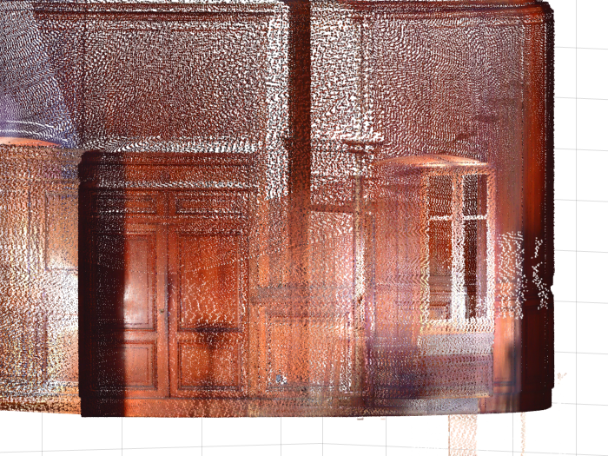

Figure 2 - Part of the Kereon scan. The white points on the right of the windows are considered as noise, and are created by the laser going throught the window

**Outliers:**

The outliers are the points far from the true surface. These artifacts are due to structural artifacts in the acquisition process. This type of artifact often appear in multi-view stereo acquisition when points taken with a different angles result in false correspondences. This is important to note that outliers must not be taken into account in the surface reconstruction and must be detected and erased.

**Missing data:**

Missing data are due to limited sensor range, high light absorption and occlusions in the scanning process. To avoid this kind of problem multiple scanned must be done in order to overlap them, reducing the quantity of missing data, but causing sometimes misaligned scans (figure 1(e)). In the case of the Kereon scans we can see some missing data located on the floor area (figure 3), where the scanner was laid.

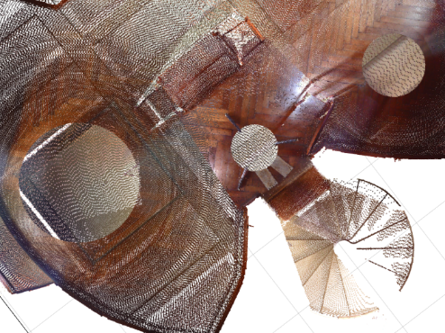

Figure 3 - missing data on Kéréon scan

## 1.2 Normal Estimation

Surface normals are really important input to some reconstruction methods such as the Poisson methods (5) that we are going to explain. We are calling normals, the normal to the tangent plane associated with a data point (cf figure 4). As a matter of fact, finding all tangent plane is a method to reconstruct the surface of the point cloud as each tangent plane is a localized part of the final surface. However we’ll explain this in another part. We’ll be focusing here on finding the normal to each point and how to correctly orient them.

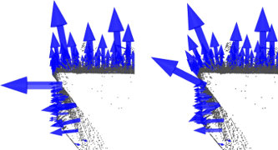

Figure 4 - Oriented normals of a cloud point (6)

Let’s define the tangent plane associated with the data point and represented by is center the point and its associated unit normal vector (4). We defined the center as the centroid of the closest neighbor (where is user-specified) of . This set of neighbor is denoted as . To compute the we will be using the covariance matrix of defined as follow

Let’s now denote the eigenvalues of CV and the associated eigenvectors. Then, using Principal Component Analysis (7) we can approximate or to be the unit normal vector of the tangent plane associated to the data point . As a matter of fact the eigenvector of the covariance matrix gives information about the pattern of the data (7). The eigenvector associated with the highest eigenvalue will represented the line where the data are the more correlated. At the opposite the eigenvector associated with the lowest eigenvalue will represented the line where the data are the less correlated. And the last eigenvector will represent a less important correlation of the data. For example the figure 5 show the two first eigenvectors of a strongly oriented set of points. Knowing that each eigenvector are perpendicular to each other, we can conclude that the two first eigenvectors will be included in the tangent plane and the third one will be the normal to this plane.

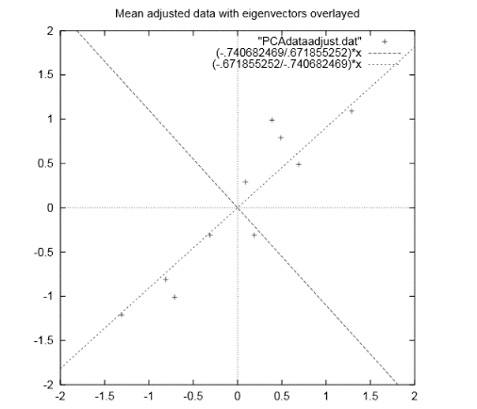

Figure 5 - Representation of the two first eigenvectors from a covariance matrix of a given dataset

Now that we have our normal vectors to each data point, we should ideally oriented them, i.e. make them all point toward the inside of the surface or toward the outside. By doing so we can understand better if we are inside or outside the surface we are trying to reconstruct. This will be also useful later on in one of the algorithm we will describe.

A natural way to easily orient all the normal will be to give the same orientation to point close in the geometric point of view. However this kind of orientation in not robust when the surface we’re considering have sharp angle. As the figure 6 shows two points can be close but can have really different normal orientation.

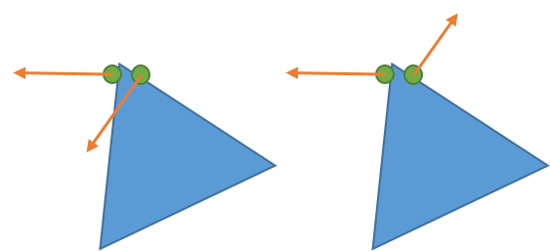

Figure 6 - Comparison between a bad orientation (on the left) and a good orientation (on the right) of the normals

In order to solve this problem (4) use the value where and represent the normal vectors associated with the close centroid and . So if then it means that the two normals are parallel and have the same orientation. Thus the ideal way to orient the normal is to propagate the orientation following the path were is always at is minimum.

Furthermore orienting normals can also be done using the coordinates of the scanner. Indeed the scanner will always be inside the surface we’re scanning or outside, and can therefore easily give the normal orientation. However this imply to note the scanner position during the scan.

# 2. Surface Function

This part will be focusing on the definition of the surface function of the object, or room we want to recreate. A surface function is not to be confused with surface reconstruction. The surface reconstruction aim to recreate the surface of the cloud point, meaning to link all the points in a coherent way. However the surface function, will be a scalar function that define the surface, i.e. can tell us whether or not a point is located on the surface. The surface function can be used to define an isosurface. An isosurface is an implicit function defined as follow:

(8)

can be seen as a threshold delimiting the surface and is called the isovalue. Basically if then we are at the exterior of the surface and if we are inside the surface. Therefore here define our isosurface but is also the surface function we are looking for. We will present to you two methods to determine this function in the section below.

## 2.1 Signed Distance Function (4)

This part will use the same notation as the part 1.2. However we will here define to be a sampled data point vector approximating the surface . Furthermore each vector of can be defined as follow:

Here represent the inaccuracy of the laser, thus will be the error. The sample is called -noisy.

is also -dense, meaning that any sphere with a radius of and center in contains at least one sample point in .

The signed distance function can be defined as follow:

The sign of this function will give us on which side of the surface the point is located. However this signed distance is not totally the surface function we are searching as it will not give us the belonging or not of the point to the surface . To define the surface function, (4) used the fact that is -dense and -noisy. Therefore the projection of a point on will always be at a distance inferior to . Thus, the surface function can be defined using the algorithm:

This structure function allow to easily recreate a surface, however it is not really robust to the noise especially for small value of were the noise hide the true nature of surface by not giving the right centroid for the tangent plane. On the opposite taking bigger value for will result in a less precise mesh. The key factor is to correctly determine to obtain the best representation possible. The next part will present a more robust surface function using the Poisson problem to be computed.

## 2.2 Indicator function

The indicator function is used to compute the surface function used in the Poisson surface reconstruction (5) one of the easiest and most efficient method to do surface reconstruction. The indicator function is defined as follow:

The indicator function, is therefore really useful to describe a surface. However finding it is not trivial. To do so we’re going to use the oriented vectors we learnt to compute in the 1.2 section.

As a matter of fact, the gradient of will be equal to 0 everywhere, except on the surface of the model we are studying by definition of the indicator function (indeed is nearly constant everywhere). Thus we can say that where represent the inward surface normals. Then we can change this problem in a Poisson problem by applying the divergence operator. Thus, finding the indicator function will be possible by solving this equation:

Solving this Poisson problem offer some advantages one being that it takes into account all the points at the same time. This advantage allow a really robust 3D reconstruction of the surface to the noise. This robustness is allowed by the surface function we are using to extract our isosurface.

The surface function will be defined as follow (using the same notation as before):

Here the isovalue will be . The isovalue allow a really robust to the noise reconstruction because it takes into account all the points of the surface, therefore diminishing the impact of the noise on the 3D surface.

This surface function is not only reluctant to noise but also offer really good result in term of resolution. Using the Poisson surface reconstruction is really an efficient way to obtain good results, even with non-uniform and non-oriented data.

# 3. Surface reconstruction

The final step to the creation of our mesh is the surface reconstruction. To do so we’ll have to create

# . References

1. **Bey, Aurélien.** *CNRS.* [Online] Juin 25, 2012. http://liris.cnrs.fr/~rchaine/EDF_A_BEY/These-Aurelien-Bey.pdf.

2. **Wikipedia The Free Encyclopedia.** Polygon Mesh. [Online] https://en.wikipedia.org/w/index.php?title=Polygon_mesh&oldid=706022466.

3. **Berger, Matthew, Andrea Tagliasacchi, Lee Seversky, Pierre Alliez, Joshua Levine, Andrei Sharf Claudio Silva.** State of the Art in Surface Reconstruction from Point Clouds. [Online] 2014. http://lgg.epfl.ch/publications/2014/reconstar/paper.pdf.

4. **Hugues Hoppe, Tony DeRose, Tom Duchamp, John McDonald, Werner Stuetzle.** Surface Reconstruction from Unorganized Points. [Online] http://research.microsoft.com/en-us/um/people/hoppe/recon.pdf.

5. **Kazdhan Micheal, Bolitho Matthew, Hoppe Hugues.** Poisson Surface Reconstruction. [Online] 2006. http://faculty.cs.tamu.edu/schaefer/teaching/689_Fall2006/poissonrecon.pdf.

6. **Point Cloud Library.** Estimating Surface Normals in a PointCloud. [Online] http://pointclouds.org/documentation/tutorials/normal_estimation.php.

7. **Smith, Lindsay I.** A tutorial on Principal Component Analysis. [Online] February 26, 2002. http://www.cs.otago.ac.nz/cosc453/student_tutorials/principal_components.pdf.

8. **Wenger, Rephael.** *Isosurfaces: Geometry, Topology, and Algorithms.* s.l. : A K Peters/CRC Press, 2013. ISBN 9781466570979.