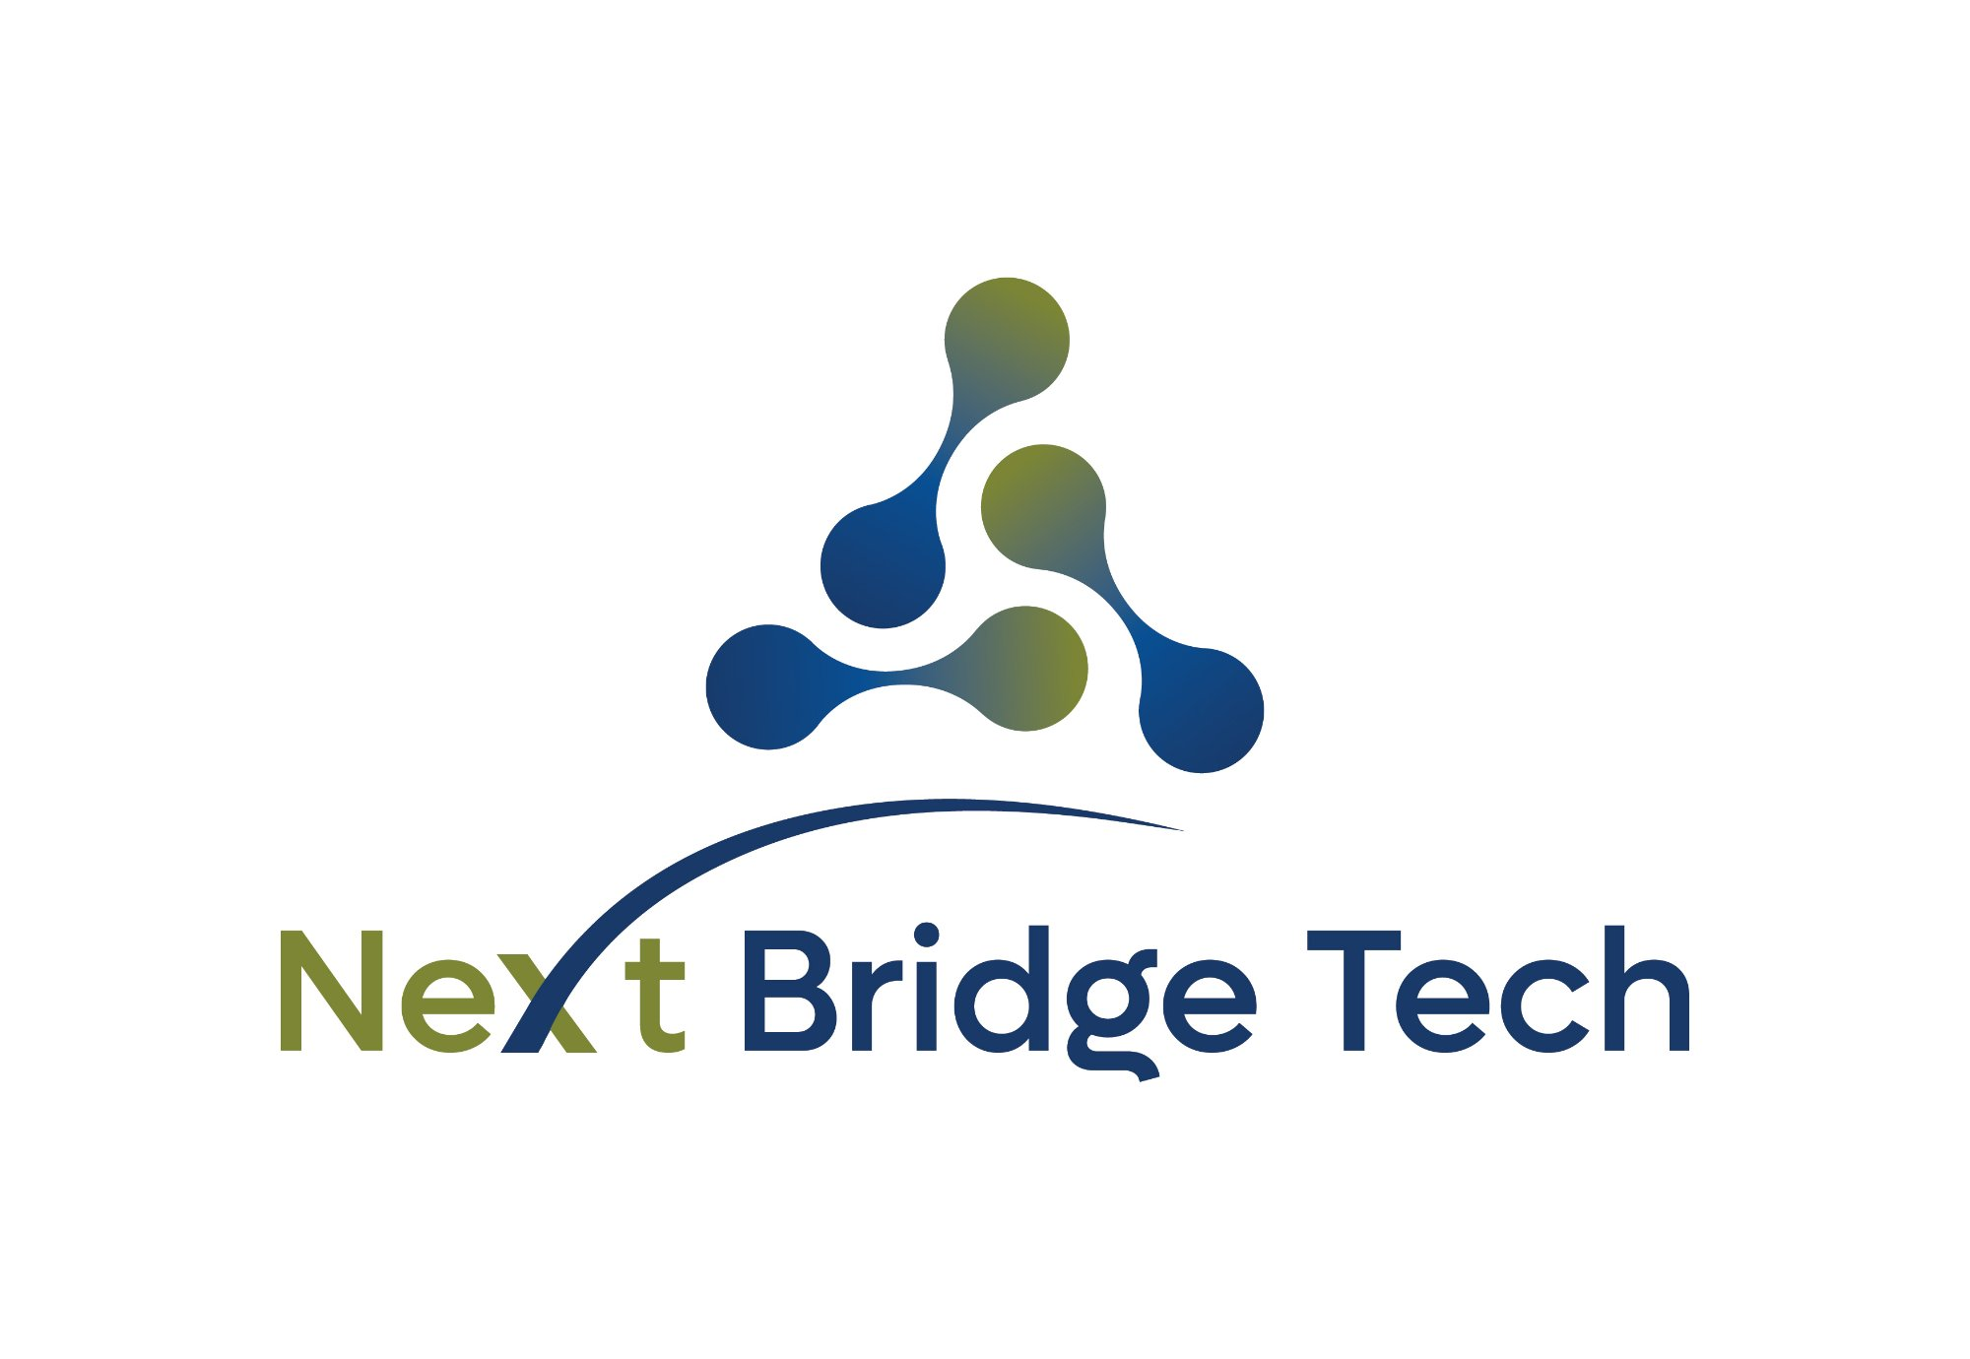
SCOPE OF WORK
Kopa Telecom Customer Mobile Application Development
iOS & Android apps and an Administration Web Portal

Prepared by (Service Provider) | Prepared for (Client)
NextBridge Tech Ltd | Kopa Telecom

Document Control
Field | Detail
Document title | Scope of Work - Kopa Telecom Customer Mobile Application Development
Client | Kopa Telecom
Service provider | NextBridge Tech Ltd
Version | 1.0

1. Introduction & Background
Kopa Telecom intends to deliver a customer-facing mobile application that allows its subscribers to self-manage their accounts directly from their smartphones. A dedicated mobile application improves the customer experience, reduces load on assisted channels and gives Kopa Telecom a modern digital touchpoint with its subscriber base.
NextBridge Tech Ltd (“NextBridge”, the Service Provider) has been engaged to design, build, deploy and support this application on behalf of Kopa Telecom (the “Client”). The application will connect to Kopa Telecom’s existing Business Support System (BSS) through the documented KTRN API, and to a separate SMS notification service for customer messaging.
This Scope of Work defines what will be delivered, the boundaries of the engagement, the functional and non-functional requirements, the integrations required, and the shared responsibilities, risks and assumptions on which delivery depends.

1.1 Purpose of this document
- Establish a single, agreed definition of the solution to be delivered.
- Set the boundary between what is in scope and what is explicitly out of scope.
- Record the obligations of each party so that delivery can proceed without ambiguity.
- Provide the basis for acceptance, change control and sign-off.

1.2 Parties
Party | Role | Primary responsibilities
NextBridge Tech Ltd | Service Provider | Solution design, development, functional testing, deployment and agreed post-launch support.
Kopa Telecom | Client / Owner | KTRN and SMS API access, Server environments and VPN, business rules, brand assets, Appstore and Playstore account ownership, review and acceptance.

2. Objectives & Success Criteria

2.1 Business objectives
- Give subscribers a self-service channel to manage their accounts without visiting an agent or calling support.
- Increase bundle and recharge transactions completed through digital channels.
- Provide Kopa Telecom with an administrative view over app usage and customer activity through a web portal.
- Establish a foundation that can later extend to additional payment methods and services.

2.2 Success criteria
The engagement is considered successful when the following are demonstrably true:
- The iOS and Android apps are published and available for download on the Apple App Store and Google Play Store under Kopa Telecom’s accounts.
- A subscriber can register/activate, log in, view balance and usage, purchase a bundle, recharge and view their statement end-to-end.
- Transaction-authorising actions are confirmed by an OTP delivered through the SMS service.
- Administrators can access the web portal and view the agreed operational information.
- The solution passes System Integration Test (SIT) and User Acceptance Testing (UAT).

3. Solution Overview
The solution comprises three delivered components supported by a middleware/back-end layer:
Component | Description
Customer Mobile App (iOS) | Cross-platform app published to the Apple App Store for subscriber self-care.
Customer Mobile App (Android) | Cross-platform app published to the Google Play Store, feature-equivalent to the iOS app.
Administration Web Portal | Browser-based portal for Kopa Telecom staff to administer the service and view app-related operational information. This is an internal, staff-facing tool - not a customer channel.
Application Back-End / Middleware | A secure microservice layer that mediates between the apps/portal and KTRN and SMS services, handles sessions, OTP orchestration, and shields the apps from direct exposure to back-end systems.
The mobile apps and portal do not call the KTRN API directly. All KTRN and SMS interactions are brokered through the application back-end, which enforces authentication, validation, logging and rate control.

3.1 Target platforms
- iOS - current and recent supported versions, subject to agreement at design stage.
- Android - current and recent supported versions, subject to agreement at design stage.
- Administration Web Portal - latest versions of mainstream web browsers.

4. Scope of Work

4.1 In scope
The following capabilities are included in the release:

Registration & Activation
- Self-registration and line activation for new customers, driven by the KTRN activation services.
- Capture of customer details and required identity information supported by the KTRN API.

Authentication & Access
- Login using MSISDN (phone number) and a 6-digit PIN.
- PIN set-up, PIN change and PIN reset flows.
- One-Time Password (OTP) via SMS is required to authorise transactions — not at login. Login uses MSISDN + PIN only; OTP is requested at the point of transaction authorisation.

Balance & Usage
- View account balance.
- View usage and remaining balance for active bundles.

Bundles & Recharge
- Browse bundles available for purchase on the subscriber’s line.
- Purchase a bundle, with transaction confirmation.
- Recharge the account, including recharge by voucher, through the existing KTRN recharge services.
- Purchase/recharge funded through the customer’s existing balance / e-wallet as supported by the current KTRN APIs.

Statement / History
- View a history of purchases, recharges and usage available from the KTRN API.

Notifications
- Transactional SMS notifications (e.g. OTP, purchase and recharge confirmations) through the SMS notification service.

Administration Web Portal
- Administrator login and role-based access.
- View of app registrations and customer/account activity available through the integrated services.
- Operational dashboards/reports covering app usage and transactions, to a level agreed at design stage.

4.2 Out of scope
The following are explicitly excluded from this release and would be handled as separate initiatives or future phases:
- Direct Mobile Money integration (MTN MoMo, Airtel Money) and card payment gateways. The architecture will be designed to accommodate Mobile Money in a later phase, but no such integration is built or delivered in this version.
- Any feature not currently exposed by the provided KTRN API or SMS API.
- Loyalty/rewards programmes, referral schemes and promotional engines beyond what the KTRN API already provides.
- In-app chat, live agent or full CRM/ticketing capabilities.
- Roaming management, device/eSIM provisioning, and value-added third-party services.
- Migration of historical data.
- Marketing, app-store optimisation and end-user support operations after handover, unless covered by a separate support agreement.

4.3 Provision for future phases
The solution will be architected so that Mobile Money payment integration can be added later without a fundamental redesign. This is a design consideration only; the corresponding build, testing and go-live are outside this version and would be scoped separately.

5. Functional Requirements
The table below lists the functional requirements for this version.
Ref | Requirement | Description
FR-01 | Registration & activation | A prospective customer can register and activate a line through the app using the KTRN activation services.
FR-02 | Login | A customer can log in with MSISDN and a 6-digit PIN.
FR-03 | PIN management | A customer can set, change and reset their PIN securely.
FR-04 | Transaction OTP | The system requires an SMS OTP to authorise transactions such as purchases and recharges.
FR-05 | View balance | A customer can view their current account balance.
FR-06 | View usage | A customer can view usage and remaining allowances for active bundles.
FR-07 | Browse bundles | A customer can see the bundles available for purchase on their line.
FR-08 | Purchase bundle | A customer can purchase a bundle and receive confirmation of success or failure.
FR-09 | Recharge | A customer can recharge their account, including recharge by voucher.
FR-10 | Statement / history | A customer can view a history of transactions and usage available from the KTRN API.
FR-11 | Notifications | The system sends transactional SMS notifications for key events.
FR-12 | Profile | A customer can view their basic account/profile information.
FR-13 | Admin login | An administrator can log in to the web portal with role-based access.
FR-14 | Admin monitoring | An administrator can view app registrations, customer/account activity and transaction/usage reports.
FR-15 | Session handling | The system manages sessions securely, with automatic timeout and safe logout.

6. Non-Functional Requirements
Area | Requirement
Security | Encrypted communication in transit; secure storage of credentials and tokens; PIN never stored in clear; OTP for transaction authorisation; protection against common mobile and API threats.
Privacy & compliance | Handling of personal data in line with applicable Rwandan data-protection law and Kopa Telecom policy; consent captured where required.
Performance | Common actions (balance, usage, bundle list) respond promptly under normal load; targets to be agreed and measured, bounded by KTRN API/SMS response times.
Availability | The app back-end is designed for high availability during customer-facing hours; dependent on KTRN API/SMS availability.
Scalability | The back-end can scale to Kopa Telecom’s subscriber base and transaction peaks without redesign.
Usability & accessibility | Clean, intuitive interface consistent with Kopa Telecom branding; support for the agreed language(s); reasonable accessibility practices.
Reliability | Graceful handling of KTRN API/SMS errors and timeouts, with clear user messaging and no duplicate transactions.
Observability | Logging, monitoring and alerting on the back-end for support and troubleshooting, excluding sensitive data.
Store compliance | Apps meet Apple App Store and Google Play Store policy and technical requirements for approval.

7. Integrations Required
Delivery depends on two integrations, both provided and maintained by Kopa Telecom (or its vendors).

7.1 KTRN API
- Purpose: balance and usage enquiry, bundle browsing and purchase, recharge (including voucher), registration/activation, customer information and MSISDN services.
- Dependency: a stable, reachable test/sandbox environment plus production access, valid credentials, business identifiers and reference data.

7.2 SMS notification service
- Purpose: delivery of OTPs for transaction authorisation and transactional notifications (purchase/recharge confirmations, etc.).
- Dependency: API specification, credentials, sender ID/short code, and a usable test path for message delivery.

8. Assumptions & Dependencies
- Kopa Telecom provides timely access to the KTRN API and SMS APIs, including test and production environments, Server Access and VPN Tunnels establishment, credentials and documentation.
- The KTRN API and the SMS API accurately reflect the live systems and remain stable during delivery; material changes are handled through change control.
- Kopa Telecom owns (or authorises creation of) the Apple Developer and Google Play Console accounts and provides the legal and business information those stores require.
- Kopa Telecom provides brand assets, content, legal texts (terms, privacy policy) and business rules (bundle catalogue behaviour, limits, messaging).
- Kopa Telecom nominates a product owner and reviewers empowered to make decisions and sign off deliverables within agreed timeframes..
- Third-party review timelines (Apple, Google) are outside NextBridge’s control and are planned for but not guaranteed.

9. Roles & Responsibilities
Activity | NextBridge | Kopa Telecom
Requirements & detailed design | Lead | Review & approve
UI/UX design | Lead | Review & approve
Brand assets & content | Support | Provide
Server Access, VPN, KTRN API & SMS API access | Consume | Provide
Application development | Lead | —
Testing (unit, integration, system) | Lead | Support
User Acceptance Testing (UAT) | Support | Lead & sign off
Store accounts & legal info | Consume | Own & provide
Store submission & review handling | Lead | Support
Production deployment | Lead | Approve
Post-launch support (agreed period) | Lead | Support

10. Risks & Mitigations
Risk | Rating | Mitigation
KTRN/SMS API instability or gaps in test environments | High | Joint issue log with Kopa Telecom; formal escalation path.
Changes to KTRN or SMS APIs mid-delivery | Medium | Formal communication to be issued by Kopa Telecom on any changes happening to the KTRN or SMS APIs.
App-store rejection or extended review | Medium | Build to store guidelines from the start; pre-submission checklist; buffer in the schedule; prompt response to reviewer feedback.
OTP / SMS delivery latency or failure | Medium | Retry and resend logic; clear user messaging; timeouts; fallback guidance; monitoring of delivery outcomes.
Security vulnerabilities | High | Kopa Telecom to avail an independent VAPT scanning partner for vulnerability scanning and NextBridge Tech to remediate the raised vulnerabilities..

11. Deliverables
- Detailed requirements, reviewed and approved.
- iOS mobile application, published to the Apple App Store.
- Android mobile application, published to the Google Play Store.
- Administration Web Portal, deployed to the agreed environment.
- Application back-end / middleware integrating the KTRN and SMS services.
- Test evidence and UAT support materials.
- Deployment and basic operational/handover documentation.
- Agreed post-launch support for the defined period.

12. Acceptance Criteria
A deliverable is accepted when it meets its agreed requirements and passes the associated tests. For the solution as a whole:
- The functional requirements in Section 5 are demonstrated end-to-end against Kopa Telecom’s environments.
- The non-functional targets in Section 6 are met to the agreed thresholds.
- UAT is completed and signed off by Kopa Telecom.
- The iOS and Android apps are approved and live on their respective stores under Kopa Telecom’s accounts.
- The Administration Web Portal is deployed and accessible to authorised staff.
Kopa Telecom will review each deliverable within a mutually agreed period. Where issues are found, they are logged, prioritised and resolved before acceptance.

13. Change Control
Any change to the scope, requirements or deliverables defined here is handled through a written change request. Each request records the change, its rationale and its impact on scope, timeline and cost. Work on a change begins only after both parties approve it in writing.

14. Approval & Sign-Off
By signing below, both parties confirm that they have reviewed and agree to the scope, requirements, assumptions and responsibilities set out in this document.

For NextBridge Tech Ltd (Service Provider)  Name  Title  Signature  Date | For Kopa Telecom (Client)  Name  Title  Signature  Date

