Graphe Exemple 0
Site : http://graphonline.ru/fr/?graph=qWYmvlIyJsAjNIEX
graph_exemple0.graphml
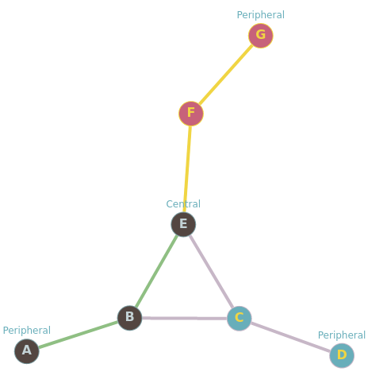

Matrice d’adjacence :
0, 1, 0, 0, 0, 0, 0,
1, 0, 1, 0, 1, 0, 0,
0, 1, 0, 1, 1, 0, 0,
0, 0, 1, 0, 0, 0, 0,
0, 1, 1, 0, 0, 1, 0,
0, 0, 0, 0, 1, 0, 1,
0, 0, 0, 0, 0, 1, 0,

Matrice des distances
0, 1, 2, 3, 2, 3, 4
1, 0, 1, 2, 1, 2, 3
2, 1, 0, 1, 1, 2, 3
3, 2, 1, 0, 2, 3, 4
2, 1, 1, 2, 0, 1, 2
3, 2, 2, 3, 1, 0, 1
4, 3, 3, 4, 2, 1, 0

Graph radius: 2 (E⇒B⇒A). Graph diameter: 4 (A⇒B⇒E⇒F⇒G).

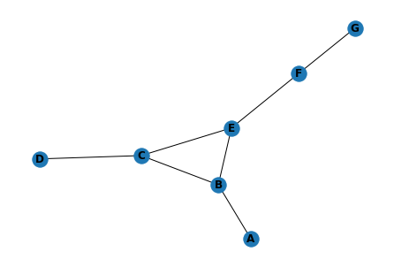

 | A | B | C | D | E | F | G | somme | dist_max | centre | rayon | diametre
A | 0.0 | 1.0 | 2.0 | 3.0 | 2.0 | 3.0 | 4.0 | 15.0 | 4.0
B | 1.0 | 0.0 | 1.0 | 2.0 | 1.0 | 2.0 | 3.0 | 10.0 | 3.0
C | 2.0 | 1.0 | 0.0 | 1.0 | 1.0 | 2.0 | 3.0 | 10.0 | 3.0
D | 3.0 | 2.0 | 1.0 | 0.0 | 2.0 | 3.0 | 4.0 | 15.0 | 4.0
E | 2.0 | 1.0 | 1.0 | 2.0 | 0.0 | 1.0 | 2.0 | 9.0 | 2.0 | E | 2.0
F | 3.0 | 2.0 | 2.0 | 3.0 | 1.0 | 0.0 | 1.0 | 12.0 | 3.0
G | 4.0 | 3.0 | 3.0 | 4.0 | 2.0 | 1.0 | 0.0 | 17.0 | 4.0 |  |  | 4.0

Avec Traitement_graphml,py

