Graphe Exemple 3

http://graphonline.ru/fr/?graph=JrTuJkwYzpMGqJvT

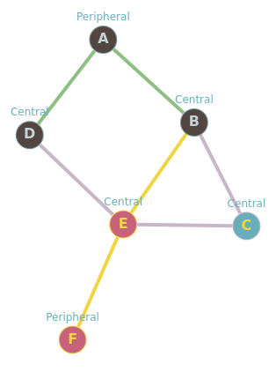
graph_exemple3.graphml

matrice d'adjacence
0, 1, 0, 1, 0, 0,
1, 0, 1, 0, 1, 0,
0, 1, 0, 0, 1, 0,
1, 0, 0, 0, 1, 0,
0, 1, 1, 1, 0, 1,
0, 0, 0, 0, 1, 0,

La matrice des distances minimales
0, 1, 2, 1, 2, 3
1, 0, 1, 2, 1, 2
2, 1, 0, 2, 1, 2
1, 2, 2, 0, 1, 2
2, 1, 1, 1, 0, 1
3, 2, 2, 2, 1, 0

Graph radius: 2 (B⇒A⇒D). Graph diameter: 3 (A⇒B⇒E⇒F).

 | A | B | C | D | E | F | somme | dist_max | centre | rayon | diametre
A | 0.0 | 1.0 | 2.0 | 1.0 | 2.0 | 3.0 | 9.0 | 3.0
B | 1.0 | 0.0 | 1.0 | 2.0 | 1.0 | 2.0 | 7.0 | 2.0
C | 2.0 | 1.0 | 0.0 | 2.0 | 1.0 | 2.0 | 8.0 | 2.0
D | 1.0 | 2.0 | 2.0 | 0.0 | 1.0 | 2.0 | 8.0 | 2.0
E | 2.0 | 1.0 | 1.0 | 1.0 | 0.0 | 1.0 | 6.0 | 2.0 | E | 2.0
F | 3.0 | 2.0 | 2.0 | 2.0 | 1.0 | 0.0 | 10.0 | 3.0 |  |  | 3.0

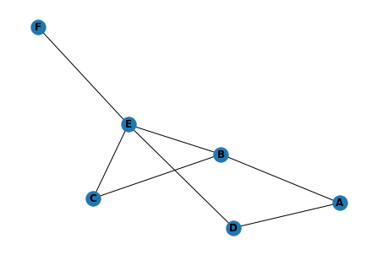

Avec Traitement_graphml,py

