Graphe Exemple 4A
http://graphonline.ru/fr/?graph=vRaORBFPVcTUVQpw
graph_exemple4A.graphml
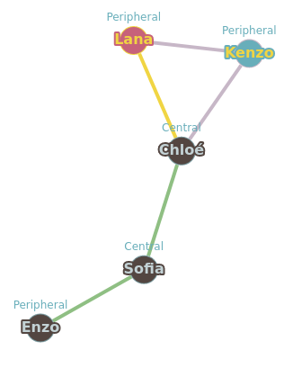

Graph radius: 2 (Chloé⇒Sofia⇒Enzo). Graph diameter: 3 (Lana⇒Chloé⇒Sofia⇒Enzo).

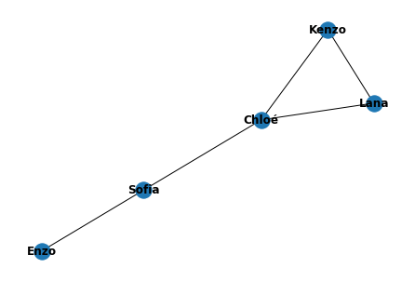
Matrice d'adjacence.
0, 1, 1, 0, 0,
1, 0, 1, 1, 0,
1, 1, 0, 0, 0,
0, 1, 0, 0, 1,
0, 0, 0, 1, 0,

La matrice des distances minimales
0, 1, 1, 2, 3
1, 0, 1, 1, 2
1, 1, 0, 2, 3
2, 1, 2, 0, 1
3, 2, 3, 1, 0

 | Lana | Chloé | Kenzo | Sofia | Enzo | somme | dist_max | centre | rayon | diametre
Lana | 0.0 | 1.0 | 1.0 | 2.0 | 3.0 | 7.0 | 3.0
Chloé | 1.0 | 0.0 | 1.0 | 1.0 | 2.0 | 5.0 | 2.0 | Chloé | 2.0
Kenzo | 1.0 | 1.0 | 0.0 | 2.0 | 3.0 | 7.0 | 3.0
Sofia | 2.0 | 1.0 | 2.0 | 0.0 | 1.0 | 6.0 | 2.0
Enzo | 3.0 | 2.0 | 3.0 | 1.0 | 0.0 | 9.0 | 3.0 |  |  | 3.0

