Graphe Exemple 4B
http://graphonline.ru/fr/?graph=wANYvijfWGgZaxED
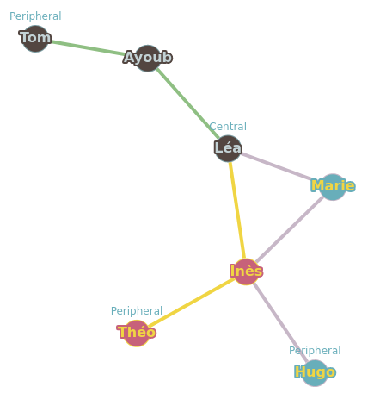
graph_exemple4B.graphml

Matrice d'adjacence.
0, 1, 0, 1, 0, 0, 0,
1, 0, 0, 0, 0, 0, 0,
0, 0, 0, 1, 0, 0, 1,
1, 0, 1, 0, 0, 0, 1,
0, 0, 0, 0, 0, 0, 1,
0, 0, 0, 0, 0, 0, 1,
0, 0, 1, 1, 1, 1, 0,
Matrice des distances minimales
0, 1, 2, 1, 3, 3, 2
1, 0, 3, 2, 4, 4, 3
2, 3, 0, 1, 2, 2, 1
1, 2, 1, 0, 2, 2, 1
3, 4, 2, 2, 0, 2, 1
3, 4, 2, 2, 2, 0, 1
2, 3, 1, 1, 1, 1, 0

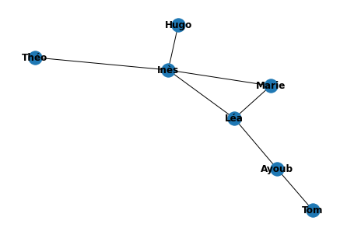
Graph radius: 2 (Léa⇒Ayoub⇒Tom). Graph diameter: 4 (Tom⇒Ayoub⇒Léa⇒Inès⇒Théo).

 | Ayoub | Tom | Marie | Léa | Théo | Hugo | Inès | somme | dist_max | centre | rayon | diametre
Ayoub | 0.0 | 1.0 | 2.0 | 1.0 | 3.0 | 3.0 | 2.0 | 12.0 | 3.0
Tom | 1.0 | 0.0 | 3.0 | 2.0 | 4.0 | 4.0 | 3.0 | 17.0 | 4.0 |  |  | 4.0
Marie | 2.0 | 3.0 | 0.0 | 1.0 | 2.0 | 2.0 | 1.0 | 11.0 | 3.0
Léa | 1.0 | 2.0 | 1.0 | 0.0 | 2.0 | 2.0 | 1.0 | 9.0 | 2.0 | Léa | 2.0
Théo | 3.0 | 4.0 | 2.0 | 2.0 | 0.0 | 2.0 | 1.0 | 14.0 | 4.0
Hugo | 3.0 | 4.0 | 2.0 | 2.0 | 2.0 | 0.0 | 1.0 | 14.0 | 4.0
Inès | 2.0 | 3.0 | 1.0 | 1.0 | 1.0 | 1.0 | 0.0 | 9.0 | 3.0

