Graphe TP1 exemple 1
http://graphonline.ru/en/?graph=uGbEADKqgwzEBoMP
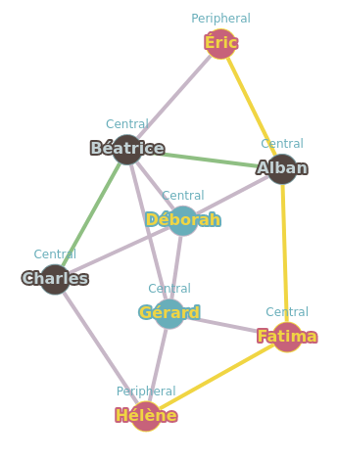
graph_TP1_1.graphml
Matrice d'adjacence.
0, 1, 0, 1, 1, 1, 0, 0,
1, 0, 1, 1, 1, 0, 1, 0,
0, 1, 0, 1, 0, 0, 0, 1,
1, 1, 1, 0, 0, 0, 1, 0,
1, 1, 0, 0, 0, 0, 0, 0,
1, 0, 0, 0, 0, 0, 1, 1,
0, 1, 0, 1, 0, 1, 0, 1,
0, 0, 1, 0, 0, 1, 1, 0,

La matrice des distances minimales
0, 1, 2, 1, 1, 1, 2, 2
1, 0, 1, 1, 1, 2, 1, 2
2, 1, 0, 1, 2, 2, 2, 1
1, 1, 1, 0, 2, 2, 1, 2
1, 1, 2, 2, 0, 2, 2, 3
1, 2, 2, 2, 2, 0, 1, 1
2, 1, 2, 1, 2, 1, 0, 1
2, 2, 1, 2, 3, 1, 1, 0

Graph radius: 2 (Alban⇒Béatrice⇒Charles). Graph diameter: 3 (Éric⇒Alban⇒Fatima⇒Hélène).

 | Alban | Béatrice | Charles | Déborah | Éric | Fatima | Gérard | Hélène | somme | dist_max | centre | rayon | diametre
Alban | 0.0 | 1.0 | 2.0 | 1.0 | 1.0 | 1.0 | 2.0 | 2.0 | 10.0 | 2.0
Béatrice | 1.0 | 0.0 | 1.0 | 1.0 | 1.0 | 2.0 | 1.0 | 2.0 | 9.0 | 2.0 | Béatrice | 2.0
Charles | 2.0 | 1.0 | 0.0 | 1.0 | 2.0 | 2.0 | 2.0 | 1.0 | 11.0 | 2.0
Déborah | 1.0 | 1.0 | 1.0 | 0.0 | 2.0 | 2.0 | 1.0 | 2.0 | 10.0 | 2.0
Éric | 1.0 | 1.0 | 2.0 | 2.0 | 0.0 | 2.0 | 2.0 | 3.0 | 13.0 | 3.0 |  |  | 3.0
Fatima | 1.0 | 2.0 | 2.0 | 2.0 | 2.0 | 0.0 | 1.0 | 1.0 | 11.0 | 2.0
Gérard | 2.0 | 1.0 | 2.0 | 1.0 | 2.0 | 1.0 | 0.0 | 1.0 | 10.0 | 2.0
Hélène | 2.0 | 2.0 | 1.0 | 2.0 | 3.0 | 1.0 | 1.0 | 0.0 | 12.0 | 3.0

