Graphe TP1 exemple 2
http://graphonline.ru/fr/home?graph=JBlYfRFVmkVekapn
graph_TP1_2.graphml
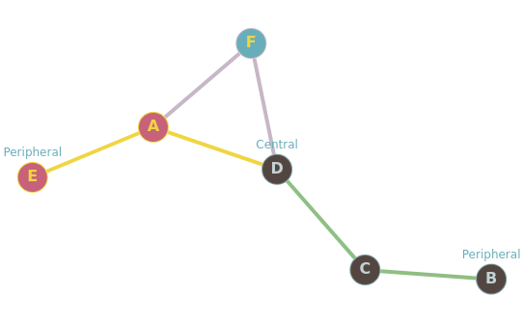

Graph radius: 2 (D⇒C⇒B). Graph diameter: 4 (B⇒C⇒D⇒A⇒E).
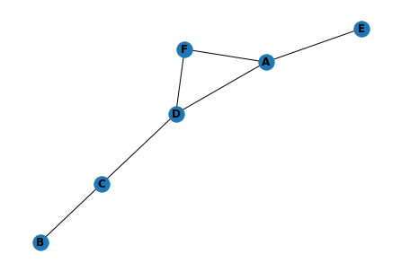
matrice d'adjacence.
0, 0, 0, 1, 1, 1,
0, 0, 1, 0, 0, 0,
0, 1, 0, 1, 0, 0,
1, 0, 1, 0, 0, 1,
1, 0, 0, 0, 0, 0,
1, 0, 0, 1, 0, 0,

Matrice des distances minimales
0, 3, 2, 1, 1, 1
3, 0, 1, 2, 4, 3
2, 1, 0, 1, 3, 2
1, 2, 1, 0, 2, 1
1, 4, 3, 2, 0, 2
1, 3, 2, 1, 2, 0

 | A | B | C | D | E | F | somme | dist_max | centre | rayon | diametre
A | 0.0 | 3.0 | 2.0 | 1.0 | 1.0 | 1.0 | 8.0 | 3.0
B | 3.0 | 0.0 | 1.0 | 2.0 | 4.0 | 3.0 | 13.0 | 4.0 |  |  | 4.0
C | 2.0 | 1.0 | 0.0 | 1.0 | 3.0 | 2.0 | 9.0 | 3.0
D | 1.0 | 2.0 | 1.0 | 0.0 | 2.0 | 1.0 | 7.0 | 2.0 | D | 2.0
E | 1.0 | 4.0 | 3.0 | 2.0 | 0.0 | 2.0 | 12.0 | 4.0
F | 1.0 | 3.0 | 2.0 | 1.0 | 2.0 | 0.0 | 9.0 | 3.0

