Graphe TP1 exemple 3
http://graphonline.ru/fr/home?graph=LWFHpLQZlpAnYdnn
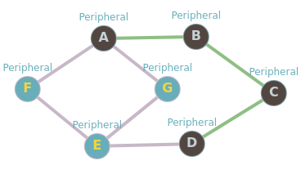
graph_TP1_3.graphml
matrice d'adjacence
0, 1, 0, 0, 0, 1, 1,
1, 0, 1, 0, 0, 0, 0,
0, 1, 0, 1, 0, 0, 0,
0, 0, 1, 0, 1, 0, 0,
0, 0, 0, 1, 0, 1, 1,
1, 0, 0, 0, 1, 0, 0,
1, 0, 0, 0, 1, 0, 0,

La matrice des distances minimales
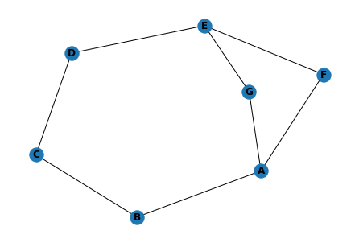
0, 1, 2, 3, 2, 1, 1
1, 0, 1, 2, 3, 2, 2
2, 1, 0, 1, 2, 3, 3
3, 2, 1, 0, 1, 2, 2
2, 3, 2, 1, 0, 1, 1
1, 2, 3, 2, 1, 0, 2
1, 2, 3, 2, 1, 2, 0

Graph radius: 3 (A⇒B⇒C⇒D). Graph diameter: 3 (A⇒B⇒C⇒D).

 | A | B | C | D | E | F | G | somme | dist_max | centre | rayon | diametre
A | 0.0 | 1.0 | 2.0 | 3.0 | 2.0 | 1.0 | 1.0 | 10.0 | 3.0 | A | 3.0
B | 1.0 | 0.0 | 1.0 | 2.0 | 3.0 | 2.0 | 2.0 | 11.0 | 3.0
C | 2.0 | 1.0 | 0.0 | 1.0 | 2.0 | 3.0 | 3.0 | 12.0 | 3.0 |  |  | 3.0
D | 3.0 | 2.0 | 1.0 | 0.0 | 1.0 | 2.0 | 2.0 | 11.0 | 3.0
E | 2.0 | 3.0 | 2.0 | 1.0 | 0.0 | 1.0 | 1.0 | 10.0 | 3.0 | E | 3.0
F | 1.0 | 2.0 | 3.0 | 2.0 | 1.0 | 0.0 | 2.0 | 11.0 | 3.0
G | 1.0 | 2.0 | 3.0 | 2.0 | 1.0 | 2.0 | 0.0 | 11.0 | 3.0

