Functionalities represented by the async/await keyword in .Net are based on the functionalities previously regrouped in the “Task Parallel Library” (TPL). In this library was introduced the Task Class, which supported asynchronous programming.
Invocation of a method returning Task or Task<T> returns immediately, and these methods are executing on another thread. If you wanted to wait for a such method to be complete before executing another method you had to use “ContinueWith”:
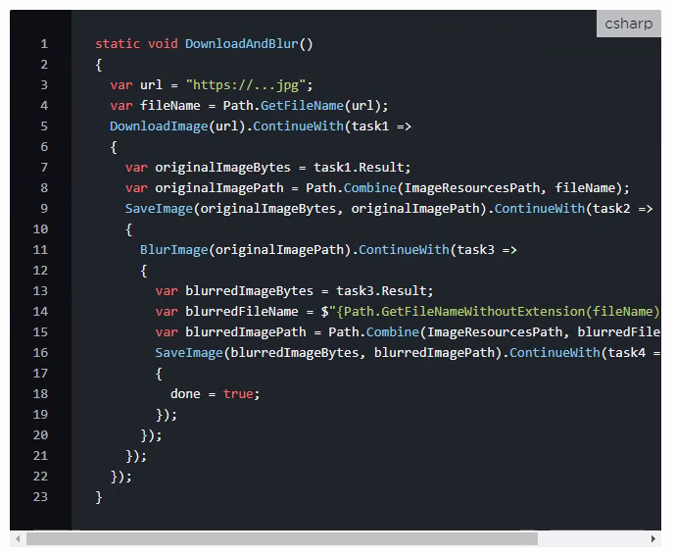

Where
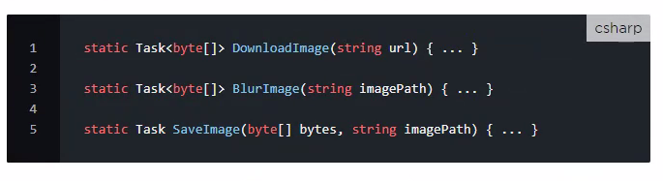

…creating so a chain not easy to read.
With Await/Async we can write an easier to understand code instead:
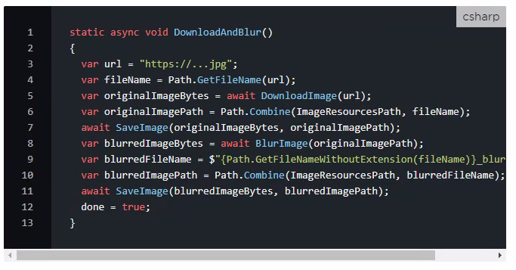

- Using await pause the main thread while the awaited method is being executed by another thread. Execution is done sequentially. Awaited methods are executed without blocking the main thread.
We need the async keyword to tell the compiler that this use of the await keyword is related to asynchronous flow.

Take-away:
- to be executed asynchronously (on another thread) a method shall return Task or Task<T>.
- if the main thread must wait the asynchronous method to be finished, await + async keywords must be used.

