Contents
Installing packages 1
Models 1
DbContext 1
Initiating the DB 1
Relation between tables 2
Seeding Table 3
Eager Loading 3

Installing packages
- EntityFrameworkCore
- EntityFrameworkCore.SqlServer if the DB used is SQLServer
- EntityFramworkCore.Tools give access to the commands needed to handle the DB (migrations…)

Models
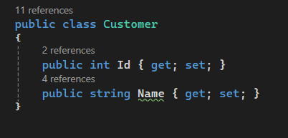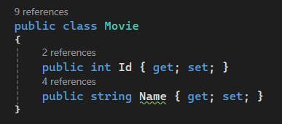

DbContext
To access the DB from the app, we get to write a class that will represent it. That class must inherit from DbContext. It will represent each table with a property of DbSet<T>:
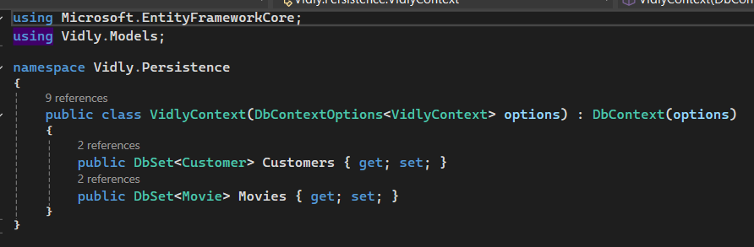
When instantiating the context, we get to pass an object of type DbContextOptions. Here example of registering an instance of the DbContext in a .net Core app using a sql server DB:

Initiating the DB
- Install SQL Express
- Create the DataBase:
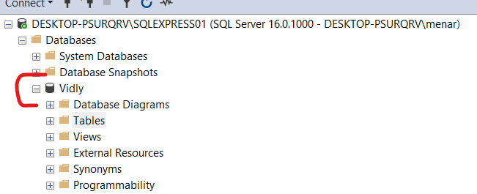
- Create the tables:
for that in visual studio in the package manager window, create the first migration:
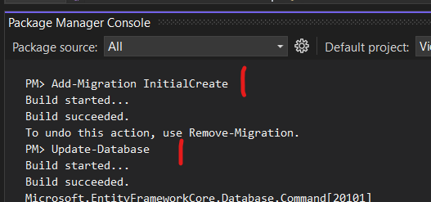
- Add / modify a table: change the DbContext class according to the needs, add a new migration and update the database.

Relation between tables
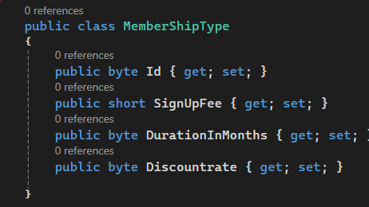
Then: 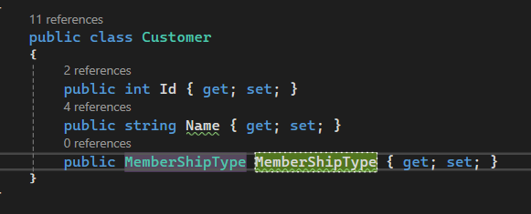
If we don’t want to load the whole object in the customer instance, we can just link it to a MemberShipType using its id. We then have to follow the convention LinkedObjectType + Id:
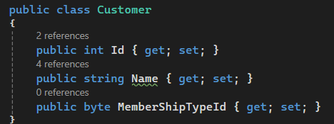

Seeding Table
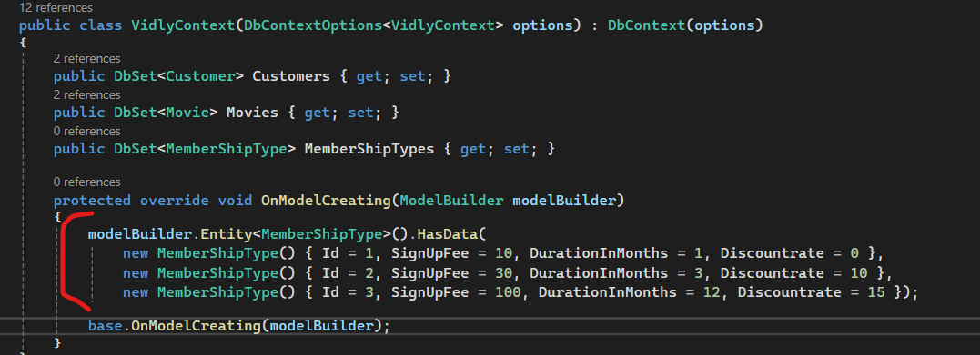

Eager Loading
When loading an object from database, EF per default does not load related objects: only properties of primitive types are loaded those of complex types not. To force complex objects to be loaded, we get to explicitly include them:
