Cuprins
Event-driven Architecture 1
Monolithic vs microservices 2
Monolithic Apps 3
Microservices 3
Kafka 3
Message 3
Producer 4
Consumer 4
Kafka Broker 4
Kafka Cluster 4
Topics 4
Partitions 4
Offsets 4
MES 4

Event-driven Architecture
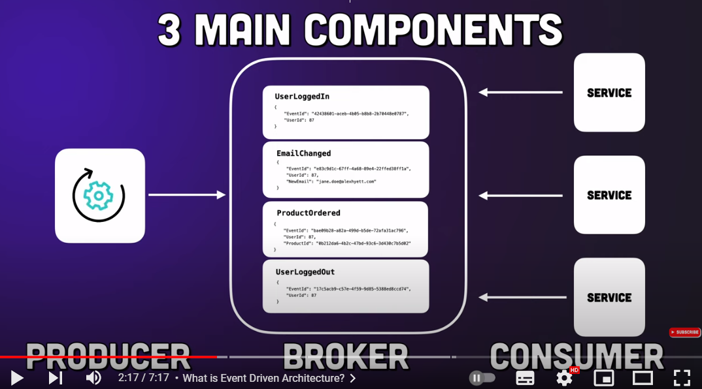

Benefits over typical API driven model:
- Decoupling
Producer and consumer don’t know from each other. Note that it is not the case by the message driven architecture, where the producer knows about the recipient.
- Allows to use dependency inversion:
The high-level component (producer) does not depend on the low-level components (consumers). But rely on an abstraction (broker). So, it’s easy to replace consumers.
- Scaling
It is easy and quick to add new publishers / subscriber if needed (audit function…)
Disadvantages:
- Data consistency:
Delay between publishing and subscriber getting the event. Usually minuscule but can increase if subscribers fall behind (they execute successively). This can be addressed adding a cache, storing critical information the time the app eventually gets consistent.
- Duplicate messages
the message broker sets a checkpoint on the published events to mark them as consumed by the subscribers. But for performance reasons, it does not do that for each event. Consequence when a subscriber goes offline and comes back, it can be fed with events it has already processed before going off.
To address that, we shall make our subscribers idempotent (the same operation can be executed more than once, all executions having the same result as the first one). We can decorate the events with a unique id and check by the subscribers if an event has already been processed.
- Complexity increase / harder to debug.

Monolithic vs microservices

Monolithic Apps
Are apps made in 1 block.
Pros:
- Easy to develop / single repo.
- Easy to deploy (1 pipeline).
- Easy to debug.
- Performance: it is quicker for objects to call each other from within the same project
Cons:
- Gets bigger and bigger, will make on boarding of new team members longer and longer as they are going to learn a lot before starting development.
- Longer release. Even a small local change leads to the release of the whole
- Hard to scale. If one part of the app gets overloaded, we must scale up
(increase the instance number) the whole app, which might take a lot of space on the server (= money) although a small part of the is requiring the scaling.

Microservices
By microservices we split the app in different modules (components/services) that are self-contained, independent and have a single responsibility.
Having different services in an app, we have 3 ways to implement communication between the services:
- Using services API (HTTP based).
To use when synchronous communication is required. Introduces latency (slower) if using text based data format to serialize data (json or xml). gRPC is a quicker technology if speed is required.
- Message broker. Sender and consumer are not linked to one another. The sender sends the message to the broker, the receiver gets notified by the broker when an awaited message kicks in.
→ services will run asynchronously (sender does not wait the consumer to consume its message to go back to its activities).
RabbitMQ / AWS SQS / Kafka
- Service mesh
Pros:
- Easier to maintain. Each service has a single responsibility.
- Each service can have its own tech stack (for example the programming language) although it’s a good practice to have homogeneity.
- Scalability. Easier and cheaper to scale up a single small component as an entire big app.
- Deployment
Cons
- Harder to debug when services are dependent from each other (requires a lot of mocking)

Kafka
Is an open-source message broker service that can be used over the net. A main difference to traditional message brokers (RabbitMQ…) is that by Kafka, messages persist if the user wants them to; they are not deleted once they are consumed, according to the queue principle (first in first out). They are stored in topics and can be kept for as much time as wanted.

Message (also called event or record)
Is a small to medium size piece of data.

Producer
A producer is an application (microservice) that creates messages and send them to Kafka / publish them.

Consumer
A consumer is an application (microservice) that consumes messages from Kafka. It subscribes to a specific message type (topic) and each time Kafka receives such a message it gets informed.

Kafka Broker
Is a server/computer that host a Kafka application which is a message broker app.

Kafka Cluster
A cluster is a group of computers sharing workload for a common purpose. So, a Kafka cluster is a group of computers each of them executing an instance of Kafka.
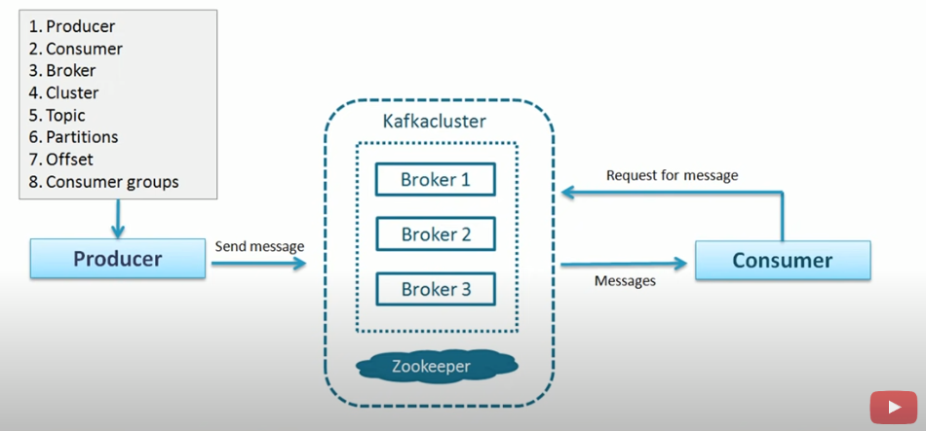

Topics
Messages related to the same topic are stored in a unique “topic”. This is set by hand by the developer:
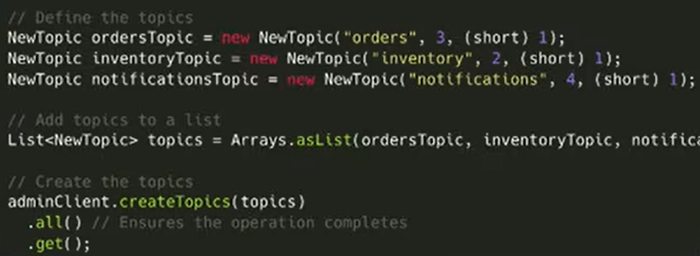
A topic is a unique name for a data stream. A topic can host events (messages of different types).

Partitions
As the messages can be persistent (the duration is set by the user) a topic can grow huge and may not be storable on a single computer. That’s why the Kafka service is deployed over a group of computers (Kafka cluster): Kafka can split a topic in partitions and stores it over numerous hardware pieces. The number of partitions used by a topic shall be set by the user in dependency of the storage space the topic will require and the space available in one partition. 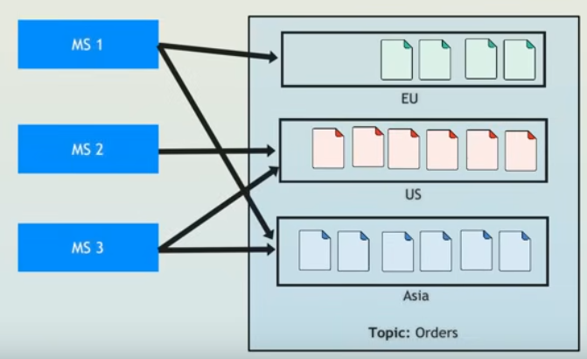
Having the events dispatched on different partition also allowed the usage of multiple instances of the concerned consumer, which speed up the processing of the events. The association partition / consumer instance id one by Kafka automatically.
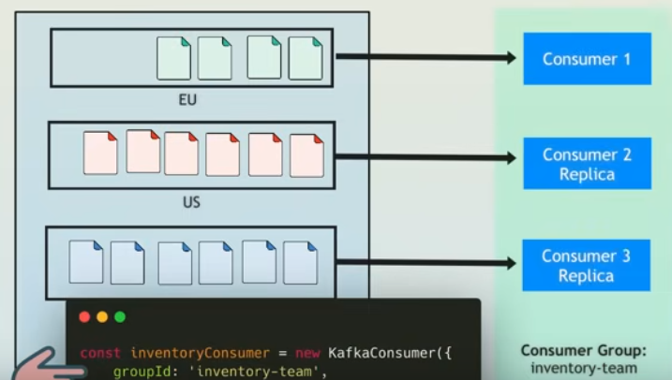

Offsets
In a partition, the messages are stored in a list. Each message gets an index when stored. The index is called offset. Therefore, the address of a message in Kafka is made by:
TopicName/PartitiPPierreonNumber/Offset

MES
Manufacturing Execution System: software system that manages and monitors the entire manufacturing process from raw materials to finished products. It provides real time data to operators and managers, allowing them to take actions shall the production not go according to plan.

