Fourier Transform

Convolution
How do we find out if a random signal contains a sinusoid of frequency f? What phase resp. amplitude shall then have that sinusoid?
We multiply the signal by the given sinusoid and calculate then the surface covered by the resulting function (integral):
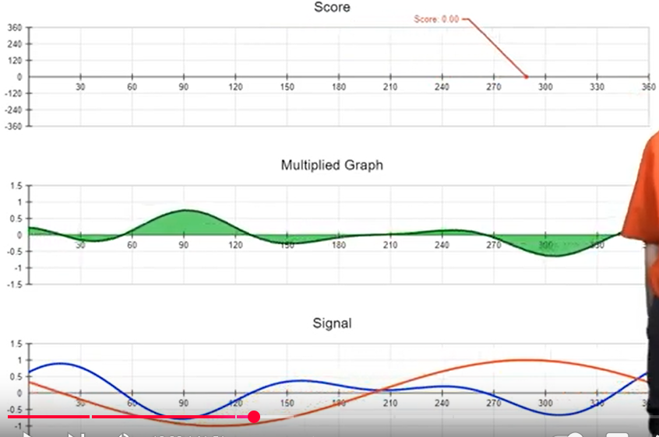
We then change the phase of the test sinusoid and check the integral again. If the integral of the result function is 0 whatever the phase we try, then the input signal doesn’t contain any sinusoid of the given frequency. If not, it does contain a sinusoid of the given frequency. Its phase is the one where we reached the highest integral and its relative amplitude A_{rel} is then the result of that integral. It’s real amplitude is A / (Period / 2), in the case of the picture: A = A_{rel} / 180.
So finding if a sinusoid of frequency f belongs to a random signal, we get to convolute it and find the phase the integral reaches its highest value (score) lot of work. When we see the score function, we however see that it has the form of a sinusoid and the same phase, as the one we searched:
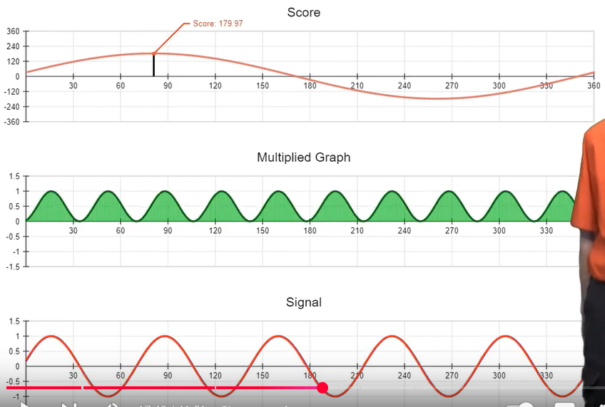
On top of that, we know that any cosine wave with a phase of α can be expressed as the sum of a cosine wave and a sine wave with same frequency, a phase of 0 and different amplitudes:
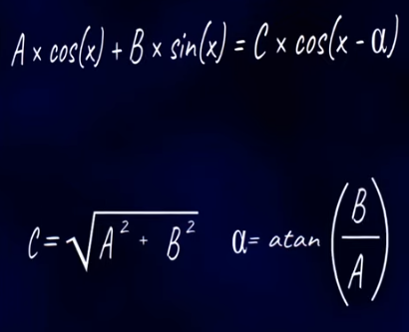 where .
So instead of convoluting, we can multiply our input signal with a cosine wave, then with a sine wave with both phase of 0, measure their max scores and then use Pythagoras and tangent to get amplitude and phase of the searched sine wave.
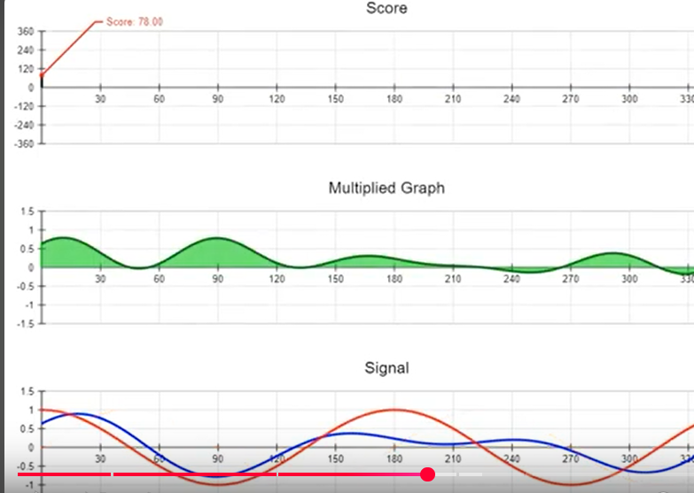
Figure 1: non shifted cosine wave score 78
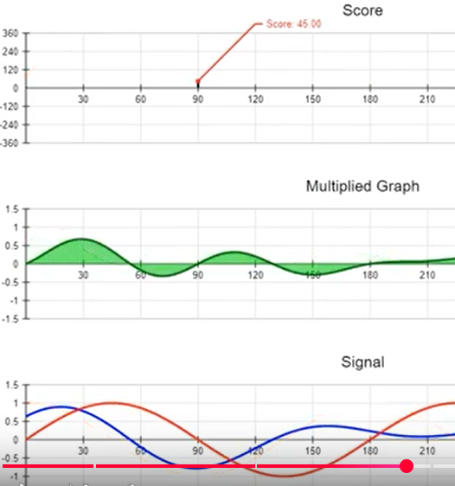
Figure 2: non shifted sine wave score 45
- 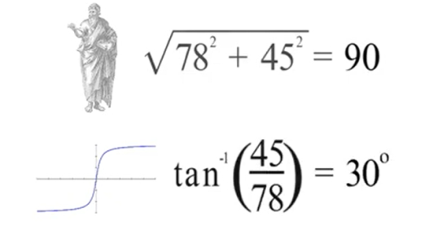
- 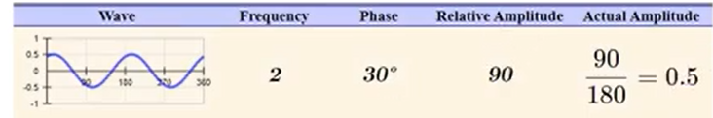

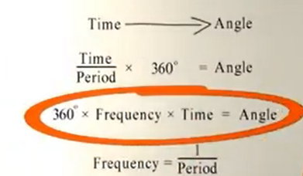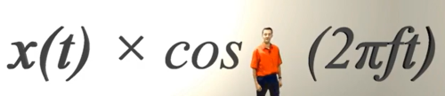
Calculating the score (the integral) of the multiplication of our signal by a non-shifted cosine wave, resp. by a non-shifted sine wave writes itself:
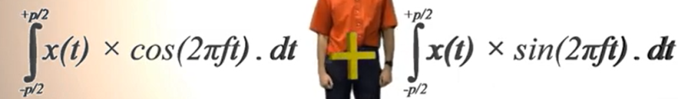
We can combine (per convention we subtract) those integrals after multiplying one of them by i to keep them separated: 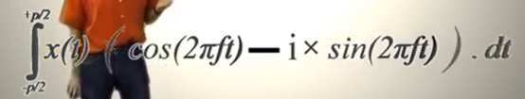.
Using Eulers’s formulas we then get: 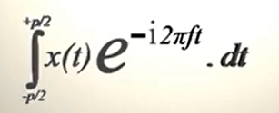
So finding if there is a sine wave of frequency f in an input signal x(t) ends up calculating that formula. It gives us a complex expression a+ ib where a is the cosine contribution and b the sine contribution, which we then have to combine with Pythagoras and tangent. Generalizing to any frequency we have:
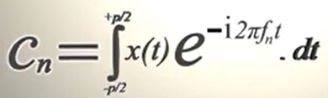
That applies for signals repeating themselves as we see with integral extremities. Most signals do not repeat themselves however, so we get to replace the integral extremities by -∞ / +∞.

Fast Fourier Transform
When analyzing a signal, we get to calculate the Fourier Transform for a set of k potential frequencies. We do that a discreet way, picking a given number of abscises (N) where we are going to compute the Fourier formula. This is the Discreet Fourier Transform (DFT):
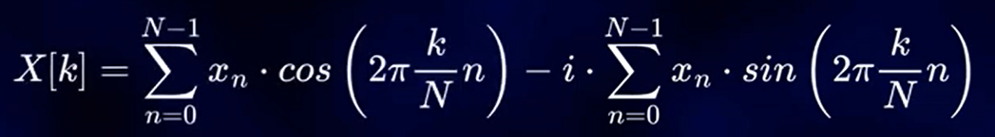
We end up filling up a table like (using 8 samples):
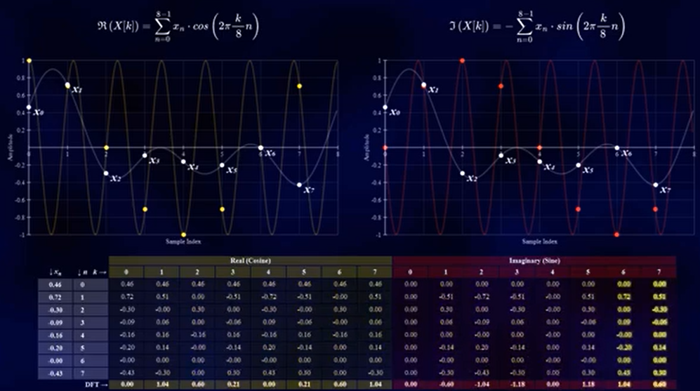
Some operations there are done multiple times because the value of cos(x_{n}) is the same at multiple tried frequencies. On top of that, some values are mirrored to one another, because cos(x) = cos(-x) and sin(x) 0= -sin(-x). So it is possible to optimize the computation if we avoid those repetitions. This what the FFT does.
The exploitation of those potential requires the number of samples chosen to be multiple of 2.

