- Branching
Used when a new feature is to be developed which shall not disturb the main stand. After development, we add the new feature to the main branch (merge) and delete the branch.
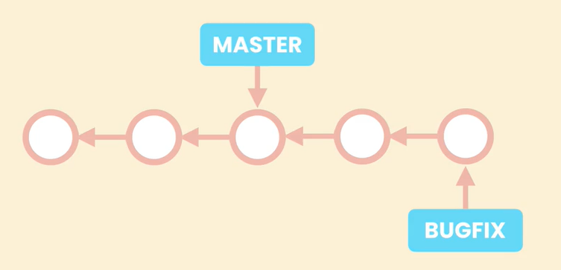
Branching in Git mean we add a new pointer onto the main branch.
  - Comparing
Git diff
  - Stashing

when switching to a branch, the working directory is filled with the new branch content. This is possible if the WD is cleaned, means all changes are commited. If not, and if the status is not mature for a commit, it is possible to stash the content, means to save it somewhere without it to be mapped into the history.
  - Merging
Fast forward if branches have not diverged
3-way if they did
It can be advantageous to user a 3 way merge even if the branches have not diverged, because then it is easier to reverse/cancel a merge
    - Conflicts
When tried to merge a branch with modifications concerning the objects which have been modified in the main branch too, git will report a conflict. Workflow:
- Edit the code
- Set up manually what the new file shall be (without adding code not belonging to either both files), save and close the editor
- Add file to SA
- Commit

  - Aborting a merge
2 options:
- We create a new commit reproducing the status of the common parent (revert cmd)
- We just move the HEAD back to the common parent (reset cmd), the faulty merge will be automatically erased by git. This is a bad practice when working in collaboration

  - Squash Merging
When we want to merge but don’t want the 2ndary branch history being archived (because bad quality for instance).
Git merge –squash branchName
Doing so we keep a linear branch, and we shall think of deleting the 2nd branch

  - Rebasing
To keep linear structure. The pointer of a branch pointing to its parent is moved to the last commit of the main branch. Bad practice by collaboration cause in fact the commit from the branch are recreated by git after the last main branch commit. Means the real commit are leading to no where and will be deleted, so if some colleagues have built on them mess!

  - Cherry Picking
To merge a single commit from 2ndary branch. Instead a commit it is also possible for single files.

- Collaboration
In a team, we use a central repo (cloud or server) and each team member uses an own repo which is a local copy of the central repo.
To download changes made on the central repo (other team members have pushed their code) we use the fetch command. Then we get to merge the downloaded commit with our current commit.
Alternative: we use the pull command, which combines the fetch and the merge command. Per default, the merge is 3way merge but we can use the –rebase argument if we want the structure to stay linear.
To upload own code to central repo we use the push command. It requires our last commit to contain all code from last central repo commit. Otherwise we have an error (instead of replacing other people’s work with our).
Pull request: done after having pushed changes into a branch, which we now want to merge into the main branch. Let collaborator know about the upcoming / open discussion / set team member to check the branch.
When working on open source projects, if I am not the project owner I get first to fork the central repo, means I create a copy of the repo in my own GitHub account. Then I clone this copy on my local machine before I can start working on it.

