Content
Getting Started 2
Advantages of unit Testing 2
Different types of testing 2
Test driven development (tdd) 3
Fundamentals 3
Characteristics of a good test 3
Conventions 3
Setup Teardown 5
Parameterized tests 5
Ignoring test 5
Trustworthy test 6
Core Unit testing technics 6
Specific/general tests 6
Testing Arrays and Collections 6
Testing returned Type of a method 7
Testing void methods 8
Throwing exception methods 9
Raising event methods 10
Testing private methods 10
Code coverage 11
Testing in the real world 11
Breaking the external dependencies 12
Loosely coupled and testable code 12
Dependency Injection via Method Parameters 14
Dependency Injection via Properties 15
Dependency Injection via Constructor 15
Dependency injection framework 16
Mocking Frameworks 16
Creating Mock Objects Using Moq 17

Getting Started

Advantages of unit Testing
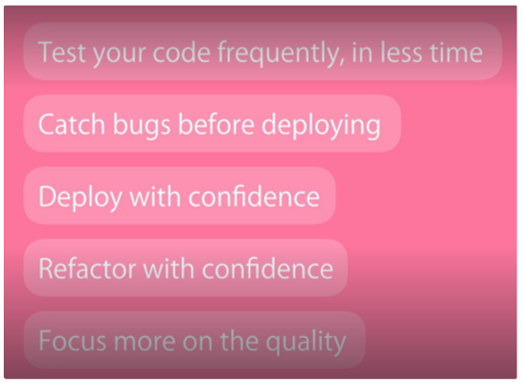

Different types of testing
- Unit testing
external dependencies are excluded. Quick.
- Integration testing
external dependencies are taken in account.
- End to End testing
To test the code and the UI together. Slow, fragile.
Most of a project shall be covered by unit tests, interface to external dependencies with integration tests, UI main path with e2e tests:
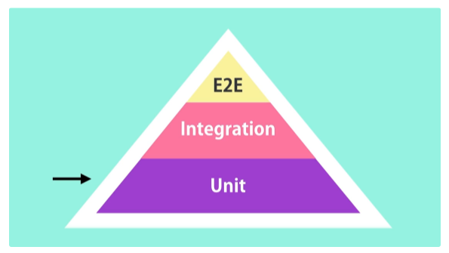

Test driven development (tdd)
Development method where the developer writes the test first and then the source code. Advantages:
- Source code is tested straight away
- All code is covered by tests
- usually leads to a simpler implementation of the function

Fundamentals
There are usually as many test methods for 1 production method as they are executing paths in the method.
Writing a test method, the tested method shall be considered as a black box, its content shall be ignored, jus its function shall be considered.

Characteristics of a good test
- clean code / single responsibility principle / <10 lines of code
- no logic (chances are a bug appears in the test method)
- isolated (no dependencies between different test methods)

Conventions
For each project in the production code; we shall have a test project named: ProjectName.UnitTests
Test class name: ClassToBeTestedNameTests
Test method name: MethodeName_ScenarioDescription_ExpectedBehavior
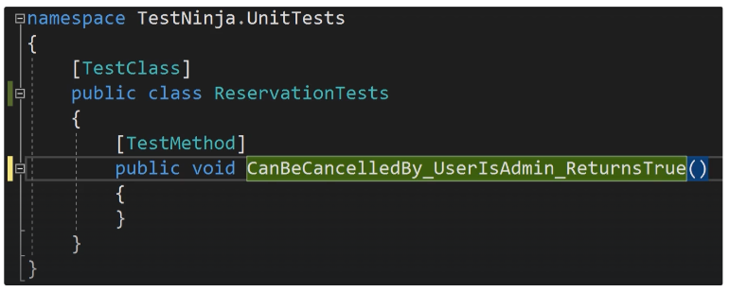
Method structure:
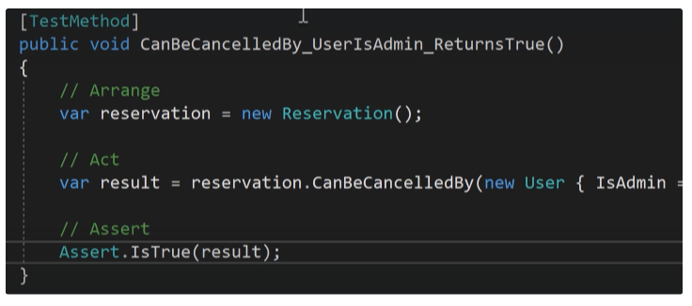
Unit tests represent a sort of documentation of what function is expected from a class / a method that helps new developers to get into a project:
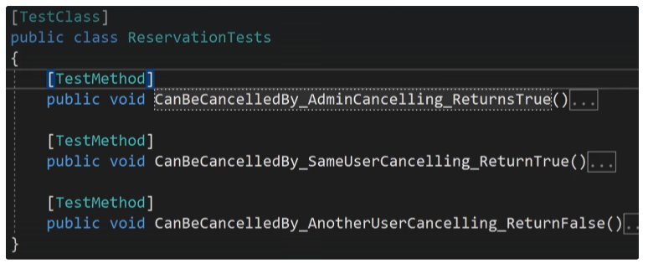

Setup Teardown
When all test methods in a test class share the same “arrange“ code, we can simplify them using the NUnit Setup feature:
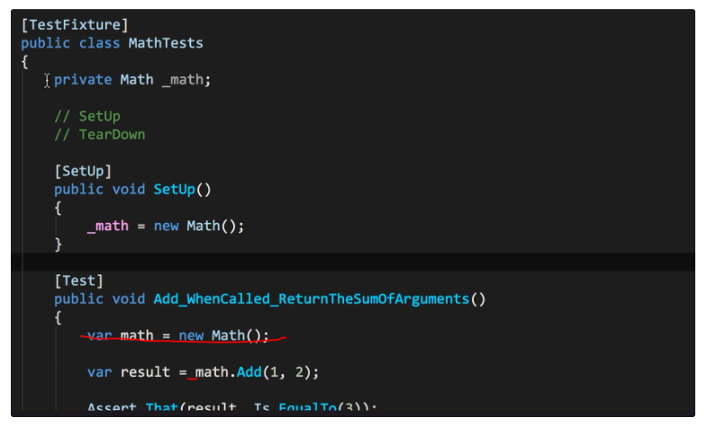
The setup method will be called before each test execution. The test methods are also still independent from each other’s.
There is the same feature for the code that shall be be executed after the tests (TearDown, often used by integration tests to correct for instance DB content, to its stand before the test).

Parameterized tests
To cover different execution paths in & go (NUnit):
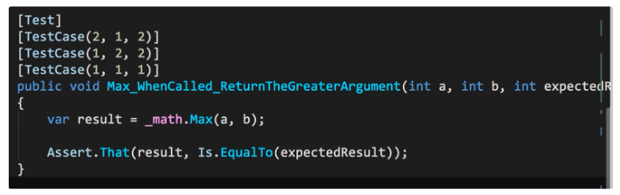

Ignoring test
When a test needs to be ignore temporarily (NUnit):
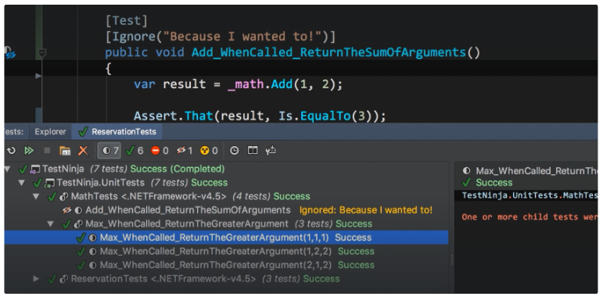

Trustworthy test
To test our test methods, we can add voluntarily a bug in the production code and verify the test does not pass anymore.

Core Unit testing technics

Specific/general tests
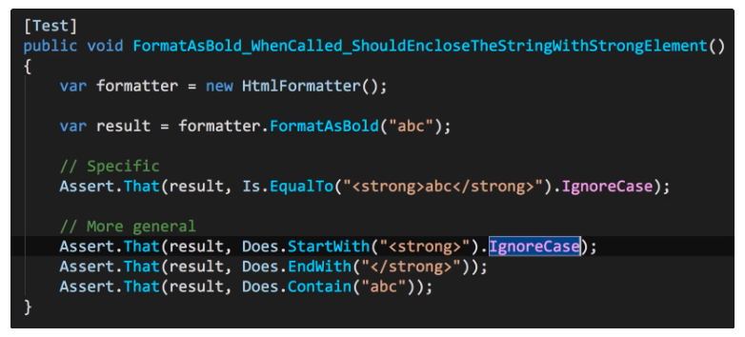
→ Test should not be too specific / too general.

Testing Arrays and Collections
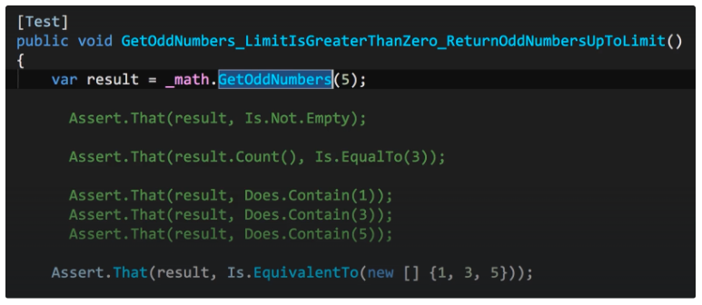
IsEquivalentTo does not care of the order.

Testing returned Type of a method
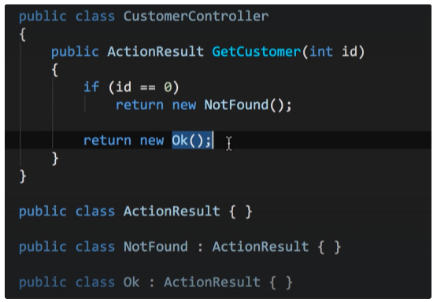
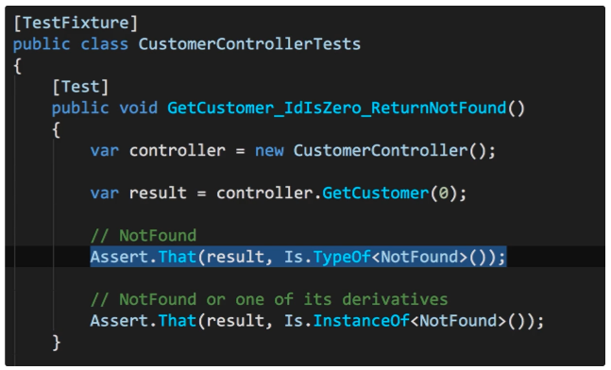

Testing void methods
They are 2 kinds of methods in programs:
- Query Methode → return a value
- Command methods → change the state of an object in memory
Void methods belong to command methods.
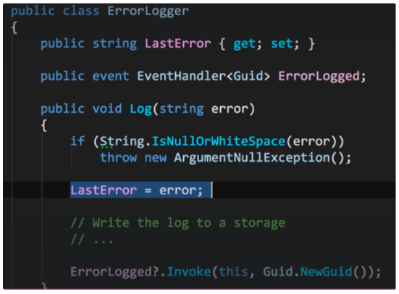
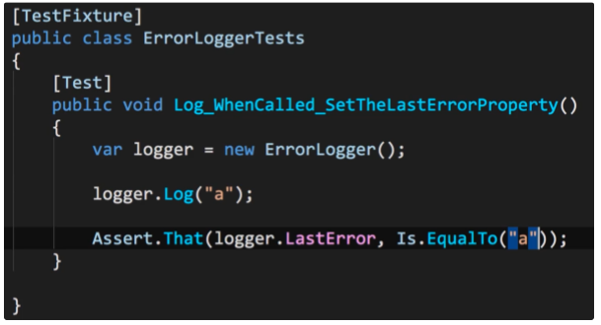

Throwing exception methods
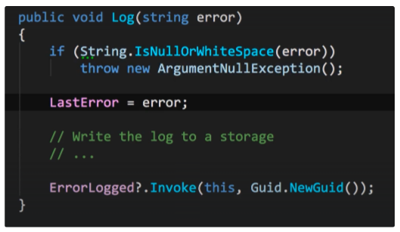
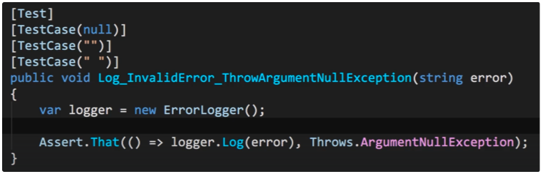

Raising event methods
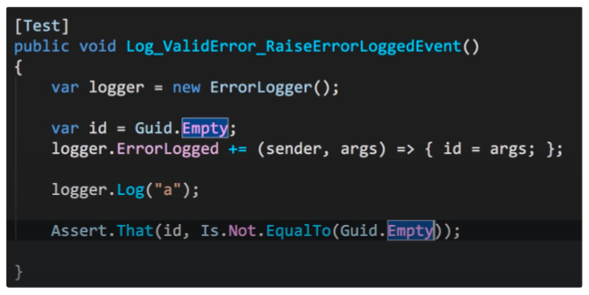
→ We have to subscribe to the event using a function that assigns the event argument to a previously set to empty variable. Then we provoke the event to be fired and assert that the variable received a new value.

Testing private methods
Privates or protected methods shall not be unit tested. They are implementations details and unit tests should not focus on the implementation but on the public API of the class.
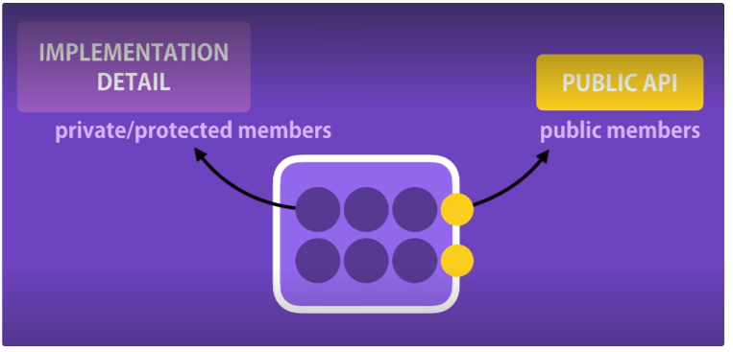
The public API of a class shall not change over the time, when the implementation details might do, which would make corresponding unit tests break.
What if a public method calls a private method, that calls another private method etc.. (chain)? In that case, there will be many different execution paths contained.
→ a proper unit testing of such a class in simply not possible. This is the symptom of a design smell! The sign that the class contains code, that should probably be stored in another class (in public methods), that could be properly unit tested.

Code coverage
They are tools to measure the proportion of the code being covered by unit tests. Example DotCover (jetbrains):
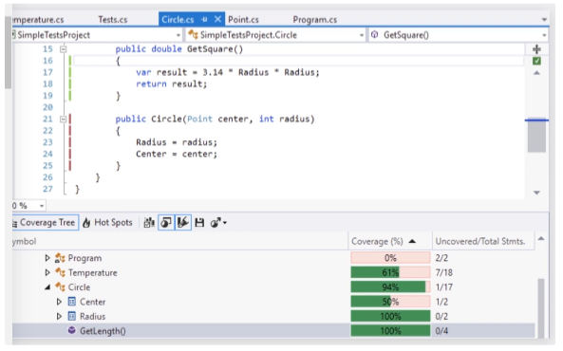
Or in Visual Studio Entreprise Edition.

Testing in the real world
A program can be unit tested only if it is cleanly written. In the real world, it is not always so, so we work on project fulfilling this requirement:
- legacy projects
- quick projects
- the rest of the project team does not write clean testable code
For legacy projects, it is often a huge refactoring action to make the code testable, so the benefits might be outweighed by the cost → only there where changes occur shall be the code made testable.
For quick project, only the main execution path shall be tested.
For team project, the team should be convinced by the benefits, and change its approach.

Breaking the external dependencies
Unit tests do not touch external dependencies (files, database, webservice…). To still unit test a class that depends from something external, we have to replace the external object with a fake one.

Loosely coupled and testable code
To easily replace the external object, we should:
- extract the code that touch the external dependency in a separate class
- extract an interface from that new class
- make the production code pointing to the interface
Having that it is going to be easy to create a fake object representing the external object: it just has to implement the interface.
Before:
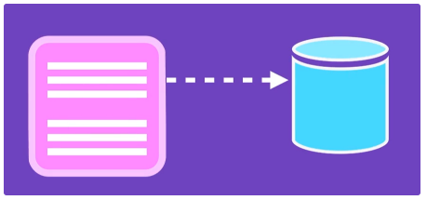
After:
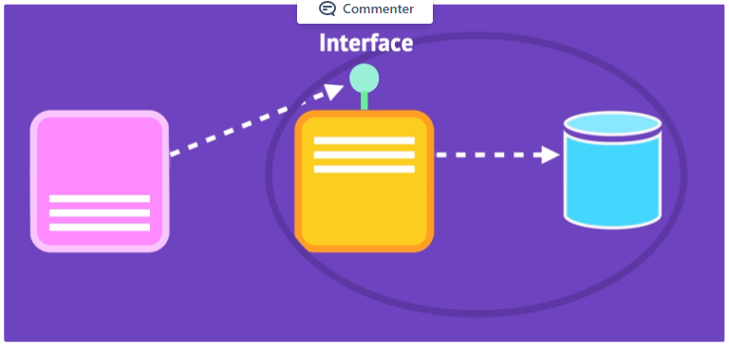
Example:
Before:
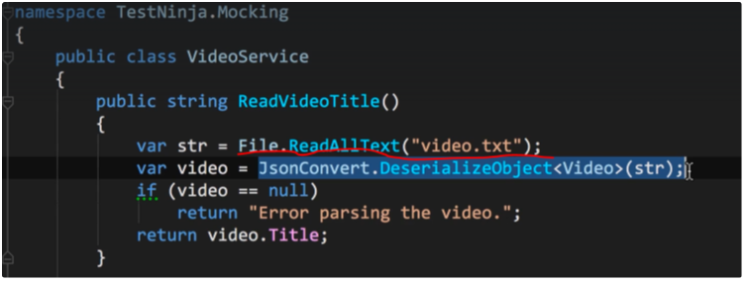
After:
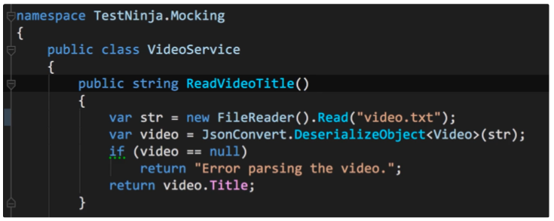
With:
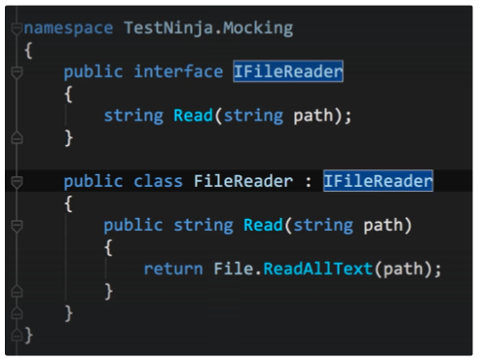
And the fake object:
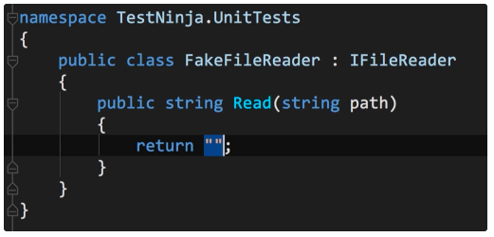
The production is still tightly coupled to the external dependency, to finish off the process we now have to inject it somehow. There are 3 ways for doing so:

Dependency Injection via Method Parameters
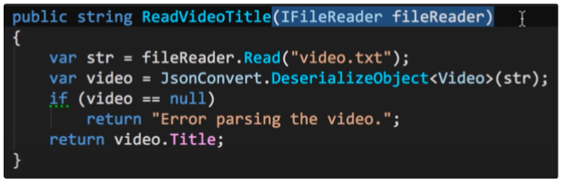
Testing:
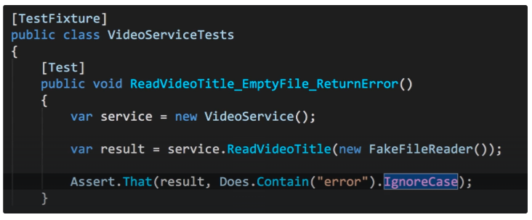

Dependency Injection via Properties
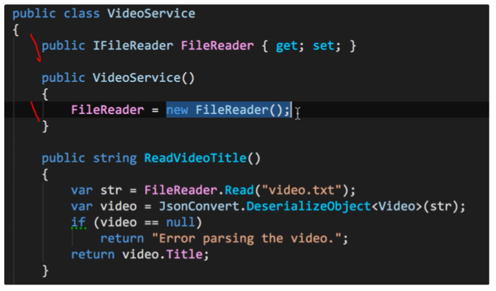
Testing:
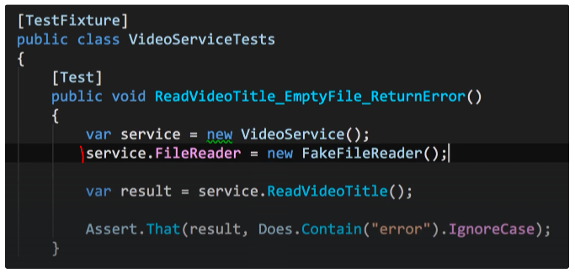

Dependency Injection via Constructor
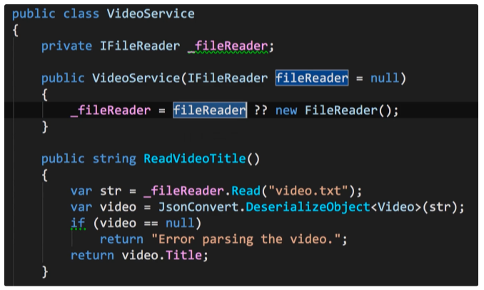
Note that the parameter in the constructor is optional. Having that it will not break the production code (where the no parameters is needed) an we can use the constructor with a parameter in the testing class.

Dependency injection framework
In an enterprise application, a DI framework is usually used. It works based on a container in which divers object are registered. The DIF is responsible for injecting the correct object when a class is initiated.
Note: in the prism framework the unity DIF is used in the background.

Mocking Frameworks
To fake (mock) the behaviour of an object for the purpose of testing a method we can use mocking framework that dynamically generate the needed object at run time. For example to create a mock object returning a string representing a real movie object:
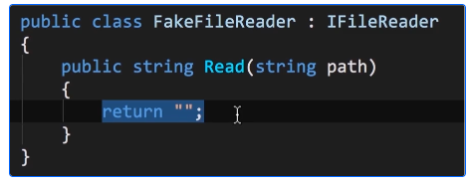

Creating Mock Objects Using Moq
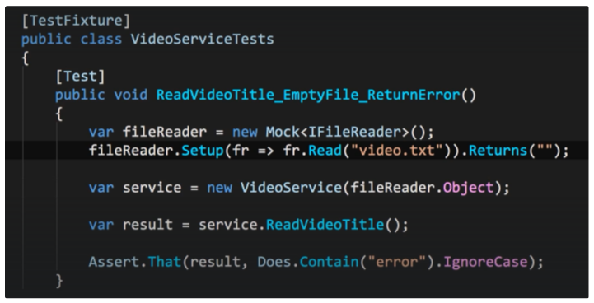
Here we create a fake object and set its behaviour when its read method is called using a setup method:
