**S**ynchrotron-light for **E**xperimental **S**cience and **A**pplication in the **m**iddle **e**ast

 **Experiment Report**

|  | **Experiment title:**  A multi resolution micro-tomography study of the microstructure of corals adapted to diverse sea environments | **Experiment number**:  20235124 |
| --- | --- | --- |
| **Beamline**:  ID10  BEATS | **Date of experiment**:  from: 28/05/2024 to: 01/06/2024 | **Date of report**: |
| **Shifts:**  12 | **Local contact(s)**:  Philipp Hans and Gianluca Iori | *13/06/24* |
| **Names and affiliations of applicants** (* indicates experimentalists):  **Tali Mass:** University of Haifa, Marine Biology, 199 Aba Khoushy Ave. IL - Haifa.  **Katrein Sauer:** University of Haifa, Marine Biology, 199 Aba Khoushy Ave. IL - Haifa.  **Pierrick Harnay:** University of Haifa, Marine Biology, 199 Aba Khoushy Ave. IL - Haifa.  **Wei Li: Charite:** Universitätsmedizin Berlin, Department of Operative Dentistry, Assmannshauser, Str. 4-6, Berlin, Germany.  **Paul Zaslansky:** Universitätsmedizin Berlin, Department of Operative Dentistry, Assmannshauser, Str. 4-6, Berlin, Germany. | | |

**Report:**

During our beamtime at BEATS ID10, we obtained high-resolution tomography data of adult coral skeletons collected at two sites of the island of Mo’orea in French Polynesia. Four species of *Pocillopora spp.* weregrown under different environmental conditions characterized by high flow (stronger currents) and low flow (weaker currents).

We performed 81 scans on 26 coral samples with an object pixel size of 1.3 µm (lower resolution) and 7 scans on 7 samples with an object pixel size of 0.33 µm (extreme high resolution). Scanning details are outlined in Table 1. During our beamtime, we also reconstructed our measured data and transferred most of the collected datasets to external discs.

| **sample** | **number samples** | **number scans** | **beam used** | **lenses** | **Energy [keV]** | **object pixels size [µm]** |
| --- | --- | --- | --- | --- | --- | --- |
| **coral** (lower resolution) | 26 | 81 | pink | x10 | 36 | 1.3 |
| **coral** (higher resolution) | 7 | 7 | mono | x20 | 20 | 0.33 |

**Table 1:** **Overview of samples**. Number of samples, number of scans, and experimental settings used during our beamtime at BEATS ID10.

We placed all the samples on top of screws mounted on a sample stage equipped with a magnetic sample holder. Samples were affixed to the screws using a glue gun, with the screws secured into plastic bases containing magnets on the bottom. An example of a mounted mouse sample is shown in Fig. 1a. We scanned all samples with a 180° rotation, and using a multilayer crystal ([Ru/B4C]65 – d = 4.0 nm).

The coral samples scanned at lower resolution were imaged at three different positions within each sample, spaced 3 mm apart (Fig. 1b), to capture both absorption and phase contrast images at 36 keV. An example for an absorption image is given in Fig. 1e. Up to 3601 projection images per sample were acquired with a 0.075 s exposure time using a white-beam twin microscope with a x10 lens (Det 1 (OptiquePeter Twin Mic) 10 X). Specific filters (PCO.edge 5.5, LSO:TB 15 µm) created a pink beam. The field of view (FOV) was 3.33 x 2.81 µm (horizontal x vertical), with a sample-to-detector distance (SSD) of 60 mm.

For higher-resolution coral scans, a monochromatic beam (Det 3 (OptiquePeter mono mic) OLYMPUS 20x) was used. Scanning was focused at the top of the corals to identify the regions of interest (ROI) for high-resolution images (indicated with an arrow in Fig 1c) at 20 keV. An example of an absorption image is shown in Fig. 1f. Up to 3001 projection images per sample were acquired with a 1.5 s exposure time. Specific filters (PCO edge 5.5; LSO:TB 15 µm, glass correction: 0.17 mm) created a monochromatic beam. The SSD was 10 mm.

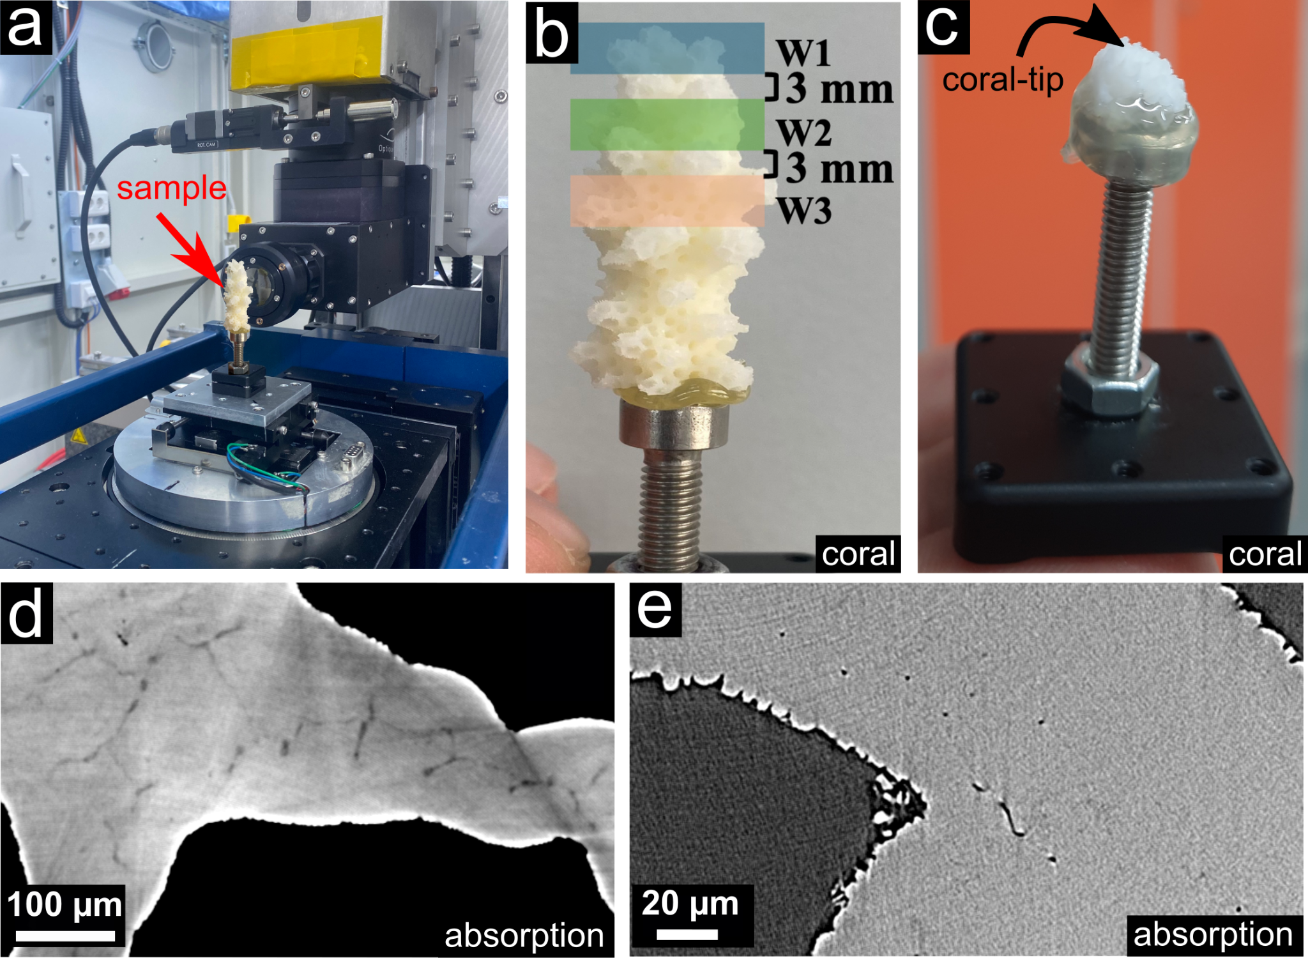**Fig. 1: Sample stage, sample configurations and resulting images.** **a)** Coral sample scanned at lower resolution across three windows (w1, w2, w3). **b)** Coral sample scanned at higher resolution at the tip. **d)** Lower resolution absorption image of a coral sample **e)** Higher resolution absorption image of a coral sample tip.

Although we encountered some minor delays that hindered data acquisition, we successfully scanned all planned samples. For most of the coral scans, we obtained highly-detailed reconstructions of the skeletons using the inhouse reconstruction software [TomoPy](https://tomopy.readthedocs.io/en/stable/) Al recon. The reconstruction process was smooth, although it was not possible to remove the ring artifacts completely. Despite this, the reconstructions provided sufficient information to reveal highly detailed insights into the structures of coral skeletons.

We experienced one beam loss lasting approximately four hours, and a malfunction of the writer which resulted in several hours of lost time during one night. We also faced challenges with finding the center of rotation (COR) using the extended field of view (FOV). Additionally, due to the slow network speed, we encountered difficulties copying all the accumulated raw data and reconstructions to our external discs within the available time, even though we stayed an extra day after the experiment.

Our results will provide detailed insights into the structural development of mineral phases in corals under different oceanic conditions (high and low flow) and the dynamics of the various mineral phases within the coral skeleton.

Our data from SESAME will enhance our understanding of the morphological adaptations of the four species of adult *Pocillopora spp.*, shedding light on the impact of environmental changes. This provides a foundation for future work on corals across different life stages and growth phases in the context of climate change.