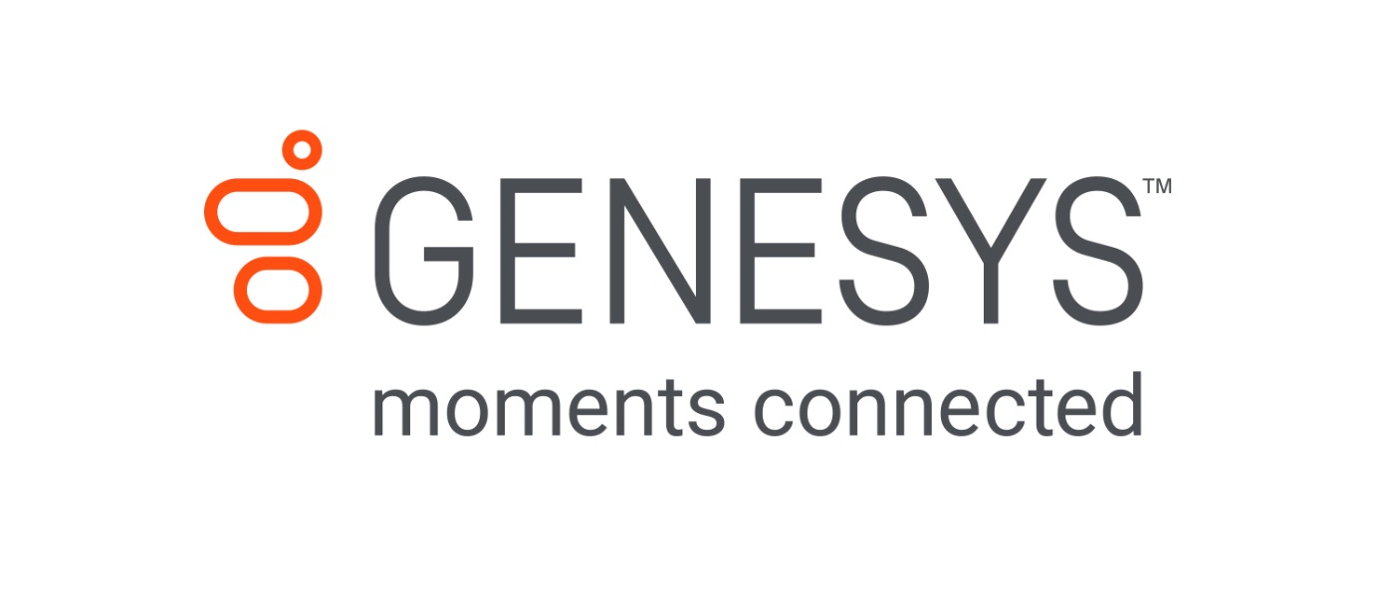

Rapid Response Questionnaire

Monday, March 23, 2020

08

**Fall**

# Table of contents

Table of contents 2

1.1 Organization Setup 3

1.2 Sites 3

1.3 Users 3

1.4 Hours of Operation 4

1.5 Skills 4

1.6 Queues 4

1.7 Wrap-up codes 5

1.8 Design your Call Flow Experience 6

1.9 Number Ranges/DID’s (if applicable) 7

1.10 Prompts 7

Terminology 9

## Organization Setup

|  |  |
| --- | --- |
|  |  |
| **Company Name** | **TBD** |
| **Genesys Cloud region (Genesys to fill)** |  |
| **Number of users (Genesys to fill)** | XXX |

## Sites

|  |  |  |  |  |  |  |  |  |
| --- | --- | --- | --- | --- | --- | --- | --- | --- |
| Location Name | Street Address | City | State | Zip Code | Country Abbreviation | Country | Notes | Emergency Number |
| TestLoc1 | 555 North St. | Indianapolis | Indiana | 433377 | US | United States | Main HQ | 13174444444 |
| TestLoc2 | 557 South St. | Hollywood | California | 234090 | US | United States | CA HQ | 17510349352 |

Note: Genesys will create **up to two** location for base configuration:

## Users

Users are assigned roles which determine their business function within PureCloud. Users will be added to theorganization by using a CSV file. Use the following file as an example. **Fill out the CSV with the users that will be on the Genesys Cloud platform.**

***\*\*There are references to Location, Queues, and Skills which you will fill out later in this Questionnaire. Please reference those names in the below people_import_exmple.csv\*\****



## Hours of Operation

Schedules are used to determine your open hours for the call centre. Genesys will configure **up to two** Open Schedules.

|  |  |  |  |
| --- | --- | --- | --- |
| Schedule name | Time | Recurrence | Days/Hours |
| Open Hours Weekday | 09:00-18:00 | Weekly | Monday-Friday |
| Open Hours Saturday | 09:00-15:00 | Weekly | Saturday |

## Skills

A skill is a task, expertise, or knowledge that an agent must have to handle an interaction. For example, skills might be Linux, Windows, billing, or sales. Agents with assigned skills can have proficiency ratings for those skills. Proficiency ratings indicate the agent’s level of expertise or knowledge of that skill. PureCloud ACD considers proficiency ratings when matching agents and interactions.

**Genesys will configure up to 10 skills. These Skills will be leveraged in the user import csv for agents that use them**.

|  |
| --- |
| ACD Skill Names |
| Billing Support |
| Tier 3 Support |
|  |
|  |
|  |
|  |
|  |
|  |
|  |
|  |

## Queues

A queue is a “waiting line” of interactions. **Genesys will configure up to 3 Queues. The below Queues will be leveraged in the user import csv for agents that are members of the Queue(s).**

|  |  |  |
| --- | --- | --- |
| Queue name (inbound) | Supports Callbacks (if applicable)? | Supports Email (if applicable)? |
| Sample Queue | Yes or No | Yes or No |
| XX | Yes or No | Yes or No |
| XX | Yes or No | Yes or No |

## Wrap-up codes

Wrap-up codes indicate the nature of an interaction. Agents specify wrap-up codes after completing an interaction. **Genesys will configure up to 20 wrap-up codes.**

|  |  |
| --- | --- |
| Wrap-up code name | Assigned to which Queues? |
| ExampleWrapUp1 | Sample Queue |
|  |  |
|  |  |
|  |  |
|  |  |
|  |  |
|  |  |
|  |  |
|  |  |
|  |  |
|  |  |
|  |  |
|  |  |
|  |  |
|  |  |
|  |  |
|  |  |
|  |  |
|  |  |
|  |  |

## Design your Call Flow Experience

We will build a main inbound IVR/call flow to route your customers to your agents. Within the main menu, you will have up to 10 options based on the available options on a telephone (0 – 9, we will reserve * for to repeat the menu and # to go back to the previous menu (if applicable) that are an industry standard option).

*You do not need to use all 11 options and we recommend keeping the main menu within 5-6 options at most based on our best practices.*

**Route to Queue:**

(Queue Name)

**Leverage an ACD Skill?** (Yes or No)

**If yes, ACD Skill Name:**

(ACD Skill Name)

**Default Option*?:** (Yes or No)

**Route to Queue:**

(Queue Name)

**Leverage an ACD Skill?** (Yes or No)

**If yes, ACD Skill Name:**

(ACD Skill Name)

**Default Option*?:** (Yes or No)

**Route to Queue:**

(Queue Name)

**Leverage an ACD Skill?** (Yes or No)

**If yes, ACD Skill Name:**

(ACD Skill Name)

**Default Option*?:** (Yes or No)

**Route to Queue:**

(Queue Name)

**Leverage an ACD Skill?** (Yes or No)

**If yes, ACD Skill Name:**

(ACD Skill Name)

**Default Option*?:** (Yes or No)

**Route to Queue:**

(Queue Name)

**Leverage an ACD Skill?** (Yes or No)

**If yes, ACD Skill Name:**

(ACD Skill Name)

**Default Option*?:** (Yes or No)

**Route to Queue:**

(Queue Name)

**Leverage an ACD Skill?** (Yes or No)

**If yes, ACD Skill Name:**

(ACD Skill Name)

**Default Option*?:** (Yes or No)

**Route to Queue:**

(Queue Name)

**Leverage an ACD Skill?** (Yes or No)

**If yes, ACD Skill Name:**

(ACD Skill Name)

**Default Option*?:** (Yes or No)

**Route to Queue:**

(Queue Name)

**Leverage an ACD Skill?** (Yes or No)

**If yes, ACD Skill Name:**

(ACD Skill Name)

**Default Option*?:** (Yes or No)

**Route to Queue:**

(Queue Name)

**Leverage an ACD Skill?** (Yes or No)

**If yes, ACD Skill Name:**

(ACD Skill Name)

**Default Option*?:** (Yes or No)

**Route to Queue:**

(Queue Name)

**Leverage an ACD Skill?** (Yes or No)

**If yes, ACD Skill Name:**

(ACD Skill Name)

**Default Option*?:** (Yes or No)

*\*Default Option – This option will be used if the caller does not select any option. It will default to this option after it repeats the menu three times*

## Number Ranges/DID’s (if applicable)

A DID is a dialable number that routes to an object, for example an inbound call flow or a user. Multiple number ranges may be provided by multiple telephony providers.

|  |  |  |
| --- | --- | --- |
| DID Start | DID End | Comments |
| +1-XXX-XXX-XXXX | +1-XXX-XXX-XXXX | Twilio DIDs |
| +1-XXX-XXX-XXXX |  | Main Inbound Number |
|  |  |  |
|  |  |  |

## 

## Prompts

Prompts are used for the IVR/Call Flows. Recommended transcripts below:

|  |  |  |
| --- | --- | --- |
| Prompt Name | IVR | Transcript |
| MainGreetingMessage.wav | Open Hours Flow/Closed Hours Flow/Holiday Flow/Emergency Flow | *Example: Thank you for calling <Company Name>* |
| MainMenuMessage.wav | Open Hours Flow | *Example: If you are a new customer and looking for more information about our product, press 1. If you have purchased our product and currenting have any issues or inquiries, press 2. If you are a 3rd party vendor seeking marketing material, press 3. For all other inquiries press 4. To repeat this options press star.* |
| ClosedMessage.wav | Closed Hours Flow | *Example: Our offices are closed at present; please call back during our normal opening hours which are 8 AM to 5 PM, Monday through Friday.* |
| HolidayMessage.wav | Holiday Flow | *Example: We are closed for holiday. Please see our website at www.company.com/businesshours for when we will return to normal operating hours. Have a great day.* |
| EmergencyMessage.wav | Emergency Flow | *Example: We are closed for holiday. Please see our website at www.company.com/businesshours for when we will return to normal operating hours. Have a great day.* |

If providing prompts for your IVR, they are required to be in wav format, specific codec details can be found below

* 11,025 Hz 16-bit PCM
* 8,000 Hz 16-bit PCM
* 11,025 Hz 8-bit PCM
* 11,025 Hz µ-Law
* 8,000 Hz 8-bit PCM
* 8,000 Hz µ-Law
* 11,025 Hz 4-bit ADPCM
* 8,000 Hz 4-bit ADPCM
* 11,025 Hz GSM 06.10
* 8,000 Hz GSM 06.10

Note: The recorded prompts file size should not exceed more than **25 MB**.

# Terminology

|  |  |
| --- | --- |
| Term | Definition |
| ACD | Automated Contact Distribution (ACD) intelligently routes various interactions to users assigned via ACD Workgroups. |
| ACD Agent | These individuals are single contributors within a Workgroup, responsible for servicing both the internal and external customers within the various business practices. |
| ACD Supervisor | These leaders are responsible for the ACD Agents productivity, enforcement of business practices, customer escalations and goal achievement, through the use of monitoring and reporting tools. |
| ANI | Auto Number Identification, the number that is given to the telephone provider on outbound calls. |
| DID | Direct Inward Dial, the number assigned for direct access on inbound calls from the telephone provider. |
| DNIS | Dialled Number Identification Service, the number that is assigned by the telephone provider on inbound calls. |
| IVR | Integrated Voice Response – for terms of this document, the acronym refers to typical and customary ACD functions as they relate to call routing. |
| Queue | A queue is a “waiting line” of interactions. |
| Skill | A skill is a task, expertise, or knowledge that an agent must have to handle an interaction. For example, skills might be Linux, Windows, billing, or sales). Agents with assigned skills can have proficiency ratings for those skills. Proficiency ratings indicate the agent’s level of expertise or knowledge of that skill. PureCloud ACD considers proficiency ratings when matching agents and interactions. |