ADM-OSC Panner – VST & Audio Unit for MAC OS (ARM)
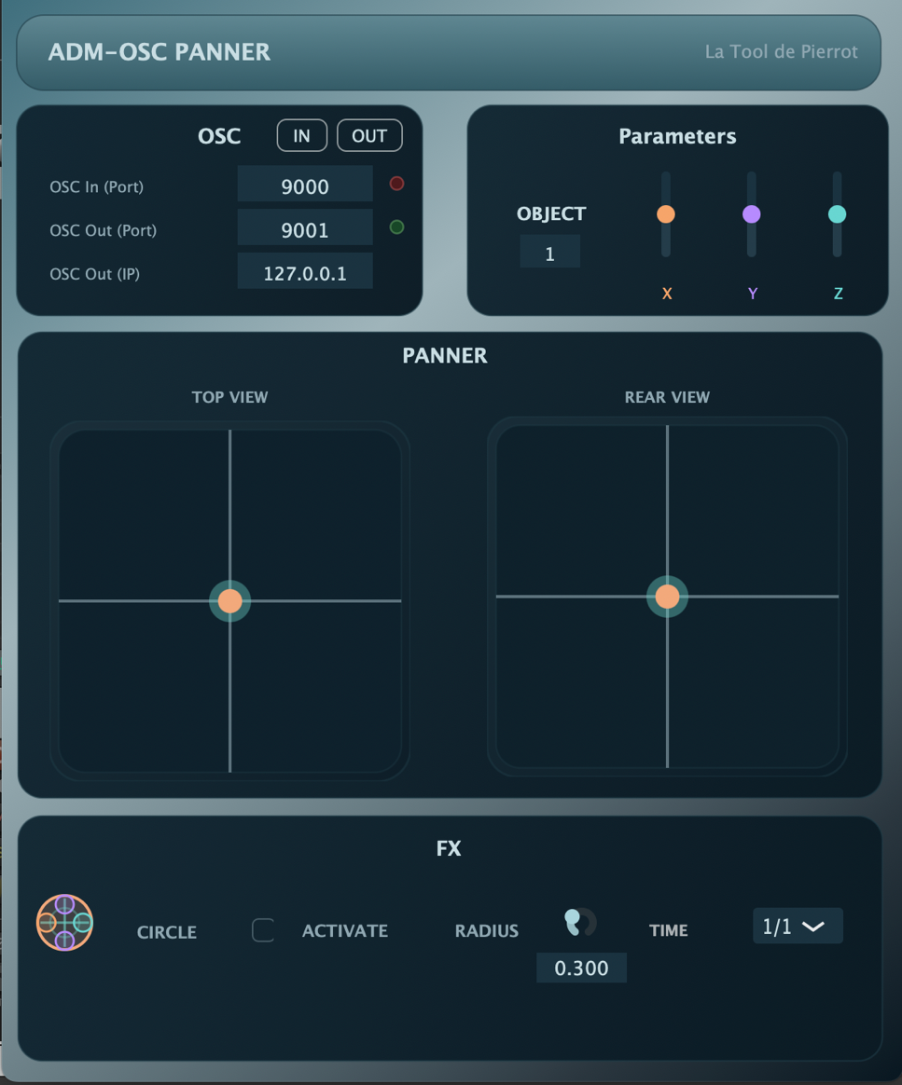

Presentation:
ADM-OSC Panner is a VST / AU for Mac OS that turns any DAW or VST Host into an ADM-OSC controller.
It can receive X Y Z coordinates from another ADM-OSC client and write them into you DAW as automation data.
You You can also encode ADM-OSC movements directly within your DAW and send them to an external ADM-OSC server.

Functions:
OSC tab:
IN / OUT buttons allow the user to enable / disable the reception and transmission of OSC messages.
OSC In (Port): defines the port used to receive OSC messages.
OSC Out (Port): defines the port used to send OSC messages.
OSC Out (IP): defines the IP Address of the OSC Server to which ADM-OSC data will be sent.
Parameters tab:
OBJECT: Selects which ADM-OSC index the plugin instance controls.
X Y Z sliders: Allow manual position editing via sliders instead of the 2D layout.
PANNER tab:
All the axis are defined from -1 to 1.
TOP VIEW : represents an X / Y 2D surface allowing the user to move the object and create movements on the X / Y axis.
REAR VIEW : represents an X / Z 2D surface allowing the user to move the object and create height / lateral movements.
Note : The « glow » around the object increases with the Z value (1 = full glow, -1 = no glow)
FX tab: WORK IN PROGRESS …
Allows the user to generate automated movements directly within the plugin synchronized to the DAW tempo.
Currently only a circular movement can be generated, with an editable radius.
TIME: divides the current tempo of your project to slow down the movement. 1/1 is full speed (120bpm project means 120 round per minute for the object).

Known limitations:
OSC and use of multiple objects:
Currently, the VST uses 1 OSC Server for each instance of the VST. This means that if you want to receive several objects datas from 1 OSC Client, you must use 1 port for each instance of your VST.
N.B : a receiving port can only be used by one software by your computer

Details:
OSC is received / sent as a bundle :
/adm/obj/n/xyz float float float

