**THE JOURNAL**

Adam Wilkie

2025

# Contents

Contents 2

The Idea: 3

First Issues encountered: 3

What I began to add. 6

The Restart 8

# The Idea:

Before beginning my project. I had to find something to base my game on. My original idea was a Pokémon-like game called ‘Critters’, which would have been a pixel style game where you could catch ‘Critters’ to use in battle, and at the start of the game, there would be a character selection screen which could allow you to pick from different races, such as ogre, dwarf, etc. I found a video that looked promising in helping me make this game.

<https://www.youtube.com/watch?v=fo4e3njyGy0>

This was exactly what I was looking for, I could add the character selection screen onto this, and tweak is so I could be my own game, but then I realized that it was the exact same one a previous student had done. I felt as if I had to do something else, so, I decided to do ‘The Legend of Zelda’, I was able to find a video from the same creator that made the Pokémon game, that being “Clear Code”. This Legend of Zelda style game offers things such as monster battles, different weapon selection, magic, stats upgrade, etc.

<https://www.youtube.com/watch?v=QU1pPzEGrqw>

# First Issues encountered:

After installing the Github file, I attempted to run the code, but I was faced with many lines of things such as

Saying that the Image directory was wrong, and so I had to go through and fix them all. I had changed all from things like:



To:



After doing this, I was able to run the code, which was great but that’s when the next issue struck. I couldn’t move. There should have already been controls,

Movement: WASD

Magic attack: LCTRL

Magic swap: E

Attack: SPACE

Weapon Swap: Q

Stats screen: M

Stat Swap: ARROWS

Stat Upgrade: SPACE

With all these that should be set, I expected them to work but instead I was met with this.

I was unable to move, I was stuck here, nothing was doing anything. But upon looking at the code, I was unable to find that movement wasn’t defined, there was lines there for the movement, except it didn’t work. A screen shot of a computer program
This Is the weapon class for example, it has it so where if you direction is let’s say down, you have the down attack animation, except there was nothing like “K_S”.

So, I went and added things like



After a lot of trial and error, I was able to get it working. The next thing I decided to do was clean up the files. Originally it looked like this.

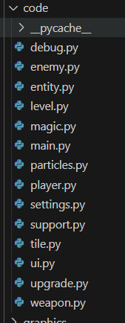and I had moved a lot of the classes into similar files and so it ended up looking like this.

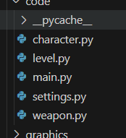

# What I began to add.

I was still wanting the character selection screen, so I wished to add that but first I thought I needed a title screen. The first thing I did to add the title screen was just make an image for the title screen.

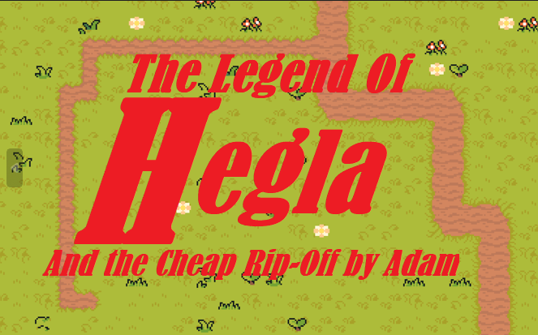

I just made it so any button clicked took you to the next thing I coded, the character selection.

I spent a lot of time on this part. Each character animation was cut up and wasn’t actually a sprite sheet, so I had to spend time manually cutting up the images and ended up with 5 characters.

Sam

Ninja

Flame

Skelly

Porky

Which looked like this:

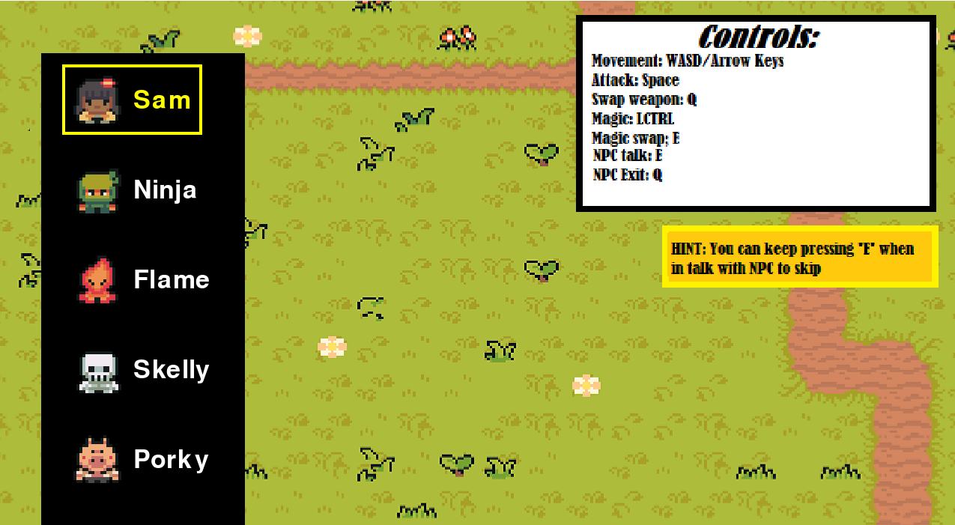

After adding this I decided to finally work on the lore. The NPC.

I just cut up another image except this time only 1 animation, this made it easy and I was able to have npc as like a talking statue. And after adding some text I came into to the issue of quests. I wanted to add them but I was struggling but when I decided to make a big decision.

# The Restart

I decided to restart and make it terminal based. I feel this was the right decision for continuing with this project as it was becoming too much to make before.