Installation Manual
Project | TestFramework
Project Description | TestFramework Installation
Customer Number
Customer Name

Version | Creation |  | Review |  | Approval
Version | Author | Date | Reviewers | Date | Approvers | Date
0.01 | RPR | 31-08-16 | CE | 01/09/2016
0.02 | RPR | 02-09-2016

Copyright

All information in this document is subject to change without notice. No part of this document may be reproduced or transmitted in any form or by any means, electronic or mechanical, for any purpose, without the express written permission of Televic.

© 2016 Televic NV. All rights reserved.

Document history

Enter in chronological order the document history.
- Draft versions: 0.yz starting with 0.01.
- Released versions: x.yz starting with 1.01
They can only be changed by an engineering change note. Make reference to that engineering note where available (in column “description).

Version | Description
0.01 | Initial Version
0.02 | Added pyvisa, PyDAQmx to list

Table of contents

1 Introduction 4
1.1 Scope 4
2 Procedure 5
2.1 Python installation and packages 5
2.2 Test Framework 6

List of figures

No table of figures entries found.

List of tables

No table of figures entries found.

Terminology

Name | Meaning

References

ID | Reference | Version | Name and meaning

Applicable documents

Standards | Name and meaning

Introduction

Scope

This document describes the installation of the Python framework in a production environment.

Procedure

Python installation and packages
The python version and the packages to be installed for the test framework can be found on:
S:\R&D\Ontwikkelingen\33.96.7535\F.studie\4.Software\Python libs
Copy all content below to a local folder on the machine the installation is done on.
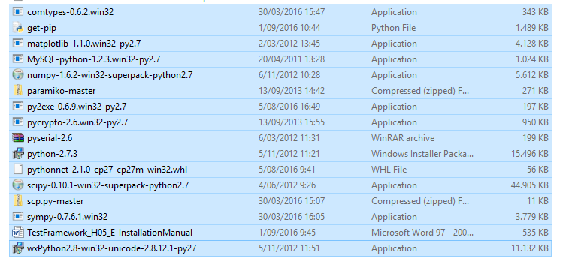

DO NOT COPY OR OPEN THE .zepto files (virus)!!!!
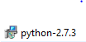

Install following items in the order shown below:

- install python 2.7 (32 bit) with the installer provided
- install pip : [cmd] python get-pip
- install pythonnet: [cmd] python –m pip install pythonnet-2.1.0-cp27-cp27m-win32.whl
- install pyvisa: [cmd] pip install –U pyvisa
- install PyDAQmx: [cmd] pip install PyDAQmx

- install matplotlib: run matplotlib-1.1.0.win32-py2.7 installer
- install mysql: run MySQL-python-1.2.3.win32-py2.7 installer
- install numpy: run numpy-1.6.2-win32-superpack-python2.7 installer
- install pycrypto: run pycrypto-2.6.win32-py2.7 installer
- install scipy: run scipy-0.10.1-win32-superpack-python2.7 installer
- install wxpython: run wxPython2.8-win32-unicode-2.8.12.1-py27 installer
- Navigate to the ./pyusb-1.0.0.a2 folder on the cmd line
- install pyusb: [cmd] python setup.py install
- Unzip pyserial-2.6
- Navigate to the ./pyserial-2.6 folder on the cmd line
- install pyserial: [cmd] > python setup.py install
- Unzip paramiko-master
- Navigate to the ./paramiko-master folder on the cmd line
- install paramiko: [cmd] > python setup.py install
- Unzip scp.py-master
- Navigate to the ./scp.py-master folder on the cmd line

- install scp: [cmd] > python setup.py install

[cmd] = type command in Command Prompt window in the folder where the extracted files are located.

Test Framework
The latest version of the test framework can be found in:
\\fileserver\fileserver\R&D\Ontwikkelingen\33.96.7535\F.studie\4.Software

- Create folder C:\TestFramework on testPC.
- Copy the latest version to this folder on the testPC (extract if needed)
- Create .bat file in this folder with following lines in:
cd C:\TestFramework\33.96.7535\
c:\python27\python.exe C:\TestFramework\33.96.7535\testsystem_main.py productiondatabase

Run the .bat file.

