GAME DESIGN DOCUMENT

INPUT OUTPUT\*

Door: Pieter Winderlich

Naam:

Concept:

Name:Hells’ six feet deep

Setting: WW2 italian campaign

Narrative: US army soldier trying to hold position against axis powers

Engine: JavaFX

Mechanics: Shoot soldiers in different lanes to survive. Move via controller to move to different lanes. Use controller to reload.

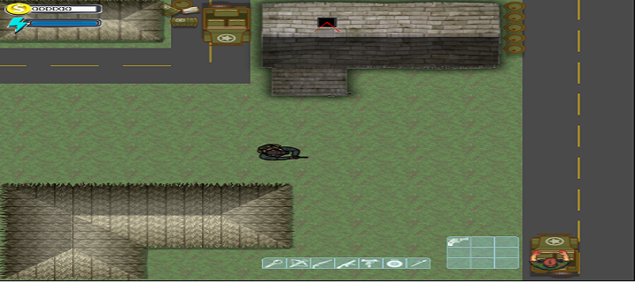

\*Input:

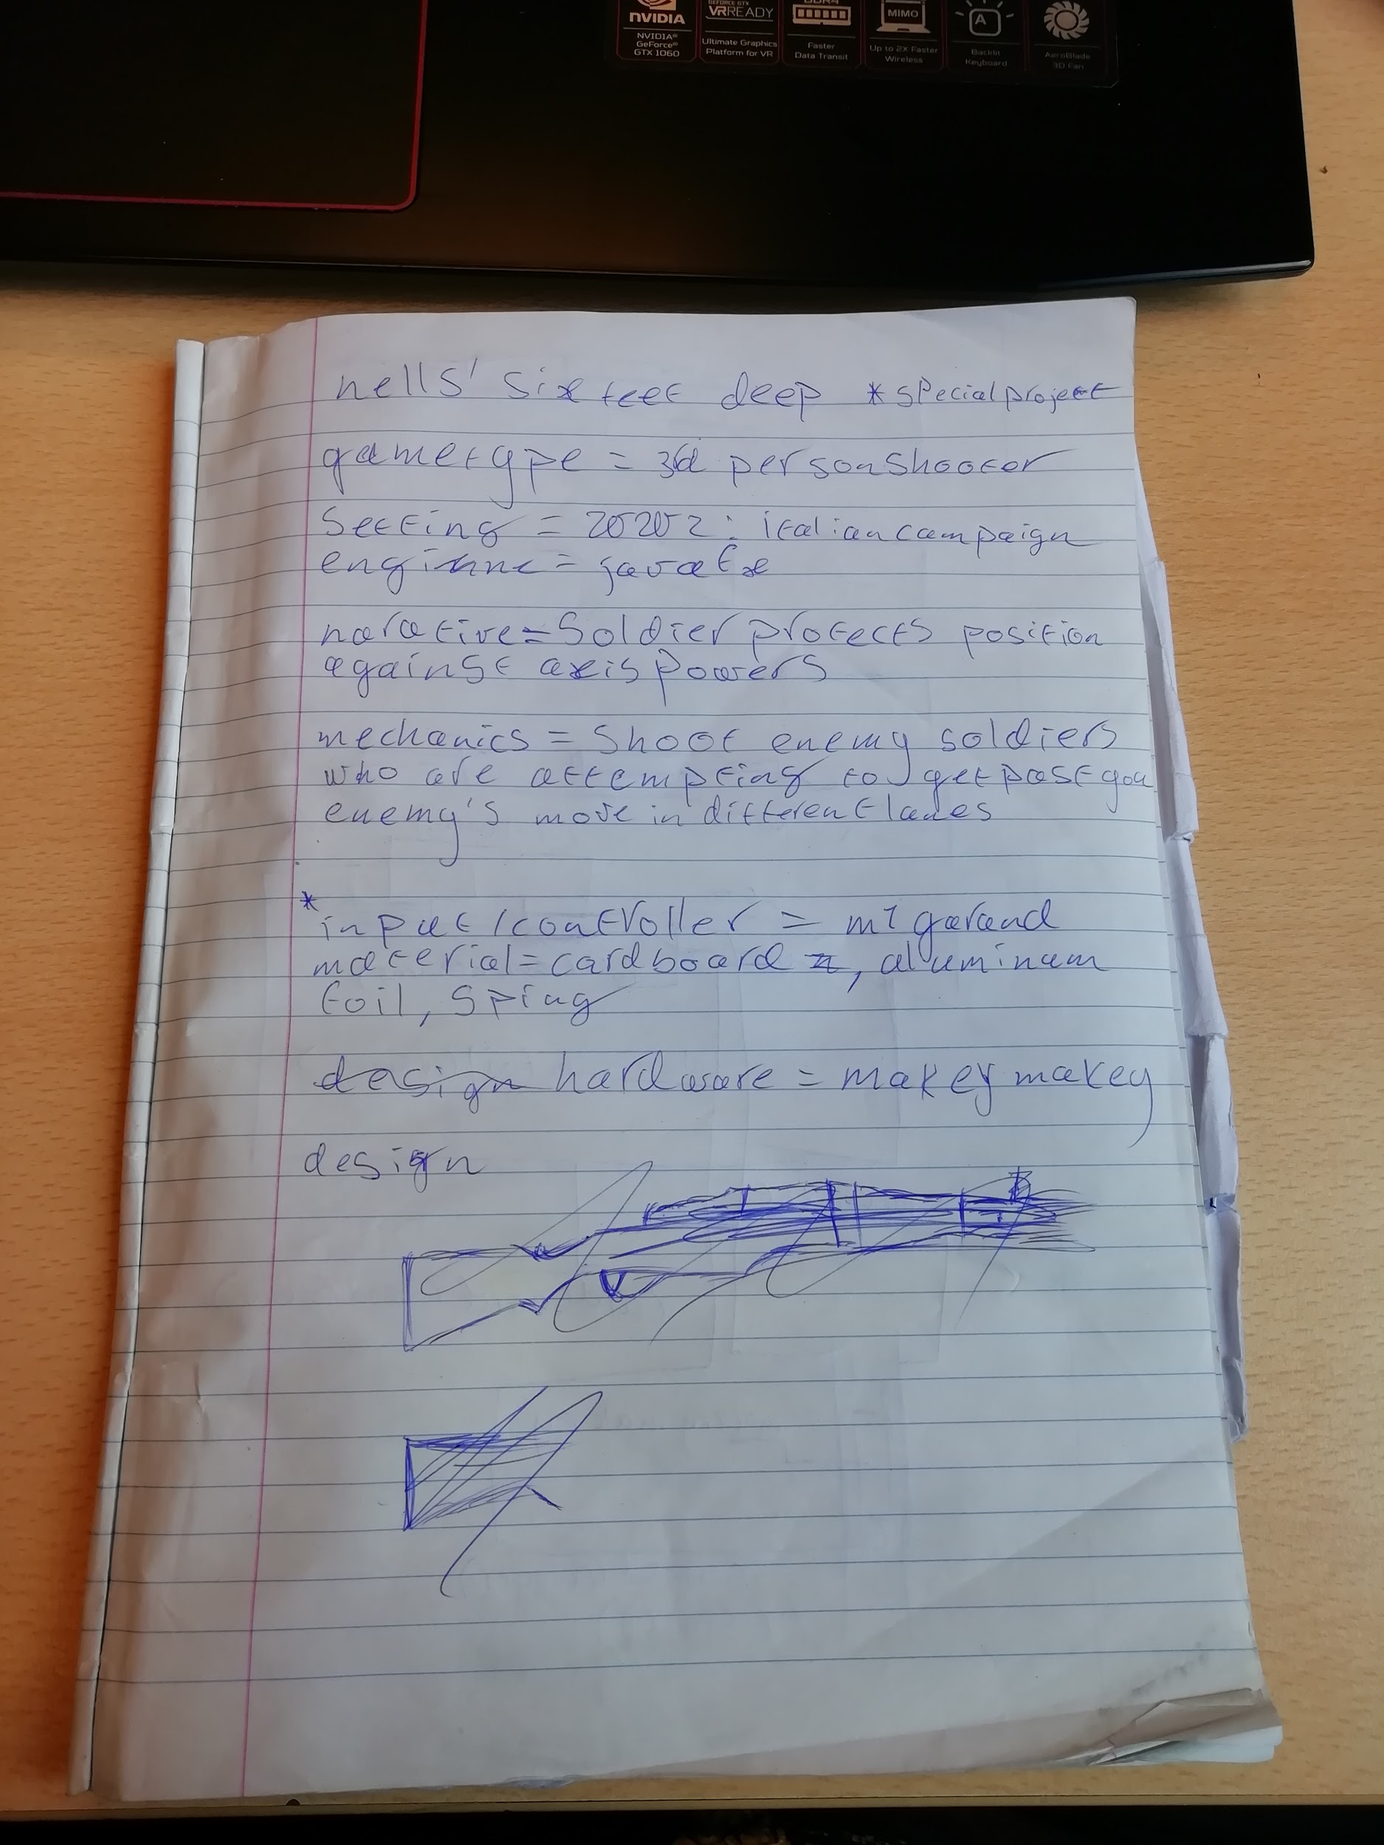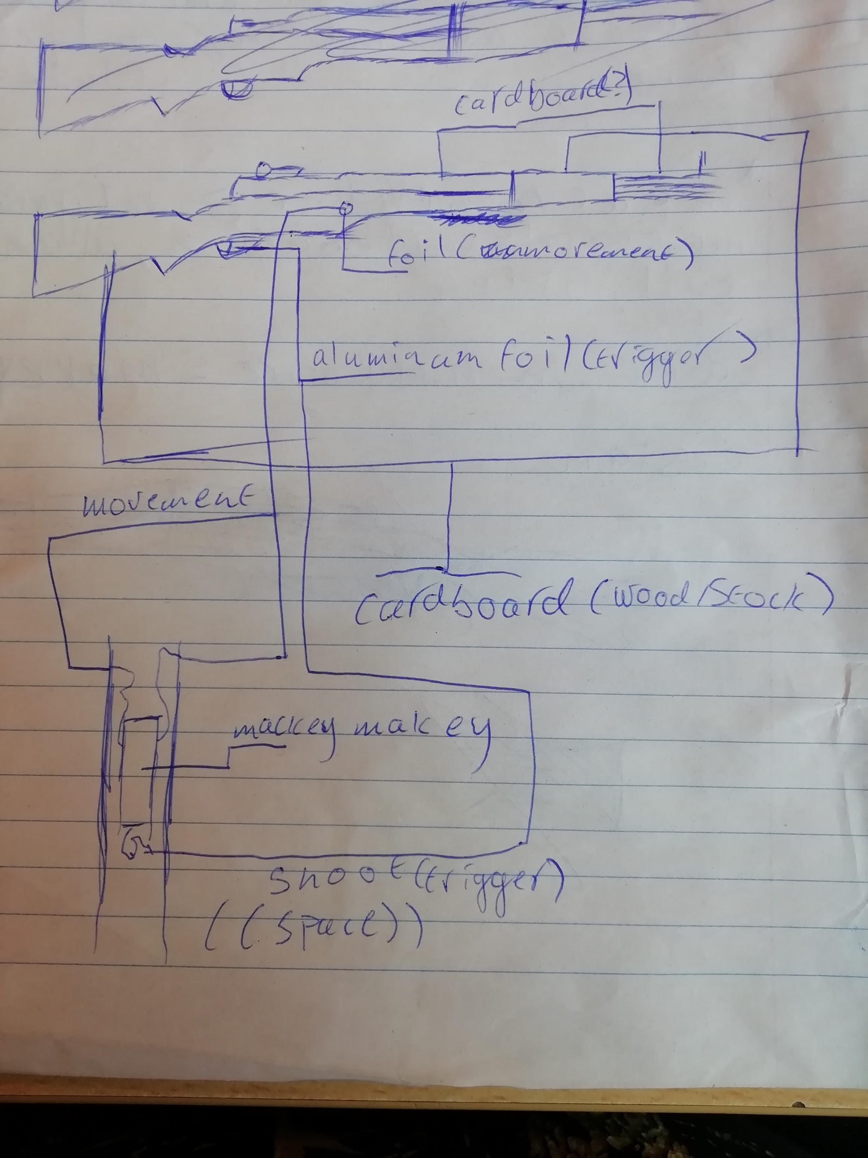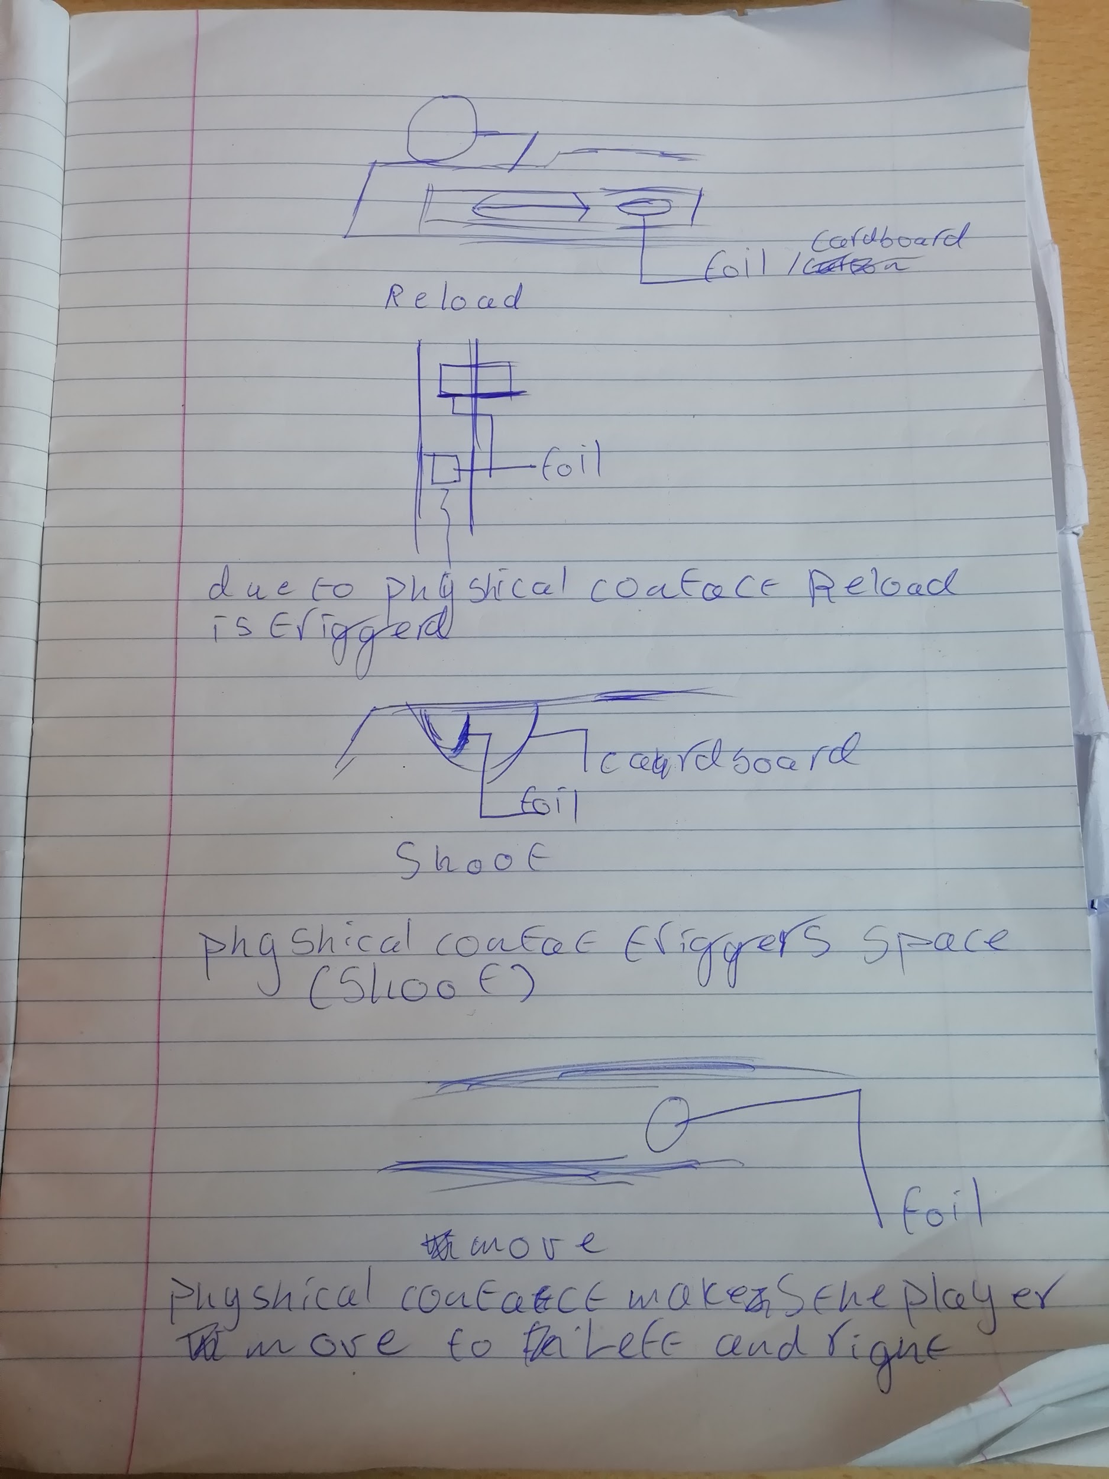

Source: <https://www.youtube.com/watch?v=UNN0yrnFsIA>;