Empirical Testing of Uncovered Interest Rate Parity:
Evidence from the JPY/USD Exchange Rate (2010–2026)

Executive Summary 2
1. Introduction 2
2. Preliminary Analysis 3
3. Regression Analysis 5
3.1 Baseline OLS Estimation and Hypothesis Tests 5
3.2 Rolling Regression Analysis 6
4. Interpretation of Results 7
5. Implied Trading Strategy 7
6. Limitation of findings 8
References 9

Executive Summary
This paper tests Uncovered Interest Rate Parity (UIP) using daily JPY/USD data from March 2010 to March 2026. It estimates the standard regression via OLS with HAC standard errors that combines a monthly robustness check and a rolling window analysis. This paper finds that the estimated slope coefficient was statistically indistinguishable from zero and, in fact, below the value of one. Furthermore, the joint Wald test of the UIP restrictions was strongly rejected. Our findings were consistent with the Fama Puzzle. This paper finds that JPY/USD movements are mainly influenced by carry trade dynamics, the yen’s demand as a safe-haven currency and shifts in BOJ policy, rather than by the interest rate parity between the two countries.

1. Introduction
This currency pair is especially informative for testing UIP because it combines one of the world’s longest periods of ultra-low interest rates in Japan with a sharp and well-documented tightening cycle in the United States. Such persistent monetary-policy divergence creates a strong setting in which UIP should, in theory, imply offsetting exchange-rate movements, making any deviation from that prediction particularly visible.
Uncovered Interest Rate Parity is a foundational no arbitrage condition within international finance. Under risk neutrality and free capital mobility, the expected change in a bilateral exchange rate should equal the interest rate differential between the two countries, which means that investors are indifferent to a country’s assets or fiscal policy. Formally, the testable regression form is:
$$ΔS_{t}=α+β(i_{t-1}^{JP}-i_{t-1}^{US})+ε_{t}$$
Wherein $ΔS_{t}=\ln\left({S_{t}}/{S_{t-1}}\right)$ is the log change in the JPY/USD daily spot rate in which a positive $ΔS_{t}$is Yen depreciation, the log change allows us to remove non-stationarity and ensuring symmetry with respect to the direction of movements of the exchange.
The interest rate differential is $i_{t}^{JP}-i_{t}^{US}$ in our case the yearly market interest rates of both countries measured daily have been divided by 12 to go from the annual rate to a monthly variable, which has then been lagged by 1 period , making it possible to compare the differential with the next day exchange rate change which is according to UIP theory is supposed to be able to predict. For UIP to be confirmed we would require $α=0$ and $β=1$, proving that we are able to explain all movements aside from the error term $ε_{t}$and the relationship of interest rate differential holds fully. Despite its theoretical appeal in establishing a simple and robust method of determining exchange rates, UIP has been proven empirically flawed in the short term. Fama (1984) documented that the estimated $β$ is typically below 1 and often negative with those currencies with higher interest rates countries appreciating rather than depreciating.
All data was collected from Bloomberg. The dataset consists of daily observations, 4,154 observations after alignment of the series, of the USD/JPY spot exchange rate together with US and Japanese short-term interest rates over the sample from March 2010 to March 2026. In Python, the series was cleaned, ordered chronologically and merged on common trading dates to build the UIP variables, after which standard OLS regression of exchange-rate depreciation was estimated on the lagged interest-rate differential, with robustness checks across maturities and time variation.

2. Preliminary Analysis
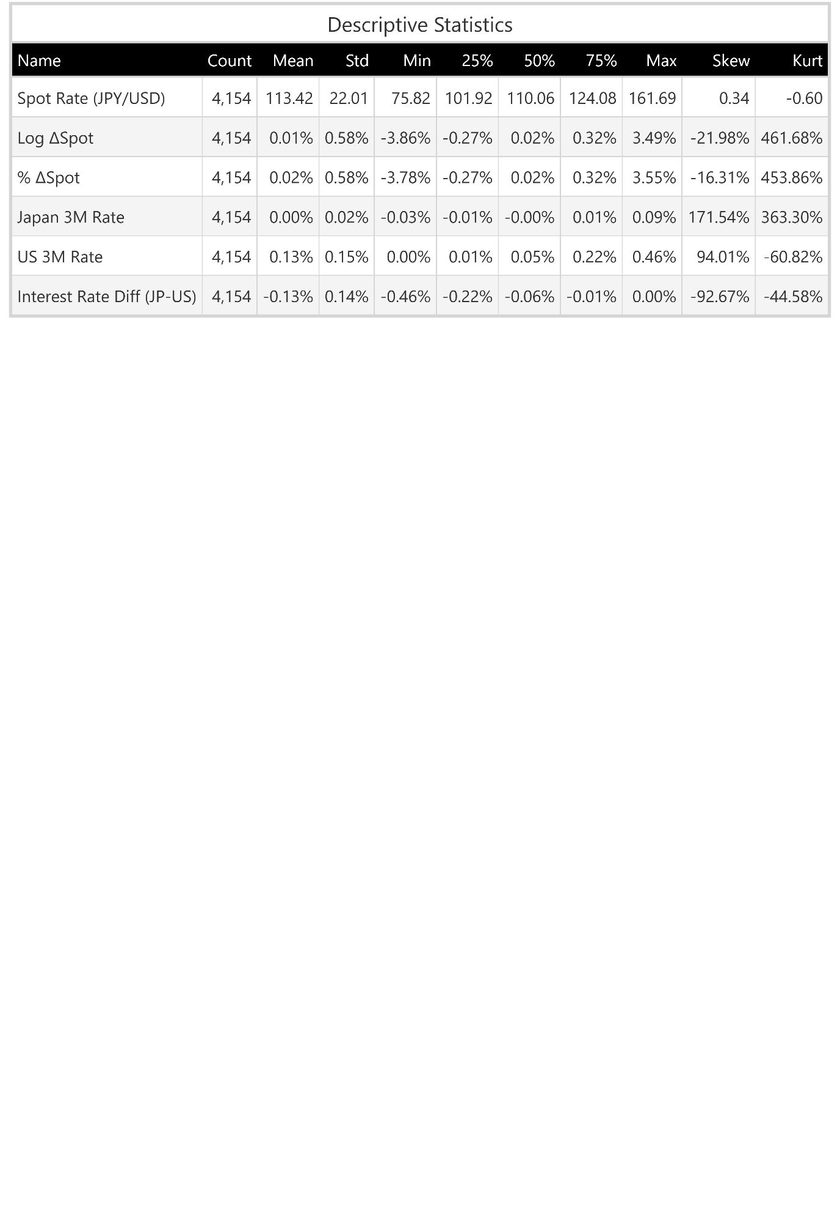
Table 1 shows the descriptive statistics for the JPY/USD exchange rate and the interest rates. The average daily change in the spot rate is basically zero (around 0.01–0.02%), which is what we would expect if exchange rates behaved in a random behaviour. At the same time, the standard deviation is about 0.58%, and the range is quite wide (from roughly −3.8% to +3.5%), so there is still a lot of day-to-day movement.
Table 1: Descriptive Statistics

Looking at the distribution, there is strong skewness and very high kurtosis, which means that large and sudden moves happen from time to time, even if most days are relatively calm. For interest rates, Japan is close to zero with very little variation, while US rates are higher with more volatility. This means the interest rate differential is negative on average (about −0.13%) and does not change that much compared to the exchange rate.

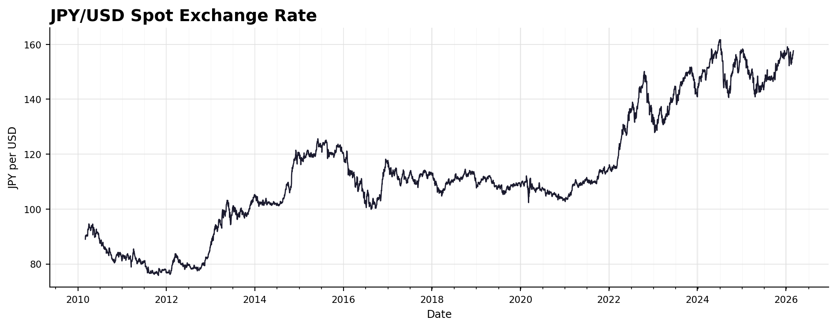
Figure 1: JPY/USD Spot Exchange Rate. Source: Bloomberg.
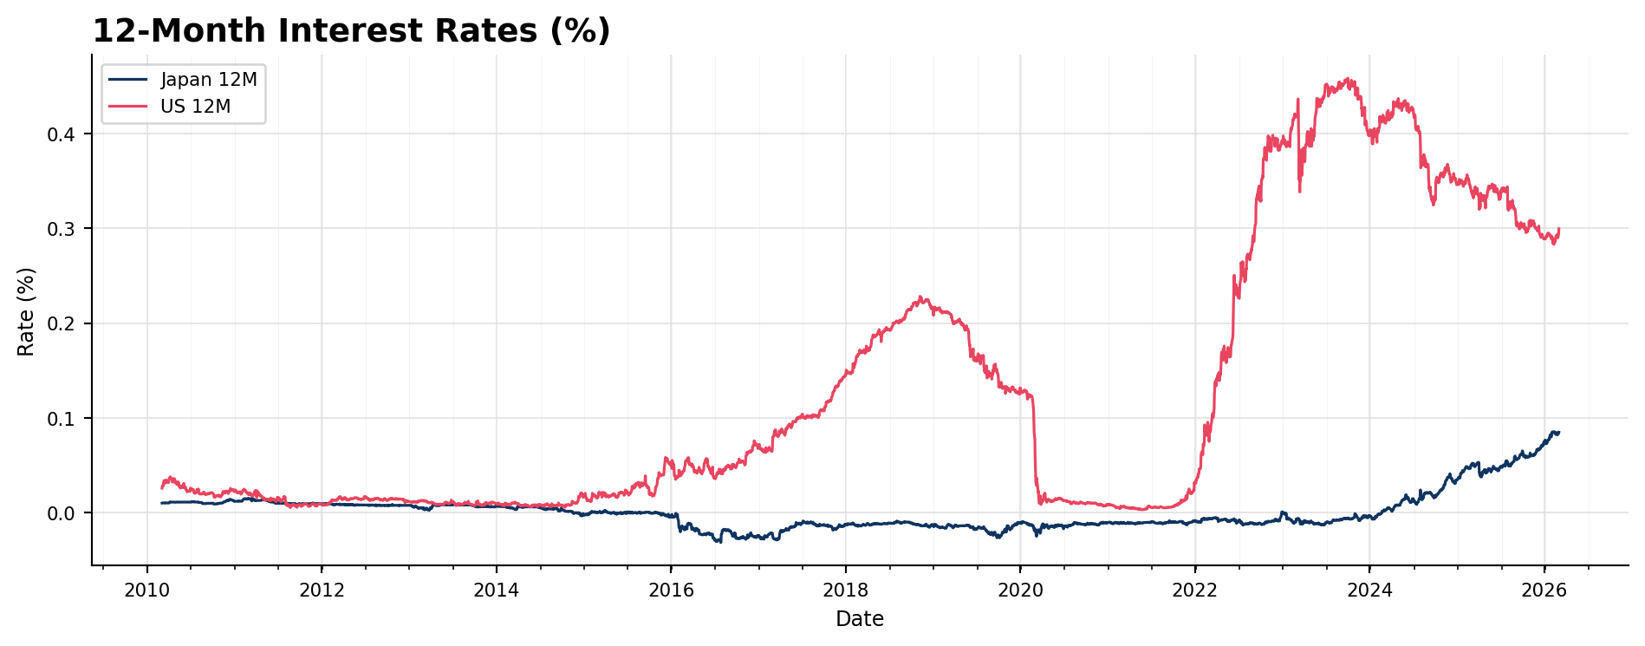
Figure 2: Monthly US and Japanese interest rates derived from 12-month market rates. Source: Bloomberg.
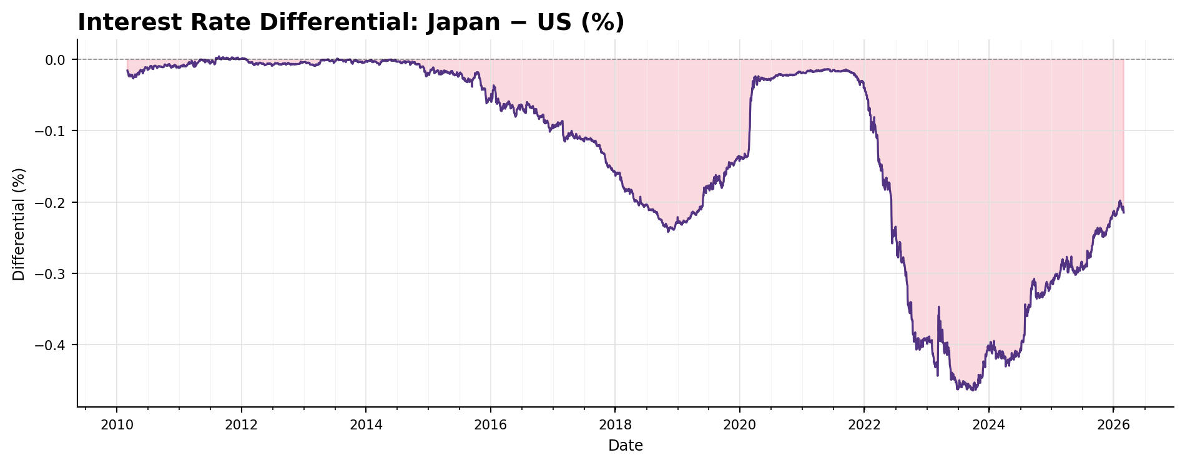
Figure 3: Japan–US 12-Month Rate Differential JPY-USD. Source: Bloomberg.

Figure 1 reveals sustained yen depreciation, from approximately 88 JPY/USD in 2010 to roughly between 140 and 160 between 2024 and 2026. It shows that whilst the yen remained stable around 110 JPY/USD between 2016 and 2022 it weakened sharply after as monetary policy began to diverge.
Figure 2 combines the JPY and USD short-term interest rates over the same period and shows that the major weakening of the JPY in 2022 coincided with a marked divergence in monetary policy. However, as made clear in Figure 3, which isolates the Fed/BOJ interest rate differential, between 2014 and 2020 monetary policy began to gradually diverge between the Fed and BOJ whilst exchange rates remained stable. This is counter to the theory of UIP as there should be a depreciation of the yen in this period. Then, in 2020-2022 there was a period of policy convergence at which point the JPY/USD exchange rate remained stable. This convergence was then reversed and followed by significant Fed and BOJ policy deviation throughout the year 2022 by around -0.46% per month. It then began to narrow in 2024 and 2025, falling back by roughly 0.2% per month.
Although exchange rate movements broadly followed the interest rate differential directional movements during the 2022–2024 period of policy divergence, the yen’s depreciation against the dollar from ~115 to a peak of ~160 JPY/USD was far greater than UIP would predict. This indicates that other factors other than UIP were also at play, such as the Ukraine war and Japan’s dependence on Russian LNG.

3. Regression Analysis

3.1 Baseline OLS Estimation and Hypothesis Tests
 | Estimate | Std Error (NW) | t-stat (H₀: α=0 β=1) | p-value
α (Constant) | 0.000179 | 0.000121 | 1.48 | 0.174
β (IR Diff, lagged) | 0.018355 | 0.000663 | -14.82 | < 0.001
Table 2: OLS Regression Results
Note: Dependent variable is the daily log change in JPY/USD. Standard errors are Newey-West HAC (10 lags).
Hypothesis | Test Statistic | p-value | Decision
H₀: α = 0 | t = 1. 48 | 0.174 | Fail to Reject
H₀: β = 1 (NW SE) | t = −14.82 | < 0.001 | Strongly Rejected
H₀: α=0 & β=1 (Wald) | $χ^{2}$ = 438.97 | < 0.001 | Strongly Rejected
Monthly: H₀: β = 1 (NW SE) | t = −0.514 | 0.608 | Fail to Reject
Monthly: H₀: α=0 & β=1 (Wald) | t = 6.008 | 0.042 | Rejected
Table 3: Hypothesis Tests of UIP Restrictions
The estimated intercept $α = 0.000179$is statistically insignificant (p = 0.174), which is consistent with the UIP restriction that $α$ should be 0, meaning that there is no other variable that we are failing to check that is not part of the error term $ε_{t}$.. However, the slope is also statistically indistinguishable from 0, rather than 1, which UIP predicts, showing that the model does not support the theory. Furthermore, the near-zero R² of 0.00002 indicates that the lagged differential explains none of the daily variation in exchange rate changes and that almost all movements are explained by other factors. This conclusion is reinforced by the Wald test, which strongly rejects the joint UIP restrictions.

3.2 Rolling Regression Analysis
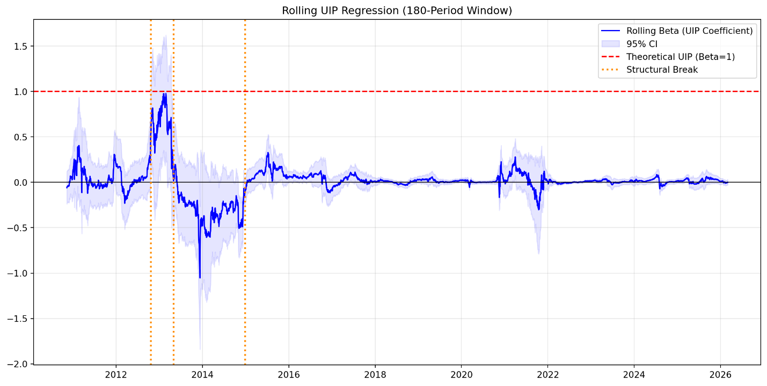

Figure 4: Rolling 180-Day Window Estimates of β. Dashed line indicates the UIP-implied value of β = 1

Figure 4 shows that the rolling $β$ fluctuates around zero throughout the entire sample, with 95% confidence levels consistently excluding the UIP value of 1. Structural break tests identify significant breaks, which confirm that the exchange rate to interest rate relationship is not only far from UIP but also structurally unstable, likely shifting in response to major central bank interventions. Furthermore, although β occasionally spikes to 1, these episodes are brief and quickly revert towards 0, further showing that UIP does not hold in a stable or reliable way.

4. Interpretation of Results
The evidence offers no empirical support for UIP at daily frequency over this sample. The close to zero slope coefficient and rejected Wald test collectively confirm the Fama Puzzle stated in the beginning. Furthermore, rather than depreciating in line with its lower interest rate, the yen failed to offset the US-Japan interest differential and at times even appreciated, allowing traders to profit from the spread. This is not necessarily a market inefficiency, but rather a reflection of the equilibrium in a market populated by traders who earn a premium by bearing the inherent risk in short-yen positions.
Two additional mechanisms strengthen this explanation. First, the yen’s safe-haven status means it often appreciates during periods of global stress regardless of interest rates, pushing the OLS estimate of β toward zero. Second, major BOJ policy shifts, especially the expansion of unconventional easing in 2013–2014, created persistent pressure on the yen that a simple OLS model cannot fully capture. The post-2022 episode is especially telling; it suggests that portfolio rebalancing flows and speculative positioning amplified rather than arbitraged the interest rate.
These findings suggest that UIP failure in the JPY/USD market reflects a combination of risk premium effects and lack of proportion for monetary policy, both absent from the standard UIP framework. The results do not invalidate UIP as a theoretical benchmark but show that its empirical conditions of risk neutrality and free arbitrage are not consistently met over a sixteen-year window. Therefore, this paper shows that UIP is not a sufficient predictor for the movement of a currency and that macroeconomics, geopolitics and carry trade dynamics have a greater influence over the appreciation or depreciation of a currency. The regression results show that UIP has, effectively, zero influence over the movement of a currency.

5. Implied Trading Strategy
The implied strategy is to borrow in yen at Japan’s very low interest rate, convert the proceeds into US dollars, and invest in higher-yielding US Treasury securities. Because exchange-rate movements did not fully offset the US–Japan interest-rate differential over the sample, the investor could earn positive carry on average. This strategy would have been especially attractive during 2022–2023, when the Federal Reserve raised rates sharply while Japanese rates remained very low.
However, the strategy is exposed to sharp yen appreciation, particularly during carry unwinds, when investors rush to close yen-funded positions at the same time. For example, episodes of monetary-policy surprise and weaker US macroeconomic factors can trigger rapid reversals in USD/JPY, generating losses large enough to erase months of carry income in a short period. This means the strategy is not an arbitrage: risk management, position sizing, and stop-loss rules are essential for practical implementation.

6. Limitation of findings
Although the paper looks at the validity of UIP theory regarding US and Japan 12 months rates, which our findings disprove, there are alternative results with different rates.
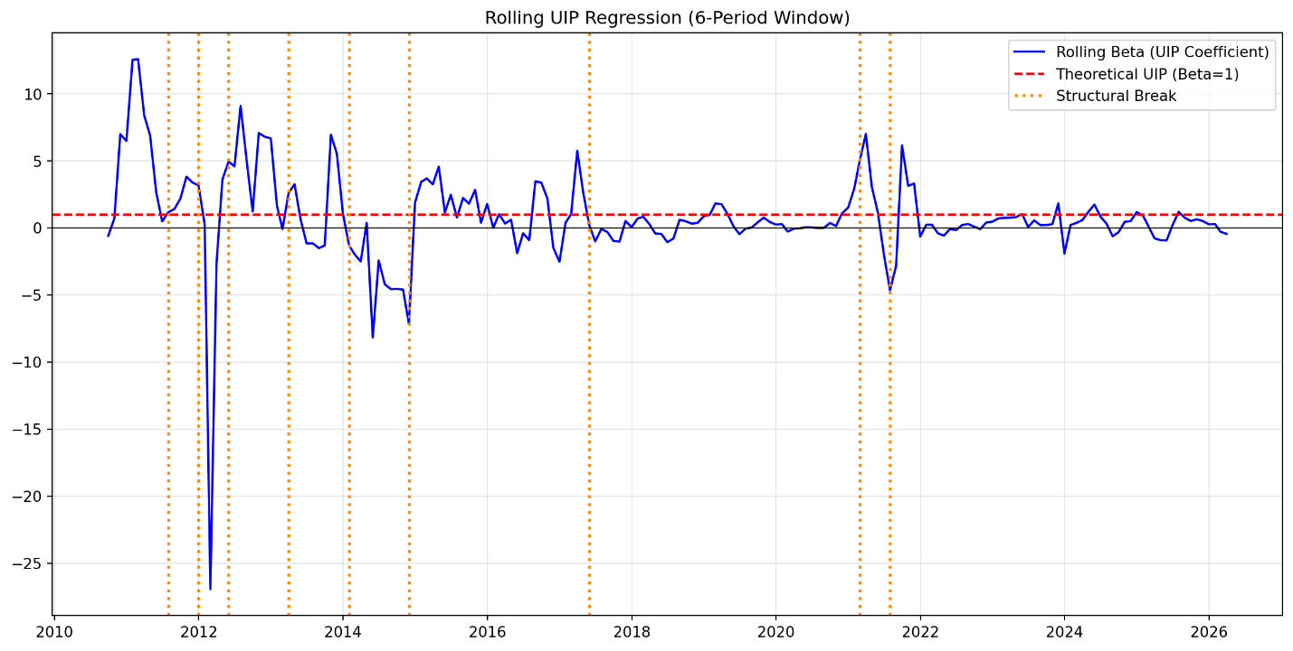
Figure 4: Rolling 6-Month Window Estimates of β. Dashed line indicates the UIP-implied value of β = 1 for monthly
Figure 4 shows that by using monthly rate, UIP theory does hold better, however it is still never consistently at the β = 1 levels needed to confirm the existence of UIP in the dataset.

References
Bussière, M., Chinn, M., Ferrara, L., & Heipertz, J. (2022). The New Fama Puzzle. IMF Economic Review, 70(3), 451–486.
Fama, E. F. (1984). Forward and spot exchange rates. Journal of Monetary Economics, 14(3), 319–338.
Ichiue, H., & Koyama, K. (2011). Regime switches in exchange rate volatility and uncovered interest parity. Journal of International Money and Finance, 30(7), 1436–1450.
McCallum, B. T. (1994). A reconsideration of the uncovered interest parity relationship. Journal of Monetary Economics, 33(1), 105–132.
Meredith, G., & Chinn, M. D. (1998). Long-horizon uncovered interest rate parity. NBER Working Paper No. 6797. National Bureau of Economic Research.
Newey, W. K., & West, K. D. (1987). A simple, positive semi-definite, heteroskedasticity and autocorrelation consistent covariance matrix. Econometrica, 55(3), 703–708.

