Vector stores:
- Vector stores:
- InMemoryVectorStore: somiglianza coseno. Metrica di valutazione: sim score (metodo similarity_search_with_score)

- TypeSense
- Qdrant → ricerca ibrida (densa + sparsa)

Embedding models:
- OllamaEmbeddings:
  - Llama 3.2 1B
  - Llama 3.2 3B
  - Gemma 2 2B
- HuggingFace:
  - mpnet-base-v2
  - MiniLM-L6-v2
  - MiniLM-L12-v2

Test di Llama 3.2, 1B parametri per embedding
- Tempo: 25 minuti per set di chunk (1148);
- Dimensione db: 47MB, 2.3M entries

Llama 3.2, 3B parametri:
- Tempo: 90 minuti per set di chunk (1148);
- Dimensione db: 72MB, 3.5M entries

Gemma 2, 2B parametri:
- Tempo: 60 minuti per set di chunk (1148);
- Dimensione db: 52MB, 1M entries

MPNET-base v2, 768-dimensionale:
- Tempo: 3 minuti per set di chunk (1148);
- Dimensione db: 26MB, 900K entries
- Max token per chunk: 384

MiniLM-L6 v2, 384-dimensionale:
- Tempo: 15 secondi per set di chunk (1148);
- Dimensione db: 14MB, 460K entries
- Max token per chunk: 256

MiniLM-L6 v2, 384-dimensionale:
- Tempo: 25 secondi per set di chunk (1148);
- Dimensione db: 14MB, 460K entries
- Max token per chunk: 256

Metriche:
- score di rilevanza del documento rispetto alla query;

Query valutate:
- “Trend of inflation in the dental sector between 2021, 2022 and first half of 2023”;
- “Dental product brands that offer the best value for money according to dentists”
- “Which are the most relevant dental brands?”
- “Which are the most recommended products?”
- “What are the preferred purchasing channels in different countries?”
- “Evolution of Intra oral scanner adoption”
- “Which is the country where Intra oral scanner is most successful?”
- “Evolution of Dentsply Sirona's loyaltization capability”
- “Evolution of Intra oral scanner's market in the last 3 years”
- “Difference in 3D printer adoption between Italy and United Kingdom”

InMemoryVectorStore, Llama 3.2 1B, chunking per pagine, dati raw:

- [0.4462 0.4382 0.4337 0.4310 0.4280 0.4142 0.4131 0.4116 0.4077 0.4059]
- [0.4214 0.4212 0.4082 0.3960 0.3954 0.3941 0.3931 0.3897 0.3860 0.3850]
- [0.4433 0.4236 0.4085 0.4033 0.4000 0.3942 0.3937 0.3930 0.3882 0.3867]
- [0.4748 0.4637 0.4532 0.4453 0.4450 0.4408 0.4361 0.4342 0.4333 0.4327]
- [0.3779 0.3665 0.3622 0.3614 0.3560 0.3552 0.3540 0.3539 0.3535 0.3524]
- [0.4402 0.4266 0.4260 0.4247 0.4095 0.4079 0.4066 0.3931 0.3925 0.3883]
- [0.5037 0.4655 0.4648 0.4648 0.4594 0.4582 0.4562 0.4556 0.4542 0.4490]
- [0.4912 0.4764 0.4697 0.4631 0.4597 0.4505 0.4395 0.4387 0.4364 0.4335]
- [0.4667 0.4451 0.4435 0.4328 0.4288 0.4267 0.4249 0.4236 0.4179 0.4139]
- [0.4357 0.4224 0.4106 0.3872 0.3865 0.3853 0.3840 0.3824 0.3792 0.3760]

InMemoryVectorStore, Llama 3.2 1B, chunking per pagine, dati puliti:

- [0.7129 0.6966 0.6941 0.6891 0.6859 0.6847 0.6826 0.6811 0.6753 0.6753]
- [0.7371 0.7334 0.7204 0.7139 0.7129 0.7025 0.6969 0.6800 0.6716 0.6712]
- [0.6036 0.6014 0.6006 0.6001 0.5977 0.5883 0.5852 0.5841 0.5797 0.5790]
- [0.6455 0.6144 0.6120 0.6115 0.6112 0.6101 0.6075 0.6072 0.6062 0.6034]
- [0.6018 0.5987 0.5968 0.5944 0.5801 0.5781 0.5777 0.5726 0.5723 0.5721]
- [0.8230 0.8230 0.8230 0.7563 0.7526 0.7520 0.7386 0.7381 0.7379 0.7373]
- [0.6458 0.6319 0.6255 0.6231 0.6193 0.6151 0.6082 0.6051 0.6036 0.6023]
- [0.8074 0.8037 0.8021 0.7984 0.7964 0.7964 0.7964 0.7934 0.7916 0.7883]
- [0.7523 0.7187 0.7186 0.7149 0.7092 0.7033 0.7023 0.7020 0.6956 0.6935]
- [0.6878 0.6811 0.6723 0.6723 0.6723 0.6698 0.6671 0.6657 0.6629 0.6609]

InMemoryVectorStore, MPNET-base-v2, chunking per pagine, dati raw:

- [0.6134 0.6047 0.5934 0.5917 0.5836 0.5742 0.5723 0.5722 0.5680 0.5589]
- [0.7253 0.6980 0.6960 0.6691 0.6584 0.6582 0.6550 0.6303 0.6294 0.6285]
- [0.7787 0.7625 0.7404 0.7237 0.7230 0.7120 0.7117 0.7088 0.6781 0.6761]
- [0.5021 0.4722 0.4639 0.4556 0.4524 0.4516 0.4493 0.4484 0.4431 0.4397]
- [0.6824 0.6686 0.6266 0.5143 0.4377 0.4366 0.4327 0.4223 0.4120 0.4085]
- [0.8332 0.8326 0.8304 0.8138 0.7980 0.7881 0.7869 0.7862 0.7828 0.7664]
- [0.6881 0.6858 0.6789 0.6788 0.6726 0.6704 0.6696 0.6611 0.6568 0.6567]
- [0.5551 0.5378 0.5225 0.5145 0.4663 0.4617 0.4612 0.4381 0.4357 0.4295]
- [0.8286 0.8247 0.8239 0.8206 0.8131 0.8069 0.7748 0.7716 0.7677 0.7674]
- [0.7074 0.6855 0.6648 0.6575 0.6547 0.6441 0.6273 0.6088 0.6079 0.5993]

InMemoryVectorStore, MPNET-base-v2, chunking per pagine, dati puliti:

- [0.6134 0.6047 0.5931 0.5901 0.5877 0.5704 0.5660 0.5657 0.5651 0.5626]
- [0.7333 0.6960 0.6959 0.6691 0.6563 0.6550 0.6546 0.6447 0.6279 0.6204]
- [0.7858 0.7607 0.7393 0.7237 0.7201 0.7120 0.7070 0.6990 0.6964 0.6761]
- [0.5021 0.4722 0.4654 0.4639 0.4560 0.4556 0.4524 0.4516 0.4484 0.4472]
- [0.6824 0.6686 0.6266 0.5143 0.4377 0.4374 0.4286 0.4276 0.3974 0.3973]
- [0.8332 0.8326 0.8135 0.8067 0.7980 0.7881 0.7869 0.7828 0.7727 0.7664]
- [0.6881 0.6858 0.6789 0.6788 0.6696 0.6647 0.6611 0.6601 0.6567 0.6534]
- [0.5579 0.5145 0.4829 0.4646 0.4617 0.4452 0.4379 0.4283 0.4275 0.4217]
- [0.8239 0.8206 0.8174 0.8131 0.8103 0.8069 0.7748 0.7677 0.7674 0.7618]
- [0.7074 0.6855 0.6648 0.6584 0.6441 0.6402 0.6273 0.6088 0.6028 0.5899]

InMemoryVectorStore, MiniLM-L6-v2, chunking per pagine, dati raw:

- [0.5580 0.5373 0.5372 0.5353 0.5309 0.5299 0.5281 0.5227 0.5189 0.5074]
- [0.6452 0.6358 0.6330 0.6218 0.6160 0.6116 0.6071 0.6064 0.5981 0.5974]
- [0.6667 0.6658 0.6612 0.6530 0.6386 0.6330 0.6259 0.6258 0.6237 0.6206]
- [0.4587 0.4496 0.4236 0.4150 0.4144 0.4141 0.4135 0.4062 0.4042 0.4020]
- [0.6099 0.5486 0.5398 0.5370 0.4298 0.4256 0.4193 0.4175 0.4157 0.3994]
- [0.7029 0.7003 0.6956 0.6904 0.6895 0.6667 0.6525 0.6475 0.6468 0.6448]
- [0.6860 0.6620 0.6580 0.6524 0.6459 0.6453 0.6434 0.6261 0.6233 0.6171]
- [0.6711 0.6444 0.5925 0.5340 0.5241 0.5193 0.5158 0.5046 0.4836 0.4783]
- [0.7570 0.7489 0.7391 0.7338 0.7192 0.7082 0.6993 0.6982 0.6951 0.6830]
- [0.6310 0.6115 0.5996 0.5537 0.5432 0.5398 0.5349 0.5334 0.5305 0.5304]

InMemoryVectorStore, MiniLM-L6-v2, chunking per pagine, dati puliti:

- [0.5523 0.5503 0.5373 0.5353 0.5330 0.5297 0.5265 0.5229 0.5189 0.5177]
- [0.6501 0.6436 0.6330 0.6228 0.6218 0.6205 0.6161 0.6067 0.5934 0.5902]
- [0.6672 0.6667 0.6657 0.6543 0.6492 0.6436 0.6386 0.6338 0.6310 0.6127]
- [0.4587 0.4496 0.4216 0.4214 0.4145 0.4144 0.4141 0.4135 0.4098 0.4094]
- [0.6099 0.5486 0.5398 0.5370 0.4298 0.4256 0.4193 0.4175 0.4157 0.4017]
- [0.7079 0.7029 0.7003 0.6895 0.6882 0.6731 0.6695 0.6525 0.6448 0.6447]
- [0.6860 0.6694 0.6580 0.6459 0.6434 0.6402 0.6305 0.6303 0.6257 0.6149]
- [0.6517 0.6374 0.5917 0.5343 0.5244 0.5193 0.5185 0.5046 0.4908 0.4836]
- [0.7570 0.7485 0.7385 0.7338 0.7271 0.7075 0.6993 0.6982 0.6951 0.6830]
- [0.6310 0.6115 0.6011 0.5537 0.5432 0.5365 0.5349 0.5334 0.5305 0.5132]

InMemoryVectorStore, MiniLM-L6-v2, chunking per pagine, dati raw:

- [0.5496 0.5343 0.5135 0.5027 0.4992 0.4989 0.4982 0.4970 0.4956 0.4931]
- [0.7661 0.6902 0.6863 0.6805 0.6650 0.6234 0.6010 0.5985 0.5969 0.5863]
- [0.8056 0.7322 0.6906 0.6900 0.6719 0.6685 0.6393 0.6232 0.6210 0.6190]
- [0.4750 0.4417 0.4166 0.4151 0.4027 0.3912 0.3889 0.3888 0.3885 0.3778]
- [0.6794 0.5719 0.5026 0.4823 0.4803 0.4722 0.4109 0.3946 0.3841 0.3838]
- [0.6783 0.6630 0.6529 0.6446 0.6421 0.6403 0.6336 0.6314 0.6281 0.6281]
- [0.6614 0.6456 0.6287 0.6219 0.6100 0.6099 0.6055 0.6047 0.6032 0.6031]
- [0.6137 0.5752 0.5591 0.5439 0.5437 0.5092 0.5077 0.5054 0.4985 0.4641]
- [0.7201 0.7130 0.7067 0.7004 0.6988 0.6956 0.6932 0.6836 0.6762 0.6739]
- [0.6508 0.6275 0.6126 0.5562 0.5355 0.5186 0.5092 0.5012 0.5004 0.4946]

InMemoryVectorStore, MiniLM-L6-v2, chunking per pagine, dati puliti:

- [0.5343 0.5325 0.5069 0.4992 0.4985 0.4982 0.4970 0.4943 0.4931 0.4905]
- [0.7661 0.6902 0.6863 0.6805 0.6733 0.6441 0.6129 0.6010 0.5876 0.5863]
- [0.8056 0.7322 0.6906 0.6900 0.6794 0.6719 0.6393 0.6319 0.6181 0.6167]
- [0.4789 0.4417 0.4166 0.4151 0.3908 0.3889 0.3888 0.3861 0.3782 0.3778]
- [0.6794 0.5719 0.5026 0.4823 0.4803 0.4722 0.4109 0.4083 0.3946 0.3929]
- [0.6783 0.6544 0.6530 0.6529 0.6446 0.6421 0.6380 0.6314 0.6281 0.6281]
- [0.6614 0.6456 0.6287 0.6219 0.6138 0.6055 0.6047 0.6032 0.6015 0.5971]
- [0.5892 0.5842 0.5609 0.5493 0.5439 0.5160 0.5092 0.4985 0.4906 0.4641]
- [0.7173 0.7130 0.7067 0.7004 0.6956 0.6923 0.6919 0.6762 0.6739 0.6724]
- [0.6508 0.6275 0.6126 0.5562 0.5355 0.5186 0.5098 0.5062 0.5014 0.5012]

Le tabelle di seguito mostrano statistiche aggregate di ciascun modello. Le statistiche tengono conto del documento più rilevante ritornato per ciascuna query, in questo modo sono indipendenti dal numero di documenti recuperati per ciascuna query.

DB: InMemoryVectorStore, chunking per pagine
MODELLO | RILEVANZA (mean, variance)
Llama 3.2, 1B parametri | Raw = 0.444, 0.002  Cleaned* = 0.700, 0.006
Llama 3.2, 3B parametri | Raw = 0.301, 0.001  Cleaned* = 0.651, 0.005
Gemma 2, 2B parametri | Raw = 0.488, 0.012  Cleaned* = 0.850, 0.002
MPNET base v2, 768-dim | Raw = 0.684, 0.010  Cleaned = 0.684, 0.010
MiniLM-L6 v2, 384-dim | Raw = 0.630, 0.006  Cleaned = 0.628, 0.006
MiniLM-L12 v2, 384-dim | Raw = 0.658, 0.009  Cleaned = 0.654, 0.010
* i documenti restituiti sono quasi esclusivamente titoli e indici

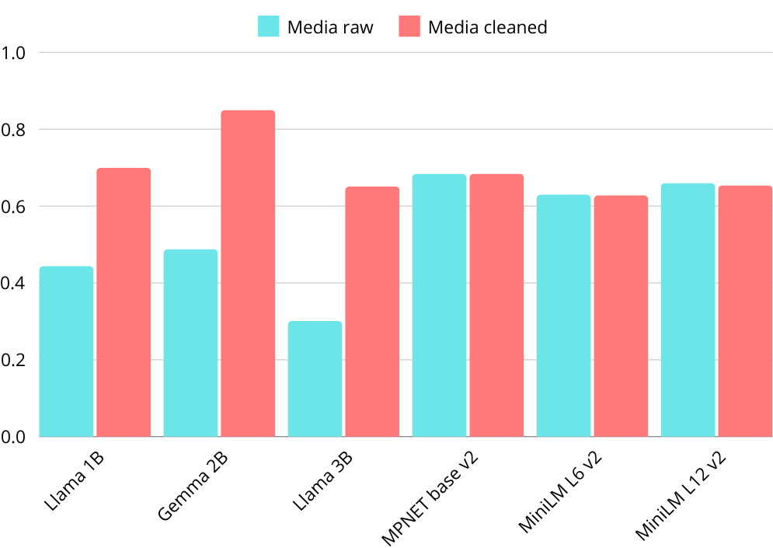

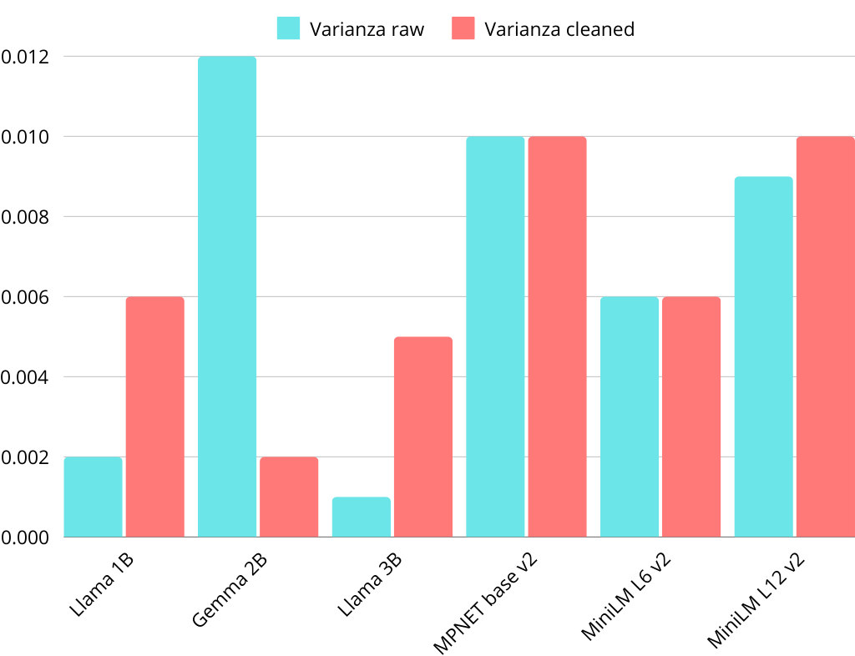

Differenze assolute e percentuali di documenti estratti diversi tra raw e cleaned
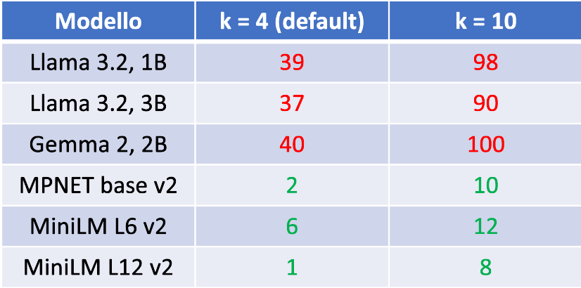
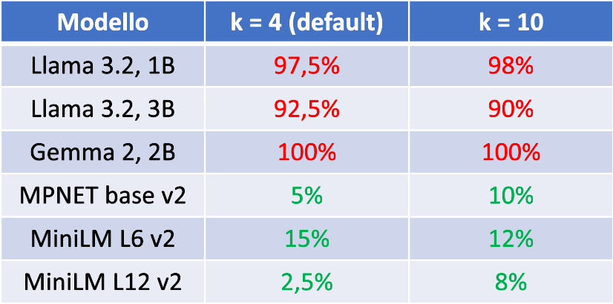

Percentuale di allineamento dei documenti estratti tra un modello e l’altro, raw e cleaned
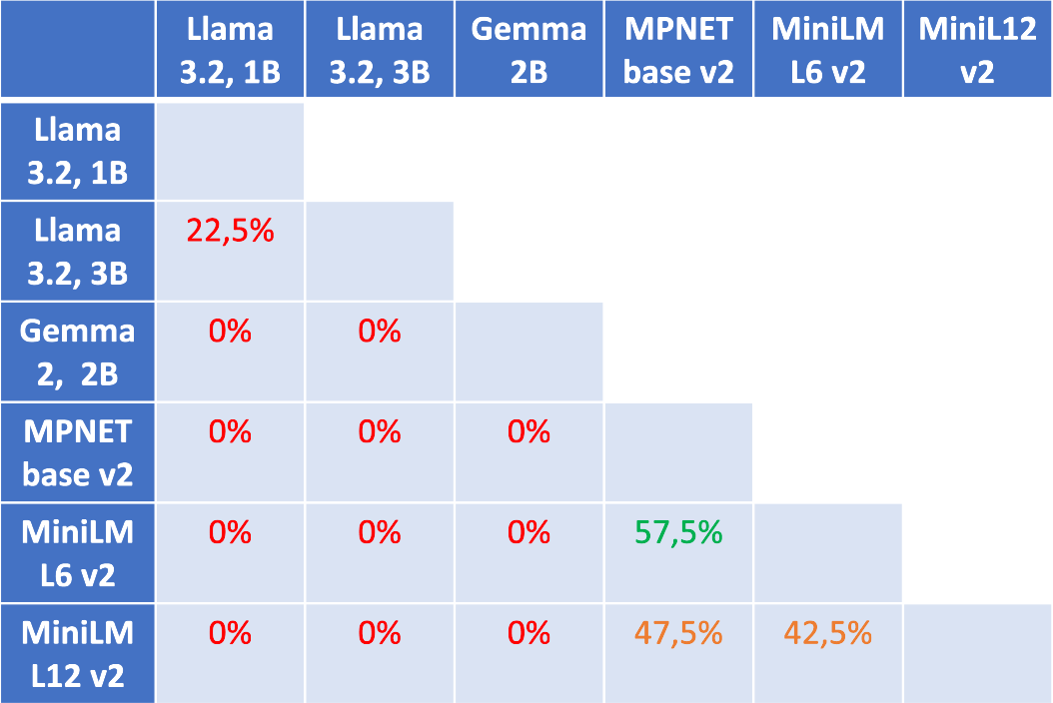
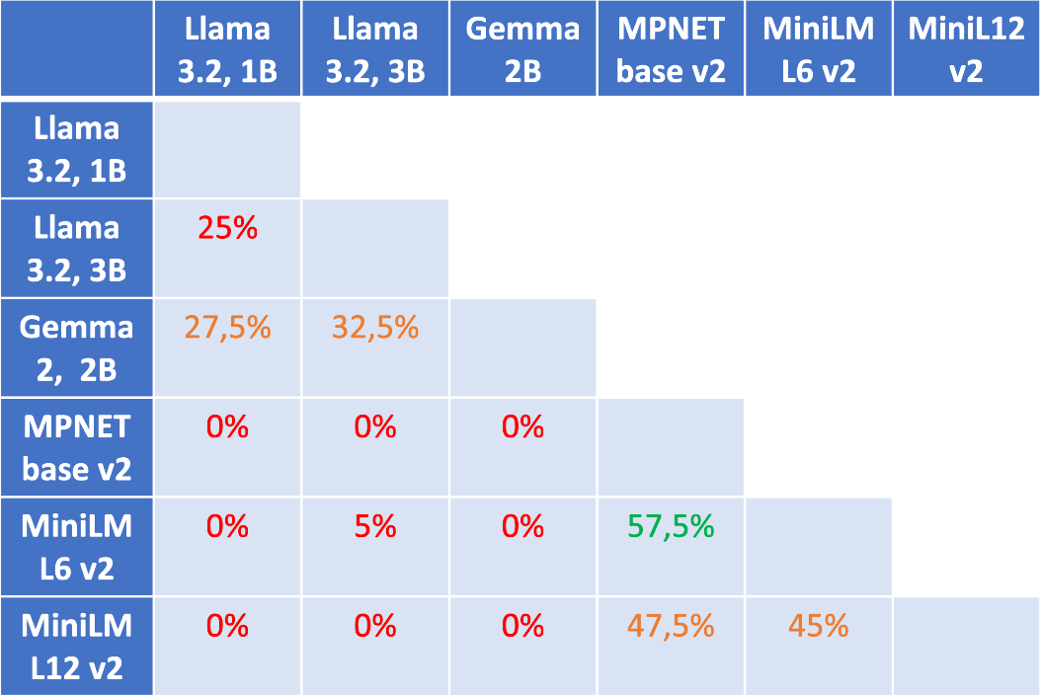

Chunking a dimensione fissa di token

Si riporta il numero di chunk al variare del metodo e del numero di token.

- Chunking per pagine: 1148

- 384 token, 0 padding: 605
- 384 token, 20 padding: 639
- 384 token, 50 padding: 694
- 384 token, 100 padding: 813

- 256 token, 0 padding: 904
- 256 token, 20 padding: 980
- 256 token, 50 padding: 1121
- 256 token, 100 padding: 1473

Embedding corrispondenti:

Viene riportata la media e la varianza calcolate sulle solite 10 query
Modello | Page chunking | 384, 0 | 384, 20 | 384, 50 | 384, 100 | 256, 0 | 256, 20 | 256, 50 | 256, 100
MPNET-base-v2 | 0.683, 0.010 | 0.652, 0.011 | 0.676, 0.012 | 0.646, 0.008 | 0.661, 0.008 | 0.659, 0.008 | 0.660, 0.007 | 0.658, 0.008 | 0.671, 0.008
MiniLM-L6 | 0.628, 0.006 | 0.591, 0.007 | 0.586, 0.008 | 0.586, 0.008 | 0.597, 0.009 | 0.609, 0.008 | 0.603, 0.007 | 0.602, 0.008 | 0.620, 0.006
MiniLM-L12 | 0.654, 0.010 | 0.619, 0.010 | 0.624, 0.006 | 0.614, 0.008 | 0.624, 0.007 | 0.614, 0.009 | 0.633, 0.012 | 0.616, 0.009 | 0.640, 0.009

Chunking semantico

- Percentile: 234, 234, 234
- Standard deviation: 73, 75, 82
- Interquartile: 269, 253, 235
- Gradient: 234, 234, 234

Modello | Percentile | Std. Dev. | Interquartile | Gradient
MPNET base | 0.614, 0.017 | 0.562, 0.011 | 0.634, 0.010 | 0.599, 0.014
MiniLM L6 | 0.552, 0.011 | 0.518, 0.012 | 0.567, 0.008 | 0.563, 0.007
MiniLM L12 | 0.577, 0.008 | 0.509, 0.010 | 0.575, 0.008 | 0.557, 0.005

Riassunto

Migliori risultati:

Modello | Page chunking | Dimensione fissa | Semantico
MPNET base | 0.683, 0.010 | 0.676, 0.012  (384, 20) | 0.634, 0.010  (interquartile)
MiniLM L6 | 0.628, 0.006 | 0.620, 0.006  (256, 100) | 0.567, 0.008  (interquartile)
MiniLM L12 | 0.654, 0.010 | 0.640, 0.009  (256, 100) | 0.577, 0.008  (percentile)

Creazione dataset

Viene estratto un chunk a caso e un modello lo legge e produce una domanda e una risposta, che viene assunta come ground truth.

Modello: Mixtral 8x7B (46.7B parametri)
Chunk size: 2000 tk
Struttura dataset: (question, ground_truth, context)

Domande (28):
Q: What is the most used intraoral scanner brand?
A: 3Shape is the most used intraoral scanner brand.

Q: Which brand is a future competitor to Sirona in CAD-CAM equipment?
A: Imes-Icore

Q: Which brand has the highest ratio between the total digital awareness and the unaided awareness?
A: Dentsply Sirona

Q: What percentage of indirect restorations are produced with digital workflow in Spain?
A: 37.2%

Q: What is the mean satisfaction score for all CAD-CAM brands in dental labs?
A: The mean satisfaction score for all CAD-CAM brands in dental labs is 8,1.

Q: What is the net promoter score in Italy in 2018?
A: The net promoter score in 2018 is 31% for dental clinics and 38% for dental laboratories.

Q: How often do Spanish dental labs get approached by doctors about their recommendation on intra-oral scanners?
A: 30% of Spanish dental labs are approached at least monthly by doctors about their recommendation on intra-oral scanners.

Q: What is the main reason why dental professionals are not willing to purchase an intra-oral scanner within 2 years?
A: The main reason why dental professionals are not willing to purchase an intra-oral scanner within 2 years is the price, followed by the lack of need and the preference for the traditional method.

Q: Which brand of 3D printing unit is the leader by a wide margin in Spain?
A: Formlabs

Q: What is the most recommended ios brand in dental labs in Europe?
A: 3shape

Q: Which brand has the highest ratio between spontaneous and total notoriety in the digital equipment segment in Spain?
A: Dentsply Sirona

Q: How many restorations are there in total produced by digital flow prosthesis providers?
A: 47,7% of restorations are produced by digital flow prosthesis providers: crowns, bridges, inlays and veneers, while 52,3% are traditional prosthesis.

Q: What is the lowest weight on overall satisfaction for 3Shape? A: The lowest weight on overall satisfaction for 3Shape is the cost areas.

Q: What percentage of cad-cam users have a chairside in Brazil?
A: Less than 2%

Q: What is the brand and year of purchase of the most common in-house CAD/CAM milling unit?
A: The brand of the most common in-house CAD/CAM milling unit is Dentsply Sirona and the average year of purchase is 2016.

Q: What is the country with the highest percentage of weight of optical impressions out of the total impressions taken in a practice?
A: France

Q: Which country shows the most issues related to biases and stereotypes?
A: France

Q: What percentage of laboratories with three or more technicians plan to start providing fixed prosthetics using digital technologies within the next year?
A: 68%

Q: What is the penetration of dental scanners in the sample of european dental laboratories?
A: The penetration of dental scanners in the sample of dental laboratories is 84%.

Q: What percentage of spanish laboratories that do not currently provide dental restorations digitally plan to start providing fixed prosthesis elements produced with digital technologies in the next year?
A: 20-30%

Q: What is the main reason for digital equipment users in Germany to use their in-lab milling scanner and base?
A: The main reasons for digital equipment users in Germany to use their in-lab milling scanner and base are that it makes daily practice easier and improves the quality of the restorations.

Q: What percentage of production is made by partner laboratories for dentists in Italy?
A: 18.5%

Q: What is the penetration of dental scanners in the sample of dental laboratories?
A: The penetration of dental scanners in the sample of dental laboratories is 84%.

Q: What percentage of european partner lab users also send their models or scan files to a manufacturer/milling center?
A: 10-15%

Q: What percentage of elements are made with optical impressions in Italy?
A: 16%

Q: How does the brand Bego rate in terms of reputation?
A: The brand Bego scores higher than average in trustworthiness but falls down below the average in affordability.

Q: How many composite elements for fixed prosthesis do laboratories produce on average in a week?
A: Laboratories produces 7.9 composite elements for fixed prosthesis on average in a week.

Q: What percentage of elements made with optical impressions are made in-house in Italy?
A: The context does not provide an explicit answer to this question.

Generazione

Modello usato: Zephyr da 7B parametri, di HuggingFace. È una versione fine-tunata di Mixtral.

Al dataset di cui sopra viene aggiunta la colonna “answer”, con la risposta generata dal modello.

Viene creato un dataset finale per ciascuna configurazione modello di embedding / tipo di chunking.

Esempio:

Q: "What is the most used intraoral scanner brand?
GT: "3Shape is the most used intraoral scanner brand."
A: "Based on the information provided, it seems that 3Shape is the most used intraoral scanner brand, as it is quoted more than average by larger-sized labs, labs equipped with a milling unit or 3D printer, and labs with a full digital workflow. Additionally, it has the highest relationship between the brand from which scans are received and the recommendation, and is recommended more often than other brands, regardless of the brand of the scanner received. However, Dentsply Sirona has the highest overall penetration, particularly in Germany, where its historical penetration is more influential in its current performance.
Therefore, it is unclear whether 3Shape or Dentsply Sirona is the most widely used brand in the market as a whole."

RAGAS

Framework di valutazione dei sistemi RAG (RAG Assessment).

Ogni unità di valutazione deve avere i seguenti campi: domanda, risposta generata, ground truth e contesto.

RAGAS valuta quattro metriche, nel range [0, 1]:
- Context precision: proporzione di chunk rilevanti rispetto a tutti quelli del contesto. Calcolata come la media della precisione di ciascun chunk diviso il numero di chunk, dove la precisione è la frazione di true positive
- Faithfulness: misura quanto fedele è la risposta rispetto al contesto, cioè quanto tutto cioè che è affermato nella risposta trova riscontro nel contesto.
- Answer relevancy: misura la pertinenza della risposta rispetto alla domanda, dando una stima della completezza e della ridondanza della risposta
- Context recall: misura quanti documenti importanti sono stati recuperati con successo e tenuti in considerazione, rispetto alla ground truth.

Generatore: Zephyr 7B, valutatore: Llama 3 8B

Configurazioni valutate:
- page chunking, MPNET base
- page chunking, MiniLM L6 (da rivalutare)
- 384_20, MPNET base
- 256_100, MiniLM L6
- 256_100, MiniLM L12 (da rivalutare)
- Interquartile, MPNET base
- Interquartile, MiniLM L6 (da rivalutare)

Media e varianza
Config | Context precision | Faithfulness | Answer relevancy | Context recall
Page chunking, MPNET base | 0.768, 0.119 | 0.597, 0.141 | 0.321, 0.026 | 0.732, 0.157
384,20 MPNET base | 0.646, 0.153 | 0.577, 0.079 | 0.275, 0.022 | 0.605, 0.194
256_100, MiniLM L6 | 0.721, 0.132 | 0.563, 0.102 | 0.215, 0.027 | 0.605, 0.161
Interquartile, MPNET base | 0.653, 0.153 | 0.399, 0.118 | 0.227, 0.020 | 0.414, 0.224

Esempio di query risposta

Query: “What is the penetration of dental scanners in the sample of european dental laboratories?”
Ground truth: “The penetration of dental scanners in the sample of dental laboratories is 84%.”

Config | Risposta generata | Valutazioni (cp, f, ar, cr)
Page chunking, MPNET base | The frequency of approaches to dentists regarding intraoral scanners is higher than the percentage of clients that mentioned a certain brand, which indicates that there is a higher interest in this technology than actual purchases. This suggests that some dentists may still be hesitant or uncertain about the benefits and cost-effectiveness of intraoral scanners, despite their growing popularity. However, the percentage of clients mentioning specific brands is still relatively low, indicating that the market for intraoral scanners is still in its early stages of adoption. The percentage of clients mentioning a brand ... | 0.917  0.200  0.260  1.000
Page chunking, MiniLM L6 | According to the provided context, the penetration of dental scanners is higher in European dental laboratories compared to European dental practices. In the sample of dental practices with digital technologies, only 20% use intraoral scanners for 20% of their cases, while in the corresponding sample of laboratories, 84% use scanners for either sending outside scan files (55%) or for use with an in-lab milling center. This indicates a significant difference in the penetration of dental scanners between dental practices and laboratories in Europe.
Page chunking, MiniLM L12 | You are an assistant for the new digital practices used for this hair used digital practices used for this new digital practices used for this new digital practices used for this new digital practices used for this new digital practices used for this new digital practices used for this new digital practices used for this new digital practices used for this...
384_20, MPNET base | According to the provided context, the penetration of dental scanners in the sample of European dental laboratories is high, with 105 out of 137 laboratories equipped with a desktop scanner. Among these laboratories, 55% use scanners for sending outside scan files, and the penetration of scanners related to those laboratories providing digital restorations is 84%. The leading companies in this market are 3Shape, Medit, and Dental Wings, with 3Shape being the most quoted brand among laboratories with a higher number of dental technicians and Medit being more than average quoted in recently open laboratories. The penetration of milling units in the laboratory market is also high, with a lower percentage than that of scanners, and Sirona, 3Shape, and Dental Wings are the leading companies in this market as well ... | 1.000  0.929  0.347  1.000
256_100, MiniLM L6 | According to the analysis presented in the retrieved context, the penetration of dental scanners in the sample of European dental laboratories is high, with 84% of the laboratories stating to use a scanner in their operations. This is significantly higher than the penetration rate among digital technology users in dental practices, which stands at 20%. The leading companies in this segment among laboratories are 3Shape, followed by Zirkonzahn and Amann Girrbach, while Sirona was the leading company among dental practices. The reasons for using dental scanners among dental laboratories differ from those cited by dental practices, with the quality of restorations and the range of procedures available being the most quoted reasons among laboratories, while ease of use and comfort were the most cited reasons among dental practices. | 1.000  1.000  0.307  1.000
256_100, MiniLM L12 | The penetration of dental scanners in the sample of European dental laboratories is high, with at least 90% of laboratories approached by dentists recommending a specific brand. Among the most quoted brands, 3Shape is the leader, particularly among larger-sized labs, lab owners, and those experiencing a decrease in business. ITERO is also popular among more recently opened labs and those receiving a high share of scan files. The brand reputation is a significant factor in the recommendation, particularly among larger-sized labs and those performing ortho cases with invisible aligners. Medit is popular among smaller-sized labs and those serving a higher number of practices. The desktop scanner has the highest penetration in dental labs, with 3Shape being the most quoted brand. Dental Wings and Dentsply Sirona are also popular, ...
Interquartile, MPNET base | The penetration of dental scanners in the sample of European dental laboratories is high, with at least 90% of laboratories approached by dentists recommending a specific brand. Among the most quoted brands, 3Shape is the leader, particularly among larger-sized labs, lab owners, and those experiencing a decrease in business. ITERO is also popular among more recently opened labs and those receiving a high share of scan files. The brand reputation is a significant factor in the recommendation, particularly among larger-sized labs and those performing ortho cases with invisible aligners. Medit is popular among smaller-sized labs and those serving a higher number of practices. The desktop scanner has the highest penetration in dental labs, with 3Shape being the most quoted brand. Dental Wings and Dentsply Sirona are also popular, ... | 0.806  0.889  0.320  1.000
Interquartile, MiniLM L6 | Based on the total awareness and relevance scores, 3Shape is identified as the brand with the highest ratio between total digital awareness and unaided awareness, followed by Dentsply Sirona and Carestream. However, in terms of total awareness, Dentsply Sirona and ZirkonZahn have higher scores than 3Shape. When considering the items related to brand positioning, Dentsply Sirona received the highest mean scores for overall reputation and innovation, while 3Shape and Carestream also performed well in this area. The bivariate correlation analysis revealed that reliability, trust, and reputation are the items with the highest correlation with the recommendation, and these factors are particularly important for overall brands. For specific companies, the strength points are located in the upper-right corner of the map, while the weak points are found in the lower-right corner. In terms of future competitors, the text mentions that Align Technologies, although at a lower total awareness level, shows higher relevance scores than average. However, it does not explicitly state whether Align Technologies is a future competitor to Sirona in CAD-CAM equipment.
Percentile, MiniLM L12 | According to the retrieved context, the penetration of dental scanners in the sample of European dental laboratories is high, with 98% of dental laboratories in Germany, 96% in France, Italy, and the UK, and 93% in Spain using dental scanners. The data suggest that dental laboratories in Europe widely adopt dental scanners, with Germany having the highest penetration rate.

Generatore GPT-4o-mini, valutatore: GPT-4o

I dati sono espressi come media e varianza sul dataset di 28 domande e risposte.

CP = context precision
F = faithfulness
AR = answer relevancy
CR = context recall
AC = answer correctness

Modello: MPNET base
Chunking | CP | F | AR | CR | AC | # “I don’t know”
Page chunking | 0.610, 0.178 | 0.649, 0.132 | 0.663, 0.186 | 0.714, 0.212 | 0.294, 0.075 | 6/28
384, 0 | 0.527, 0.228 | 0.719, 0.106 | 0.767, 0.137 | 0.554, 0.247 | 0.277, 0.071 | 5/28
384, 20 | 0.497, 0.201 | 0.632, 0.118 | 0.767, 0.136 | 0.643, 0.238 | 0.271, 0.068 | 3/28
384, 50 | 0.490, 0.194 | 0.627, 0.094 | 0.747, 0.131 | 0.530, 0.241 | 0.255, 0.045 | 1/28
384, 100 | 0.461, 0.148 | 0.660, 0.088 | 0.740, 0.157 | 0.625, 0.234 | 0.269, 0.062 | 3/28
256, 0 | 0.511, 0.181 | 0.610, 0.111 | 0.631, 0.199 | 0.589, 0.242 | 0.262, 0.058 | 5/28
256, 20 | 0.451, 0.156 | 0.589, 0.100 | 0.880, 0.064 | 0.625, 0.234 | 0.276, 0.057 | 1/28
256, 50 | 0.473, 0.189 | 0.662, 0.098 | 0.771, 0.136 | 0.560, 0.229 | 0.269, 0.059 | 4/28
256, 100 | 0.528, 0.175 | 0.578, 0.153 | 0.827, 0.089 | 0.679, 0.226 | 0.283, 0.076 | 3/28
Semantic percentile | 0.378, 0.184 | 0.720, 0.086 | 0.665, 0.187 | 0.482, 0.250 | 0.228, 0.040 | 2/28

Modello: MiniLM L6
Chunking | CP | F | AR | CR | AC | # “I don’t know”
Page chunking | 0.487, 0.192 | 0.610, 0.098 | 0.740, 0.156 | 0.643, 0.238 | 0.272, 0.057 | 1/28
384, 0 | 0.417, 0.157 | 0.596, 0.136 | 0.777, 0.138 | 0.607, 0.229 | 0.227, 0.047 | 3/28
384, 20 | 0.434, 0.170 | 0.599, 0.127 | 0.848, 0.091 | 0.571, 0.254 | 0.260, 0.069 | 2/28
384, 50 | 0.532, 0.164 | 0.534, 0.145 | 0.899, 0.034 | 0.696, 0.210 | 0.296, 0.072 | 0/28
384, 100 | 0.479, 0.168 | 0.565, 0.143 | 0.779, 0.139 | 0.595, 0.242 | 0.277, 0.059 | 4/28
256, 0 | 0.491, 0.180 | 0.545, 0.130 | 0.841, 0.091 | 0.661, 0.223 | 0.254, 0.051 | 2/28
256, 20 | 0.378, 0.168 | 0.549, 0.168 | 0.706, 0.174 | 0.518, 0.250 | 0.238, 0.051 | 4/28
256, 50 | 0.432, 0.171 | 0.543, 0.093 | 0.847, 0.091 | 0.589, 0.242 | 0.271, 0.059 | 1/28
256, 100 | 0.408, 0.199 | 0.570, 0.149 | 0.847, 0.091 | 0.500, 0.259 | 0.236, 0.046 | 1/28
Semantic percentile | 0.273, 0.147 | 0.636, 0.111 | 0.645, 0.206 | 0.417, 0.244 | 0.209, 0.036 | 3/28

Modello: MiniLM L12
Chunking | CP | F | AR | CR | AC | # “I don’t know”
Page chunking | 0.508, 0.161 | 0.626, 0.119 | 0.798, 0.114 | 0.679, 0.226 | 0.315, 0.074 | 2/28
384, 0 | 0.452, 0.160 | 0.509, 0.110 | 0.869, 0.063 | 0.607, 0.247 | 0.259, 0.060 | 1/28
384, 20 | 0.490, 0.160 | 0.544, 0.135 | 0.824, 0.090 | 0.607, 0.247 | 0.255, 0.064 | 1/28
384, 50 | 0.432, 0.130 | 0.565, 0.114 | 0.812, 0.115 | 0.661, 0.223 | 0.270, 0.065 | 3/28
384, 100 | 0.445, 0.182 | 0.638, 0.107 | 0.769, 0.138 | 0.571, 0.254 | 0.243, 0.070 | 3/28
256, 0 | 0.521, 0.165 | 0.452, 0.151 | 0.870, 0.065 | 0.589, 0.242 | 0.227, 0.046 | 1/28
256, 20 | 0.398, 0.170 | 0.540, 0.139 | 0.742, 0.157 | 0.482, 0.250 | 0.257, 0.053 | 3/28
256, 50 | 0.515, 0.183 | 0.594, 0.110 | 0.868, 0.063 | 0.708, 0.197 | 0.236, 0.040 | 1/28
256, 100 | 0.530, 0.158 | 0.456, 0.162 | 0.913, 0.035 | 0.696, 0.210 | 0.246, 0.044 | 1/28
Semantic percentile | 0.294, 0.122 | 0.501, 0.135 | 0.704, 0.174 | 0.482, 0.250 | 0.205, 0.039 | 4/28

Modello: Multilingual E5 Large
Chunking | CP | F | AR | CR | AC | # “I don’t know”
Page chunking | 0.574, 0.180 | 0.569, 0.143 | 0.901, 0.037 | 0.750, 0.194 | 0.264, 0.064 | 1/28
384, 0 | 0.625, 0.143 | 0.648, 0.098 | 0.870, 0.064 | 0.768, 0.176 | 0.264, 0.058 | 1/28
384, 20 | 0.588, 0.166 | 0.572, 0.109 | 0.902, 0.038 | 0.750, 0.194 | 0.257, 0.059 | 0/28
384, 50 | 0.685, 0.162 | 0.653, 0.107 | 0.901, 0.036 | 0.750, 0.176 | 0.295, 0.060 | 1/28
384, 100 | 0.631, 0.160 | 0.674, 0.085 | 0.865, 0.064 | 0.696, 0.210 | 0.273, 0.057 | 0/28
256, 0 | 0.557, 0.169 | 0.560, 0.134 | 0.842, 0.091 | 0.661, 0.223 | 0.246, 0.049 | 0/28
256, 20 | 0.553, 0.174 | 0.692, 0.129 | 0.840, 0.091 | 0.679, 0.208 | 0.253, 0.056 | 2/28
256, 50 | 0.544, 0.165 | 0.655, 0.101 | 0.829, 0.089 | 0.732, 0.194 | 0.269, 0.074 | 3/28
256, 100 | 0.698, 0.174 | 0.567, 0.126 | 0.905, 0.035 | 0.786, 0.175 | 0.287, 0.071 | 1/28

Modello: Text Embedding 3 Large
Chunking | CP | F | AR | CR | AC | # “I don’t know”
Page chunking | 0.657, 0.130 | 0.630, 0.127 | 0.875, 0.064 | 0.786, 0.175 | 0.268, 0.066 | 1/28
384, 0 | 0.550, 0.167 | 0.605, 0.127 | 0.878, 0.063 | 0.696, 0.210 | 0.257, 0.061 | 1/28
384, 20 | 0.538, 0.165 | 0.500, 0.114 | 0.914, 0.034 | 0.714, 0.212 | 0.269, 0.062 | 1/28
384, 50 | 0.612, 0.180 | 0.612, 0.150 | 0.837, 0.091 | 0.714, 0.193 | 0.274, 0.050 | 1/28
384, 100 | 0.589, 0.131 | 0.580, 0.158 | 0.877, 0.063 | 0.750, 0.194 | 0.312, 0.076 | 0/28
256, 0 | 0.464, 0.188 | 0.636, 0.120 | 0.833, 0.090 | 0.607, 0.229 | 0.237, 0.043 | 0/28
256, 20 | 0.451, 0.146 | 0.549, 0.165 | 0.797, 0.115 | 0.661, 0.223 | 0.227, 0.049 | 2/28
256, 50 | 0.592, 0.200 | 0.627, 0.157 | 0.761, 0.134 | 0.607, 0.229 | 0.238, 0.048 | 3/28
256, 100 | 0.729, 0.129 | 0.584, 0.143 | 0.903, 0.034 | 0.857, 0.127 | 0.275, 0.064 | 1/28

Query: “Which brand has the highest ratio between spontaneous and total notoriety in the digital equipment segment in Spain?”
Ground truth: “Dentsply Sirona”

Modello: MPNET base

Chunking | Risposta generata | CP, F, AR, CR | AC
Page chunking | I don't know. | 0.000, 1.000, 0.000, 0.000 | 0.028
384, 0 | The brand with the highest ratio between total digital awareness and unaided awareness is likely to be Zirkonzahn, as it is noted for having a significant weight of digital awareness compared to its total awareness. Additionally, 3shape is also mentioned as having a strong presence in the digital segment. Other brands such as Carestream and Dentsply Sirona show notable total awareness but may not have the highest ratio. | 0.5  0.667  0.986  1.0 | 0.136
384, 20 | I don't know. | 0.000, 1.000, 0.000, 1.000 | 0.028
384, 50 | Dentsply Sirona has the highest ratio between total digital awareness and unaided awareness, along with the highest total awareness overall. Carestream also performs well but has a lower quality of awareness. Align Technology, while less known, exhibits higher awareness quality in spontaneous mentions. | 0.5  1.0  0.927  1.0 | 0.161
384, 100 | Dentsply Sirona has the highest ratio between total digital awareness and unaided awareness among the brands mentioned. It also exhibits the highest total awareness overall. Carestream follows, but with a lower awareness quality. | 0.25  0.75  0.99  1.0 | 0.165
256, 0 | Dentsply Sirona has the highest ratio between total digital awareness and unaided awareness. It also exhibits the highest total awareness overall. Carestream follows but with a lower awareness quality. | 0.333  0.75  0.927  1.0 | 0.163
256, 20 | I don't know. | 0.0  1.0  0.0  0.0 | 0.028
256, 50 | The brand with the highest ratio between total digital awareness and unaided awareness is not explicitly mentioned in the provided context. The context discusses various brands and their awareness levels but does not specify which brand leads in this particular metric. Therefore, I don't know the answer. | 0.0  1.0  0.0  0.0 | 0.046
256, 100 | Dentsply Sirona has the highest ratio between total digital awareness and unaided awareness, along with the highest total awareness overall. Carestream also performs well but has lower awareness quality. Align Technology, while less known, demonstrates higher spontaneous mention frequency. | 0.75  1.0  0.927  1.0 | 0.163
Semantic percentile | The brand with the highest ratio between spontaneous and total notoriety in the digital equipment segment in Spain is 3shape. This brand is noted for its ability to be recalled spontaneously by respondents, despite not having the highest total awareness. Dentsply Sirona and Zirkonzahn follow but with lower spontaneous recall. | 0.500,  0.400,  0.989,  1.000 | 0.142

Modello: MiniLM L6
Chunking | Risposta generata | CP, F, AR, CR | AC
Page chunking | The brand with the highest ratio between spontaneous and total notoriety in the digital equipment segment in Spain is Dentsply Sirona. It not only has the highest total awareness but also excels in spontaneous recognition among respondents. Carestream follows, but with a lower quality of awareness. | 0.417, 0.400, 0.989, 1.000 | 0.147
384, 0 | The brand with the highest ratio between total digital awareness and unaided awareness is 3shape. It has a significant presence in the digital segment, with a notable ability to be recalled as a top brand. Other brands like Dentsply Sirona and Zirkonzahn also show strong awareness but do not surpass 3shape in this ratio. | 0.0  0.333  0.986  0.0 | 0.138
384, 20 | The brand with the highest ratio between total digital awareness and unaided awareness is 3shape. Although it does not have the highest total awareness value, it leads in this specific ratio. This suggests that 3shape is highly recognized in the digital segment relative to its overall unaided awareness. | 0.333  1.0  0.986  0.0 | 0.091
384, 50 | The brand with the highest ratio between total digital awareness and unaided awareness is 3shape. It has a significant percentage of respondents recalling it as the first brand, indicating strong prominence in the digital equipment market. | 0.25  0.667  0.986  0.0 | 0.105
384, 100 | The brand with the highest ratio between total digital awareness and unaided awareness is not specified in the provided context. However, it is mentioned that some brands traditionally related to the digital world have a high weight of digital awareness on their total awareness. Brands like 3shape are noted for their strong association with digital workflow equipment. | 0.0  1.0  0.0  0.0 | 0.081
256, 0 | The brand with the highest ratio between total digital awareness and unaided awareness is 3shape. This brand has shown considerable growth in awareness related to digital equipment. Dentsply Sirona, while leading in awareness, does not have as high a ratio as 3shape. | 1.0  0.5  0.989  1.0 | 0.148
256, 20 | The brand with the highest ratio between total digital awareness and unaided awareness is not explicitly mentioned in the provided context. However, 3shape is frequently highlighted as a leading brand in awareness. There is no specific data indicating the highest ratio among the brands discussed. | 0.0  1.0  0.0  1.0 | 0.087
256, 50 | The brand with the highest ratio between total digital awareness and unaided awareness is not explicitly mentioned in the provided context. However, 3shape is noted for its significant top-of-mind awareness and could be a candidate based on its high recognition among respondents. Without specific numerical data for all brands, it's difficult to definitively identify the one with the highest ratio. | 0.0  0.75  0.0  0.0 | 0.087
256, 100 | The brand with the highest ratio between spontaneous and total notoriety in the digital equipment segment in Spain is Sirona. It is noted for its strong brand awareness and positioning in the market. Other brands mentioned include 3M, but Sirona stands out in this context. | 0.000, 0.600, 0.989, 0.000 | 0.125
Semantic percentile | Dentsply Sirona has the highest ratio between spontaneous and total notoriety in the digital equipment segment in Spain. It is followed by 3shape and Carestream. These brands demonstrate significant awareness and relevance in the market. | 0.639, 0.500, 0.940, 1.000 | 0.169

Modello: MiniLM L12
Chunking | Risposta generata | CP, F, AR, CR | AC
Page chunking | The brand with the highest ratio between spontaneous and total notoriety in the digital equipment segment in Spain is 3shape. Although it does not have the highest total awareness, it has the best ratio indicating a strong spontaneous recall among respondents. Brands like Zirkonzahn and Dentsply Sirona have higher total awareness but lower spontaneous mentions. | 0.583, 0.875, 0.989, 0.000 | 0.131
384, 0 | The brand with the highest ratio between total digital awareness and unaided awareness is 3shape. Although it does not have the highest total awareness value, it excels in this specific ratio. Other brands like Zirkonzahn and Dentsply Sirona have higher total awareness but are mentioned less frequently in a spontaneous context. | 1.0  0.571  0.986  1.0 | 0.130
384, 20 | Dentsply Sirona has the highest ratio between total digital awareness and unaided awareness. This brand also exhibits the highest total awareness overall. Carestream follows, but with lower awareness quality. | 0.25  0.5  0.986  1.0 | 0.163
384, 50 | The brand with the highest ratio between total digital awareness and unaided awareness is 3shape. While it does not have the highest total awareness value, it stands out for this specific ratio. Zirkonzahn and Dentsply Sirona have higher total awareness but lower spontaneous recognition. | 0.25  1.0  0.986  0.0 | 0.131
384, 100 | The brand with the highest ratio between total digital awareness and unaided awareness is 3shape. Although it does not have the highest total awareness value, it shows the best ratio in this regard. Dentsply Sirona also has a high total awareness but is not mentioned as having the highest ratio. | 0.333  0.8  0.986  1.0 | 0.137
256, 0 | The brand with the highest ratio between total digital awareness and unaided awareness is 3shape. Although it does not have the highest total awareness value, it stands out for its digital awareness in relation to unaided awareness. Other brands like Zirkonzahn and Dentsply Sirona have higher total awareness but lower spontaneous mentions. | 0.5  1.0  0.986  0.0 | 0.131
256, 20 | The brand with the highest ratio between total digital awareness and unaided awareness is likely one that is traditionally associated with the digital world, such as Zirconzahn or 3Shape. These brands demonstrate a significant presence in the digital segment compared to their overall awareness. Specific numerical values or comparisons are not provided in the context. | 0.25  0.571  0.0  0.0 | 0.101
256, 50 | Dentsply Sirona has the highest ratio between total digital awareness and unaided awareness, followed by 3shape and Carestream. | 0.25  1.0  0.927  1.0 | 0.166
256, 100 | The brand with the highest ratio between spontaneous and total notoriety in the digital equipment segment in Spain is 3shape. While it does not have the highest total awareness value, it demonstrates the highest ratio of total digital awareness to unaided awareness. Other brands like zirkonzahn and dentsply sirona have higher total awareness but lower spontaneous mentions. | 0.250, 0.800, 0.989, 0.000 | 0.126
Semantic percentile | Dentsply Sirona has the highest ratio between spontaneous and total notoriety in the digital equipment segment in Spain. This brand shows significant unaided awareness compared to others in the sector. Following Dentsply Sirona, 3Shape and Carestream also exhibit notable relevance in this aspect. | 0.583,  0.500, 0.989, 1.000 | 0.171

Modello: Multilingual E5 Large
Chunking | Risposta generata | CP, F, AR, CR | AC
Page chunking | The brand with the highest ratio between total digital awareness and unaided awareness is Dentsply Sirona. It also has the highest total awareness overall. Carestream follows, but with lower awareness quality. | 0.250 0.750 0.986 1.000 | 0.140
384, 0 | Dentsply Sirona has the highest ratio between total digital awareness and unaided awareness. While other brands like Carestream also perform well, Dentsply Sirona stands out in this aspect. | 0.583 0.667 0.986 1.000 | 0.175
384, 20 | The brand with the highest ratio between total digital awareness and unaided awareness is Dentsply Sirona. It not only has the highest ratio but also the highest total awareness. Carestream follows but has a lower awareness quality compared to Dentsply Sirona. | 1.000 0.400 0.986 1.000 | 0.143
384, 50 | The brand with the highest ratio between total digital awareness and unaided awareness is 3shape. This indicates that while it may not have the highest total awareness, it has a strong presence in terms of spontaneous recognition. Other brands like Zirkonzahn and Dentsply Sirona have higher total awareness but lower unaided mentions. | 0.250 0.600 0.986 0.000 | 0.133
384, 100 | The brand with the highest ratio between total digital awareness and unaided awareness is 3shape. Although it does not have the highest total awareness value, its ratio stands out due to the relatively high level of unaided awareness compared to its total awareness. | 0.333 0.750 0.986 1.000 | 0.085
256, 0 | The brand with the highest ratio between total digital awareness and unaided awareness is 3shape. While other brands like zirkonzahn and dentsply sirona have higher total awareness values, they are mentioned less frequently in a spontaneous context. Therefore, 3shape stands out in this specific metric. | 0.500 0.667 0.986 0.000 | 0.139
256, 20 | Dentsply Sirona has the highest ratio between total digital awareness and unaided awareness, followed by 3Shape and Carestream. This indicates its strong presence and recognition in the market. | 0.500 1.000 0.927 1.000 | 0.174
256, 50 | I don't know. | 0.000 1.000 0.000 1.000 | 0.028
256, 100 | The brand with the highest ratio between the total digital awareness and the unaided awareness is 3shape. While it does not have the highest total awareness value, it excels in this specific ratio. Dentsply Sirona and Zirkonzahn have higher total awareness values but lower spontaneous mentions. | 0.500 0.857 0.986 1.000 | 0.135

Modello: Text Embedding 3 Large
Chunking | Risposta generata | CP, F, AR, CR | AC
Page chunking | The brand with the highest ratio between total digital awareness and unaided awareness is Sirona. It is identified as a strong digital technology brand with significant recognition in the digital segment compared to its overall awareness. Other brands like Carestream and Align Technology also show high digital awareness, but Sirona stands out in this context. | 0.333 0.667 0.986 1.000 | 0.129
384, 0 | I don't know. | 0.000 1.000 0.000 0.000 | 0.028
384, 20 | Dentsply Sirona has the highest ratio between total digital awareness and unaided awareness, as well as the highest total awareness overall. Carestream also performs well but with lower awareness quality. Align Technology, while less known, shows higher awareness quality in spontaneous mentions. | 0.500 1.000 0.927 1.000 | 0.161
384, 50 | Dentsply Sirona has the highest ratio between total digital awareness and unaided awareness. It also exhibits the highest total awareness overall among the brands analyzed. Carestream follows but with lower awareness quality. | 0.417 0.750 0.986 1.000 | 0.169
384, 100 | Dentsply Sirona has the highest ratio between total digital awareness and unaided awareness. It also demonstrates the highest total awareness among the brands evaluated. Carestream performs well but has lower awareness quality compared to Dentsply Sirona. | 1.000 1.000 0.986 1.000 | 0.168
256, 0 | The brand with the highest ratio between total digital awareness and unaided awareness is likely one of those traditionally associated with the digital world, such as Zirzonzahn or 3Shape. These brands show a significant weight of their total digital awareness compared to their overall awareness. Other brands, like Kavo or Ivoclar Vivadent, have a lower incidence of digital awareness. | 0.000 0.857 0.000 0.000 | 0.114
256, 20 | I don't know. | 0.000 1.000 0.000 1.000 | 0.028
256, 50 | The brand with the highest ratio between total digital awareness and unaided awareness is not explicitly mentioned in the provided context. The context discusses various brands, their awareness levels, and performance but does not specify which brand holds the highest ratio. Therefore, I don't know the answer. | 0.000 1.000 0.000 0.000 | 0.045
256, 100 | The brand with the highest ratio between total digital awareness and unaided awareness is Dentsply Sirona. It also has the highest total awareness overall. Carestream follows but has a lower awareness quality. | 0.833 0.750 0.986 1.000 | 0.140

Migliori configurazioni:

Conf | CP | F | AR | CR | AC | # “I don’t know”
MPNET base, (256, 100) | 0.528, 0.175 | 0.578, 0.153 | 0.827, 0.089 | 0.679, 0.226 | 0.283, 0.076 | 3/28
MiniLM L6, (384, 50) | 0.532, 0.164 | 0.534, 0.145 | 0.899, 0.034 | 0.696, 0.210 | 0.296, 0.072 | 0/28
MiniLM L12, (256, 50) | 0.515, 0.183 | 0.594, 0.110 | 0.868, 0.063 | 0.708, 0.197 | 0.236, 0.040 | 1/28
Multilingual E5, (384, 50) | 0.685, 0.162 | 0.653, 0.107 | 0.901, 0.036 | 0.750, 0.176 | 0.295, 0.060 | 1/28
TE3 Large, page chunking | 0.657, 0.130 | 0.630, 0.127 | 0.875, 0.064 | 0.786, 0.175 | 0.268, 0.066 | 1/28
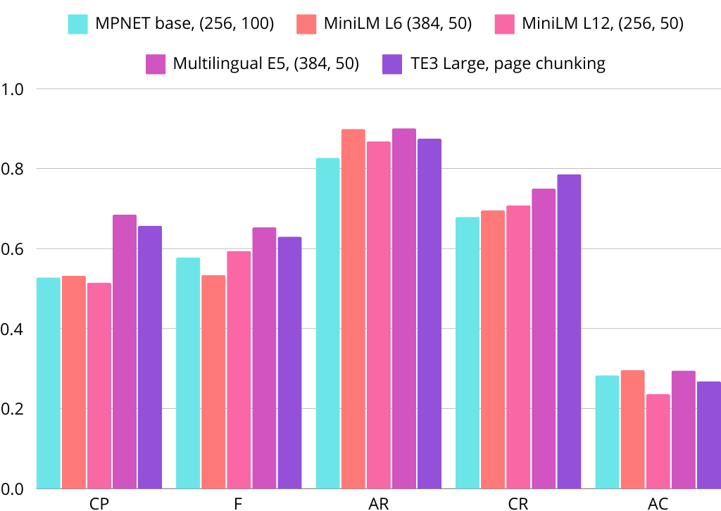

Testo e immagini

Procedimento:
- Estrazione di tutte le descrizioni di immagini dal file ChromaDB (type = “image”) e salvataggio su disco;
- Divisione in pagine dei documenti;
- Per ogni pagina vengono appese tutte le descrizioni immagine che nel PDF appartengono a quella pagina;
- (NUOVO!)Rimozione slide copertina e indici (1148 → 1126 pagine);
- Pulizia del testo risultante;
- Divisione in chunk;
- Embedding.

Spazio occupato:
- 1,5 MB solo testo
- 4,9 MB testo + descrizioni

Metadati

Ogni documento presenta i seguenti metadati aggiuntivi (stringa “keywords”):
- Anno
- Paese o continente di riferimento
- Target: clinic o lab (“all” se entrambi)

Aggiunti tramite editor PaperClip (Linux).
Questi metadati sono ereditati dai chunk e dagli embedding, quindi possono funzionare da filtro per ricerche testuali e vettoriali.

Dataset di valutazione

Il nuovo dataset tiene conto delle informazioni spazio-temporali e del target di riferimento dei documenti, che altrimenti sono interpretabili nei casi fortunati in cui sono menzionati espressamente nel testo.

Modello usato: GPT 4o

Basato su due approcci e quindi due tipologie di domande:
- Selezione random di un chunk (2000 caratteri / 200 padding), da cui il modello genera una domanda e una risposta → già visto e usato;
  - 71 domande
- Trova le differenze;
  - (Anno, Paese1), (Anno, Paese2): 27 domande
  - (Paese, Anno, Brand1), (Paese, Anno, Brand2): 28 domande

Trova le differenze

Il modello è espressamente istruito a chiedere confronti su due variabili date 1-2 informazioni fisse.

- Scrittura di categorie di informazioni: anno, paese, target (metadati), brand, prodotti, ecc.;
- Ogni domanda è basata su 1-2 informazioni fisse e 2 variabili,
  - “Paese, anno” fissi e prodotti variabili;
  - “Prodotto, anno” fissi e Paesi variabili;
  - “Prodotto” fisso e Paesi variabili;
  - “Prodotto” fisso e anni variabili.
3. Si creano due tuple di tipo (anno, paese1), (anno, paese2) oppure (anno1, paese), (anno2, paese), ecc. ecc.;
4. Si usano le tuple per effettuare due ricerche vettoriali in un file di embedding, usando i metadati come filtro e le informazioni non filtrabili come query.
5. I documenti restituiti dalle due ricerche (2 x k) vengono concatenati e passati al modello, che genera la domanda e risposta.

Risultati

I risultati mostrati in seguito hanno l’obiettivo di evidenziare eventuali limiti e vantaggi di diversi approcci RAG:
- RAG semplice: il retriever non ha informazioni circa l’anno, il Paese e il target di riferimento, cioè i documenti non vengono filtrati;
- RAG con filtri al retriever: il retriever conosce i metadati e i documenti vengono filtrati prima di entrare nel generatore. Viene fatto con una chiamata preventiva all’LLM incaricata di estrarre dalla query i metadati richiesti, per poi usarli come filtro;
- RAG con filtri al generatore: è il generatore a filtrare il contesto in base ai metadati della query, prendendo solo i chunk che soddisfano i criteri richiesti.

Per questioni di tempo, i test sono stati effettuati su sottoinsiemi dei dataset, di 15 domande ciascuno, per un totale di 45 domande.

RAG semplice

Modello: Multilingual E5 Large
Chunking | CP | F | AR | CR | AC | # “I don’t know”
Page chunking | 0.506, 0.100 | 0.501, 0.092 | 0.848, 0.043 | 0.500, 0.152 | 0.499, 0.047 | 2/45
384, 0 | 0.533, 0.162 | 0.557, 0.093 | 0.861, 0.042 | 0.544, 0.144 | 0.476, 0.032 | 0/45
384, 20 | 0.556, 0.146 | 0.552, 0.096 | 0.906, 0.004 | 0.507, 0.151 | 0.492, 0.038 | 0/45
384, 50 | 0.386, 0.177 | 0.544, 0.104 | 0.877, 0.025 | 0.489, 0.176 | 0.445, 0.036 | 0/45
384, 100 | 0.518, 0.168 | 0.522, 0.115 | 0.887, 0.020 | 0.474, 0.212 | 0.511, 0.052 | 0/45
256, 0 | 0.435, 0.193 | 0.473, 0.106 | 0.876, 0.024 | 0.500, 0.213 | 0.516, 0.046 | 0/45
256, 20 | 0.586, 0.154 | 0.594, 0.115 | 0.835, 0.058 | 0.600, 0.204 | 0.521, 0.040 | 0/45
256, 50 | 0.442, 0.144 | 0.597, 0.069 | 0.840, 0.057 | 0.533, 0.181 | 0.483, 0.052 | 1/45
256, 100 | 0.465, 0.162 | 0.527, 0.095 | 0.847, 0.058 | 0.500, 0.187 | 0.462, 0.043 | 2/45

Modello: Text Embedding 3 Large
Chunking | CP | F | AR | CR | AC | # “I don’t know”
Page chunking | 0.499, 0.171 | 0.593, 0.091 | 0.811, 0.078 | 0.467, 0.206 | 0.452, 0.047 | 1/45
384, 0 | 0.422, 0.191 | 0.543, 0.132 | 0.904, 0.004 | 0.441, 0.170 | 0.506, 0.040 | 0/45
384, 20 | 0.515, 0.141 | 0.530, 0.121 | 0.879, 0.020 | 0.489, 0.162 | 0.471, 0.039 | 0/45
384, 50 | 0.383, 0.172 | 0.467, 0.137 | 0.880, 0.027 | 0.389, 0.213 | 0.451, 0.055 | 0/45
384, 100 | 0.527, 0.200 | 0.419, 0.118 | 0.879, 0.025 | 0.519, 0.219 | 0.477, 0.059 | 0/45
256, 0 | 0.328, 0.196 | 0.405, 0.138 | 0.888, 0.024 | 0.367, 0.240 | 0.399, 0.054 | 0/45
256, 20 | 0.431, 0.189 | 0.577, 0.092 | 0.899, 0.005 | 0.511, 0.222 | 0.475, 0.051 | 0/45
256, 50 | 0.440, 0.150 | 0.523, 0.127 | 0.873, 0.042 | 0.500, 0.199 | 0.449, 0.041 | 0/45
256, 100 | 0.489, 0.184 | 0.497, 0.103 | 0.860, 0.041 | 0.489, 0.217 | 0.490, 0.055 | 0/45

RAG con filtri al retriever

Modello: Multilingual E5 Large
Chunking | CP | F | AR | CR | AC | # “I don’t know”
Page chunking | - | - | - | - | - | -
384, 0 | 0.535, 0.176 | 0.469, 0.116 | 0.834, 0.073 | 0.544, 0.144 | 0.560, 0.061 | 2/45
384, 20 | 0.543, 0.126 | 0.492, 0.114 | 0.849, 0.054 | 0.496, 0.138 | 0.570, 0.065 | 2/45
384, 50 | 0.350, 0.169 | 0.517, 0.137 | 0.769, 0.110 | 0.444, 0.167 | 0.562, 0.083 | 5/45
384, 100 | 0.536, 0.182 | 0.539, 0.152 | 0.796, 0.093 | 0.496, 0.199 | 0.595, 0.073 | 2/45
256, 0 | 0.393, 0.184 | 0.388, 0.147 | 0.793, 0.094 | 0.500, 0.213 | 0.547, 0.105 | 3/45
256, 20 | 0.568, 0.137 | 0.606, 0.137 | 0.810, 0.091 | 0.600, 0.185 | 0.542, 0.069 | 5/45
256, 50 | 0.473, 0.152 | 0.570, 0.155 | 0.773, 0.101 | 0.522, 0.196 | 0.542, 0.081 | 4/45
256, 100 | 0.457, 0.161 | 0.469, 0.179 | 0.798, 0.094 | 0.456, 0.195 | 0.563, 0.077 | 5/45

Modello: Text Embedding 3 Large
Chunking | CP | F | AR | CR | AC | # “I don’t know”
Page chunking | 0.486, 0.177 | 0.500, 0.134 | 0.736, 0.135 | 0.467, 0.206 | 0.488, 0.101 | 6/45
384, 0 | 0.450, 0.203 | 0.465, 0.170 | 0.853, 0.056 | 0.452, 0.195 | 0.511, 0.081 | 1/45
384, 20 | 0.517, 0.137 | 0.407, 0.112 | 0.852, 0.048 | 0.489, 0.162 | 0.569, 0.067 | 0/45
384, 50 | 0.398, 0.177 | 0.487, 0.128 | 0.789, 0.102 | 0.400, 0.204 | 0.565, 0.087 | 1/45
384, 100 | 0.514, 0.204 | 0.402, 0.166 | 0.834, 0.066 | 0.519, 0.219 | 0.578, 0.100 | 1/45
256, 0 | 0.344, 0.191 | 0.366, 0.178 | 0.833, 0.070 | 0.385, 0.231 | 0.468, 0.090 | 2/45
256, 20 | 0.431, 0.189 | 0.461, 0.108 | 0.878, 0.038 | 0.511, 0.222 | 0.594, 0.092 | 0/45
256, 50 | 0.449, 0.152 | 0.497, 0.169 | 0.799, 0.097 | 0.500, 0.199 | 0.536, 0.073 | 4/45
256, 100 | 0.507, 0.172 | 0.480, 0.144 | 0.856, 0.060 | 0.489, 0.217 | 0.556, 0.098 | 2/45

Confronto (dataset globale)

RAG type | Conf | CP | F | AR | CR | AC | # “I don’t know”
Semplice | Mult. E5L, (384, 0) | 0.533, 0.162 | 0.557, 0.093 | 0.861, 0.042 | 0.544, 0.144 | 0.476, 0.032 | 0/45
Filtri al retriever | Mult. E5L, (384, 0) | 0.535, 0.176 | 0.469, 0.116 | 0.834, 0.073 | 0.544, 0.144 | 0.560, 0.061 | 2/45
Semplice | TE3L (256, 100) | 0.489, 0.184 | 0.497, 0.103 | 0.860, 0.041 | 0.489, 0.217 | 0.490, 0.055 | 0/45
Filtri al retriever | TE3L (256, 100) | 0.507, 0.172 | 0.480, 0.144 | 0.856, 0.060 | 0.489, 0.217 | 0.556, 0.098 | 2/45

Analisi per singoli dataset

Si prendono in esame, per semplicità, soltanto le configurazioni migliori di cui sopra.

Config | Punteggi RAG semplice | Punteggi RAG filtri al retriever
E5L, (384, 0) | 0.433, 0.431, 0.880, 0.400, 0.325 | 0.472, 0.300, 0.892, 0.400, 0.396
 | 0.833, 0.849, 0.849, 1.000, 0.742 | 0.800, 0.844, 0.861, 1.000, 0.867
 | 0.331, 0.390, 0.853, 0.233, 0.362 | 0.331, 0.262, 0.749, 0.233, 0.417
TE3L, (256, 100) | 0.350, 0.416, 0.863, 0.467, 0.322 | 0.361, 0.362, 0.884, 0.467, 0.444
 | 0.667, 0.756, 0.912, 0.733, 0.688 | 0.678, 0.844, 0.863, 0.733, 0.735
 | 0.450, 0.320, 0.805, 0.267, 0.461 | 0.483, 0.233, 0.820, 0.267, 0.488

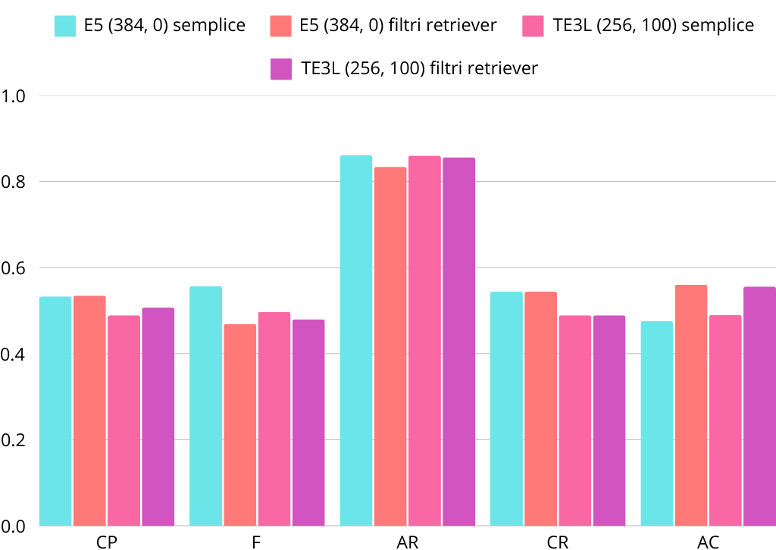

Domanda: “What is the utilization percentage of the scanner technology in partner labs in Europe in 2015?”
Ground truth: “The utilization percentage of the scanner technology in partner labs is 60%.”
RAG type | Config | Risposta generata
Semplice | E5L (384, 0) | The utilization percentage of scanner technology in partner labs in Europe in 2015 was 95%. This indicates a high reliance on scanner technology within that channel. Additionally, other channels showed different utilization rates for scanners, with varying preferences across the industry.
Filtri al retriever | E5L (384, 0) | The utilization percentage of scanner technology in partner labs in Europe in 2015 was 95%.
Semplice | TE3L, (256, 100) | In 2015, the utilization percentage of scanner technology in partner labs in Europe was 60%. This indicates that a significant portion of partner labs employed this technology for their operations. Additionally, full outsourcing technology had a utilization rate of 48% in these labs.
Filtri al retriever | TE3L, (256, 100) | The utilization percentage of scanner technology in partner labs in Europe in 2015 was 60%.

Domanda: “What is the percentage of intraoral scanners purchased in 2021 in the UK compared to Germany?”
Ground truth: “In 2021, 8% of intraoral scanners were purchased in the UK, compared to 13% in Germany.”
RAG type | Config | Risposta generata
Semplice | E5L (384, 0) | In 2021, the percentage of intraoral scanners purchased in the UK was 8%, while in Germany it was 13%. This indicates that Germany had a higher percentage of intraoral scanner purchases compared to the UK for that year.
Filtri al retriever | E5L (384, 0) | In 2021, the percentage of intraoral scanners purchased in the UK was 8%, while in Germany it was 13%.
Semplice | TE3L, (256, 100) | In 2021, the percentage of intraoral scanners purchased in the UK was 8%, while in Germany, it was 13%. This indicates that Germany had a higher percentage of intraoral scanner purchases compared to the UK that year.
Filtri al retriever | TE3L, (256, 100) | In 2021, 8% of intraoral scanners were purchased in the UK, compared to 13% in Germany.

Domanda: “In Spain in 2019, which company had a higher relevance index between 3shape and 3M?”
Ground truth: “In Spain in 2019, 3shape had a higher relevance index of 0.21 compared to 3M's relevance index of 0.03.”
RAG type | Config | Risposta generata
Semplice | E5L (384, 0) | In Spain in 2019, 3shape had a higher relevance index of 0.21 compared to 3M's relevance index of 0.03. This indicates that 3shape was significantly more relevant in the market during that time.
Filtri al retriever | E5L (384, 0) | In Spain in 2019, 3shape had a higher relevance index (0.21) compared to 3M, which had a relevance index of 0.03.
Semplice | TE3L, (256, 100) | In Spain in 2019, 3shape had a higher relevance index compared to 3M. The data indicates that 3shape received more mentions and positive perceptions overall. Therefore, 3shape was perceived as more relevant in that year. (DATI???)
Filtri al retriever | TE3L, (256, 100) | In Spain in 2019, 3shape had a higher relevance index (0.21) compared to 3M (0.03).

