**Applicazioni per Dispositivi Mobili**

**A.A. 2021/2022**

**Compravendita-NFT**

**Design documentation**

|  |  |  |
| --- | --- | --- |
| **Team Members** | | |
| **Name** | **Student Number** | **E-mail address** |
| Alessandro Di Benedetto | *265181* | alessandro.dibenedetto1@student.univaq.it |
| Pietro Pisegna | *265589* | pietro.pisegna@student.univaq.it |

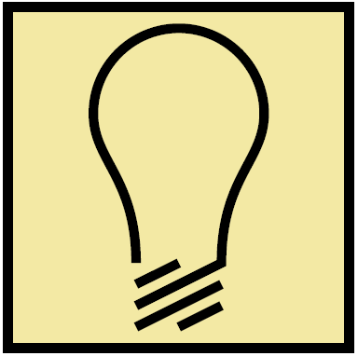Strategy

# Product Objectives

# Business goals

The Application’s purpose is to provide a commercial environment among NFT picture artists all over the world.

# Product Overview

NFT–SHOP is an APP that helps people & NFT artists to sell and buy NFT pictures, providing a stable platform and showroom to make themselves a name in the artistic business. This APP aims to be usable by a vast diversified audience, from expert artists to beginners and public / collectors.

# Competitors

Crypto.com: one of the first marketplace of NFT ARTs. It is an online platform providing multiple features, including NFT pictures. Its main issue is that it doesn’t provide a user-friendly environment to grow artists’ drawing skills.

**User Needs**

**Needs & goals**

We want the emerging artist to gain visibility, grow its business and skills, meanwhile expand their collection. We provide users with easy-to-use platform, a common marketplace, and a personal storage to save own NFTs; all done in few taps.

# User Research

A typical user session for this application has a medium-long period of activity because the user spends time searching, buying, and building his own NFT picture collection.

All features will be probably used in situations where the user isn’t in a hurry, and he is focused on the app usage.

# Personas

|  |
| --- |
| **Nickname:** Lukezoff1 |
| **Level of skill:** amateur |
| **Description:** I am an amateur of the art world. I like to draw dead nature pictures. |

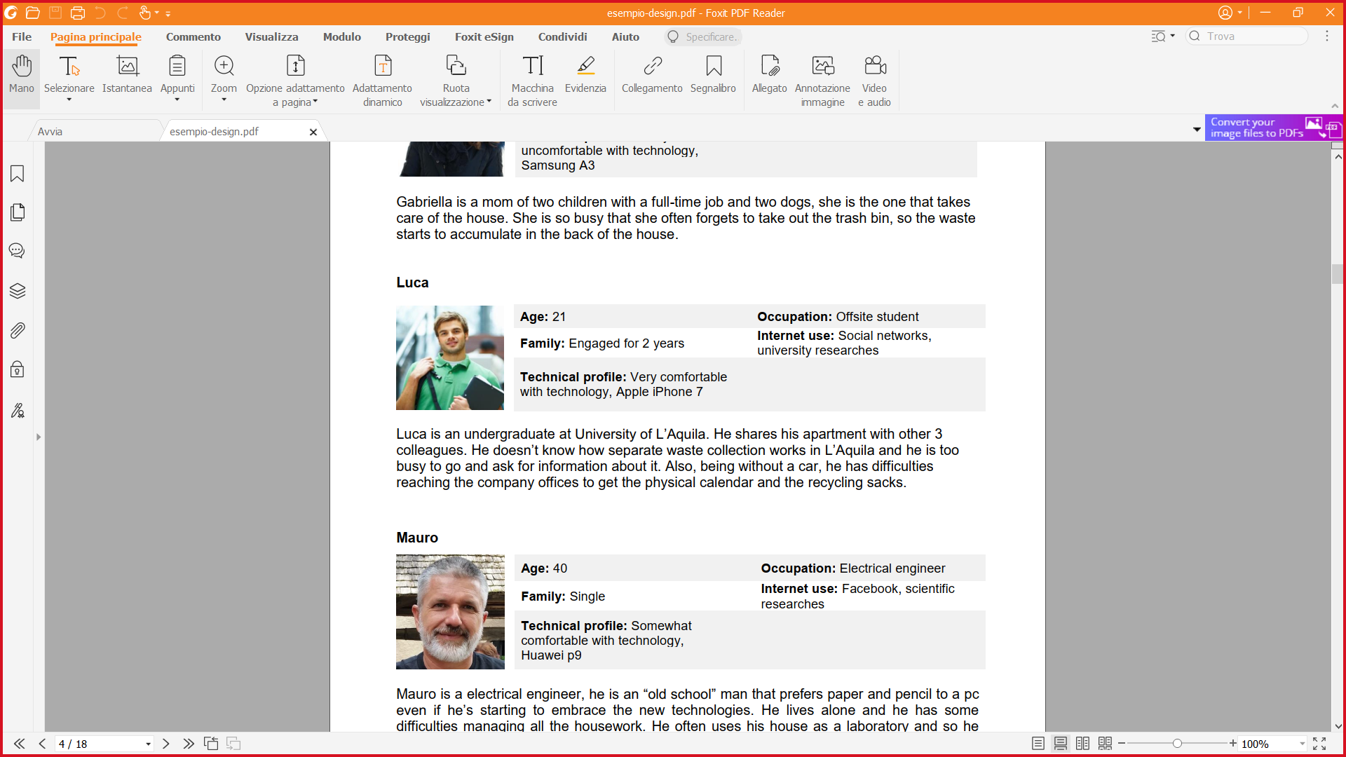

|  |
| --- |
| **Nickname:** Maurius324 |
| **Level of skill:** professionist |
| **Description:** I love drawing since I was a child and I like collecting NFT pictures too. |

|  |
| --- |
| **Nickname:** Maurius324 |
| **Level of skill:** none |
| **Description:** I’m not an artist and I can’t draw but I love collecting pictures representing landscapes. I’m a great collectionist. |

Scope

**Features**

REMOVE THE DESCRIPTION

Provide a list of all the features of your app.

**Other requirements**

REMOVE THE DESCRIPTION

Provide a list of other requirements (not implicitly included in the features) of your app (for instance, branding requirements, technical requirements, …).

**Scenarios**

REMOVE THE DESCRIPTION

It is a short, simple narrative describing how a persona might go about trying to fulfill one of those user needs. By imagining the process our users might go through, we can come up with potential requirements to help meet their needs. (One for persona)

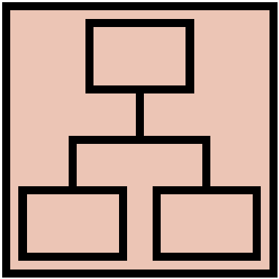Structure

# Navigation model

REMOVE THE DESCRIPTION

Navigation model of your app.

# Data model

REMOVE THE DESCRIPTION

UML Class diagram that represents the data model of the app containing entities and relationships between them. Entities and relationships derive from the functionality and scenarios described in the previous chapter.

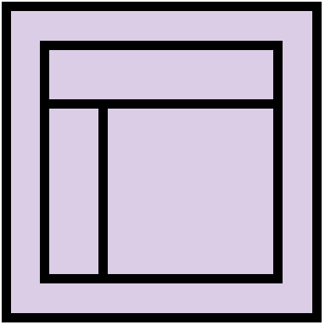Skeleton

REMOVE THE DESCRIPTION

Lo-Fi Wireframes of your app. In this phase you have to create a **complete wireframe** representing all the views described in the navigation model.

Also, for each LO-FI wireframe give a brief description and highlight the design principles used and the design patterns.

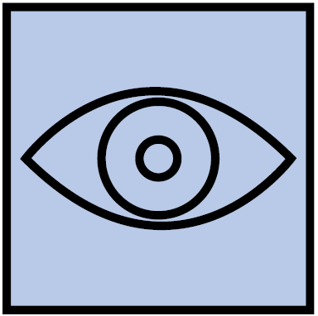Surface

REMOVE THE DESCRIPTION

Description of the relevant choices you made about the layout and color palette, fonts, icons, etc.

Provide a Hi-Fi Wireframes of a **single (or two) view** of your app. Please choose a representative view to show here.