**Applicazioni per Dispositivi Mobili**

**A.A. 2021/2022**

**NFT- SHOP**

**Design documentation**

|  |  |  |
| --- | --- | --- |
| **Team Members** | | |
| **Name** | **Student Number** | **E-mail address** |
| Alessandro Di Benedetto | *265181* | alessandro.dibenedetto1@student.univaq.it |
| Pietro Pisegna | *265589* | pietro.pisegna@student.univaq.it |

Strategy

# Product Objectives

# Business goals

The Application’s purpose is to provide a commercial environment among NFT picture artists all over the world.

# Product Overview

NFT–SHOP is an APP that helps people & NFT artists to sell and buy NFT pictures, providing a stable platform and showroom to make themselves a name in the artistic business. This APP aims to be usable by a vast diversified audience, from expert artists to beginners and public / collectors.

# Competitors

Crypto.com: one of the first marketplace of NFT ARTs. It is an online platform providing multiple features, including NFT pictures. Its main issue is that it doesn’t provide a user-friendly environment to grow artists’ drawing skills.

**User Needs**

**Needs & goals**

We want the emerging artist to gain visibility, grow its business and skills, meanwhile expand their collection. We provide users with easy-to-use platform, a common marketplace, and a personal storage to save own NFTs; all done in few taps.

# User Research

A typical user session for this application has a medium-long period of activity because the user spends time searching, buying, and building his own NFT picture collection.

All features will be probably used in situations where the user isn’t in a hurry, and he is focused on the app usage.

# Personas

|  |
| --- |
| **Nickname:** Lukezoff1 |
| **Level of skill:** amateur |
| **Description:** I am an amateur of the art world. I want to try drawing pictures. |

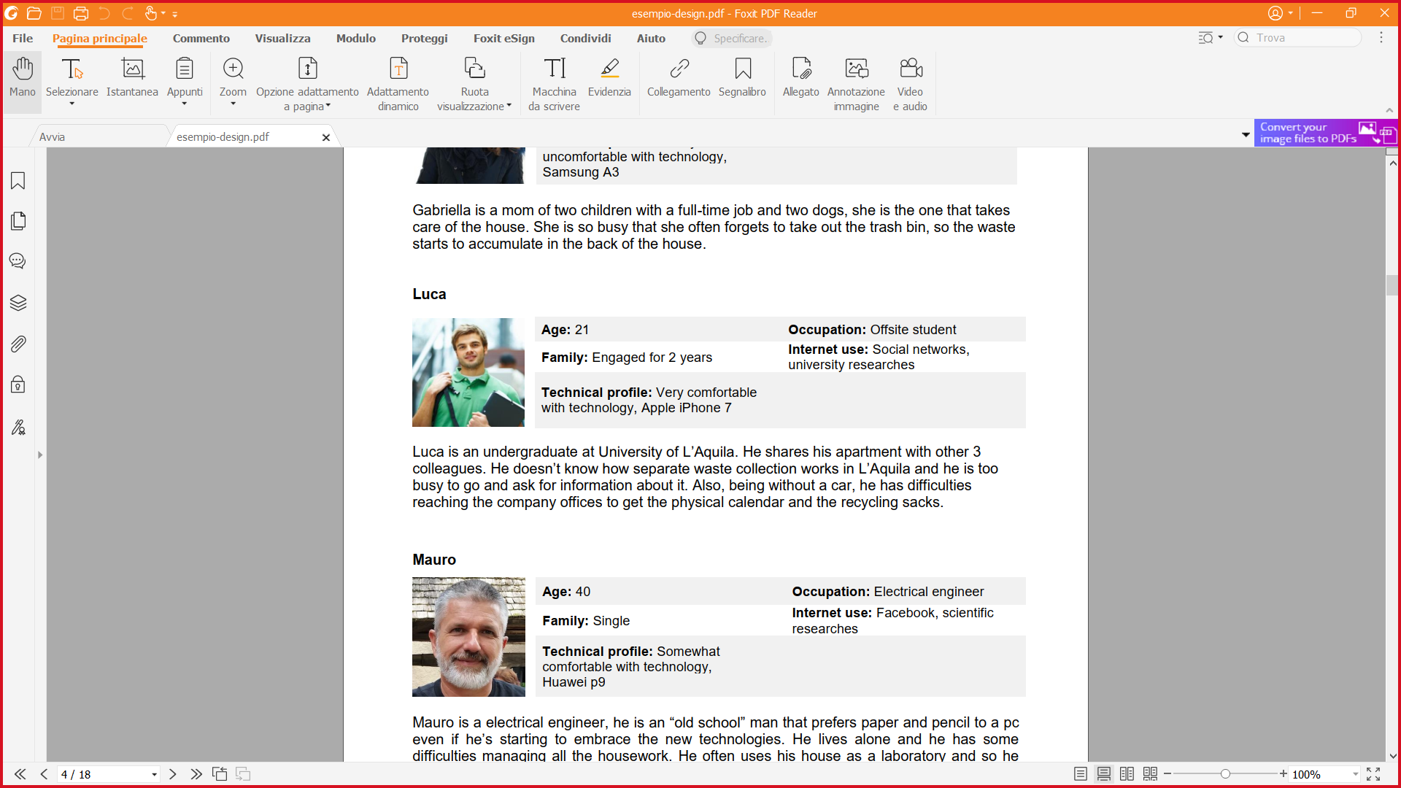

|  |
| --- |
| **Nickname:** Maurius324 |
| **Level of skill:** professional |
| **Description:** I love drawing since I was a child and I like collecting NFT pictures too. I’m now an expert of the environment but I’m not known a lot. I’m unemployed right now. |

|  |
| --- |
| **Nickname:** Gabry65 |
| **Level of skill:** amateur |
| **Description:** I’m not an artist and I can’t draw but I love collecting pictures representing landscapes. I’m a great collector. |

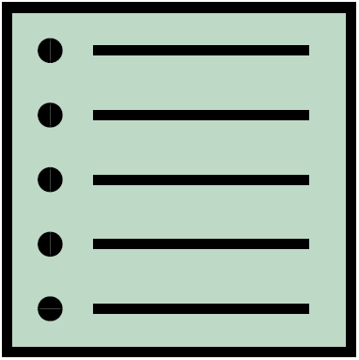Scope

**Features**

* The application allows the user to **CREATE** a personal buyer-seller profile with only one action.
* The application provides users with an internal **MARKETPLACE** that permits users to buy/sell NFTs of their liking.
* Every user will be provided with a personal **STORAGE** to use as a **GALLERY** of NFTs.
* **LOGIN/LOGOUT.**
* Every user has the possibility to **ADD** NFTs in their gallery from external sources.
* Every user has the possibility to **DELETE** ownedNFTs only from their gallery.
* The application has its own **INTERNAL CURRENCY** (CASHART) to manage transactions. Every user will be provided with a fixed amount of CASHART at the first access.

**Other requirements**

* **SHOP WINDOW** common to all users where will be shown the last six added NFTs on the market.
* The user has the possibility to switch between **PERSONAL/PUBLIC COLLECTION** with the benefit of choosing which NFTs will be shown to other users when scrolling their profile.
* **NOTIFY** the user when the picture is sold with a summary of the transaction.
* The application **DOES NOT** permit users to create NFTs within the APP, because the app is not provided with an own editor nor linked to external editors.
* The user is provided with a **SEARCH** function. He can search between artist profiles and NFTs on sale.
* The application provides a brief **SUMMARY** of the last NFTs sold and bought in the private profile section for the user.
* The application shows a brief **SUMMARY** of the user’s on-sale NFTs in the public profile section.
* The application provides a **DETAIL PAGE** for each NFTs.

**Scenarios**



Luca is passionate of the art. He discovers the existence of NFT pictures, and he falls in love with the idea of drawing pictures himself. He has great ideas and a lot of spare time, but he is a beginner, so he wants to gain skills and improve his drawings. One day, his friend told him about NFT-SHOP, a great application for amateurs and professionals of the drawings. He thinks of using this app to improve his skills inspired by the works of other artists.

Mauro is a professional drawing artist. He has worked for a local newspaper as a cartoonist for 8 years. Recently the company’s financial broke and he became unemployed. He wants to continue his drawing career, so he started searching for a job. Eventually he got suggested, by his online research, of an app: NFT-SHOP. He decides to try it and started to post his artwork having a lot of success at that too. He became famous in a short time and eventually he got employed by a successful cinematographic company.

Gabriella is a famous art collector. She needs a digital platform to store and publicize her physical art collection. She wants also to know more about digital art and NFT artists, so she can expand her collection. After a brief research on the Internet, she discovers a perfect application that satisfies her needs: NFT-SHOP, the perfect app to store a personal collection in a safe place, share it with all the users and to discover new art talents.

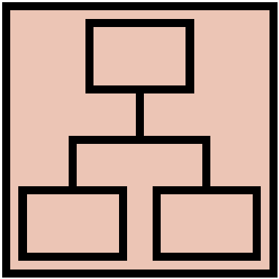Structure

# Navigation model

REMOVE THE DESCRIPTION

Navigation model of your app.

# Data model

REMOVE THE DESCRIPTION

UML Class diagram that represents the data model of the app containing entities and relationships between them. Entities and relationships derive from the functionality and scenarios described in the previous chapter.

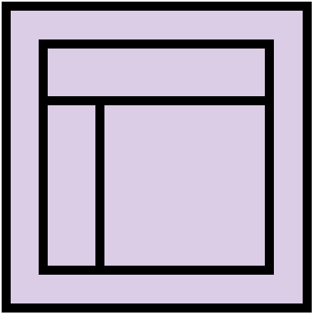Skeleton

REMOVE THE DESCRIPTION

Lo-Fi Wireframes of your app. In this phase you have to create a **complete wireframe** representing all the views described in the navigation model.

Also, for each LO-FI wireframe give a brief description and highlight the design principles used and the design patterns.

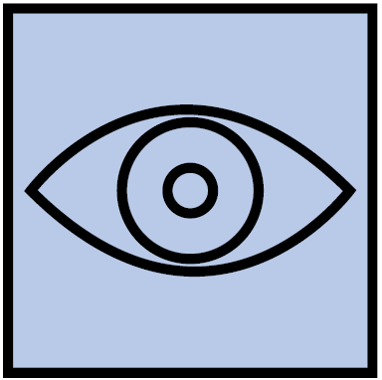Surface

REMOVE THE DESCRIPTION

Description of the relevant choices you made about the layout and color palette, fonts, icons, etc.

Provide a Hi-Fi Wireframes of a **single (or two) view** of your app. Please choose a representative view to show here.