Sprawozdanie nr 1 Aplikacje Internetowe Filip Konior

**1.Hello World**

def Hello():  
 print('Hello, Wolrld!')  
  
Hello()

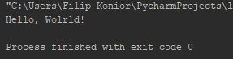

1. **Kółko i krzyżyk**

def tictactoeboard ():  
 a ="\n | | \n"  
 b ="--------"  
 print(a,b,a,b,a)  
  
tictactoeboard()

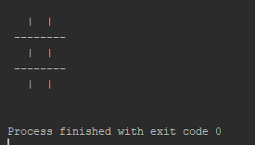

1. **Super kółko i krzyżyk**

def supertictactoeboard():  
 a = " | | H | | H | | "  
 b = "\n--+--+--H--+--+--H--+--+--\n"  
 c = "\n========+========+========\n"  
 print(" "+a, b,a,b,a,c,a,b,a,b,a,c,a,b,a,b,a)  
  
supertictactoeboard()

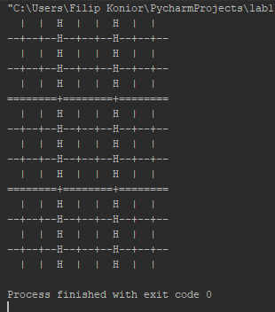

1. **Fizzbuzz (suma wielokrotności 3 albo 5)**

def fizzbuzz(n):  
 suma = 0  
 for i in range(n):  
 if i % 3 == 0 or i % 5 == 0:  
 suma += i  
 print(suma)

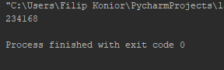

1. **Problem Collatza**

def Collatz(n):  
 dlugosc = 1  
 while n > 1:  
 if n % 2 == 0:  
 n /= 2  
 else:  
 n = 3 * n + 1  
 dlugosc += 1  
 print(dlugosc)  
  
  
Collatz(5)

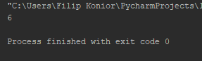

1. **Konwerter temperatur**

temp = input("Podaj temperature jeśli jest ona w stopniach Celcjusza dodaj C natomiast jeśli jest w skali Fahrenheita dodaj F (np. 90F, 15C): ")  
degree = int(temp[:-1])  
i_convention = temp[-1]  
if i_convention.upper() == "C":  
 result = int(round((9 * degree) / 5 + 32))  
 o_convention = "Fahrenheita"  
elif i_convention.upper() == "F":  
 result = int(round((degree - 32) * 5 / 9))  
 o_convention = "Celcjusza"  
else:  
 print("źle wpisane dane.")  
 quit()  
print("Temperatura w stopniach", o_convention, "to", result)

