The Scholar
User Guide

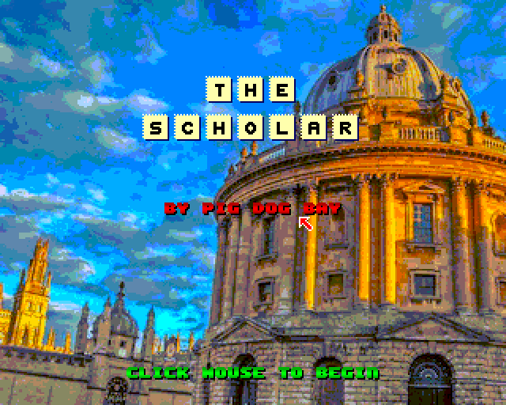

1. Overview

The Scholar is an anagram puzzle game played against the clock. Lifelines are available to help you out. Each round consists of three anagrams to solve. The anagrams are related, e.g. Carry On Films.

After each round the category changes. Complete eight rounds to win the game. On the start screen (Prospectus) you can select game difficulty by choosing a particular college.

2. Requirements

ZX Spectrum Next or emulator such as ZEsarUX.
A mouse is essential, however you can use a Kempston joystick in port 1.

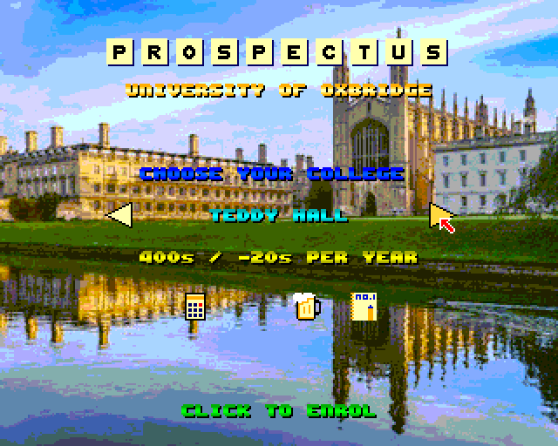

3. Welcome To Oxbridge University

First select your college by clicking on the right or left arrow buttons

Each college has different time settings and Study Aids available to you. You can hover the mouse over the Study Aids icons to see what they do, shown above are the Calculator, Beer and Notepad.

When you are done click anywhere on the background to continue.

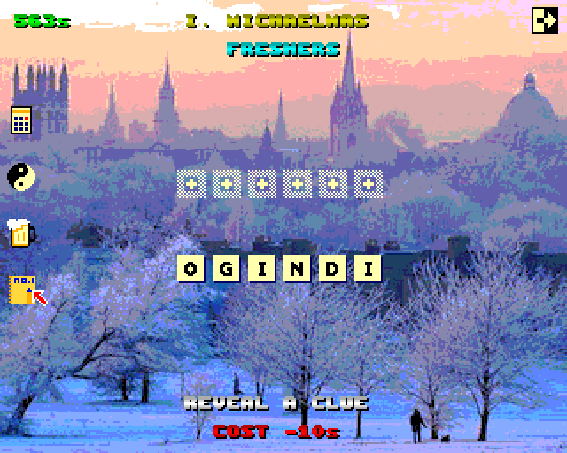

4. Game Play

Click on the letter tiles and drag them to the slots above. Arrange the tiles to solve the anagram.
You may also right-click on a tile to send it directly to the first available slot.

In the top left a timer counts down, if it reaches 0 you will fail the exam and drop out of college.

On the lefthand side are your Study Aids, hover over them to see what each one does:

- Calculator – Pick a tile to reveal a matching slot
- Yin and Yang – Pick a slot to reveal a matching tile
- Beer – Picks a random un-slotted tile and matches it to a slot
- Notepad – Gives you a clue for this years set of anagrams

Use the Study Aids wisely as they cost you time!

Each year has 3 terms, Michaelmas, Hilary and Trinity. Each term has its own anagram to solve, all 3 anagrams are related (below are names of telescopes)

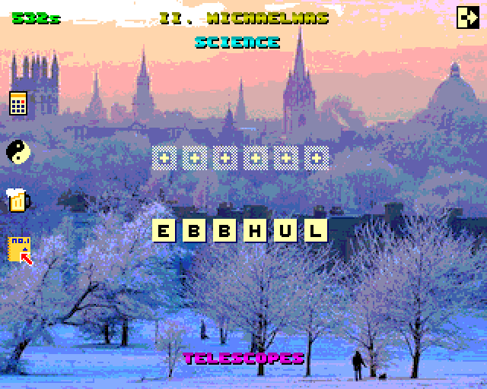
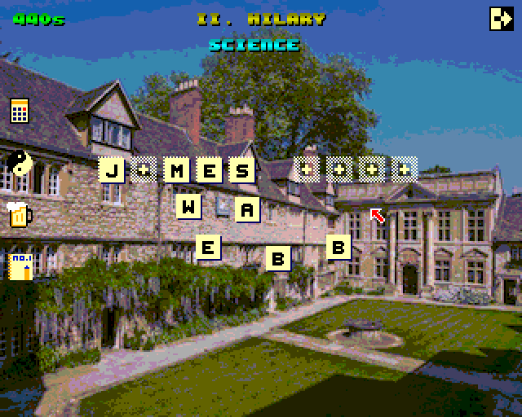

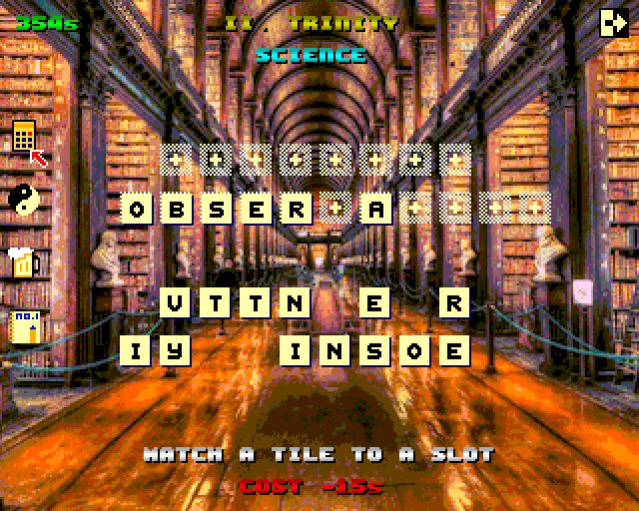

The Notepad Study Aid will reveal a clue, there is only 1 clue for the set of 3 anagrams, here the clue is “Telescopes”

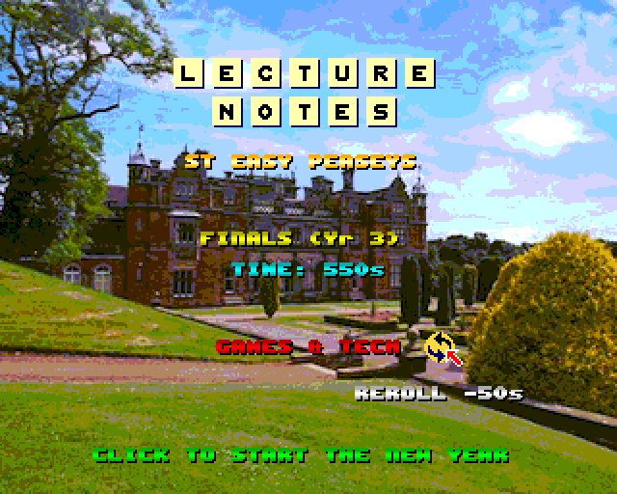

5. End Of Round

A new academic year begins, this means a new subject category is chosen. The start time is reset but is reduced by a set amount.

The subject is randomly chosen and you can press the Re-roll button to chose a different random subject. Each re-roll has a time penalty.

There are 8 academic years to complete before you can become a Scholar.

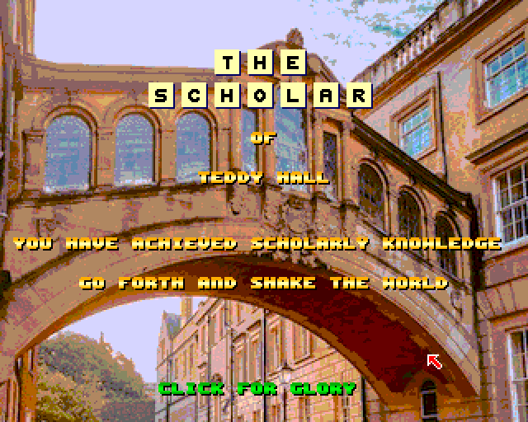

6. Tips

- Make good use of the Study Aids on the left hand side, pay attention to the instruction at the bottom of the screen.
- For an easier game select a college with a larger start time such as St Easy Peaseys
- Only use Notepad once per year as there is only one clue per year
- Each set of puzzles are related, eg famous French scientists, use this knowledge to guess.
- You can change a category by pressing the Re-roll button on the Lecture Notes screen
- Reposition the letters to help you to see the anagram
- The study aids have different time costs, use them wisely.
- Really stuck? Cheat, use my Anagram Solver app:
  - Android: https://play.google.com/store/apps/details?id=com.pigdogbay.anagramsolver
  - iOS: https://apps.apple.com/app/id973923699

As a challenge try to be a scholar for each of the colleges.

7. Credits

Game by Pig Dog Bay
Title Music by RetroSteveUK
Music composed using NextDAW by Gari Biasillo
Fonts by Damien Guard
Testing by Rich ‘ Tufty’ Hollins

Special Thanks to

Graeme Mason for his cracking review (On The ZX Spectrum Nextra #11) and suggesting to use the right mouse button to speed up the placement of tiles.

Mike Mee (Mug UK https://mug-uk.co.uk/) for pointing out a couple of spelling howlers!

Gentlemen’s Pixel Club for his brilliant comprehensive play through and review
https://youtu.be/YF0sWCzqgVQ

TJ Ferreira for his very entertaining review, RILE A VIKING is a very acceptable answer!
https://youtu.be/po0J9jpsSPA

Adrian Sinclair and the Crash team for producing the excellent Nextcade Volume 1

BAPSTARCADE for playing the game on his Next live steam:
https://www.twitch.tv/bapstarcade

©MPD Bailey Technology 2026

