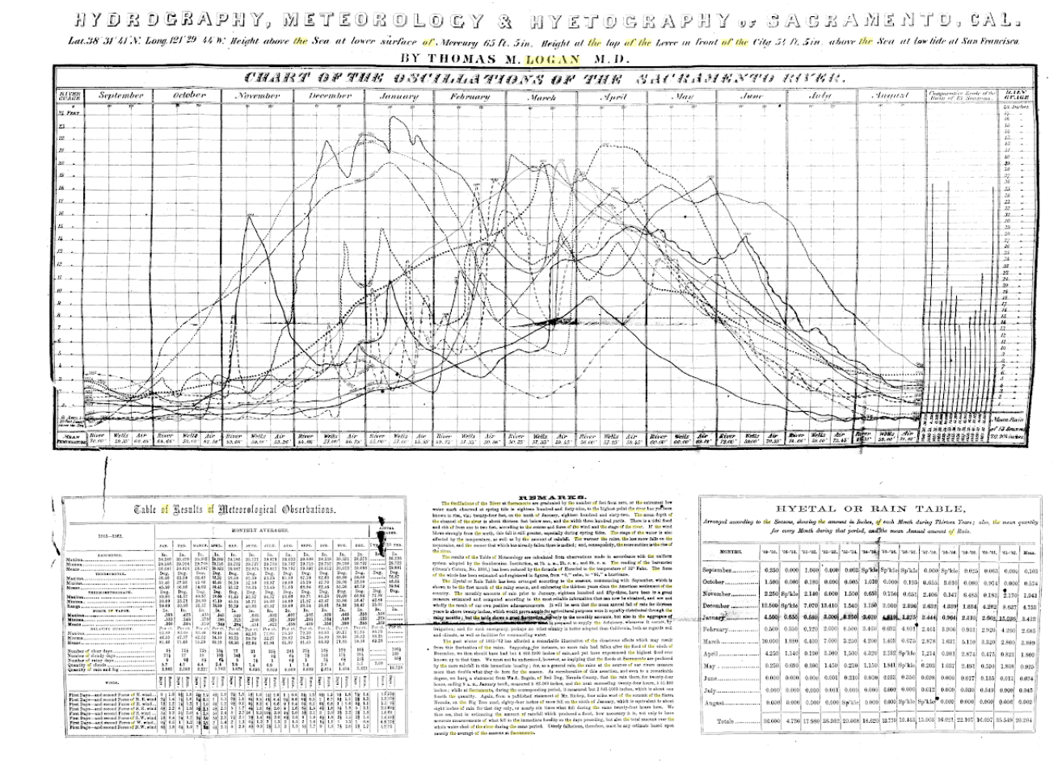

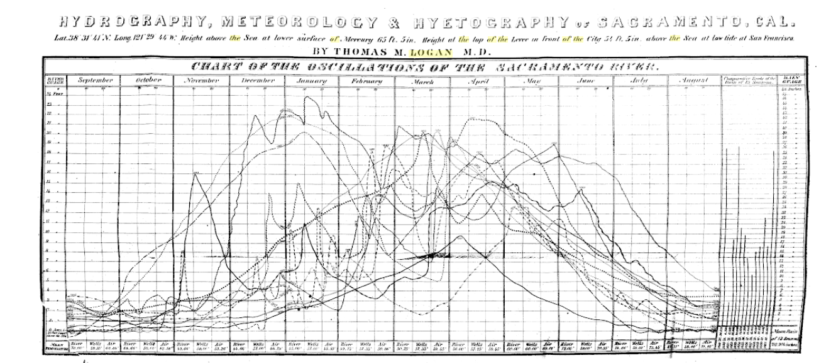

**Format for spreadsheet template**

**Station:** (see list below)

**Months:** (December 1861 and January 1862)

**Vertical axis** day of month

1-30 (Dec 1861) 1-31 (Jan 1862)

**Horizontal axis**

**Temperature**

7 am 2pm 9pm

**Wind**

7 am 2pm 9pm

direction/force direction/force direction/force

**Weather**

7 am 2pm 9pm

**Clouds** (most forts data sheets don’t have a cloud category)

7 am 2pm 9pm

**Rain**

Begin End Quantity

**Remarks**

**Stations**

Ft Steilacoom, WT

Ft Vancouver, WT

Ft Walla Walla, WT

Ft Churchill, NT

Ft San Francisco

Alcatraz Island

Benicia Barracks

Fort Bragg

Fort Crook

Fort Yuma

Marysville

San Benito

New San Diego

Union Ranch

Sacramento

Example of data below. Some sheets are slightly different

