PROJECT REPORT
on
HANDWRITTEN DIGIT RECOGNITION USING PYTHON PROGRAM
(CSE III Semester Mini project)
2023-2024

Submitted to: Submitted by:
Ms. Jyoti Ramola Mr. Karan Ray
(CC-CSE-S-III-Sem) Roll. No:2318031
Guided by: CSE-S-III-Sem
Ms. Jyoti Ramola Session: 2023-2024
DEPARTMENT OF COMPUTER SCIENCE AND INFORMATION TECHNOLOGY
GRAPHIC ERA HILL UNVERSITY, DEHRADUN
CERTIFICATE

Certified that Mr. Karan Ray (Roll No.- 2318031) has developed mini project on “Handwritten Digit Recognition” for the CS III Semester Mini Project Lab in Graphic Era Hill University, Dehradun. The project carried out by Students is their own work as best of my knowledge.

Date:

Ms. Jyoti Ramola
Class Co-ordinator
CSE-S-III-Sem
(CSE Department)
GEHU Dehradun

ACKNOWLEDGMENT

We would like to express our gratitude to The Almighty Shiva Baba, the most Beneficent and the most Merciful, for completion of project.
We wish to thank our parents for their continuing support and encouragement. We also wish to thank them for providing us with the opportunity to reach this far in our studies.
We would like to thank particularly our project Co-ordinator Ms. Jyoti Ramola and our Project Guide Ms. Jyoti Ramola for his patience, support, and encouragement throughout the completion of this project and having faith in us.
At last but not the least We greatly indebted to all other persons who directly or indirectly helped us during this work.

Mr. Karan Ray
Roll No.- 2318031
CSE-S-III-Sem
Session: 2023-2024
GEHU, Dehradun

Table of Contents

- Introduction
- Convolutional neural network (CNN, or ConvNet)
- Objective
- Approach

- Import the dependencies and load the dataset

- Data Overview
- Dimensions of train and test data
- Visualizing the data using TSNE
- Splitting data into training and validation dataset
- Dimensions of training and validation data
- Converting training, testing and validation data into array
- Dimensions of training, testing and validation data after reshaping

- Explore the data
- Visualize how the digits were written
- Reshaping train, test, and validation data
- Normalize train, test and validation data

- Build the CNN model to classify Handwritten Digits
- Summary of the training model
- Visualization of model
- Train the model

- Model Evaluation
- Loss plot curve for training and validation
- Accuracy plot curve for training and validation
- Evaluation of the model accuracy
- Performance of training dataset
- Performance of validation dataset
- Save and load model
- Visualise validation predicted data on how the digit were written
- Confusion matrix of validation dataset

- Model prediction on unseen dataset (test data)
- Visualize test predicted data how digits were written

- Whole Source Code

- References

1 | INTRODUCTION

Handwritten Digit Recognition is the process of digitizing human handwritten digit images. It is a difficult task for the machine because handwritten digits are not perfect and can be made with a variety of flavors. To address this issue, we created HDR, which uses the image of a digit to identify the digit that is present in the image.
In this project, we developed a Convolutional Neural Network (CNN) model using Tensorflow framework to Recognition of Handwritten Digit.

Convolutional neural network (CNN, or ConvNet)
A convolutional neural network (CNN, or ConvNet) is a Deep Learning algorithm that can take in an input image, assign learnable weights and biases to various objects in the image and be able to distinguish one from the other.
It is used to analyse visual imagery. Object detection, face recognition, robotics, video analysis, segmentation, pattern recognition, natural language processing, spam detection, topic categorization, regression analysis, speech recognition, image classification are some of the examples that can be done using Convolutional Neural Networking.

Objective
The primary objective of this project is to design an efficient and robust system capable of recognizing and classifying handwritten digits from various sources, such as scanned images or digital tablets. By utilizing advanced machine learning techniques, the program aims to achieve high accuracy in digit recognition.

Methodology
The proposed program employs a Convolutional Neural Network (CNN), a powerful deep learning architecture, to automatically learn and extract intricate features from handwritten digit images. The MNIST dataset, a benchmark dataset in the field of machine learning, is utilized for training and evaluating the model. The program preprocesses the input data, trains the CNN model, and evaluates its performance for accurate digit classification.

Approach
We have used Sequential Keras model which has two pairs of Convolution2D and MaxPooling2D layers. The MaxPooling layer acts as a sort of downsampling using max values in a region instead of averaging. After that we will use Flatten layer to convert multidimensional parameters to vector.
The last layer has a Dense layer with 10 Softmax outputs. The output represents the network guess. The 0-th output represents a probability that the input digit is 0, the 1-st output represents a probability that the input digit is 1 and so on...

Result

CNN performed well, providing validation accuracy and loss scores of 98.9%% and 4.5% respectively.
The Handwritten Digit Recognition Program demonstrates remarkable accuracy in classifying handwritten digits from 0 to 9. The program achieves high precision and recall rates, indicating its ability to correctly identify digits while minimizing false positives and false negatives. The system's performance establishes its suitability for applications in digit-based CAPTCHA systems, automated form processing, and optical character recognition (OCR) tasks.
2 | Import the dependencies and load the dataset

We will import all the modules that we will require to train our model.

- Tensorflow
TensorFlow is an open source framework developed by Google researchers to run machine learning, deep learning and other statistical and predictive analytics workloads.

- Matplotlib
Matplotlib is a cross-platform, data visualization and graphical plotting library (histograms, scatter plots, bar charts, etc) for Python and its numerical extension NumPy.

- Seaborn
Seaborn is a library for making statistical graphics in Python. It builds on top of matplotlib and integrates closely with pandas data structures. Seaborn helps you explore and understand your data.

- Numpy
NumPy is a Python library used for working with arrays. It also has functions for working in domain of linear algebra, fourier transform, and matrices.

- Pandas
Pandas is a Python library used for working with data sets. It has functions for analysing, cleaning, exploring, and manipulating data. The name "Pandas" has a reference to both "Panel Data", and "Python Data Analysis".

- Math
Using The math Module in Python. math is a built-in module in the Python standard library that provides standard mathematical constants and functions.

- Platform
The platform module in Python provides functions that access information of the underlying platform (operating system). The platform. platform() method returns a single string containing as much information about the underlying platform as feasible.

3 | Data Overview

The MNIST dataset contains 42,000 training images of handwritten digits from zero to nine (10 different classes) and 28,000 images for testing without the label identifier (for submission). These images are the grayscaled pixel value and are represented as a 28×28 matrix.

Dimension of train and test data

- Train data

RangeIndex: 42000 entries, 0 to 41999
Columns: 785 entries, label to pixel 783
dtypes: int64(785)
memory usage: 251.5 MB
Shape - (None, (42000, 785))

- Test data

RangeIndex: 28000 entries, 0 to 27999
Columns: 784 entries, pixel 0 to pixel 783
dtypes: int64(784)
memory usage: 167.5 MB
Shape - (None, (28000, 784))

Visualizing the data using TSNE

TSNE - t-Distributed Stochastic Neighbour embedding. This is a dimensionality reduction algorithm that is designed to keep local structure in the high dimensional data set but cares less about global structure. Here, we use it to go from the 784 pixel-dimension of the images to two dimensions. This makes plotting easier. The colour scale is the original MNIST label, and one can see that the separation of the labels is apparent.

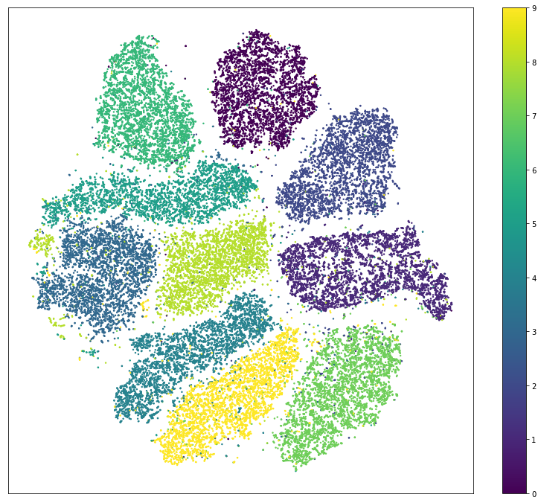

Splitting data into training and validation dataset

We are dividing our dataset (X) into two parts.
- The training dataset (80%) is used to fit our models
- The Validation dataset (20%) is used to evaluate our models

train_test_split() method returns us the training data, its labels and also the validation data and its labels.

Dimensions of training and validation data

X_train: (33600, 784)
y_train: (33600,)
X_validation: (8400, 784)
y_validation: (8400,)

Converting training, testing and validation data into array

Dimensions of training, testing and validation data after reshaping
x_train: (33600, 28, 28)
y_train: (33600,)
x_validation: (8400, 28, 28)
y_validation: (8400,)
x_test: (28000, 28, 28)

IMAGE_WIDTH: 28
IMAGE_HEIGHT: 28
IMAGE_CHANNELS: 1
4 | Explore the data

Here is how each image in the dataset looks like. It is a 28x28 matrix of integers (from 0 to 255) and each integer represents a color of a pixel.
28 rows * 28 columns

Visualise how the digits were written
This number matrix may be drawn as follows:
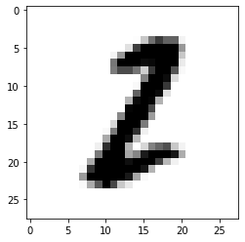

Our first record of training data represents 2.

Let's print some more training examples to get the feeling of how the digits were written.

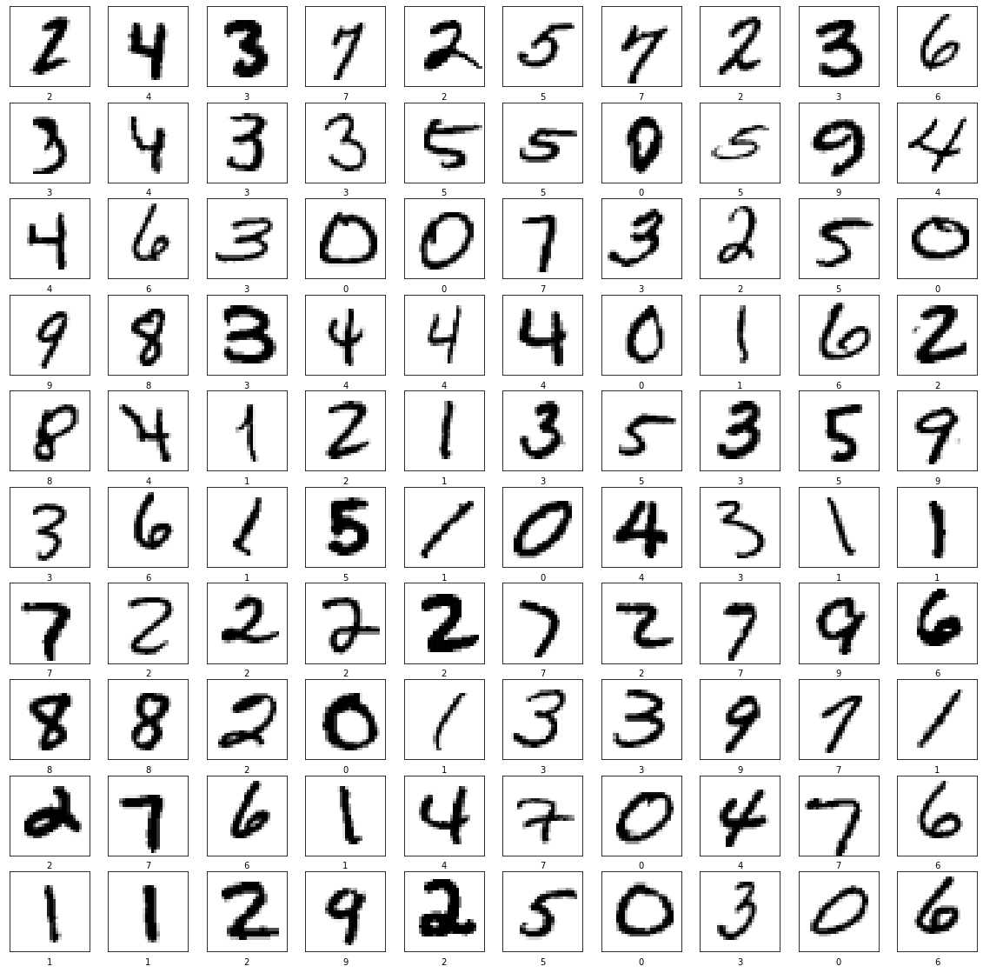

Reshaping train, test, and validation data

In order to use convolution layers we need to reshape our data and add a color channel to it. As you've noticed currently every digit has a shape of (28, 28) which means that it is a 28x28 matrix of color values form 0 to 255. We need to reshape it to (28, 28, 1) shape so that each pixel potentially may have multiple channels (like Red, Green and Blue).

x_train_with_chanels: (33600, 28, 28, 1)
x_validation_with_chanels: (8400, 28, 28, 1)
x_test_with_chanels: (28000, 28, 28, 1)

Normalize train, test, and validation data

Here we're just trying to normalize from values range of [0...255] to [0...1].

array([[0. ],
[0. ],
[0. ],
[0. ],
[0. ],
[0. ],
[0. ],
[0. ],
[0. ],
[0. ],
[0. ],
[0. ],
[0. ],
[0. ],
[0.02352941],
[0.99607843],
[0.99607843],
[0.99607843],
[0.76862745],
[0. ],
[0. ],
[0. ],
[0. ],
[0. ],
[0. ],
[0. ],
[0. ],
[0. ]])

5 | Build the CNN model to classify Handwritten Digits

A Convolutional Neural Network model generally consists of convolutional and pooling layers.
We are using Sequential Keras model which have two pairs of Convolution2D and MaxPooling2D layers. The MaxPooling layer acts as a sort of downsampling using max values in a region instead of averaging.
After that we will use Flatten layer to convert multidimensional parameters to vector.
The last layer will be a Dense layer with 10 Softmax outputs. The output represents the network guess. The 0-th output represents a probability that the input digit is 0, the 1-st output represents a probability that the input digit is 1 and so on...

Summary of the training model

Here is our model summary so far.

Model: "sequential"
_________________________________________________________________
Layer (type) Output Shape Param #
=================================================================
conv2d (Conv2D) (None, 24, 24, 8) 208
_________________________________________________________________
max_pooling2d (MaxPooling2D) (None, 12, 12, 8) 0
_________________________________________________________________
conv2d_1 (Conv2D) (None, 8, 8, 16) 3216
_________________________________________________________________
max_pooling2d_1 (MaxPooling2 (None, 4, 4, 16) 0
_________________________________________________________________
flatten (Flatten) (None, 256) 0
___________________________________________________________
dense (Dense) (None, 128) 32896
_________________________________________________________________
dropout (Dropout) (None, 128) 0
_________________________________________________________________
dense_1 (Dense) (None, 10) 1290
=================================================================
Total params: 37,610
Trainable params: 37,610
Non-trainable params: 0
_________________________________________________________________

Visualization of the model
In order to plot the model the graphviz should be installed.
A model summary that describes the various layers defined in the model.
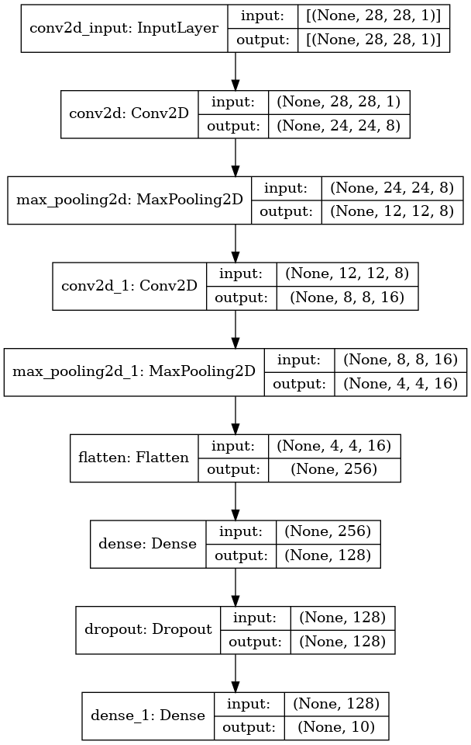
Train the model
6 | Model Evaluation

Loss plot curve for training and validation

Let's see how the loss function was changing during the training. We expect it to get smaller and smaller with every next epoch.

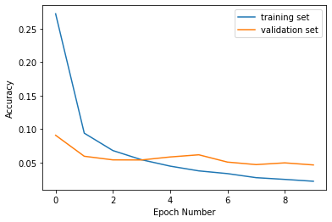

Accuracy plot curve for training and validation

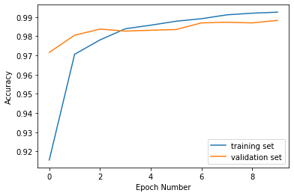

Evaluation of the model accuracy

We need to compare the accuracy of our model on training set and on validation set. We expect our model to perform similarly on both sets. If the performance on a validation set will be poor comparing to a training set it would be an indicator for us that the model is overfitted and we have a "high variance" issue.

Performance of training dataset

Train loss: 0.009457636624574661
Train accuracy: 0.997083306312561

Performance of validation dataset

Validation loss: 0.04620610177516937
Validation accuracy: 0.9882143139839172
With a validation score of close to 99%, we proceed to use this model to predict for the test set.

Save and load the model

We will save the entire model to a HDF5 file. The .h5 extension of the file indicates that the model shuold be saved in Keras format as HDF5 file.

Visualise validation predicted data on how the digit were written

To use the model that we've just trained for digits recognition we need to call predict() method.

predictions_one_hot: (8400, 10)

Each prediction consists of 10 probabilities (one for each number from 0 to 9). We need to pick the digit with the highest probability since this would be a digit that our model most confident with.

Predictions in form of one-hot vectors (arrays of probabilities)
8400 rows × 10 columns

Let's extract predictions with highest probabilites and detect what digits have been recognized.
8400 rows × 1 columns

So our model is predicting that the first example from the validation set is 1.
Let's print the first image from a validation set to see if model's prediction is correct.
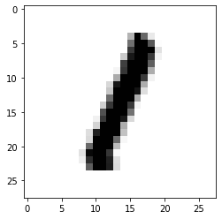
We see that our model made a correct prediction and it successfully recognized digit 1. Let's print some more test examples and correspondent predictions to see how model performs and where it does mistakes.

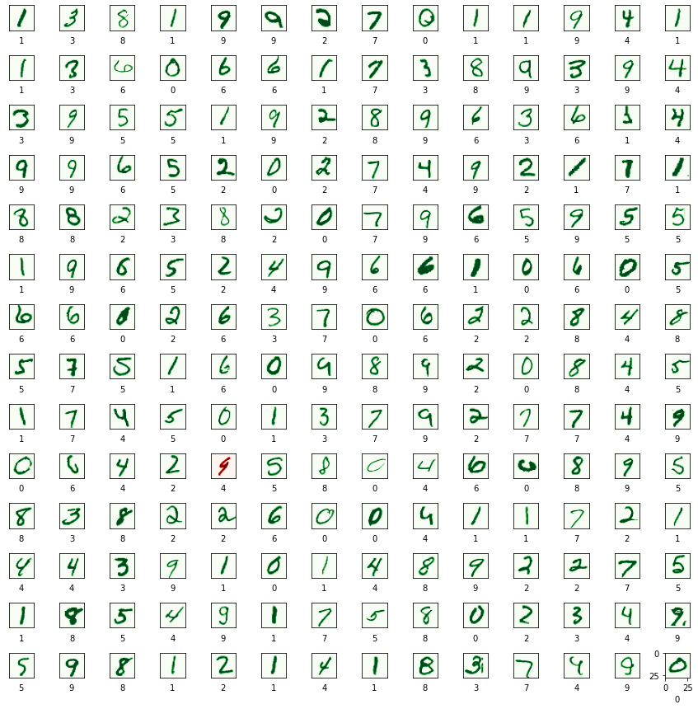

Confusion matrix of validation dataset

Confusion matrix shows what numbers are recognized well by the model and what numbers the model usually confuses to recognize correctly.

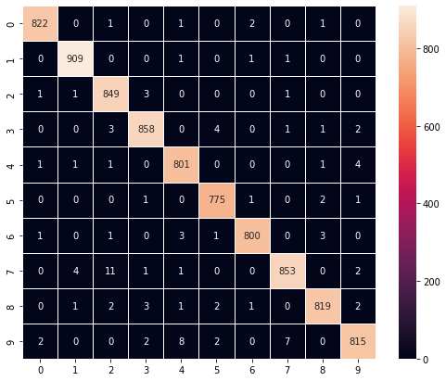

7 | Model prediction on unseen dataset (test data)

predictions_one_hot: (28000, 10)

Each prediction has ten probabilities (one for each number from 0 to 9). We need to choose the digit with the highest probability.

Predicted probabilities of all digits
28000 rows × 10 columns

Visualize test predicted data how the digits were written
Predicted digits with highest probabilites

Actual first digit from the test data

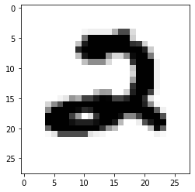
Model is predicting that the first example from the test data is 2.
8 | Whole Code

import tensorflow as tf
import matplotlib.pyplot as plt
import seaborn as sn
import numpy as np # linear algebra
import pandas as pd # data processing, CSV file I/O (e.g. pd.read_csv)
import math
import datetime
import platform

# Input data files are available in the read-only "../input/" directory
# For example, running this (by clicking run or pressing Shift+Enter) will list all files under the input directory

import os
for dirname, _, filenames in os.walk('/kaggle/input'):
for filename in filenames:
print(os.path.join(dirname, filename))

print('Python version:', platform.python_version())
print('Tensorflow version:', tf.__version__)
print('Keras version:', tf.keras.__version__)

# Load the TensorBoard notebook extension.
# %reload_ext tensorboard
get_ipython().run_line_magic('load_ext', 'tensorboard')

# Clear any logs from previous runs.
get_ipython().system('rm -rf ./.logs/')

train = pd.read_csv('E:\\python\\train.csv')
test = pd.read_csv('E:\\python\\test.csv')

train.head()

train.info(), train.shape

test.info(), test.shape

X = train.iloc[:, 1:785]
y = train.iloc[:, 0]

X_test = test.iloc[:, 0:784]

# WARNING: running t-SNE on the full data set takes a while.
X_tsn = X/255

from sklearn.manifold import TSNE
tsne = TSNE()

tsne_res = tsne.fit_transform(X_tsn)

plt.figure(figsize=(14, 12))
plt.scatter(tsne_res[:,0], tsne_res[:,1], c=y, s=2)
plt.xticks([])
plt.yticks([])
plt.colorbar();

from sklearn.model_selection import train_test_split
X_train, X_validation, y_train, y_validation = train_test_split(X, y, test_size = 0.2,random_state = 1212)

print('X_train:', X_train.shape)
print('y_train:', y_train.shape)
print('X_validation:', X_validation.shape)
print('y_validation:', y_validation.shape)

x_train_re = X_train.to_numpy().reshape(33600, 28, 28)
y_train_re = y_train.values
x_validation_re = X_validation.to_numpy().reshape(8400, 28, 28)
y_validation_re = y_validation.values
x_test_re = test.to_numpy().reshape(28000, 28, 28)

print('x_train:', x_train_re.shape)
print('y_train:', y_train_re.shape)
print('x_validation:', x_validation_re.shape)
print('y_validation:', y_validation_re.shape)
print('x_test:', x_test_re.shape)

# Save image parameters to the constants that we will use later for data re-shaping and for model traning.
(_, IMAGE_WIDTH, IMAGE_HEIGHT) = x_train_re.shape
IMAGE_CHANNELS = 1

print('IMAGE_WIDTH:', IMAGE_WIDTH);
print('IMAGE_HEIGHT:', IMAGE_HEIGHT);
print('IMAGE_CHANNELS:', IMAGE_CHANNELS);

pd.DataFrame(x_train_re[0])

plt.imshow(x_train_re[0], cmap=plt.cm.binary)
plt.show()

numbers_to_display = 100
num_cells = math.ceil(math.sqrt(numbers_to_display))
plt.figure(figsize=(20,20))
for i in range(numbers_to_display):
plt.subplot(num_cells, num_cells, i+1)
plt.xticks([])
plt.yticks([])
plt.grid(False)
plt.imshow(x_train_re[i], cmap=plt.cm.binary)
plt.xlabel(y_train_re[i])
plt.show()

x_train_with_chanels = x_train_re.reshape(
x_train_re.shape[0],
IMAGE_WIDTH,
IMAGE_HEIGHT,
IMAGE_CHANNELS
)

x_validation_with_chanels = x_validation_re.reshape(
x_validation_re.shape[0],
IMAGE_WIDTH,
IMAGE_HEIGHT,
IMAGE_CHANNELS
)

x_test_with_chanels = x_test_re.reshape(
x_test_re.shape[0],
IMAGE_WIDTH,
IMAGE_HEIGHT,
IMAGE_CHANNELS
)

print('x_train_with_chanels:', x_train_with_chanels.shape)
print('x_validation_with_chanels:', x_validation_with_chanels.shape)
print('x_test_with_chanels:', x_test_with_chanels.shape)

x_train_normalized = x_train_with_chanels / 255
x_validation_normalized = x_validation_with_chanels / 255
x_test_normalized = x_test_with_chanels / 255

# Let's check just one row from the 0th image to see color chanel values after normalization.
x_train_normalized[0][10]

model = tf.keras.models.Sequential()

model.add(tf.keras.layers.Convolution2D(
input_shape=(IMAGE_WIDTH, IMAGE_HEIGHT, IMAGE_CHANNELS),
kernel_size=5,
filters=8,
strides=1,
activation=tf.keras.activations.relu,
kernel_initializer=tf.keras.initializers.VarianceScaling()
))

model.add(tf.keras.layers.MaxPooling2D(
pool_size=(2, 2),
strides=(2, 2)
))

model.add(tf.keras.layers.Convolution2D(
kernel_size=5,
filters=16,
strides=1,
activation=tf.keras.activations.relu,
kernel_initializer=tf.keras.initializers.VarianceScaling()
))

model.add(tf.keras.layers.MaxPooling2D(
pool_size=(2, 2),
strides=(2, 2)
))

model.add(tf.keras.layers.Flatten())

model.add(tf.keras.layers.Dense(
units=128,
activation=tf.keras.activations.relu
));

model.add(tf.keras.layers.Dropout(0.2))

model.add(tf.keras.layers.Dense(
units=10,
activation=tf.keras.activations.softmax,
kernel_initializer=tf.keras.initializers.VarianceScaling()
))

model.summary()

tf.keras.utils.plot_model(
model,
show_shapes=True,
show_layer_names=True,
)

adam_optimizer = tf.keras.optimizers.Adam(learning_rate=0.001)

model.compile(
optimizer=adam_optimizer,
loss=tf.keras.losses.sparse_categorical_crossentropy,
metrics=['accuracy']
)

log_dir=".logs/fit/" + datetime.datetime.now().strftime("%Y%m%d-%H%M%S")
tensorboard_callback = tf.keras.callbacks.TensorBoard(log_dir=log_dir, histogram_freq=1)

training_history = model.fit(
x_train_normalized,
y_train_re,
epochs=10,
validation_data=(x_validation_normalized, y_validation_re),
callbacks=[tensorboard_callback]
)

print("The model has successfully trained")

plt.xlabel('Epoch Number')
plt.ylabel('Accuracy')
plt.plot(training_history.history['loss'], label='training set')
plt.plot(training_history.history['val_loss'], label='validation set')
plt.legend()

get_ipython().run_cell_magic('capture', '', 'train_loss, train_accuracy = model.evaluate(x_train_normalized, y_train_re)\n')

print('Train loss: ', train_loss)
print('Train accuracy: ', train_accuracy)

get_ipython().run_cell_magic('capture', '', 'validation_loss, validation_accuracy = model.evaluate(x_validation_normalized, y_validation_re)\n')

print('Validation loss: ', validation_loss)
print('Validation accuracy: ', validation_accuracy)

model_name = 'digits_recognition_cnn.h5'
model.save(model_name, save_format='h5')

loaded_model = tf.keras.models.load_model(model_name)

predictions_one_hot = loaded_model.predict([x_validation_normalized])

print('predictions_one_hot:', predictions_one_hot.shape)

# Predictions in form of one-hot vectors (arrays of probabilities).
pd.DataFrame(predictions_one_hot)

# Let's extract predictions with highest probabilites and detect what digits have been actually recognized.
predictions = np.argmax(predictions_one_hot, axis=1)
pd.DataFrame(predictions)

plt.imshow(x_validation_normalized[0].reshape((IMAGE_WIDTH, IMAGE_HEIGHT)), cmap=plt.cm.binary)
plt.show()

numbers_to_display = 196
num_cells = math.ceil(math.sqrt(numbers_to_display))
plt.figure(figsize=(15, 15))

for plot_index in range(numbers_to_display):
predicted_label = predictions[plot_index]
plt.xticks([])
plt.yticks([])
plt.grid(False)
color_map = 'Greens' if predicted_label == y_validation_re[plot_index] else 'Reds'
plt.subplot(num_cells, num_cells, plot_index + 1)
plt.imshow(x_validation_normalized[plot_index].reshape((IMAGE_WIDTH, IMAGE_HEIGHT)), cmap=color_map)
plt.xlabel(predicted_label)

plt.subplots_adjust(hspace=1, wspace=0.5)
plt.show()

confusion_matrix = tf.math.confusion_matrix(y_validation_re, predictions)
f, ax = plt.subplots(figsize=(9, 7))
sn.heatmap(
confusion_matrix,
annot=True,
linewidths=.5,
fmt="d",
square=True,
ax=ax
)
plt.show()

predictions_one_hot = loaded_model.predict([x_test_normalized])
print('predictions_one_hot:', predictions_one_hot.s

pd.DataFrame(predictions_one_hot)

plt.imshow(x_test_normalized[0].reshape((IMAGE_WIDTH, IMAGE_HEIGHT)), cmap=plt.cm.binary)
plt.show()

test_pred = pd.DataFrame( loaded_model.predict([x_test_normalized]))
test_pred = pd.DataFrame(test_pred.idxmax(axis = 1))
test_pred.index.name = 'ImageId'
test_pred = test_pred.rename(columns = {0: 'Label'}).reset_index()
test_pred['ImageId'] = test_pred['ImageId'] + 1

test_pred.head()

test_pred.to_csv('submission.csv', index = False)
9 | References

- https://www.kaggle.com/code/itsmohammadshahid/7-cnn-handwritten-digit-recognition
- https://github.com/
- https://www.codewithharry.com/
- https://www.geeksforgeeks.org/courses?source=google&medium=cpc&device=c&keyword=geeksforgeeks&matchtype=e&campaignid=20039445781&adgroup=147845288105&gad_source=1&gclid=CjwKCAiAzJOtBhALEiwAtwj8ti3CY0oh0xL_6ZcoJNYe59xC598EJlxwdk2fhyDDCvdu4tvLmXXT2hoCSaAQAvD_BwE

