Reproducibility appendix and supplementary analyses
Sihuan Zhu
This supplement contains complete operational methods, numerical provenance and auxiliary biological analyses for the companion manuscript. All reported null families and diagnostic outputs remain separately identified.

Reproducibility appendix

Data and cell selection
The two animal-resolved cohorts comprised GSE174574, with three sham and three middle cerebral artery occlusion (MCAO) libraries at 24 h, and GSE245386, with three sham and two newly generated wild-type MCAO libraries. Lrg1-knockout libraries and reused GSE174574 data were excluded from GSE245386. The latter study used 60 min of occlusion followed by 24 h of reperfusion, approximately 1 h later when time is measured from ischemia onset. GSM records, sample titles, filenames and source articles were reconciled, including the 2025 correction to GSE245386. The animal represented by each original library was the disease-comparison unit. [1][2][3]
An updated GEO search returned 145 GDS records; complete SOFT metadata and source articles were examined for 21 additional candidates. Queries, retrieved records and exclusion reasons were retained. This targeted update was not treated as an exhaustive systematic review. GSE332910 supplied sham and 24-h RNA libraries from ipsilateral striatum after 60-min MCAO and 24-h reperfusion. Supplementary Table S1 reports three biological replicates and three libraries per group. The number of mice contributing to each library, including whether samples were pooled, remained unspecified. Its single-nucleus assay, region and platform differed from the original cohorts. Under the revision-stage plan, this extension remained descriptive, with library-level effects and no P values, and was kept outside the original two-cohort permutation analysis. Corresponding ATAC libraries were not additional replicates. [4]
Submitted matrices were processed separately by library. Quality control retained cells or nuclei with 200–6,000 detected genes, at least 500 UMIs and at most 20% mitochondrial UMIs; duplicate gene symbols were summed. A fixed marker rule assigned astrocytes, endothelial cells and competing broad lineages, retaining unassigned cells. This rule was transferred unchanged to the third cohort. In the two original cohorts, all retained cells were additionally annotated with the independently trained CellTypist whole-mouse-brain model; an isocortex/hippocampus model provided a reference sensitivity check. Best-match prediction was used without majority voting. [5][6][7]
Scrublet was run per original library with expected doublet rate 0.05, simulated-to-observed ratio 2, 30 principal components, exact neighbors, automatic thresholds and seed 20260910. [8] The principal selections were the original marker assignment and its intersection with an agreeing whole-brain reference label, maximum sigmoid score ≥0.5 and no predicted doublet. Reference scores were treated as classifier outputs rather than calibrated correctness probabilities. Marker panels, label mappings, confidence distributions, simulated doublet scores and thresholds were retained for audit.
For rule assignment, marker log1p(CP10k) values were standardized across QC-passing cells within each library using a population-standard-deviation floor of 0.25, clipped to −3 to 10, and averaged within each lineage panel. Assignment required the highest mean score ≥0.5, a margin ≥0.25 over the second-highest panel, and at least two detected markers; remaining cells were unassigned. Astrocyte markers were Aldh1l1, Slc1a3, Slc1a2, Gja1, Glul, Sox9 and Aldoc; endothelial markers were Pecam1, Cdh5, Esam, Tek, Erg, Vwf and Kdr. Fixed panels for the other 13 competing lineages are retained in marker_panel.json. These are operational rule labels.

Animal-level scores and matched candidates
The fixed mouseconsensus resource contained 3,989 records. Directed candidates were evaluated from astrocytes to endothelial cells and in the reverse direction. For each animal, expression coavailability was the square root of the product of ligand and receptor mean log1p(CP10k), calculated within sender and receiver populations. Complex expression and detection were represented by the minimum constituent value. The original 10% gate required minimum-subunit detection ≥10% in at least two animals in either condition, assessed separately for ligand and receptor; 5% and 20% gates were retained as sensitivities. Disease effects were equal-animal MCAO means minus sham means.
LIANA 1.10.0 rank_aggregate ran CellPhoneDB, Connectome, log2FC, NATMI and SingleCellSignalR separately within each original library, using the same resource, expr_prop=0.1, min_cells=30, n_perms=100, seed=20260910, n_jobs=1 and return_all_lrs=False. [9][10] The complete network among assigned lineages with at least 30 retained cells was computed before extracting the two target directions. The reference-supported selection removed predicted doublets from all lineages and additionally required reference agreement for the target populations. Normalization used each cell's total across all submitted genes.
Metrics were grouped by interpretation. Coavailability, lr_means, expr_prod and lrscore were related expression-oriented summaries. Connectome and NATMI shared expr_prod, and the five interfaces contributed three distinct magnitude columns: lr_means, expr_prod and lrscore. Relative priority was represented by 1−magnitude_rank. Here magnitude_rank is a bounded robust rank aggregation (RRA) score, not a simple percentile rank; larger transformed values indicate higher relative priority. Within-library cell-label permutation P values were kept separate from animal-level disease inference. Unreported scores were retained as missing rather than replaced with zero.
The main comparison used the same directed candidates with finite values for all five metrics in every one of the 11 animals. This complete-case intersection was defined without treatment labels or an additional group-dependent coavailability gate. Concordance was reported as same nonzero-sign effects divided by all common candidates and, separately, by candidates with nonzero effects in both cohorts. Absolute effects ≤10^-12 were numerical zeros; zero–zero pairs did not count as concordant. Spearman correlation included all common candidates. A separate descriptive transform used within-animal average-tie percentile ranks over the same fixed target set before calculating disease effects. This target-only transform was distinguished from full-network RRA.
LIANA 1.10.0 was run separately on the six GSE332910 libraries using the original primary marker rule and QC-passing context classes with at least 30 nuclei. The analysis retained the original full-gene UMI denominator, float32 log1p(CP10k), mouseconsensus resource, 10% detection threshold, 100 internal permutations and fixed seed. Normalized sparse entries were strictly positive, and class pseudobulks matched independent stream aggregation. Native magnitude ranks were reconstructed from each complete cell-type network before ranking each distinct magnitude-score column once, then aggregating those ranks with RRA as an explicitly labeled implementation diagnostic. All six metrics were compared on the same 99 target candidates complete across all 17 libraries; ranks were calculated on full per-library networks before target restriction. The original cohort pair was also evaluated on these 99 candidates. Numerical TSVs were parsed with round-trip precision. These comparisons were descriptive and used only raw counts and primary selection for the third cohort, without reference-supported or decontaminated third-cohort versions.

Dependence-preserving label nulls
The null baseline retained each animal's entire multivariate score vector and exhaustively reassigned condition labels within studies. The three-versus-three and two-versus-three allocations generated 20×10=200 joint configurations, including the observed assignment. Genes, interaction edges and individual cells were not independently shuffled. Per-animal scores could be reused because normalization, reference selection and within-library LIANA scoring had not used disease labels. Both concordance fractions and Spearman correlation were recalculated for every configuration. A separate coavailability analysis reconstructed all gene-covered resource edges and reapplied the original group-dependent 10% gate within each allocation, including the candidate-selection step in its null distribution.
One-sided exact upper-tail P values equaled the fraction of the 200 statistics at least as large as observed, with comparison tolerance 10^-12. No Monte Carlo correction or artificial extra permutations were added. Null means, medians and 2.5th–97.5th percentiles were reported; the percentiles describe a label-randomization reference interval, not a confidence interval for observed concordance. Three Holm families were specified before computing these outputs: A, two selections×five metrics×three statistics, totaling 30 tests; B, two selections×four expression-minus-native-priority gaps×three statistics, totaling 24 tests; and C, two selections×three dynamically gated coavailability statistics, totaling six exploratory tests. Adjusted P values retain their family labels. The gap null concerns treatment-label association, not equivalence between algorithms. Exchangeability within each study remains an assumption. Revision-stage plans followed inspection of the earlier manuscript's results and were not preregistered.
After the joint results were known, a dated supplementary diagnostic fixed one cohort's observed labels and reassigned only the other cohort's labels. The saved joint configurations provided all 20 discovery-only and 10 validation-only allocations for every fixed metric and dynamically gated statistic. Complete distributions and unadjusted one-sided exact tails were reported without altering families A–C or creating a new confirmatory family. Joint randomization tests the null of no treatment association in either cohort under exchangeability; rejecting it does not establish treatment association separately in both cohorts. The conditional diagnostic retains the validation design's minimum attainable P value of 0.10. It therefore addresses the interpretation of the joint baseline rather than resolving limited biological replication.

Aggregation implementation and ranking universes
An implementation audit examined the installed aggregation code and its tagged upstream source. A deterministic four-row example directly invoked the official function to assess successive ranking of the expr_prod column shared by Connectome and NATMI. Full networks were then recomputed for all original libraries under both selections. Target scores and native consensus outputs were compared with the earlier exports after identical TSV serialization. On each unchanged full-network score table, each distinct magnitude column was then ranked once and passed to the same RRA function. [11] This explicitly named unique-column diagnostic preserved the installed package and native outputs; it was not designated an official corrected release.
A subsequent background diagnostic intersected all directed cell-type–ligand–receptor edges with finite magnitude scores across the 11 complete networks, including non-target cell-type pairs. Each distinct magnitude column was ranked once within this fixed global universe, RRA was applied, and the same original target intersection was extracted after verifying its inclusion. The intervention changed ranking-universe membership while preserving upstream expression scores and their original cellular context. Stored float32 magnitude precision was restored before aggregation, and both native and unique-column full-network scores were reconstructed as checks. Average-tie ranks of expr_prod and lrscore were compared for exact and approximate redundancy. Rank saturation, ties, zero disease effects and both concordance denominators were reported. These implementation and universe diagnostics were descriptive additions; no new inferential P values were calculated or transferred from null families A–C.
We additionally retrieved the aggregation function at the fixed merge commit d4211373692e7b9c10210488ccb1efe06452b097 of LIANA PR #261, retained source and SHA256, and executed it independently on all 22 raw complete networks for elementwise comparison with our unique-column diagnostic. This checks the aggregation function only, not a full newer pipeline release. The resource, explicit expr_prop=0.1 and expression scores were held unchanged; concurrent upstream changes to default detection thresholds were therefore excluded.

Ambient RNA and numerical convergence
DecontX was run separately for each library as a computational ambient-RNA sensitivity analysis (R 4.6.1, Bioconductor 3.23, decontX 1.10.0). Inputs were integer UMI counts for all originally QC-passing cells in 11 libraries from GSE174574 and GSE245386; counts for duplicate gene symbols were summed before fitting. The fixed whole_brain_broad labels from an independent whole-brain reference annotation were supplied as z, without reselecting cells according to target candidates or fitted results. Parameters were background=NULL, batch=NULL, seed=20260911, delta=c(10,10), estimateDelta=TRUE, convergence=0.001, and iterLogLik=10, with numerical threads set to one. The initial iteration limit was 500. All initial outputs were retained, and a uniform numerical rule required only libraries failing the convergence threshold to be refitted with maxIter=2000 using identical inputs, groups, and seed. Final sources were selected solely by this convergence rule: default outputs for initially converged libraries and extended-fit outputs for initially unconverged libraries, irrespective of candidate communication results. Corrected values were retained as fractional float64 estimates in cells-by-genes CSR NPZ and genes-by-cells MatrixMarket formats, with preserved cell and gene order, corrected per-cell totals, and SHA256 provenance. They were neither rounded nor treated as observed UMI counts or supplied to DESeq2. Without a measured empty-droplet background, the model infers non-native components from filtered cells conditional on the supplied groups; uncertain reference identities and genuinely shared expression across groups may affect this separation. Contamination fractions are therefore model estimates rather than measured contamination rates, and this analysis does not directly measure ligand secretion, receptor activation, or barrier function. [12]
Continuous nonnegative corrected counts preserve cell and gene order. Under unchanged cell selections, expression summaries and full-network native and diagnostic priorities use corrected totals across all genes as the normalization denominator. Detection in the custom coavailability gate is evaluated as estimated count >0, with estimated count ≥1 reported separately because corrected values can be fractional. LIANA retains the float32 normalized representation used in the raw pipeline. Positive-entry counts before and after conversion are recorded, and explicit numerical zeros are removed before its getnnz-based sparse expression proportions are calculated, enforcing a >0 detection rule. The ≥1 criterion is a custom expression-eligibility sensitivity, not rounding into observed UMIs. Nonpositive totals trigger an audit failure instead of reuse of raw totals. Candidate losses and common eligible sets are reported. Fractional estimates are not supplied to DESeq2; ambient correction and aggregation implementation remain separate interventions.

Sorted and spatial supplementary analyses
GSE163752 provided six matched ipsilateral–contralateral comparisons, with three or four mice contributing to each sample pool. Only astrocyte and endothelial samples with consistent metadata mappings were used. Submitted replicate identifiers defined pairing. Author-normalized values were transformed as log2(x+1); mean paired differences and pointwise 95% t intervals with five degrees of freedom summarized expression support. [13] These intervals were not simultaneous significance decisions, and contralateral tissue was not equated with sham. Earlier transcriptome-wide tests and BH results were retained in the audit record without using them as the criterion for this descriptive summary.
Barrier-related transcription provided supplementary cell-state context. Raw counts were summed by animal and cell type, requiring at least 30 cells; genes with at least 10 counts in as many animals as the smaller group size were analyzed with PyDESeq2 using design ~condition. All fixed-panel genes and full test results were retained. [14][15][16][17] GSE233814 contributed five section records to archived descriptive analyses; the supplementary expression figure displays the Control and Day 1 sections using verified spatial coordinates. Spots were not animal replicates, unverified infarct regions were not assigned, and spatial associations were treated as descriptive context. [18]

Complete fit and numerical diagnostics
DecontX fitting was completed for 115,355 originally QC-passing cells in 11 libraries. Ten libraries reached the 0.001 convergence threshold within the default 500-iteration limit. The only initially unconverged library, GSM5319992, reached the threshold at iteration 637 after refitting identical inputs and settings with only the iteration limit increased to 2000 (last maximum parameter change, 0.0009979). The final sources comprised ten default fits and this extended fit; all eleven met the specified numerical threshold, and every default result was retained. The pooled cell-level median estimated contamination fraction was 6.13%, and library-specific medians ranged from 3.98% to 8.16%. Pooled summaries were descriptive and did not treat cells as independent biological replicates. All cells retained positive corrected totals, and all eleven final matrices contained fractional float64 estimates. For GSM5319992, extending the fit changed the median estimated contamination from 6.32% to 6.14%; the sum of absolute matrix differences was 0.3565% of its original total UMI count. However, the maximum absolute change in an individual cell's estimated contamination was 37.54 percentage points, so a small aggregate change cannot replace cell-level or downstream checks. These results characterize model fitting and numerical sensitivity and do not by themselves support particular communication candidates or barrier-regulatory mechanisms.

Independent CellChat methods and provenance
The exploratory extension used the complete native CellChat R package 2.2.0.9001 (official upstream commit 75253cd0c9e68410e6e721a6d3a0419a1d7e358f) in R 4.6.1. The Windows binary was a third-party r-universe build of the official source; its build provenance, installed core functions and complete native mouse database were verified against the pinned source. Each of the original 11 libraries was analyzed separately: GSE174574 contained three Sham and three MCAO libraries, and GSE245386 contained three Sham and two MCAO libraries. Frozen primary QC labels and all context cell types with at least 30 cells were retained. Third-cohort, reference-selected and DecontX-corrected inputs were outside this extension. [19][20]
Complete complex subunits were expanded and canonically ordered without orthology conversion or alias substitution. Among native mouse protein-signaling pairs shared with mouseconsensus, 1,548 had unambiguous native rows and complete ligand, receptor and referenced cofactor gene coverage in all original matrices. Native complex and cofactor definitions were retained. Per-cell log1p(10,000×count/all-gene UMI total) values reproduced the archived LIANA float32 normalization, then were losslessly promoted to float64 for R input. Signaling genes were exported only after normalization; their subset totals were not used as denominators.
Each native CellChat object used this controlled catalogue, subsetData and computeCommunProb with explicit LR.use, type="triMean", raw.use=TRUE, population.size=FALSE, nboot=100, seed.use=20260911, Kh=0.5 and n=1. Execution was sequential, with no PPI projection or spatial-distance modeling. Explicit LR.use bypassed per-library overexpressed-interaction preselection; thus this was a controlled configuration rather than the default end-to-end workflow. The native routine additionally scales signaling expression by its library-specific maximum. Its net$prob is termed probability by the package but represents inferred communication strength, not a calibrated biological probability. All scores, including zeros, and internal cell-label P values were retained. These internal P values neither filtered this comparison nor served as animal-level disease tests.
The comparison network was fixed before reading new cross-cohort CellChat results: 1,222 source–target–interaction keys had complete LIANA component scores in all 11 libraries on the controlled resource and were present in every native output. This selection conditions the comparison on LIANA detection eligibility. For each library, the analyst-derived CellChat percentile was (ascending average rank of native strength−1)/(1,222−1), so larger values indicate higher relative strength. This is not a native CellChat consensus rank. LIANA unique-column RRA was recomputed over precisely the same 1,222 entries using lr_means, expr_prod and lrscore once each, with the archived float32 component representation restored. The RRA priority was 1−RRA. Original ranks from other network backgrounds were not reused. The original expression coavailability formula was evaluated on the same 32 target entries.
For each metric, the cohort contrast was the MCAO mean minus the Sham mean across library-level scores. Spearman correlation, same-direction counts over all 32 entries, same-direction counts among entries nonzero in both cohorts, and zero-effect counts were reported separately. The existing absolute effect tolerance of 10^−12 was applied and audited. Native RDS scores were preserved; lossless 17-significant-digit exports were verified against them before round-trip parsing. Original A/B/C permutation P values do not apply to the changed metrics and candidate set, and no new inferential disease tests were run. Direction and cofactor subsets were descriptive only. The separate full native-resource sensitivity arm was not run; this analysis does not assess CellChat performance across its complete native catalogue.

Sources and release layout
Repository paths and checksums are listed in FILE_INDEX.tsv; figure inputs are mapped in FIGURE_SOURCE_INDEX.tsv. ENVIRONMENT.md distinguishes the tested analysis runtime from restoration recipes. RUNNING.md describes cached reconstruction, raw inference and fixed-commit aggregation replay. Public version identifiers are provided in the companion Code availability section.

Controlled independent-framework results
The resource audit retained 32/187 original directed candidates (17.1%): 8 astrocyte→endothelial and 24 endothelial→astrocyte entries, representing 29 distinct ligand–receptor definitions. The remaining 155 lacked an exact complete subunit-pair match in native CellChatDB; none was additionally lost at the common full-network intersection. These exclusions concern resource definitions, not failed CellChat predictions. Thirty-one retained entries lacked native cofactors and one had a cofactor, precluding a meaningful cofactor-stratum correlation.
On the common 32 entries, coavailability concordance was 23/32 (71.9%; ρ=0.565); native strength concordance was 10/32 (31.3%; ρ=0.549); derived percentile concordance was 16/32 (50.0%; ρ=0.364); and matched-network LIANA RRA priority concordance was 13/32 (40.6%; ρ=0.451). Native strength had 19 zero effects in discovery and 3 externally, leaving 13 entries nonzero in both cohorts; 10/13 (76.9%) were concordant. LIANA RRA had 10 and 12 zero effects, leaving 19 nonzero-both entries; 13/19 (68.4%) were concordant. Coavailability and the derived percentile had no zero cohort effects. The 10^−12 tolerance removed no nonzero contrasts for these four metrics in either cohort.
Native strength was zero in all 11 libraries for astrocyte→endothelial Lamb2–Dag1 and Lamb2–Itga6_Itgb1, and endothelial→astrocyte Entpd1–Adora2b. Nevertheless, each acquired a derived percentile contrast of approximately +0.014060 in discovery and −0.024775 externally. Across libraries, 160–862 of the 1,222 network strengths were zero, giving the average-ranked zero block a percentile floor of 0.065111–0.352580. Thus these percentile changes reflect a changing relative background despite unchanged zero native strength.
Direction-stratified coavailability concordance was 4/8 (ρ=0.071) for astrocyte→endothelial entries and 19/24 (ρ=0.696) for the reverse direction. Native-strength concordance was 1/8 (1/4 among nonzero-both effects; ρ=−0.230) and 9/24 (9/9 among nonzero-both effects; ρ=0.817), respectively. These small, unequal subsets are descriptive and do not establish a between-direction or between-method difference. Complete scores, effects, resource attrition and tie audits are archived alongside Supplementary Figure S6.

Supplementary biological analyses
Sorted-data summaries retained all six paired pool-level differences. Astrocytic Spp1 had a mean log2(x+1) difference of 3.376 (pointwise 95% CI 0.653–6.100), astrocytic Timp3 −0.686 (−1.096 to −0.275), and endothelial Plat −0.043 (−0.809 to 0.722). The complete descriptive export contained 49,914 cell-type–gene effects and intervals. Raw pseudobulk barrier transcription and the five spatial section records remained supplementary biological context (Figures S3–S5).

Supplementary figure legends
Supplementary Figure S1. Reference identity and cell retention. A–D: Each position represents an animal library. Circles show whole-brain label agreement, diamonds cortical/hippocampal agreement, and open squares retention after whole-brain agreement, maximum sigmoid score ≥0.5 and exclusion of Scrublet flags. Denominators are primary-rule target cells. E,F: Whole-brain reference proportions are computed within each animal's original label and then equally averaged; annotations are rounded percentages. Best-match reference prediction has no unassigned output. Agreement is not measured identity accuracy.
Supplementary Figure S2. Scrublet observed and simulated score distributions by library. Common bins show fractions normalized to the respective observed or simulated total. Blue solid lines denote observed cells, orange dashed lines simulated doublets, and black dash-dotted lines saved automatic thresholds. The GSM7841720 threshold exceeds all observed scores and flags no cells; thresholds were not manually tuned. This is technical QC without cell-level disease inference.
Supplementary Figure S3. Selection sensitivity of barrier-related gene effects. Cells show animal-level endothelial PyDESeq2 log2 fold changes for MCAO versus Sham in each original cohort and selection. Open circles denote BH-adjusted P<0.05 within the corresponding endothelial transcriptome. Color is capped at ±3; complete values are archived. White lines separate junction, transport, activation and angiogenesis panels. Four selections reuse the same animals. These are original integer-UMI pseudobulk analyses; fractional DecontX estimates were not supplied to DESeq2.
Supplementary Figure S4. Paired sorted-sample effects and intervals. A: Astrocyte components; B: endothelial components. Colored points show each of six independent pools' ipsilateral-minus-contralateral log2(author-normalized value+1) difference. Black points and segments show means and pointwise 95% t intervals (5 degrees of freedom). Pools contain 3–4 mice, and the contralateral hemisphere is not Sham. The eleven components were retained from existing examples rather than selected by this display. All 49,914 descriptive results and historical P values are archived; intervals do not provide simultaneous significance classification.
Supplementary Figure S5. Spatial expression context. Each point is a QC-passing Visium spot in the Control (top; 2,416 spots) or Day 1 section (bottom; 2,498 spots). A–D show Spp1, Itga5, Ptn and Ptprz1. Coordinates derive from original alignment JSON and verified barcode mapping. Each gene shares one scale across both sections, capped at the pooled 99th percentile. Histological region labels were unavailable; core and penumbra labels were not assigned. Spots mix multiple cell types. This supplementary display supplies expression context; complete descriptive tables for all five section records remain archived.
Supplementary Figure S6. Controlled-resource comparison with native CellChat. Panels show cohort contrasts in (A) expression coavailability, (B) native CellChat inferred strength (net$prob), (C) analyst-derived strength percentile, and (D) LIANA unique-column RRA priority recomputed on the same 1,222-entry network. Both axes show MCAO mean minus Sham mean at the library level: GSE174574 on the horizontal axis and GSE245386 on the vertical axis. All panels retain the same 32 directed candidates. Blue circles denote the 8 astrocyte→endothelial entries and orange triangles the 24 reverse-direction entries. Hollow symbols mark the same three entries whose native strength was zero in all 11 libraries; overlapping entries may occupy identical coordinates. Annotations report Spearman ρ, concordant directions using both the complete and nonzero-effect denominators, and the number with a zero effect in either cohort. Among effects nonzero in both cohorts, native strength was concordant for 10/13 and LIANA RRA for 13/19. Hollow points in panel C illustrate percentile movement of an unchanged zero-strength block as the network background varies. The percentile is analyst-derived, not a native CellChat consensus output. These comparisons are descriptive.

References
1. Kai Zheng, Lingmin Lin, Wei Jiang, Lin Chen, Xiyue Zhang, Qian Zhang, et al. Single-cell RNA-seq reveals the transcriptional landscape in ischemic stroke. Journal of Cerebral Blood Flow & Metabolism. 2022;42:56-73. doi:10.1177/0271678X211026770
2. Zhaohui Ruan, Guosheng Cao, Yisong Qian, Longsheng Fu, Jinfang Hu, Tiantian Xu, et al. Single-cell RNA sequencing unveils Lrg1's role in cerebral ischemia‒reperfusion injury by modulating various cells. Journal of Neuroinflammation. 2023;20:285. doi:10.1186/s12974-023-02941-4
3. Zhaohui Ruan, Guosheng Cao, Yisong Qian, Longsheng Fu, Jinfang Hu, Tiantian Xu, et al. Correction: Single-cell RNA sequencing unveils Lrg1’s role in cerebral ischemia‒reperfusion injury by modulating various cells. Journal of Neuroinflammation. 2025;22:269. doi:10.1186/s12974-025-03610-4
4. Ruolin Zhang, Chang Liu, Yuneng Zhou, Kaichen Zhao, Muyang Li, Bingcheng Cai, et al. Nrsn1–Smarcc1 Coupling Regulates Neural Stem Cell Differentiation and Chronic‐phase Recovery After Ischemic Stroke. Advanced Science. 2026;e77547. doi:10.1002/advs.77547
5. C. Domínguez Conde, C. Xu, L. B. Jarvis, D. B. Rainbow, S. B. Wells, T. Gomes, et al. Cross-tissue immune cell analysis reveals tissue-specific features in humans. Science. 2022;376:eabl5197. doi:10.1126/science.abl5197
6. Zizhen Yao, Cindy T.J. van Velthoven, Thuc Nghi Nguyen, Jeff Goldy, Adriana E. Sedeno-Cortes, Fahimeh Baftizadeh, et al. A taxonomy of transcriptomic cell types across the isocortex and hippocampal formation. Cell. 2021;184:3222-3241.e26. doi:10.1016/j.cell.2021.04.021
7. Zizhen Yao, Cindy T. J. van Velthoven, Michael Kunst, Meng Zhang, Delissa McMillen, Changkyu Lee, et al. A high-resolution transcriptomic and spatial atlas of cell types in the whole mouse brain. Nature. 2023;624:317-332. doi:10.1038/s41586-023-06812-z
8. Samuel L. Wolock, Romain Lopez, Allon M. Klein. Scrublet: Computational Identification of Cell Doublets in Single-Cell Transcriptomic Data. Cell Systems. 2019;8:281-291.e9. doi:10.1016/j.cels.2018.11.005
9. Daniel Dimitrov, Dénes Türei, Martin Garrido-Rodriguez, Paul L. Burmedi, James S. Nagai, Charlotte Boys, et al. Comparison of methods and resources for cell-cell communication inference from single-cell RNA-Seq data. Nature Communications. 2022;13:3224. doi:10.1038/s41467-022-30755-0
10. Daniel Dimitrov, Philipp Sven Lars Schäfer, Elias Farr, Pablo Rodriguez-Mier, Sebastian Lobentanzer, Pau Badia-i-Mompel, et al. LIANA+ provides an all-in-one framework for cell–cell communication inference. Nature Cell Biology. 2024;26:1613-1622. doi:10.1038/s41556-024-01469-w
11. Raivo Kolde, Sven Laur, Priit Adler, Jaak Vilo. Robust rank aggregation for gene list integration and meta-analysis. Bioinformatics. 2012;28:573-580. doi:10.1093/bioinformatics/btr709
12. Shiyi Yang, Sean E. Corbett, Yusuke Koga, Zhe Wang, W Evan Johnson, Masanao Yajima, et al. Decontamination of ambient RNA in single-cell RNA-seq with DecontX. Genome Biology. 2020;21:57. doi:10.1186/s13059-020-1950-6
13. Daniel Spitzer, Sylvaine Guérit, Tim Puetz, Maryam I. Khel, Moritz Armbrust, Maika Dunst, et al. Profiling the neurovascular unit unveils detrimental effects of osteopontin on the blood–brain barrier in acute ischemic stroke. Acta Neuropathologica. 2022;144:305-337. doi:10.1007/s00401-022-02452-1
14. Michael I Love, Wolfgang Huber, Simon Anders. Moderated estimation of fold change and dispersion for RNA-seq data with DESeq2. Genome Biology. 2014;15:550. doi:10.1186/s13059-014-0550-8
15. Boris Muzellec, Maria Teleńczuk, Vincent Cabeli, Mathieu Andreux. PyDESeq2: a python package for bulk RNA-seq differential expression analysis. Bioinformatics. 2023;39:btad547. doi:10.1093/bioinformatics/btad547
16. Michael Vanlandewijck, Liqun He, Maarja Andaloussi Mäe, Johanna Andrae, Koji Ando, Francesca Del Gaudio, et al. A molecular atlas of cell types and zonation in the brain vasculature. Nature. 2018;554:475-480. doi:10.1038/nature25739
17. Roeben Nocon Munji, Allison Luen Soung, Geoffrey Aaron Weiner, Fabien Sohet, Bridgette Deanne Semple, Alpa Trivedi, et al. Profiling the mouse brain endothelial transcriptome in health and disease models reveals a core blood–brain barrier dysfunction module. Nature Neuroscience. 2019;22:1892-1902. doi:10.1038/s41593-019-0497-x
18. Daniel Zucha, Pavel Abaffy, Denisa Kirdajova, Daniel Jirak, Mikael Kubista, Miroslava Anderova, et al. Spatiotemporal transcriptomic map of glial cell response in a mouse model of acute brain ischemia. Proceedings of the National Academy of Sciences. 2024;121:e2404203121. doi:10.1073/pnas.2404203121
19. Suoqin Jin, Maksim V. Plikus, Qing Nie. CellChat for systematic analysis of cell–cell communication from single-cell transcriptomics. Nature Protocols. 2025;20:180–219. doi:10.1038/s41596-024-01045-4
20. Suoqin Jin, Christian F. Guerrero-Juarez, Lihua Zhang, Ivan Chang, Raul Ramos, Chen-Hsiang Kuan, et al. Inference and analysis of cell-cell communication using CellChat. Nature Communications. 2021;12:1088. doi:10.1038/s41467-021-21246-9

Supplementary Figure S1
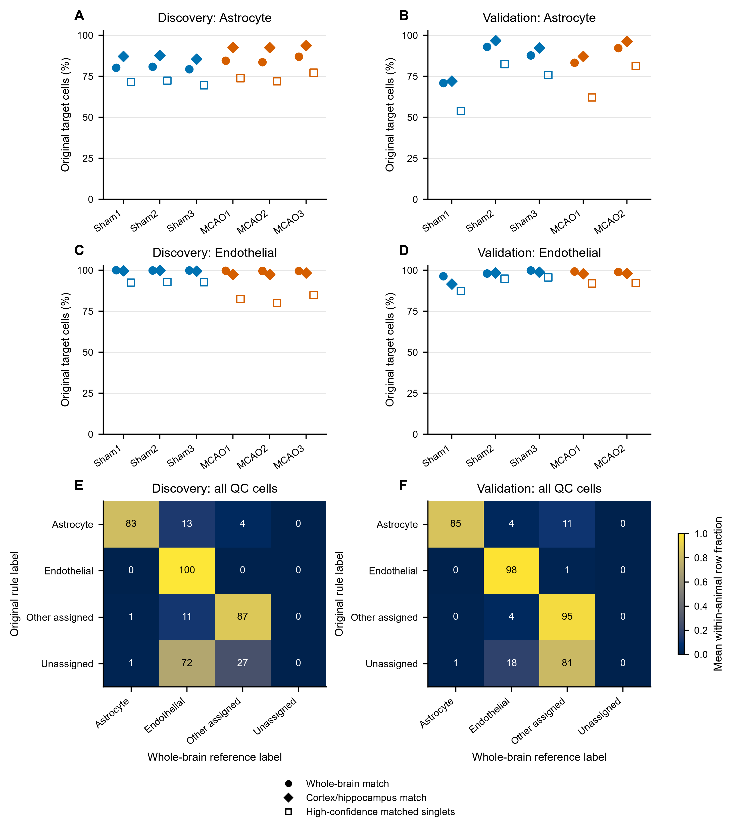

Supplementary Figure S2
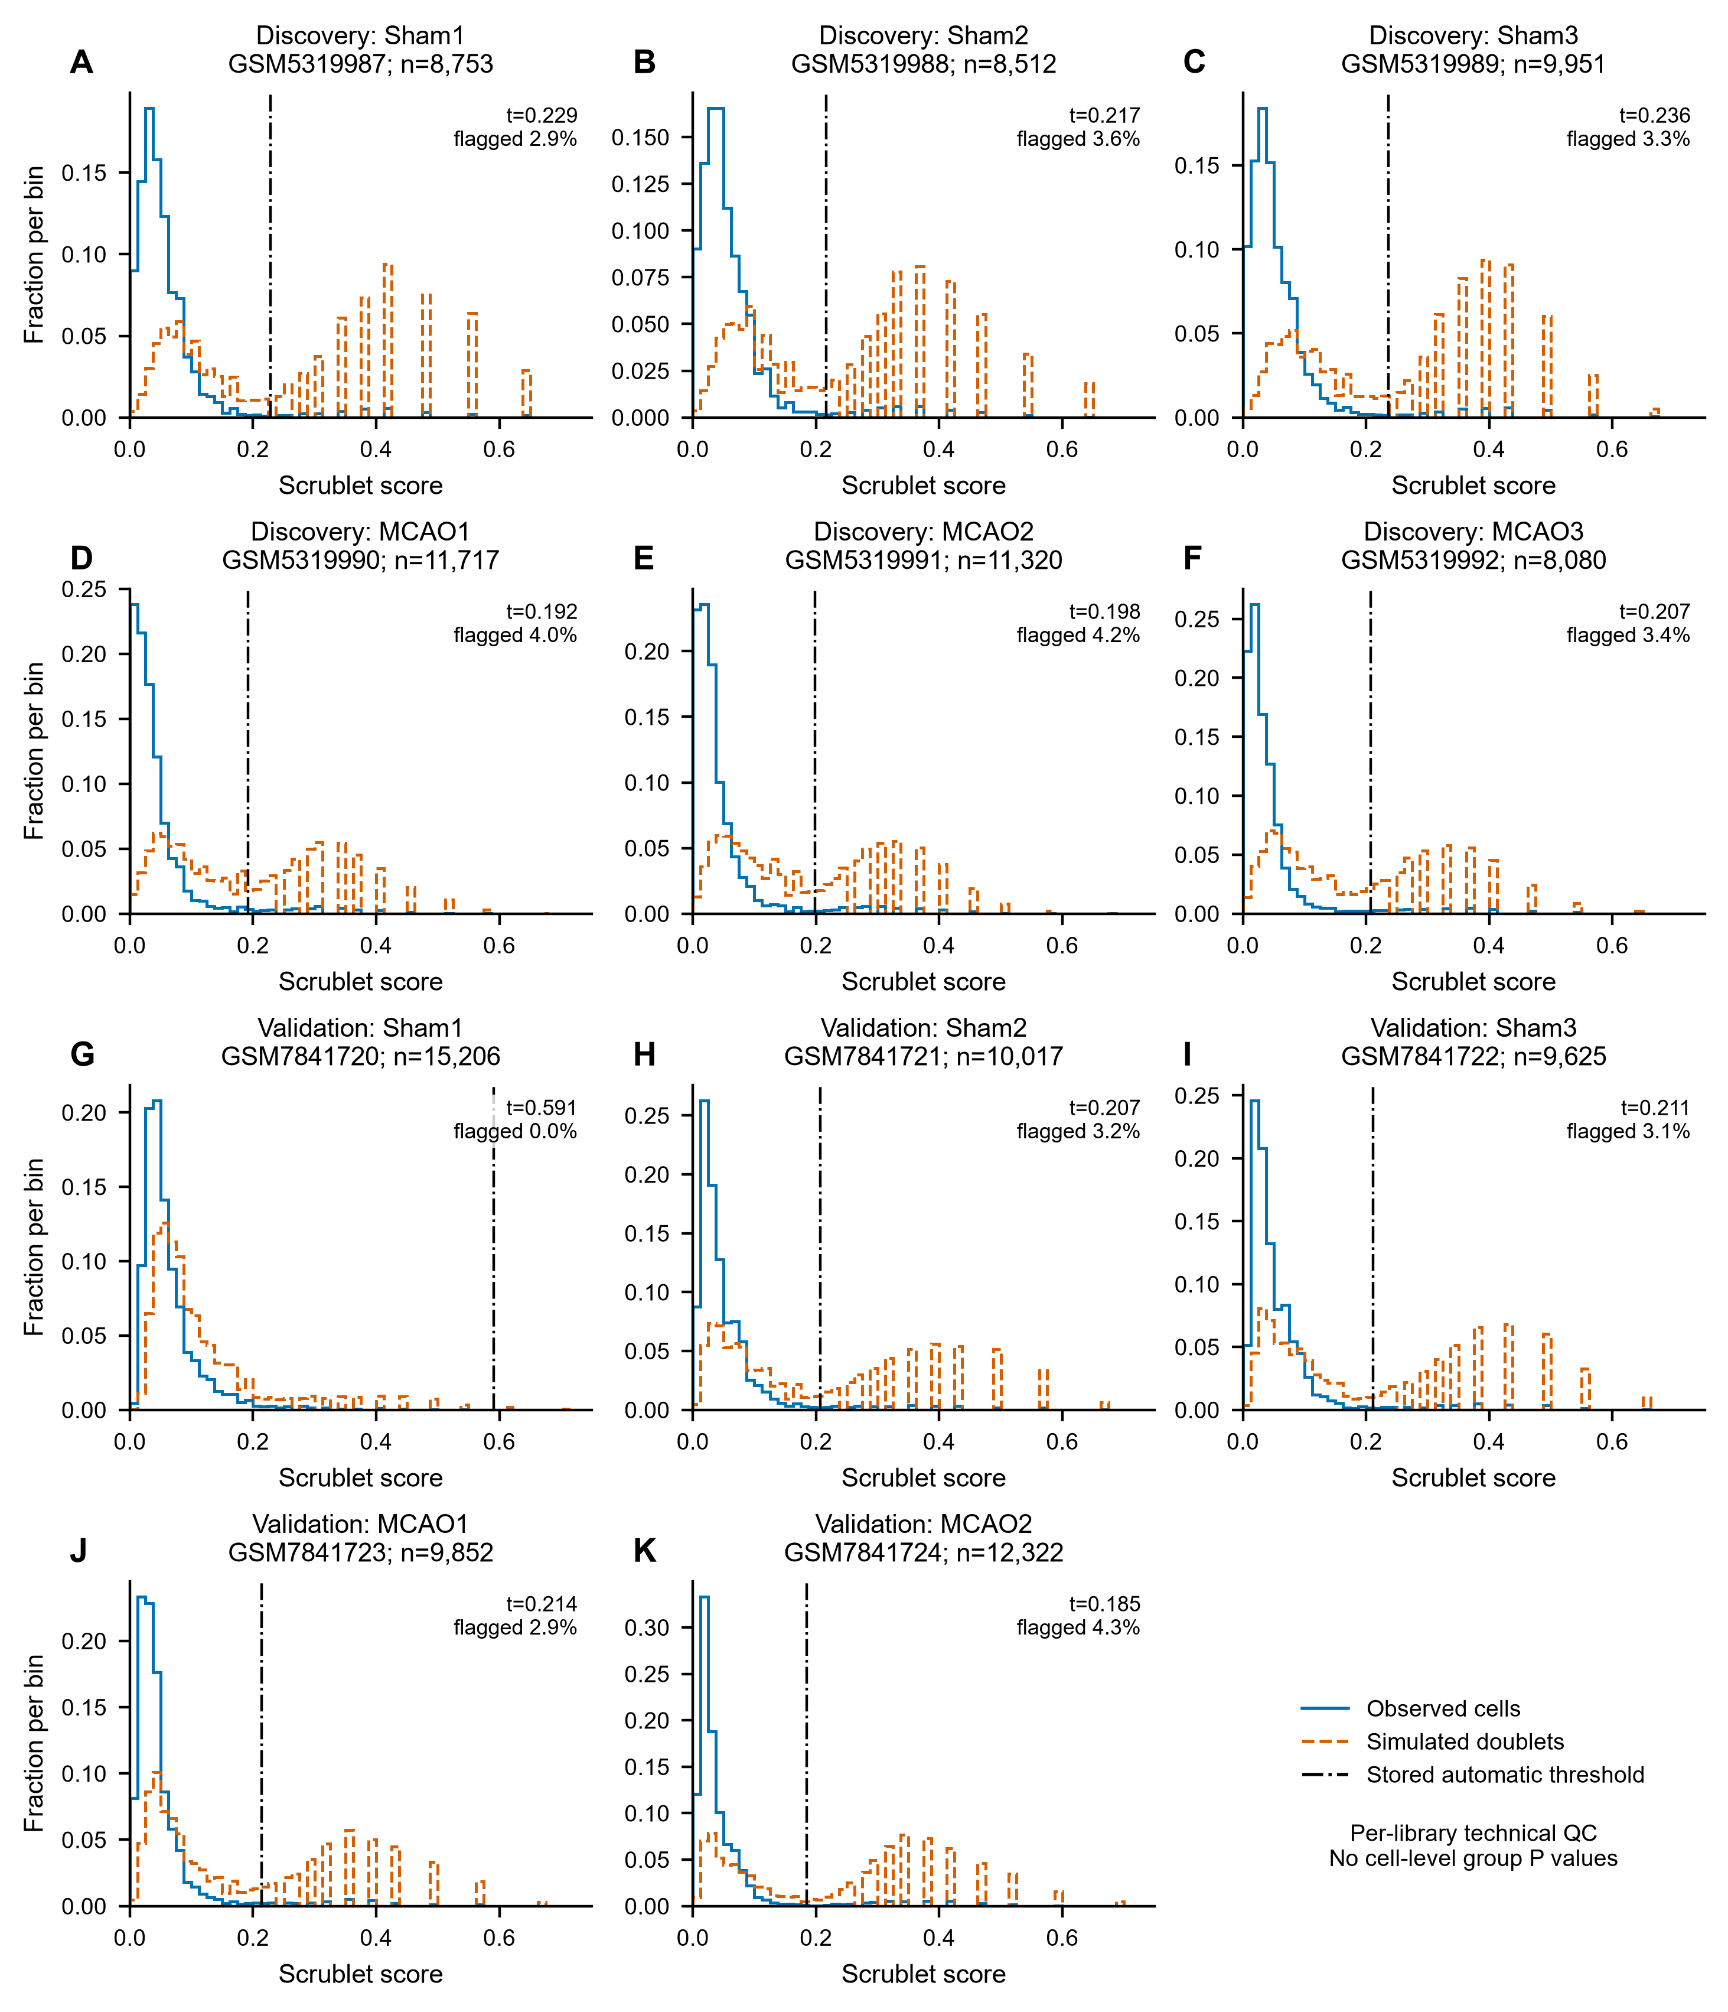

Supplementary Figure S3
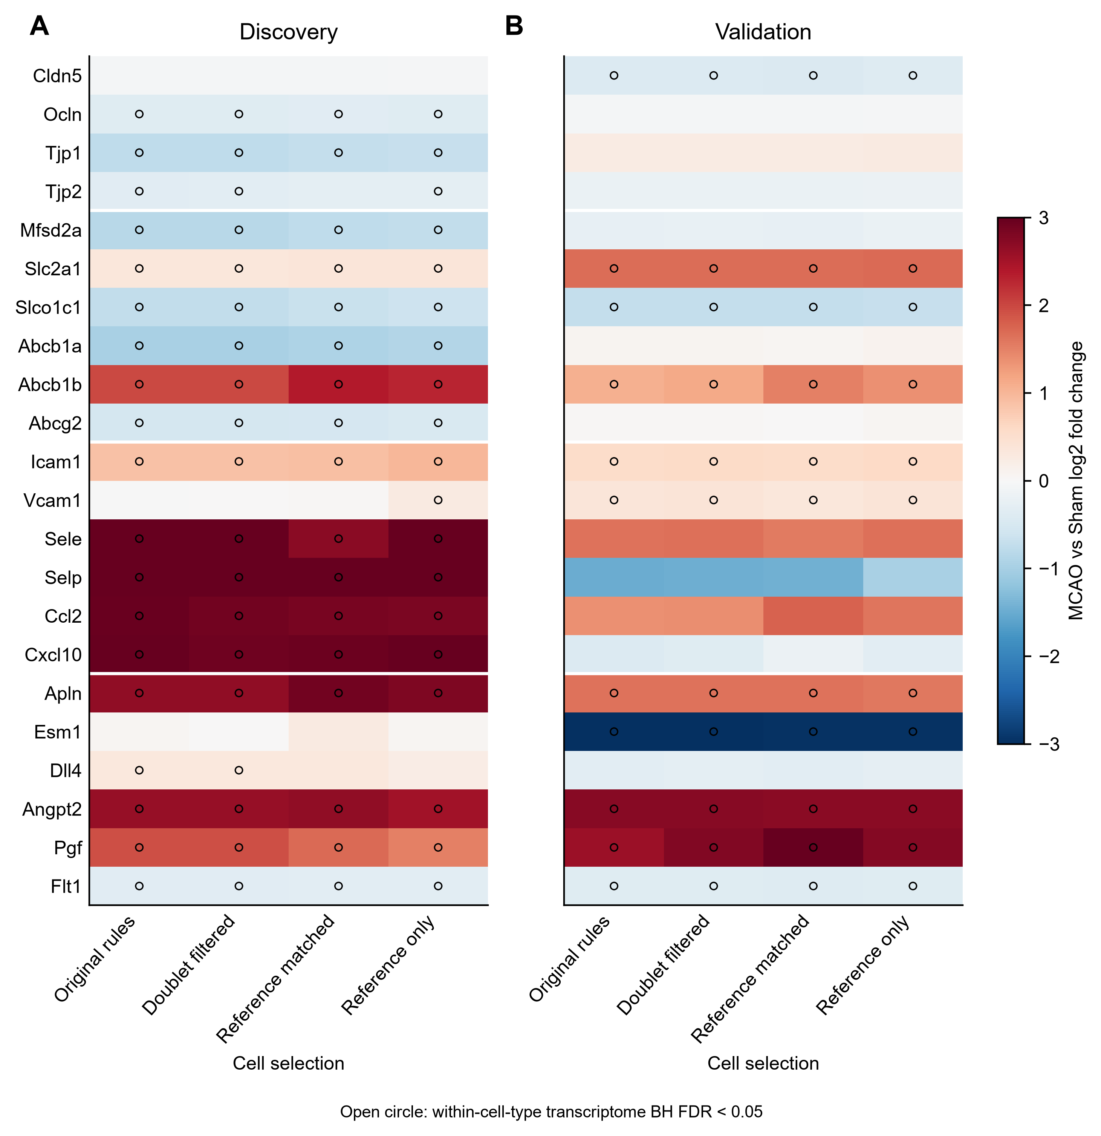

Supplementary Figure S4
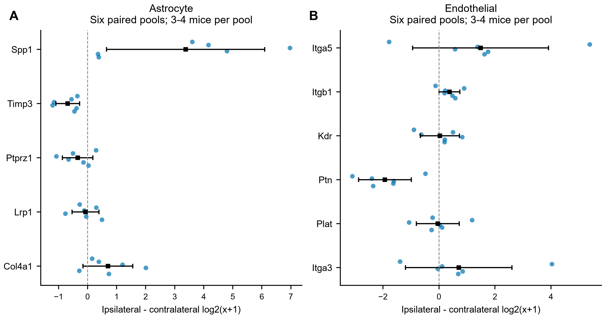

Supplementary Figure S5
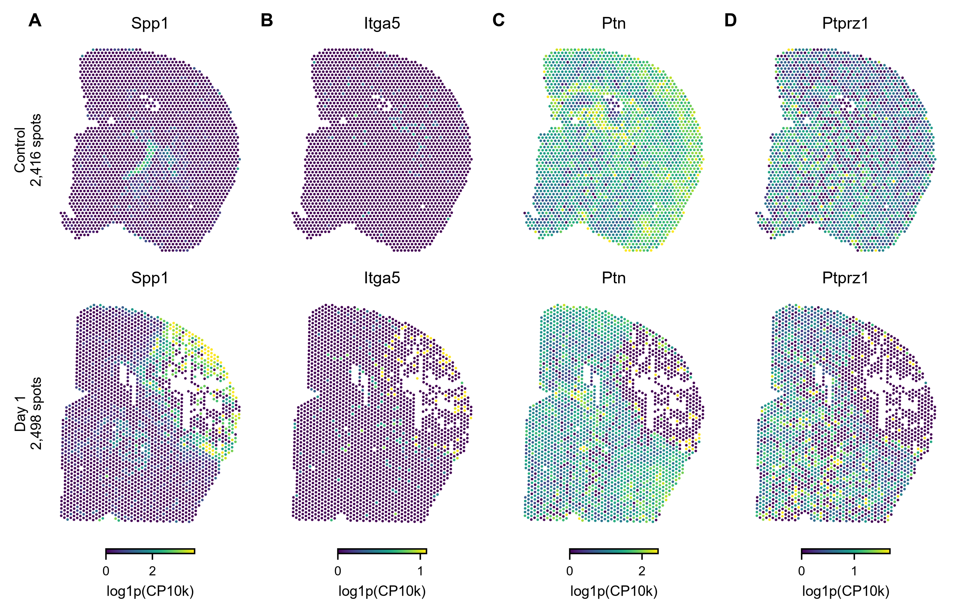

Supplementary Figure S6
