Expression-level concordance and implementation sensitivity of ligand⁠–⁠receptor priority rankings in mouse cerebral ischemia
Sihuan Zhu
Anhui University of Chinese Medicine
Correspondence: 15856965750@163.com
ORCID 0009-0005-9705-0585

Abstract
Cross-cohort agreement of ligand–receptor expression effects can differ from agreement of inferred priority changes. We assessed astrocyte–endothelial candidates in two mouse cerebral ischemia cohorts (11 animal libraries), with an additional single-nucleus cohort reporting three biological replicates per group. Dependence-preserving label permutations, controlled aggregation diagnostics, fixed ranking universes and DecontX sensitivity analyses separated sources of disagreement. On the same 187 primary-selection candidates, expression coavailability agreed for 150/187 (80.2%; Spearman ρ=0.725), compared with 105/187 for native LIANA 1.10.0 priorities (56.1%; ρ=0.228). Ranking each distinct score column once increased priority correlation to 0.519; this diagnostic exactly reproduced the upstream aggregation correction merged on 9 September 2026. Fixing the global ranking universe yielded ρ=0.645 with more zero effects. Dynamic-gate expression concordance was 79.9% versus a 50.0% joint label-null median (exact P=0.005; six-test Holm P=0.030), while conditional validation P remained 0.10. DecontX reduced matched expression correlation from 0.725 to 0.641. On 99 candidates available across all 17 libraries, original-cohort expression concordance was 80/99, whereas comparisons involving the third cohort yielded 53/99 and 58/99 (ρ=0.551 and 0.576). Thus, the native expression–priority gap partly reflects a known aggregation implementation, while residual agreement depends on ranking context and cohort. This case study quantifies those consequences and supports separately auditing expression effects, prioritization and candidate eligibility.
Keywords: cerebral ischemia; ligand–receptor inference; reproducibility; astrocytes; endothelial cells; LIANA

Introduction
Ligand–receptor inference converts cell-type expression profiles into candidate interactions and relative priorities. Cross-cohort evaluation consequently involves two related but distinct questions: whether an expression-based interaction score changes in the same direction after a perturbation, and whether the corresponding candidate gains or loses relative priority in another study. These contrasts operate on different scales and can involve different eligible interactions and network backgrounds. Agreement at one stage therefore warrants direct evaluation at subsequent stages. Distinguishing these quantities is particularly useful when a candidate list is intended to guide biological follow-up, because reproducible expression availability and reproducible prioritization represent different properties of the analysis. [1][2]
Previous benchmarks have examined interaction resources, scoring methods, differential communication inference and spatial support, including reproducibility across samples or tissue sections. [3][4] Building on this work, an informative disease-specific assessment should compare representations on the same candidates, preserve the biological sampling unit, and identify which analytic choices account for changes in agreement. Such an assessment also requires a relevant null reference: ligand–receptor candidates share genes, so their concordance indicators cannot be treated as independent trials. Preserving each sample's complete score vector while reallocating treatment labels provides a way to retain this dependence. In parallel, explicit interventions on score representation and ranking procedures can distinguish an observed reproducibility gap from explanations that have not been directly tested.
Experimental cerebral ischemia provides a traceable setting for this assessment. Public studies contain acute ischemic and sham-operated mouse brain samples with astrocytes and endothelial cells, while differing in tissue sampling, cellular composition and replication. [5][6] These cells offer a focused pair of interacting lineages, and barrier-related transcription supplies a biologically relevant context for their responses. The same setting also makes identity uncertainty and contaminating transcripts consequential: apparent expression of a candidate ligand may depend on which cells are assigned to the sending population.
Here, we assess cross-cohort reproducibility along the path from expression coavailability to relative ligand–receptor priority. We use animal-level contrasts in two primary cohorts, a dependence-preserving label-allocation baseline, independent-reference cell-selection checks, and an ambient-RNA sensitivity protocol. We additionally examine the installed aggregation implementation and the membership of its ranking universe, with the affected quantities held constant at each intervention. A third cohort with author-reported biological replication, together with supplementary sorted and spatial datasets, provides descriptive extensions. The objective is to identify reproducible features and sources of sensitivity in this specific inference workflow, while providing an auditable basis for subsequent validation.
LIANA developers merged a correction for repeated ranking of shared score columns on 9 September 2026 in LIANA PR #261. We use this known correction as a controlled intervention to quantify its consequences in ischemia cohorts and the remaining dependence on ranking context.

Methods

Data and cell selection
The two animal-resolved cohorts comprised GSE174574, with three sham and three middle cerebral artery occlusion (MCAO) libraries at 24 h, and GSE245386, with three sham and two newly generated wild-type MCAO libraries. Lrg1-knockout libraries and reused GSE174574 data were excluded from GSE245386. The latter study used 60 min of occlusion followed by 24 h of reperfusion, approximately 1 h later when time is measured from ischemia onset. GSM records, sample titles, filenames and source articles were reconciled, including the 2025 correction to GSE245386. The animal represented by each original library was the disease-comparison unit. [5][6][7]
An updated GEO search returned 145 GDS records; complete SOFT metadata and source articles were examined for 21 additional candidates. Queries, retrieved records and exclusion reasons were retained. This targeted update was not treated as an exhaustive systematic review. GSE332910 supplied sham and 24-h RNA libraries from ipsilateral striatum after 60-min MCAO and 24-h reperfusion. Supplementary Table S1 reports three biological replicates and three libraries per group. The number of mice contributing to each library, including whether samples were pooled, remained unspecified. Its single-nucleus assay, region and platform differed from the original cohorts. Under the revision-stage plan, this extension remained descriptive, with library-level effects and no P values, and was kept outside the original two-cohort permutation analysis. Corresponding ATAC libraries were not additional replicates. [8]
Submitted matrices were processed separately by library. Quality control retained cells or nuclei with 200–6,000 detected genes, at least 500 UMIs and at most 20% mitochondrial UMIs; duplicate gene symbols were summed. A fixed marker rule assigned astrocytes, endothelial cells and competing broad lineages, retaining unassigned cells. This rule was transferred unchanged to the third cohort. In the two original cohorts, all retained cells were additionally annotated with the independently trained CellTypist whole-mouse-brain model; an isocortex/hippocampus model provided a reference sensitivity check. Best-match prediction was used without majority voting. [9][10][11]
Scrublet was run per original library with expected doublet rate 0.05, simulated-to-observed ratio 2, 30 principal components, exact neighbors, automatic thresholds and seed 20260910. [12] The principal selections were the original marker assignment and its intersection with an agreeing whole-brain reference label, maximum sigmoid score ≥0.5 and no predicted doublet. Reference scores were treated as classifier outputs rather than calibrated correctness probabilities. Marker panels, label mappings, confidence distributions, simulated doublet scores and thresholds were retained for audit.
For rule assignment, marker log1p(CP10k) values were standardized across QC-passing cells within each library using a population-standard-deviation floor of 0.25, clipped to −3 to 10, and averaged within each lineage panel. Assignment required the highest mean score ≥0.5, a margin ≥0.25 over the second-highest panel, and at least two detected markers; remaining cells were unassigned. Astrocyte markers were Aldh1l1, Slc1a3, Slc1a2, Gja1, Glul, Sox9 and Aldoc; endothelial markers were Pecam1, Cdh5, Esam, Tek, Erg, Vwf and Kdr. Fixed panels for the other 13 competing lineages are retained in marker_panel.json. These are operational rule labels.

Animal-level scores and matched candidates
The fixed mouseconsensus resource contained 3,989 records. Directed candidates were evaluated from astrocytes to endothelial cells and in the reverse direction. For each animal, expression coavailability was the square root of the product of ligand and receptor mean log1p(CP10k), calculated within sender and receiver populations. Complex expression and detection were represented by the minimum constituent value. The original 10% gate required minimum-subunit detection ≥10% in at least two animals in either condition, assessed separately for ligand and receptor; 5% and 20% gates were retained as sensitivities. Disease effects were equal-animal MCAO means minus sham means.
LIANA 1.10.0 rank_aggregate ran CellPhoneDB, Connectome, log2FC, NATMI and SingleCellSignalR separately within each original library, using the same resource, expr_prop=0.1, min_cells=30, n_perms=100, seed=20260910, n_jobs=1 and return_all_lrs=False. [1][2] The complete network among assigned lineages with at least 30 retained cells was computed before extracting the two target directions. The reference-supported selection removed predicted doublets from all lineages and additionally required reference agreement for the target populations. Normalization used each cell's total across all submitted genes.
Metrics were grouped by interpretation. Coavailability, lr_means, expr_prod and lrscore were related expression-oriented summaries. Connectome and NATMI shared expr_prod, and the five interfaces contributed three distinct magnitude columns: lr_means, expr_prod and lrscore. Relative priority was represented by 1−magnitude_rank. Here magnitude_rank is a bounded robust rank aggregation (RRA) score, not a simple percentile rank; larger transformed values indicate higher relative priority. Within-library cell-label permutation P values were kept separate from animal-level disease inference. Unreported scores were retained as missing rather than replaced with zero.
The main comparison used the same directed candidates with finite values for all five metrics in every one of the 11 animals. This complete-case intersection was defined without treatment labels or an additional group-dependent coavailability gate. Concordance was reported as same nonzero-sign effects divided by all common candidates and, separately, by candidates with nonzero effects in both cohorts. Absolute effects ≤10^-12 were numerical zeros; zero–zero pairs did not count as concordant. Spearman correlation included all common candidates. A separate descriptive transform used within-animal average-tie percentile ranks over the same fixed target set before calculating disease effects. This target-only transform was distinguished from full-network RRA.
LIANA 1.10.0 was run separately on the six GSE332910 libraries using the original primary marker rule and QC-passing context classes with at least 30 nuclei. The analysis retained the original full-gene UMI denominator, float32 log1p(CP10k), mouseconsensus resource, 10% detection threshold, 100 internal permutations and fixed seed. Normalized sparse entries were strictly positive, and class pseudobulks matched independent stream aggregation. Native magnitude ranks were reconstructed from each complete cell-type network before ranking each distinct magnitude-score column once, then aggregating those ranks with RRA as an explicitly labeled implementation diagnostic. All six metrics were compared on the same 99 target candidates complete across all 17 libraries; ranks were calculated on full per-library networks before target restriction. The original cohort pair was also evaluated on these 99 candidates. Numerical TSVs were parsed with round-trip precision. These comparisons were descriptive and used only raw counts and primary selection for the third cohort, without reference-supported or decontaminated third-cohort versions.

Dependence-preserving label nulls
The null baseline retained each animal's entire multivariate score vector and exhaustively reassigned condition labels within studies. The three-versus-three and two-versus-three allocations generated 20×10=200 joint configurations, including the observed assignment. Genes, interaction edges and individual cells were not independently shuffled. Per-animal scores could be reused because normalization, reference selection and within-library LIANA scoring had not used disease labels. Both concordance fractions and Spearman correlation were recalculated for every configuration. A separate coavailability analysis reconstructed all gene-covered resource edges and reapplied the original group-dependent 10% gate within each allocation, including the candidate-selection step in its null distribution.
One-sided exact upper-tail P values equaled the fraction of the 200 statistics at least as large as observed, with comparison tolerance 10^-12. No Monte Carlo correction or artificial extra permutations were added. Null means, medians and 2.5th–97.5th percentiles were reported; the percentiles describe a label-randomization reference interval, not a confidence interval for observed concordance. Three Holm families were specified before computing these outputs: A, two selections×five metrics×three statistics, totaling 30 tests; B, two selections×four expression-minus-native-priority gaps×three statistics, totaling 24 tests; and C, two selections×three dynamically gated coavailability statistics, totaling six exploratory tests. Adjusted P values retain their family labels. The gap null concerns treatment-label association, not equivalence between algorithms. Exchangeability within each study remains an assumption. Revision-stage plans followed inspection of the earlier manuscript's results and were not preregistered.
After the joint results were known, a dated supplementary diagnostic fixed one cohort's observed labels and reassigned only the other cohort's labels. The saved joint configurations provided all 20 discovery-only and 10 validation-only allocations for every fixed metric and dynamically gated statistic. Complete distributions and unadjusted one-sided exact tails were reported without altering families A–C or creating a new confirmatory family. Joint randomization tests the null of no treatment association in either cohort under exchangeability; rejecting it does not establish treatment association separately in both cohorts. The conditional diagnostic retains the validation design's minimum attainable P value of 0.10. It therefore addresses the interpretation of the joint baseline rather than resolving limited biological replication.

Aggregation implementation and ranking universes
An implementation audit examined the installed aggregation code and its tagged upstream source. A deterministic four-row example directly invoked the official function to assess successive ranking of the expr_prod column shared by Connectome and NATMI. Full networks were then recomputed for all original libraries under both selections. Target scores and native consensus outputs were compared with the earlier exports after identical TSV serialization. On each unchanged full-network score table, each distinct magnitude column was then ranked once and passed to the same RRA function. [13] This explicitly named unique-column diagnostic preserved the installed package and native outputs; it was not designated an official corrected release.
A subsequent background diagnostic intersected all directed cell-type–ligand–receptor edges with finite magnitude scores across the 11 complete networks, including non-target cell-type pairs. Each distinct magnitude column was ranked once within this fixed global universe, RRA was applied, and the same original target intersection was extracted after verifying its inclusion. The intervention changed ranking-universe membership while preserving upstream expression scores and their original cellular context. Stored float32 magnitude precision was restored before aggregation, and both native and unique-column full-network scores were reconstructed as checks. Average-tie ranks of expr_prod and lrscore were compared for exact and approximate redundancy. Rank saturation, ties, zero disease effects and both concordance denominators were reported. These implementation and universe diagnostics were descriptive additions; no new inferential P values were calculated or transferred from null families A–C.
We additionally retrieved the aggregation function at the fixed merge commit d4211373692e7b9c10210488ccb1efe06452b097 of LIANA PR #261, retained source and SHA256, and executed it independently on all 22 raw complete networks for elementwise comparison with our unique-column diagnostic. This checks the aggregation function only, not a full newer pipeline release. The resource, explicit expr_prop=0.1 and expression scores were held unchanged; concurrent upstream changes to default detection thresholds were therefore excluded.

Ambient RNA and numerical convergence
DecontX was run separately for each library as a computational ambient-RNA sensitivity analysis (R 4.6.1, Bioconductor 3.23, decontX 1.10.0). Inputs were integer UMI counts for all originally QC-passing cells in 11 libraries from GSE174574 and GSE245386; counts for duplicate gene symbols were summed before fitting. The fixed whole_brain_broad labels from an independent whole-brain reference annotation were supplied as z, without reselecting cells according to target candidates or fitted results. Parameters were background=NULL, batch=NULL, seed=20260911, delta=c(10,10), estimateDelta=TRUE, convergence=0.001, and iterLogLik=10, with numerical threads set to one. The initial iteration limit was 500. All initial outputs were retained, and a uniform numerical rule required only libraries failing the convergence threshold to be refitted with maxIter=2000 using identical inputs, groups, and seed. Final sources were selected solely by this convergence rule: default outputs for initially converged libraries and extended-fit outputs for initially unconverged libraries, irrespective of candidate communication results. Corrected values were retained as fractional float64 estimates in cells-by-genes CSR NPZ and genes-by-cells MatrixMarket formats, with preserved cell and gene order, corrected per-cell totals, and SHA256 provenance. They were neither rounded nor treated as observed UMI counts or supplied to DESeq2. Without a measured empty-droplet background, the model infers non-native components from filtered cells conditional on the supplied groups; uncertain reference identities and genuinely shared expression across groups may affect this separation. Contamination fractions are therefore model estimates rather than measured contamination rates, and this analysis does not directly measure ligand secretion, receptor activation, or barrier function. [14]
Continuous nonnegative corrected counts preserve cell and gene order. Under unchanged cell selections, expression summaries and full-network native and diagnostic priorities use corrected totals across all genes as the normalization denominator. Detection in the custom coavailability gate is evaluated as estimated count >0, with estimated count ≥1 reported separately because corrected values can be fractional. LIANA retains the float32 normalized representation used in the raw pipeline. Positive-entry counts before and after conversion are recorded, and explicit numerical zeros are removed before its getnnz-based sparse expression proportions are calculated, enforcing a >0 detection rule. The ≥1 criterion is a custom expression-eligibility sensitivity, not rounding into observed UMIs. Nonpositive totals trigger an audit failure instead of reuse of raw totals. Candidate losses and common eligible sets are reported. Fractional estimates are not supplied to DESeq2; ambient correction and aggregation implementation remain separate interventions.

Sorted and spatial supplementary analyses
GSE163752 provided six matched ipsilateral–contralateral comparisons, with three or four mice contributing to each sample pool. Only astrocyte and endothelial samples with consistent metadata mappings were used. Submitted replicate identifiers defined pairing. Author-normalized values were transformed as log2(x+1); mean paired differences and pointwise 95% t intervals with five degrees of freedom summarized expression support. [15] These intervals were not simultaneous significance decisions, and contralateral tissue was not equated with sham. Earlier transcriptome-wide tests and BH results were retained in the audit record without using them as the criterion for this descriptive summary.
Barrier-related transcription provided supplementary cell-state context. Raw counts were summed by animal and cell type, requiring at least 30 cells; genes with at least 10 counts in as many animals as the smaller group size were analyzed with PyDESeq2 using design ~condition. All fixed-panel genes and full test results were retained. [16][17][18][19] GSE233814 contributed five section records to a supplementary expression figure using verified spatial coordinates. Spots were not animal replicates, unverified infarct regions were not assigned, and spatial associations were treated as descriptive context. [20]

Results

Expression concordance against a dependence-preserving null baseline
The original cohorts retained 115,355 QC-passing cells. Under the original 10% group-dependent expression gate, 258 of 323 common directed candidates had concordant disease-effect signs (79.9%; Spearman ρ=0.743). Reapplying the gate under all 200 joint animal-label allocations gave a median concordance of 50.0% and a 95% null-reference interval of 24.5%–75.5%. Reference-supported singlet selection yielded 247/326 concordant effects (75.8%; ρ=0.703), against a null interval of 26.7%–73.3%. All six dynamically gated statistics had exact P=0.005 and Holm-adjusted P=0.030 within exploratory family C (Figure 2D).
The supplementary conditional diagnostic retained the other cohort's observed labels. For both selections, dynamically gated concordance and correlation gave P=0.05 when only discovery labels were reassigned and P=0.10 when only validation labels were reassigned. These unadjusted diagnostic results distinguish the 200-allocation joint baseline from evidence attributable to each cohort separately.

Matched candidates expose the native priority gap
The all-animal, all-metric intersection contained 187 candidates under the original selection and 174 under reference-supported singlet selection. Expression coavailability showed concordance of 150/187 (80.2%) and 127/174 (73.0%), with ρ=0.725 and 0.695. Native LIANA 1.10.0 priority effects gave 105/187 (56.1%) and 95/174 (54.6%), with ρ=0.228 and 0.102. Restricting the denominator to nonzero effects in both cohorts increased the native fractions to 105/177 (59.3%) and 95/166 (57.2%; Figure 2A–C).
Exact coavailability concordance P values were 0.010/0.020 and correlation P values were 0.005/0.005; the corresponding native-priority values were 0.145/0.225 and 0.125/0.270. The smallest Holm-adjusted values were 0.15 in fixed-metric family A and 0.12 in gap-statistic family B. Thus, the observed differences were descriptive contrasts, with family C evidence retained under its own denominator and multiplicity definition.

A specific aggregation behavior accounts for part of the gap
A four-row deterministic example showed that the installed method loop ranked the shared expr_prod column twice, reversing its rank direction relative to the other magnitude columns. Complete-network reruns reproduced the saved target scores and native consensus in all 22 library–selection combinations. Ranking each distinct magnitude column once on these unchanged networks increased cross-cohort priority correlation to 0.519 and 0.514. Concordance became 122/187 (65.2%) and 115/174 (66.1%), or 122/168 (72.6%) and 115/158 (72.8%) among nonzero effects. These are explicitly labeled unique-column diagnostic outputs (Figure 3).
LIANA PR #261 had already corrected this repeated-ranking behavior on 9 September 2026. Independently executing its fixed-commit aggregation function reproduced the unique-column diagnostic exactly on all 22 raw complete networks and the 187/174 targets (maximum absolute difference 0). This links the diagnostic to a known upstream correction while isolating the aggregation step from a complete newer release.

Fixing the ranking universe increases correlation and zero effects
Under the original selection, complete networks ranged from 17,267–33,735 eligible edges in discovery libraries to 57,934–77,691 in validation libraries. The all-library global intersection retained 7,675 and 7,109 edges under the two selections, each covering 81 cell-type directions and containing every fixed target candidate. Unique-column RRA within these fixed universes yielded ρ=0.645/0.555. However, candidates with a zero effect in at least one cohort increased to 64/59: concordance was 100/187 (53.5%) and 84/174 (48.3%) overall, versus 100/123 (81.3%) and 84/115 (73.0%) among nonzero effects. These zero effects traced to RRA scores of 1 in every library of the relevant cohort.
A simpler fixed-target percentile transform retained expression-effect correlations of 0.609–0.697. Complete-network expr_prod and lrscore ranks were nearly redundant (ρ>0.9999999998), with small residual floating-point and tied-rank differences.

Corrected myeloid-marker estimates and eligibility sensitivity
DecontX fitting was completed for 115,355 originally QC-passing cells in 11 libraries. Ten libraries reached the 0.001 convergence threshold within the default 500-iteration limit. The only initially unconverged library, GSM5319992, reached the threshold at iteration 637 after refitting identical inputs and settings with only the iteration limit increased to 2000 (last maximum parameter change, 0.0009979). The final sources comprised ten default fits and this extended fit; all eleven met the specified numerical threshold, and every default result was retained. The pooled cell-level median estimated contamination fraction was 6.13%, and library-specific medians ranged from 3.98% to 8.16%. Pooled summaries were descriptive and did not treat cells as independent biological replicates. All cells retained positive corrected totals, and all eleven final matrices contained fractional float64 estimates. For GSM5319992, extending the fit changed the median estimated contamination from 6.32% to 6.14%; the sum of absolute matrix differences was 0.3565% of its original total UMI count. However, the maximum absolute change in an individual cell's estimated contamination was 37.54 percentage points, so a small aggregate change cannot replace cell-level or downstream checks. These results characterize model fitting and numerical sensitivity and do not by themselves support particular communication candidates or barrier-regulatory mechanisms.
In primary-rule target cells, mean estimated counts per cell for C1qa, Lyz2 and Tyrobp were lower than raw values in every library. Each of the six cell-type–gene combinations was summarized across eleven libraries; median library-level reductions ranged from 64.5% to 90.5% (Figure 4A,B). These changes follow model-based subtraction and do not independently validate an ambient-RNA origin. Under the >0 detection rule, corrected common sets contained 323/326 candidates. Primary and reference-supported concordance was 238/323 (73.7%; ρ=0.642) and 230/326 (70.6%; ρ=0.578). Applying an additional, stricter estimated-count ≥1 detection threshold with the same 10% group eligibility rule yielded 37/45 common candidates, with concordance of 31/37 (83.8%) and 36/45 (80.0%) and ρ=0.797/0.801 (Figure 4E,F). Within these two smaller matched candidate sets, expression-effect correlations changed from 0.795 to 0.797 and from 0.798 to 0.801 from raw to corrected data. Higher agreement in the smaller sets therefore does not establish improvement across the original candidates.
To compare the same targets, candidates complete across raw/corrected data, all eleven animals and all six metrics were fixed at 187 under primary selection and 174 under reference-supported selection. Under primary selection, raw-to-corrected correlations were 0.725 to 0.641 for coavailability, 0.228 to 0.205 for native priority, and 0.519 to 0.442 for the unique-column diagnostic. Under reference-supported selection, the corresponding changes were 0.695 to 0.660, 0.102 to 0.126, and 0.514 to 0.430 (Figure 4C,D). Animal-level scores, all-candidate and nonzero-effect denominators, and every metric are retained; raw-data permutation P values do not apply to these descriptive sensitivity comparisons. Timp3–Kdr and Ptn–Ptprz1 retained eligibility under the ≥1 threshold in both cohorts and selections, with expression effects retaining their raw-data directions. Spp1–Itga5/Itgb1 did not meet that eligibility rule in any of the four cohort–selection combinations. Plat–Lrp1 did not meet it in primary-rule discovery cells but retained eligibility in the other three combinations. Failing ≥1 eligibility does not establish absence of expression or communication, nor can the model alone determine the cellular origin of these transcripts.

A third cohort and sorted expression define the biological scope
GSE332910 reported three biological replicates and three RNA libraries per group. Of 119,278 submitted nuclei, 116,308 passed QC; the unchanged marker rule assigned 6,430 astrocyte and 1,112 endothelial nuclei, while 66.7% remained unassigned. Every library contained at least 75 assigned endothelial nuclei. Among candidates passing the 10% gate, third-cohort effects agreed with discovery for 141/223 candidates (63.2%; ρ=0.560) and with validation for 267/445 (60.0%; ρ=0.547). These descriptive comparisons used separate assessable intersections.
Among the same 99 target candidates complete across all 17 libraries, the original cohort pair showed 80/99 concordant custom effects (80.8%; rho=0.767), compared with 65/99 for native priority (65.7%; rho=0.350) and 70/99 for the unique-column diagnostic (70.7%; rho=0.571). Against the original discovery cohort, the third cohort yielded 53/99 for custom effects (53.5%; rho=0.551), 48/99 for native priority (48.5%; rho=0.219), and 52/99 for diagnostic priority (52.5%; rho=0.460). Against the original external cohort, the corresponding results were 58/99 (58.6%; rho=0.576), 48/99 (48.5%; rho=0.287), and 48/99 (48.5%; rho=0.392). Across the four expression-related scores, rho ranged from 0.514 to 0.720 and from 0.512 to 0.659 in the two third-cohort comparisons. The diagnostic increased priority-effect correlation, whereas direction agreement improved only slightly or remained unchanged. In comparisons involving the discovery cohort, three native and six diagnostic candidates had a zero disease effect in at least one cohort; neither priority metric had zero effects in the third-versus-external comparison. Direction agreement and effect correlation therefore capture distinct aspects of transfer. On a common target set, expression-direction transfer varied across cohorts, while priority relationships also depended on score implementation.
Sorted-data summaries retained all six paired pool-level differences. Astrocytic Spp1 had a mean log2(x+1) difference of 3.376 (pointwise 95% CI 0.653–6.100), astrocytic Timp3 −0.686 (−1.096 to −0.275), and endothelial Plat −0.043 (−0.809 to 0.722). The complete descriptive export contained 49,914 cell-type–gene effects and intervals. Raw pseudobulk barrier transcription and the five spatial section records remained supplementary biological context (Figures S3–S5).
Table 1. Data sources and analytical roles
GEO | Contrast and sample unit | Sham / MCAO | QC retained | Role
GSE174574 | Acute ischemia; animal libraries | 3 / 3 | 58,333 cells | Primary cohort
GSE245386 | Wild type; animal libraries | 3 / 2 | 57,022 cells | Original validation
GSE332910 | Ipsilateral striatum; author-reported biological replicates | 3 / 3 | 116,308 nuclei | Descriptive extension
GSE163752 | Ipsilateral vs contralateral; independent pools | 6 paired pools | Not applicable | Sorted effect intervals
GSE233814 | Control and D1/D3/D7 section records | 5 sections | 11,969 spots | One supplementary map

Table 2. Expression and priority agreement on matched targets
Selection | Metric | N | All concordant | Nonzero concordant | ρ
Primary | Expression coavailability | 187 | 150/187 (80.2%) | 150/187 (80.2%) | 0.725
Primary | Native LIANA 1.10.0 | 187 | 105/187 (56.1%) | 105/177 (59.3%) | 0.228
Primary | Unique-column diagnostic | 187 | 122/187 (65.2%) | 122/168 (72.6%) | 0.519
Primary | Fixed-global diagnostic | 187 | 100/187 (53.5%) | 100/123 (81.3%) | 0.645
Reference | Expression coavailability | 174 | 127/174 (73.0%) | 127/174 (73.0%) | 0.695
Reference | Native LIANA 1.10.0 | 174 | 95/174 (54.6%) | 95/166 (57.2%) | 0.102
Reference | Unique-column diagnostic | 174 | 115/174 (66.1%) | 115/158 (72.8%) | 0.514
Reference | Fixed-global diagnostic | 174 | 84/174 (48.3%) | 84/115 (73.0%) | 0.555

N denotes the fixed target-candidate count. All-candidate concordance uses N; nonzero concordance uses effects nonzero in both cohorts. Spearman correlation includes all N candidates. These representations reuse the same animals and targets and do not provide new formal between-method significance evidence.

Discussion
This analysis identifies an implementation-sensitive component of cross-cohort ligand–receptor prioritization. Expression coavailability and native consensus priority produced different disease-effect concordance on the same candidates, and a controlled change to the aggregation procedure substantially narrowed that gap. The resulting contribution is a traceable computational case study: the score representation, eligible network and denominator can each be inspected and intervened upon. Previous evaluations have established the importance of resources, scoring choices and benchmark targets; this study adds a disease-matched assessment that connects a reproducibility pattern to a specific implementation behavior. [1][2][3][4]
The strongest explanatory evidence comes from preserving the complete network while changing only how shared magnitude columns are ranked. Connectome and NATMI both reference expr_prod. In the audited LIANA 1.10.0 implementation, repeated in-place descending ranking reverses this column before duplicate score names are removed. The deterministic example and full-network reproduction establish that this behavior reached the analyzed outputs. Ranking distinct columns once increased correlation under both cell selections, directly implicating this step in the observed native gap. The diagnostic exactly matches the aggregation function of the known upstream correction in LIANA PR #261. It quantifies that correction's consequences while remaining distinct from a full newer-release rerun. Its improved agreement measures a computational consequence on these data, rather than establishing a biologically correct consensus.
The ranking universe supplies a second, separately controlled source of sensitivity. Fixed-global aggregation increased correlation while reducing the number of target candidates with nonzero disease effects. This combination follows from the bounded RRA score: saturation at 1 maps to zero transformed priority across an entire cohort, even when ligand and receptor expression remains measurable. RRA aggregates evidence from relative ranks and differs from a simple percentile transform. [13] Reporting only conditional concordance would favor the surviving directional subset and conceal this loss of informative effects. The all-candidate fraction, nonzero fraction, correlation and zero counts together describe the intervention's consequences.
The dependence-preserving null adds a reference for expression agreement while clarifying the replication claim. Dynamic-gate concordance exceeded its joint random-label reference after correction within exploratory family C. Fixed-metric and gap families retained their separate, less conclusive adjusted results. Joint rejection concerns the configuration in which both cohorts' labels are exchangeable; it does not establish the relevant disease association separately in both cohorts. The conditional validation tail remains limited to increments of 0.10. Moving to an aggregate statistic therefore permits a finer joint null comparison while leaving the underlying small-sample design intact.
The third cohort further limits transfer. On the same 99 candidates, expression signs agreed for 80/99 between the original cohorts but for 53/99 and 58/99 in comparisons involving the third study. Tissue region, nuclear versus cellular sampling, platform and study identity change together, so their individual contributions cannot be identified here. The extension provides a descriptive boundary for this case rather than a causal explanation of cohort differences.
Ambient-RNA sensitivity requires separate interpretation of estimated counts and candidate eligibility. Myeloid-marker count estimates were lower than raw values, while correlations on fixed candidate sets changed differently across cell selections and metrics; these computations do not provide independent ground truth for cellular origin. A single observed UMI can become a positive estimate below one after subtraction, so the ≥1 threshold changes inclusion of low-abundance features and is not a criterion for absence of expression. Retained >0 eligibility likewise does not establish absence of contamination effects. DecontX groups cells by whole-brain reference labels while downstream cell selections remain fixed; genuine expression in reference-discordant cells may therefore be assigned to the non-native component. For candidates such as Spp1, label and detection-threshold sensitivity should be reported without claiming an established cellular source or communication mechanism from the model alone.
Several limitations delimit interpretation. The original validation ischemia group contains two animals; the third study reports biological replication but leaves each library's mouse or pool composition unspecified. Tissue region, single-cell versus single-nucleus sampling, platform and annotation transfer accompany its more moderate expression agreement. Fixed-global reranking retains upstream expression context and therefore does not isolate cell composition. Expression-oriented metrics are also related: shared expr_prod and near-monotonic lrscore ranks provide fewer independent dimensions than the number of method interfaces suggests. Cell identity and contamination sensitivity require their own audits, while sorted ipsilateral–contralateral contrasts and spatial descriptions interrogate different biological comparisons. Functional ligand release, receptor engagement and barrier physiology remain unmeasured.
The practical implication is to retain the intermediate quantities that make prioritization reproducible: animal-level expression scores, cell selection, candidate eligibility, software version, aggregation inputs, network membership and directional denominators. Expression concordance can nominate interpretable candidates, and explicit implementation checks can reveal why their priorities change. A reproducibility assessment that preserves both stages offers a stronger basis for subsequent experimental selection and larger-cohort benchmarking than a single consensus list.

Conclusion
The original two cohorts showed higher expression-effect concordance than native LIANA 1.10.0 priority agreement. Controlled aggregation checks reproduced a known upstream correction and explained part of this gap; ranking context and ambient-count estimates contributed further sensitivity. On the same 99 candidates, expression agreement was 80/99 between the original cohorts and 53/99 or 58/99 with the third cohort. This case supports auditing expression effects, priority effects and candidate eligibility separately, with explicit software versions and directional denominators. Broader transfer and functional interpretation require independent evidence.

Data availability
Public source data are available from GEO: GSE174574, GSE245386, GSE332910, GSE163752, GSE233814.

Ethics statement
This study reanalyzed public animal data and performed no new animal or human experiments. Approval and consent for source experiments are reported by the original studies.

Figure legends
Figure 1. Animal libraries and uncorrected marker expression. A,B: Primary-rule astrocyte and endothelial counts; each point is one animal library and the short black line is the group mean. Discovery has 3 Sham/3 MCAO animals and validation has 3/2. C,D: Raw-count detection (>0) is calculated within each animal and averaged with equal animal weights. White separators distinguish target-lineage and myeloid markers. These are pre-correction identity audits; ambient sensitivity is shown in Figure 4.
Figure 2. Expression and native-priority effects on matched candidates and animal-label null references. A,B: MCAO-minus-Sham mean effects for the same 187 all-animal-complete primary-rule directed candidates; blue indicates nonzero concordant effects and orange denotes other outcomes. C: Observed all-candidate concordance for five metrics under primary and reference-supported selection, using 187/174 candidates. Reference segments denote the 2.5th–97.5th percentiles across 200 joint label allocations, with null medians also shown; these are not effect confidence intervals. D: The original 10% group gate is recomputed in each allocation. Observed 258/323 concordance (79.9%) is compared with a 50.0% null median; exact P=0.005 and Holm-adjusted P=0.030 refer to exploratory family C (six tests). Adjusted fixed-set results are reported separately. Whole-animal score vectors preserve shared ligand/receptor dependence. The conditional validation diagnostic still has only ten label allocations.
Figure 3. Aggregation implementation and ranking-universe sensitivity. Columns represent primary and reference-supported singlet selection, retaining the same 187/174 target candidates throughout. Native v1.10.0 is the installed LIANA consensus. Unique-column RRA ranks each distinct magnitude-score column once on the unchanged full network. The fixed-global variant additionally restricts ranking to the 7,675/7,109 complete full-network edges shared by all 11 libraries. A,B: Spearman correlation of disease mean effects. C,D: Filled points use all fixed candidates; open points use candidates with nonzero effects in both cohorts. E,F: Counts of nonzero and at-least-one-zero disease effects, which do not indicate missing expression. Absolute effects ≤10⁻¹² are treated as numerical zero. This descriptive intervention adds no P values; the bounded RRA score differs from a simple percentile rank. The unique-column diagnostic exactly matched the isolated aggregation function of the known upstream correction in LIANA PR #261 on the 22 raw networks; this is not a complete newer-release rerun.
Figure 4. Ambient-RNA sensitivity. A,B: Log1p-transformed library-level mean counts per cell for C1qa, Lyz2 and Tyrobp in primary-rule astrocytes and endothelium. Thin lines connect raw and DecontX-estimated values from the same animal library (11 libraries). C,D: Primary and reference-supported selections compare cross-cohort effect correlations on the same candidates complete for raw/corrected data, every animal and all six metrics. Blue circles denote raw values and orange triangles corrected estimates. Native and Unique denote native and unique-column diagnostic priorities. E,F: Common candidate counts passing the 10% group gate under raw >0, corrected >0 and corrected ≥1 detection definitions; these eligible sets may differ. The ≥1 rule is an additional sensitivity threshold, and failure does not establish absence of expression. No new inferential tests are shown. Estimated counts, detection thresholds and numerical-convergence source selection are documented separately.
Figure 5. Effect transfer to an acute striatal single-nucleus cohort. A,B: assigned astrocyte and endothelial nuclei in each GSE332910 library under the original primary rule. Each point denotes one library; S1–S3 and M1–M3 identify the submitted Sham and 24-h MCAO replicates. Source Table S1 reports three biological replicates and three libraries per group; mice per library were unspecified. C,D: third-cohort comparisons with GSE174574 and GSE245386 on the same 99 target candidates complete across all 17 libraries. Dots show Spearman correlation of MCAO-minus-Sham effects for custom coavailability, native RRA priority and the unique-column RRA diagnostic. Labels report concordant nonzero effects/all 99 candidates and candidates with a zero effect in either cohort (absolute effect <=1e-12). Priorities were computed on each full library network before target restriction. Original-pair comparisons on the same 99 candidates are provided in the supplementary table third_rank_diagnostic_original_pair_on99.tsv. The third cohort used raw counts and primary selection only; all estimates are descriptive.
Supplementary Figure S1. Reference identity and cell retention. A–D: Each position represents an animal library. Circles show whole-brain label agreement, diamonds cortical/hippocampal agreement, and open squares retention after whole-brain agreement, maximum sigmoid score ≥0.5 and exclusion of Scrublet flags. Denominators are primary-rule target cells. E,F: Whole-brain reference proportions are computed within each animal's original label and then equally averaged; annotations are rounded percentages. Best-match reference prediction has no unassigned output. Agreement is not measured identity accuracy.
Supplementary Figure S2. Scrublet observed and simulated score distributions by library. Common bins show fractions normalized to the respective observed or simulated total. Blue solid lines denote observed cells, orange dashed lines simulated doublets, and black dash-dotted lines saved automatic thresholds. The GSM7841720 threshold exceeds all observed scores and flags no cells; thresholds were not manually tuned. This is technical QC without cell-level disease inference.
Supplementary Figure S3. Selection sensitivity of barrier-related gene effects. Cells show animal-level endothelial PyDESeq2 log2 fold changes for MCAO versus Sham in each original cohort and selection. Open circles denote BH-adjusted P<0.05 within the corresponding endothelial transcriptome. Color is capped at ±3; complete values are archived. White lines separate junction, transport, activation and angiogenesis panels. Four selections reuse the same animals. These are original integer-UMI pseudobulk analyses; fractional DecontX estimates were not supplied to DESeq2.
Supplementary Figure S4. Paired sorted-sample effects and intervals. A: Astrocyte components; B: endothelial components. Colored points show each of six independent pools' ipsilateral-minus-contralateral log2(author-normalized value+1) difference. Black points and segments show means and pointwise 95% t intervals (5 degrees of freedom). Pools contain 3–4 mice, and the contralateral hemisphere is not Sham. The eleven components were retained from existing examples rather than selected by this display. All 49,914 descriptive results and historical P values are archived; intervals do not provide simultaneous significance classification.
Supplementary Figure S5. Spatial expression context. Each point is a QC-passing Visium spot in the Control (top; 2,416 spots) or Day 1 section (bottom; 2,498 spots). A–D show Spp1, Itga5, Ptn and Ptprz1. Coordinates derive from original alignment JSON and verified barcode mapping. Each gene shares one scale across both sections, capped at the pooled 99th percentile. Histological region labels were unavailable; core and penumbra labels were not assigned. Spots mix multiple cell types. This supplementary display supplies expression context; complete descriptive tables for all five section records remain archived.

References
1. Daniel Dimitrov, Dénes Türei, Martin Garrido-Rodriguez, Paul L. Burmedi, James S. Nagai, Charlotte Boys, et al. Comparison of methods and resources for cell-cell communication inference from single-cell RNA-Seq data. Nature Communications. 2022;13:3224. doi:10.1038/s41467-022-30755-0
2. Daniel Dimitrov, Philipp Sven Lars Schäfer, Elias Farr, Pablo Rodriguez-Mier, Sebastian Lobentanzer, Pau Badia-i-Mompel, et al. LIANA+ provides an all-in-one framework for cell–cell communication inference. Nature Cell Biology. 2024;26:1613-1622. doi:10.1038/s41556-024-01469-w
3. Giulia Cesaro, Giacomo Baruzzo, Gaia Tussardi, Barbara Di Camillo. Differential cellular communication inference framework for large-scale single-cell RNA-sequencing data. NAR Genomics and Bioinformatics. 2025;7:lqaf084. doi:10.1093/nargab/lqaf084
4. Li-Ting Ku, Vincent Bernard, Jimin Min, Ying Yuan, Eugene Jon Koay, Anirban Maitra, et al. Benchmarking tools for deciphering cellular crosstalk in spatially-resolved transcriptomics. Genome Biology. 2026;27:163. doi:10.1186/s13059-026-04063-5
5. Kai Zheng, Lingmin Lin, Wei Jiang, Lin Chen, Xiyue Zhang, Qian Zhang, et al. Single-cell RNA-seq reveals the transcriptional landscape in ischemic stroke. Journal of Cerebral Blood Flow & Metabolism. 2022;42:56-73. doi:10.1177/0271678X211026770
6. Zhaohui Ruan, Guosheng Cao, Yisong Qian, Longsheng Fu, Jinfang Hu, Tiantian Xu, et al. Single-cell RNA sequencing unveils Lrg1's role in cerebral ischemia‒reperfusion injury by modulating various cells. Journal of Neuroinflammation. 2023;20:285. doi:10.1186/s12974-023-02941-4
7. Zhaohui Ruan, Guosheng Cao, Yisong Qian, Longsheng Fu, Jinfang Hu, Tiantian Xu, et al. Correction: Single-cell RNA sequencing unveils Lrg1’s role in cerebral ischemia‒reperfusion injury by modulating various cells. Journal of Neuroinflammation. 2025;22:269. doi:10.1186/s12974-025-03610-4
8. Ruolin Zhang, Chang Liu, Yuneng Zhou, Kaichen Zhao, Muyang Li, Bingcheng Cai, et al. Nrsn1–Smarcc1 Coupling Regulates Neural Stem Cell Differentiation and Chronic‐phase Recovery After Ischemic Stroke. Advanced Science. 2026;e77547. doi:10.1002/advs.77547
9. C. Domínguez Conde, C. Xu, L. B. Jarvis, D. B. Rainbow, S. B. Wells, T. Gomes, et al. Cross-tissue immune cell analysis reveals tissue-specific features in humans. Science. 2022;376:eabl5197. doi:10.1126/science.abl5197
10. Zizhen Yao, Cindy T.J. van Velthoven, Thuc Nghi Nguyen, Jeff Goldy, Adriana E. Sedeno-Cortes, Fahimeh Baftizadeh, et al. A taxonomy of transcriptomic cell types across the isocortex and hippocampal formation. Cell. 2021;184:3222-3241.e26. doi:10.1016/j.cell.2021.04.021
11. Zizhen Yao, Cindy T. J. van Velthoven, Michael Kunst, Meng Zhang, Delissa McMillen, Changkyu Lee, et al. A high-resolution transcriptomic and spatial atlas of cell types in the whole mouse brain. Nature. 2023;624:317-332. doi:10.1038/s41586-023-06812-z
12. Samuel L. Wolock, Romain Lopez, Allon M. Klein. Scrublet: Computational Identification of Cell Doublets in Single-Cell Transcriptomic Data. Cell Systems. 2019;8:281-291.e9. doi:10.1016/j.cels.2018.11.005
13. Raivo Kolde, Sven Laur, Priit Adler, Jaak Vilo. Robust rank aggregation for gene list integration and meta-analysis. Bioinformatics. 2012;28:573-580. doi:10.1093/bioinformatics/btr709
14. Shiyi Yang, Sean E. Corbett, Yusuke Koga, Zhe Wang, W Evan Johnson, Masanao Yajima, et al. Decontamination of ambient RNA in single-cell RNA-seq with DecontX. Genome Biology. 2020;21:57. doi:10.1186/s13059-020-1950-6
15. Daniel Spitzer, Sylvaine Guérit, Tim Puetz, Maryam I. Khel, Moritz Armbrust, Maika Dunst, et al. Profiling the neurovascular unit unveils detrimental effects of osteopontin on the blood–brain barrier in acute ischemic stroke. Acta Neuropathologica. 2022;144:305-337. doi:10.1007/s00401-022-02452-1
16. Michael I Love, Wolfgang Huber, Simon Anders. Moderated estimation of fold change and dispersion for RNA-seq data with DESeq2. Genome Biology. 2014;15:550. doi:10.1186/s13059-014-0550-8
17. Boris Muzellec, Maria Teleńczuk, Vincent Cabeli, Mathieu Andreux. PyDESeq2: a python package for bulk RNA-seq differential expression analysis. Bioinformatics. 2023;39:btad547. doi:10.1093/bioinformatics/btad547
18. Michael Vanlandewijck, Liqun He, Maarja Andaloussi Mäe, Johanna Andrae, Koji Ando, Francesca Del Gaudio, et al. A molecular atlas of cell types and zonation in the brain vasculature. Nature. 2018;554:475-480. doi:10.1038/nature25739
19. Roeben Nocon Munji, Allison Luen Soung, Geoffrey Aaron Weiner, Fabien Sohet, Bridgette Deanne Semple, Alpa Trivedi, et al. Profiling the mouse brain endothelial transcriptome in health and disease models reveals a core blood–brain barrier dysfunction module. Nature Neuroscience. 2019;22:1892-1902. doi:10.1038/s41593-019-0497-x
20. Daniel Zucha, Pavel Abaffy, Denisa Kirdajova, Daniel Jirak, Mikael Kubista, Miroslava Anderova, et al. Spatiotemporal transcriptomic map of glial cell response in a mouse model of acute brain ischemia. Proceedings of the National Academy of Sciences. 2024;121:e2404203121. doi:10.1073/pnas.2404203121

Figure 1
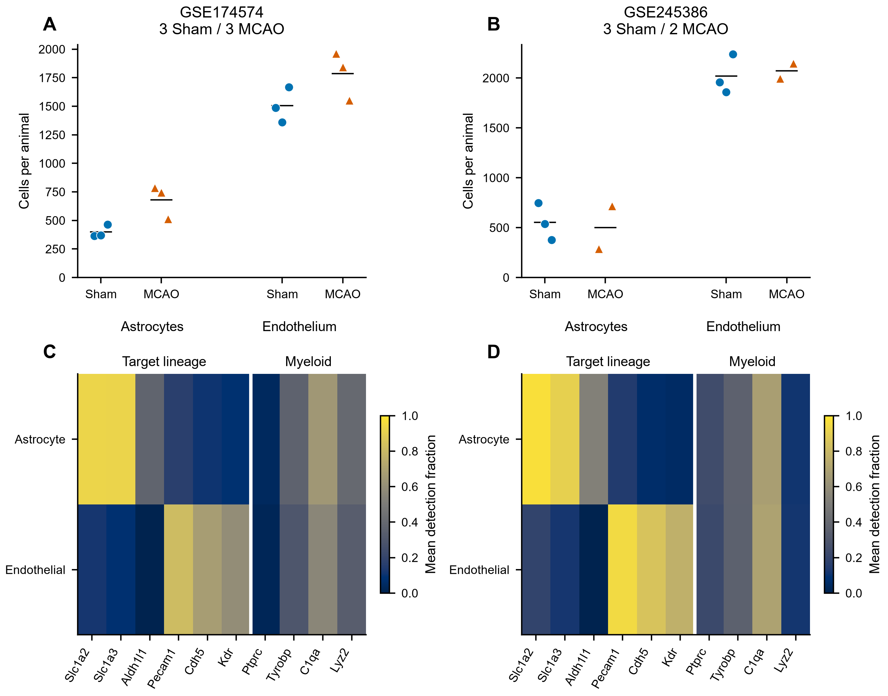

Figure 2
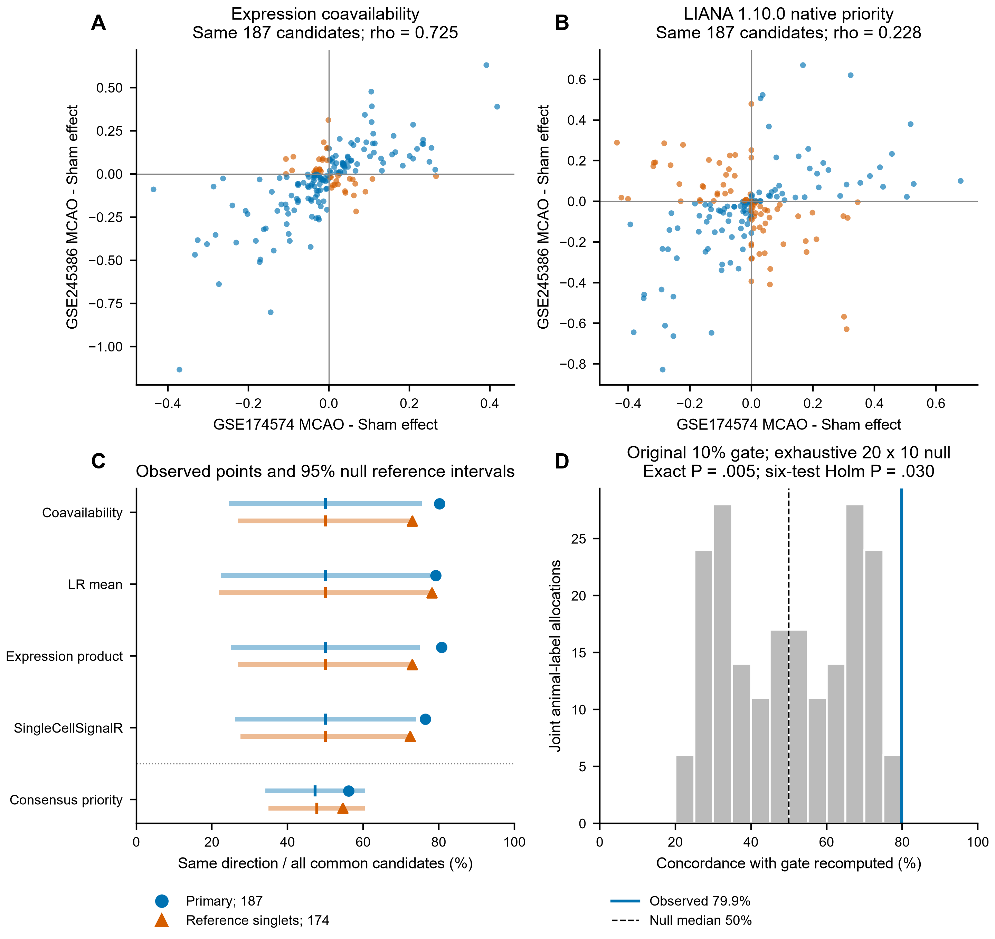

Figure 3
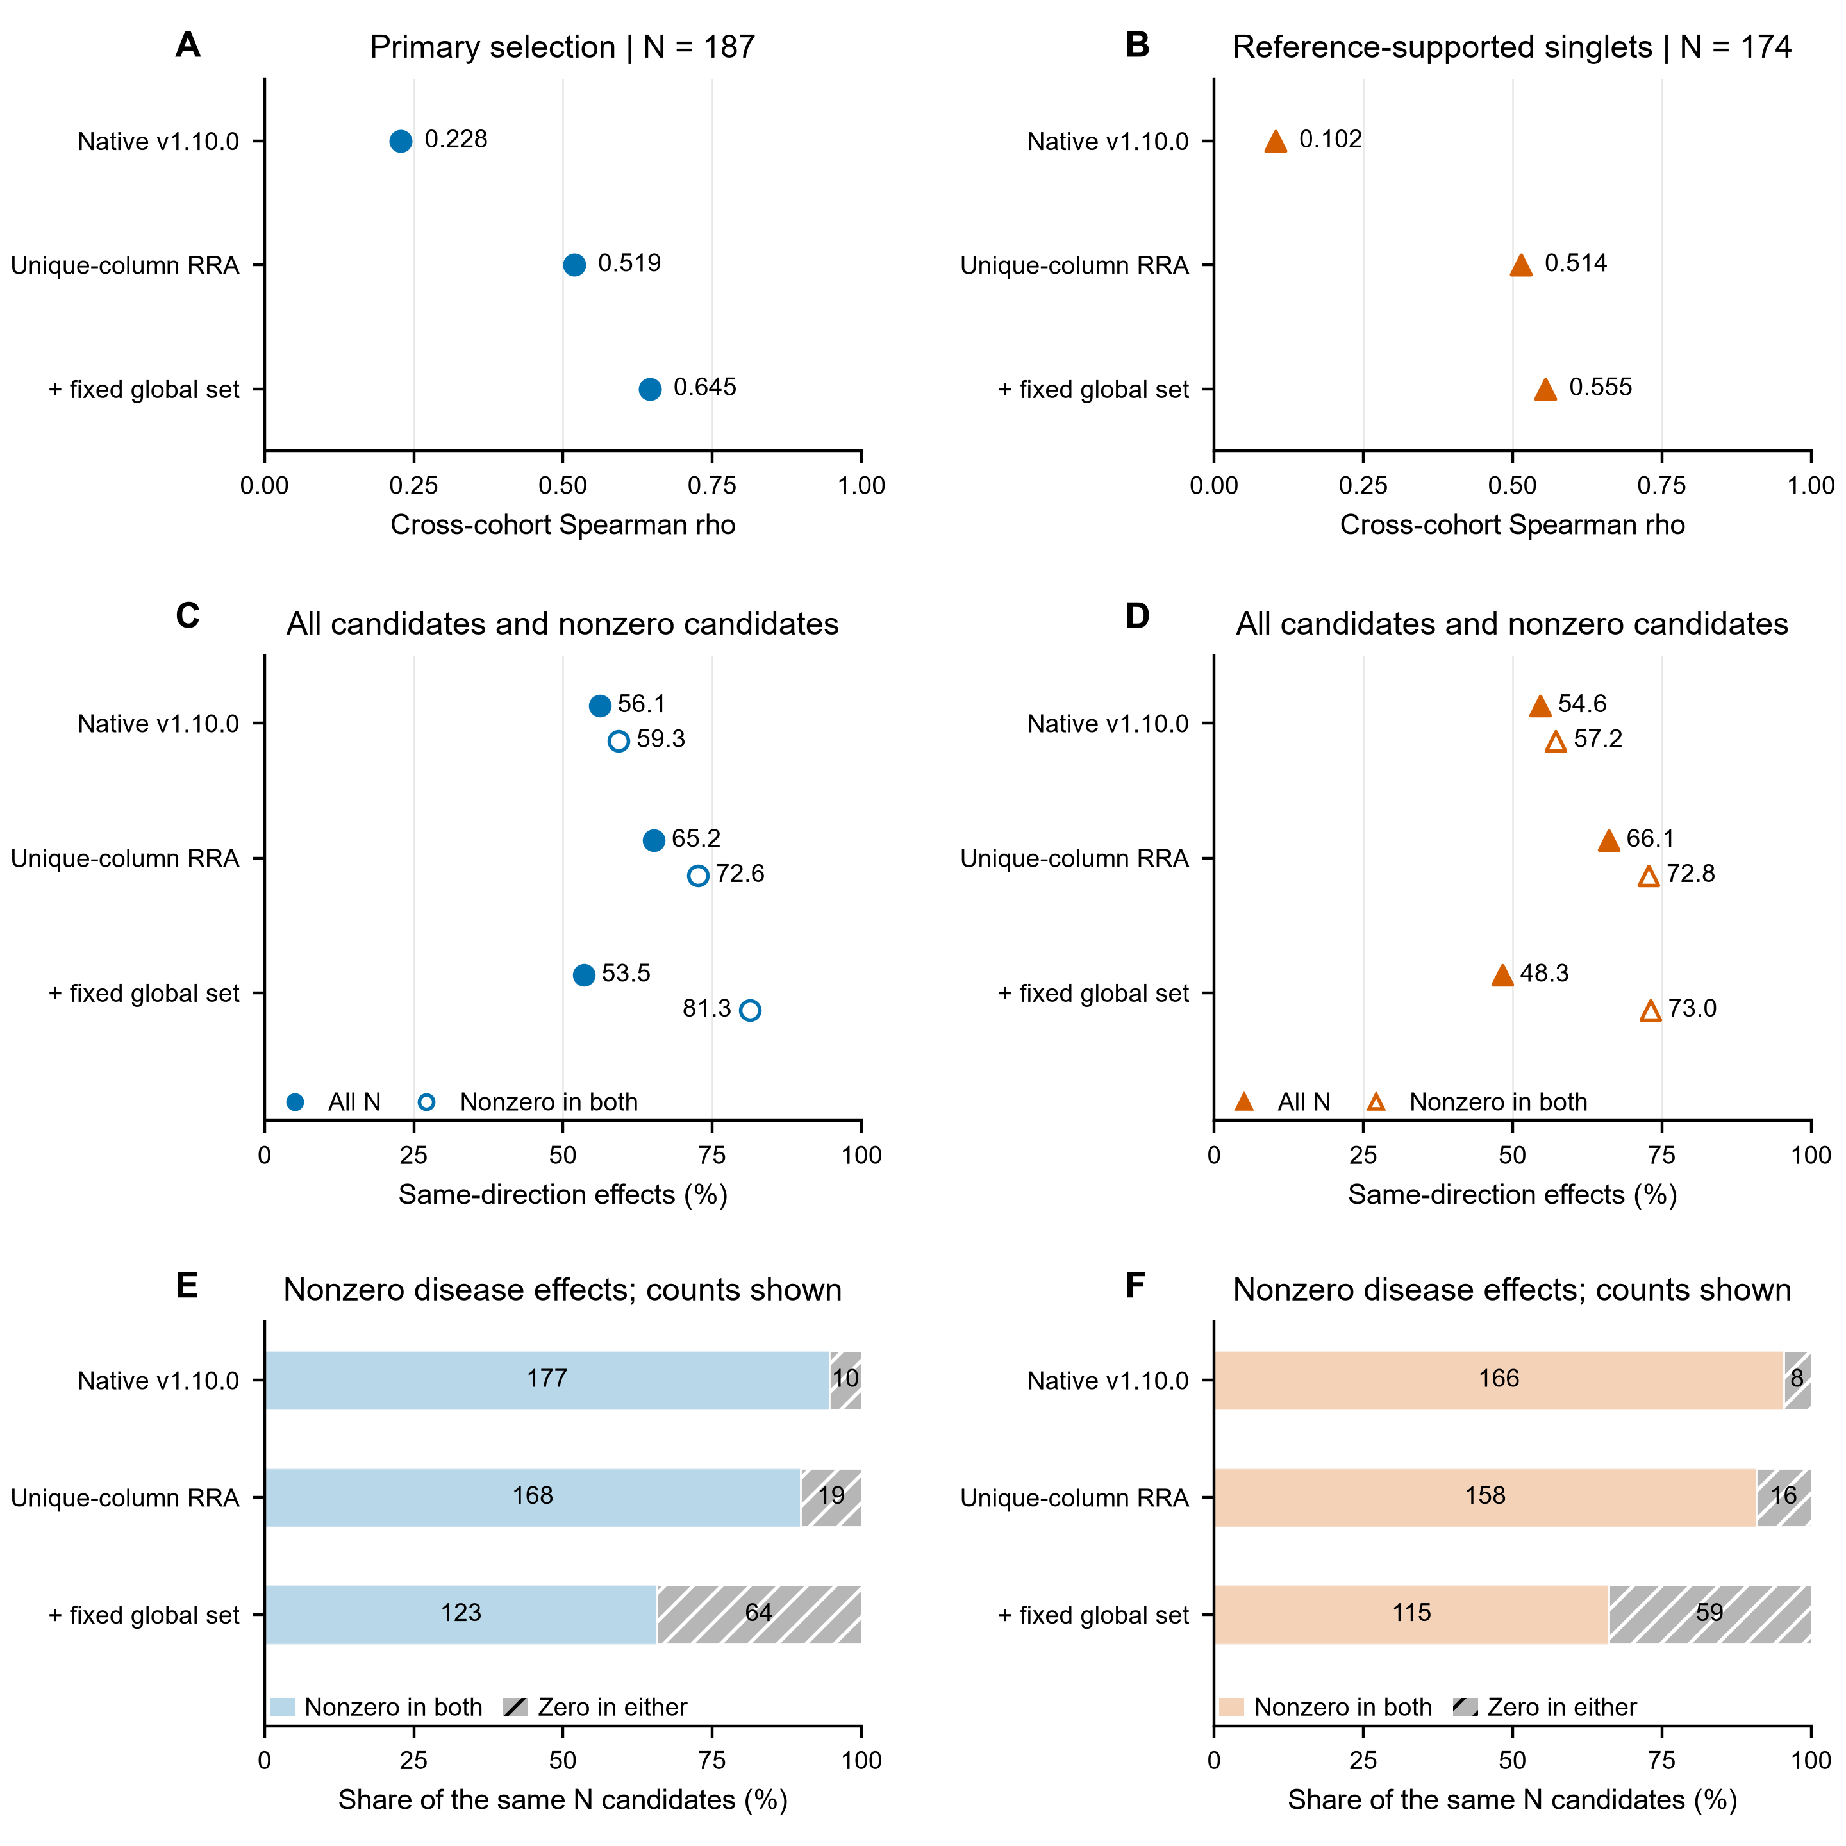

Figure 4
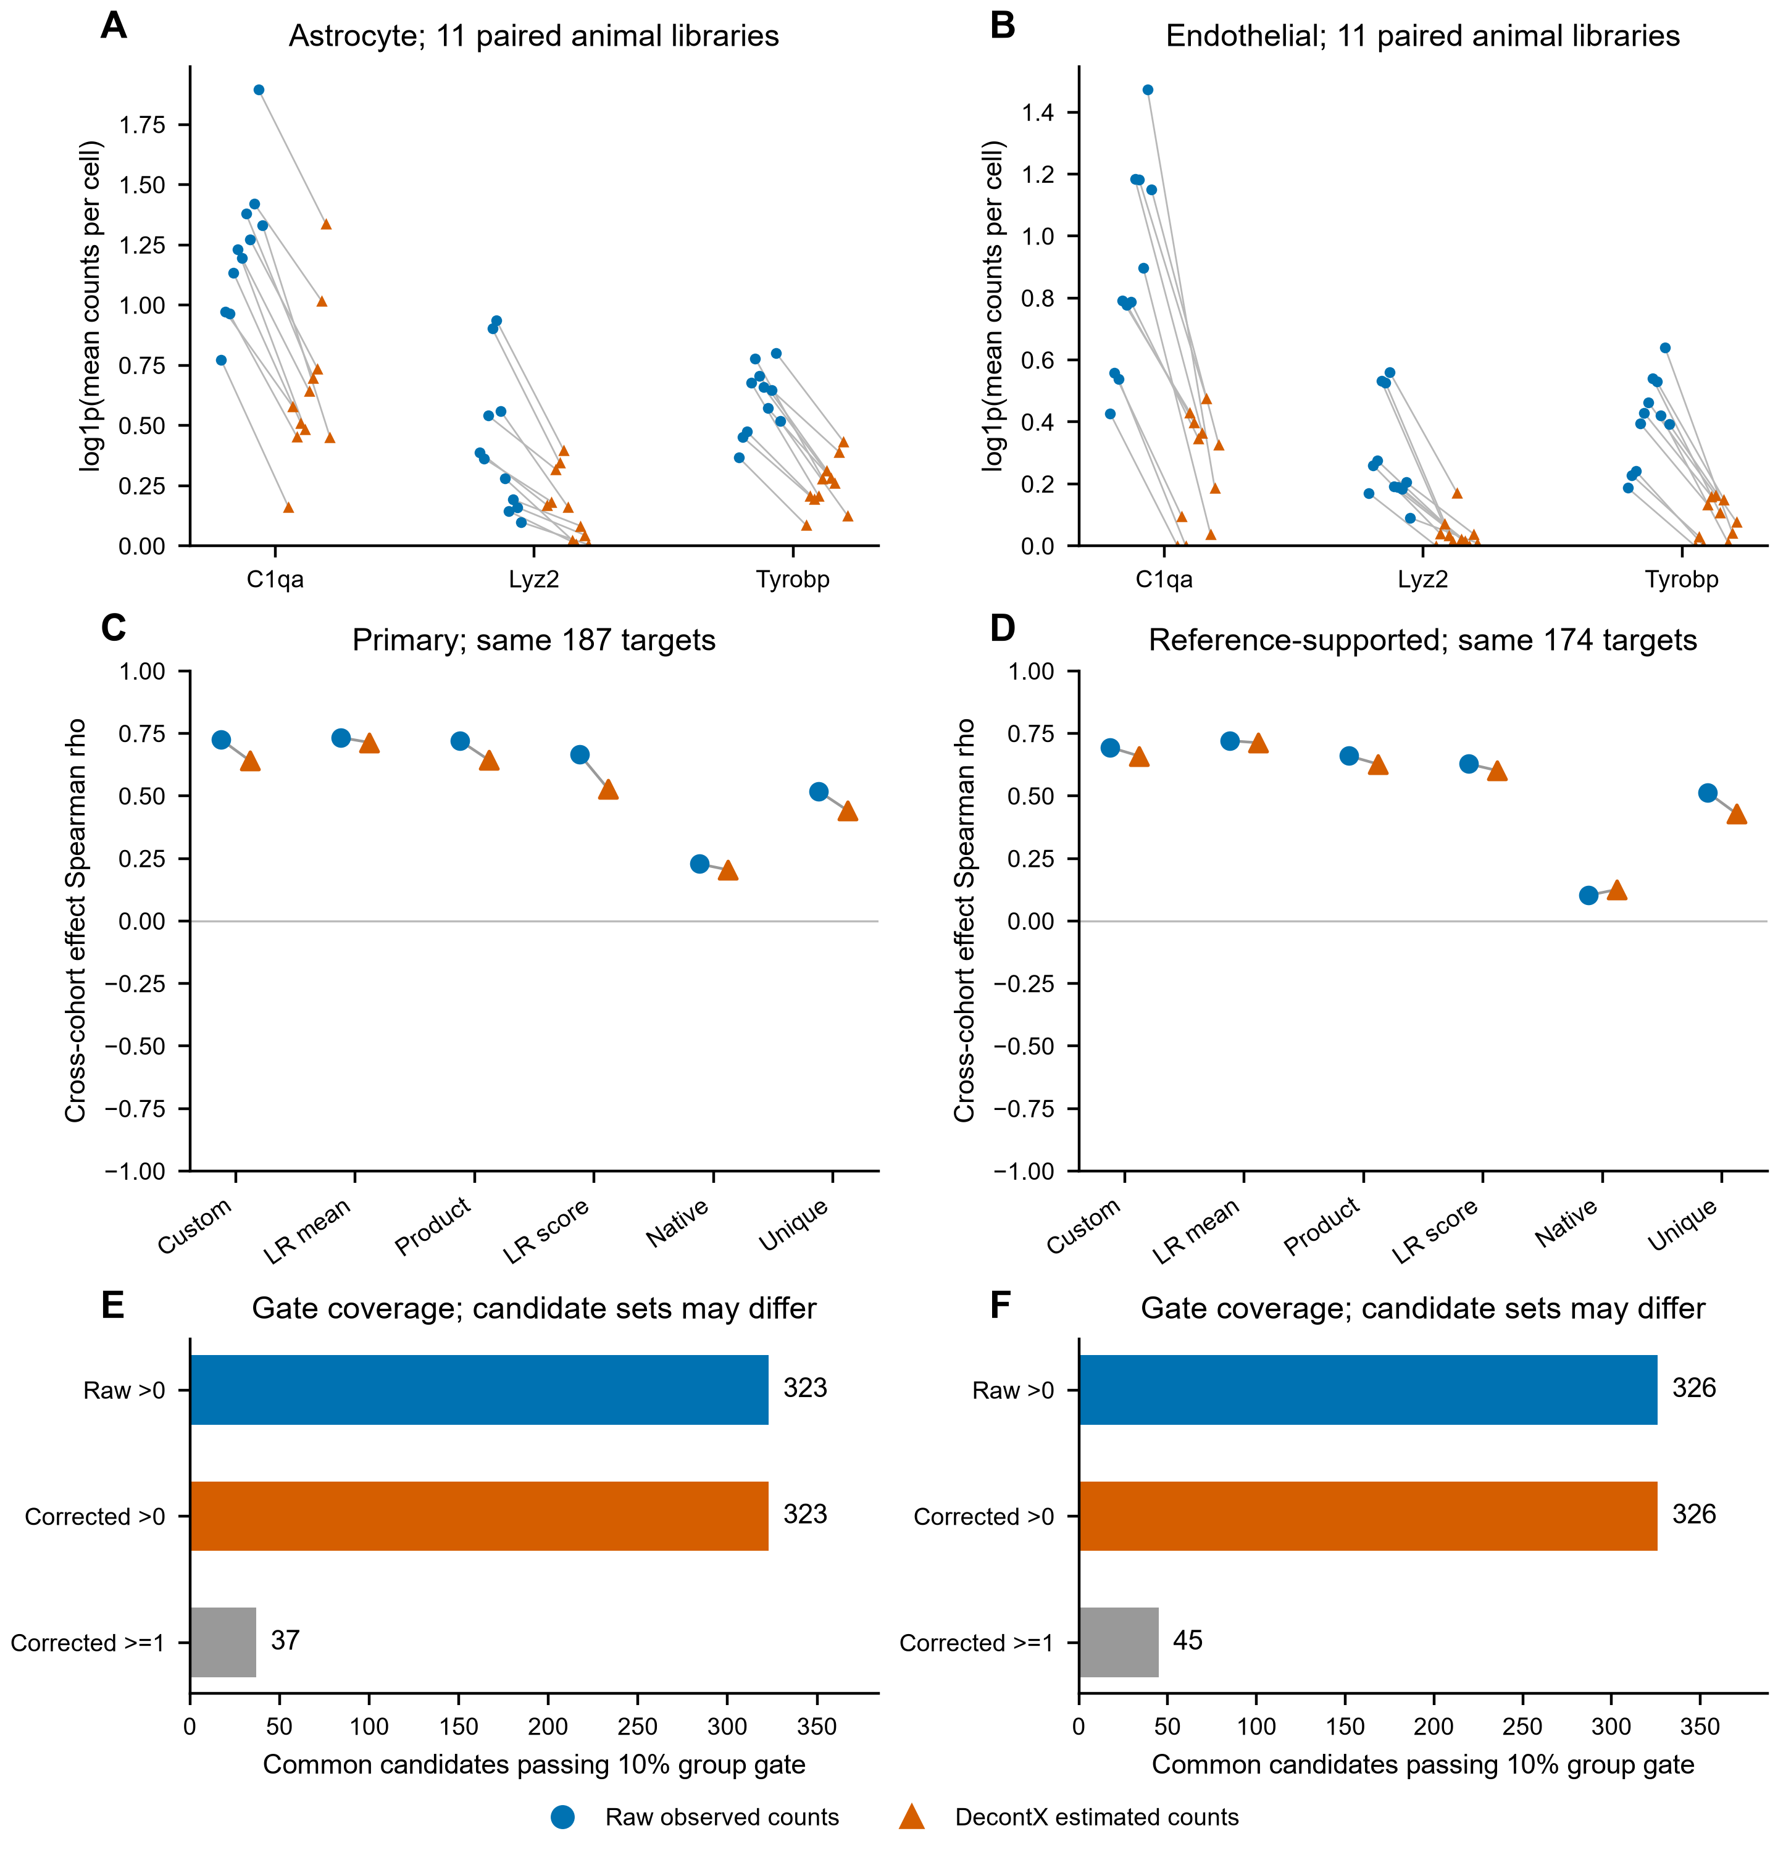

Figure 5
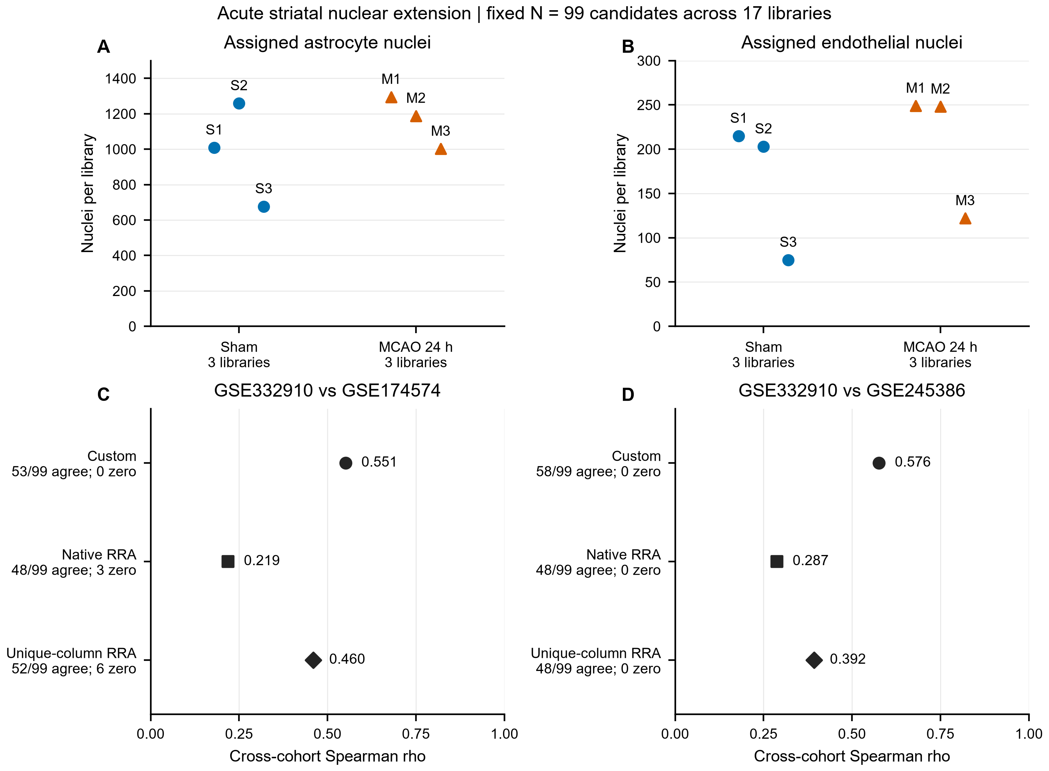

Supplementary Figure S1
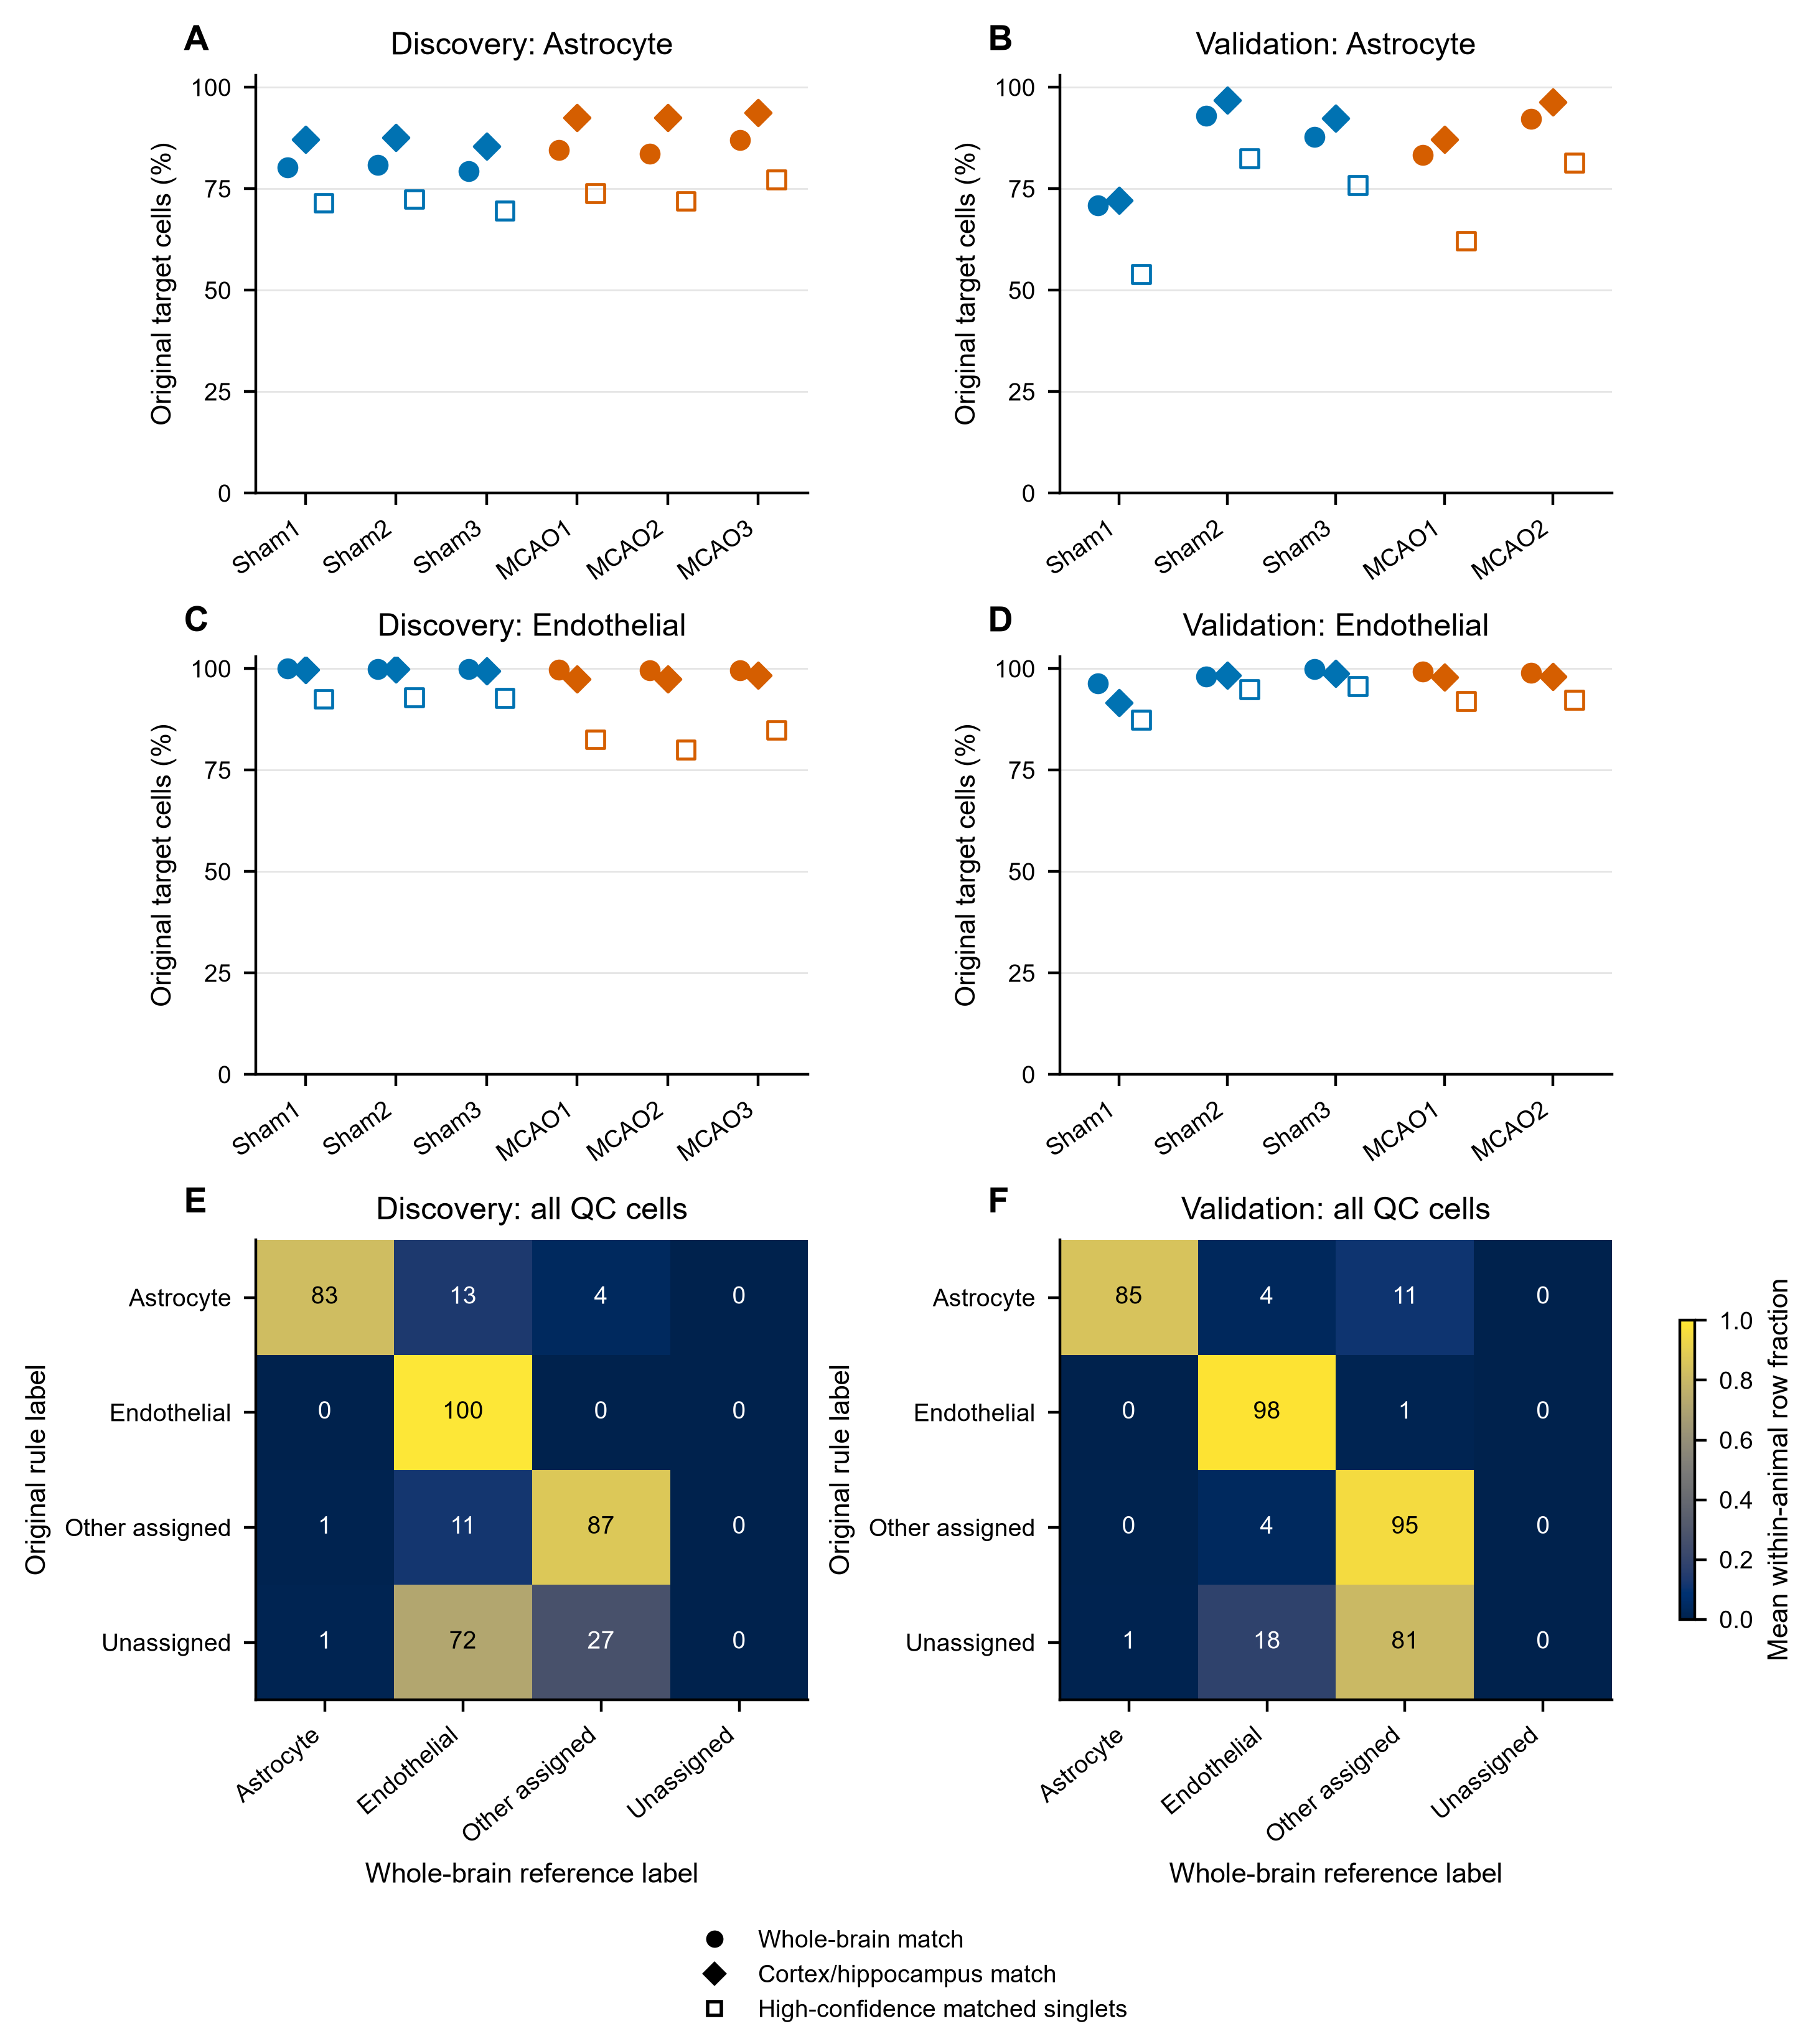

Supplementary Figure S2
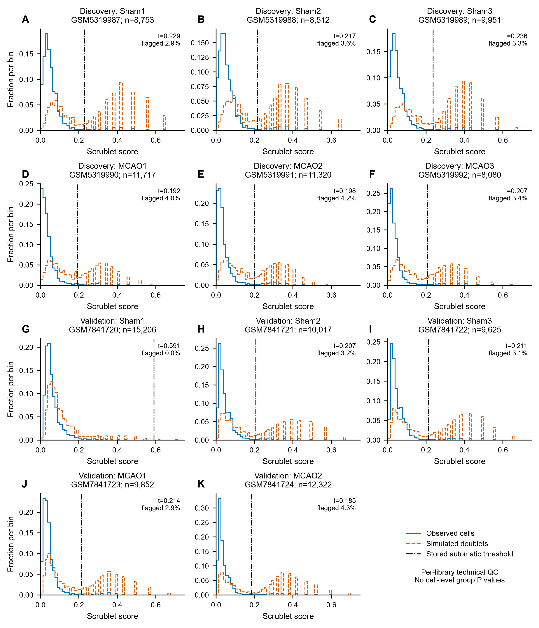

Supplementary Figure S3
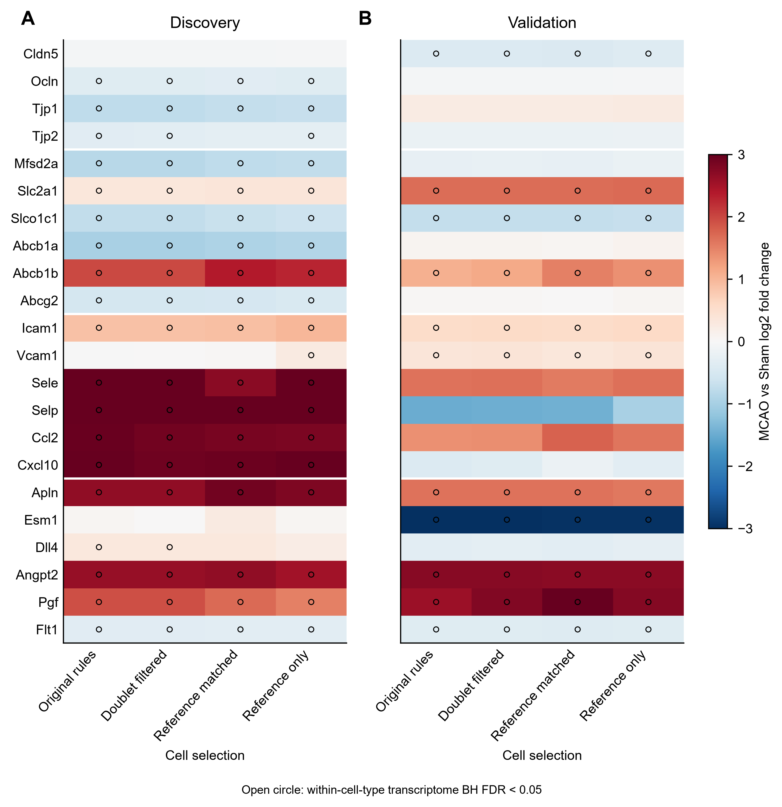

Supplementary Figure S4
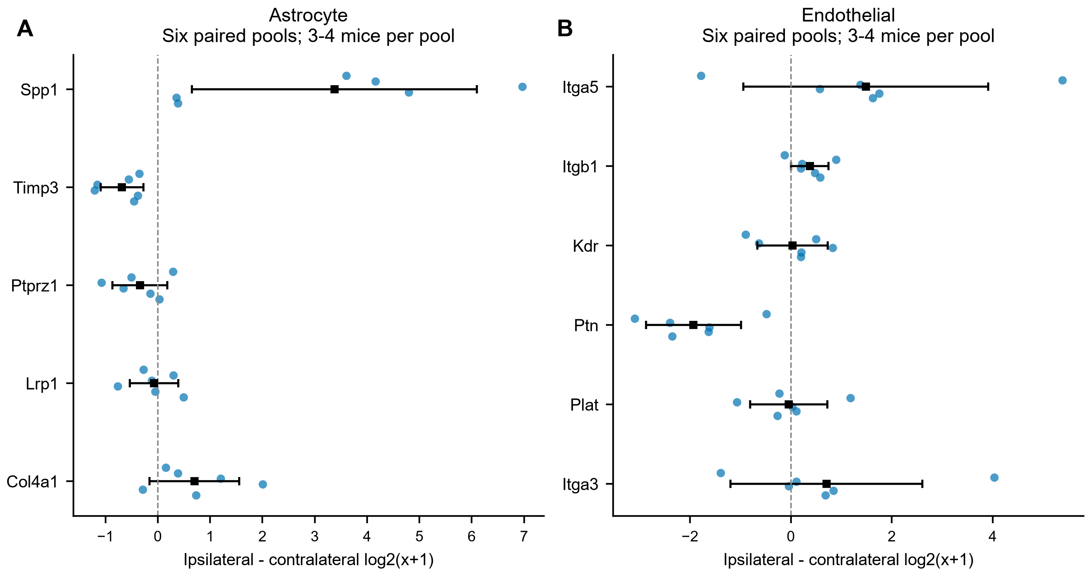

Supplementary Figure S5
