Instructions for creating a bootable SD Card using Vision Tracking Pi boot OS image and using the sample code

* Download and install Win32DiskImager from this location:

[https://sourceforge.net/projects/win32diskimager/](https://sourceforge.net/projects/win32diskimager/vision_tracking.img)

* Get the Pi image for vision tracking from this location and save it your PC

<https://github.com/Pigmice2733/Vision-Tracking/tree/master/rpi3_images/vision_tracking.img>

* Format and insert a 32GB or larger SD card into your laptop.
* Run Win32DiskImager application you installed above. Browse to the location of the Pi image file that you downloaded from Pigmice GitHub.
* Follow these steps (Page 2 of this document) to create a bootable SD using the Pi image

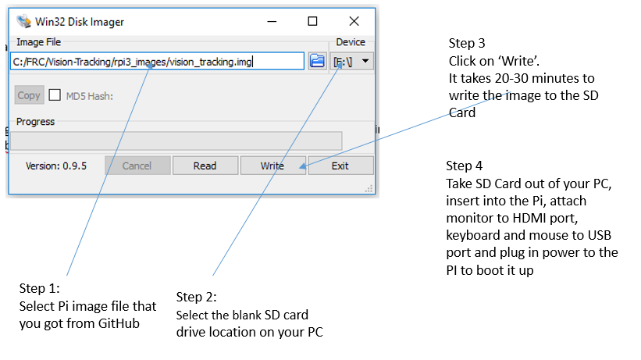

* After the Pi desktop has booted up, run Geany. Geany is a really editor and works great for writing Python code. You should see all the samples that we worked with Tuesday. For your Windows PC you can download Geany from here:

<https://www.geany.org/Download/Releases#windowsBinaries>

The following are the samples:

To run the example, go into terminal (command-prompt) [icon on the top bar in Pi desktop]

Commands that you need to type in are in bold.

Type in:

**workon cv3**<enter> (this loads the virtual machine environment for running OpenCV3 and Python3 libraries and shared files in isolation without being overwritten)

test_image.py: demonstrates grabbing an image from the camera and showing it on the debug window

Run it by typing in:

**python test_image.py**<enter>

test_video.py: demonstrates getting a video stream into your code as a stream of images that you can process. Display live video in a debug window.

Run it by typing in:

**python test_video.py**<enter>

object_movement.py: demonstrates how to track a single color object (green in my sample), illustrates the creation of mask for the color green, finding the contours and the center of what is being tracked

Run it by typing in:

**python object_movement.py**<enter>

bunny_track.py: demonstrates how to do tracking of an arbitrary object. In this example, you will need to press ‘i’, then select four corners of what you need to track from the still image, then hit any key after that to start tracking what you selected.

Run it by typing in:

**python bunny_track.py**<enter>

edges.py: this one was inspired by Ron’s suggestion Tuesday that it would be good to track bumpers of other robots, possibly to fire Nerf gun at them. It demonstrates a simple example of one way to track the bumpers of another robot. It uses a very classic edge detection algorithm called Canny edge detector, which does not rely on color or shapes of objects in an image.

Run it by typing in:

**python edges.py**<enter>

What to buy if you want to play with the Pi at home for vision tracking:

Board:

[https://www.amazon.com/Raspberry-Pi-RASP-PI-3-Model-Motherboard/dp/B01CD5VC92](%20https://www.amazon.com/Raspberry-Pi-RASP-PI-3-Model-Motherboard/dp/B01CD5VC92)

Camera:

<https://www.amazon.com/Raspberry-Pi-Camera-Module-Megapixel/dp/B01ER2SKFS>

SD Card (64GB):

<https://www.amazon.com/dp/B010Q588D4>

Case & power supply:

<https://www.amazon.com/Smraza-Starter-Raspberry-Supply-Heatsinks/dp/B01I1OESI6>