16/11/2024
Priority level guide:
Level 0: Base sheets
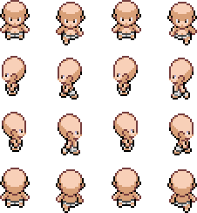
Level 1: base Clothes
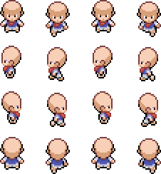

Level 2: “Male” Hair style (1,2,4)
Hair style #1
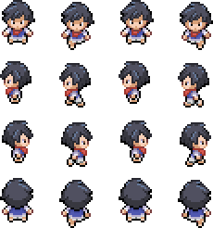
Hair style #2
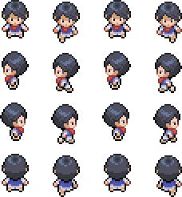

Hair style #4
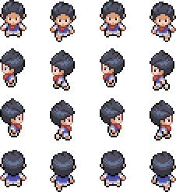
Level 3: back view elements (scarf, hoddie bag, backpacks, etc…)
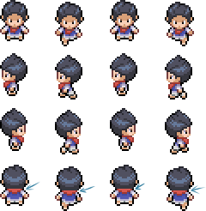

Level 4: hair style #3
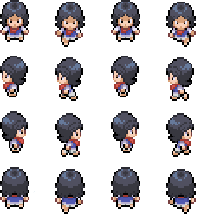
-¿Why is hair style #4 one level up? To avoid this…
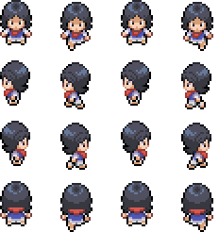
Level 5(coming soon…): hats, cat ears, capes, etc..

