DSS2 Project Report
Todo Management API
1. Overview
A RESTful Todo application with JWT authentication, public/private todo access, pagination/filtering/sorting and PostgreSQL. Backend also containerized in Docker. React fronted(was provided) included for testing.
2. How to run locally
1. appsettings.Development.json Connection String set to: “Host=localhost;Port=5432;Database=todo_db;Username=todo_user;Password=0987654321”
2. Start PostgreSQL
3. Run migrations:
“dotnet ef database update”
4. Run API:
“dotnet run”
5. Check Swagger:
“http://localhost:3087/swagger”
2.1 How to run frontend
1. “cd dss2-frontend”
2. “npm install”
3. “npm run dev”
4. UI runs on “http://localhost:5173”
3. How to run Docker
1. Build and start
“docker compose up --build”
2. Go to:
“http://localhost:3087”
4. DB Setup/Migrations
- Migrations are in /Migrations
- On Docker setup migrations applied automatically
- Tables created: Users, TodoItems, __EFMigrationsHistory

5. Swagger/Postman API Screenshots
1.Swagger UI
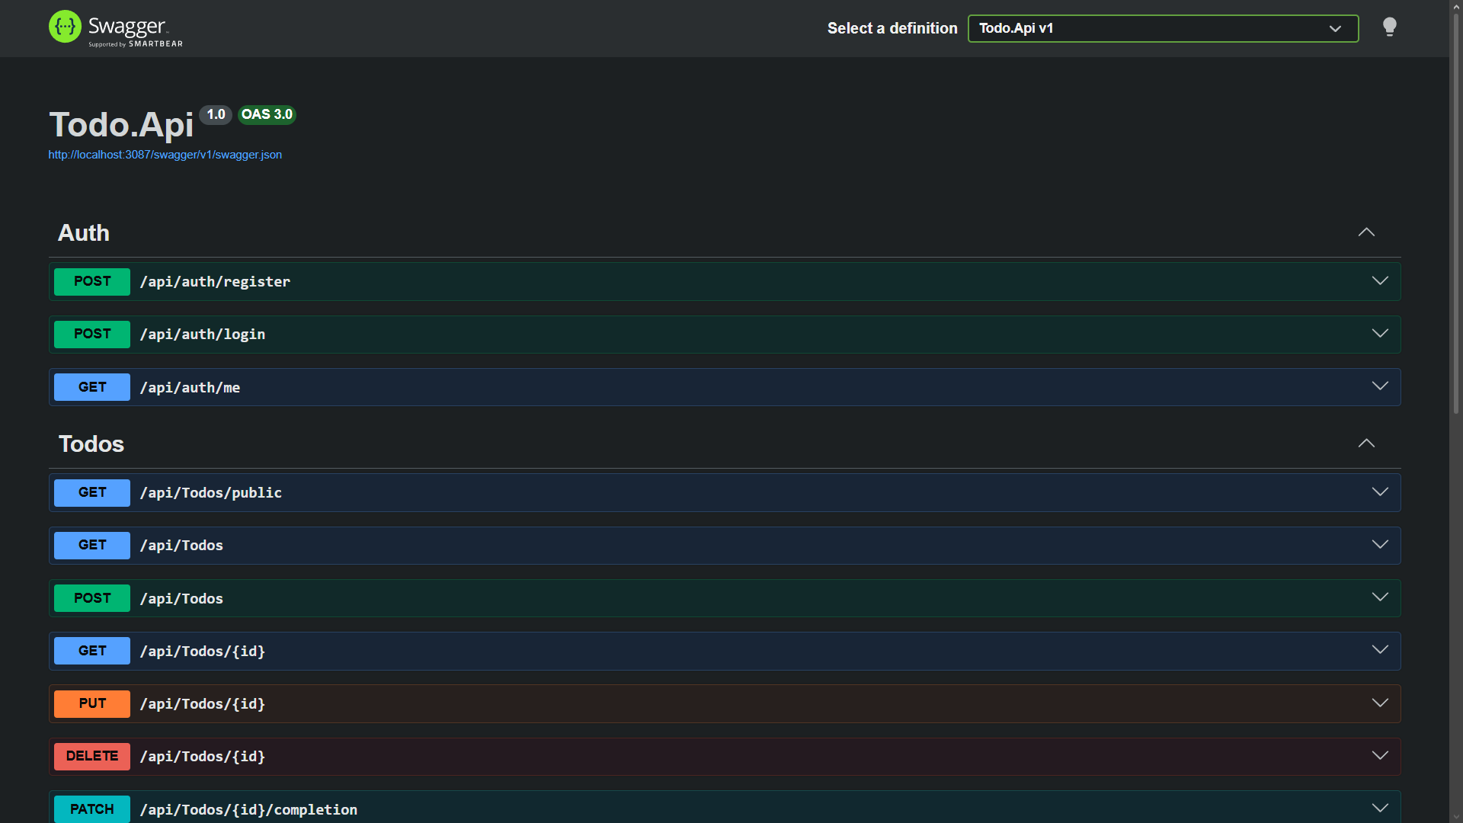

For request and response used I then used Postman as it’s more convenient and reliable with JWT testing.
2. Register
POST http://localhost:3087/api/auth/register
201 Created
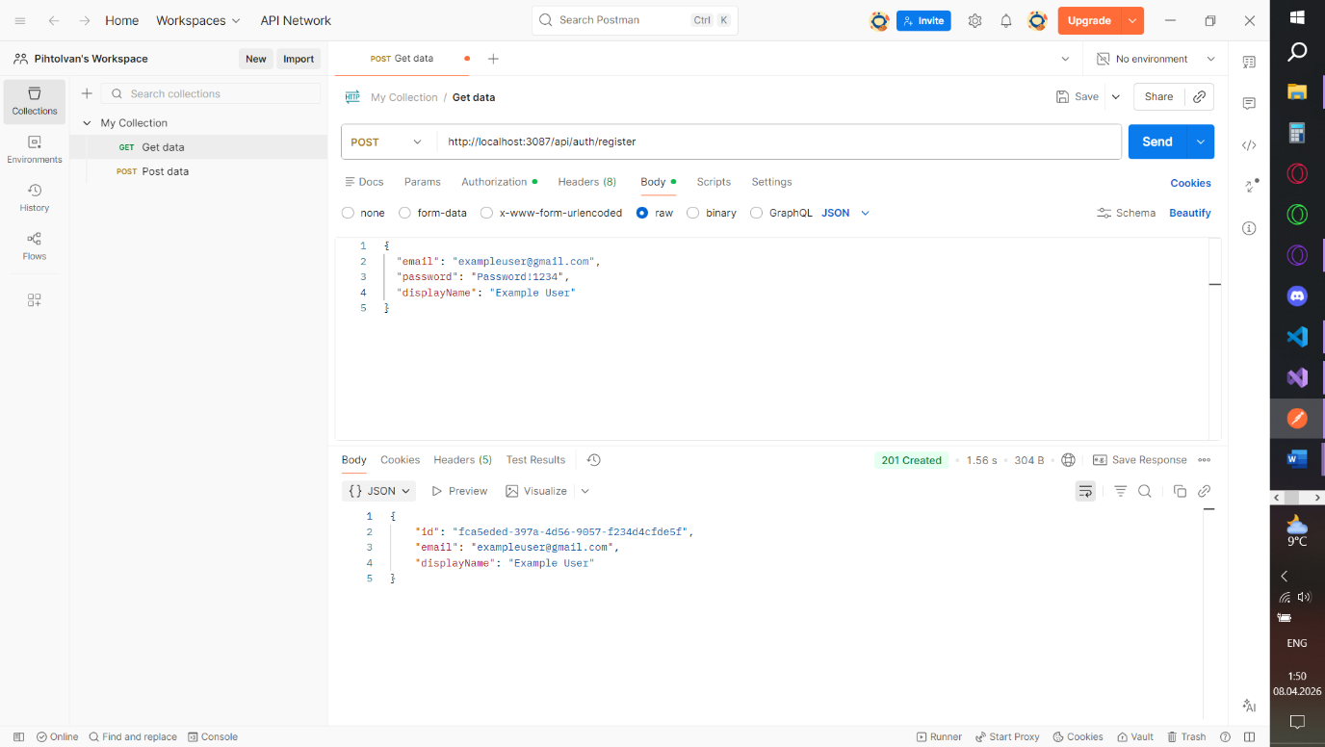
3. Login
POST http://localhost:3087/api/auth/login
200 OK
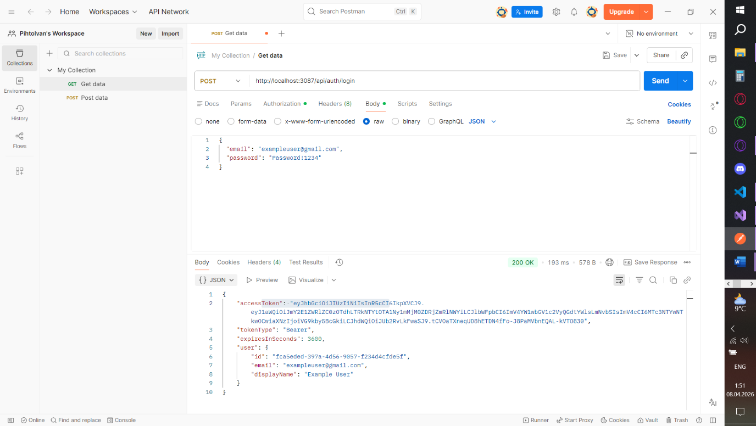
4. Create Todo
POST http://localhost:3087/api/todos
201 Created
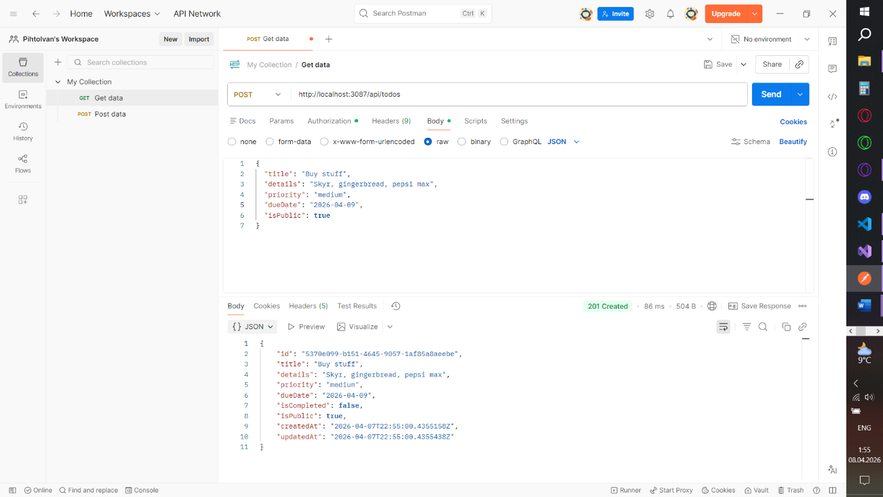
5. Get Public Todos
GET http://localhost:3087/api/todos/public
200 OK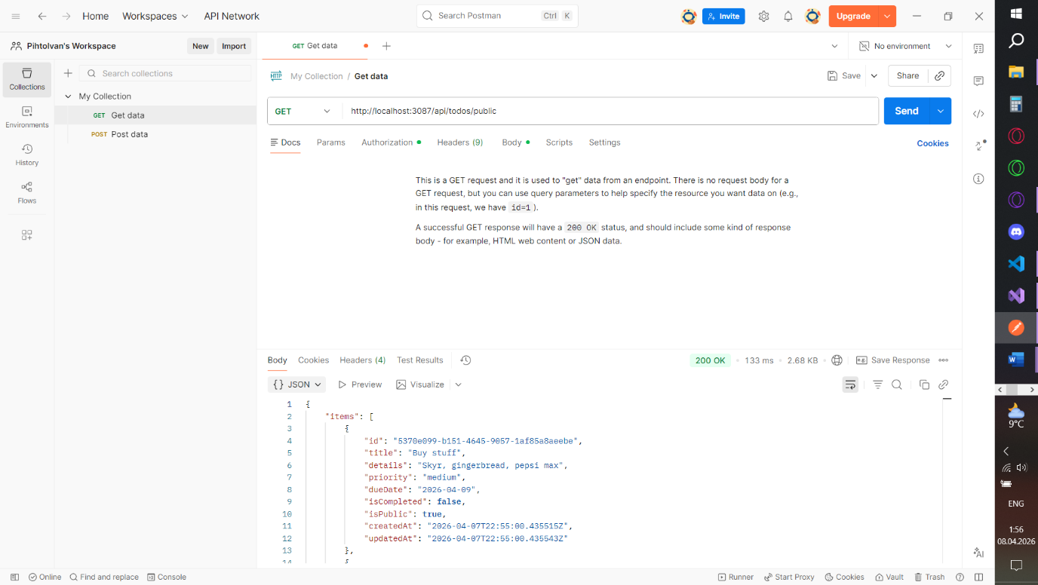
6. Get My Todos
GET http://localhost:3087/api/todos
200 OK
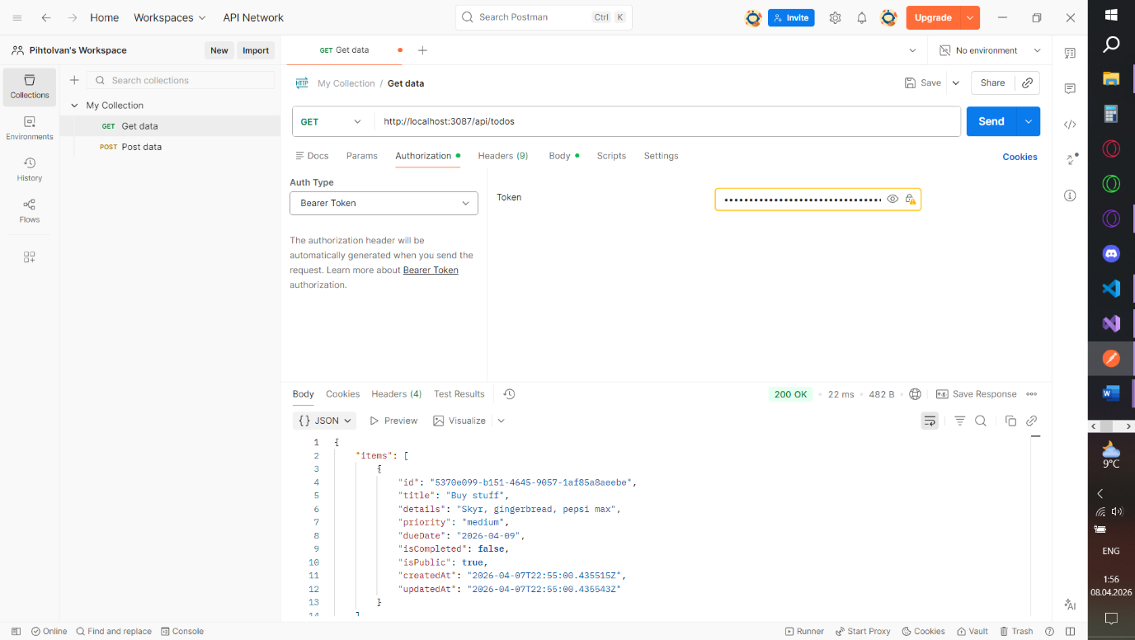

7. Update Todo
PUT http://localhost:3087/api/todos/id
200 OK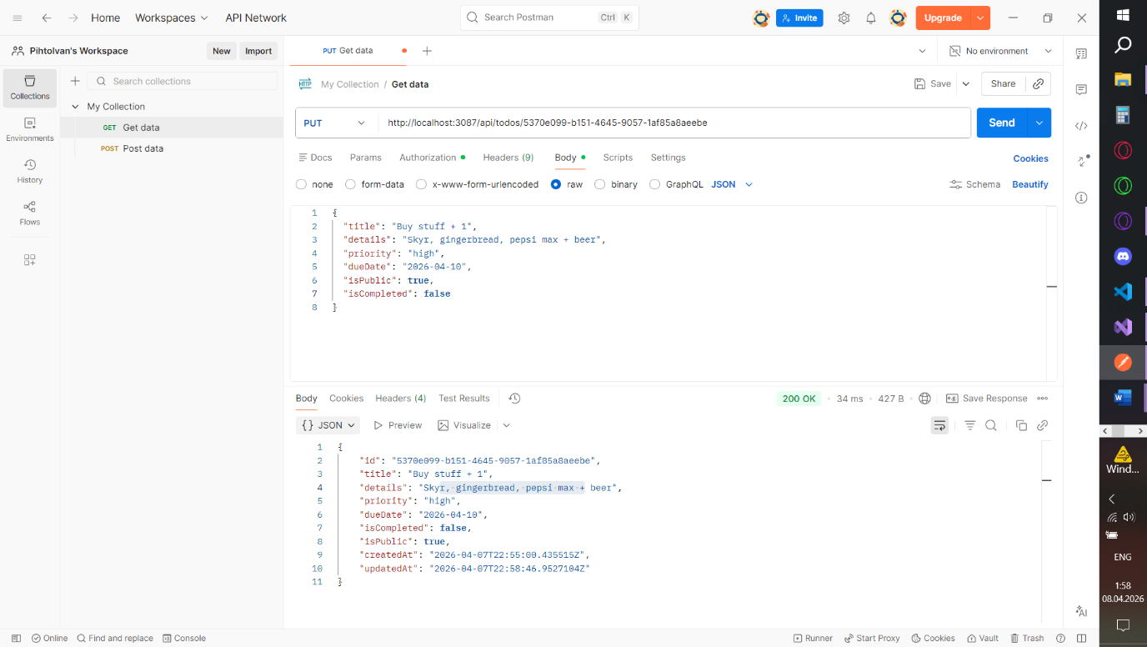
8. Complete
PATCH http://localhost:3087/api/todos/id/completion
200 OK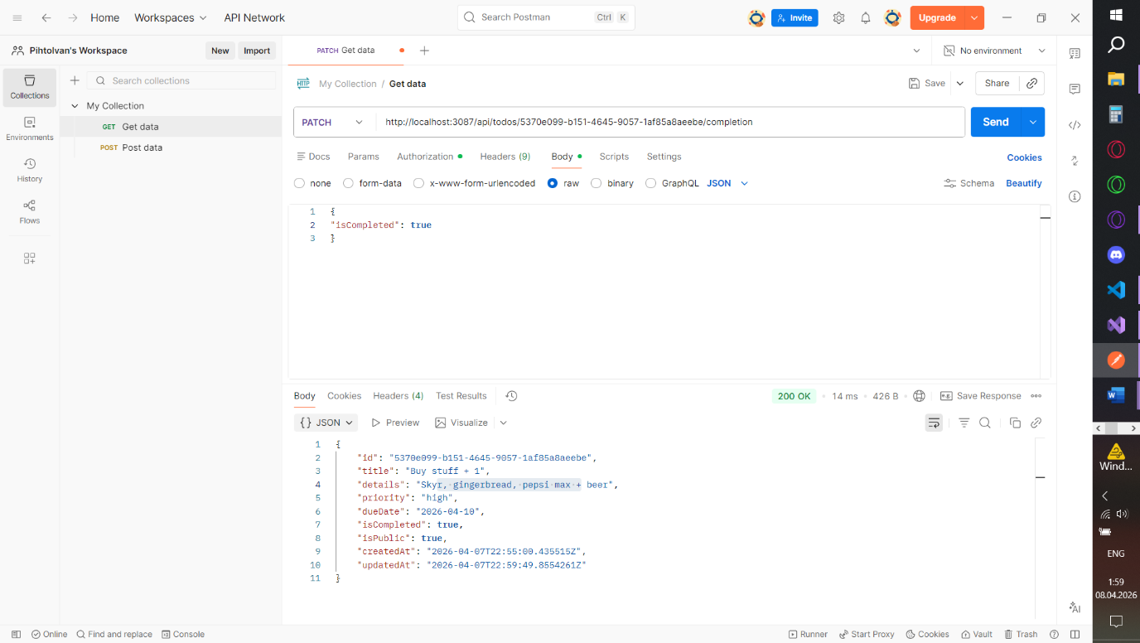

9. Delete
DELETE http://localhost:3087/api/todos/id
204 No Content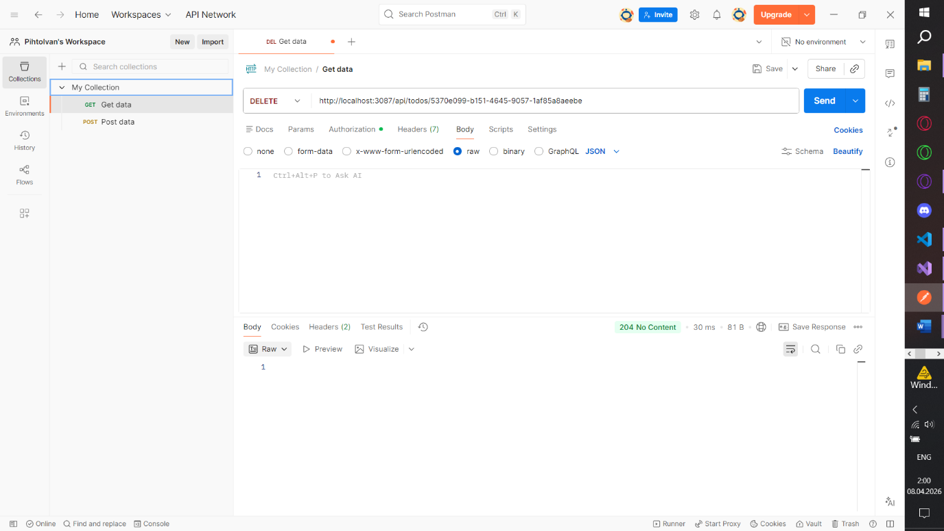
10. Invalid Priority
POST http://localhost:3087/api/todos
400 Bad Request
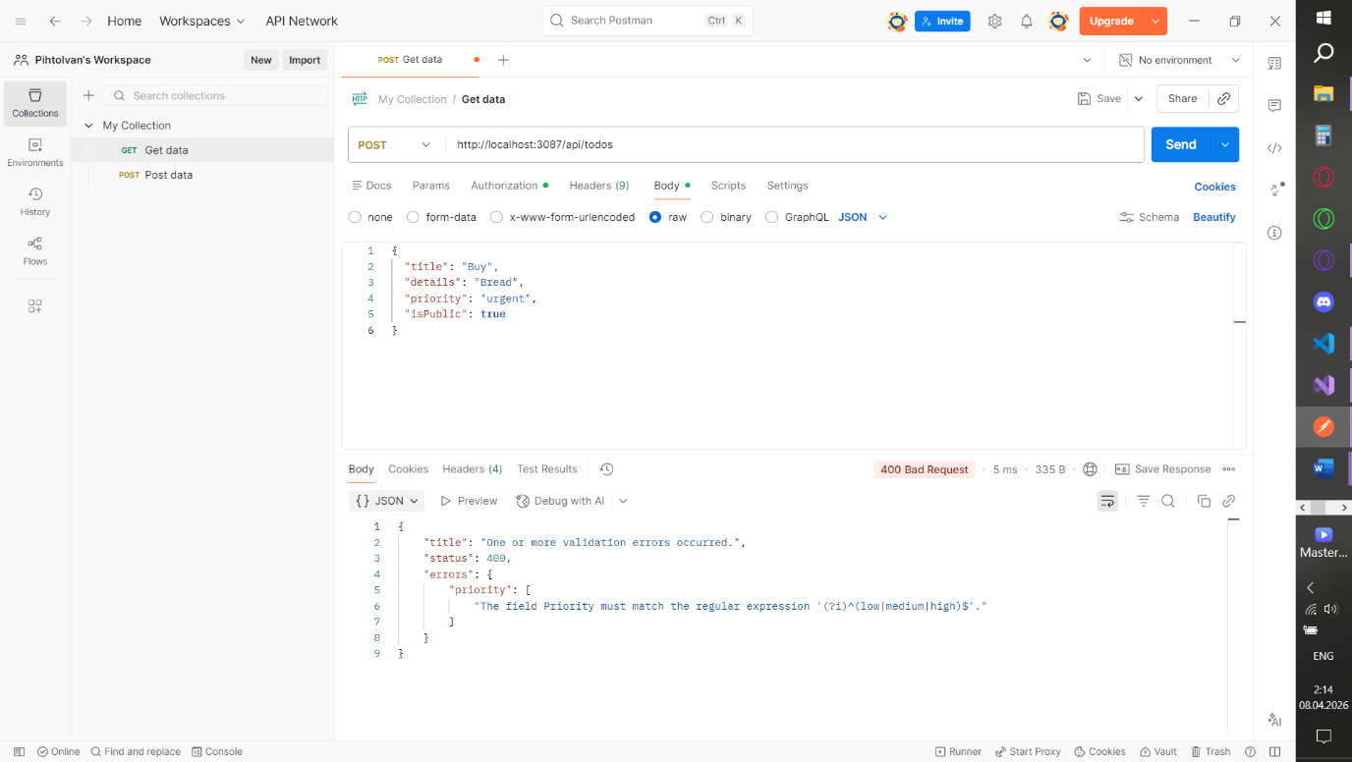

11 Unauthorized Access
GET http://localhost:3087/api/todos
401 Unauthorized
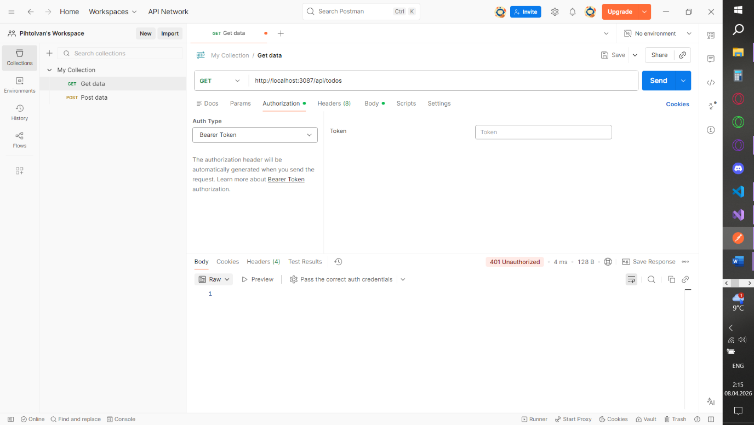
6. Database Screenshots
Users Table: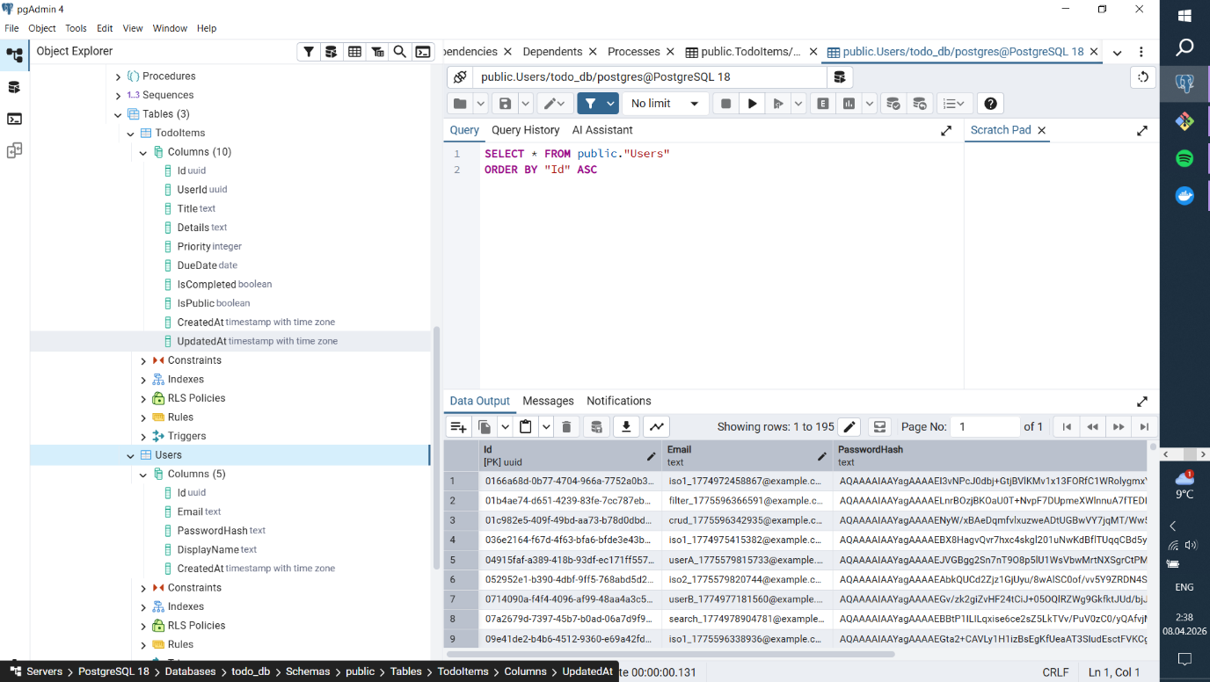
TodoIdtems Table:
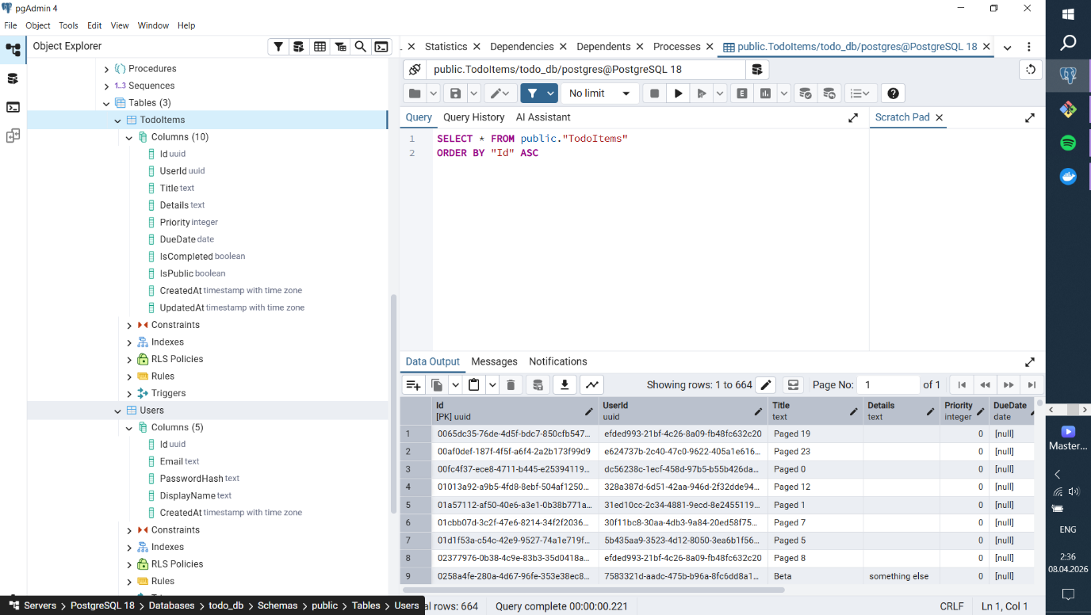
7. Cypress Test
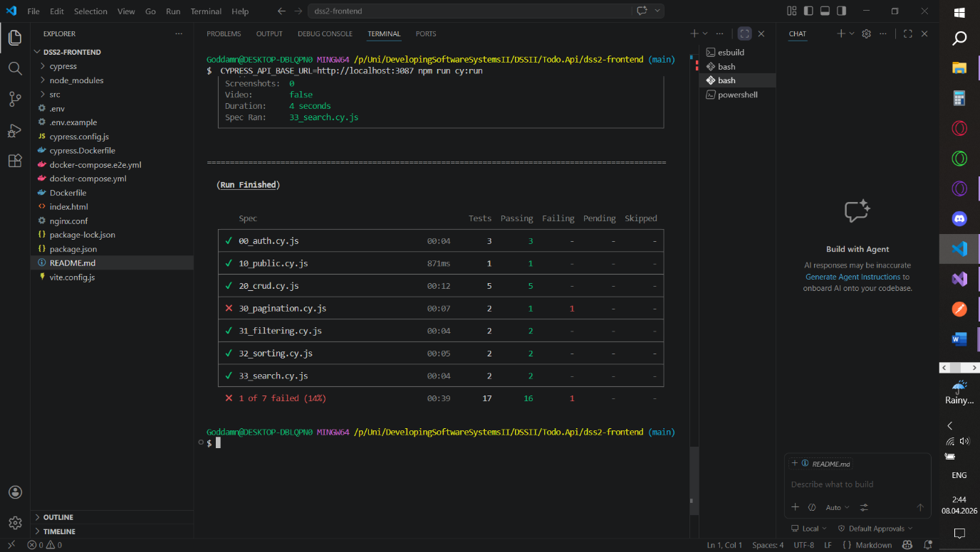
All tests going smoothly excluding 30_pagination