Web Programming Report
Paradise Hotel - React App
1. Overview
Paradise Hotel is a React based web application designed for both hotel guests and administrators. The application serves as a frontend interface for the Paradise Hotel API, which manages authentication, hotel locations, room inventory, and bookings.The project emphasizes a clean UI/UX, responsive design, and robust integration with a RESTful backend.

2. Stack
- Frontend Framework: React (Vite)
- Routing: React Router DOM
- UI Library: MUI
- HTTP Client: Axios
- State Management: React Context (Auth Provider)
- Authentication: JWT (JSON Web Token)

3. Project Structure
- /src/api/api.js: Centralized Axios instance configuration. It includes a request interceptor that automatically attaches the JWT Bearer token from localStorage to all authenticated requests
- /src/components/: Shared UI components including:
  - Layout.jsx: The main application shell
  - Navbar.jsx: Responsive navigation that adapts based on user role (Guest and Admin)
  - AdminNav.jsx: Tabbed navigation specifically for administrative pages
  - PageContainer.jsx: A standardized wrapper for consistent layout spacing

- /src/pages/: Main views for guests (Home, About, Search, My Reservations)
- /src/pages/admin/: High-privilege pages for data management and reporting
- /src/theme.js: Custom MUI theme configuration
- /src/auth/: Contains route guards (RequireAuth, RequireAdmin)

4. Core Functionalities
4.1 Guest & User Features
- Authentication: Users can Register and Login. Session data is stored under the key paradise_auth

- Room Search & Filtering: A sophisticated search interface allows users to find rooms by date and capacity. Results can be filtered by city, rating, and specific amenities (Free Parking, Wellness Center)

- Booking Management: Authenticated users can book rooms and manage their stay via the "My Reservations" page, which includes the ability to cancel active bookings

4.2 Administrative Features
- Dashboard: A data-driven overview displaying:
  - Summary cards for total locations, rooms, and reservations
  - Reservations by month
  - Status distributtion (Active and Cancelled)
  - Performance metrics for top hotel locations

- Locations CRUD: A full management suite to Create, Read, Update, and Delete hotel locations with integrated form validation

- Room & Reservation Control: Admins have control of all roomsw and can cancel any reservation across the system

5. Technical Implementation
5.1 Route Protection
The application uses a declarative routing approach in App.jsx. Specific routes are wrapped in RequireAuth or RequireAdmin components. If an unauthenticated user attempts to access these pages, they are redirected to the login page, preserving their intended destination in the navigation state

5.2 API Interceptors / Error Handling
In api.js, an interceptor checks for the existence of a token before every request. The application handles API errors (400, 401, 403, 404, 409) by catching Axios exceptions and displaying Alert components

6. How to Run
- npm install

- npm run dev

7. Flow Screenshots
7.1 No Auth
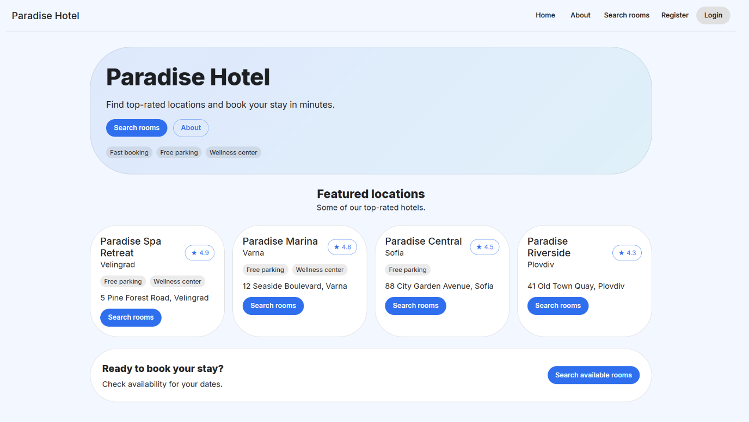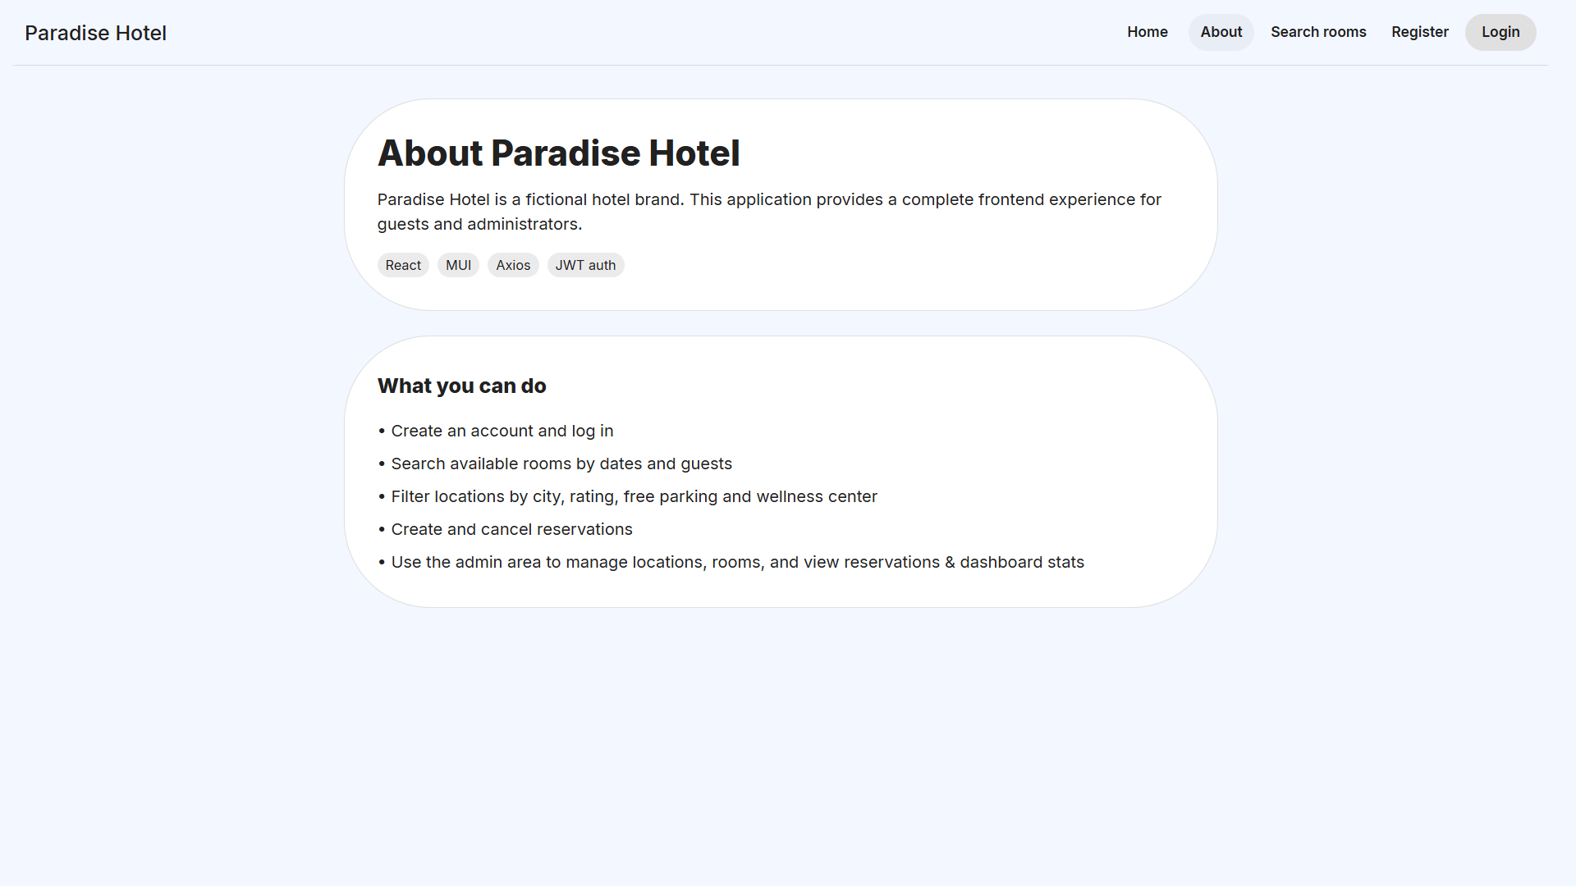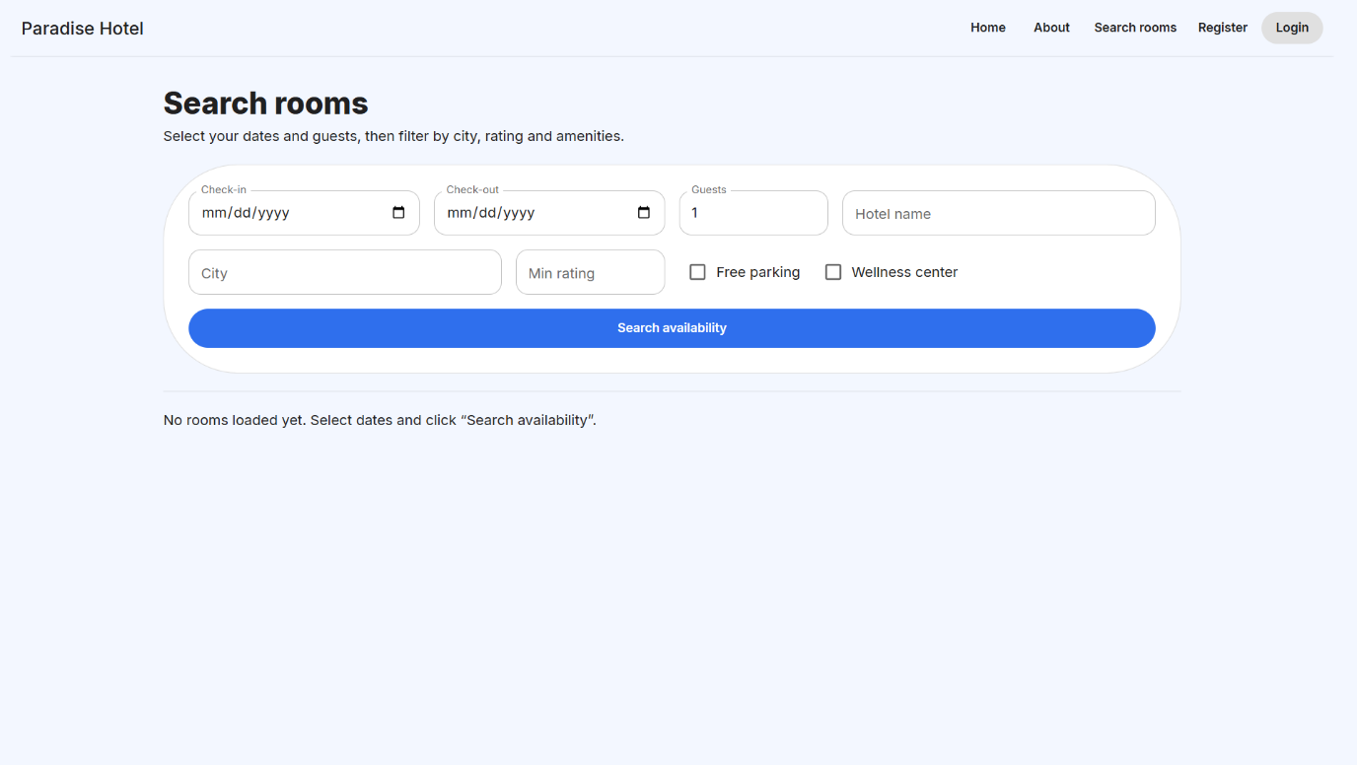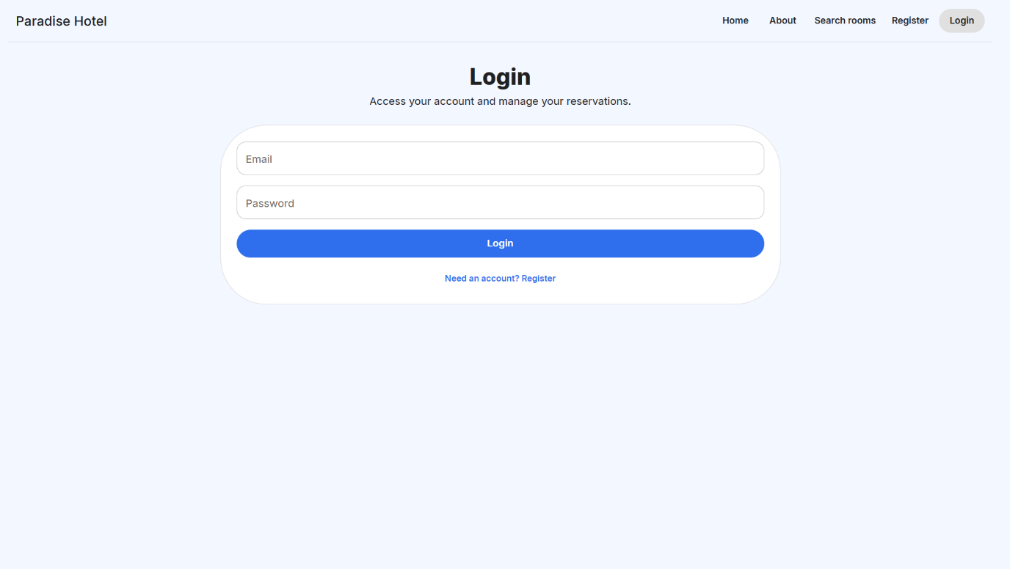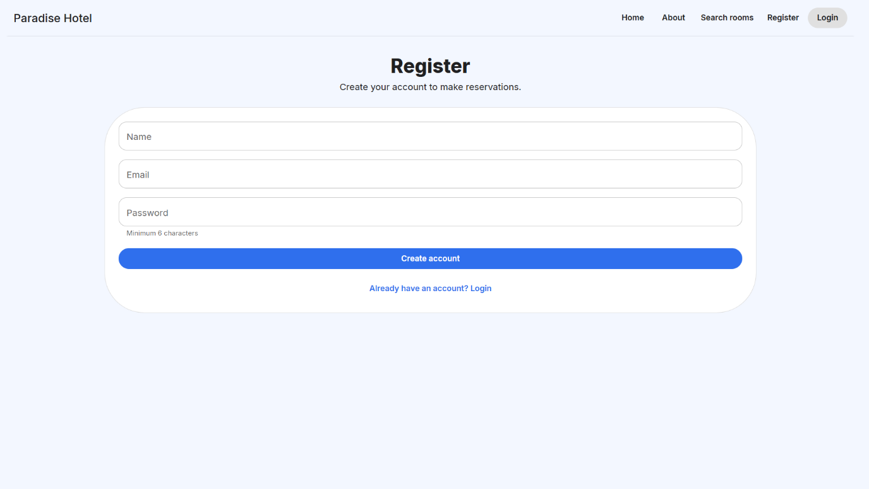

7.2 User Centered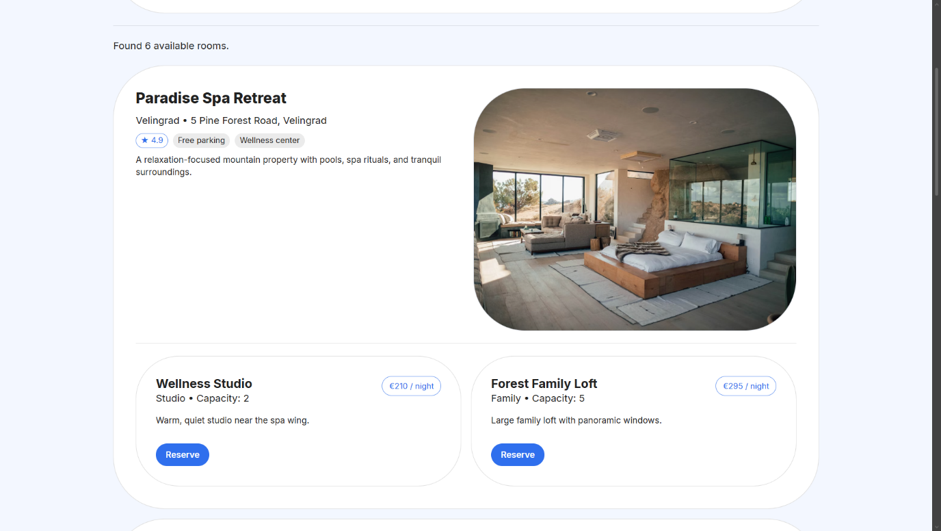
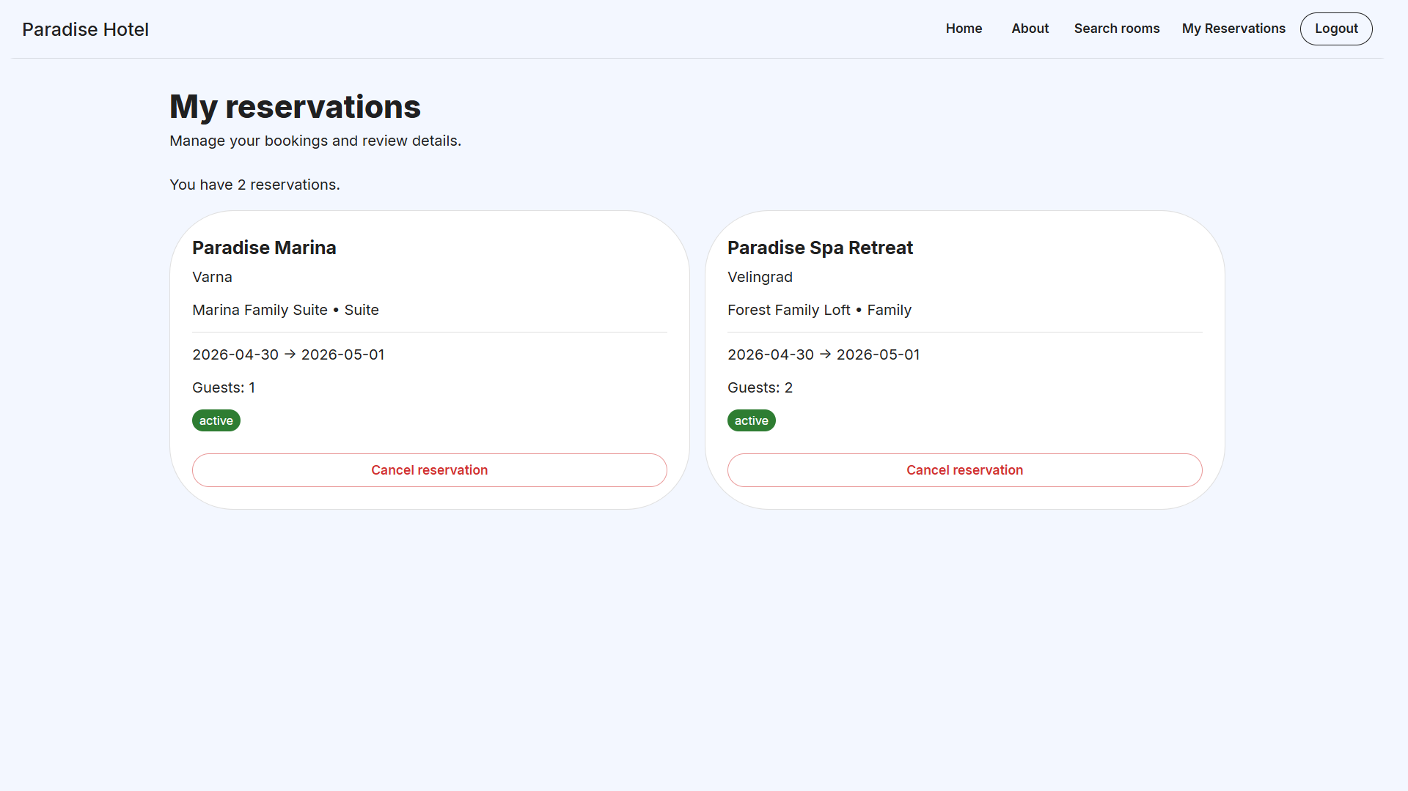

7.3 Admin Centered