"Responsive Web-Based Patient Referral and Admission System for Salaam Hospital”

COLLEGE OF INFORMATION AND COMPUTING STUDIES
Mindanao State University – Main Campus

A Capstone Project 1
Presented to the Faculty of
College of Information and Computing Sciences

In Partial Fulfillment of the Requirements for the Degree of
Bachelor of Science in Information Technology

By:
Abdul Naafi A. Macapodi
Alimar B. Datunaim
Al-raafi C. Indanan

January 202
TABLE OF CONTENTS
TITLE PAGE ..................................................................................................................... i
TABLE OF CONTENTS ................................................................................................. ii
LIST OF TABLES ........................................................................................................... iv
LIST OF FIGURES .......................................................................................................... v

CHAPTER I – INTRODUCTION ................................................................................... 1

1.1 Project Context ............................................................................................................ 2
1.2 Purpose and Description ............................................................................................ 3
1.3 Objectives .................................................................................................................... 5
1.3.1 General Objective .................................................................................................... 5
1.3.2 Specific Objectives ................................................................................................... 5
1.4 Scope and Limitations ................................................................................................ 5

CHAPTER II – REVIEW OF RELATED LITERATURE AND SYSTEMS ............. 7
`
2.1 Review of Related Concepts ....................................................................................... 7
2.2 Review of Related Studies ......................................................................................... 10
2.3 Review of Related Systems ........................................................................................14
2.4 Technical Background.............................................................................................. 24
2.5 Workflow…………………………………………………………………….……...25

CHAPTER III – METHODOLOGY ............................................................................ 28

3.1 Agile Model Methodology .........................................................................................28
3.2 Kanban Framework .................................................................................................. 28
3.3 Plan…………………… ............................................................................................ 30
3.4 Design .........................................................................................................................41
3.4.1 Hierarchy Input Process Output (HIPO) ............................................................ 41
3.4.2 Input Process Output (IPO) .................................................................................. 42
3.4.3 Use Case Diagram .................................................................................................. 45
3.4.4 Entity Relationship Diagram ................................................................................ 48
3.4.5 Architectural Design .............................................................................................. 50
3.5 Development .............................................................................................................. 51
3.6 Test Plan......................................................................................................................53

CHAPTER IV – RESULTS AND DISCUSSION ......................................................... 56

4.1 System Interface ........................................................................................................ 56
4.1.1 Landing Page ...........................................................................................................56
4.1.2 Nurse/Staff Dashboard........................................................................................... 58
4.1.3 Patient Management ...............................................................................................58
4.1.4 Triage and Vital Signs Recording............................................................................... 59
4.1.5 Diagnosis and Treatment............................................................................................60
4.1.6 Referral Processing ................................................................................................ 61
4.1.7 Admission and Discharge .......................................................................................63
4.1.8 Administrative Functions ...................................................................................... 64
4.1.9 Responsive Design ................................................................................................. 65
4.2 System Usability Scale (SUS) Questionnaire .......................................................... 67
4.2.1 Alpha Test ............................................................................................................... 67
4.2.2 Beta Test ................................................................................................................. 69
4.2.2.1 Admin Evaluation ............................................................................................... 69
4.2.2.2 Doctor Evaluation ............................................................................................... 70
4.2.2.3 Doctor-in-Charge Evaluation ............................................................................ 71
4.2.2.4 Nurse/Staff Evaluation ....................................................................................... 72
4.2.3 Overall Test Result ................................................................................................. 73

CHAPTER V – SUMMARY, CONCLUSION, AND RECOMMENDATION …..... 75

5.1 Summary ................................................................................................................... 75
5.2 Conclusion ................................................................................................................. 76
5.3 Recommendation ...................................................................................................... 76

REFERENCES ............................................................................................................... 78
APPENDICES………………………………………………..…………………..……..80

LIST OF FIGURES

Figure 2.1:Integrated Hospital Operations and Management Information System(iHOMIS)………...14
Figure 2.2 CNR Software Systems………………………………………………………….16
Figure 2.3: WAH (We Are Health)…………………………………………………………18
Figure 2.4: Phressia referral management system ……………………………...…………………...19
Figure 2.5: WellSky Enterprise Referral Manager ……………………………………………20
Figure 2.6: Organizational Chart of Salaam Hospital ……………………………………………24
Figure 2.7: Current Internal Referral Workflow……………………………………………………….25
Figure 2.8: Current Admission Workflow……………………………………………………………...26
Figure 2.9: Proposed Referral Workflow………………………………………………………………27
Figure 2.10:Proposed Admission Workflow…………………………………………………………..27
Figure 3.1: Agile Methodology……………………………………………………………….28
Figure 3.2 Empathy map of the staff/nurse……………………………………………………32
Figure 3.3 Empathy map of the Doctors……………………………………………………………….34
Figure 3.4 Empathy map of the Patient………………………………………………………………...36
Figure 3.5 Empathy map of Admin…………………………………………………………………..37
Figure 3.6 Hierarchical Input-Process-Output……………………………………………………..…..42
Figure 3.7 Input-Process-Output for Researcher Sign-Up / Registration………………………………42
Figure 3.8 Patient Triage and Internal Referral Management……………………………….………43
Figure 3.9 Input-Process-Output for System Homepage………………………………………………44
Figure 3.10.1 Use case Diagram of Admin Role………….…………………………………………..……45
Figure 3.10.1 Use case Diagram of Nurse/Staff Role…….……………………………………………...…46
Figure 3.10.1 Use case Diagram of Doctor Role………….……………………………………………48
Figure 3.11 Patient Referral and Admission System Entity-Relationship Diagram……………………48
Figure 3.12 Architectural Design……………………………………………………………………..……50
Figure 4.1 Login Page…………….......................................................................................... 57
Figure 4.2 Nurse/Staff Dashboard ................................................................................................ 57
Figure 4.3 Patients List Page......................................................................................................... 58
Figure 4.4 Patient Registration Form (Nurse/Staff) ..................................................................... 58
Figure 4.5 Triage Page (Nurse/Staff) ............................................................................................ 59
Figure 4.6 Triage Form (Nurse/Staff) ........................................................................................... 59
Figure 4.7 Vital Signs Form (Nurse/Staff) ............................................................………………60
Figure 4.8 Patient Detail Page (Doctor)........................................................................................ 60
Figure 4.9 Diagnosis Form ………............................................................................................... 61
Figure 4.10 Referral Form with E-Signature (Doctor) ................................................................. 61
Figure 4.11 Referrals List Page (Doctor) ..................................................................................... 62
Figure 4.12 Referral Notification (Doctor) .................................................................................. 62
Figure 4.13 Admissions Page (Nurse/Staff) ................................................................................. 63
Figure 4.14 Rooms Page (Nurse/Staff) ......................................................................................... 63
Figure 4.15 User Management Page (Filtered to show Doctor Accounts only) (Admin)............ 64
Figure 4.16 Reports Page (Admin) .............................................................................................. 64
Figure 4.17 Audit Trail Page (Admin) ......................................................................................... 65
Figure 4.18 Login Page (Mobile View) ....................................................................................... 65
Figure 4.19 Nurse/Staff Dashboard (Mobile View) ..................................................................... 66
Figure 4.20 Referral Form with E-Signature (Doctor — Mobile View) ..................................... 66
Figure 4.21: System Usability Scale (SUS) Survey Result (Alpha Test)………………….…….68

LIST OF TABLES

Table 3.1 Functional and Non-Functional Requirements ............................................................. 38
Table 3.2 Kanban Board ............................................................................................................... 40
Table 3.3 Gantt Chart ................................................................................................................... 41
Table 3.4 Developer Software Requirements ............................................................................... 52
Table 3.5 Client Software Requirements ...................................................................................... 52
Table 3.6 Developer Hardware Requirements .............................................................................. 52
Table 3.7 Client Hardware Requirements ..................................................................................... 53
Table 3.8 System Usability Scale (SUS) Questionnaire................................................................ 54
Table 3.9 Scale of Weighted Mean on the Likert-type Scale.........................................................55
Table 4.1 Mean of System Usability Scale (SUS) Survey Result (Alpha Test) ........................... 67
Table 4.2 Mean of System Usability Scale (SUS) Survey Result (Admin Evaluation)……….... 69
Table 4.3 Mean of System Usability Scale (SUS) Survey Result (Doctor Evaluation)………..... 70
Table 4.4 Mean of System Usability Scale (SUS) Survey Result (Doctor-in-Charge Evaluation)... ……………………………………………………………………………………….………...…71
Table 4.5 Mean of System Usability Scale (SUS) Survey Result (Nurse/Staff Evaluation)……..72
Table 4.6 Mean of System Usability Scale (SUS) Survey Result (Overall) ................................. 73

Chapter 1
Introduction

Hospital Management Systems (HMS) have become essential in modern healthcare because they integrate and automate various hospital processes, including patient registration, admission, medical record management, referral coordination, and reporting. By replacing manual and paper-based procedures with centralized digital platforms, HMS enables healthcare providers to access accurate and up-to-date patient information, improve communication among departments, and support timely clinical decision-making. The implementation of Hospital Management Systems has also been associated with improved operational efficiency, reduced documentation errors, enhanced patient safety, and better quality of healthcare services. As healthcare institutions continue to adopt digital technologies, Hospital Management Systems play a significant role in improving both administrative and clinical workflows while ensuring more organized and efficient hospital operations (Al-Shorbaji et al., 2016; Khosravi et al., 2023).
Despite the benefits offered by Hospital Management Systems, many healthcare institutions continue to experience operational challenges due to the absence of an integrated digital system. Hospitals that rely on manual documentation and paper-based processes often encounter delays in patient admission, difficulty in retrieving medical records, poor coordination among healthcare personnel, incomplete documentation, and increased risks of human error. Similar conditions were observed at Salaam Hospital in Blis Papandayan, Marawi City, where patient admissions, medical record management, and internal specialist referrals are primarily handled through handwritten forms, physical records, and manual communication among healthcare personnel. Based on interviews and consultations conducted with hospital staff during the requirement analysis phase of this study, these manual practices make it difficult to organize patient information, monitor patient admissions, retrieve previous medical records, and efficiently coordinate internal referrals. Studies have likewise shown that ineffective health information management negatively affects the accessibility, accuracy, and quality of healthcare services by limiting the availability of reliable patient information and reducing workflow efficiency (Influence of Health Information Management Practices on the Quality of Healthcare, 2023).
To address these challenges, this study proposes the development of a Responsive Web-Based Patient Referral and Admission System for Salaam Hospital. The proposed system is designed to digitalize patient registration, medical record management, admission monitoring, and internal specialist referral processes through a centralized and role-based platform that can be accessed using different devices through a web browser. By providing organized patient records, real-time information access, and improved coordination among healthcare personnel, the system is expected to minimize documentation errors, reduce delays in hospital operations, and improve the overall efficiency of patient referral and admission workflows. Consistent with previous studies on healthcare information systems, implementing a responsive web-based hospital management solution can enhance workflow efficiency, strengthen communication among healthcare providers, and support better patient care through timely access to accurate and complete patient information (Khajouei et al., 2022; Windari et al., 2023)
1.1 Project Context
The Responsive Web-Based Patient Referral and Admission System for Salaam Hospital was developed to provide a centralized and digital platform for managing patient admission, medical records, and internal referral processes within the hospital. The system is designed to replace manual and paper-based procedures by integrating essential hospital functions into a single web-based application that is accessible through various devices with an internet connection. By utilizing a responsive web platform, the system enables authorized healthcare personnel to efficiently access, update, and manage patient information while supporting faster communication and coordination among different hospital departments.
The proposed system incorporates several core functionalities that support the hospital's daily operations. These include patient registration, electronic medical record management, patient admission monitoring, internal specialist referral management, bed allocation and monitoring, role-based user authentication, report generation, and notification features. The system allows hospital administrators to oversee patient admissions and referrals, while doctors and nurses can securely access and update patient information based on their designated responsibilities. Through these integrated features, the system promotes organized record management, minimizes redundant data entry, improves information accessibility, and enhances the efficiency of hospital workflows.
The implementation of the proposed system is expected to provide significant benefits to Salaam Hospital and its stakeholders. Hospital administrators will be able to monitor admissions, referrals, and patient records more effectively through centralized information management. Doctors and nurses will benefit from timely access to accurate and updated patient information, enabling improved coordination in delivering healthcare services. Patients are also expected to experience a more efficient admission and referral process through reduced processing time and better management of their medical records. Overall, the proposed Responsive Web-Based Patient Referral and Admission System is expected to enhance operational efficiency, improve service delivery, and support Salaam Hospital's transition toward a more organized, reliable, and technology-driven healthcare environment.
1.2 Purpose and Description
The primary purpose of this study is to develop a Responsive Web-Based Patient Referral and Admission System for Salaam Hospital that will improve the efficiency of patient admission, medical record management, and internal referral processes through the use of an integrated digital platform. The proposed system aims to support the hospital's transition from manual and paper-based procedures to a more organized, accurate, and efficient method of managing patient information and hospital operations.
The study addresses the operational challenges identified at Salaam Hospital, including delays in patient admission, difficulty in retrieving and updating patient records, inefficient coordination of internal specialist referrals, and the risk of incomplete or misplaced documentation resulting from manual record-keeping practices. These challenges affect the efficiency of hospital workflows and may delay the delivery of healthcare services. To address these concerns, the proposed system provides centralized patient information management, electronic medical records, digital admission monitoring, and an organized internal referral process that enables authorized healthcare personnel to access and update patient information in real time. The system also incorporates role-based access, report generation, and responsive web accessibility to further improve workflow efficiency, communication, and information management across different hospital departments.
Through the implementation of the proposed system, Salaam Hospital is expected to achieve a more systematic and reliable patient referral and admission process while improving collaboration among hospital administrators, doctors, and nurses. By minimizing manual documentation, reducing processing time, and improving the accessibility of patient information, the system is expected to enhance the quality of hospital services, support informed clinical decision-making, and contribute to more efficient healthcare delivery for the benefit of both healthcare providers and patients.
Beneficiaries of the Study
Hospital Administration
The proposed system will help hospital administrators efficiently monitor patient admissions, medical records, and internal referrals through a centralized digital platform. By providing accurate and real-time information, the system enables administrators to monitor hospital operations, generate reports, and make informed decisions regarding resource allocation and service management. This supports more efficient hospital administration and improved operational performance. This is supported by Windari et al. (2023), who reported that the implementation of Electronic Medical Records (EMR) significantly improves hospital administrative services, enhances healthcare quality, and increases operational efficiency compared with paper-based systems.
Medical Staff (Doctors and Nurses)
The proposed system will provide doctors and nurses with quick and easy access to patient medical histories, treatment records, and referral information. Electronic access to patient records reduces delays caused by manual documentation, improves communication among healthcare professionals, and facilitates continuity of patient care. Khajouei et al. (2022) found that Health Information Systems improve patient flow management, enhance communication and coordination among healthcare providers, strengthen documentation processes, and support more efficient clinical workflows.
Administrative Staff
The proposed system will simplify patient admission, record management, and documentation by replacing manual paperwork with a centralized digital system. This minimizes repetitive administrative tasks, reduces documentation errors, and improves the efficiency of daily hospital operations. Similarly, Windari et al. (2023) concluded that Electronic Medical Record systems streamline administrative processes, improve record accessibility, and enhance the quality and efficiency of hospital administrative services.
Patients
Patients will benefit from faster admissions, smoother referrals among specialist doctors, and improved continuity of care because healthcare providers can immediately access complete and accurate patient records. The availability of electronic patient information reduces delays associated with manual record retrieval and supports timely medical interventions. Alharbi (2025) concluded that Electronic Health Record implementation enhances hospital efficiency, strengthens communication among healthcare providers, and contributes to improved patient outcomes and continuity of care.
Researchers
The researchers will gain practical experience in system analysis, database design, software development, testing, and implementation within a real healthcare environment. The study will strengthen their technical competencies in developing healthcare information systems while contributing to the existing body of knowledge on web-based hospital management systems. Furthermore, the findings of this study may serve as a valuable reference for future researchers who intend to develop or enhance similar healthcare information systems.
1.3 Objectives
1.3.1 General Objective
This capstone project aims to design and develop a hospital management and admission system that will assist the beneficiaries in their hospital operation.
1.3.2 Specific Objectives
To achieve the general objective of the study, the following specific objectives are identified:
- To gather data and conduct requirements analysis by assessing the current manual processes of Salaam Hospital, including patient admission, medical record and internal referral workflows.
- To design the system processes, user interface, and database structure that will be use on the system development.summ
- To develop a responsive web application, based on the approved design and requirements.
- To test and evaluate the developed Responsive Web-Based Patient Referral and Admission System using the System Usability Scale (SUS) to determine its usability, functionality, efficiency, and overall acceptability among hospital administrators, doctors, doctors-in-charge, and nurses.
1.4 Scope and Limitations
This capstone project focuses on the design and development of a computerized system intended to assist the hospital’s patient referral and admission processes. The study covers only the activities related to recording, managing, and monitoring of patient referral and admission information within Salaam Hospital. It also includes the coordination between hospital departments involved in referring and admitting patients. The project is primarily concerned with data management, documentation, and communication related to the referral and admission workflow of the hospital.
The system includes basic medical record management related to patient admission, internal referral, diagnosis, triage, and treatment documentation but does not support full laboratory systems, billing, or external health system integration.
This study is limited to the administrative and operational aspects of handling patient referrals and admissions. It does not include financial transactions, and billing. External hospital networks outside Salaam Hospital and third-party health institutions are also not covered in this project. The proposed system’s focus is on improving internal hospital efficiency in processing referrals and admissions, without addressing broader health information systems or government-level health data integration.

Chapter 2
Review of Related Literature and Systems
This chapter presents the theoretical foundations that underpin the development of the "Responsive Web-Based Patient Referral and Admission System for Salaam Hospital". It organizes the discussion into local, national, and international theories to provide a comprehensive scientific and conceptual basis for the study. By examining these theoretical frameworks, the chapter establishes the relevance, justification, and scholarly grounding of the proposed system within the broader context of healthcare, information technology, and systems development.
2.1 Review of Related Concepts
This section presents the key concepts and terminologies that are essential to understanding the development of the proposed patient referral and admission system. Each concept is defined and discussed in relation to its role in healthcare information management and its relevance to the study. By clarifying these foundational ideas—such as hospital management systems, patient referral, admission processes, and responsive web design—this section establishes a common understanding that guides the succeeding discussions in this chapter.
2.1.1 Hospital Management Systems (HMS)
Hospital Management Systems (HMS) are comprehensive software platforms that automate and streamline the operational, administrative, and clinical processes of healthcare facilities. HMS integrates multiple modules, including patient registration, appointment scheduling, billing, laboratory management, pharmacy, and human resource management. By centralizing all hospital operations, HMS reduces paperwork, prevents duplication of records, and improves communication between departments. the implementation of HMS enhances hospital efficiency by allowing staff to access patient and operational data in real time, enabling informed decision-making and timely response to patient needs. For instance, a patient admitted through the HMS can have their medical history, lab results, and billing details immediately available to doctors, nurses, and administrative staff, which reduces delays and errors. Moreover, HMS supports reporting and analytics functions that help hospital management monitor resource utilization, track performance, and plan improvements in healthcare delivery. This system ultimately contributes to higher quality patient care and smoother hospital workflows.
2.1.2 Patient Admission and Discharge Systems
Patient Admission and Discharge Systems are specialized software solutions that manage the complete lifecycle of a patient’s stay in a healthcare facility, from admission to discharge. These systems handle patient intake, bed allocation, recording of medical histories, generation of discharge summaries, and coordination with billing departments. By automating these processes, hospitals can reduce patient waiting times, minimize errors in documentation, and improve workflow efficiency among healthcare staff. According to research, such systems enhance operational management by providing real-time updates on bed availability, patient status, and required treatments. For example, when a patient is admitted, the system can automatically notify nurses, doctors, and lab personnel about the patient’s condition and scheduled tests, ensuring timely care. Additionally, centralized recordkeeping ensures that all patient information is securely stored and easily accessible for future reference, supporting continuity of care and informed decision-making.
2.1.3 Integration of EMR/EHR with Hospital Management Systems
The integration of Electronic Medical Records (EMR) and Electronic Health Records (EHR) with Hospital Management Systems (HMS) allows hospitals to create a seamless, centralized digital platform that connects administrative and clinical processes. This integration enables real-time synchronization of medical histories, diagnostic reports, treatment plans, and billing information across departments. Studies indicate that such integration improves operational efficiency, reduces redundant testing, and enhances continuity of care by ensuring that all healthcare providers have access to accurate and up-to-date patient information. For example, when a patient is transferred from one department to another, doctors and nurses can immediately access previous test results, medications, and referral notes, minimizing delays and potential errors. Moreover, integrating EMR/EHR with HMS supports advanced analytics, enabling hospitals to monitor performance, plan resource allocation, and improve service delivery.
2.1.4 Digital Admission Management Systems in Hospital Operations
Digital admission management systems in hospitals provide a centralized electronic platform that streamlines patient intake and replaces traditional manual or paper-based admission workflows. These systems often include features such as online pre-registration, real-time tracking of patient admissions, and integrated data capture at the point of service, allowing administrative and clinical staff to manage admissions efficiently. Research indicates that digital admission systems improve operational efficiency, reduce patient waiting times, and enhance coordination among registration, clinical, and administrative units.
Hospitals implementing such systems report faster patient turnaround, while patients and families benefit from greater convenience and reduced waiting. Electronic admission platforms also minimize administrative workload, decrease documentation errors, and provide real-time access to bed availability, admission progress, and patient flow. For example, when a patient is admitted through the digital system, all relevant staff can immediately access their registration details and medical information, ensuring smooth transitions between departments. Integrating digital admission management into the proposed Hospital Management and Admission System for Salaam Hospital can therefore optimize patient flow, improve data accuracy, and support higher-quality service delivery.

2.2 Review of Related Studies
This section reviews previous studies and research works related to the development of web-based patient management, referral, and admission systems. These studies provide insights into existing approaches, methodologies, and findings that inform the design of the proposed system and highlight the gaps this study aims to address.
2.2.1 Design and Development of a Web-Based Patient Management Information System
The study titled “Design and Development of a Web-Based Patient Management Information System” by Shah et al. (2024) explored the implementation of a web-based hospital management system designed to streamline patient registration, queue management, medical record tracking, and automated reminders. The system aimed to enhance operational efficiency by reducing reliance on manual processes and providing centralized access to patient data.
Findings indicated that web-based management improved hospital workflow, minimized delays in patient processing, and reduced administrative errors.
This study is directly relevant to the proposed system for Salaam Hospital as it demonstrates the benefits of digitalizing patient admission and record management processes. By adopting a similar web- and mobile-based approach, Salaam Hospital can reduce manual errors, improve coordination among staff, and provide faster access to patient information.
2.2.2 Acceptance Model of a Hospital Information System
The study “Acceptance Model of a Hospital Information System” by Tung et al. (2016) examined factors influencing the adoption of Hospital Information Systems (HIS) among hospital staff, focusing on technological, human, and organizational determinants. Using survey and case study methods, the research found that staff engagement, ease of use, and perceived usefulness significantly impacted HIS acceptance.
This research highlights that user acceptance is as important as technical design. For Salaam Hospital, ensuring that doctors, nurses, and administrative staff find the system easy and beneficial to use will determine its success. The proposed system should prioritize usability and stakeholder involvement to encourage adoption and maximize its operational impact.
2.2.3 Integration of Electronic Medical Records Between Primary and Specialist Care Institutions
The study entitled “The Benefits of Integrating Electronic Medical Record Systems Between Primary and Specialist Care Institutions” analyzed how shared and integrated EMR systems influence patient referrals, medical record tracking, and coordination of care. The findings revealed that EMR integration improves continuity of care by allowing healthcare providers from different departments or specialties to access unified patient information. The study emphasized that centralized medical records reduce redundant testing, minimize information gaps, and enhance collaboration among healthcare professionals.
This study is relevant to the current capstone project because it supports the development of a centralized hospital management system that integrates patient medical records and referral information. By enabling seamless access to patient data across departments, the proposed system improves referral efficiency, enhances coordination between specialist doctors and other healthcare staff, and supports effective hospital service delivery.
2.2.4 Improving the Inpatient Referral System in Acute Medical Care
The article “Improving the inpatient referral system in the acute medical setting” focused on an electronic referral system designed to replace traditional paper-based referral processes for all medical specialties. The findings revealed that the system facilitated faster submission of referrals, better data accuracy, reduced paperwork, and improved shared access to referral information across departments. Users also reported a reduction in errors and enhanced overall workflow as compared to manual referral tracking.
This study supports the rationale for your project by highlighting that electronic referral systems streamline internal hospital referrals a core component of your proposed system for Salaam Hospital. By digitizing referral forms and automating communication between departments, your system can achieve similar improvements in accuracy, speed, and coordination of patient care.
2.2.5 Real-Life Implementation and Evaluation of an Electronic Referral System
A study titled “Real Life Implementation and Evaluation of the e-Referral System SIPILINK” examined the deployment and early outcomes of an electronic referral platform designed to streamline intra-hospital referral workflows, enhance communication among clinical staff within the same hospital, and improve patient care pathways. The research found that SIPILINK significantly improved the efficiency of the referral process by enabling faster communication between physicians and specialists, reducing delays in internal care coordination. The system also demonstrated effectiveness in supporting direct admissions within the hospital by facilitating rapid acceptance and processing of internal specialist referrals.
This study is particularly relevant to the proposed Hospital Management and Admission System for Salaam Hospital because it validates the practical advantages of implementing a hospital-based electronic referral system in real clinical settings. The findings demonstrate how digital referral features can improve communication and coordination among departments and healthcare providers within a single hospital, reduce waiting times, minimize miscommunication, and enhance overall operational efficiency in managing internal referrals and admissions.
2.2.6 Lessons from a Web-Based Referral System for Acute Neurosurgical Referrals
The article “Lessons from a Web-Based Referral System for Acute Neurosurgical Referrals. Part 1: System Features and Evaluation” examined the implementation and evaluation of a web-based electronic referral system designed to replace informal paper-based referral processes within a single hospital, particularly among departments referring patients to the neurosurgical unit. The system was developed to support intra-hospital specialist referrals, enabling physicians from different departments within the same hospital to electronically submit and track neurosurgical referral requests.
The study found that transitioning to an electronic referral platform resulted in more organized and searchable referral records, improved documentation quality, and reduced reliance on incomplete or illegible paper referrals. The system provided a centralized database where each internal referral contained detailed patient information and timestamps, thereby improving communication, traceability, and coordination among hospital departments involved in the referral process.
This study supports the objectives of the proposed Hospital Management and Admission System for Salaam Hospital by demonstrating the effectiveness of a hospital-based digital referral workflow. By centralizing referral data and automating communication within the hospital, the system can reduce documentation errors, improve response times, and enhance coordination among in-house specialists. These outcomes align with the proposed system’s goals of streamlining internal referral processes, improving patient management, and increasing overall operational efficiency.
2.3 Review of Related Systems
This section examines existing systems that are similar in purpose or function to the proposed system. Each system is described in terms of its features, strengths, and limitations, providing a basis for comparison and helping to identify the functionalities that the proposed system should improve upon or incorporate..
2.3.1 Integrated Hospital Operations and Management Information System(iHOMIS)
The Integrated Hospital Operations and Management Information System (iHOMIS) was developed by the Department of Health (DOH), Philippines, to modernize hospital operations and optimize healthcare service delivery in public hospitals. Its main objective is to digitally centralize hospital processes such as patient admission, registration, billing, laboratory management, pharmacy coordination, and medical record maintenance. By doing so, the system allows healthcare staff to access real-time patient information, track the status of admissions, and make data-driven decisions efficiently. iHOMIS operates through a centralized database that integrates multiple modules, including admission and registration which collects patient personal information, assigns beds, and schedules treatments; medical record management which maintains electronic health records including past consultations, lab results, and referral history; billing and PhilHealth claims processing which automates fee computation, payment tracking, and insurance documentation; and reporting and analytics which generates operational and clinical reports to support hospital management and government compliance. The system has been implemented in several DOH public hospitals, improving operational efficiency, reducing human errors caused by manual documentation, and facilitating timely patient care. It is widely used by hospital administrators, doctors, nurses, and clerical staff, making it an essential tool for public hospital operations. This system is highly relevant to the capstone project because it exemplifies the integration of patient admission and history tracking in a centralized platform. The proposed Web and Mobile-Based Hospital Management System builds upon these concepts, providing web and mobile accessibility,

real-time updates, and a user-friendly interface for tracking patient records and admissions efficiently.
Figure 2.1: Integrated Hospital Operations and Management Information System(iHOMIS)
2.3.2 CNR Software Systems
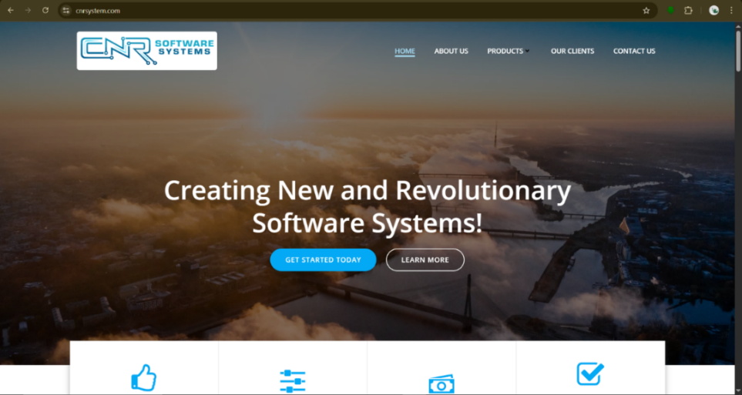
The CNR Software Systems developed the Appoluz Hospital Information System (HIS) and Electronic Medical Records (EMR) to automate hospital operations and improve the efficiency of patient care in Philippine health facilities. Its primary purpose is to streamline workflows, including patient registration, admissions, medical records management, laboratory and radiology processes, pharmacy inventory, and billing, thereby reducing manual paperwork and minimizing errors. The system was designed as a comprehensive digital platform that integrates all major hospital departments and supports real-time data management. Patients’ medical information is digitized through EMR, allowing doctors and nurses to access historical records, vital signs, diagnoses, and e-prescriptions easily. The system also supports ICD-10 coding, automated billing, and PhilHealth or HMO processing to ensure regulatory compliance and accurate documentation. CNR Software Systems developed the platform locally in the Philippines, focusing on cost-effective solutions accessible to hospitals of various sizes. The Appoluz HIS incorporates features such as smart pharmacy inventory, laboratory and radiology result management, patient queuing, and financial reporting modules. It is DOH-accredited, which ensures that it meets national standards for e-health systems. Many hospitals and clinics in the Philippines, including Clinica Antipolo, Soriano-Leyble Medical and Maternity Hospital, St. Therese Hospital, San Isidro Hospital, and Taytay Maternity and Child Care Center, have implemented the system. Reported benefits include improved workflow efficiency, reduced paperwork, better coordination among departments, accurate and faster billing, and streamlined access to patient information. The system allows hospital staff to monitor patient progress, track laboratory and pharmacy usage, and maintain a centralized database for easier decision-making. While there is no formal peer-reviewed study quantifying its impact, the adoption of Appoluz HIS has reportedly enhanced operational efficiency, improved documentation, and supported hospitals in providing more organized and reliable patient care.

Figure 2.2: CNR Software Systems
2.3.3 WAH (We Are Health)
The We Are Health (WAH) Platform is a Philippine-based digital health solution designed to support health facilities and local government units (LGUs) in managing patient information, clinical workflows, and health program monitoring. Its primary purpose is to streamline hospital and clinic operations, improve record-keeping, and enhance patient care through digital solutions. WAH is composed of several modules, including WAH4C for clinics, WAH4H for hospitals, WAH4P for patients, and WAH4Interoperability for sharing patient information across health facilities. These modules enable electronic medical records, laboratory and radiology result management, pharmacy inventory, patient queuing, automated billing, and health alerts. The system was developed to be cloud-based and accessible, providing real-time data management and integration with national health programs. WAH supports interoperability between multiple health facilities, allowing patient information to be securely shared and coordinated across different clinics and hospitals. Health facility staff such as doctors, nurses, and administrative personnel are the primary users, while patients can access the platform for appointment reminders, health alerts, queuing, and feedback. The platform employs a “Train Now, Pay Later” scheme for LGUs and facilities with limited budgets, while some patient-facing features are expected to be free of charge. WAH has been reported to reduce manual documentation, improve workflow efficiency, and enhance patient follow-up, particularly for rural health units implementing national health programs. Patients benefit from timely reminders, organized queuing, and better access to their medical history, which can lead to improved clinical outcomes. Overall, the WAH platform demonstrates how an integrated digital health system can optimize hospital and clinic operations, improve patient engagement, and support efficient healthcare delivery in the Philippine context.
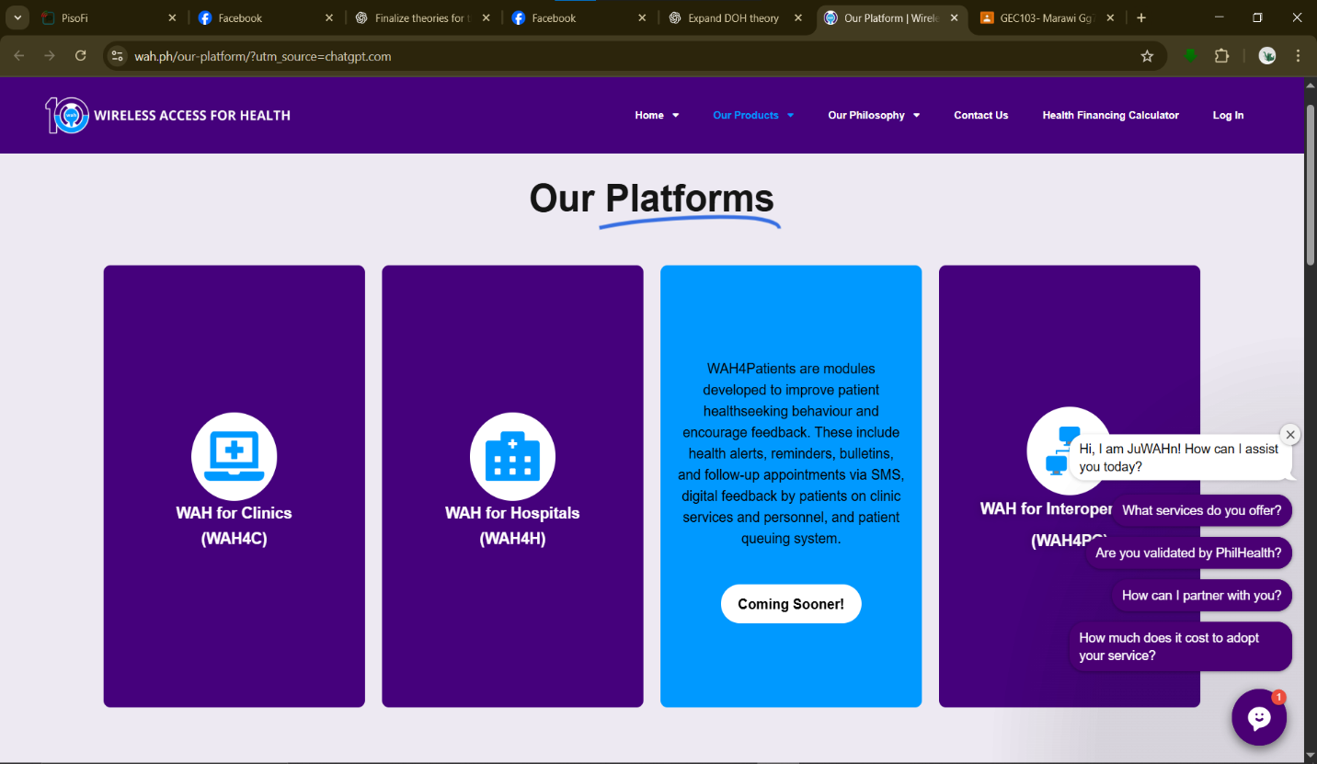
Figure 2.3: WAH (We Are Health)
2.3.4 Phreesia Referral Management System
The Phreesia Referral Management System, developed by Phreesia, Inc. in the United States, streamlines patient referrals among healthcare providers and hospitals. It centralizes referral information, including demographic data, clinical notes, and supporting documents, into a single digital platform. The system can capture referrals sent through traditional methods like fax, converting them into structured digital records, and integrates with EMR/EHR systems to reduce duplication of patient information.
The platform also automates patient outreach through text or email, tracks referral status, and coordinates appointments, reducing administrative workload and improving patient care continuity. Widely used in hospitals and clinics, Phreesia Referral Management enhances efficiency, referral tracking, and inter-provider coordination.
By providing real-time visibility of referral status and outcomes, the system supports better clinical decision-making and timely patient care. Healthcare organizations using Phreesia have reported faster referral processing, improved coordination between referring and receiving providers, and increased patient satisfaction. Its functionality is particularly relevant to the proposed Mobile and
automating and centralizing referral workflows.
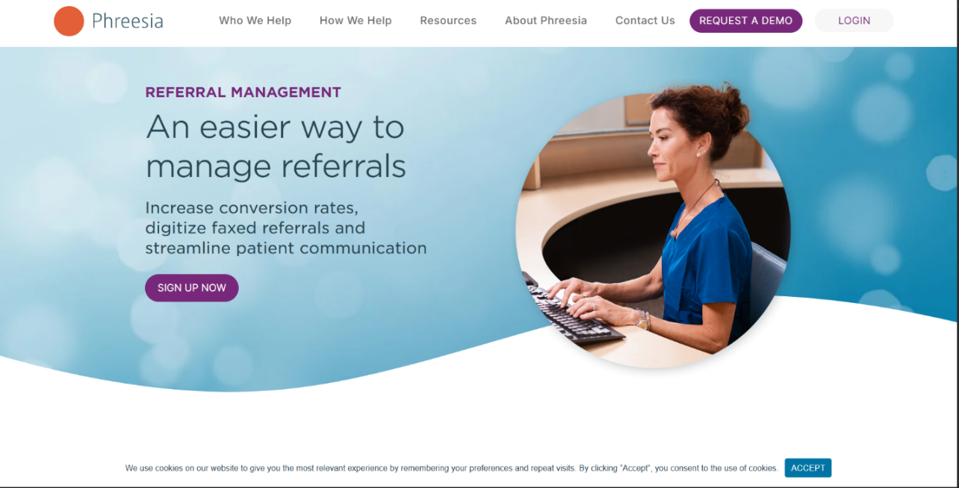

Figure 2.4: Phressia referral management system
2.3.5 Bizbox Hospital Information System (HIS)
The Bizbox Hospital Information System (HIS) is a Philippine-developed healthcare information system designed to automate and integrate various hospital operations. Developed by Bizbox, Inc., the system aims to improve hospital efficiency by replacing manual processes with a centralized digital platform that manages patient information, administrative transactions, and clinical workflows. It is designed for hospitals and healthcare institutions that require organized management of patient records, admissions, billing, and other operational activities.
Bizbox HIS provides several modules that support different hospital departments. These include patient registration and admission management, which handles patient information, admission transactions, and hospital stay monitoring; Electronic Medical Records (EMR), which allows healthcare providers to store and access patient histories, diagnoses, laboratory results, and treatment information; billing and insurance management, which supports accurate computation of hospital charges and processing of insurance-related transactions; and reporting modules that generate operational and administrative reports for decision-making. The system also supports coordination between departments by allowing authorized personnel to access relevant patient information based on their assigned roles.
The system is utilized by various hospitals and healthcare facilities in the Philippines to improve workflow efficiency, reduce documentation errors, and enhance accessibility of patient information. Through its centralized database, hospital staff can manage patient records more effectively, monitor admissions, and improve coordination among different departments. Its implementation demonstrates how hospital information systems can support better healthcare delivery by improving data management and operational processes.
Bizbox HIS is relevant to the proposed Web-Based Hospital Management and Admission System for Salaam Hospital because it provides a reference for integrating patient admission, medical record management, and hospital workflow automation into a single platform. However, while Bizbox HIS focuses on comprehensive hospital operations, the proposed system specifically addresses the needs of Salaam Hospital by emphasizing internal specialist referral management, real-time admission and referral tracking, role-based access, and a simplified interface designed according to the hospital's workflow requirements.
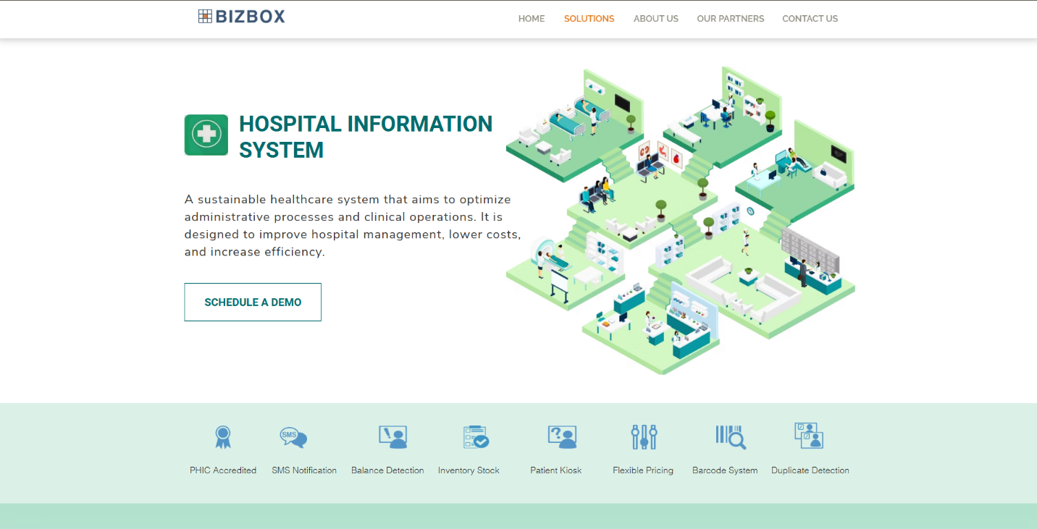
Figure 2.5: Bizbox Hospital Information System

2.3.6 Summary of Related Systems
The review of related systems highlights the importance of integrating digital technologies to improve hospital operations, patient admission, medical record management, and referral coordination. Systems such as iHOMIS, Appoluz Hospital Information System, We Are Health (WAH), and Bizbox Hospital Information System demonstrate how centralized platforms can support hospital workflows through patient registration, electronic medical records, billing management, reporting, and coordination among healthcare departments. These systems help reduce dependence on manual documentation, improve accessibility of patient information, and support more organized healthcare operations.
On the other hand, referral-focused systems such as the Phreesia Referral Management System emphasize the importance of digital referral coordination through centralized referral records, document management, referral tracking, and communication between healthcare providers. These existing systems show that digital solutions can improve the efficiency of patient management by reducing delays, improving information availability, and supporting better coordination among healthcare personnel.
However, most existing systems are designed as large-scale commercial or institutional solutions that cover broad hospital operations or specialized referral workflows. The proposed Responsive Web-Based Patient Referral and Admission System for Salaam Hospital focuses specifically on integrating patient admission management and internal specialist referral processes within a single platform. It incorporates relevant features from existing systems, such as centralized patient records, role-based access control, referral history tracking, document management, reporting, and real-time updates, while being tailored to the workflow and operational requirements of Salaam Hospital.
Table 2.1: Summary of Related Systems
Key Features | iHOMIS (PAS) | CNR Systems | We Are Health | Bizbox HIS | Phreesia | Proposed System
Hospital Workflow Integration | ✅ | ✅ | ✅ | ✅ | ◐ | ✅
Patient Admission Management | ✅ | ✅ | ◐ | ✅ | — | ✅
Electronic Medical Records (EMR) | ✅ | ✅ | ✅ | ✅ | ◐ | ✅
Reporting & Analytics | ✅ | ✅ | ✅ | ✅ | ✅ | ✅
Real-Time Referral / Admission Tracking | — | — | ◐ | ◐ | ✅ | ✅
Multi-Department Coordination | ✅ | ✅ | ✅ | ✅ | ✅ | ✅
Web-Based Access | ✅ | ✅ | ✅ | ✅ | ✅ | ✅
Mobile Accessibility | ◐ | ◐ | ✅ | ◐ | ◐ | ✅
User Authentication / Login | ✅ | ✅ | ✅ | ✅ | ✅ | ✅
User Data Entry (Health Staff) | ✅ | ✅ | ✅ | ✅ | ✅ | ✅
Centralized Patient Database | ✅ | ✅ | ✅ | ✅ | ✅ | ✅
Patient Information Management | ✅ | ✅ | ✅ | ✅ | ✅ | ✅
Priority & Triage Level Tagging | ◐ | ◐ | — | — | — | ✅
Document Upload (Referral Forms, Lab Results) | ◐ | ✅ | ✅ | ✅ | ✅ | ✅

- ✓ = Confirmed/documented as an available feature
- ◐ = Partially available, has related functionality, or depends on the module/implementation
- - = Not explicitly identified in the available documentation

2.4 Technical Background
A significant challenge identified at Salaam Hospital is the absence of a centralized digital platform that specifically integrates patient admission management, medical record organization, and internal referral coordination based on the hospital’s current operational needs. Because information is managed through separate manual records and communication methods, hospital personnel may experience difficulties in accessing updated patient information, monitoring admission progress, and coordinating responsibilities among healthcare providers.
Existing healthcare systems such as PAS, Appoluz HIS, and WAH demonstrate the benefits of digx ital solutions in improving hospital workflows, electronic record management, and healthcare service coordination. However, these systems are designed with different scopes and implementations depending on the requirements of their respective healthcare institutions. Therefore, the proposed system focuses on addressing the specific workflow requirements of Salaam Hospital by integrating patient admission, medical record management, and internal referral processes into a responsive web-based platform.

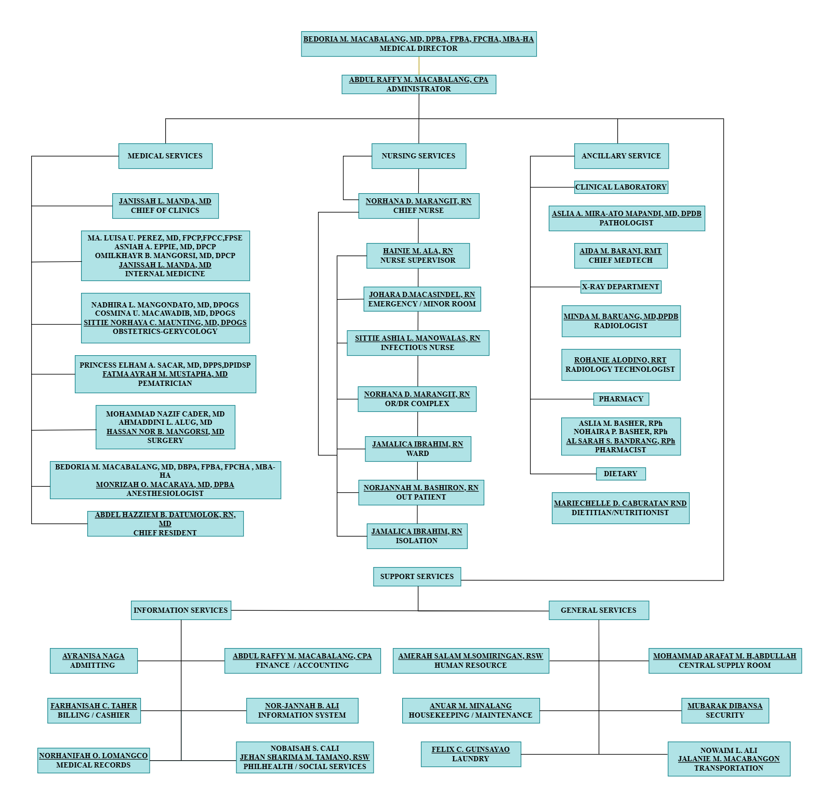
2.4.1 Organizational Chart
Figure 2.6: Organizational Chart of Salaam Hospital

2.5 Workflow
This section presents the workflow of the hospital's patient referral and admission processes. It describes the current workflow used by Salaam Hospital and the proposed workflow enabled by the system, illustrating how the proposed system streamlines and improves upon existing procedures.
2.5.1 Current Workflow
Salaam Hospital primarily manages patient admissions, medical records, and internal referrals through manual and paper-based processes. Upon arrival, patients’ personal information and admission details are recorded by staff using handwritten forms, logbooks, and physical patient charts.
Doctors and nurses document medical histories, diagnoses, treatments, and medications on paper records. When an internal referral to an in-house specialist is needed, the process is handled through verbal communication or handwritten referral notes. Patient records are stored physically in folders and filing cabinets, requiring staff to manually search and retrieve files whenever information is needed for treatment or reporting.
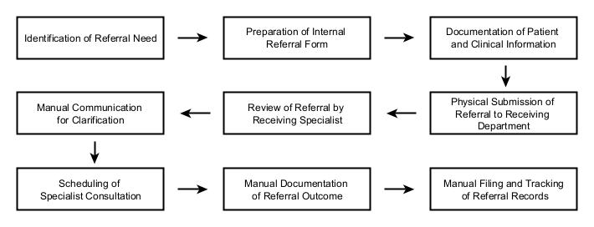
INTERNAL REFERRAL WORKFLOW
Figure 2.7: Current Internal Referral Workflow

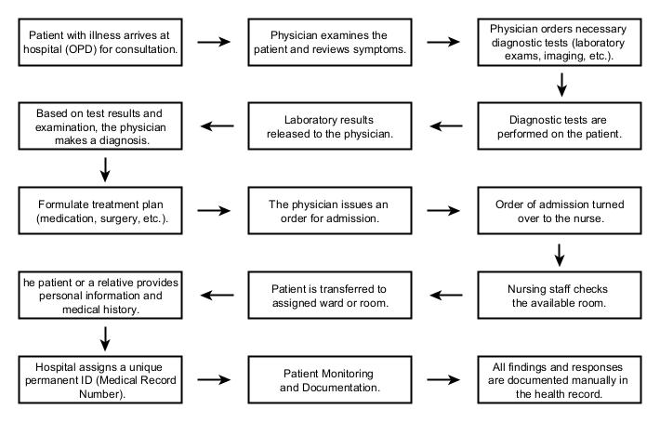
ADMISSION WORKFLOW
Figure 2.8: Current Admission Workflow

2.5.2 Proposed Workflow
Salaam Hospital’s proposed system will manage patient admissions, medical records, and internal referrals through a computerized and centralized digital platform. Patient information will be recorded electronically upon admission and stored securely in a centralized database.
Medical staff will be able to access and update patient records in real time, including medical history, treatments, and referral details. Internal referrals will be processed digitally, allowing faster coordination among departments and reducing reliance on paper-based documentation.

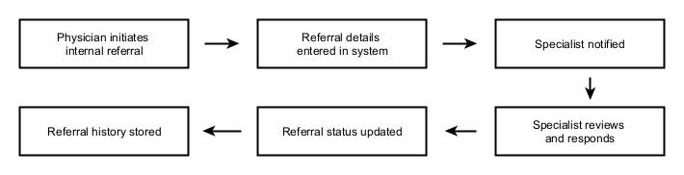
REFERRAL WORKFLOW
Figure 2.9: Proposed Referral Workflow

ADMISSION WORKFLOW
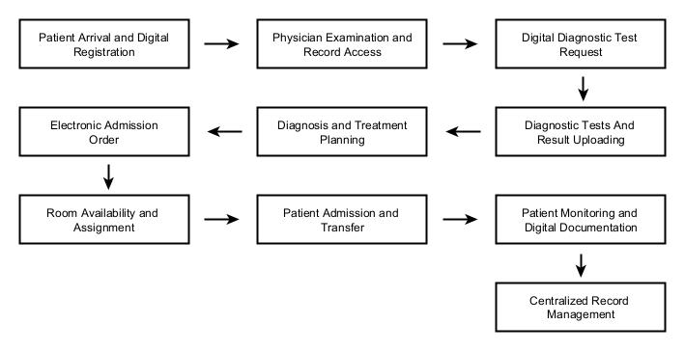
Figure 2.10: Proposed Admission Workflow

Chapter 3
METHODOLOGY
This chapter discusses the methodology of the projects, development phase, results of the conducted tests and the diagrams of the different processes involved in the system.
3.1 Agile Model Methodology
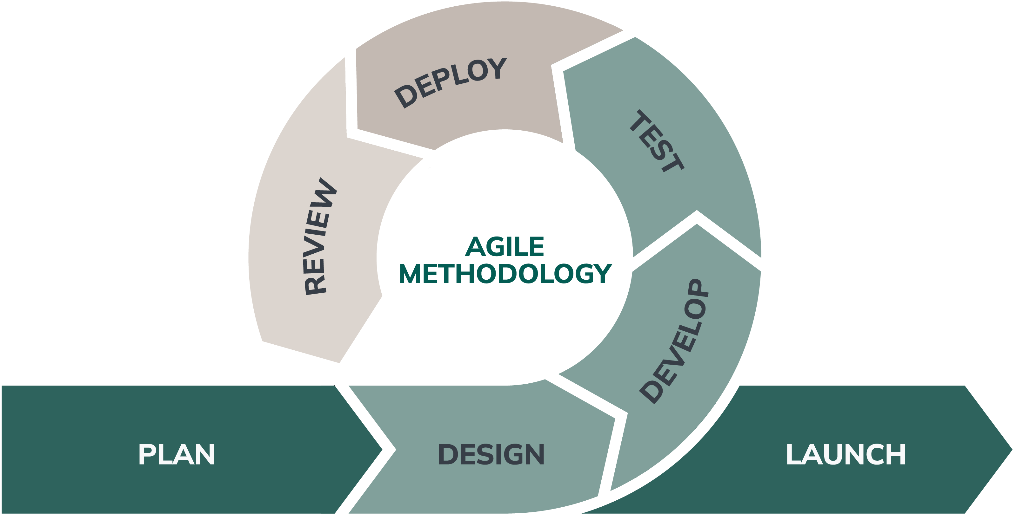
Figure 3.1 Agile Methodology
The developers used Agile Methodology as the software development life cycle for this project. Agile is an iterative and incremental approach to software development that emphasizes flexibility, collaboration, continuous improvement, and adaptation to changing requirements. Unlike traditional development approaches where requirements are finalized before implementation, Agile allows developers to continuously review, refine, and improve the system throughout the development process.
Agile methodology was selected for the development of the “Responsive Web-Based Patient Referral and Admission System for Salaam Hospital” because the project required continuous communication, validation, and feedback from stakeholders, particularly hospital personnel who are the intended users of the system. Since the system was developed based on the operational needs of Salaam Hospital, changes and improvements in requirements could be identified during the development process. Agile provided the flexibility needed to accommodate these changes without affecting the overall progress of the project.
During the development process, the project was divided into several iterations or development cycles. Each iteration involved planning, requirement review, system design, implementation, testing, and evaluation of developed features. The developers prioritized important functionalities such as patient registration, admission management, medical record handling, internal referral processing, and user access management. After each development cycle, the system was reviewed and evaluated to identify possible improvements and ensure that the developed features aligned with the requirements of Salaam Hospital.
The Agile approach also encouraged collaboration between the developers, project adviser, and hospital stakeholders. Regular consultations and progress evaluations were conducted to gather feedback regarding the system’s usability, workflow, and functionality. These inputs helped the developers make necessary adjustments to improve the system before proceeding to the next development phase.
Through the use of Agile Methodology, the developers were able to create a responsive web-based system that continuously evolved based on user requirements and evaluation results. This approach supported the development of a functional, user-centered, and adaptable system that addresses the needs of Salaam Hospital in managing patient admissions, medical records, and internal referral processes.
3.2 Kanban Framework
Kanban was selected as the Agile framework for the development of the Responsive Web-Based Patient Referral and Admission System for Salaam Hospital. This framework emphasizes continuous delivery, visual workflow management, and adaptability, making it highly suitable for a small development team working with changing hospital requirements. Since healthcare systems often evolve due to policy updates and user feedback, Kanban allows tasks to be added, modified, and prioritized without the need for fixed-length iterations, ensuring continuous progress throughout the system development.
The implementation of Kanban in this project followed several core Kanban practices that guided the development process:
- Visualize the Workflow
A Kanban board was utilized to visually represent all development activities of the system. Tasks were organized into columns such as To Do, In Progress, and Done. This visualization enabled the developers to easily track the status of features such as patient referral processing, admission management, and user interface enhancements, while also providing a clear overview of the project’s progress.
- Limit Work in Progress (WIP)
To avoid task overload and ensure quality output, limits were applied to the number of tasks being worked on simultaneously. This practice helped the development team focus on completing critical modules such as referral approval and patient admission records before starting new tasks, thereby improving efficiency and reducing unfinished work.
- Manage Flow
The movement of tasks across the Kanban board was continuously monitored to identify delays or bottlenecks in development. This allowed the team to address issues related to system functionality, database integration, or responsiveness early, ensuring a smoother and more efficient development flow.
- Make Process Policies Explicit
Clear guidelines were established regarding how tasks moved between columns on the Kanban board. For example, a task could only move from To Do to In Progress once its requirements were clearly defined, and from In Progress to Done only after successful testing and validation. This ensured consistency and quality throughout the development process.
- Implement Feedback Loops
Regular discussions were conducted among the development team to review completed tasks, assess system performance, and address any issues encountered. Feedback from these discussions was used to refine system features, particularly those related to hospital workflows such as patient referrals, admissions, and record management.
- Improve Collaboratively and Evolve Experimentally
The team continuously improved their workflow by identifying areas for enhancement and adjusting their development practices based on experience and feedback. This collaborative and adaptive approach allowed the system to evolve gradually, ensuring that it effectively meets the operational needs of Salaam Hospital.
3.3 Plan
During the initial phase of the project, the development team conducted a planning process to identify the objectives, scope, and required functionalities of the Responsive Web-Based Patient Referral and Admission System for Salaam Hospital. This phase focused on understanding the existing patient referral, admission, and medical record management workflows of the hospital and determining how the proposed system could improve efficiency, organization, and coordination among hospital personnel.
To organize the development activities, the team utilized the Kanban approach by creating a product backlog containing the identified system requirements, features, and development tasks. The backlog included activities such as requirements gathering, interface design, database development, patient registration module, admission management, referral management, user access control, testing, and system improvements. These tasks were prioritized based on their importance and contribution to the overall objectives of the system.
The development progress was monitored using a Kanban board, where tasks were categorized into different stages such as To Do, In Progress, and Done. A Work in Progress (WIP) limit was applied to control the number of tasks being actively developed at a given time. This helped the development team maintain focus, prevent task overload, identify possible delays, and ensure that ongoing activities were completed before starting new tasks.
Through the use of Kanban practices, the team was able to visualize the workflow, track development progress, and continuously improve the process throughout the project lifecycle. This structured approach helped ensure that the required system functionalities were properly implemented while allowing flexibility for adjustments based on feedback and evaluation results.
3.3.1 Requirement Analysis
The requirement analysis phase focused on identifying the functional and non-functional requirements of the proposed system. Requirements were primarily gathered through interviews and consultations with the staff of Salaam Hospital to understand the current patient referral and admission processes, existing challenges, and the specific needs of hospital personnel involved in managing patient information and workflows. The gathered information provided insights into how referrals are processed, how admission records are maintained, and how communication and coordination between hospital departments are currently handled.
In addition to the information gathered from hospital staff, the researchers also utilized related studies, existing healthcare information systems, and online references to further support the identification of appropriate system features and technical requirements. These references helped the researchers analyze existing practices in hospital management systems and determine relevant functionalities such as patient referral submission, admission management, electronic record keeping, user access control, document management, and responsive system design.
The results of the requirement analysis served as the foundation for designing and developing a responsive web-based system that addresses the operational needs of Salaam Hospital. By incorporating the insights gathered from hospital personnel and supported by existing healthcare technology references, the proposed system aims to improve patient referral and admission processes while promoting data accuracy, accessibility, security, and usability for hospital staff.=

3.3.1.1 Empathy Map
Below is a complete empathy map for the user of the Patient Referral and Admission System for Salaam Hospital
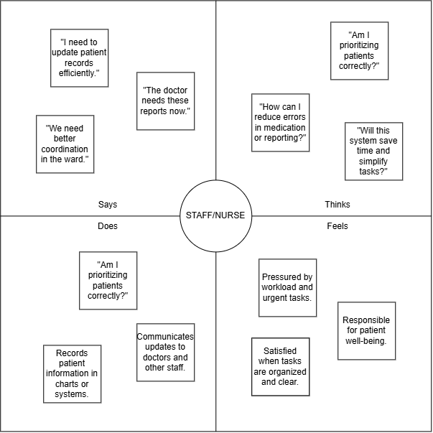Figure 3.2 Empathy map of the staff/nurse
The empathy map of the staff/nurse was developed based on the interview responses of Johara D. Macasindel and Norhana D. Marangit, who are involved in handling patient-related tasks, documentation, coordination, and admission processes at Salaam Hospital. Their experiences and insights served as the basis for identifying the challenges, responsibilities, and workflow concerns represented in the empathy map.
This empathy map illustrates the daily challenges experienced by hospital staff involved in patient referral and admission processes. By analyzing what staff and nurses think, feel, say, and do during the patient referral and admission process, the proponents gain a deeper understanding of their daily responsibilities, challenges, and workflow pressures. Staff and nurses are often required to manage multiple patients simultaneously while handling documentation, coordination, and communication tasks, which can become overwhelming when processes are manual and fragmented.
Using the empathy map allows the proponents to design system features that directly address these challenges, such as streamlined referral processing, faster access to patient information, and reduced duplication of data entry. This user-centered approach improves efficiency, minimizes errors, and reduces workload stress among staff and nurses. Moreover, the empathy map serves as a shared reference point that enhances communication among the proponents and guides design decisions throughout system development. Ultimately, it helps validate design choices, prioritize essential functions, and ensure that the Patient Referral and Admission System effectively supports staff and nurses in delivering timely, organized, and quality patient care at Salaam Hospital.
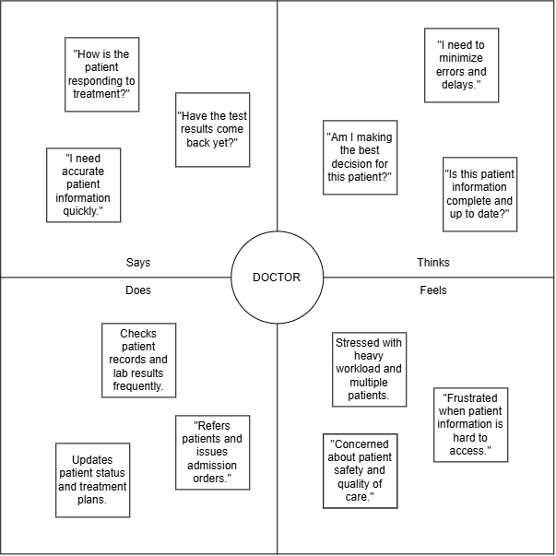Figure 3.3 Empathy map of the Doctors
The empathy map of the doctors was developed based on the interview responses of Dr. Janisa L. Manda and Dr. Mohammad Nazif Cader, who provided insights regarding their clinical responsibilities, patient assessment, referral evaluation, and admission decision-making processes. Their perspectives helped the proponents understand the specific needs and challenges faced by doctors when accessing patient information and managing referrals.
By carefully analyzing what doctors think, feel, say, and do during the patient referral and admission process, the proponents gain a deeper understanding of their professional needs, challenges, and expectations. Doctors often require timely access to accurate patient information to make informed clinical decisions, and delays or incomplete records can negatively affect patient care.
Using the empathy map allows the proponents to design system features that directly address real concerns of doctors, such as efficient referral review, quick access to patient medical details, and clear admission status updates. Rather than relying on assumptions, this approach improves the relevance, usability, and clinical value of the system. Additionally, the empathy map serves as a shared reference among the proponents, strengthening communication and guiding design decisions throughout the development process. Ultimately, it helps validate system design choices, prioritize essential functionalities, and identify opportunities to enhance workflow efficiency, making the Patient Referral and Admission System more effective and supportive of doctors’ clinical responsibilities.

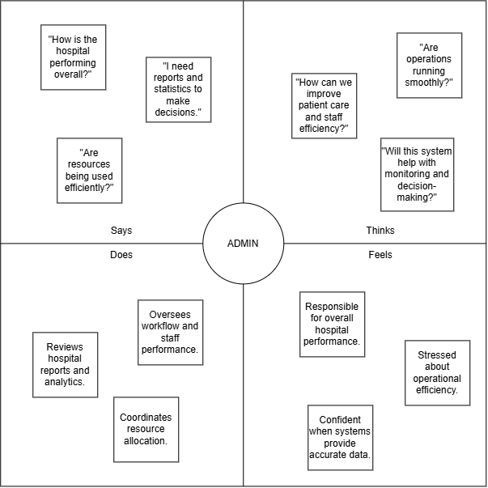Figure 3.5 Empathy map of Admin
The empathy map of the administrator was developed based on the interview response of Abdul Raffy Macabalang, who shared insights regarding hospital operations, administrative responsibilities, referral and admission monitoring, and the challenges encountered in managing hospital processes. His experiences provided valuable information in identifying administrative requirements and operational concerns that were considered during the system design.
By examining what hospital administrators think, feel, say, and do during the management of referrals, admissions, and hospital operations, the proponents gain a clearer understanding of the responsibilities, pressures, and decision-making challenges faced by administrators. Administrators often deal with high workloads, system inefficiencies, and the need to ensure that hospital policies, resources, and patient flow are properly managed. Delays, incomplete data, and lack of real-time system visibility can lead to stress and operational bottlenecks.
Through the use of the empathy map, the proponents are able to design system features that support administrative needs such as centralized data management, real-time monitoring of referral and admission statuses, accurate reporting, and streamlined coordination among departments. This approach ensures that the system assists administrators in making informed decisions, improving efficiency, and maintaining compliance with hospital standards. Furthermore, the empathy map helps prioritize administrative functionalities that enhance oversight, accountability, and communication across the hospital. Ultimately, this tool supports the development of a more organized, efficient, and data-driven patient referral and admission system that strengthens hospital operations and service quality at Salaam Hospital.
3.3.1.2 Functional Requirements and Non-Functional Requirements
Table 3.1 Functional Requirements and Non-Functional Requirements
REQUIREMENTS | TYPE | PRIORITY
Centralized Patient Information Database | Functional | Mandatory
Patient Registration and Admission Management | Functional | Mandatory
Internal Patient Referral Management | Functional | Mandatory
Patient Medical History and Record Tracking | Functional | Mandatory
Role-Based User Management (Admin, Doctor, Nurse, Staff) | Functional | Mandatory
Referral Status Tracking and History Log | Functional | Mandatory
Search and Filter Patient Records | Functional | Mandatory
Admission and Referral Monitoring Dashboard | Functional | Mandatory
Document Upload (Referral Forms, Medical Records) | Functional | Mandatory
Automated Notifications (In-App / SMS / Email) | Functional | Mandatory
Reporting and Analytics (Admissions, Referrals, Turnaround Time) | Functional | Mandatory
Mobile-Responsive Web Interface | Functional | Mandatory
Secure Login and Authentication | Functional | Mandatory
System Audit Trail and Activity Logs | Functional | Optional
Data Backup and Recovery Module | Functional | Optional
3.3.1.3 Data Gathering
The data required for the development of the Responsive Web-Based Patient Referral and Admission System for Salaam Hospital were gathered primarily through interviews and consultations with hospital staff. These interactions were conducted to understand the existing patient admission, medical record management, and internal referral processes of the hospital. Through the responses and insights provided by the hospital personnel, the developers were able to identify the current challenges, workflow procedures, and specific requirements needed for the proposed system.
The information gathered from the interviews was supported by the review of existing hospital documents, records, forms, and related materials used in the daily operations of Salaam Hospital. These included admission forms, referral documents, patient record templates, and other relevant documentation that helped identify the necessary data elements for patient registration, admission tracking, referral processing, and medical record management.
In addition, the developers reviewed related literature, existing healthcare management systems, and relevant online references to further understand standard practices in healthcare system development. The combination of information gathered from hospital staff and supporting references served as the foundation for defining the system requirements, designing the database structure, and developing workflows that accurately represent the operational needs of Salaam Hospital.
Through this data gathering process, the developers ensured that the proposed system was based on the actual experiences and requirements of its intended users while incorporating established practices in healthcare information system development.

3.3.2 Gantt Chart
The Gantt Chart presents the project timeline, showing the sequence and duration of the major tasks involved in developing the "Responsive Web-Based Patient Referral and Admission System for Salaam Hospital". It outlines the activities from requirement gathering, design, development, and testing up to documentation. This chart provides a clear overview of the project’s progress and ensures that each phase is completed within the planned schedule.
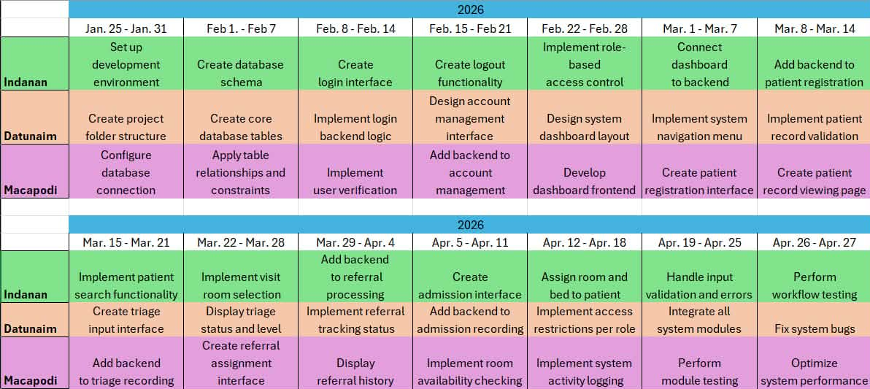
Table 3.2 Kanban Board

Activities | Jna | Feb | Mar | Apr | May | Jun | Jul
Project Proposal and Planning
Initial Consultation with Hospital
Data Gathering and Requirements Analysis
Interviews with Hospital Personnel
Empathy Mapping
System Requirements Specification (SRS)
System Workflow Design
UI/UX Design and Prototyping
Database Design / ERD
System Architecture Design
System Development
System Integration and Refinement
Alpha Testing
Beta Testing
SUS Evaluation
System Revision and Improvement
Documentation (Chapters 1–5)
Final Review and Revision
Table 3.3 Gantt chart

3.4 Design
This section presents the design phase of the system, which translates the identified requirements into a structured blueprint for development. It includes the diagrams and models used to represent the system's structure, data flow, and interactions among its components.

3.4.1 Hierarchical Input-Process-Output
Developers use draw.io for the HIPO, it shows the hierarchical input-process-output of the system. This is graphic illustration of the data flow diagram. It shows the flow of the data and logic within the system.
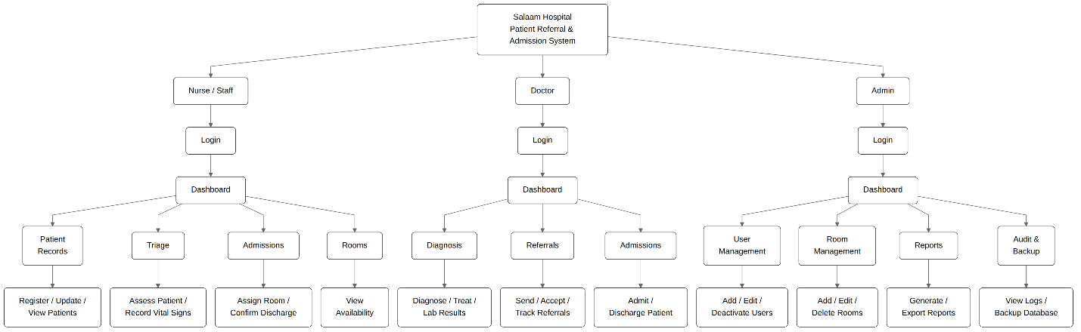
Figure 3.6 Hierarchical Input-Process-Output
3.4.2 Input-Process-Output
This section presents the Input-Process-Output (IPO) model of the system's major functions. Each diagram identifies the inputs required, the processes performed, and the outputs produced for a specific function of the system.
3.4.2.1 Patient Registration and Record Management
Figure 3.7 Input-Process-Output for Researcher Sign-Up / Registration
Figure 3.7 shows the process of capturing and managing patient information within the system. Patient personal details such as name, sex, date of birth, contact information, and emergency contact details are entered into the system as inputs. The system validates the entered data to ensure completeness and correctness before generating a unique Patient_ID. Once validated, the information is stored in the Patient table of the database. The system also allows authorized hospital staff to view and update patient records when necessary. As a result, a registered patient profile is created, patient records are securely stored in the database, and updated patient information can be retrieved for future visits.

3.4.2.2 Patient Triage and Internal Referral Management

Figure 3.8 Patient Triage and Internal Referral Management
Figure 3.8 shows the workflow for patient triage and internal referral within the hospital. The process begins with inputs such as the Patient_ID, employee details, visit room information, triage level, vital signs, diagnosis details, and assigned doctor. The system records triage data and links the patient to the appropriate visit room. Vital signs are saved and associated with the triage record, after which a diagnosis is created by the attending medical professional. The system assigns a doctor in charge and generates an internal referral record, allowing the referral status and date to be tracked. The outputs of this process include stored triage records, vital signs records, diagnosis information, internal referral records, and a complete referral history for monitoring patient flow.
3.4.2.3 Patient Admission and Room Assignment
Figure 3.9 Input-Process-Output for System Homepage
Figure 3.9 shows the admission process and room assignment for patients requiring hospitalization. Inputs such as the Patient_ID, diagnosis reference, admission type, room details, assigned doctor, and admission date are submitted to the system. The system validates the admission request and checks the availability of rooms and beds before assigning the appropriate room to the patient. Admission details are then recorded in the database, and room availability status is updated accordingly. The outputs of this process include a confirmed admission record, room and bed assignment details, and an updated room availability record, ensuring accurate monitoring of hospital resources.
3.4.3 Use Case Diagram
Figure 3.18 shows the use case diagram of the "Responsive Web-Based Patient Referral and Admission System for Salaam Hospital". It illustrates how different users interact with the medical appointment system. The system supports four main actors: Nurse/staff, Doctor, and Administrator, each with specific roles and responsibilities.
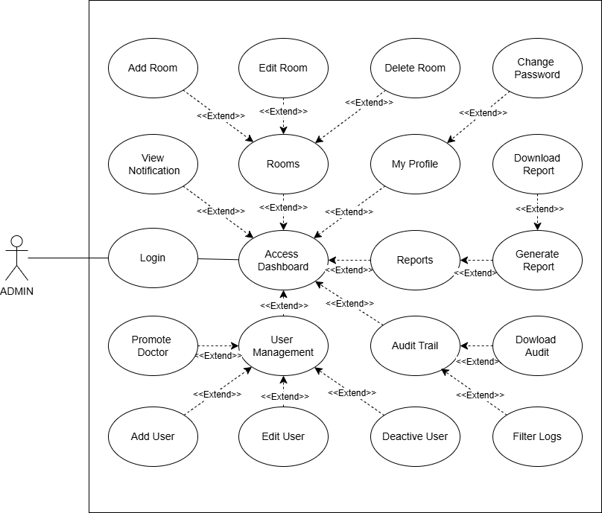Figure 3.10.1 : Use case Diagram of Admin Role

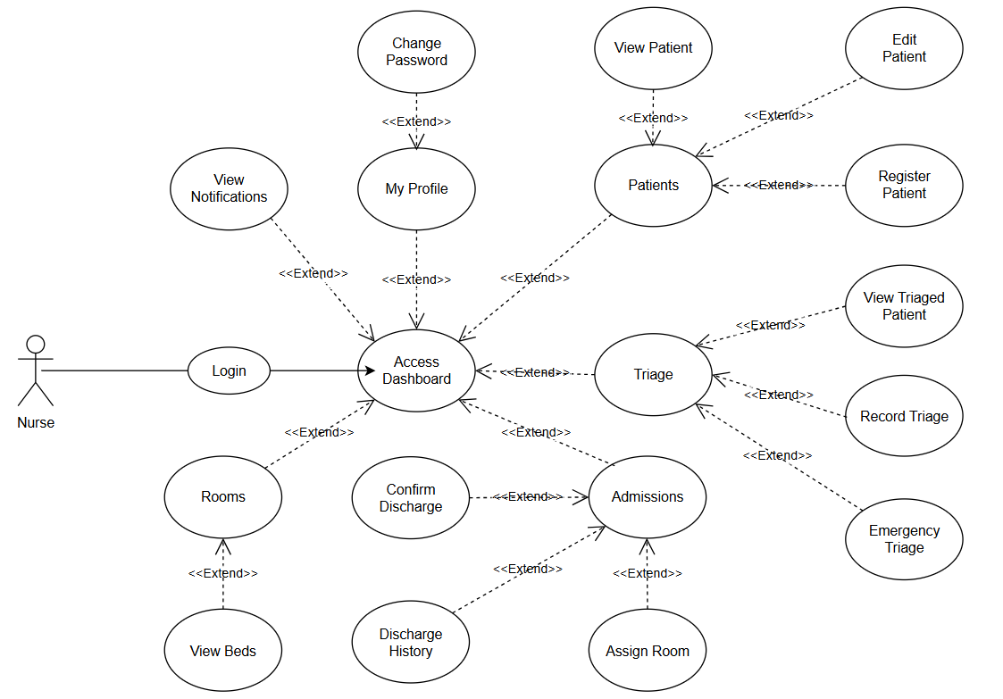
Figure 3.10.2 : Use case Diagram of Nurse Role

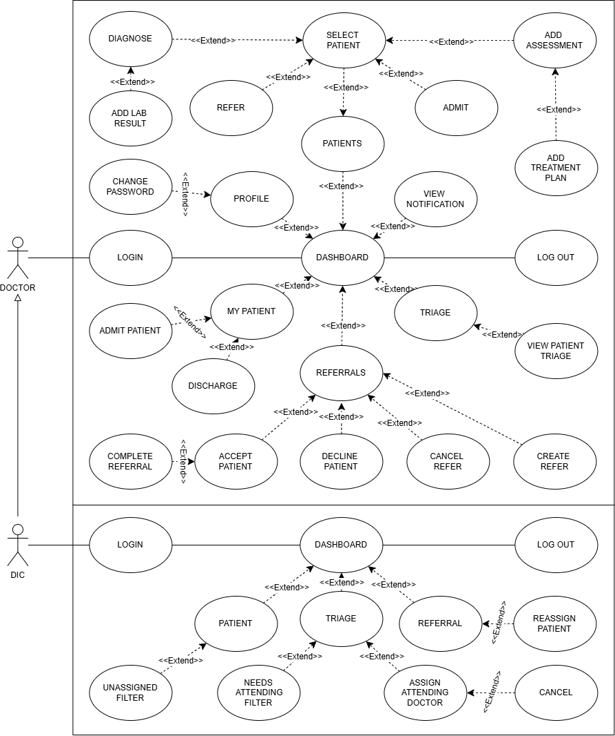
Figure 3.10.3 : Use case Diagram of Doctor Role

3.4.4 Entity-Relationship Diagram
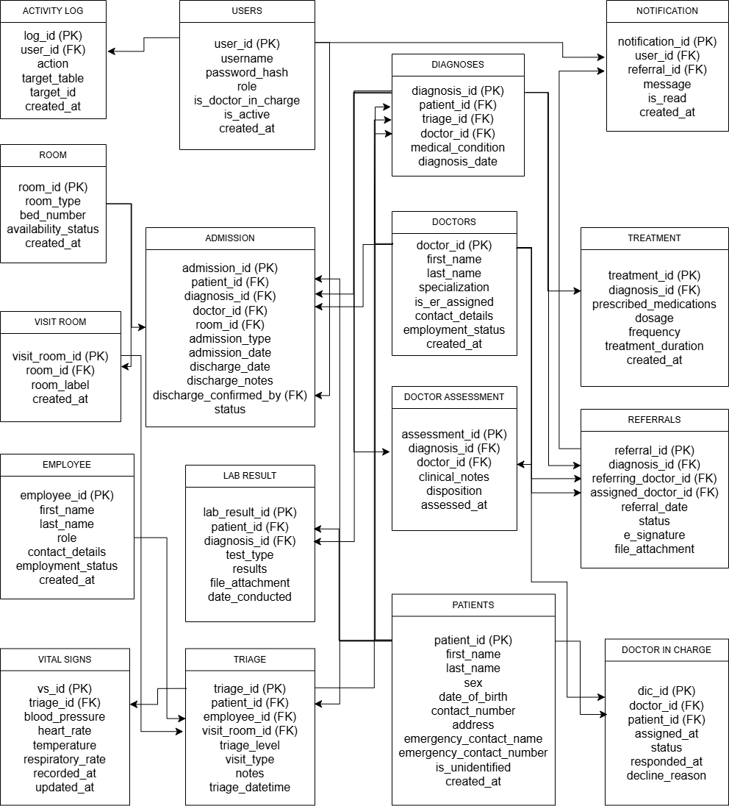
Figure 3.11 Patient Referral and Admission System Entity-Relationship Diagram
Figure 3.11 presents the Entity–Relationship Diagram (ERD) of the "Responsive Web-Based Patient Referral and Admission System for Salaam Hospital", illustrating the logical structure of the system’s database and the relationships among its core entities. The ERD demonstrates how patient information, clinical processes, hospital resources, and staff roles are interconnected to support efficient emergency care, referral, and admission workflows.
The Patient entity serves as one of the central components of the system, storing essential patient information such as Patient_ID, name, sex, date of birth, contact details, address, and emergency contact information. This entity ensures that patient records are accurately maintained and can be referenced throughout the triage, diagnosis, laboratory, treatment, referral, and admission processes.
The Employee and Doctor entities represent hospital personnel involved in patient care and system operations. The Employee entity includes staff such as nurses and other ER personnel, while the Doctor entity stores information about licensed physicians, including specialization, contact details, and employment status. These entities support role-based access and accountability within the system. The Admin entity represents system administrators who manage user accounts and system access, ensuring secure authentication and proper system maintenance.
The Triage entity captures initial patient assessment data upon arrival at the emergency room. It is linked to the Patient, Employee, and Visit_Room entities, allowing the system to record triage level (Critical, Urgent, or Non-Urgent), notes, assigned room, and date and time of assessment. Associated with triage is the Vital_Signs entity, which stores recorded health indicators such as blood pressure, heart rate, temperature, and respiratory rate, providing clinical data necessary for medical decision-making.
Medical evaluation and treatment processes are represented by the Diagnosis, Treatment, and Lab_Results entities. The Diagnosis entity records the identified medical condition, the doctor in charge, laboratory references, and diagnosis date. The Treatment entity is linked to Diagnosis and includes prescribed medications, dosage, frequency, and treatment duration. The Lab_Results entity stores laboratory findings related to the patient, including test type, results, file attachments, and dates conducted, supporting accurate and timely diagnosis.
Hospital resource management is handled through the Room, Visit_Room, and Admit entities. The Room entity stores information about room types, bed numbers, and availability status. The Admit entity links patients to assigned doctors and rooms, recording admission type and admission date. These entities ensure proper bed allocation and monitoring of patient admissions within the hospital.
The Referral/Assign entity manages patient referrals and doctor assignments, linking diagnoses to responsible doctors and documenting referral dates. Additionally, the Doctor_In_Charge entity supports tracking of doctor assignments over time, ensuring continuity of care and clear responsibility for patient management.
Overall, the ERD illustrates a well-structured and integrated database design that supports emergency room operations, from patient arrival and assessment to diagnosis, treatment, referral, and admission. The defined relationships ensure data integrity, efficient information flow, and coordinated collaboration among hospital staff. This design enables the development of a reliable, secure, and efficient emergency referral and admission system that enhances service delivery and patient care at Salaam Hospital.

3.4.5 Architectural Design
The system architecture of the “Responsive Web-Based Patient Referral and Admission System for Salaam Hospital” provides an overview of how the system’s components work together to support efficient patient referral, triage, admission, and hospital resource management. This section presents the arrangement of system layers and the interaction between users, the web-based application, the server-side processing layer, and the centralized database.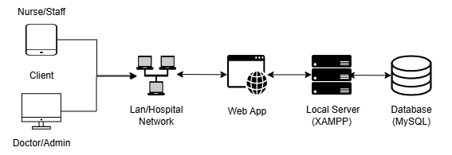
Figure 3.12 Architectural Design
The system follows a layered web-based architecture composed of three main components: the Client Layer, Application Server Layer, and Database Layer. This architectural design ensures clear separation of concerns, efficient data processing, and ease of system maintenance. The Client Layer consists of the web and mobile interfaces used by hospital personnel such as nurses, doctors, and administrators. Through this layer, users can perform tasks such as managing patient records, creating referrals, viewing admission details, and monitoring room availability. The client layer is responsible for presenting information to users and sending user requests to the application server. The Application Server Layer handles the core system logic and business processes. It processes requests received from the client layer, including validating user inputs, managing patient registration, handling referral workflows, assigning doctors, and processing patient admissions. This layer also enforces system rules and access control before interacting with the database layer. The Database Layer is responsible for securely storing and managing all system data. It contains records related to patients, referrals, diagnoses, admissions, rooms, and user accounts. The application server communicates with the database layer to retrieve, insert, update, and maintain data consistency and integrity. Overall, this architectural design supports efficient referral and admission workflows, secure data handling, and scalable system expansion. By separating the system into distinct layers, the architecture enhances reliability, simplifies future modifications, and ensures smooth operation within the hospital environment.
3.5 Development
This section describes the development phase, where the system design is implemented into a working application. It outlines the software and hardware specifications required to develop and run the proposed system.
3.5.1 Software Specification

Requirements | Details
Operating System | Windows 11
Browser | Google Chrome, Microsoft Edge
Local Server | XAMPP
Database Management System (DBMS) | MySQL
Programming Environment | Visual Studio Code
Framework | React.js
Backend | Node.js
Table 3.4 Developer software requirements

Requirements | Details
Operating System | Windows 10/11, Android, iOS, macOS, Linux
Browser | Google Chrome, Microsoft Edge, Safari, Mozilla Firefox (Latest versions)
Table 3.5 Client software requirements
3.5.2 Hardware Specification
Requirements | Details
Processor | Intel Core i5/Ryzen 5
RAM | 8GB – 16GB
Storage | 256GB
Operating System | Windows 10/11
GPU | Integrated or dedicated graphics
Peripherals | Mouse, keyboard, monitor
Table 3.6 Developer hardware requirements

Requirements | Details
Processor | Intel Core i3 or equivalent
RAM | 4GB
Storage | 120GB
GPU | Integrated graphics
Device | Desktop, Laptop, Tablet, or Smartphone
Processor | Intel Core i3 or equivalent
Table 3.7 Client hardware requirements

3.6 Test Plan
The test plan outlines the evaluation process designed to assess the usability, efficiency, and overall functionality of the Responsive Web-Based Patient Referral and Admission System for Salaam Hospital. The primary goal of the testing phase is to ensure that the system is user-friendly, responsive, secure, and capable of supporting accurate patient referral, triage, and admission processes. Testing aims to determine whether the system features meet the operational and informational needs of hospital administrators, doctors, nurses, and staff.
3.6.1 Respondents and Locale
The respondents for the system evaluation will consist of selected hospital personnel and Information Technology students who are familiar with web-based systems. These respondents may include nurses, hospital staff, and BSIT students who can provide both practical and technical feedback. A maximum of 35 respondents will participate in the testing process to ensure a range of user perspectives.
The data gathering and system testing will be conducted at Salaam Hospital and within an academic environment where stable internet access and appropriate devices are available, allowing respondents to interact with the system efficiently and conveniently.
3.6.2 Procedure
The testing procedure will follow a structured and step-by-step approach to collect consistent and measurable feedback. First, respondents will be given a brief orientation and demonstration of the system’s features, including login, patient registration, triage recording, referral handling, and admission management.
Second, respondents will be asked to perform specific tasks such as entering patient data, updating referral status, assigning doctors or rooms, and viewing admission records. After completing the assigned tasks, respondents will answer a usability evaluation questionnaire. Qualitative feedback and suggestions will also be collected to identify areas for system improvement.

3.6.3 Tools (Questionnaire)
System Usability Scale (SUS) Questionnaire
Participants rated the following statements using a five-point Likert scale: 1 = Strongly Disagree, 2 = Disagree, 3 = Neutral, 4 = Agree, 5 = Strongly Agree.
Table 3.8 System Usability Scale (SUS) Questionnaire
No. | Statement | 1 | 2 | 3 | 4 | 5
1. | I think that I would like to use this system frequently.
2. | I found the system unnecessarily complex.
3. | I thought the system was easy to use.
4. | I think that I would need the support of a technical person to be able to use this system.
5. | I found the various functions in this system were well integrated.
6. | I thought there was too much inconsistency in this system.
7. | I would imagine that most people would learn to use this system very quickly.
8. | I found the system very cumbersome to use.
9. | I felt very confident using the system.
10. | I needed to learn a lot of things before I could get going with this system.

3.6.4 Scale of Weighted Mean of System Usability Scale (SUS)
During the pilot testing, the materials used were the finished prototype of the Responsive Web-Based Patient Referral and Admission System for Salaam Hospital and the survey questionnaire. These materials were essential in determining how useful the system is to its intended users..

Table 3.9 Scale of Weighted Mean on the Likert-type Scale
Numerical Value | Weighted Mean | Description
1 | 1.00 – 1.79 | Strongly Disagree
2 | 1.80 – 2.59 | Disagree
3 | 2.60 – 3.39 | Neutral
4 | 3.40 – 4.19 | Agree
5 | 4.20 – 5.00 | Strongly Agree

Table 3.9 above presents the scale of the weighted mean based on the 5-point Likert-type scale, which serves as a guide for interpreting user responses. This interpretation framework helps to assess the overall perception of the system. The weighted mean reflects the collective feedback of the participants, offering insights into how well the system meets user expectations and needs. It highlights the areas where the system performs effectively and identifies opportunities for improvement. By analyzing the results through this scale, the researchers can draw meaningful conclusions about the intuitiveness, efficiency, and user-friendliness of the system.

CHAPTER IV
RESULTS AND DISCUSSION
This chapter presents the results and discussion of the development, testing, and evaluation of the Responsive Web-Based Patient Referral and Admission System for Salaam Hospital. The discussion focuses on how the objectives of the study were achieved throughout the system development process, including the requirement analysis, system design, development, testing, and evaluation phases.
The first objective was achieved through data gathering and requirements analysis conducted with the assistance of Salaam Hospital personnel. Interviews and consultations were conducted to understand the existing manual processes involved in patient admission, medical record management, and internal referral workflows. The gathered information was analyzed to identify the challenges encountered by hospital staff and determine the necessary functional and non-functional requirements of the proposed system.
The second objective was achieved through the design of the system processes, user interface, and database structure based on the identified requirements. Various software design tools, including Use Case Diagrams, Entity Relationship Diagrams (ERD), Input-Process-Output (IPO) diagrams, and system architecture designs, were utilized to illustrate the workflow, data relationships, and overall structure of the proposed system. The user interface was also designed to provide an organized and accessible platform suitable for hospital administrators, doctors, and nurses.
The third objective was achieved through the development and implementation of the responsive web application based on the approved designs and requirements. The system was developed using HTML, CSS, JavaScript, and React.js for the frontend, Node.js for the backend, and MySQL for database management. The developed system includes functionalities for patient registration, admission management, medical record handling, internal referrals, user access management, and monitoring of hospital processes.
The fourth objective was achieved through functional testing and usability evaluation to determine the system’s performance, reliability, and acceptability. The system underwent testing involving selected respondents who evaluated its functionality, usability, and effectiveness in supporting hospital workflows. The results of these evaluations were analyzed to identify the strengths of the system and determine areas for possible improvement.
This chapter is organized according to the stages of system development and evaluation. It presents the results of the requirement analysis, system design, implementation, and testing outcomes to demonstrate how the developed system addressed the operational needs of Salaam Hospital and fulfilled the objectives of the study.

4.1 User Interface
The figures of the developed Responsive Web-Based Patient Referral and Admission System for Salaam Hospital are shown below to give an insight into the interface and the functionality of the system. The screenshots are organized according to the system's core workflows: authentication, patient registration and triage, diagnosis and treatment, referral processing, admission and discharge, and administrative functions. A section on the system's responsive design is also included to demonstrate its adaptability across different screen sizes.

4.1.1 Landing Page
Figure 4.1 shows the login page of the system. All authorized users (nurses, staff, doctors, and administrators) enter their credentials here to access the system. Upon login, the user is redirected to the dashboard corresponding to their role.
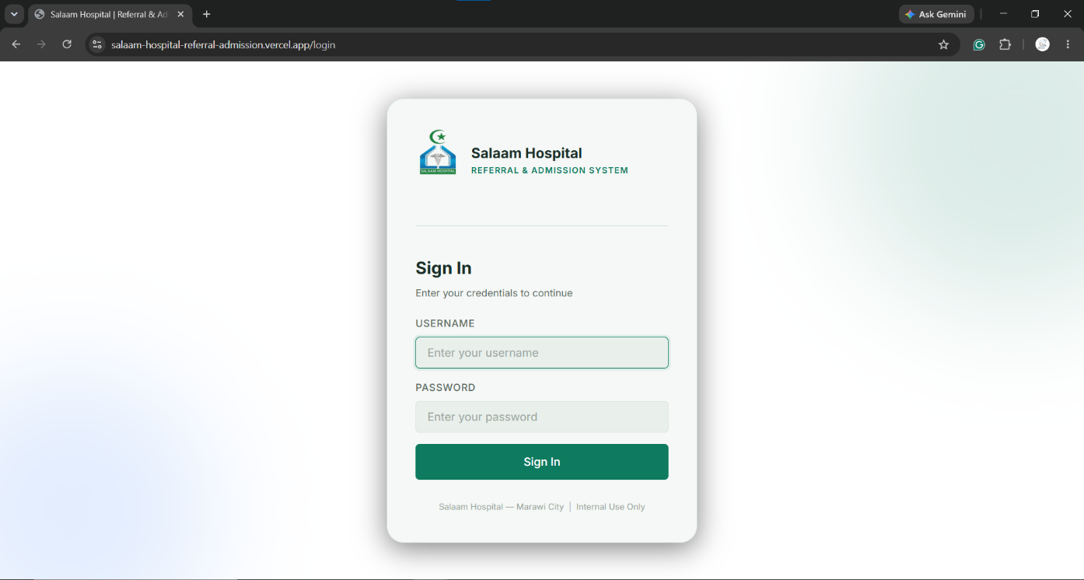
Figure 4.1 Login Page

4.1.2 Nurse/Staff Dashboard
Figure 4.2 shows the dashboard page of a nurse/staff user. It displays summary cards for total patients, active admissions, pending referrals, and room availability, along with recent patient and triage activity. Each role has its own dashboard showing information relevant to their responsibilities.
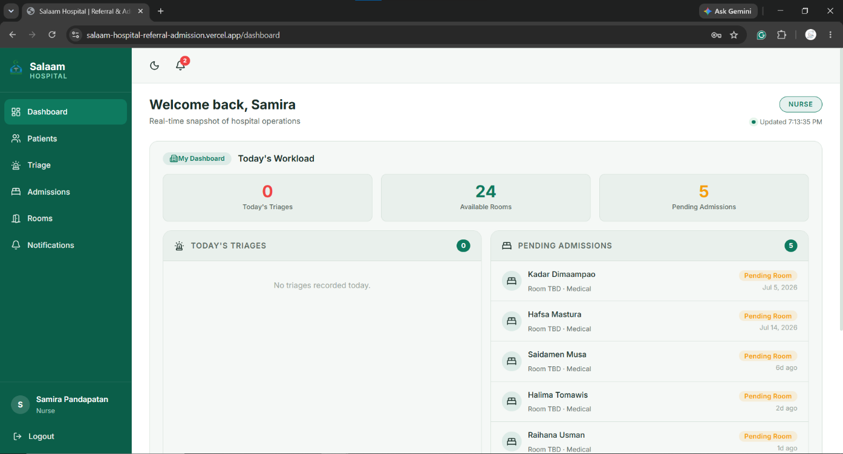
Figure 4.2 Nurse/Staff Dashboard Page

4.1.3 Patient Management
Figure 4.3 shows the patients list page. It displays all registered patients in a table with
search and filter options for quickly locating records.
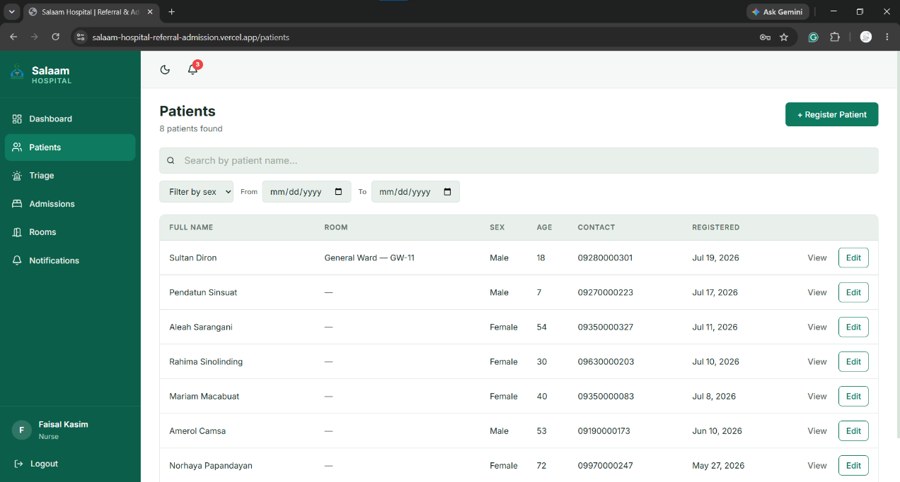
Figure 4.3 Patients List Page

Figure 4.4 shows the patient registration form. It captures the patient's personal information, address (with a Philippine address picker), and emergency contact details. An option for registering unidentified emergency patients is also available.
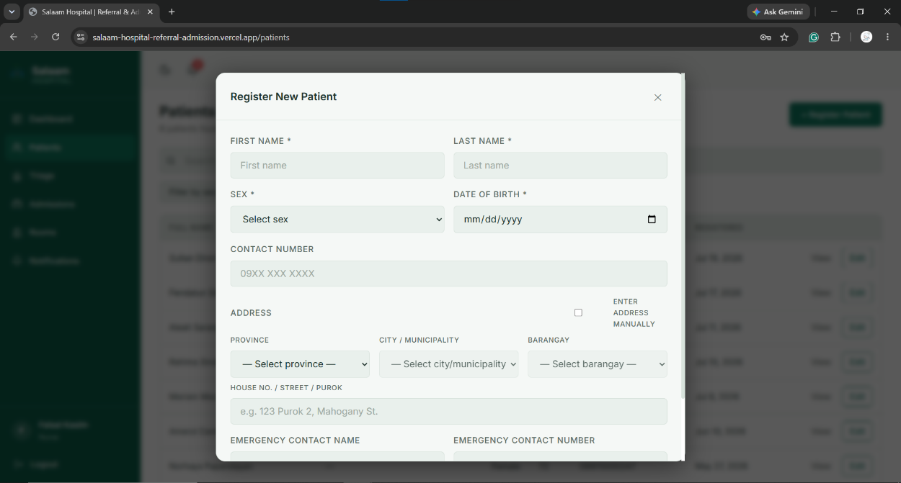
Figure 4.4 Patient Registration Form (Nurse/Staff)
4.1.4 Triage and Vital Signs Recording
Figure 4.5 shows the triage page. It displays a table of all triage records with the patient name, triage level, visit type, and date. Nurses and staff can search, filter, and select a record to view its details or create a new triage assessment. 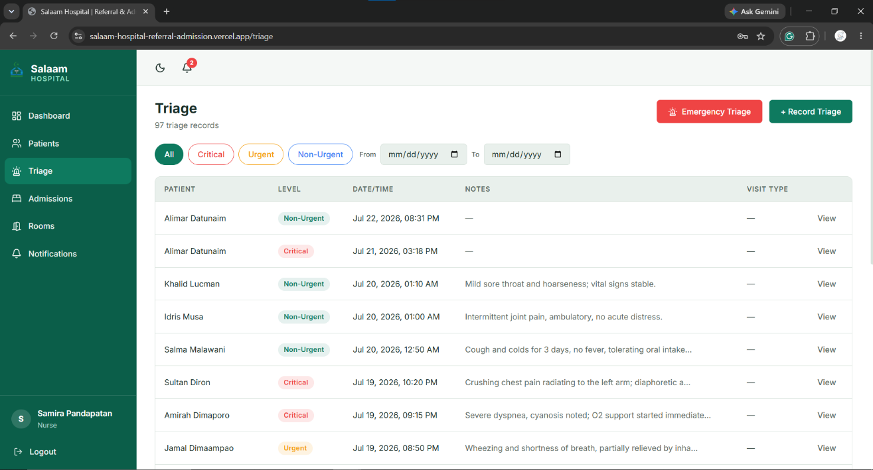
Figure 4.5 Triage Page (Nurse/Staff)
Figure 4.6 shows the triage form used to assess incoming patients. It captures the triage level (Critical, Urgent, or Non-Urgent), visit room, attending nurse/staff, and additional clinical notes.
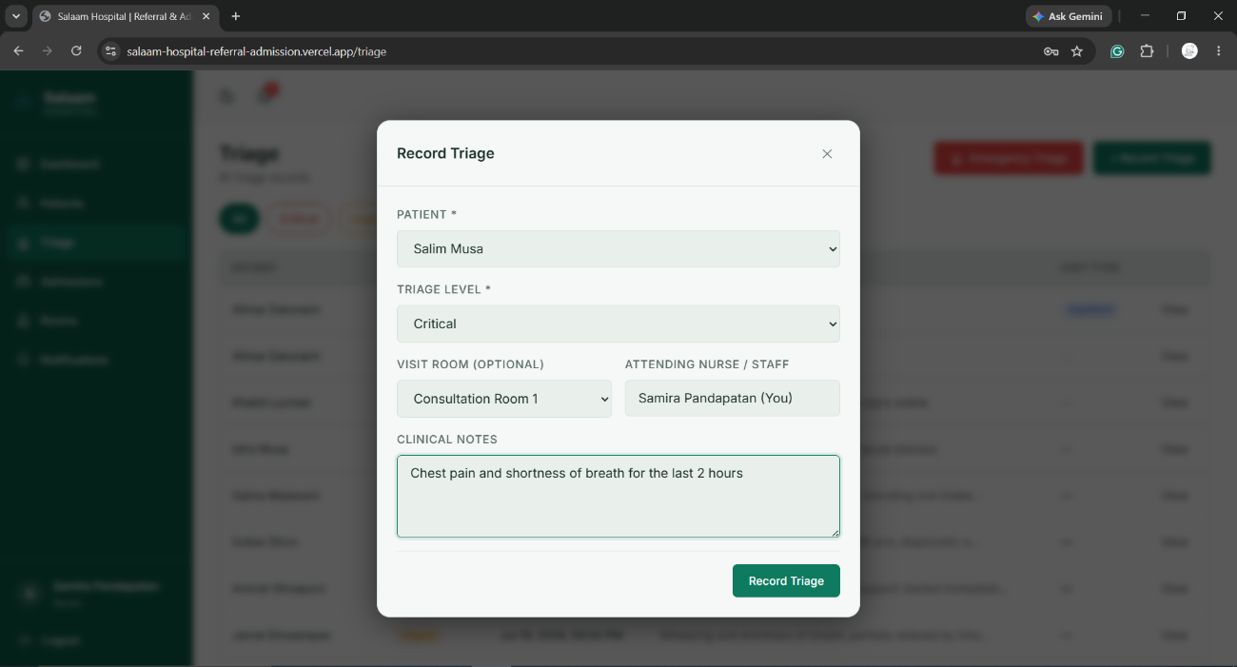
Figure 4.6 Triage Form (Nurse/Staff)
Figure 4.7 shows the vital signs form. It records the patient's blood pressure, heart rate, temperature, and respiratory rate. The recorded data is linked to the triage record and becomes part of the patient's medical history.
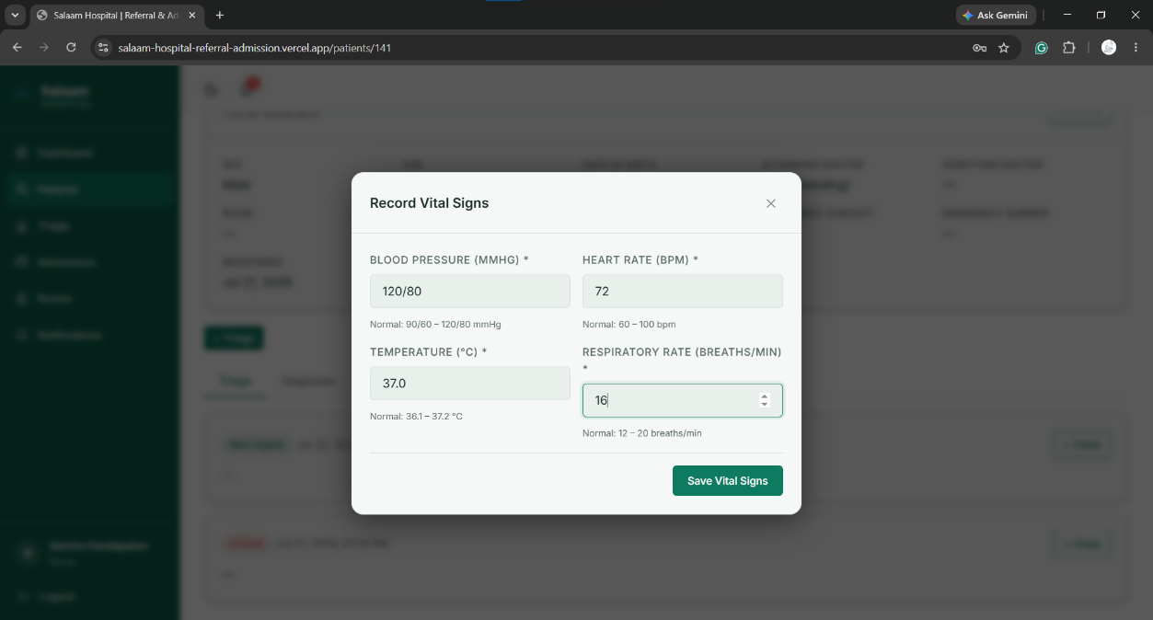
Figure 4.7 Vital Signs Form (Nurse/Staff)
4.1.5 Diagnosis and Treatment
Figure 4.8 shows the patient detail page as viewed by a doctor. It presents the patient's complete medical history, including triage records, vital signs, diagnoses, treatments, laboratory results, referrals, and admission status in a timeline format.
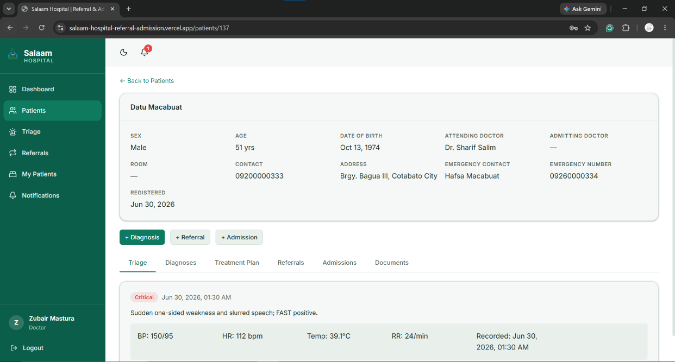
Figure 4.8 Patient Detail Page (Doctor)
Figure 4.9 shows the diagnosis form. Doctors use this form to record the medical condition and diagnosis date. After saving, the doctor may add a treatment plan, request lab tests, or initiate a referral.
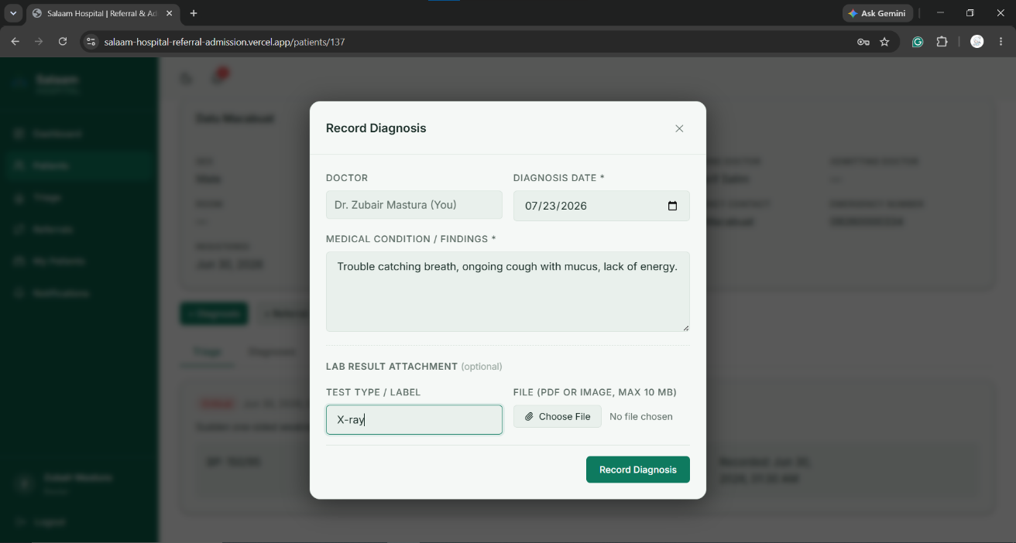
Figure 4.9 Diagnosis Form (Doctor)

4.1.6 Referral Processing
Figure 4.10 shows the referral form. It allows the doctor to select a receiving doctor, draw an electronic signature on the canvas, and optionally attach a supporting document. This is the core feature of the system's digitized referral process.
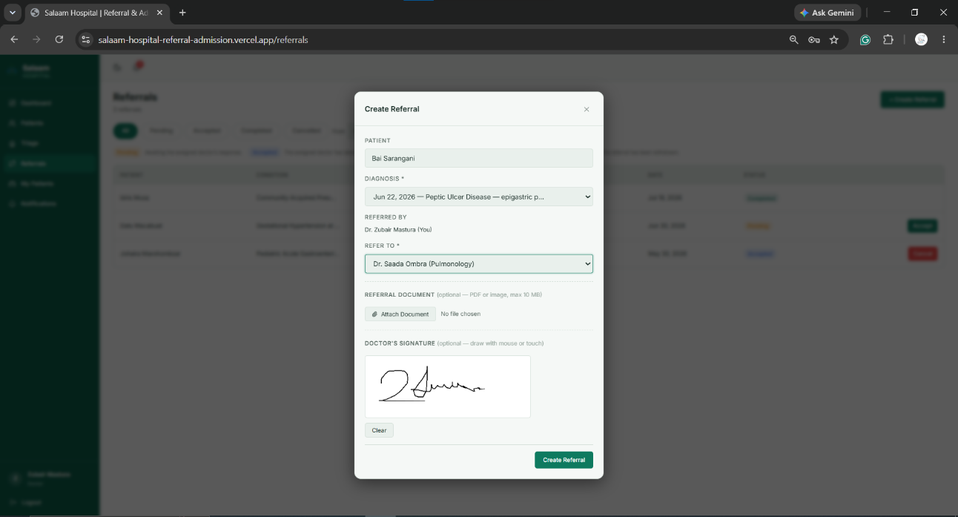
Figure 4.10 Referral Form with E-Signature (Doctor)
Figure 4.11 shows the referrals list page. It displays all referrals with their patient name, referring and assigned doctors, date, and current status (Pending, Accepted, Completed, or Cancelled).
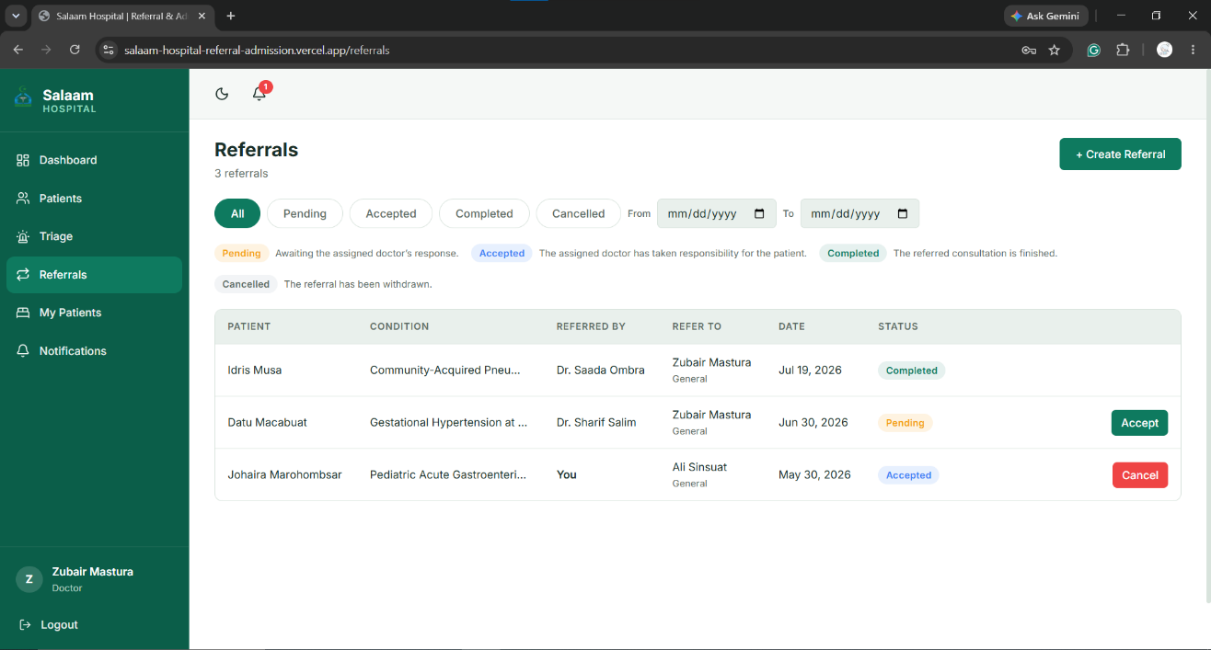
Figure 4.11 Referrals List Page (Doctor)

Figure 4.12 shows a notification alerting a doctor of a new referral assignment. The notifications page lists all system-generated alerts with timestamps and read/unread indicators.
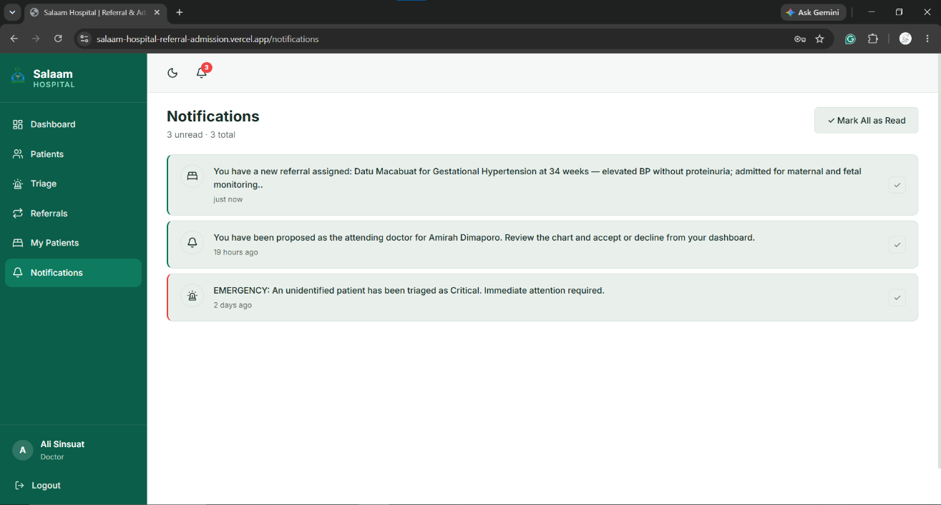
Figure 4.12 Referral Notification (Doctor)

4.1.7 Admission and Discharge
Figure 4.13 shows the admissions page. It lists all admissions with their statuses: Pending Room, Active, Pending Discharge, and Discharged. Doctors initiate discharge requests, while nurses or staff confirm them.
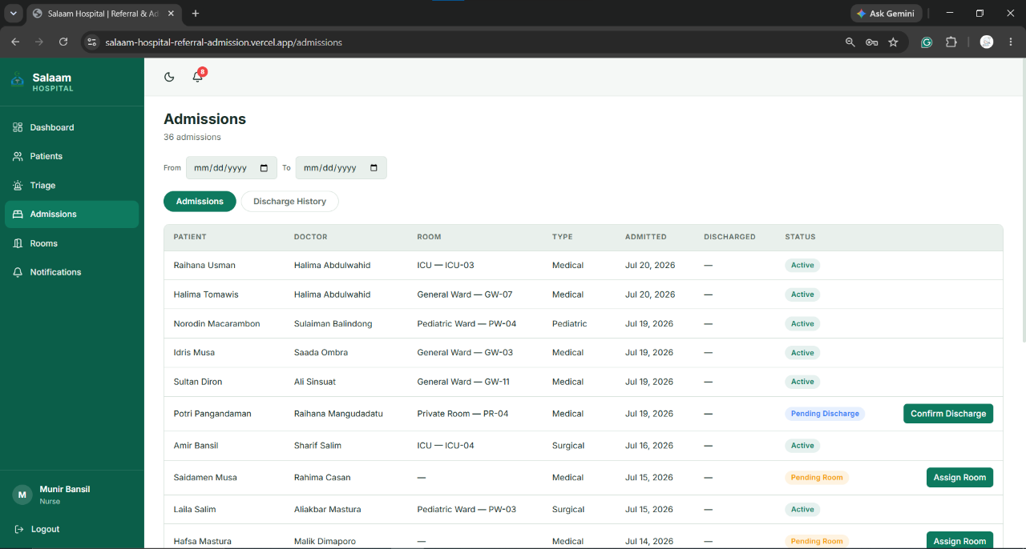
Figure 4.13 Admissions Page (Nurse/Staff)

Figure 4.14 shows the rooms page. It displays all hospital rooms with their type, bed number, and availability status (Available or Occupied), allowing staff to check availability before assigning rooms.
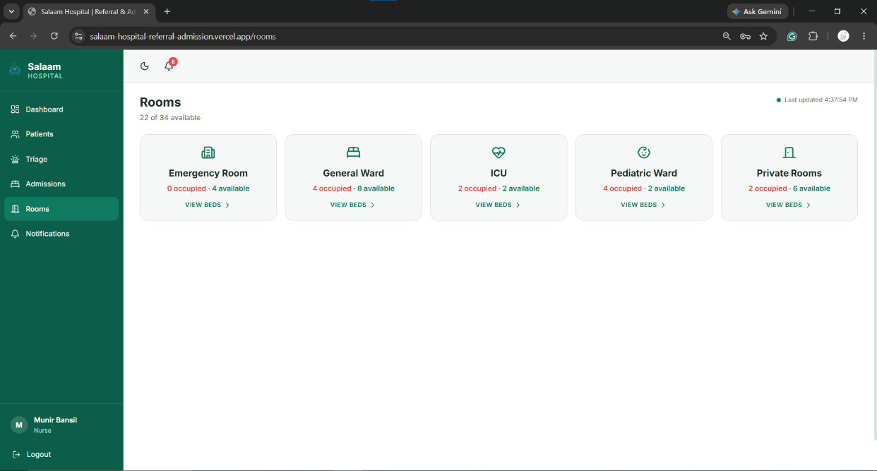
Figure 4.14 Rooms Page (Nurse/Staff)
4.1.8 Administrative Functions
Figure 4.15 shows the user management page. The administrator can add, edit, deactivate, or reactivate user accounts. Each account is linked to a doctor or employee profile with a designated role.
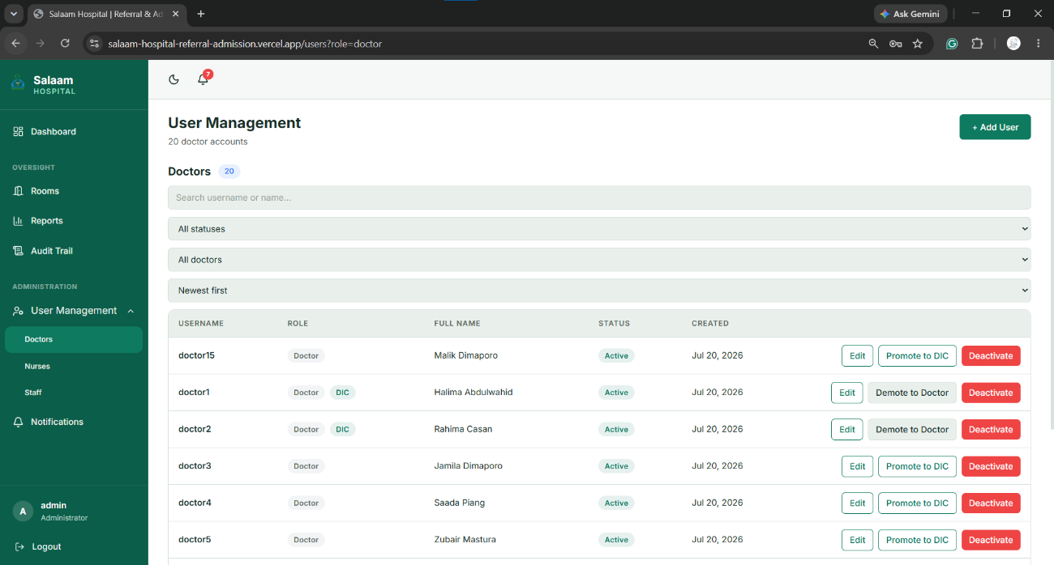
Figure 4.15 User Management Page (Filtered to show Doctor Accounts only) (Admin)

Figure 4.16 shows the reports page. It allows the administrator to generate admission, referral, turnaround, and outpatient reports with date range filters. A CSV export option is available for downloading report data.
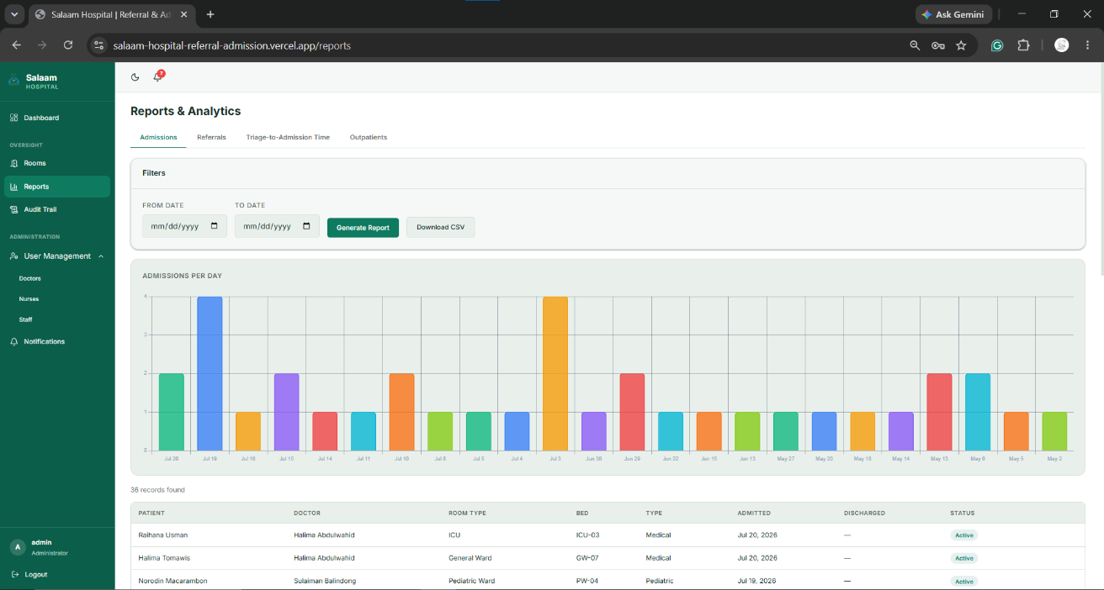
Figure 4.16 Reports Page (Admin)
Figure 4.17 shows the audit trail page. It logs all significant actions performed in the system, including the user, action type, affected record, and timestamp, with filter options for searching.
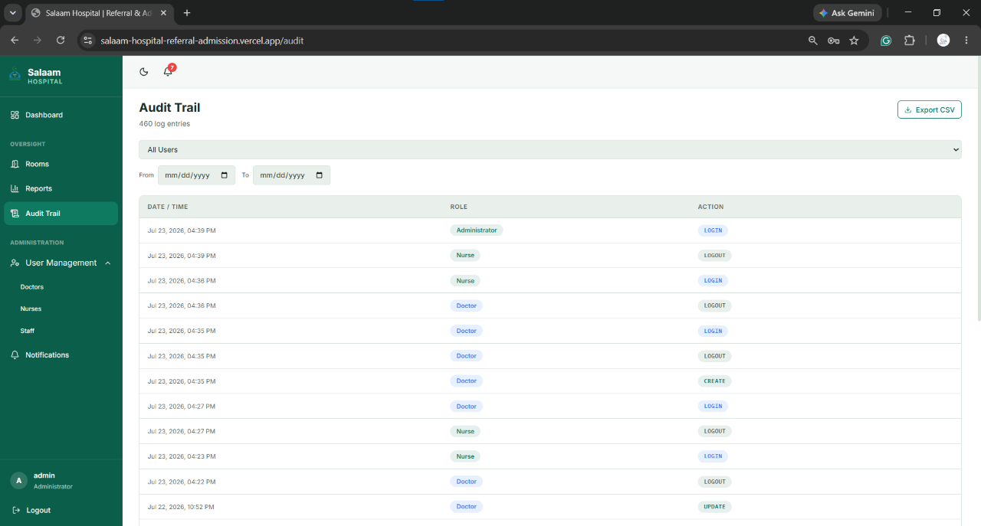
Figure 4.17 Audit Trail Page (Admin)
4.1.9 Responsive Design
The system's interface adapts to different screen sizes. On mobile devices, the sidebar is replaced by a bottom navigation bar and content is reorganized into a single-column layout.

Figure 4.18 shows the login page on a mobile device. The form fields and button are stacked vertically to fit the narrower screen.
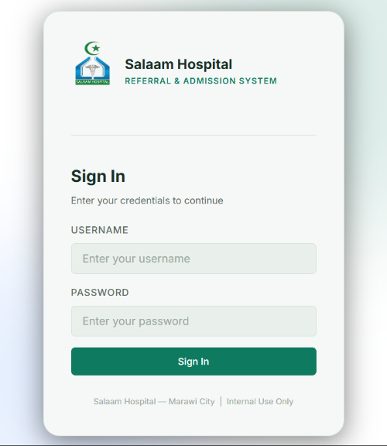
Figure 4.18 Login Page (Mobile View)
Figure 4.19 shows the nurse/staff dashboard on a mobile device. The summary cards stack vertically and the bottom navigation bar replaces the sidebar.
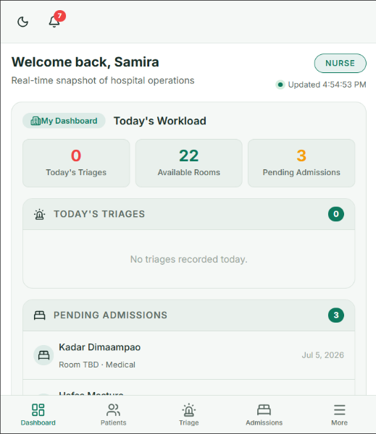
Figure 4.19 Nurse/Staff Dashboard (Mobile View)

Figure 4.20 shows the referral form with e-signature on a mobile device, demonstrating that the system's most complex form remains fully functional on smaller screens.
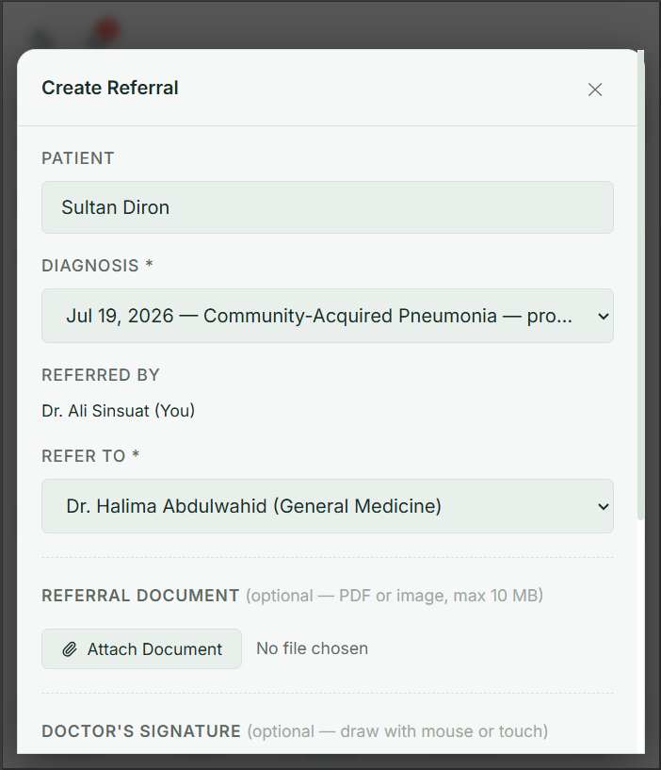
Figure 4.20 Referral Form with E-Signature (Doctor — Mobile View)

4.2 System Usability Scale (SUS) Questionnaire
This part shows the results of the System Usability Scale (SUS) survey using a weighted mean Likert-type scale. The scale ranges from 1 (Strongly Disagree) to 5 (Strongly Agree). The weighted mean was used to find the average rating of each statement to see how useful the respondents think the system is.
The participants involved are 35, 5 for the alpha test, and 30 for the beta test. The alpha testing is 5 selected hospital personnel from Salaam Hospital. The beta testing consists of 30 random CICS students of Mindanao State University – Main Campus.

4.2.1 Alpha Test
Table 4.1 Mean of System Usability Scale (SUS) Survey Result (Alpha Test).
Statement | Weighted Mean | Remark
1. I think that I would like to use this system frequently. | 4.40 | Strongly Agree
2. I found the system unnecessarily complex. | 4.40 | Strongly Agree
3. I thought the system was easy to use. | 3.20 | Neutral
4. I think that I would need the support of a technical person to be able to use this system. | 2.80 | Neutral
5. I found the various functions in this system were well integrated. | 4.60 | Strongly Agree
6. I thought there was too much inconsistency in this system. | 3.20 | Neutral
7. I would imagine that most people would learn to use this system very quickly. | 3.40 | Agree
8. I found the system very cumbersome to use. | 2.80 | Neutral
9. I felt very confident using the system. | 4.40 | Strongly Agree
10. I needed to learn a lot of things before I could get going with this system. | 3.40 | Agree
AVERAGE | 3.66 | Agree

Figure 4 presents the percentage result of the System Usability Scale (SUS) Survey during the alpha test. The responses indicate a generally positive perception of the system, with most respondents selecting "Agree" and "Strongly Agree" for the positive statements. Item 5 received the highest positive rating, with 60% of the respondents marking "Strongly Agree" and the remaining 40% selecting "Agree." Likewise, Items 1, 2, and 9 also obtained favorable responses, with 60% of the respondents choosing "Agree" and 40% selecting "Strongly Agree." Meanwhile, Items 3 and 6 were primarily rated "Neutral," with 80% of the respondents selecting "Neutral" and 20% choosing "Agree." Items 7 and 10 shared the same response pattern, with 60% of the respondents selecting "Neutral" and 40% choosing "Agree." On the other hand, Items 4 and 8 were mostly rated "Neutral," with 80% of the respondents selecting "Neutral" and 20% marking "Disagree," indicating that only a few respondents encountered difficulties that required technical assistance or found the system cumbersome to use. Overall, the responses suggest that the system was generally perceived as usable and easy to operate, although some aspects could still be improved to enhance users' confidence and overall experience.

Figure 4.21: System Usability Scale (SUS) Survey Result (Alpha Test).

4.2.2 Beta Test
Beta testing was conducted to evaluate the usability, appropriateness, and efficiency of the Responsive Web-Based Patient Referral and Admission System for Salaam Hospital from the perspective of various end-users. The results are categorized according to the user groups: Admin, Doctor, Doctor-in-Charge, and Nurse/Staff.
4.2.2.1. Admin Evaluation
Presented below is the evaluation result from the administrators who tested the system regarding overall account management, reports, and operations.

Table 4.2 Mean of System Usability Scale (SUS) Survey Result (Admin Evaluation)
Statement | Weighted Mean | Remark
I think that I would like to use this system frequently. | 4.60 | Strongly Agree
I found the system unnecessarily complex. | 2.50 | Disagree
I thought the system was easy to use. | 4.60 | Strongly Agree
I think that I would need the support of a technical person to be able to use this system. | 2.60 | Disagree
I found the various functions in this system were well integrated. | 4.60 | Strongly Agree
I thought there was too much inconsistency in this system. | 2.60 | Disagree
I would imagine that most people would learn to use this system very quickly. | 4.70 | Strongly Agree
I found the system very cumbersome to use. | 2.50 | Disagree
I felt very confident using the system. | 4.60 | Strongly Agree
I needed to learn a lot of things before I could get going with this system. | 2.70 | Neutral
AVERAGE | 3.65 | Agree

Interpretation: For the admin evaluation, most administrators expressed favorable responses, particularly on positive statements such as Items 1, 5, and 7, indicating that they easily learned system management and that the features were well-integrated.
4.2.2.2 Doctor Evaluation
This section outlines the response of the doctors regarding the use of the system in reviewing patient information, diagnosing, and making clinical decisions.

Table 4.3 Mean of System Usability Scale (SUS) Survey Result (Doctor Evaluation)
Statement | Weighted Mean | Remark
I think that I would like to use this system frequently. | 4.60 | Strongly Agree
I found the system unnecessarily complex. | 2.50 | Disagree
I thought the system was easy to use. | 4.50 | Strongly Agree
I think that I would need the support of a technical person to be able to use this system. | 2.60 | Disagree
I found the various functions in this system were well integrated. | 4.60 | Strongly Agree
I thought there was too much inconsistency in this system. | 2.70 | Neutral
I would imagine that most people would learn to use this system very quickly. | 4.70 | Strongly Agree
I found the system very cumbersome to use. | 2.50 | Disagree
I felt very confident using the system. | 4.60 | Strongly Agree
I needed to learn a lot of things before I could get going with this system. | 2.70 | Neutal
AVERAGE | 3.61 | Neutral

Interpretation: The results from the doctors show that they had confidence in using the system (Item 9) and did not find it overly complex or requiring technical support, making it appropriate for their fast-paced hospital workflow.
4.2.2.3 Doctor-in-Charge Evaluation
This part demonstrates the evaluation of the Doctors-in-Charge who directly monitor and manage patients while admitted or receiving internal referrals.

Table 4.4 Mean of System Usability Scale (SUS) Survey Result (Doctor-in-Charge Evaluation)
Statement | Weighted Mean | Remark
I think that I would like to use this system frequently. | 4.70 | Strongly Agree
I found the system unnecessarily complex. | 2.40 | Disagree
I thought the system was easy to use. | 4.60 | Strongly Agree
I think that I would need the support of a technical person to be able to use this system. | 2.50 | Disagree
I found the various functions in this system were well integrated. | 4.70 | Strongly Agree
I thought there was too much inconsistency in this system. | 2.60 | Disagree
I would imagine that most people would learn to use this system very quickly. | 4.60 | Strongly Agree
I found the system very cumbersome to use. | 2.50 | Disagree
I felt very confident using the system. | 4.60 | Strongly Agree
I needed to learn a lot of things before I could get going with this system. | 2.80 | Neutal
AVERAGE | 3.65 | Agree

Interpretation: According to the Doctors-in-Charge, the system is effective in executing admission and referral processes. It garnered high marks in Items 7 and 1, proving that it was quickly understood and desired for daily tasks.
4.2.2.4. Nurse/Staff Evaluation
For nurses and staff who are the primary users of the system for patient registration, recording triage, taking vital signs, and room management, their evaluation results are detailed below.

Table 4.5 Mean of System Usability Scale (SUS) Survey Result (Nurse/Staff Evaluation)
Statement | Weighted Mean | Remark
I think that I would like to use this system frequently. | 4.50 | Strongly Agree
I found the system unnecessarily complex. | 2.50 | Disagree
I thought the system was easy to use. | 4.60 | Strongly Agree
I think that I would need the support of a technical person to be able to use this system. | 2.60 | Disagree
I found the various functions in this system were well integrated. | 4.70 | Strongly Agree
I thought there was too much inconsistency in this system. | 2.70 | Neutral
I would imagine that most people would learn to use this system very quickly. | 4.60 | Strongly Agree
I found the system very cumbersome to use. | 2.50 | Disagree
I felt very confident using the system. | 4.60 | Strongly Agree
I needed to learn a lot of things before I could get going with this system. | 2.70 | Neutral
AVERAGE | 3.60 | Agree

Interpretation: The nurses and staff also exhibited a positive perspective. Because they are crucial to frontdesk and ward operations, their low ratings on Items 4, 8, and 10 prove that the system's features do not hinder or complicate their fast-paced duties.

4.2.3 Overall Test Result
This section consolidates the overall System Usability Scale (SUS) survey results from all registered groups (Admin, Doctor, Doctor-in-Charge, and Nurse/Staff) to show the general acceptance level of the system.

Table 4.6 Mean of System Usability Scale (SUS) Survey Result (Overall)
Statement | Weighted Mean | Remark
I think that I would like to use this system frequently. | 4.60 | Strongly Agree
I found the system unnecessarily complex. | 2.50 | Disagree
I thought the system was easy to use. | 4.58 | Strongly Agree
I think that I would need the support of a technical person to be able to use this system. | 2.58 | Disagree
I found the various functions in this system were well integrated. | 4.65 | Strongly Agree
I thought there was too much inconsistency in this system. | 2.65 | Neutral
I would imagine that most people would learn to use this system very quickly. | 4.60 | Strongly Agree
I found the system very cumbersome to use. | 2.50 | Disagree
I felt very confident using the system. | 4.60 | Strongly Agree
I needed to learn a lot of things before I could get going with this system. | 2.73 | Neutral
AVERAGE | 3.63 | Agree
Figure 4 presents the percentage results of the System Usability Scale (SUS) Survey conducted during the beta test. The responses indicate a generally positive perception of the system, particularly on the positive statements. Items 1, 3, 5, 7, and 9 received favorable responses, with most respondents selecting “Agree” and “Strongly Agree.” These results indicate that the respondents were willing to use the system, considered it easy to use, found its functions well integrated, believed that users could learn to use it quickly, and felt confident while using the system.
Meanwhile, the negative statements received generally favorable results from a usability perspective, as respondents mostly selected “Disagree” or “Neutral.” Items 2 and 4 were generally rated “Disagree,” indicating that respondents did not consider the system unnecessarily complex and did not believe that they would need technical assistance to use it. Item 6 also received mostly “Disagree” responses, suggesting that respondents did not perceive too much inconsistency in the system. Similarly, Item 8 was mostly rated “Disagree,” indicating that respondents did not find the system cumbersome to use.
Item 10 received “Disagree” and “Neutral” responses, indicating that respondents generally did not feel that they needed to learn many things before they could begin using the system. Overall, the results show a positive perception of the system’s usability. The combination of favorable responses to the positive statements and low to neutral responses to the negative statements suggests that the system was perceived as user-friendly, understandable, and easy to operate. The overall weighted mean of 3.63, interpreted as “Agree,” further indicates a generally positive evaluation of the system during the beta testing.
. Figure 4.21: System Usability Scale (SUS) Survey Result (Beta Test).

CHAPTER V

SUMMARY, CONCLUSION, AND RECOMMENDATION

This chapter presents the summary of all the data collected in this study, the conclusions drawn based on the findings, and the recommendations. This study was conducted to address the difficulties experienced by Salaam Hospital in managing patient referrals and admissions through manual processes. Based on the interviews and consultations conducted with hospital staff, the researchers identified that the current paper-based procedures create challenges in organizing patient information, monitoring referral progress, and maintaining accurate admission records. The reliance on handwritten documents and manual recording increases the possibility of delays, incomplete information, difficulty in retrieving patient records, and challenges in coordinating information among hospital personnel. These issues highlight the need for a more efficient and centralized approach to managing hospital records and workflows.

During the data gathering phase, the researchers conducted interviews and consultations with hospital personnel, including administrators, doctors, and nurses/staff of Salaam Hospital, to understand the existing patient referral and admission procedures. The gathered information helped identify the current workflow, challenges encountered by users, and the necessary requirements for the proposed system. Furthermore, empathy maps were utilized to analyze the experiences, responsibilities, and concerns of different users, allowing the researchers to determine the essential functionalities needed to address the identified problems and improve the hospital’s workflow.

Based on the gathered requirements, the researchers proceeded with the system design phase by developing the system structure, user interface design, database design, and workflow models. Various software design tools, including Use Case Diagrams, Entity-Relationship Diagrams (ERD), Input-Process-Output (IPO) diagrams, and system architectural design, were utilized to properly define the components and interactions of the proposed system. The design process ensured that the developed system was aligned with the operational requirements of Salaam Hospital and provided a user-centered solution for managing patient referrals and admissions.

To address these identified challenges, the researchers proposed the development of a Responsive Web-Based Patient Referral and Admission System that can assist hospital personnel in managing patient information, processing referrals, and monitoring admissions through a digital platform. The proposed system aims to improve record accessibility, enhance coordination among hospital departments, and provide a more organized method of handling patient referral and admission processes while reducing the limitations associated with manual documentation.

The development of the system began with the identification of critical operational inefficiencies at Salaam Hospital, such as delays and record management issues caused by traditional paper-based procedures. Guided by the gathered requirements and under the direct mentorship of the capstone adviser, Sir Mcfire, the technical implementation commenced. The application was built using HTML, CSS, JavaScript, and React.js for the frontend, Node.js for the backend, and MySQL for database management, fulfilling the objective to establish a functional, centralized web architecture.

Following the implementation phase, the system underwent continuous evaluation and validation through regular on-site consultations and progress checks at Salaam Hospital to ensure it met client specifications and operational standards. Furthermore, the development of the system followed proper software engineering phases, including requirement gathering and the use of appropriate software design tools to ensure alignment with the operational requirements of the hospital.

To evaluate the functionality and usability of the system in achieving its goals, testing was conducted in two phases. The Alpha Test involved five (5) programmers who evaluated the technical structure and system performance, while the Beta Test consisted of hospital staff from Salaam Hospital who assessed its practical usability in real-world workflows.

The Alpha Test obtained an overall weighted mean of 3.66, interpreted as "Agree," indicating that the programmers considered the system technically sound, functional, and well-structured. Likewise, the Beta Test produced favorable responses from the hospital staff, with respondents expressing positive perceptions regarding the system's usability, ease of learning, functionality, and overall user experience. The findings, alongside successful stakeholder reviews, demonstrate that the developed system effectively met its overall goal and specific objectives, providing a practical solution for improving hospital operations.

5.2 Conclusion
Based on the findings of the study, the following conclusions were drawn:
- The Responsive Web-Based Patient Referral and Admission System successfully achieved its intended objectives by providing an organized, centralized, and efficient platform for managing patient referrals, admissions, and hospital records.
- The system improved the accessibility and management of patient information by allowing authorized hospital personnel to register patients, record triage information, monitor referrals, assign hospital rooms, and manage admissions through a single web-based application.
- The results of the System Usability Scale (SUS) evaluation showed that both hospital personnel and student respondents positively accepted the system. The Alpha Test obtained an overall interpretation of "Agree," while the Beta Test also produced favorable usability results, indicating that the system is easy to use, easy to learn, and functions effectively.
- The evaluation further revealed that respondents appreciated the integration of the system's functions, particularly in organizing patient information and simplifying referral and admission workflows. Although some respondents identified minor areas for improvement, the overall feedback confirmed that the system performs reliably and meets user expectations.
- Therefore, the Responsive Web-Based Patient Referral and Admission System is considered a reliable and effective solution that can assist Salaam Hospital in improving operational efficiency, reducing manual processes, and supporting better patient management.

5.3 Recommendation
Based on the findings and conclusions of the study, the researchers recommend the following:
- Salaam Hospital may adopt and implement the Responsive Web-Based Patient Referral and Admission System as part of its daily operations to improve the efficiency of patient referral, admission, and record management.
- Future developers may enhance the system by incorporating additional features such as SMS or email notifications, online appointment scheduling, barcode or QR code integration for patient identification, and automated report generation to further improve hospital services.
- Future versions of the system may include integration with laboratory, pharmacy, billing, and electronic medical record (EMR) systems to provide a more comprehensive hospital information management solution.
- Additional security measures, such as multi-factor authentication, encrypted backups, audit logging, and enhanced access control, should be implemented to strengthen data privacy and protect sensitive patient information.
- Future researchers are encouraged to conduct evaluations involving a larger number of hospital personnel and healthcare institutions to further assess the effectiveness, usability, scalability, and adaptability of the system in different healthcare environments.
- The patient identification feature may be further enhanced through the use of a more efficient and secure identification method, such as a unique patient ID, barcode, or QR code, to facilitate faster patient identification and retrieval of medical records while reducing the possibility of duplicate or incorrect patient information.
- Future versions of the system may include a patient referral tracking feature for patients referred to other hospitals. This feature may allow authorized hospital personnel to monitor the status and progress of external referrals, helping improve coordination, follow-up, and continuity of patient care.

References
Al-Shorbaji, N., Atun, R., & Car, J. (2016). eHealth and health system strengthening: Evidence, challenges and opportunities. Bulletin of the World Health Organization, 94(10), 703–705. https://www.ncbi.nlm.nih.gov/pmc/articles/PMC5040494/
Alemu, T., Mekonnen, Z., & Getachew, M. (2023). Challenges of manual health record management systems and the need for digital solutions in hospitals. Journal of Health Informatics in Developing Countries, 17(1).
Department of Health. (n.d.). Integrated Hospital Operations and Management Information System (iHOMIS). https://doh.gov.ph/
Epizitone, A. (2023). A systematic literature review of health information systems. Healthcare, 11(7), 959. https://www.mdpi.com/2227-9032/11/7/959
Influence of health information management practices on the quality of healthcare. (2023). Healthcare Management Review.
Khosravi, A., Kazemi, A., & Hosseini, M. (2023). Hospital information systems and their impact on clinical decision-making and service quality. Journal of Medical Systems, 47(2).
Mohammadpour, A., et al. (2021). Hospital information systems and their role in improving healthcare quality. Journal of Healthcare Engineering, 2021. https://www.ncbi.nlm.nih.gov/pmc/articles/PMC8123921/
Ortiga, B., Capistrano, E., & Macalinao, M. (2012). Improving hospital admission and discharge processes to enhance operational efficiency. Asian Hospital & Healthcare Management.
Phreesia, Inc. (n.d.). Phreesia Referral Management System. https://www.phreesia.com/
Shah, R., Patel, S., & Mehta, N. (2024). Design and development of a web-based patient management information system. International Journal of Computer Applications, 185(12).
Shiferaw, K., Zewdu, S., & Sisay, A. (2023). Assessment of manual versus electronic patient record systems in hospitals. BMC Medical Informatics and Decision Making, 23, 45. https://bmcmedinformdecismak.biomedcentral.com/
Tung, F.-C., Chang, S.-C., & Chou, C.-M. (2016). An acceptance model of hospital information systems. International Journal of Medical Informatics, 95, 1–14. https://pubmed.ncbi.nlm.nih.gov/27573316/
We Are Health. (n.d.). We Are Health Digital Hospital Platform. https://www.wearehealth.ph/
WellSky Corporation. (n.d.). WellSky Enterprise Referral Manager. https://wellsky.com/
Zhao, P., Yoo, I., Lavoie, J., Lavoie, B. J., & Simoes, E. (2017). Web-based medical appointment systems: A systematic review. Journal of Medical Internet Research, 19(4), e134. https://www.jmir.org/2017/4/e134/

APPENDICES

APPENDIX A
INFORMED CONSENT FORM
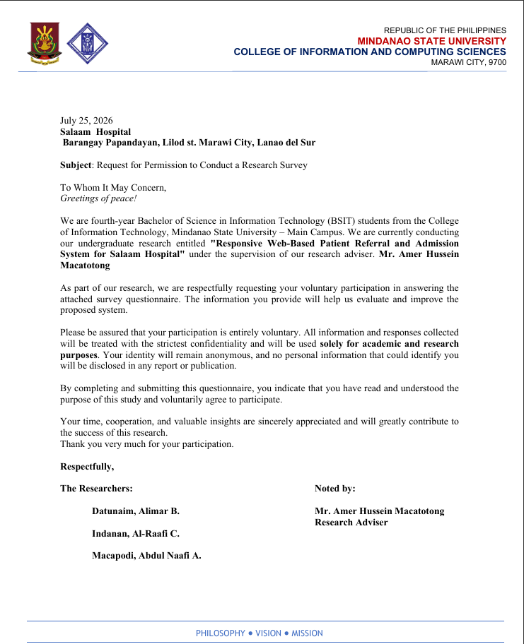
APPENDIX B
EVALUATION TOOL

Please read each statement carefully and place a check mark (✓) in the appropriate column (1–5) that best represents your opinion regarding the usability and quality of the system.
Rate each statement according to the following scale:
1 = Strongly Disagree
2 = Disagree
3 = Neutral
4 = Agree
5 = Strongly Agree

No. | I think that I would like to use this system frequently. | 1 | 2 | 3 | 4 | 5
1 | I found the system unnecessarily complex.
2 | I thought the system was easy to use.
3 | I think that I would need the support of a technical person to be able to use this system.
4 | I found the various functions in this system were well integrated.
5 | I thought there was too much inconsistency in this system.
6 | I would imagine that most people would learn to use this system very quickly.
7 | I found the system very cumbersome to use.
8 | I felt very confident using the system.
9 | I needed to learn a lot of things before I could get going with this system.
10 | I think that I would like to use this system frequently.

APPENDIX C
SAMPLE ANSWERS
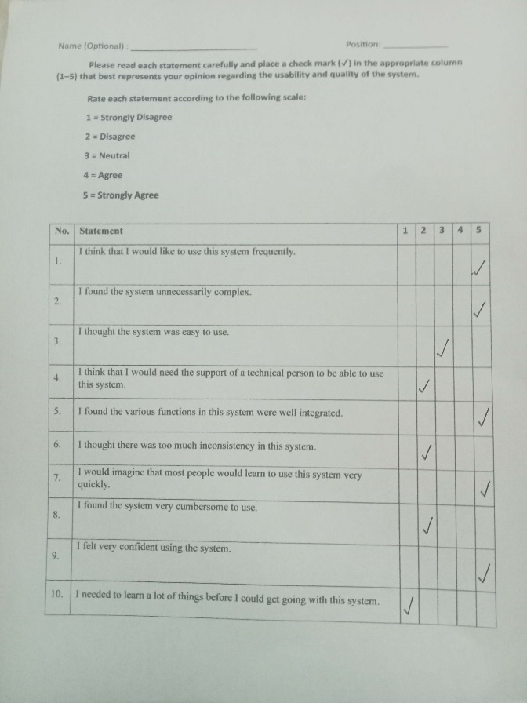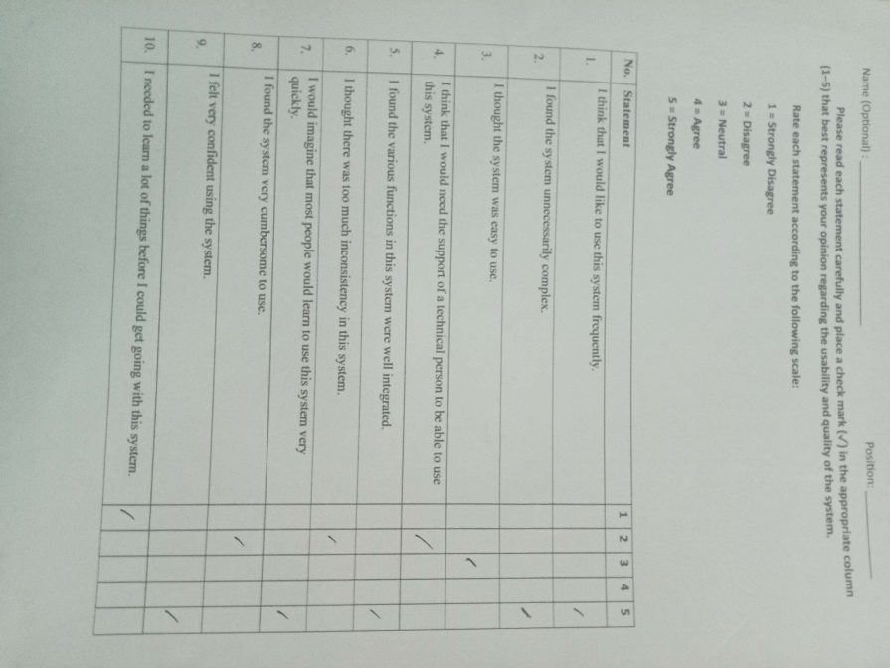
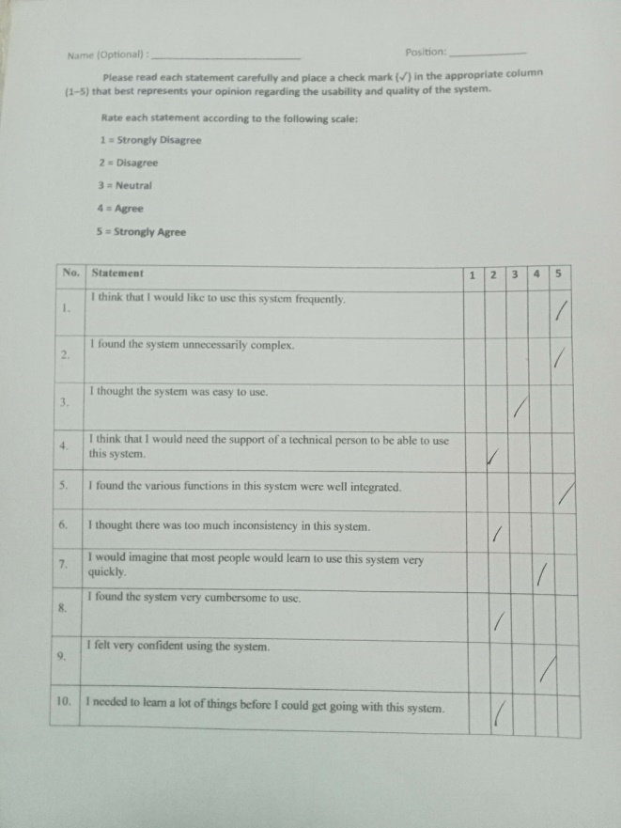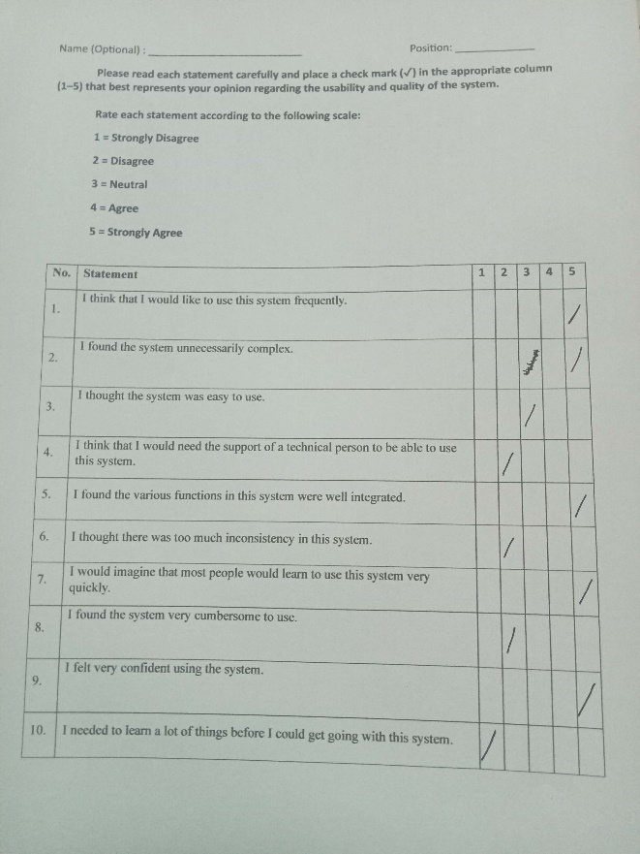
APPENDIX D
DOCUMENTATION
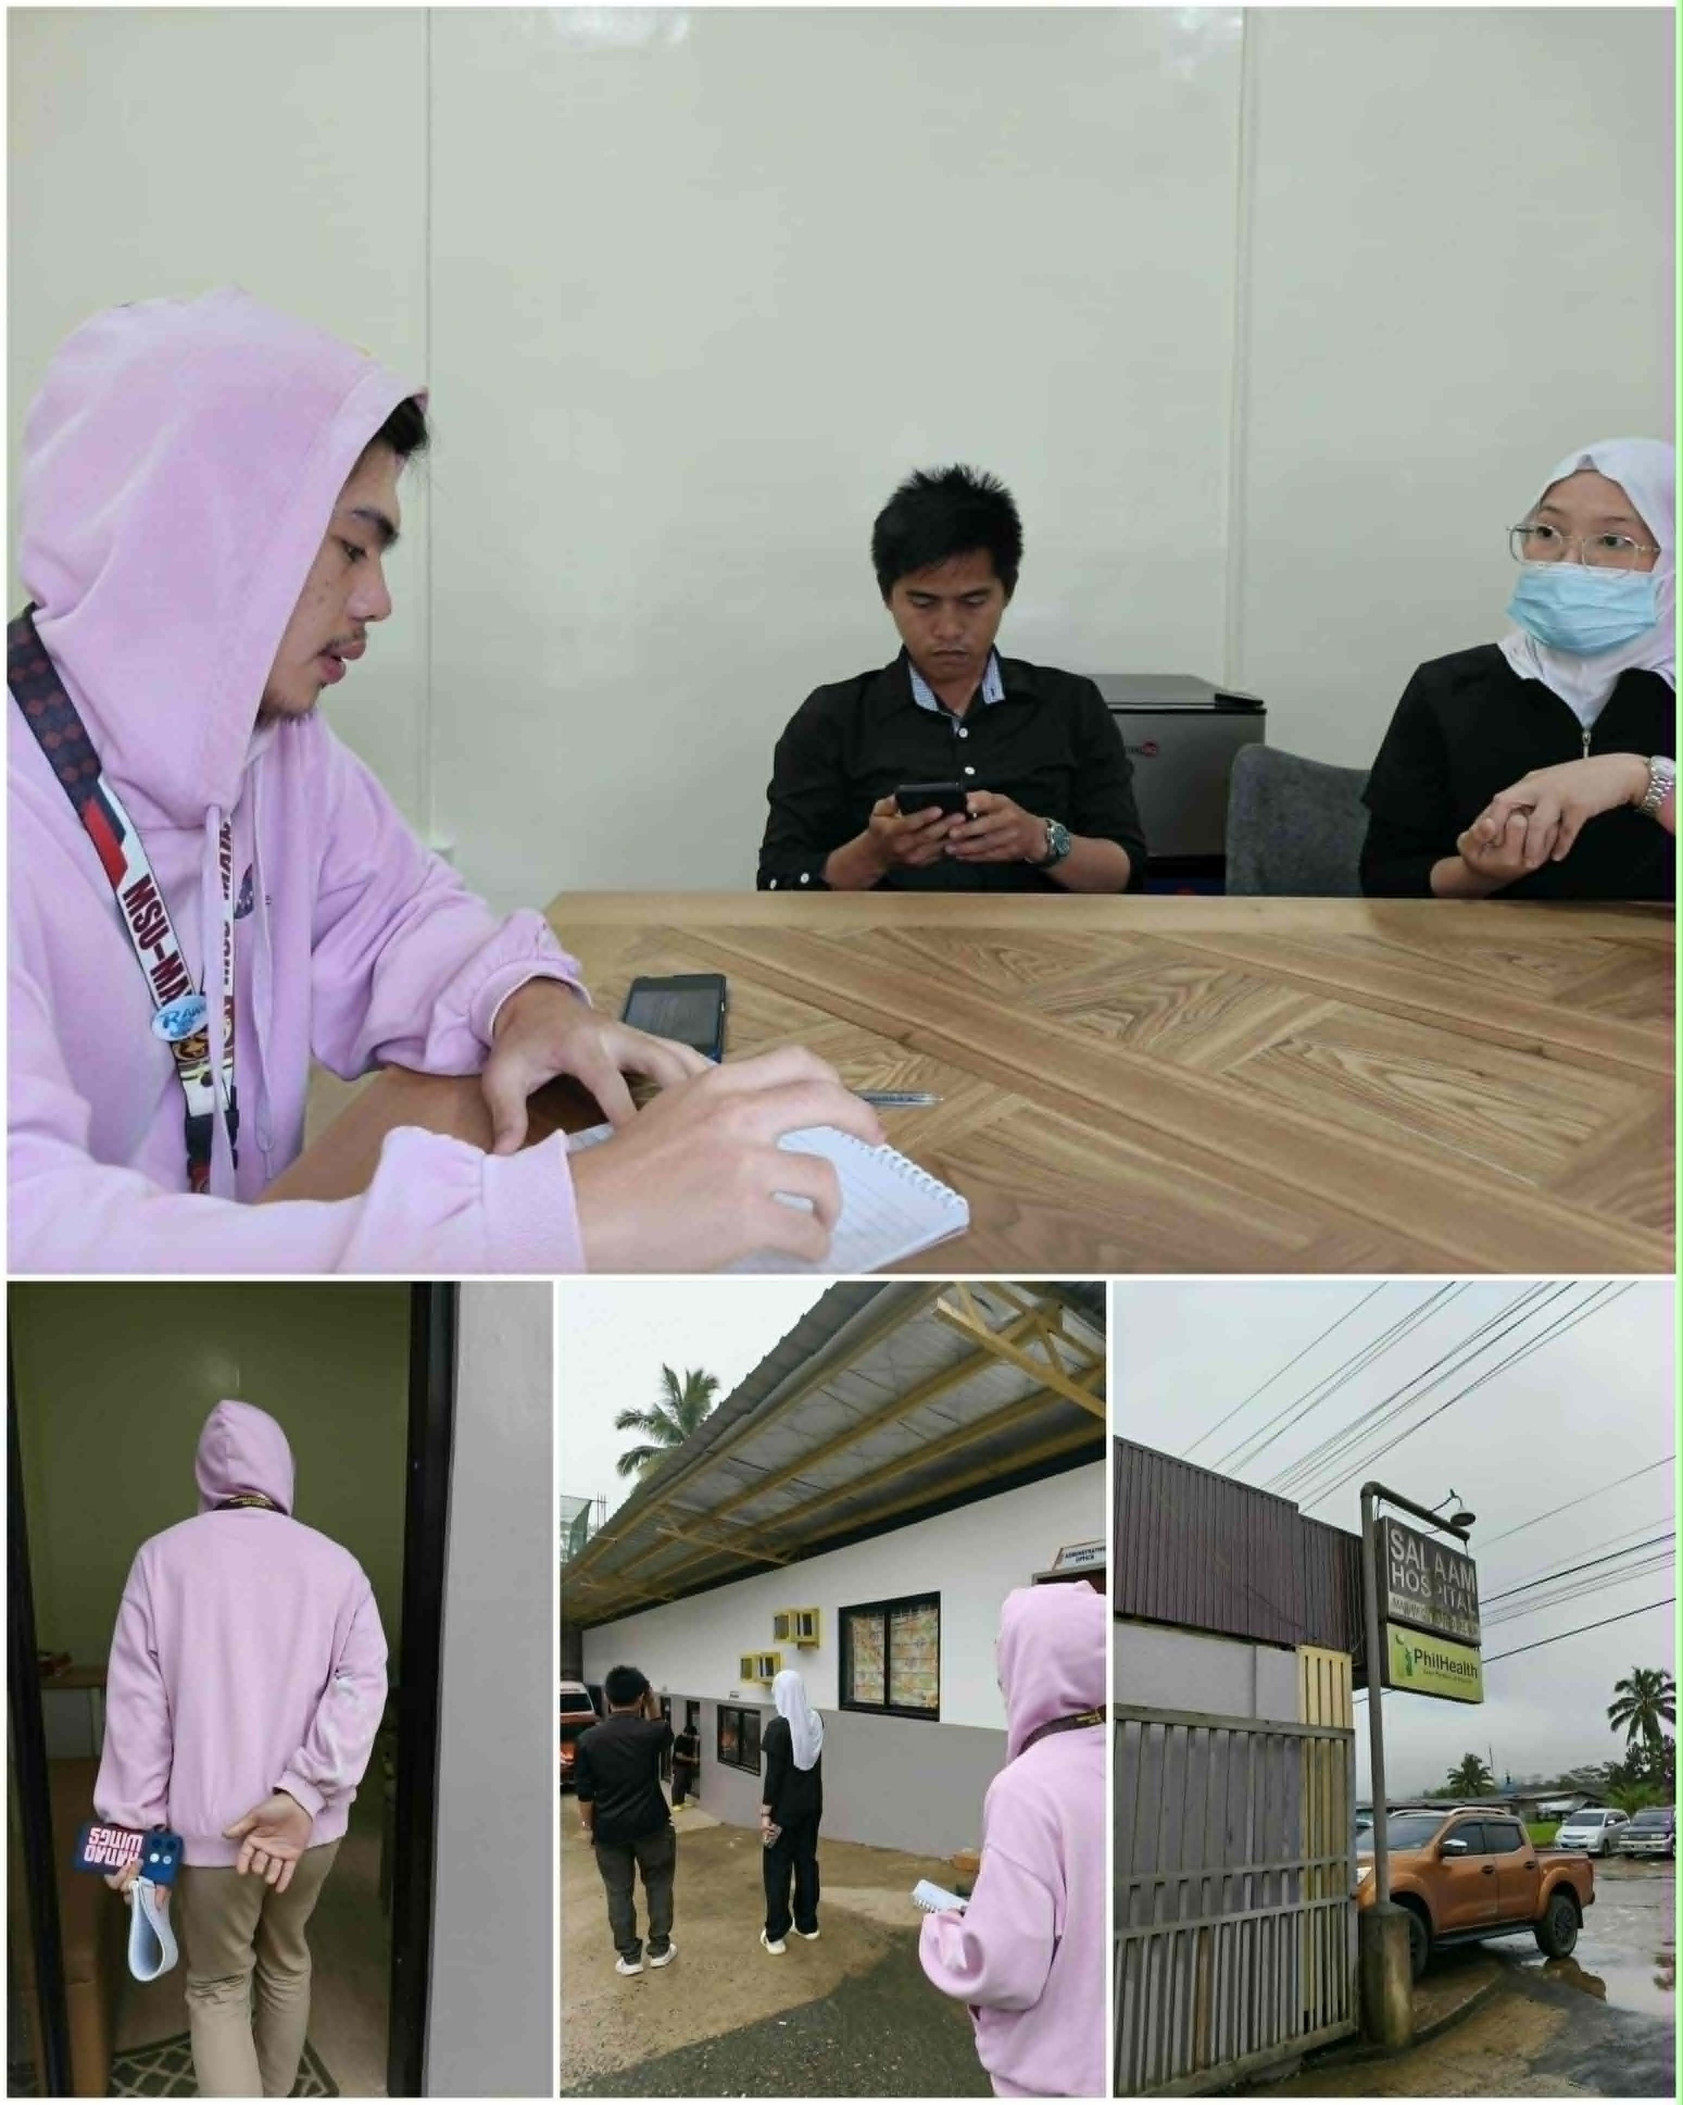

Evaluation and survey conducted with nurse and IT.

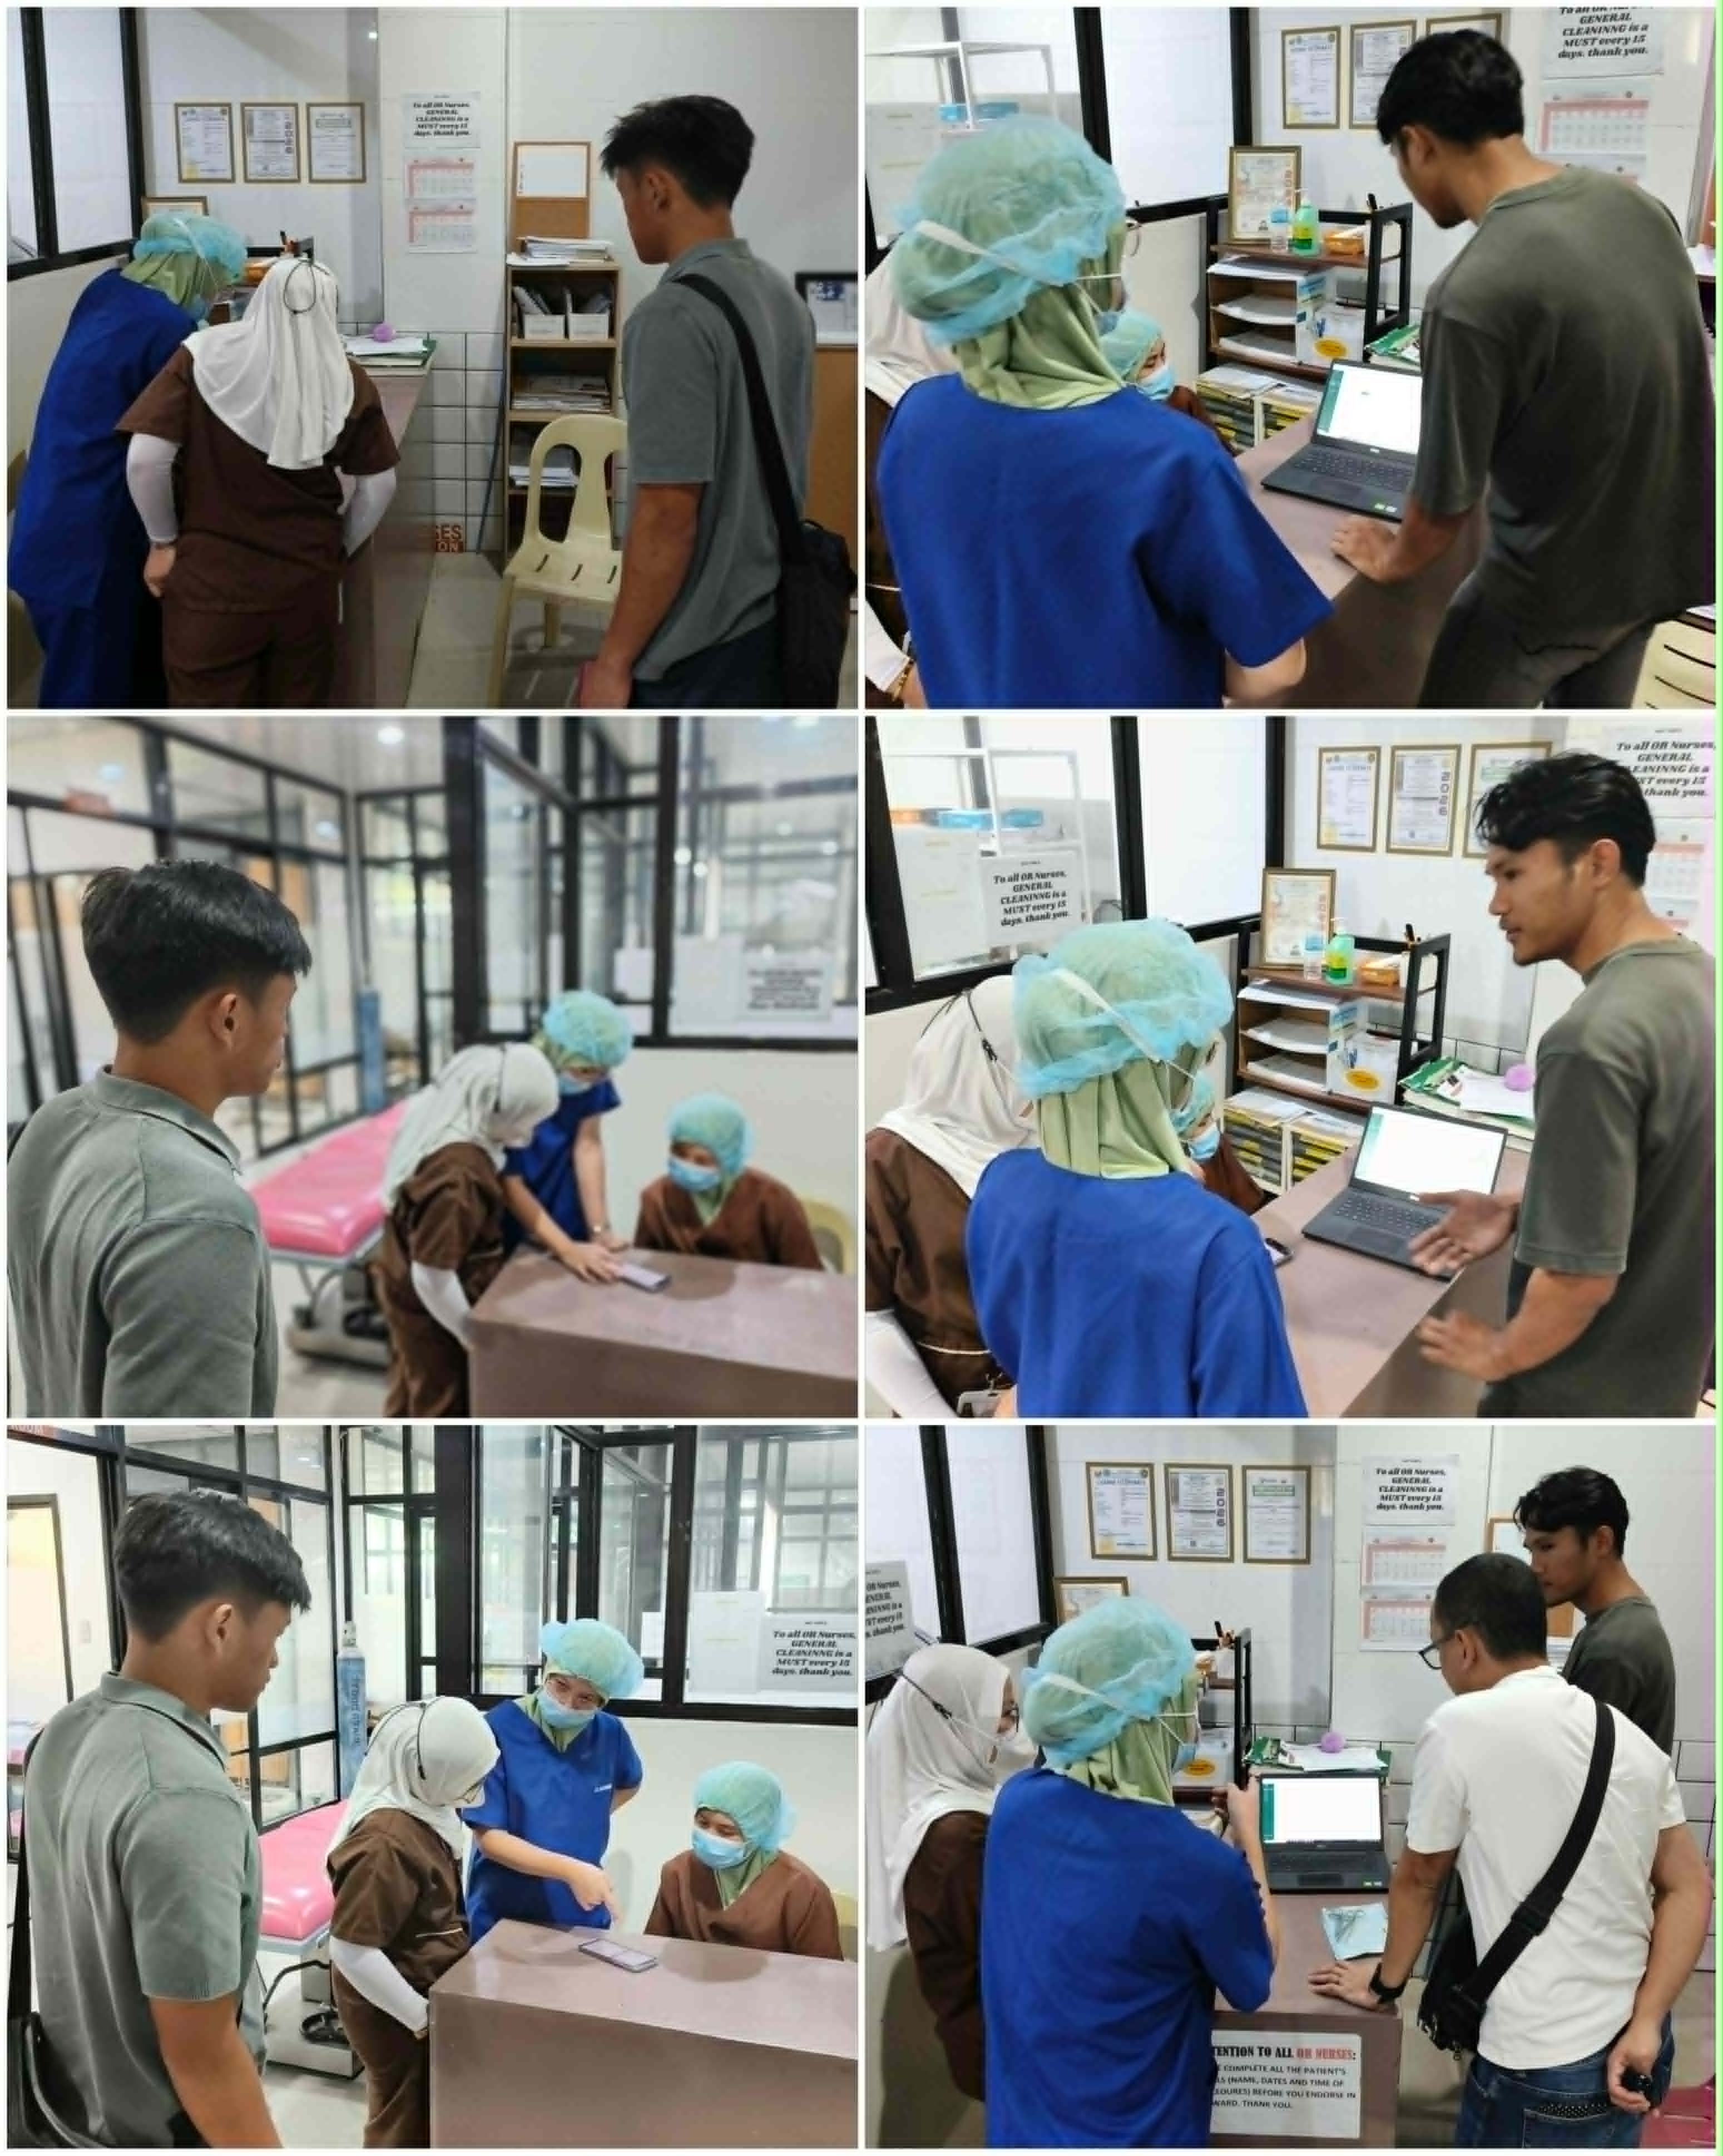
Evaluation and survey conducted with nurses and doctors.




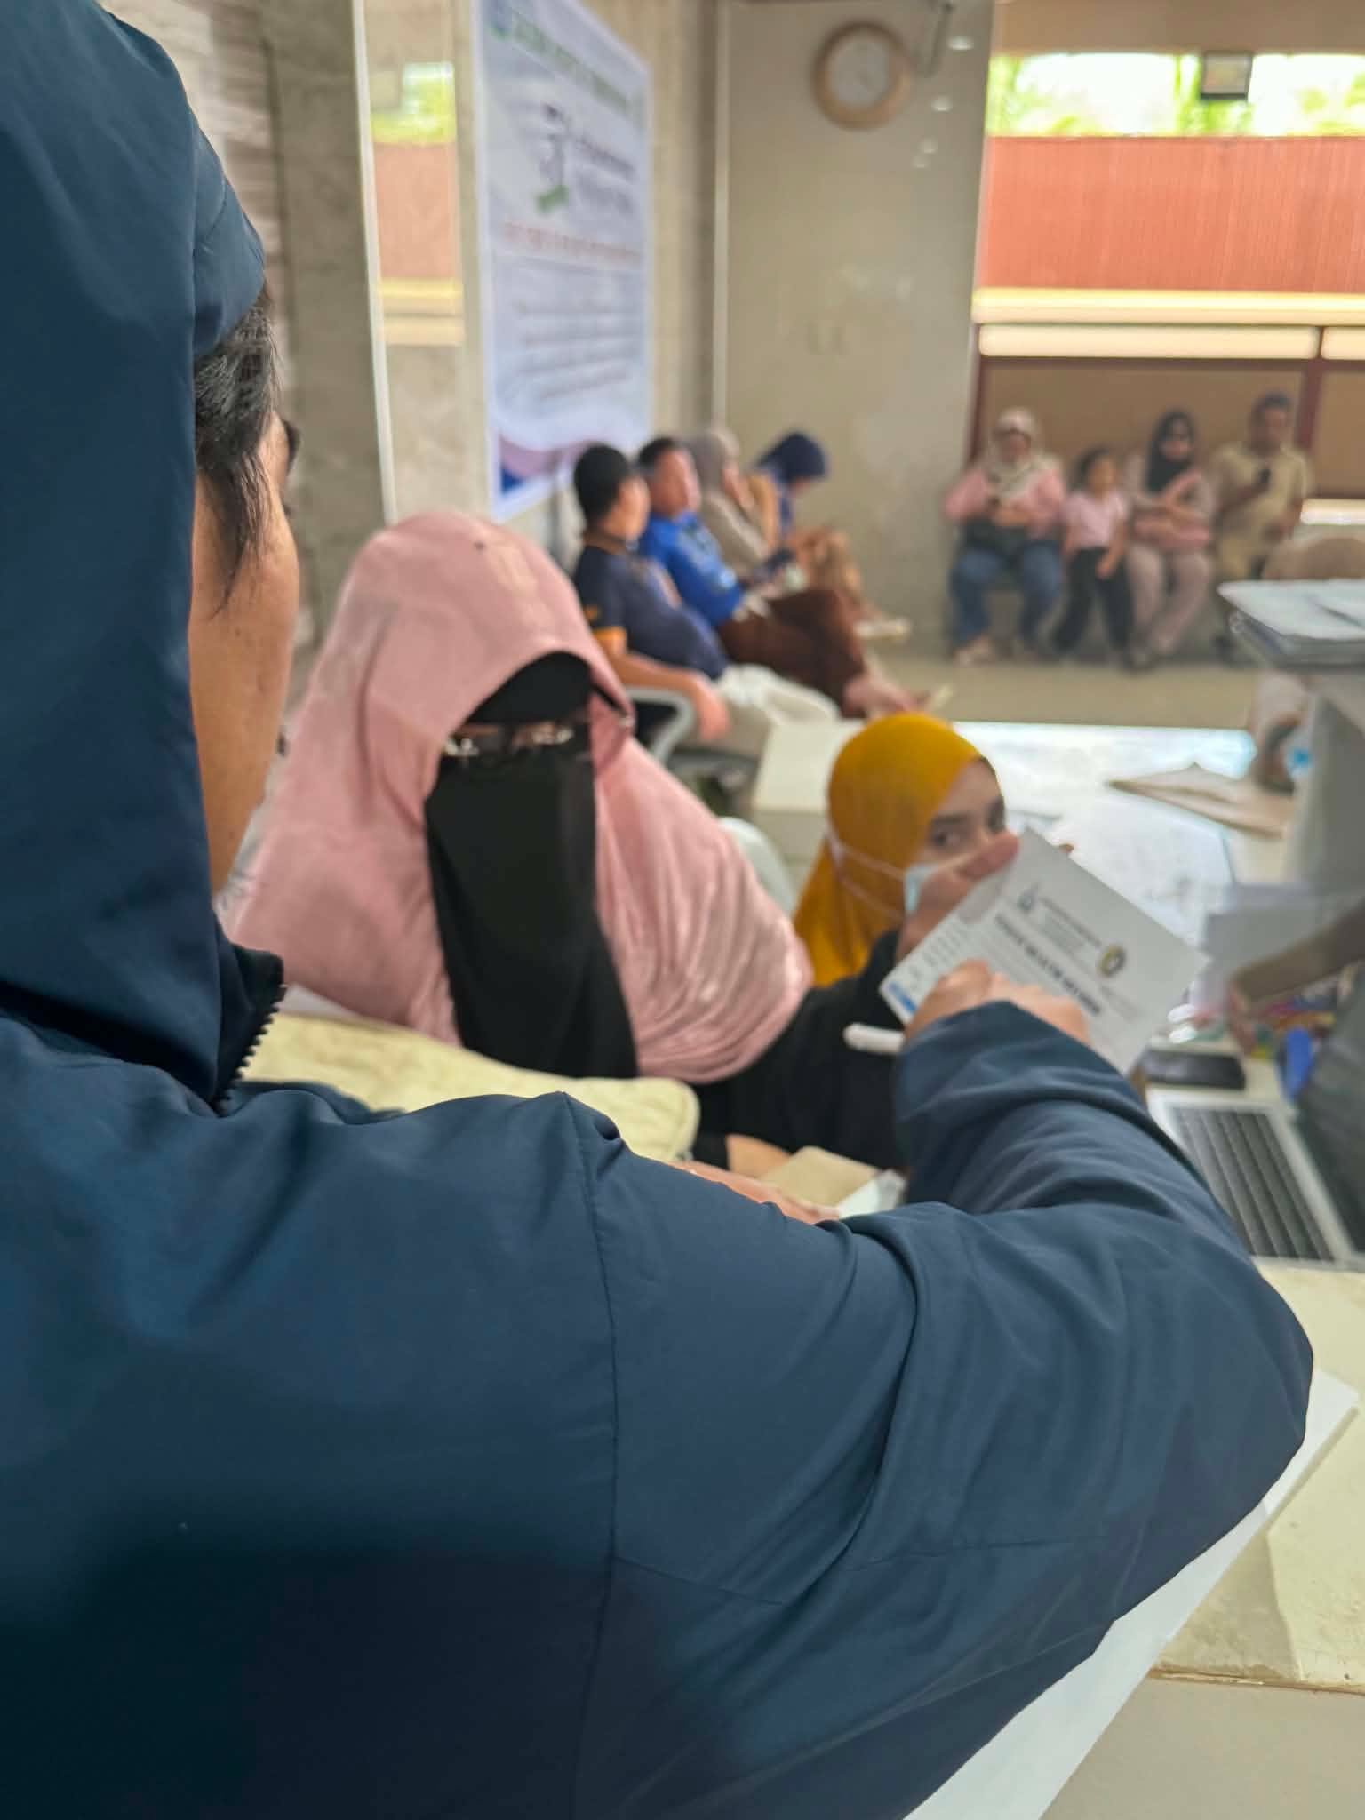

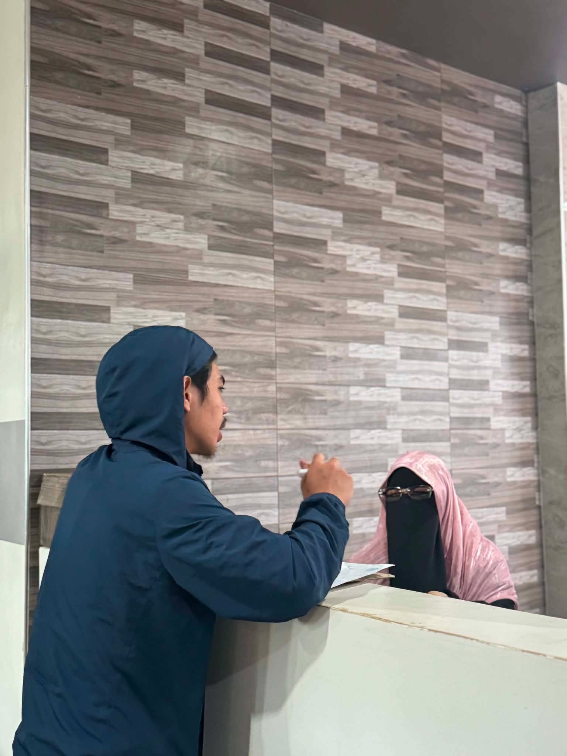
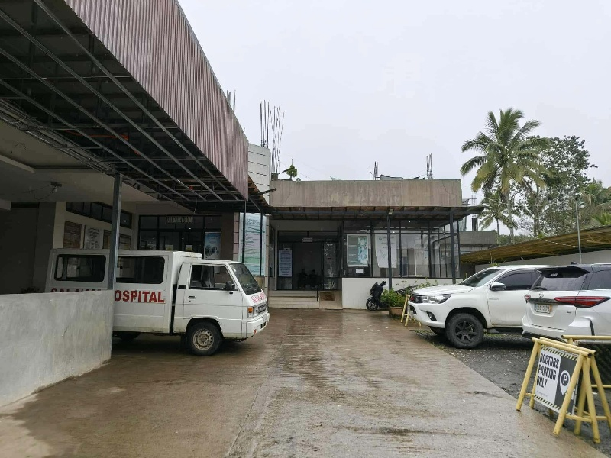
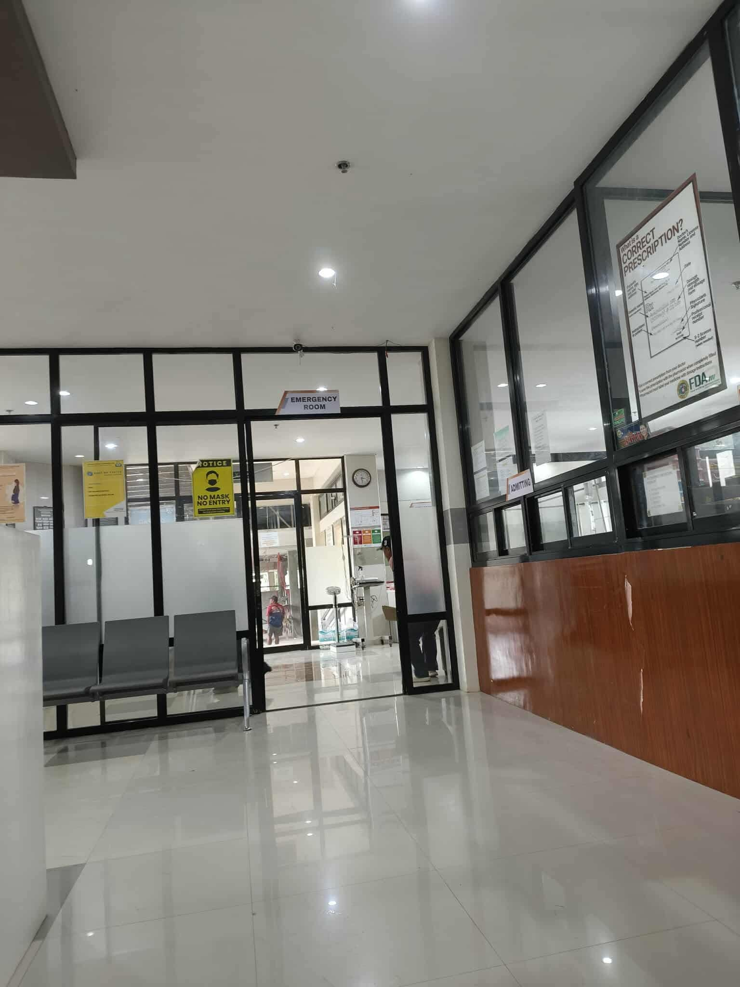
Follow-up Consultation and Interview with Nurses and Staf

