# ***Сделанные задания SQL***

Порядок исполнения команд:

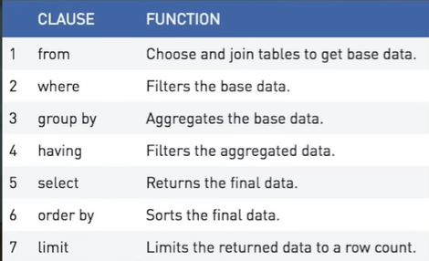

* AND

SELECT title, release_year

FROM films

WHERE (release_year > 2000 AND release_year < 2010)

AND language = 'German';

* OR

SELECT title, release_year

FROM films

WHERE (release_year = 1990 OR release_year = 1999)

    AND (language = 'English' OR language = 'Spanish')

    AND gross > 2000000;

* BETWEEN

SELECT title, release_year

FROM films

WHERE language = 'Spanish'

    AND release_year BETWEEN 1990 AND 2000

    AND budget > 100000000

* LIKE / NOT LIKE

SELECT name

FROM people

WHERE name LIKE 'B%'

    OR name LIKE '_r%'

    AND name NOT LIKE 'A%'

* WHERE, IN

SELECT title, release_year, certification

FROM films

WHERE year IN(1990, 2000)

    AND certification IN ('NC-17', 'R')

    AND longevity > 120

    AND language IN ('English', 'Spanish', 'French');

* COUNT, DISTINCT, AS

SELECT COUNT(DISTINCT title) AS nineties_english_films_for_teens

FROM films

WHERE release_year BETWEEN 1990 AND 1999

    AND language = 'English'

    AND certifications IN ('G', 'PG', 'PG-13');

* NULL

SELECT title AS no_budget_info

FROM films

WHERE budget IS NULL;

* NOT NULL

SELECT COUNT(title) AS count_language_known

FROM films

WHERE language IS NOT NULL;

* ORDER BY

SELECT release_year, duration, title

FROM films

ORDER BY release_year, duration;

* ORDER BY, DESC/ ASC

SELECT release_year, certification, title

FROM films

ORDER BY certification, release_year DESC;

## *Aggregate Functions*

* SUM()

SELECT SUM(duration) AS total_duration

FROM films;

* AVG()

SELECT AVG(duration) AS average_duration

FROM films;

* MAX()

SELECT MAX(release_year) AS latest_year

FROM films;

* MIN()

SELECT MIN(duration) AS shortest_film

FROM films;

* ROUND()

SELECT ROUND(AVG(facebook_likes), 1) AS avg_facebook_likes

FROM reviews;

SELECT ROUND(AVG(budget), -3) AS avg_budget_thousands

FROM films;

## *Grouping Data*

* **GROUP BY**

SELECT release_year, COUNT(DISTINCT language) AS d_l

FROM films

GROUP BY release_year

ORDER BY d_l DESC;

* **HAVING – use with agg_func**

SELECT country, AVG(budget) AS average_budget

FROM films

GROUP BY country

HAVING AVG(budget) > 1000000000

ORDER BY average_budget DESC;

* **DATE_FORMAT(column, ‘y%-m%-d%’)**

**SELECT DATE_FORMAT(shipment_date, '%Y-%m') date,**

**COUNT(EXTRACT(MONTH FROM shipment_date)) count_of_ship**

**FROM amazon_shipment**

**GROUP BY date**

***ВСЕ ИЗ КУСРА №2***

SELECT release_year, AVG(budget) AS avg_budget, AVG(gross) AS avg_gross

FROM films

WHERE release_year > 1990

GROUP BY release_year

HAVING AVG(budget) > 60000000

ORDER BY avg_gross DESC

LIMIT 1;

## *Joining Data in SQL*



* INNER JOIN

SELECT c.code AS country_code,

    name,

    year,

    inflation_rate

FROM countries AS C

INNER JOIN economies AS e

ON c.code = e.code;

* + USING

SELECT c.name AS country, l.name AS language, official

FROM countries AS c

INNER JOIN languages AS l

USING(code);

* Joining multiple tables

SELECT name, e.year, fertility_rate, e.unemployment_rate

FROM countries AS c

INNER JOIN populations AS p

ON c.code = p.country_code

INNER JOIN economies AS e

USING(code)

ORDER BY unemployment_rate;

/\ - joining table and eliminate double records

SELECT name, e.year, fertility_rate, unemployment_rate

FROM countries AS c

INNER JOIN populations AS p

ON c.code = p.country_code

INNER JOIN economies AS e

ON c.code = e.code

    AND e.year = p.year;

* LEFT JOIN

SELECT region, AVG(gdp_percapita) AS avg_gdp

FROM countries AS c

LEFT JOIN economies AS e

USING(code)

WHERE year = 2010

GROUP BY region

ORDER BY AVG(gdp_percapita) DESC

LIMIT 10;

* RIGHT JOIN

SELECT countries.name AS country, languages.name AS language, percent

FROM languages

RIGHT JOIN countries

USING(code)

ORDER BY language;

* FULL JOIN

SELECT

    c1.name AS country,

    region,

    l.name AS language,

    basic_unit,

    frac_unit

FROM countries as c1

FULL JOIN languages as l

USING(code)

FULL JOIN currencies AS c2

USING(code)

WHERE region LIKE 'M%esia';

* **CROSS JOIN** – creates all possible combinations.

SELECT c.name AS country, l.name AS language

FROM countries AS c

CROSS JOIN languages AS l

WHERE c.code in ('PAK','IND')

    AND l.code in ('PAK','IND');

* **SELF JOIN** - Self joins are very useful for comparing data from one part of a table with another part of the same table. Suppose you are interested in finding out how much the populations for each country changed from 2010 to 2015.

SELECT

    p1.country_code,

    p1.size AS size2010,

    p2.size AS size2015

FROM populations AS p1

INNER JOIN populations AS p2

ON p1.country_code = p2.country_code

WHERE p1.year = 2010

    AND p1.year = (p2.year - 5)

### Set Theory for SQL Joins

Both queries on the left and right of the set operation must have the same data types. The names of the fields do not need to be the same, as the result will always contain field names from the left query.

* UNION – without dublicates

SELECT *

FROM economies2015

UNION

SELECT *

FROM economies2019

ORDER BY code, year;

* ALL UNION – with dublicates

SELECT code, year

FROM economies

UNION ALL

SELECT country_code, year

FROM populations

ORDER BY code, year;

* INTERSECT

SELECT name

FROM countries

INTERSECT

SELECT name

FROM cities;

* EXCEPT

SELECT name

FROM cities

EXCEPT

SELECT name

FROM countries

ORDER BY name;

### Subquerying with semi joins and anti joins

* Semi join (also exist anti join)

SELECT DISTINCT name

FROM languages

WHERE code IN

    (SELECT code

    FROM countries

    WHERE region = 'Middle East')

ORDER BY name;

* Subqueries inside **WHERE** (can either be from the same table or a different table).

SELECT *

FROM populations

WHERE life_expectancy > 1.15 * (SELECT AVG(life_expectancy)

  FROM populations

  WHERE year = 2015)

  AND year = 2015;

* Subqueries inside **SELECT**

SELECT

    name AS league,

    ROUND(AVG(home_goal + m.away_goal), 2) AS avg_goals,

    ROUND(AVG(m.home_goal + m.away_goal) -

        (SELECT AVG(home_goal + away_goal)

         FROM match

         WHERE season = '2013/2014'), 2) AS diff

FROM league AS l

LEFT JOIN match AS m

ON l.country_id = m.country_id

WHERE season = '2013/2014'

GROUP BY l.name;

**/\ - WITHOUT GROUP BY**

SELECT name AS country,

    (SELECT COUNT(*)

    FROM cities

    WHERE countries.code = cities.country_code) AS cities_num

FROM countries

ORDER BY cities_num DESC,

            country ASC

LIMIT 9;

* Subqueries inside **FROM**

SELECT

    country,

    date,

    home_goal,

    away_goal

FROM

    (SELECT name AS country,

            m.date,

            m.home_goal,

            m.away_goal,

           (m.home_goal + m.away_goal) AS total_goals

    FROM match AS m

    LEFT JOIN country AS c

    ON m.country_id = c.id) AS subq

WHERE total_goals >= 10;

**Все выше:**

SELECT name,

country_code,

city_proper_pop,

metroarea_pop,

(city_proper_pop / metroarea_pop * 100) AS city_perc

FROM cities

WHERE name IN (SELECT capital

        FROM countries

        WHERE (continent = 'Europe' OR continent LIKE ('%America')))

   AND metroarea_pop IS NOT NULL

ORDER BY city_perc DESC

LIMIT 10;

**/\**

SELECT

    stage,

    ROUND(s.avg_goals, 2) AS avg_goal,

    (SELECT AVG(home_goal + away_goal)

    FROM match

    WHERE season = '2012/2013') AS overall_avg

FROM

    (SELECT

         stage,

         AVG(home_goal + away_goal) AS avg_goals

     FROM match

     WHERE season = '2012/2013'

     GROUP BY stage) AS s

WHERE

    s.avg_goals > (SELECT AVG(home_goal + away_goal)

                    FROM match

                    WHERE season = '2012/2013');

* Correlated Subqueries:

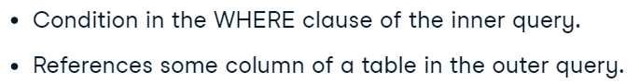

SELECT

    main.country_id,

    main.date,

    main.home_goal,

    main.away_goal

FROM match AS main

WHERE

    (main.home_goal + main.away_goal) =

        (SELECT MAX(sub.home_goal + sub.away_goal)

         FROM match AS sub

         WHERE sub.season = main.season

               AND main.country_id = sub.country_id);

**MORE EXAMPLES**:

<https://campus.datacamp.com/courses/data-driven-decision-making-in-sql/data-driven-decision-making-with-advanced-sql-queries?ex=5>

* EXISTS – works as correlated subquery

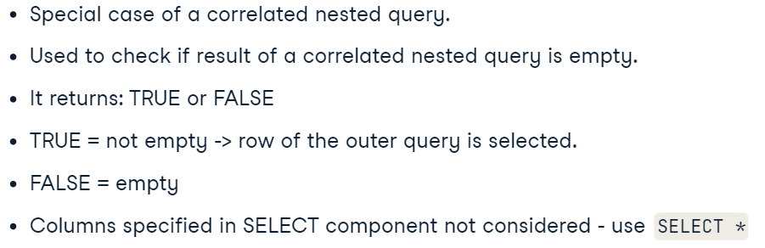

SELECT a.nationality,

    COUNT(*)

FROM actors AS a

WHERE EXISTS

    (SELECT ai.actor_id

     FROM actsin AS ai

     LEFT JOIN movies AS m

      ON m.movie_id = ai.movie_id

     WHERE m.genre = 'Comedy'

        AND ai.actor_id = a.actor_id)

GROUP BY a.nationality;

## *Data Manipultion With SQL*

### CASE

* Case

SELECT date,

        CASE WHEN hometeam_id = 8634 THEN 'FC Barcelona'

            ELSE 'Real Madrid CF' END as home,

        CASE WHEN awayteam_id = 8634 THEN 'FC Barcelona'

            ELSE 'Real Madrid CF' END as away,

        CASE WHEN home_goal > away_goal AND hometeam_id = 8634 THEN 'Barcelona win!'

          WHEN home_goal > away_goal AND hometeam_id = 8633 THEN 'Real Madrid win!'

          WHEN home_goal < away_goal AND awayteam_id = 8634 THEN 'Barcelona win!'

          WHEN home_goal < away_goal AND awayteam_id = 8633 THEN 'Real Madrid win!'

            ELSE 'Tie!' END AS outcome

FROM matches_spain

WHERE (awayteam_id = 8634 OR hometeam_id = 8634)

      AND (awayteam_id = 8633 OR hometeam_id = 8633);

* Agg func with CASE

SELECT

    c.name AS country,

    ROUND(AVG(CASE WHEN m.season='2013/2014' AND m.home_goal = m.away_goal THEN 1

             WHEN m.season='2013/2014' AND m.home_goal != m.away_goal THEN 0

             END), 2) AS pct_ties_2013_2014,

    ROUND(AVG(CASE WHEN m.season='2014/2015' AND m.home_goal = m.away_goal THEN 1

             WHEN m.season='2014/2015' AND m.home_goal != m.away_goal THEN 0

             END), 2) AS pct_ties_2014_2015

FROM country AS c

LEFT JOIN matches AS m

ON c.id = m.country_id

GROUP BY country;

### Nested subqueries

* EXTRACT()

SELECT

    season,

    MAX(home_goal + away_goal) AS max_goals,

   (SELECT MAX(home_goal + away_goal) FROM match) AS overall_max_goals,

   (SELECT MAX(home_goal + away_goal)

    FROM match

    WHERE id IN (

          SELECT id

          FROM match

          WHERE EXTRACT(MONTH FROM date) = 07)) AS july_max_goals

FROM match

GROUP BY season;

* Nested subqueries

SELECT

  c.name AS country,

  AVG(outer_s.matches) AS avg_seasonal_high_scores

FROM country AS c

LEFT JOIN

  (SELECT

      country_id,

      season,

      COUNT(id) AS matches

  FROM

    (SELECT

      country_id,

      season,

      id

    FROM match

    WHERE home_goal >= 5 OR away_goal >= 5) AS inner_s

    GROUP BY country_id, season) AS outer_s

ON c.id = outer_s.country_id

GROUP BY country;

### CTE

* CTE

WITH match_list AS (

    SELECT

        country_id,

        (home_goal+away_goal) AS goals

    FROM match

    WHERE id IN (

        SELECT id

        FROM match

        WHERE season = '2013/2014' AND

            EXTRACT(MONTH FROM date) = 8

    )

)

SELECT

    l.name,

    AVG(goals)

FROM league AS l

LEFT JOIN match_list

ON match_list.country_id = l.country_id

GROUP BY l.name

* Correlated subqueries

SELECT

    main.country_id,

    main.date,

    main.home_goal,

    main.away_goal

FROM match AS main

WHERE

    (main.home_goal + main.away_goal) =

        (SELECT MAX(sub.home_goal + sub.away_goal)

         FROM match AS sub

         WHERE sub.season = main.season

               AND main.country_id = sub.country_id);

/\

SELECT

    m.date,

   (SELECT team_long_name

   FROM team AS t

   WHERE t.team_api_id=m.hometeam_id) AS hometeam,

   (SELECT team_long_name

   FROM team AS t

   WHERE t.team_api_id=m.awayteam_id) AS awayteam,

   home_goal,

   away_goal

FROM match AS m

* + **ALL KNOWLEDGE**

WITH home AS (

  SELECT m.id, t.team_long_name,

      CASE WHEN m.home_goal > m.away_goal THEN 'MU Win'

           WHEN m.home_goal < m.away_goal THEN 'MU Loss'

           ELSE 'Tie' END AS outcome

  FROM match AS m

  LEFT JOIN team AS t

    ON m.hometeam_id = t.team_api_id),

away AS (

  SELECT m.id, t.team_long_name,

    CASE WHEN m.home_goal > m.away_goal THEN 'MU Loss'

        WHEN m.home_goal < m.away_goal THEN 'MU Win'

            ELSE 'Tie' END AS outcome

FROM match AS m

LEFT JOIN team AS t

ON m.awayteam_id = t.team_api_id)

SELECT DISTINCT m.date,

    home.team_long_name AS home_team,

    away.team_long_name AS away_team,

    m.home_goal,

    m.away_goal,

    RANK() OVER(ORDER BY ABS(home_goal-away_goal) DESC) as match_rank

FROM match AS m

LEFT JOIN home ON m.id = home.id

LEFT JOIN away ON m.id = away.id

WHERE season='2014/2015'

    AND ((home.team_long_name='Manchester United'

            AND home.outcome = 'MU Loss')

    OR (away.team_long_name='Manchester United'

            AND away.outcome = 'MU Loss'))

## Window Functions

### Over, Partition by

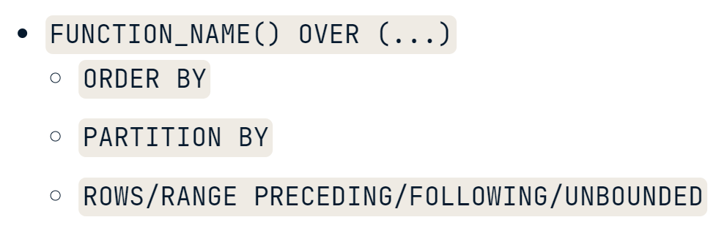

* OVER()

SELECT

    m.id,

    c.name AS country,

    m.season,

    m.home_goal,

    m.away_goal,

    AVG(m.home_goal + m.away_goal) OVER() AS overall_avg

FROM match AS m

LEFT JOIN country AS c

ON m.country_id = c.id;

* OVER(ORDER BY) – operate as a subquery

WITH Athlete_Medals AS (

  SELECT

    Athlete,

    COUNT(*) AS Medals

  FROM Summer_Medals

  GROUP BY Athlete)

SELECT

  Athlete,

  ROW_NUMBER() OVER (ORDER BY Medals DESC) AS Row_N

FROM Athlete_Medals

ORDER BY Medals DESC;

* PARTITION BY with OVER() – separetes calculating by different levels.

*(For example, you can create a single column that calculates an overall average of goals scored for each month in season.)*

SELECT

    date,

    season,

    home_goal,

    away_goal,

    CASE WHEN hometeam_id = 8673 THEN 'home'

         ELSE 'away' END AS warsaw_location,

    AVG(home_goal) OVER(PARTITION BY season,

            EXTRACT(MONTH FROM date)) AS season_mo_home,

    AVG(away_goal) OVER(PARTITION BY season,

            EXTRACT(MONTH FROM date)) AS season_mo_away

FROM match

WHERE

    hometeam_id = 8673

    OR awayteam_id = 8673

ORDER BY (home_goal + away_goal) DESC;

### Sliding windows – (BETWEEN … AND …)

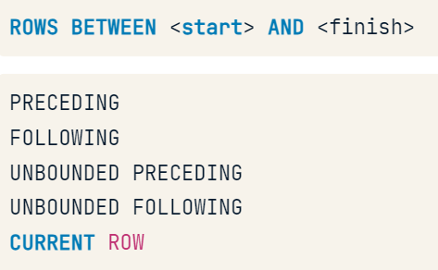

**RANGE** treats duplicates in the columns in the ORDER BY subclause as single entities, whereas **ROWS** does not.

**Sliding windows allow you to create running calculations between any two points in a window using functions such as PRECEDING, FOLLOWING, and CURRENT ROW.**

* UNBOUNDED PRECEDING

SELECT

     date,

     home_goal,

     away_goal,

    SUM(home_goal) OVER(ORDER BY date

         ROWS BETWEEN UNBOUNDED PRECEDING AND CURRENT ROW) AS running_total,

    AVG(home_goal) OVER(ORDER BY date

         ROWS BETWEEN UNBOUNDED PRECEDING AND CURRENT ROW) AS running_avg

FROM match

WHERE

     hometeam_id = 9908

     AND season = '2011/2012';

* UNBOUNDED FOLLOWING

SELECT

     date ,

     home_goal,

     away_goal,

     SUM(home_goal) OVER(ORDER BY date DESC

         ROWS BETWEEN CURRENT ROW AND UNBOUNDED FOLLOWING) AS running_total,

     AVG(home_goal) OVER(ORDER BY date DESC

     ROWS BETWEEN CURRENT ROW AND UNBOUNDED FOLLOWING) AS running_avg

FROM match

WHERE

     awayteam_id = 9908

    AND season = '2011/2012';

* BETWEEN CURRENT ROW N FOLLOWING

SELECT

  Year,

  Medals,

  MAX(Medals) OVER (ORDER BY YEAR ASC

             ROWS BETWEEN CURRENT ROW

             AND 1 FOLLOWING) AS Max_Medals

FROM Scandinavian_Medals

ORDER BY Year ASC;

* BETWEEN N PRECEDING AND CURRENT ROW

SELECT

  Athlete,

  Medals,

  MAX(Medals) OVER (ORDER BY Athlete ASC

            ROWS BETWEEN 2 PRECEDING

            AND CURRENT ROW) AS Max_Medals

FROM Chinese_Medals

ORDER BY Athlete ASC;

### Fetching (LAG, LEAD)

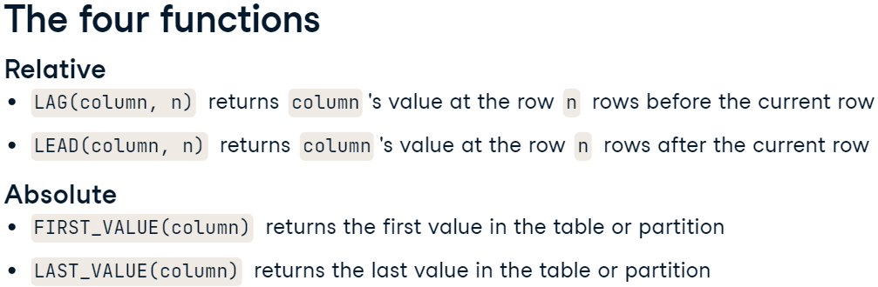

* LAG(column, n) OVER() - takes a column and a number ‘n’ and returns the column's value ‘n’ rows before the current row.

WITH Weightlifting_Gold AS (

  SELECT

    Year,

    Country AS champion

  FROM Summer_Medals

  WHERE

    Discipline = 'Weightlifting' AND

    Event = '69KG' AND

    Gender = 'Men' AND

    Medal = 'Gold')

SELECT

  Year, Champion,

  LAG(Champion) OVER

    (ORDER BY Year ASC) AS Last_Champion

FROM Weightlifting_Gold

ORDER BY Year ASC;

* Patition by with LAG() – helps not to include irrelative data.

WITH Athletics_Gold AS (

  SELECT DISTINCT

    Gender, Year, Event, Country

  FROM Summer_Medals

  WHERE

    Year >= 2000 AND

    Discipline = 'Athletics' AND

    Event IN ('100M', '10000M') AND

    Medal = 'Gold')

SELECT

  Gender,

  Year,

  Event,

  Country AS Champion,

  LAG(Country)

      OVER(PARTITION BY gender, event ORDER BY year) AS Last_Champion

FROM Athletics_Gold

ORDER BY gender

You can partition by more than one column in case your groups are spread over several columns.

* Lead(column, int) OVER() – there is a photo higher.

WITH Discus_Medalists AS (

  SELECT DISTINCT Year,

      Athlete

  FROM Summer_Medals

  WHERE Medal = 'Gold'

    AND Event = 'Discus Throw'

    AND Gender = 'Women'

    AND Year >= 2000)

SELECT

  year,

  athlete,

  LEAD(athlete, 3) OVER (ORDER BY year ASC) AS Future_Champion

FROM Discus_Medalists

ORDER BY Year ASC;

* FIRST_VALUE() – to compare the first value to the current one.

SELECT

  athlete,

  FIRST_VALUE(athlete) OVER(ORDER BY athlete) AS First_Athlete

FROM All_Male_Medalists;

* LAST_VALUE() – to compare the last value to the current one.

SELECT

  Year, City,

  LAST_VALUE(City) OVER (

   ORDER BY Year

   RANGE BETWEEN

     UNBOUNDED PRECEDING AND

     UNBOUNDED FOLLOWING

  ) AS Last_City

FROM Hosts

ORDER BY Year ASC;

### Ranking function

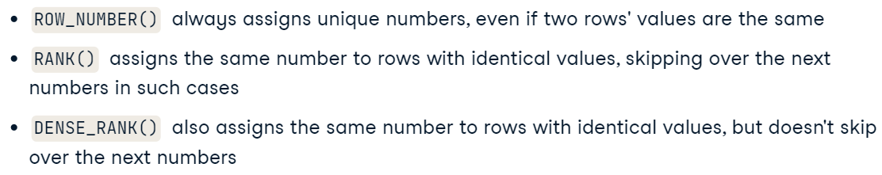

* ROW_NUMBER() – assigns a row number to it’s row.

SELECT *,

  ROW_NUMBER() OVER() AS Row_N

FROM Summer_Medals

ORDER BY Row_N ASC;

* RANK() - there is a photo higher.

SELECT

    l.name AS league,

    AVG(m.home_goal + m.away_goal) AS avg_goals,

    RANK() OVER(ORDER BY AVG(m.home_goal + m.away_goal)) AS league_rank

FROM league AS l

LEFT JOIN match AS m

ON l.id = m.country_id

WHERE m.season = '2011/2012'

GROUP BY l.name

ORDER BY league_rank;

* DENSE_RANK() – there is a photo higher.

SELECT

  Country,

  Athlete,

  DENSE_RANK() OVER (PARTITION BY Country

                ORDER BY Medals DESC) AS Rank_N

FROM Athlete_Medals

ORDER BY Country ASC, RANK_N ASC;

### Agg func in window func

* Cumsum

SELECT

  athlete,

  Medals,

  SUM(Medals) OVER (ORDER BY athlete ASC) AS Max_Medals

FROM Athlete_Medals

ORDER BY Athlete ASC;

* (cummax / cummin) – comparing values between current row and (max/min) value.

SELECT

Year,

Country,

Medals,

MAX(Medals) OVER (PARTITION BY Country

ORDER BY Year ASC) AS Max_Medals

FROM Country_Medals

ORDER BY Country ASC, Year ASC;

* Moving average of …

Using frames with aggregate window functions allow you to calculate many common metrics, including moving averages and totals. These metrics track the change in performance over time.

SELECT

  Year, Medals,

  AVG(Medals) OVER

    (ORDER BY Year ASC

     ROWS BETWEEN

     2 PRECEDING AND CURRENT ROW) AS Medals_MA

FROM Russian_Medals

ORDER BY Year ASC;

* Moving total of …

SELECT

  Year,

  Country,

  Medals,

  SUM(Medals) OVER

    (PARTITION BY Country

     ORDER BY Year ASC

     ROWS BETWEEN

     2 PRECEDING AND CURRENT ROW) AS Medals_MA

FROM Country_Medals

ORDER BY Country ASC, Year ASC;

### ROLLUP AND CUBE

* ROLLUP() - is a GROUP BY subclause that includes extra rows for group-level (sum) aggregations.

SELECT

  country,

  gender,

  COUNT(*) AS Gold_Awards

FROM Summer_Medals

WHERE

  Year = 2004

  AND Medal = 'Gold'

  AND Country IN ('DEN', 'NOR', 'SWE')

GROUP BY country, ROLLUP(gender)

ORDER BY Country ASC, Gender ASC;

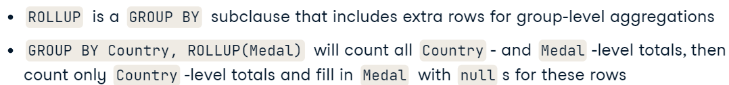

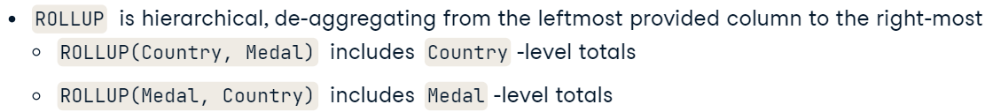

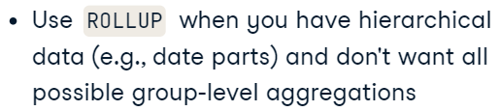

* CUBE() - generates all possible group-level aggregations.

SELECT

  Gender,

  Medal,

  COUNT(*) AS Awards

FROM Summer_Medals

WHERE

  Year = 2012

  AND Country = 'RUS'

GROUP BY CUBE(Gender, Medal)

ORDER BY Gender ASC, Medal ASC;

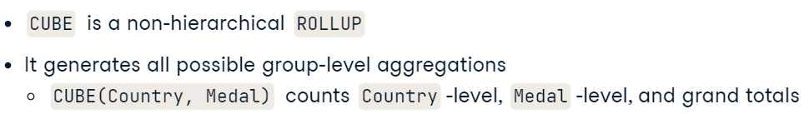

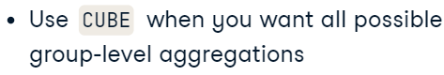

Difference:

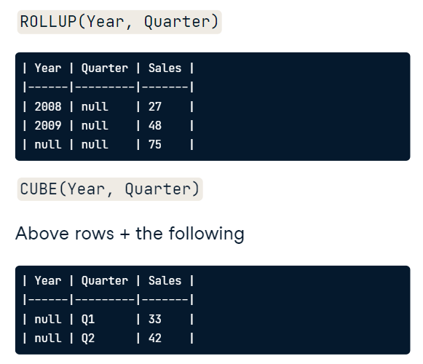

* GROUPING SETS – union all the predetermined tables and conduct total agg with “()” in the end of the query.  **May group by every aspect.**

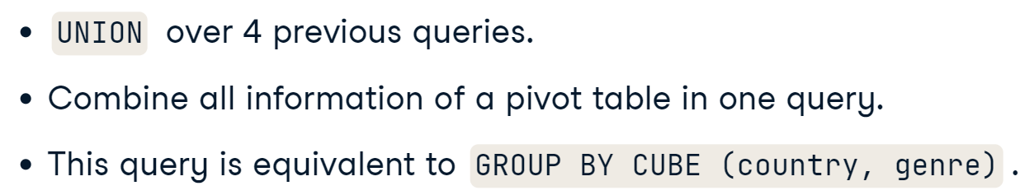

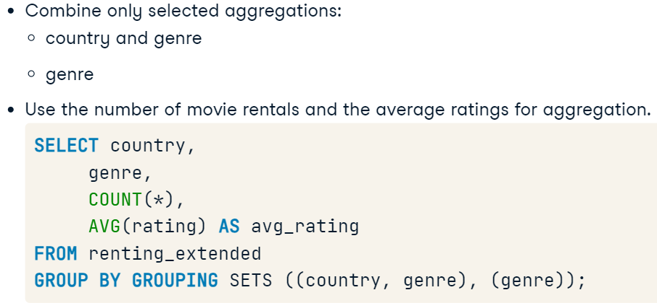

* While group by **empty par**  – gives the total (NULL, NULL):

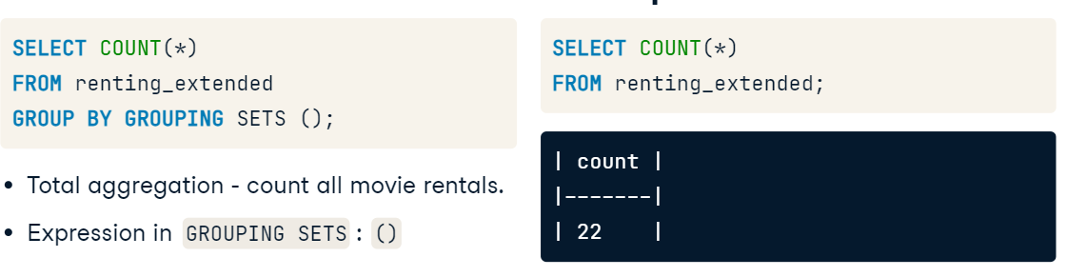

* Example of the code:

SELECT a.nationality,

       a.gender,

       AVG(r.rating) AS avg_rating,

       COUNT(r.rating) AS n_rating,

       COUNT(*) AS n_rentals,

       COUNT(DISTINCT a.actor_id) AS n_actors

FROM renting AS r

LEFT JOIN actsin AS ai

ON ai.movie_id = r.movie_id

LEFT JOIN actors AS a

ON ai.actor_id = a.actor_id

WHERE r.movie_id IN (

    SELECT movie_id

    FROM renting

    GROUP BY movie_id

    HAVING COUNT(rating) >= 4)

AND r.date_renting >= '2018-04-01'

GROUP BY GROUPING SETS ((a.nationality, a.gender),

                        (a.nationality),

                        (a.gender),

                        ())

ORDER BY AVG(r.rating) DESC

### COALESCE and STRING_AGG

* COALESCE(column, ‘name’) - takes a list of values and returns the first non-null value, going from left to right.

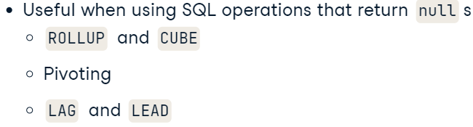

SELECT

  COALESCE(Country, 'All countries') AS Country,

  COALESCE(Gender, 'All genders') AS Gender,

  COUNT(*) AS Awards

FROM Summer_Medals

WHERE

  Year = 2004

  AND Medal = 'Gold'

  AND Country IN ('DEN', 'NOR', 'SWE')

GROUP BY ROLLUP(Country, Gender)

ORDER BY Country ASC, Gender ASC;

Result:

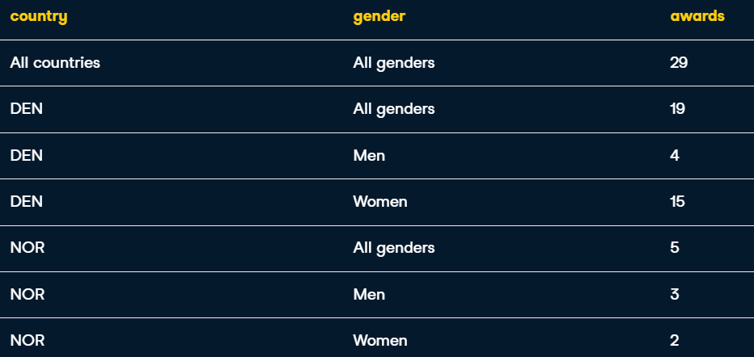

* STRING_AGG(column, separator) - takes all the values of a column and concatenates them, with a separator in between each value. Compressing three rows into one, losing no information in the process.

WITH Country_Medals AS (

  SELECT

    Country,

    COUNT(*) AS Medals

  FROM Summer_Medals

  WHERE Year = 2000

    AND Medal = 'Gold'

  GROUP BY Country),

Country_Ranks AS (

  SELECT

    Country,

    RANK() OVER (ORDER BY Medals DESC) AS Rank

  FROM Country_Medals

  ORDER BY Rank ASC)

SELECT STRING_AGG(Country, ', ')

FROM Country_Ranks

WHERE RANK <= 3;

Result:



### Pivoting

CREATE EXTENSION IF NOT EXISTS tablefunc;

* CROSSTAB

CREATE EXTENSION IF NOT EXISTS tablefunc;

SELECT * FROM CROSSTAB($$

  WITH Country_Awards AS (

    SELECT

      Country,

      Year,

      COUNT(*) AS Awards

    FROM Summer_Medals

    WHERE

      Country IN ('FRA', 'GBR', 'GER')

      AND Year IN (2004, 2008, 2012)

      AND Medal = 'Gold'

    GROUP BY Country, Year)

  SELECT

    Country,

    Year,

    RANK() OVER(PARTITION BY year

                ORDER BY Awards) :: INTEGER AS RANK

  FROM Country_Awards

  ORDER BY Country ASC, Year ASC

$$) AS ct (Country VARCHAR,

          "2004-12-01" INTEGER,

          "2008-12-01" INTEGER,

          "2012-12-01" INTEGER)

ORDER BY Country

### Paging

* NTILE(n) – devides df into n pieces.

Splitting your data into thirds or quartiles is often useful to understand how the values in your dataset are spread. Getting summary statistics (averages, sums, standard deviations, etc.) of the top, middle, and bottom thirds can help you determine what distribution your values follow.

Thirds AS (

  SELECT

    Athlete,

    Medals,

    NTILE(3) OVER (ORDER BY Medals DESC) AS Third

  FROM Athlete_Medals)

SELECT

  Third,

  ROUND(AVG(Medals), 2) AS Avg_Medals

FROM Thirds

GROUP BY Third

ORDER BY Third

## Functions for Manipulating Data

**Common data types:**

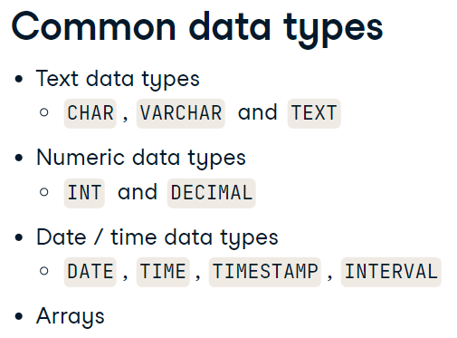

* + **INTERVAL types (**representations of periods of time**)** store date and time data as a period of time in years, months, days, hours, seconds, etc. Also, provide you with a very useful tool for performing arithmetic on date and time data types.
  + TIMESTAMP data types contain both date and time values.

### INFORMATION_SCHEMA

PostgreSQL has a system database called **INFORMATION_SCHEMA** that allows us to extract information about objects, including tables, in our **WHOLE** database.

* INFORMATION_SCHEMA.TABLES

SELECT *

FROM INFORMATION_SCHEMA.TABLES

WHERE table_schema = 'public';

Result:

* INFORMATION_SCHEMA.COLUMNS

SELECT *

FROM INFORMATION_SCHEMA.COLUMNS

WHERE table_name = 'actor';

* Determine type of each column in the table.

SELECT

    column_name,

    data_type

FROM INFORMATION_SCHEMA.COLUMNS

WHERE table_name = 'customer';

Result:

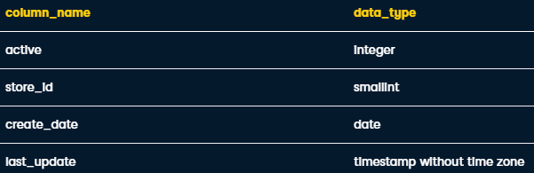

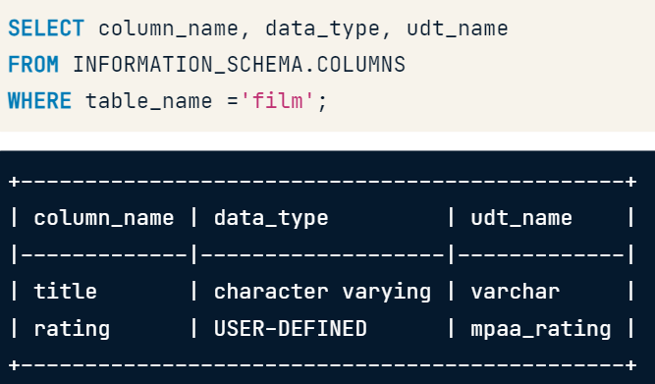

### Date and data types

* **Interval**

SELECT

    rental_date,

    return_date,

    rental_date + **INTERVAL** '3 days' as expected_return_date

FROM rental

Result:

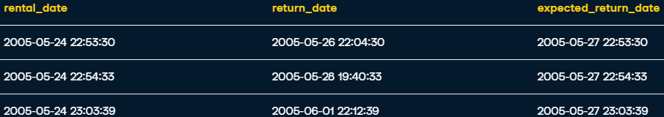

### Arrays

* Working with arrays

SELECT

  title,

  special_features

FROM film

WHERE special_features[2] = 'Deleted Scenes'

* ANY – function allows you to search for a value in any index position of an ARRAY.

SELECT

  title,

  special_features

FROM film

WHERE 'Trailers' = ANY(special_features)

/\

The contains operator @> operator is alternative syntax to the ANY function and matches data in an ARRAY using the following syntax.

SELECT

  title,

  special_features

FROM film

WHERE special_features @> ARRAY['Deleted Scenes']

* Creating ARRAY-type columns:

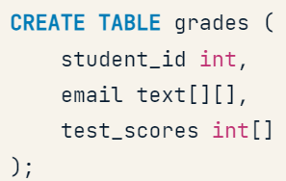

* + Inserting values:

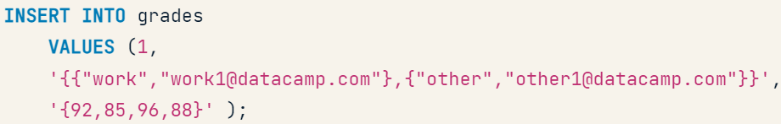

### String and character data

#### Reformatting string

* Concat columns:

SELECT

    first_name || ' ' || last_name ||' <'|| email || '>' AS full_email

FROM customer

/\

SELECT

    CONCAT(first_name, ' ', last_name, ' <', email, '>') AS full_email

FROM customer

Result:

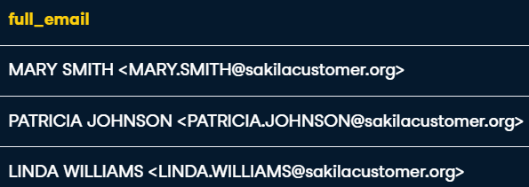

* UPPER() / LOWER() / INITCAP()

SELECT

  CONCAT(UPPER(c.name), ': ', INITCAP(f.title)) AS film_category,

  LOWER(description) AS description

FROM film f

LEFT JOIN film_category fc

  ON f.film_id = fc.film_id

LEFT JOIN category c

  ON fc.category_id = c.category_id

* REPLACE(column, str_db, str_your) – replacing values

SELECT

  REPLACE(title, ' ', '_') as title

FROM film

Result:



#### Parsing string

* CHAR_LENGTH() / LENGTH() – return the len of the string-value.

SELECT

  title,

  description,

  CHAR_LENGTH(description) AS desc_len

FROM film

* LEFT() / RIGHT() – extracts value in a sertain amout.

SELECT

  LEFT(description, 50) AS short_desc

FROM

  film AS f;

result:



* Substring() – extracts strgs from specific position in the str.

SELECT

  SUBSTRING(address FROM POSITION(' ' in address)+1 FOR CHAR_LENGTH(address))

FROM

  address;

* + Substr() – an alternative to Substring, but without (FROM … FOR …) clause.

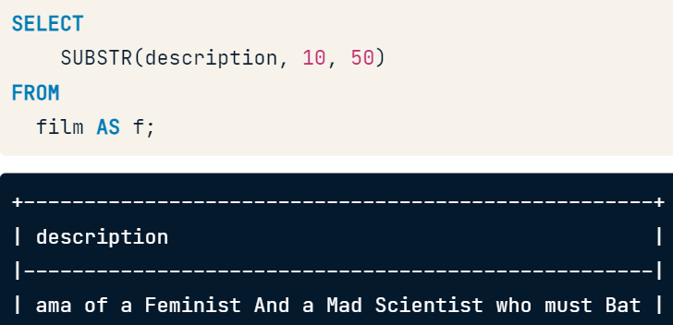

* POSITION() / STRPOS() – extracts the index of the value we search

SELECT

  SUBSTRING(email FROM 0 FOR POSITION('@' IN email)) AS username,

  SUBSTRING(email FROM POSITION('@' IN email)+1 FOR LENGTH(email)) AS domain

FROM customer

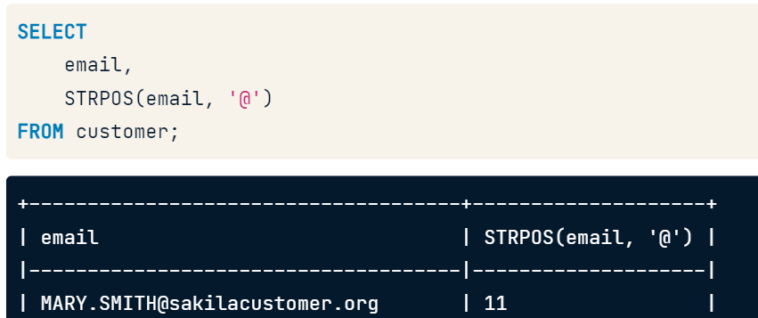

#### Truncating and padding string data

* TRIM() / LTRIM() / RTRIM()

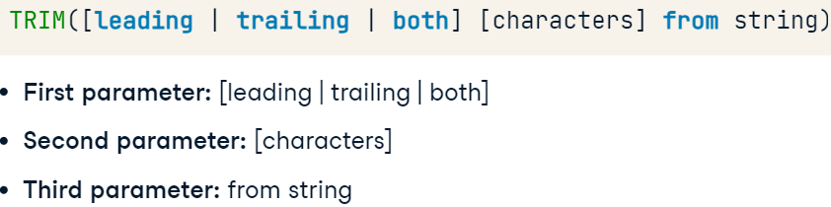



SELECT

  CONCAT(UPPER(c.name), ': ', f.title) AS film_category,

  TRIM(LEFT(f.description, 50)) AS film_desc

FROM

  film AS f

  INNER JOIN film_category AS fc

    ON f.film_id = fc.film_id

  INNER JOIN category AS c

    ON fc.category_id = c.category_id;

/\ - truncating text fields like the film table's description column without cutting off a word.

SELECT

  UPPER(c.name) || ': ' || f.title AS film_category,

  LEFT(description, 50 -

    POSITION(' ' IN REVERSE(LEFT(description, 50)))

  )

FROM

  film AS f

  INNER JOIN film_category AS fc

    ON f.film_id = fc.film_id

  INNER JOIN category AS c

    ON fc.category_id = c.category_id;

* LPAD() / RPAD()

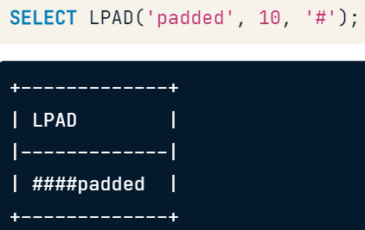

SELECT

    RPAD(first_name, LENGTH(first_name)+1, ' ')

    || RPAD(last_name, LENGTH(last_name)+2, ' <')

    || RPAD(email, LENGTH(email)+1, '>') AS full_email

FROM customer

* Unnest(string_to_array()) – breaks down string with tons of values into separate rows:

WITH cats AS (

SELECT unnest(string_to_array(categories, ';')) AS category,

review_count

FROM yelp_business

)

SELECT category,

sum(review_count) as review_cnt

FROM cats

GROUP BY category

ORDER BY review_cnt DESC

Result:

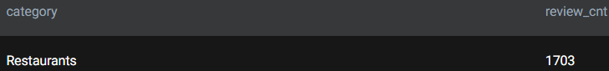

### Date manipulation

* Simple math-operations with ***timestamps***:

SELECT f.title, f.rental_duration,

    r.return_date - r.rental_date AS days_rented

FROM film AS f

    INNER JOIN inventory AS i

        ON i.film_id = f.film_id

    INNER JOIN rental AS r

        ON r.inventory_id = i.inventory_id

ORDER BY f.title;

/\

SELECT

    f.title,

    INTERVAL '1' day * f.rental_duration,

    AGE(r.return_date, r.rental_date) AS days_rented

FROM film AS f

    INNER JOIN inventory AS i ON f.film_id = i.film_id

    INNER JOIN rental AS r ON i.inventory_id = r.inventory_id

WHERE return_date IS NOT NULL

ORDER BY f.title;

* + The second arg converts “rental_duration”(int) into *INTERVAL*.

Result:



* **AGE(date, date)** – subtracts values:

SELECT f.title, f.rental_duration,

    AGE(r.return_date, r.rental_date) AS days_rented

FROM film AS f

    INNER JOIN inventory AS i ON f.film_id = i.film_id

    INNER JOIN rental AS r ON i.inventory_id = r.inventory_id

ORDER BY f.title;

#### Functions for retrieving current date/time

* NOW() – returns a timestamp with timezone by default.
* CURRENT_TIMESTAMP() – returns a timestamp with timezone by default and lets you set up precision of the time.
* CURRENT_TIME – retrieves current time.
* CURRENT_DATE – retrieves current date.
* CAST() – transformes column into specific data_type:

SELECT CAST(NOW() AS timestamp)

#### Extracting and transforming date/ time data

* EXTRACT()

SELECT

  EXTRACT(dow FROM rental_date) AS dayofweek,

  COUNT(*) AS rentals

FROM rental

GROUP BY 1;

* + Dow – the day of the week
* DATE_TRANC() - function will truncate timestamp or interval data types to return a timestamp or interval at a specified precision.

SELECT

  DATE_TRUNC('day', rental_date) AS rental_day,

  COUNT(*) AS rentals

FROM rental

GROUP BY 1

Result:

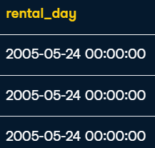

/\

SELECT

    DATE_TRUNC('year', rental_date) AS rental_year

FROM rental

Result:

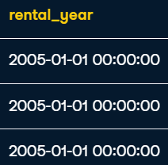

* DATE_PART() as Extract

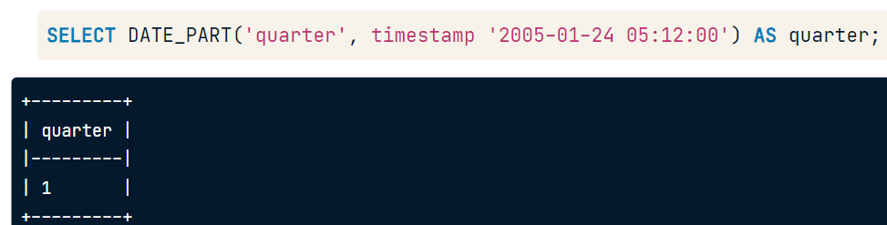

### Full-text search and Extentions

#### Full-text search

* LIKE – searches value

SELECT *

FROM film

WHERE title LIKE '%GOLD%';

* *To_tsvector* and *to_tsquery*

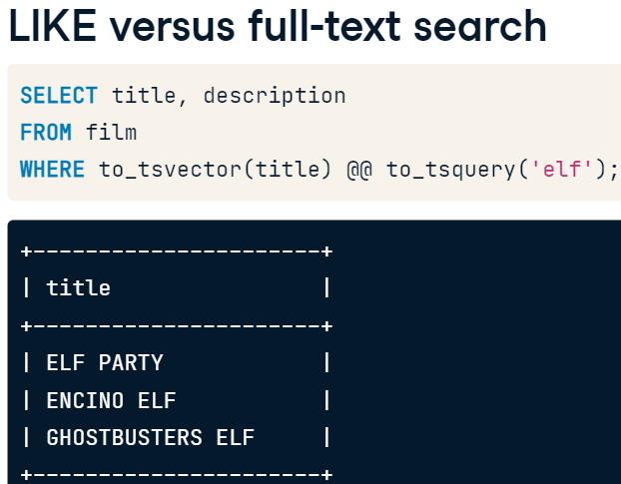

Result:

SELECT title, description

FROM film

WHERE to_tsvector(title) @@ to_tsquery('elf')

#### Extensions

* **Enumerated data types**:

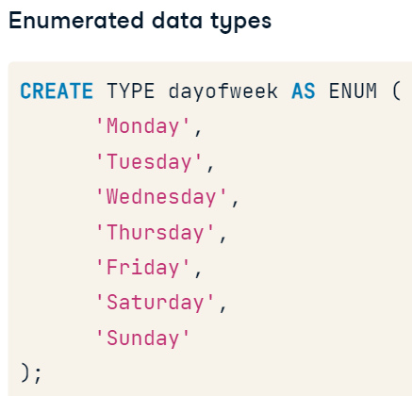

CREATE TYPE compass_position AS ENUM (

    'North',

    'South',

    'East',

    'West'

);

SELECT *

FROM pg_type

WHERE typname='compass_position'

#### FUNCTIONS

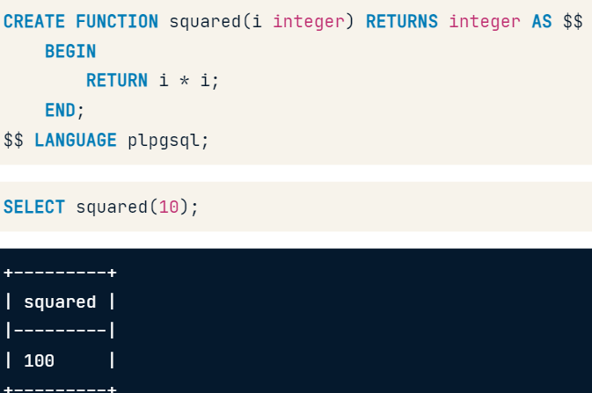

### PostgreSQL extensions

* Importing extensions:

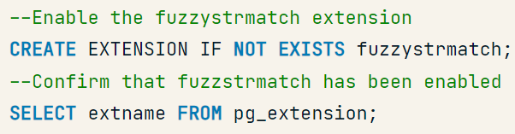

* Finding available extensions:

SELECT NAME

FROM pg_available_extensions

* Finding the similarity between words

SELECT

  title,

  description,

  similarity(description, 'Astounding & Drama')

FROM

  film

WHERE

  to_tsvector(description) @@

  to_tsquery('Astounding & Drama')

ORDER BY

  similarity(description, 'Astounding & Drama') DESC

Result:

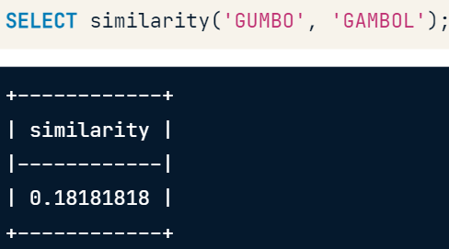

* Finding difference (“distance”) between words:

SELECT

  title,

  description,

  levenshtein(title, 'JET NEIGHBOR') AS distance

FROM

  film

ORDER BY 3

Result:

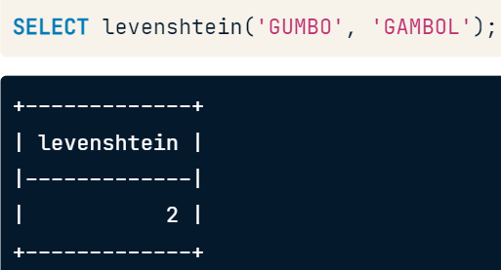

## Exploratory Data Analysis in SQL

#### RULES



#### Necessery basics!!!

* Presentiong the data:

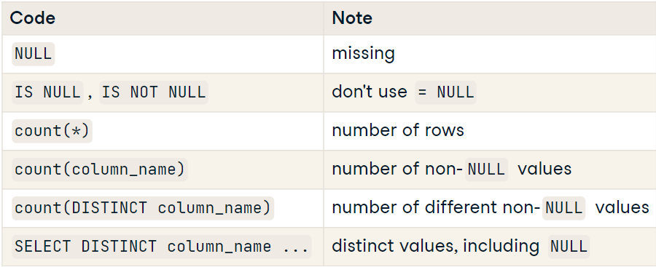

* Rules:

1. Find missing values: count(*) – count(column)
2. You can join tables when they share a column with consistent data values.
3. Foreign key: reference another row in the database via a unique ID and must reference a column with unique values for each row so the referenced row can be identified. Values in a foreign key column are restricted to values in the referenced column OR NULL.

#### Coalesce

The coalesce() function can be useful for specifying a default or backup value when a column contains NULL values.

coalesce() checks arguments in order and returns the first non-NULL value, if one exists.

* coalesce(NULL, 1, 2) = 1
* coalesce(NULL, NULL) = NULL
* coalesce(2, 3, NULL) = 2
* Example of code:

SELECT coalesce(industry, sector, 'Unknown') AS industry2,

    count(*)

FROM fortune500

GROUP BY industry2

ORDER BY count DESC

limit 1

result:

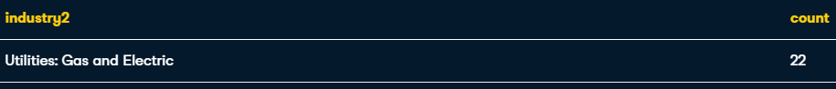

/\

SELECT company_original.name,

    title,

    rank

FROM company AS company_original

LEFT JOIN company AS company_parent

  ON company_original.parent_id = company_parent.id

INNER JOIN fortune500

  ON coalesce(company_original.ticker,

    company_parent.ticker) = fortune500.ticker

ORDER BY rank

#### Column types and constraints

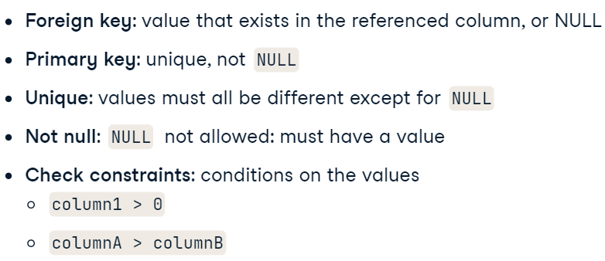

#### Types of data

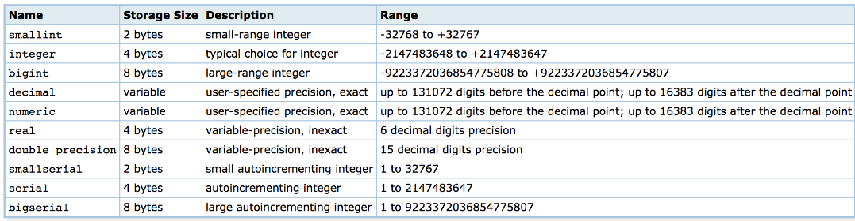

* Example:

SELECT '3.2'::numeric,

       '-123'::numeric,

       '1e3'::numeric,

       '1e-3'::numeric,

       '02314'::numeric,

       '0002'::numeric;

Result:



#### Numeric data type

* **Variance** == stddev**2:

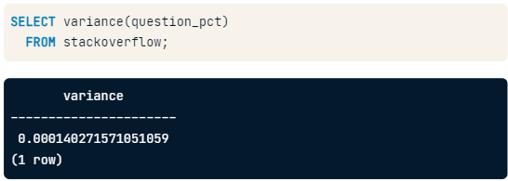

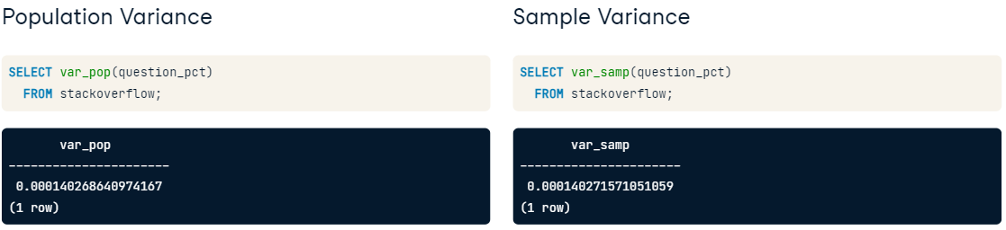

* Example of code:

SELECT

     sector,

     AVG(revenues/employees::numeric) AS avg_rev_employee

FROM fortune500

GROUP BY sector

ORDER BY avg_rev_employee;

#### Exploring distributions

* **Trunc**() – similar AS ROUND

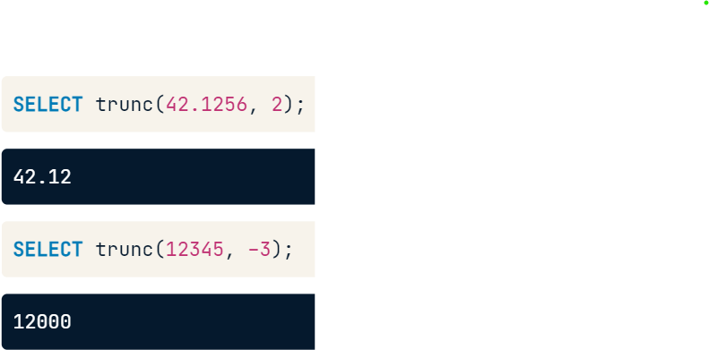

* Example of the code:

SELECT trunc(employees, -4) AS employee_bin,

  count(*)

FROM fortune500

WHERE employees < 100000

GROUP BY employee_bin

ORDER BY employee_bin

Result:

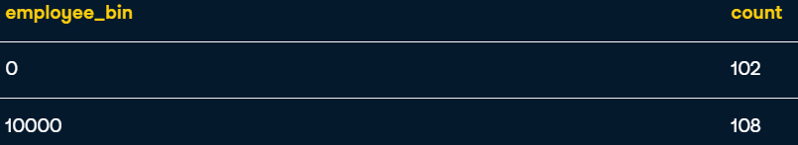

* Generate_series():

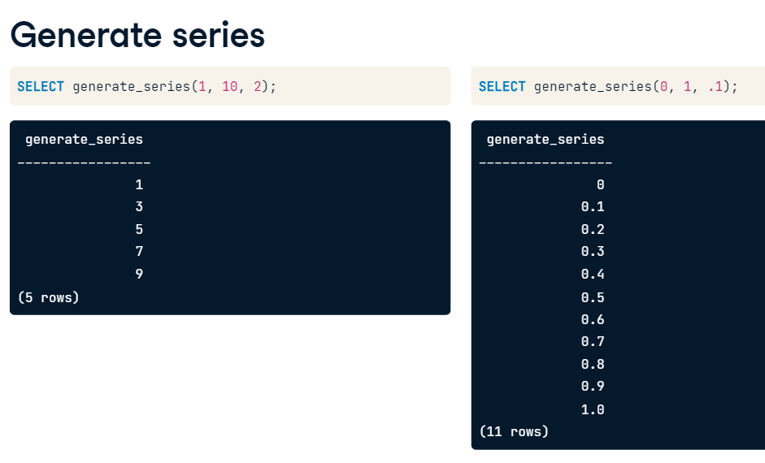

* Generating bins:

WITH bins AS (

      SELECT generate_series(2200, 3050, 50) AS lower,

             generate_series(2250, 3100, 50) AS upper),

     dropbox AS (

      SELECT question_count

        FROM stackoverflow

       WHERE tag='dropbox')

SELECT lower, upper, count(question_count)

    FROM bins

    LEFT JOIN dropbox

    ON question_count >= lower AND question_count < upper

 GROUP BY lower, upper

 ORDER BY lower;

Result:

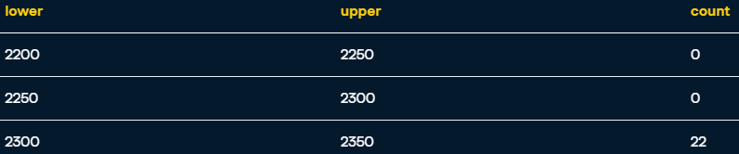

#### Summary functions

* Corr() – finds correlation between values

SELECT corr(revenues, profits) AS rev_profits,

       corr(revenues, assets) AS rev_assets,

       corr(revenues, equity) AS rev_equity

  FROM fortune500;

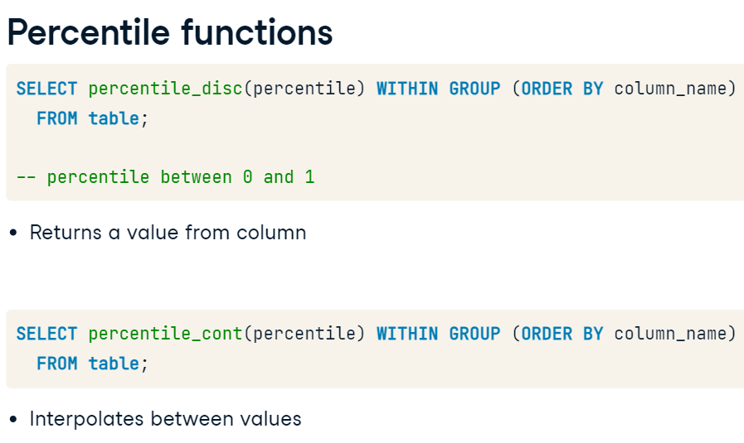

* **Percentile_disc** – finding discrete percenttile:

SELECT

  AVG(assets) AS mean,

  percentile_disc(0.5) WITHIN GROUP (ORDER BY assets) AS median,

  sector

FROM fortune500

GROUP BY sector

ORDER BY mean

* Common issues:

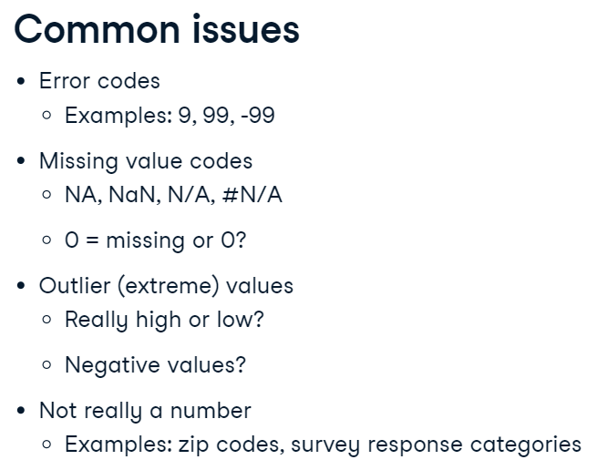

### Creating temporary tables

* Creating and deleting table:

DROP TABLE IF EXISTS profit80;

CREATE TEMP TABLE profit80 AS

  SELECT sector,

         percentile_disc(0.8) WITHIN GROUP (ORDER BY profits) AS pct80

    FROM fortune500

   GROUP BY sector;

SELECT

       Distinct title,

       fortune500.sector,

       profits,

       profits/pct80 AS ratio

FROM fortune500

left join profit80

on fortune500.sector = profit80.sector

where profits > pct80

result:

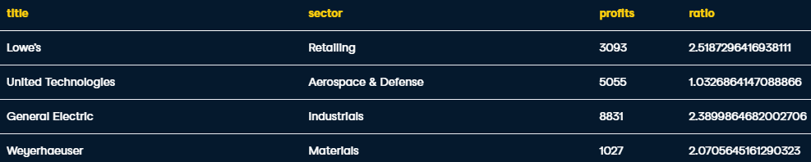

* Another example:

DROP TABLE IF EXISTS startdates;

CREATE TEMP TABLE startdates AS

SELECT tag, min(date) AS mindate

  FROM stackoverflow

 GROUP BY tag;

SELECT

      startdates.tag,

      mindate,

      so_min.question_count AS min_date_question_count,

      so_max.question_count AS max_date_question_count,

      so_max.question_count - so_min.question_count AS change

FROM startdates

INNER JOIN stackoverflow AS so_min

  ON startdates.tag = so_min.tag

  AND startdates.mindate = so_min.date

INNER JOIN stackoverflow AS so_max

  ON startdates.tag = so_max.tag

  AND so_max.date = '2018-09-25';

Result:

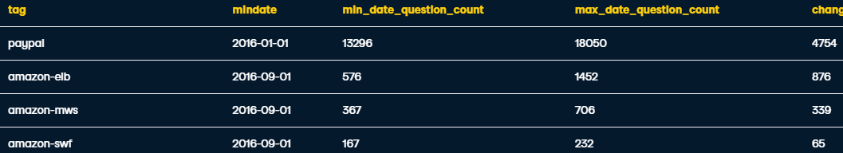

* Inserting values and creating corr-matrix:

DROP TABLE IF EXISTS correlations;

CREATE TEMP TABLE correlations AS

SELECT 'profits'::varchar AS measure,

       corr(profits, profits) AS profits,

       corr(profits, profits_change) AS profits_change,

       corr(profits, revenues_change) AS revenues_change

  FROM fortune500;

INSERT INTO correlations

SELECT 'profits_change'::varchar AS measure,

       corr(profits_change, profits) AS profits,

       corr(profits_change, profits_change) AS profits_change,

       corr(profits_change, revenues_change) AS revenues_change

  FROM fortune500;

INSERT INTO correlations

SELECT 'revenues_change'::varchar AS measure,

       corr(revenues_change, profits) AS profits,

       corr(revenues_change, profits_change) AS profits_change,

       corr(revenues_change, revenues_change) AS revenues_change

  FROM fortune500;

SELECT measure,

    ROUND(profits::numeric, 2) AS profits,

    ROUND(profits_change::numeric, 2) AS profits_change,

    ROUND(revenues_change::numeric, 2) AS revenues_change

FROM correlations

### Character data types

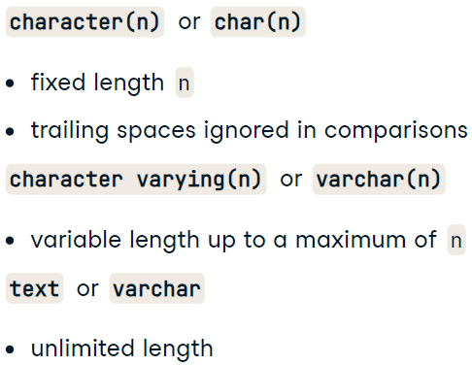

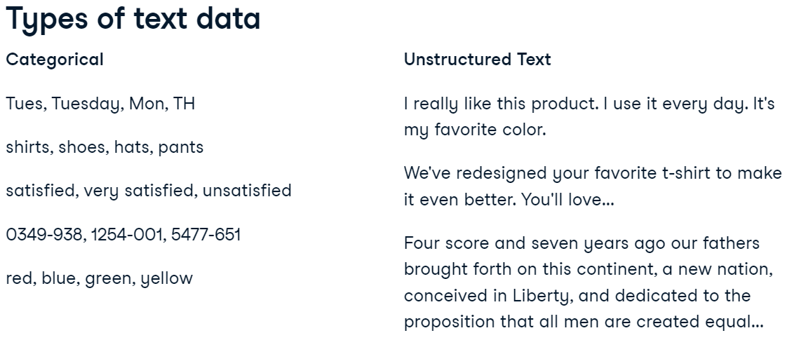

* Extra-trim – can delete any designated symbol:

SELECT DISTINCT street,

    TRIM(street, ' 0123456789#/.') AS cleaned_street

FROM evanston311

ORDER BY street

* ILIKE – non-sensenive LIKE (whould seek for “Apple” as well as for “apple”):

SELECT category,

  COUNT(*)

  FROM evanston311

  WHERE (description ILIKE '%trash%'

    OR description ILIKE '%garbage%')

   AND category NOT LIKE '%Trash%'

   AND category NOT LIKE '%Garbage%'

 GROUP BY category

 ORDER BY count DESC

 LIMIT 10;

#### Splitting and concatenating text

* split_part:

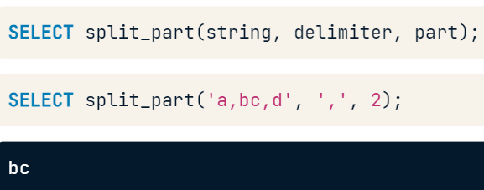

#### Multiple transformations

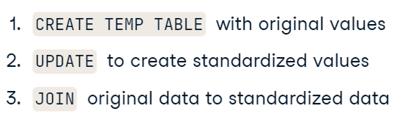

* example of code:

DROP TABLE IF EXISTS recode;

CREATE TEMP TABLE recode AS

  SELECT DISTINCT category,

         rtrim(split_part(category, '-', 1)) AS standardized

  FROM evanston311;

UPDATE recode SET standardized='Trash Cart'

 WHERE standardized LIKE 'Trash%Cart';

UPDATE recode SET standardized='Snow Removal'

 WHERE standardized LIKE 'Snow%Removal%';

UPDATE recode SET standardized='UNUSED'

 WHERE standardized IN ('THIS REQUEST IS INACTIVE...Trash Cart',

               '(DO NOT USE) Water Bill',

               'DO NOT USE Trash', 'NO LONGER IN USE');

SELECT standardized,

  count(*)

FROM evanston311

LEFT JOIN recode

ON evanston311.category = recode.category

GROUP BY standardized

ORDER BY count DESC

Result:

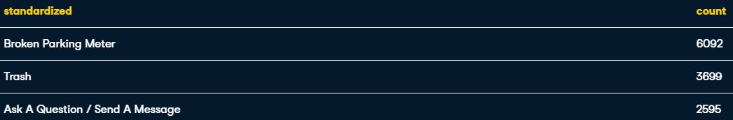

* seeking for values inside the SELECT:

DROP TABLE IF EXISTS indicators;

CREATE TEMP TABLE indicators AS

  SELECT id,

         CAST (description LIKE '%@%' AS integer) AS email,

         CAST (description LIKE '%___-___-____%' AS integer) AS phone

    FROM evanston311;

SELECT priority,

  sum(email)/count(*)::numeric AS email_prop,

  sum(phone)/count(*)::numeric AS phone_prop

FROM evanston311

LEFT JOIN indicators

  ON evanston311.ID = indicators.id

GROUP BY priority;

Result:

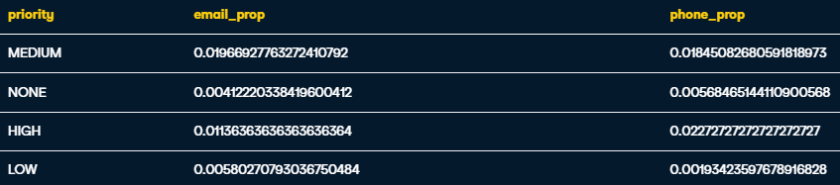

### Date/time types and formats

* Casting date from datesrampt to data to easily compare values or sum:

SELECT count(*)

  FROM evansron311

  WHERE date_created::date = '2017-01-31'

* To_char() – we can get the name of the day of the week by converting a timestamp to character data:

SELECT to_char(date_created, 'month') AS day,

     AVG(date_completed - date_created) AS duration

FROM evanston311

GROUP BY day, EXTRACT(DOW FROM date_created)

ORDER BY EXTRACT(DOW FROM date_created)

Result:

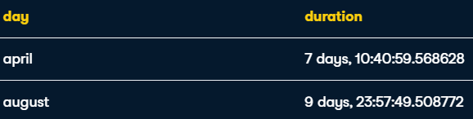

* Trunc:

SELECT

  date_trunc('month', day) AS month,

  AVG(count)

FROM (

  SELECT date_trunc('day', date_created) as day,

    count(*) AS count

  FROM evanston311

  GROUP BY day

) AS daily_count

GROUP BY month

ORDER BY month

Result:

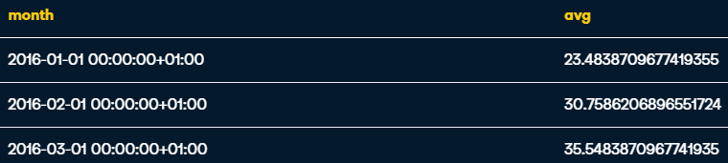

* Finding missing values with generate_series:

SELECT day

FROM (SELECT

      generate_series(MIN(date_created), MAX(date_created), '1 days'::interval)::date AS day

      FROM evanston311) AS all_dates

WHERE day NOT IN (

  SELECT date_created::date

  FROM evanston311

)

* Counting and agg values in bins:

WITH bins AS (

      SELECT generate_series('2016-01-01',

                            '2018-01-01',

                            '6 months'::interval) AS lower,

            generate_series('2016-07-01',

                            '2018-07-01',

                            '6 months'::interval) AS upper),

     daily_counts AS (

     SELECT day, count(date_created) AS count

       FROM (SELECT generate_series('2016-01-01',

                                    '2018-06-30',

                                    '1 day'::interval)::date AS day) AS daily_series

            LEFT JOIN evanston311

            ON day = date_created::date

      GROUP BY day)

SELECT

     lower, upper,

     percentile_disc(0.5) WITHIN GROUP (ORDER BY count) AS median

FROM bins

LEFT JOIN daily_counts

     ON day >= lower and day < upper

GROUP BY lower, upper

ORDER BY lower

Result:

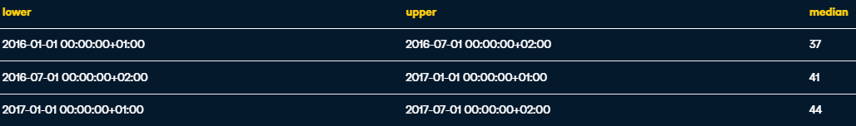

* Taking into consederation all values, and those, which are NULL:

WITH all_days AS (

     SELECT generate_series('2016-01-01',

                         '2018-06-30',

                         '1 day'::interval) AS date

),

daily_count AS (

     SELECT date_trunc('day', date_created) AS day,

          count(*)

     FROM evanston311

     GROUP BY day

)

SELECT f('month', date) AS month,

     AVG(COALESCE(count, 0)) as average

FROM all_days

LEFT JOIN daily_count

     ON all_days.date = daily_count.day

GROUP BY month

ORDER BY month

Result:

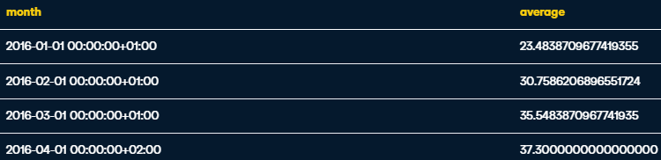

### Lag and Lead in dates

* Code:

WITH request_gaps AS (

        SELECT date_created,

             lag(date_created) OVER (ORDER BY date_created) AS previous,

             date_created - lag(date_created) OVER (ORDER BY date_created) AS gap

          FROM evanston311)

SELECT *

  FROM request_gaps

 WHERE gap = (SELECT max(gap)

                FROM request_gaps);

## Analyzing Business

### Patterns of behaviour

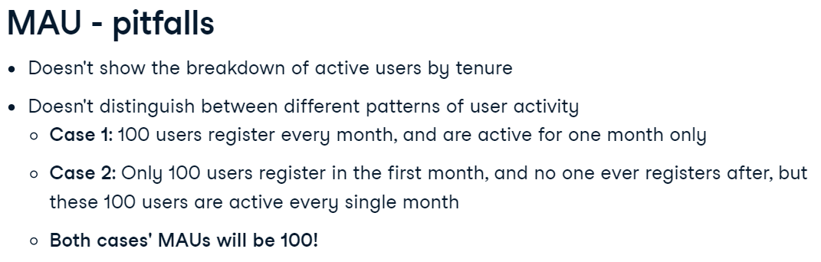

### Retention

* What is it?

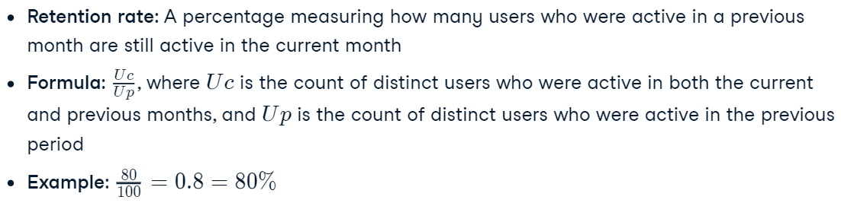

* Code:

WITH user_monthly_activity AS (

  SELECT DISTINCT

    DATE_TRUNC('month', order_date) :: DATE AS delivr_month,

    user_id

  FROM orders)

SELECT

  previous.delivr_month,

  ROUND(

    COUNT(DISTINCT current.user_id)::NUMERIC

      / COALESCE(COUNT(DISTINCT previous.user_id), 1)

        , 2) AS retention_rate

FROM user_monthly_activity AS previous

LEFT JOIN user_monthly_activity AS current

  ON previous.delivr_month = current.delivr_month - '1 month'::interval

    AND previous.user_id = current.user_id

GROUP BY previous.delivr_month

ORDER BY previous.delivr_month ASC

### ARPU

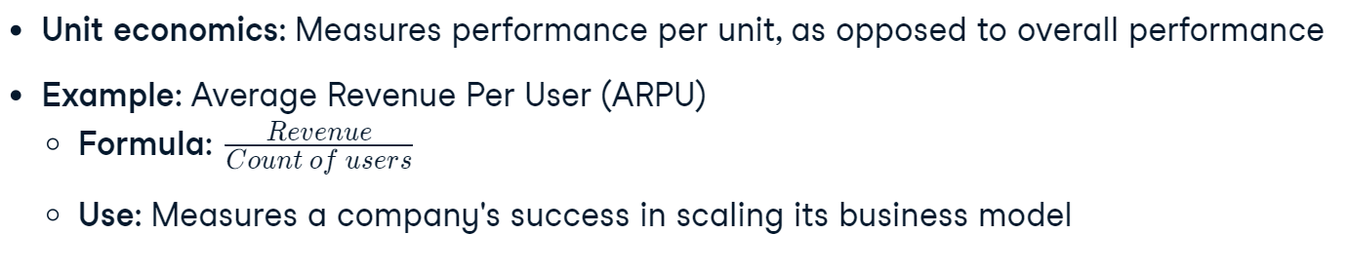

* How to calculate (1):

WITH KPI AS (

  SELECT

    user_id,

    SUM(meal_price * order_quantity) AS revenue

  FROM orders

  JOIN meals

    USING(meal_id)

  GROUP BY user_id

)

SELECT

  ROUND(AVG(revenue)::numeric,  2) AS arpu

FROM kpi

* How to calculate (2):

WITH kpi AS (

  SELECT

    DATE_TRUNC('week', order_date)::date AS delivr_week,

    SUM(order_quantity*meal_price) AS revenue,

    COUNT(DISTINCT user_id) AS users

  FROM meals AS m

  JOIN orders AS o ON m.meal_id = o.meal_id

  GROUP BY delivr_week)

SELECT

  delivr_week,

  ROUND(

    revenue::numeric / GREATEST(users, 1),

    2) AS arpu

FROM kpi

ORDER BY delivr_week ASC;

#### Histograms

* Code:

WITH user_orders AS (

  SELECT

    user_id,

    COUNT(DISTINCT order_id) AS orders

  FROM orders

  GROUP BY user_id)

SELECT

  orders,

  COUNT(user_id) AS users

FROM user_orders

GROUP BY orders

ORDER BY orders ASC;

#### Bucketing

* Code:

WITH user_revenues AS (

    SELECT

      DISTINCT user_id,

      SUM(order_quantity*meal_price) AS revenue

    FROM orders AS o

    LEFT JOIN meals AS m

      USING(meal_id)

    GROUP BY user_id

)

SELECT

  CASE WHEN revenue < 150 THEN 'Low-revenue users'

    WHEN revenue < 300 THEN 'Mid-revenue users'

    ELSE 'High-revenue users'

    END AS revenue_group,

  COUNT(user_id) AS users

FROM user_revenues

GROUP BY revenue_group

### Dealing with dates

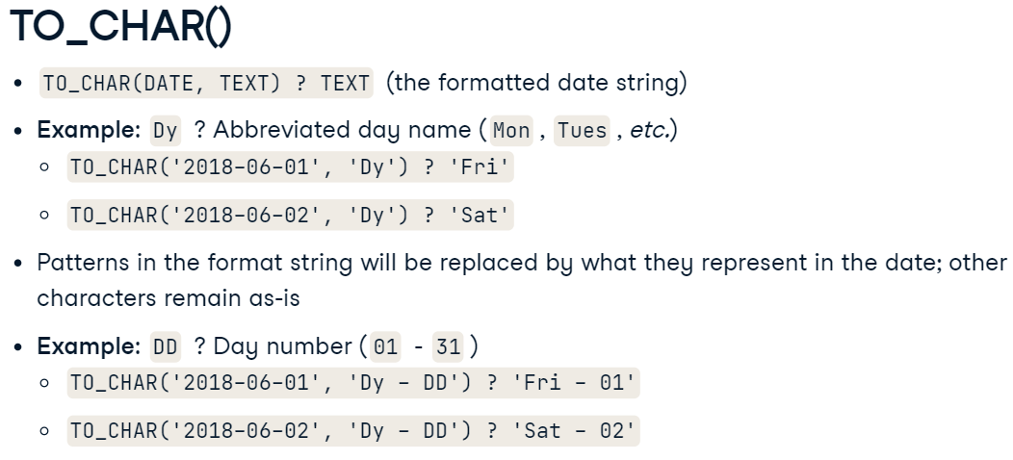

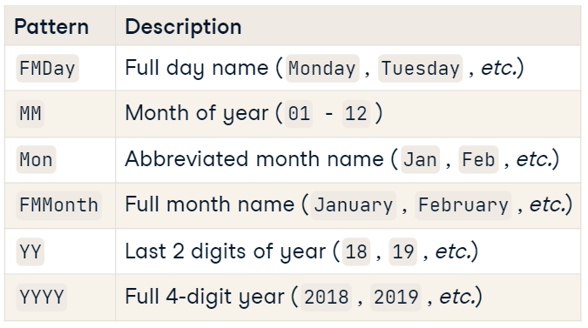

* Code:

SELECT

    DISTINCT order_date,

    TO_CHAR(order_date, 'FMDay DD, FMMonth YYYY') AS format_order_date

FROM orders

ORDER BY order_date

LIMIT 3

Result:

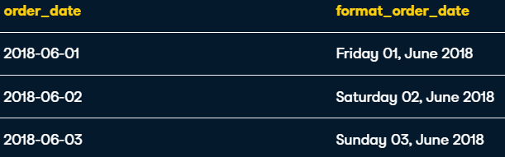

### Report readibility

* Readibility:

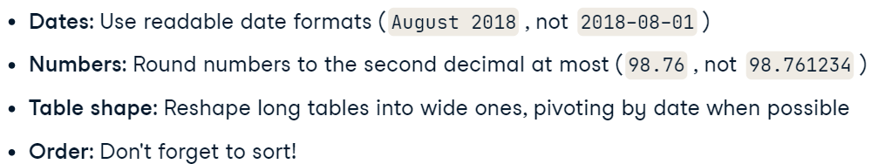

* CODE:

CREATE EXTENSION IF NOT EXISTS tablefunc;

SELECT * FROM CROSSTAB($$

  WITH eatery_users AS  (

    SELECT

      eatery,

      TO_CHAR(DATE_TRUNC('quarter', order_date), '"Q"Q YYYY') AS delivr_quarter,

      COUNT(DISTINCT user_id) AS users

    FROM orders

    LEFT JOIN meals

      USING(meal_id)

    GROUP BY eatery, delivr_quarter

    ORDER BY delivr_quarter)

    SELECT

      eatery,

      delivr_quarter,

      RANK() OVER(PARTITION BY delivr_quarter

                  ORDER BY users DESC)::INT AS users_rank

    FROM eatery_users

    ORDER BY eatery

  $$)

  AS ct (

      eatery TEXT,

      "Q2 2018" INT,

      "Q3 2018" INT,

      "Q4 2018" INT

);