Report

Allsec Technologies Attrition Rate
______________________________________________________________________

Content:

1. Data pre-processing and EDA.

  - Data Loading
  - Load Libraries
  - Summary and dimensionality checking of the data.
  - Missing value Treatment.
  - Martial status
  - Working with date and finding out Age.
  - Managing address field
  - Managing Highest educational qualification
  - Managing Overall experience
  - Managing Length of Service
  - Managing Job Title
  - Defining Target variable
  - Feature Engineering (If any).

2. Visualization.

3. Model.

4. Continual Service Improvement plan, prescriptive Analytics.

1. Data pre-processing and EDA
1.1 Data Loading

Below is the employee master data set you’ve loaded in R console and that’s showing 10095 data points each having 16 attributes. So dimensionality of the data is (10095*16).

Data Cleaning and Assumption:
Data information across 3 Databases.doc

Code:
Attrition Rate.R

Visualization & Findings (Descriptive Statistics)

> table(Test_Final_1$Gender,Test_Final_1$Marital.Status)

Married Single
F 668 2929
M 599 5326

> table(Test_Final_1$Highest.Educational.Qualification,Test_Final_1$Marital.Status)

Married Single
10th 5 78
Diploma 22 274
Graduation 643 4524
HSC 296 2105
Post Graduate Diploma 8 10
Post Graduation 235 438
Professional 17 15
PUC 41 811

> table(Test_Final_1$Resigned,Test_Final_1$Region_1)

Bangalore Chennai Dallas Hyderabad Manila Mumbai New Delhi Pune Trichy
0 570 3013 0 16 0 204 3546 27 101
1 299 795 0 4 0 117 811 3 16

> table(Test_Final_1$Overall.Experience,Test_Final_1$Resigned.y)

0 1
1Year 298 80
2Year 4674 1424
3Year 61 49

> table(Test_Final_1$Length.of.Service,Test_Final_1$Resigned.y)

0 1
0 0 0
1 1892 1008
10 4 23
11 11 36
12 10 31
13 7 19
14 3 23
15 0 11
16 2 10
17 3 8
18 0 4
2 2548 354
3 2126 177
4 570 101
5 150 61
6 49 42
7 63 73
8 32 38
9 7 26

> table(Test_Final_1$Resigned.y,Test_Final_1$Region_1)

Bangalore Chennai Dallas Hyderabad Manila Mumbai New Delhi Pune Trichy
A 299 795 0 4 0 117 811 3 16
I 570 3013 0 16 0 204 3546 27 101

> table(Test_Final_1$Resigned.y,Test_Final_1$Sal_bin)

0 1 2 3 4 5 6
A 131 232 147 129 118 110 1178
I 2240 1766 1014 712 523 381 841

> table(Test_Final_1$Resigned.y,Test_Final_1$Gender)

F M
A 724 1321
I 2873 4604

> table(Test_Final_1$Resigned.y,Test_Final_1$Marital.Status)

Married Single
A 396 1649
I 871 6606

> table(Test_Final_1$Sal_bin)

0 1 2 3 4 5 6
2371 1998 1161 841 641 491 2019

Density Curve visualization:

About Density Curve:
A density curve is a graph that shows probability. The area under the density curve is equal to 100 percent of all probabilities. ... Density curves can be a skewed distribution. Note that the right- or left-skew doesn't refer to how the graph looks. It refers to whether the data is skewed

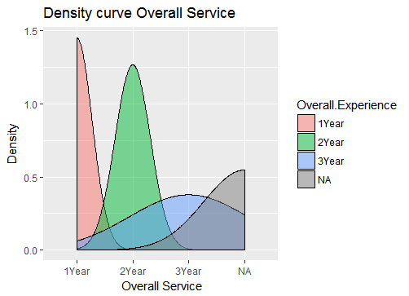

This graph depicts the density plot of the Overall Service of the employees.
For the sake of aesthetics all those with experience greater than 3 years have been put into the NA bin. One can infer the relation between number of people and overall experience.

Age Vs Salary

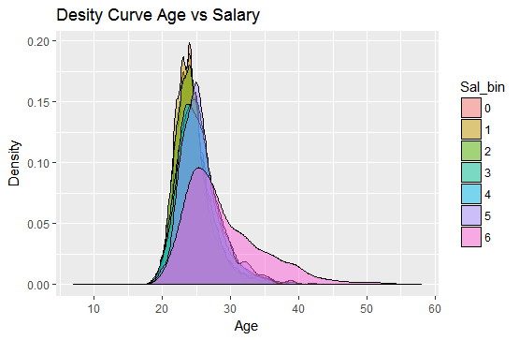

This graph depicts the density plot of the Age of the employees with information of the salary they draw. Here the salary is divided into bins where [0,7] depicts salary from 20k and below to 140K and above. One can infer the relation between number of people belonging to different age groups and salary drawn by them.

Age Vs Marital Status

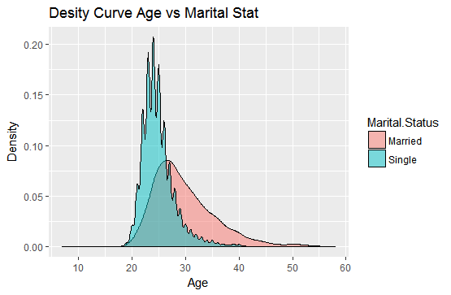

This graph depicts the density plot of the Age of the employees with information of their Marital Status. One can infer the relation between number of people belonging to different age groups and their marital status. As we can see, between ages of 20-30 the number of single people is greater than the number of married people and from age 30 and above the vice versa is true.

Boxplot with 3 Variables:

ABOUT BOXPLOT:
A simple way of representing statistical data on a plot in which a rectangle is drawn to represent the second and third quartiles, usually with a vertical line inside to indicate the median value. The lower and upper quartiles are shown as horizontal lines either side of the rectangle.

gENDER VS AGE

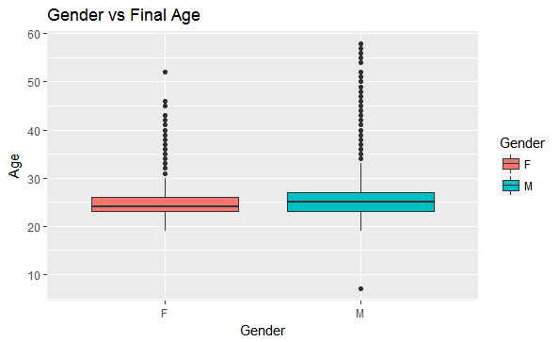

This graph depicts the box plot of the Age of the employees with information of their Gender. One can infer the relation between number of people belonging to different age groups and their gender. As we can see there are a numbers of outliers in both genders.
Average age of both genders is around 25 years.

GENDER VS AGE VS RESIGNED STATUS
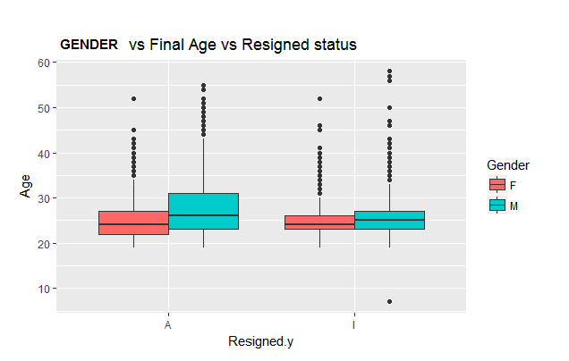

This graph depicts the box plot of the Age of the employees with information of their Gender and the resigned status. One can infer the relation between number of people belonging to different age groups, gender with attrition. As we can see there exist a number of outliers. Average age of both genders in both resigned status classes is around 25 years.

MARITAL STAUS VS FINAL AGE

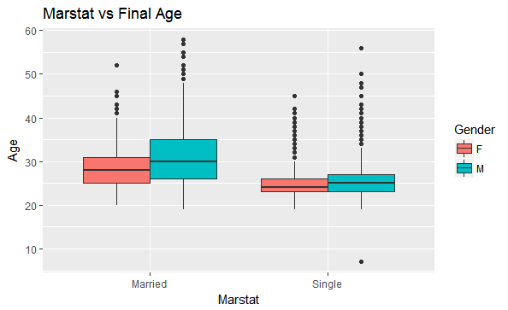

This graph depicts the box plot of the Age of the employees with information of their Gender and the marital status. One can infer the relation between numbers of people belonging to different age groups, gender with marital staus. As we can see there exist a number of outliers. Average age of both genders in married classes is around 25 years.

ABOUT SCATTER PLOT:

A scatterplot is a useful summary of a set of bivariate data (two variables), usually drawn before working out a linear correlation coefficient or fitting a regression line. It gives a good visual picture of the relationship between the two variables, and aids the interpretation of the correlation coefficient or regression model.

Region vs Gross pay Distribution

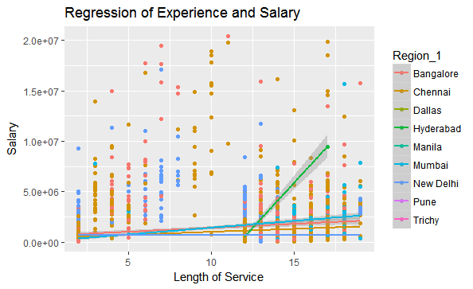

The above graph is a scatter plot between length of service and salary with trend lines which is color coded based on the region the employees work in. From these trend lines we can observe how salary gradually increases as length of service increases. Except for Hyderabad where the increase is abnormal.

REGRESSION OF AGE VS SALARY

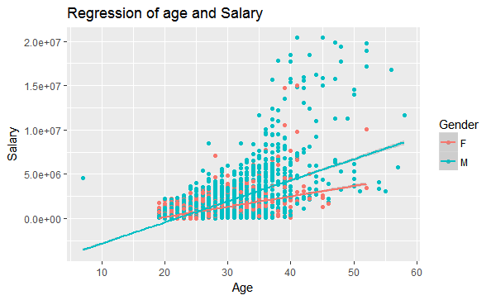

The above graph is a scatter plot between Age and salary with trend lines which is color coded based on the gender of the employees. From these trend lines we can observe how salary gradually increases as Age increases. The rate of increase in salary for men is much more than that of female employees.

ABOUT HISTOGRAM:

A diagram consisting of rectangles whose area is proportional to the frequency of a variable and whose width is equal to the class interval.

Final Age Distribution:

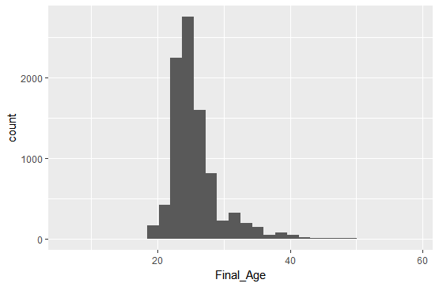

Histogram of Gross Pay

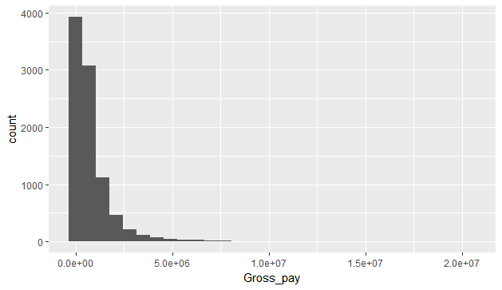
Final age vs gross pay distribution

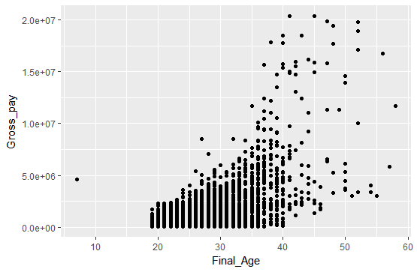

As we can see there are a lot of outliers in the age distribution. And number of outliers increases after the age of 40.

Length of Service vs Gross Pay distribution
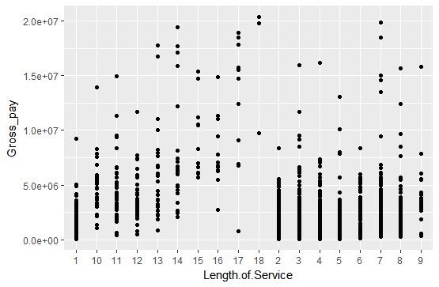
MARITAL STATUS VS GROSS PAY

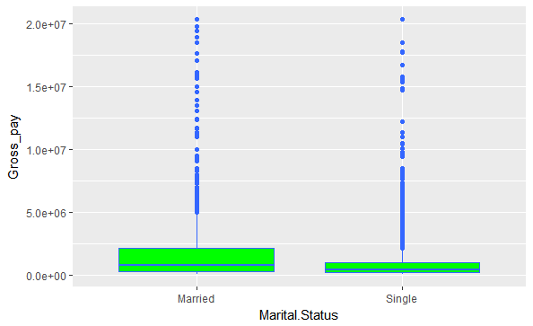

The above is a box plot of marital status versus the gross pay. In both classes there are a number of outliers.

GENDER VS SALARY BIN

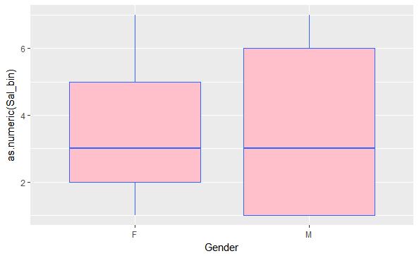
Age Distribution region wise
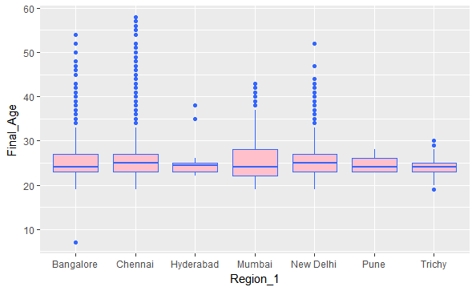

The above is a box plot of region versus age . In all classes there are a number of outliers.

Region wise Salary distribution

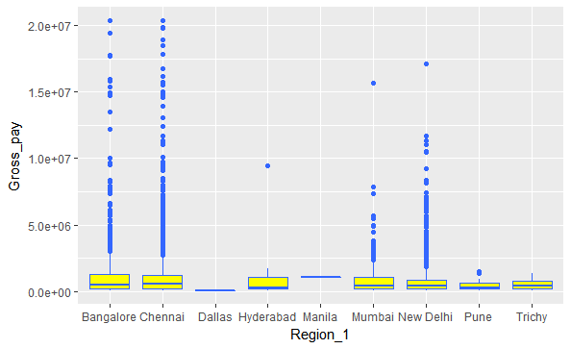

Modification (Limiting Salary value)
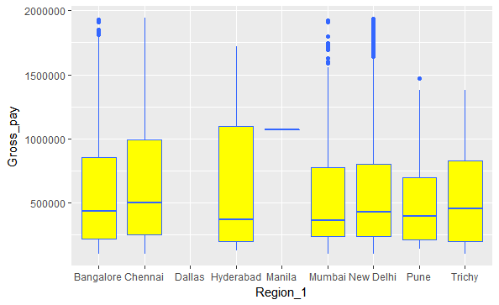

Violin Chart
A Violin Plot is used to visualise the distribution of the data and its probability density.This chart is a combination of a Box Plot and a Density Plot that is rotated and placed on each side, to show the distribution shape of the data. The thick black bar in the centre represents the interquartile range, the thin black line extended from it represents the 95% .
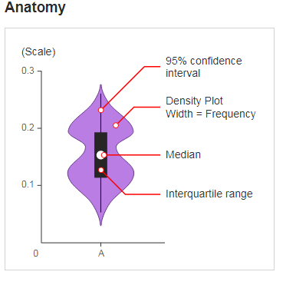
REGION VS GROSS PAY
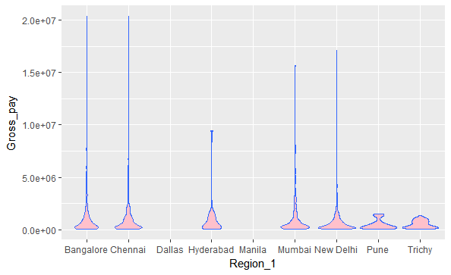
Modified Violin chart
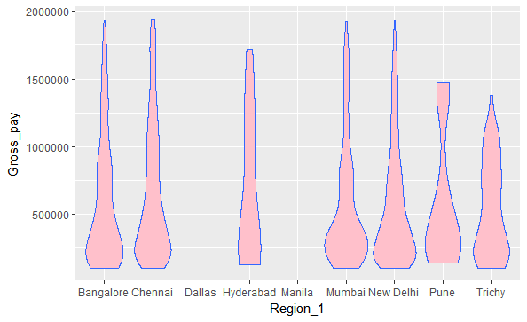
As we can see that from the graph Bangalore, Chennai, Mumbai, New Delhi the distribution is normal whereas for the other cities ( Pune , Trichy , Hyderabad) the gross pay is abnormally distributed.

Tree Model: Visualization

Full Model
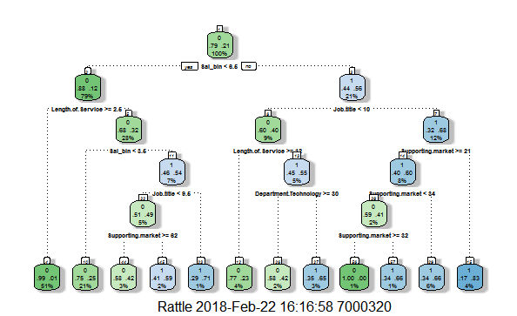

Attrition Pathways:

- Sal_bin < 5.5 + Length of Service >= 1.5
- Sal_bin < 5.5 + Length of Service >= 1.5 + sal_bin < 2.5
- Sal_bin < 5.5 + Length of Service >= 1.5 + sal_bin > 2.5 – Negative attrition
- Sal_bin < 5.5 + Length of Service >= 1.5 + sal_bin > 2.5 + Job.title < 8.5
- Sal_bin < 5.5 + Length of Service >= 1.5 + sal_bin > 2.5 + Job title > 8.5 – Negative attrition
- Sal_bin < 5.5 + Length of Service >= 1.5 + sal_bin > 2.5 + Job.title < 8.5 + Supporting market >= 61
- Sal_bin < 5.5 + Length of Service >= 1.5 + sal_bin > 2.5 + Job.title < 8.5 + Supporting market >!= 61 – Negative attrition
- Sal_bin > 5.5 – Negative attrition
- Sal_bin > 5.5 + Job.title < 9
- Sal_bin > 5.5 + Job.title > = 9 – Negative attrition
- Sal_bin > 5.5 + Job.title < 9 + Length of service >= 11
- Sal_bin > 5.5 + Job.title < 9 + Length of service <!= 11 – Negative attrition
- Sal_bin > 5.5 + Job.title < 9 + Length of service <!= 11 + Dept >= 29
- Sal_bin > 5.5 + Job.title < 9 + Length of service <!= 11 + Dept <!= 29 – Negative attrition
- Sal_bin > 5.5 + Job.title >= 9 + supporting market >= 20 – Negative attrition
- Sal_bin > 5.5 + Job.title >= 9 + supporting market <!= 20 – Negative attrition (most pure node)
- Sal_bin > 5.5 + Job.title >= 9 + supporting market >= 20 + supporting market < 33
- Sal_bin > 5.5 + Job.title >= 9 + supporting market >= 20 + supporting market > 33- Negative attrition
- Sal_bin > 5.5 + Job.title >= 9 + supporting market >= 20 + supporting market < 33
- Sal_bin > 5.5 + Job.title >= 9 + supporting market >= 20 + supporting market < 33 + supporting market >= 31
- Sal_bin > 5.5 + Job.title >= 9 + supporting market >= 20 + supporting market < 33 + supporting market < 31- Negative attrition

Modification:
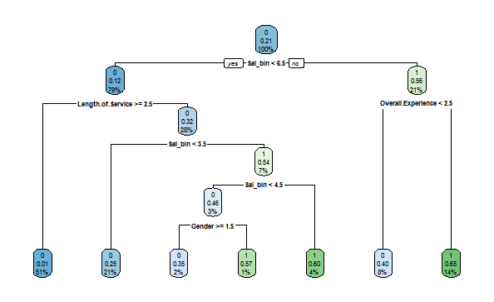

FancyRpartPlot:

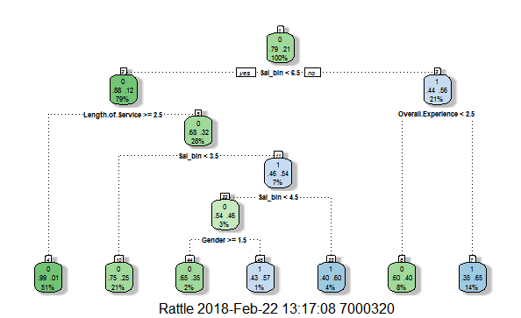

Neural Netwrok Model:

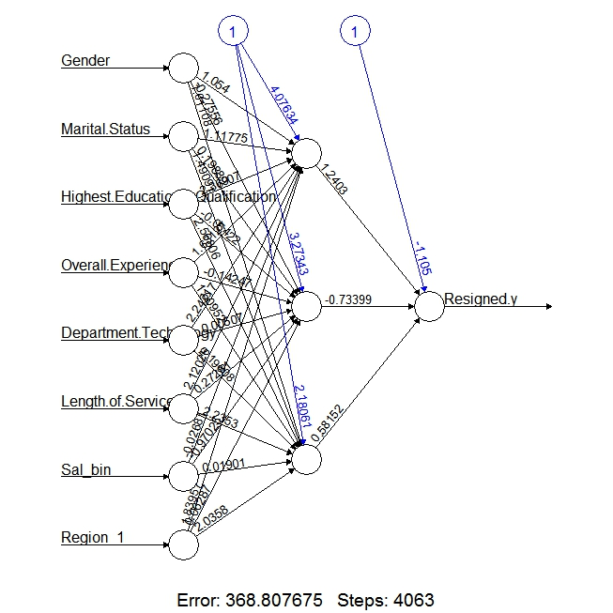

AUC Curve:

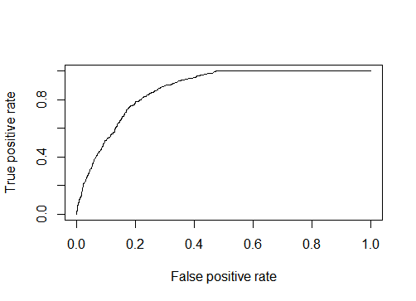

Random Forest

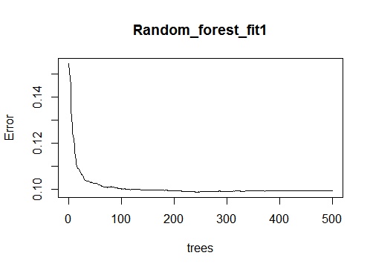
Tree based Model Result

> confusionMatrix(test1_nn$Resigned.y,prediction1)
Confusion Matrix and Statistics

Reference
Prediction 0 1
0 2015 188
1 279 375

Accuracy : 0.8365
95% CI : (0.8225, 0.8499)
No Information Rate : 0.8029
P-Value [Acc > NIR] : 2.205e-06

Kappa : 0.5132
Mcnemar's Test P-Value : 3.118e-05

Sensitivity : 0.8784
Specificity : 0.6661
Pos Pred Value : 0.9147
Neg Pred Value : 0.5734
Prevalence : 0.8029
Detection Rate : 0.7053
Detection Prevalence : 0.7711
Balanced Accuracy : 0.7722

'Positive' Class : 0

Modified Tree:

> confusionMatrix(test1_nn$Resigned.y,prediction_modified)
Confusion Matrix and Statistics

Reference
Prediction 0 1
0 2027 176
1 246 408

Accuracy : 0.8523
95% CI : (0.8387, 0.8651)
No Information Rate : 0.7956
P-Value [Acc > NIR] : 3.5e-15

Kappa : 0.5652
Mcnemar's Test P-Value : 0.0007826

Sensitivity : 0.8918
Specificity : 0.6986
Pos Pred Value : 0.9201
Neg Pred Value : 0.6239
Prevalence : 0.7956
Detection Rate : 0.7095
Detection Prevalence : 0.7711
Balanced Accuracy : 0.7952

'Positive' Class : 0

Regression Model:
1St Iteration: (Full model)

Call:
glm(formula = Resigned.y ~ ., family = binomial(link = "logit"),
data = train_nn, control = list(maxit = 50))

Deviance Residuals:
Min 1Q Median 3Q Max
-2.70271718 -0.55025812 -0.21687409 -0.09463829 2.34219566

Coefficients:
Estimate Std. Error z value Pr(>|z|)
(Intercept) -3.834811821 0.452538533 -8.47400 < 0.000000000000000222 ***
Gender 0.185362421 0.080088864 2.31446 0.02064254 *
Marital.Status 0.016885714 0.116569986 0.14485 0.88482557
Highest.Educational.Qualification 0.070290734 0.025291743 2.77920 0.00544935 **
Overall.Experience 0.092974297 0.011207964 8.29538 < 0.000000000000000222 ***
Department.Technology -0.010169090 0.003531915 -2.87920 0.00398685 **
Length.of.Service -0.221930007 0.009725870 -22.81852 < 0.000000000000000222 ***
Job.title 0.025786262 0.002255520 11.43251 < 0.000000000000000222 ***
Supporting.market 0.005399809 0.001570835 3.43754 0.00058702 ***
Final_Age -0.004705246 0.010597303 -0.44400 0.65703964
Sal_bin 0.692932970 0.023757398 29.16704 < 0.000000000000000222 ***
Region_1 -0.064782231 0.014816641 -4.37226 0.000012297 ***
---
Signif. codes: 0 ‘***’ 0.001 ‘**’ 0.01 ‘*’ 0.05 ‘.’ 0.1 ‘ ’ 1

(Dispersion parameter for binomial family taken to be 1)

Null deviance: 6828.0534 on 6664 degrees of freedom
Residual deviance: 4437.4434 on 6653 degrees of freedom
AIC: 4461.4434

Number of Fisher Scoring iterations: 6

Important variables are Gender, Highest Educational Qualification, Overall Experience, Dept, Length of service, Job title, supporting market, Sal bin and Region. Next iteration we are choosing the variables that are important only.

2nd Iteration:

> summary(Regression_fit_1)

Call:
glm(formula = Resigned.y ~ Overall.Experience + Length.of.Service +
Job.title + Sal_bin + Region_1, family = binomial(link = "logit"),
data = train_nn)

Deviance Residuals:
Min 1Q Median 3Q Max
-2.68586157 -0.55236568 -0.22921162 -0.09939932 2.20617495

Coefficients:
Estimate Std. Error z value Pr(>|z|)
(Intercept) -3.295288254 0.164300047 -20.05653 < 0.000000000000000222 ***
Overall.Experience 0.095004291 0.011057142 8.59212 < 0.000000000000000222 ***
Length.of.Service -0.221957470 0.009603360 -23.11248 < 0.000000000000000222 ***
Job.title 0.024492005 0.002103927 11.64109 < 0.000000000000000222 ***
Sal_bin 0.689594884 0.023076028 29.88360 < 0.000000000000000222 ***
Region_1 -0.066094020 0.014770102 -4.47485 0.0000076464 ***
---
Signif. codes: 0 ‘***’ 0.001 ‘**’ 0.01 ‘*’ 0.05 ‘.’ 0.1 ‘ ’ 1

(Dispersion parameter for binomial family taken to be 1)

Null deviance: 6828.0534 on 6664 degrees of freedom
Residual deviance: 4461.2863 on 6659 degrees of freedom
AIC: 4473.2863

Number of Fisher Scoring iterations: 6

ANOVA Test.

> anova(Regression_fit_1, test = "Chisq")
Analysis of Deviance Table

Model: binomial, link: logit

Response: Resigned.y

Terms added sequentially (first to last)

Df Deviance Resid. Df Resid. Dev Pr(>Chi)
NULL 6664 6828.0534
Overall.Experience 1 291.44902 6663 6536.6044 < 0.000000000000000222 ***
Length.of.Service 1 140.84385 6662 6395.7606 < 0.000000000000000222 ***
Job.title 1 575.02627 6661 5820.7343 < 0.000000000000000222 ***
Sal_bin 1 1339.26319 6660 4481.4711 < 0.000000000000000222 ***
Region_1 1 20.18481 6659 4461.2863 0.0000070309 ***
---
Signif. codes: 0 ‘***’ 0.001 ‘**’ 0.01 ‘*’ 0.05 ‘.’ 0.1 ‘ ’ 1

Regression Accuracy:

> confusionMatrix(test1_nn$Resigned.y,Reg_predict)
Confusion Matrix and Statistics

Reference
Prediction 0 1
0 2088 115
1 385 269

Accuracy : 0.8249912
95% CI : (0.8105524, 0.8387611)
No Information Rate : 0.8655933
P-Value [Acc > NIR] : 1

Kappa : 0.4200855
Mcnemar's Test P-Value : <0.0000000000000002

Sensitivity : 0.8443186
Specificity : 0.7005208
Pos Pred Value : 0.9477985
Neg Pred Value : 0.4113150
Prevalence : 0.8655933
Detection Rate : 0.7308365
Detection Prevalence : 0.7710886
Balanced Accuracy : 0.7724197

'Positive' Class : 0

3. Neural Network.

Confusion Matrix and Statistics

Reference
Prediction 0 1
0 2023 337
1 208 289

Accuracy : 0.8092405
95% CI : (0.7943445, 0.8235001)
No Information Rate : 0.780889
P-Value [Acc > NIR] : 0.0001092934

Kappa : 0.3979256
Mcnemar's Test P-Value : 0.00000004183679

Sensitivity : 0.9067683
Specificity : 0.4616613
Pos Pred Value : 0.8572034
Neg Pred Value : 0.5814889
Prevalence : 0.7808890
Detection Rate : 0.7080854
Detection Prevalence : 0.8260413
Balanced Accuracy : 0.6842148

'Positive' Class : 0

Pos Pred Value : 0.7392093
Neg Pred Value : NaN
Prevalence : 0.7392093
Detection Rate : 0.7392093
Detection Prevalence : 1.0000000
Balanced Accuracy : 0.5000000

'Positive' Class : 1

Random Forest
Variable Importance.

> importance(Random_forest_fit1, type = 1)
%IncMSE
Gender 0.1126698796
Marital.Status 3.9091496514
Highest.Educational.Qualification 11.8435255658
Overall.Experience 23.0519678070
Department.Technology 31.2782544482
Length.of.Service 85.7361063948
Job.title 24.7131414331
Supporting.market 58.0096126731
Final_Age 19.2222915282
Sal_bin 156.5623149678
Region_1 17.4389830303

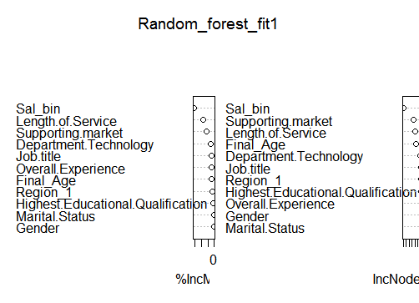
Random Forest Accuracy:
> confusionMatrix(Pred_rf, test1_nn$Resigned.y)
Confusion Matrix and Statistics

Reference
Prediction 0 1
0 2036 223
1 195 403

Accuracy : 0.8536927
95% CI : (0.8401967, 0.8664596)
No Information Rate : 0.780889
P-Value [Acc > NIR] : < 0.00000000000000022

Kappa : 0.565463
Mcnemar's Test P-Value : 0.1866304

Sensitivity : 0.9125952
Specificity : 0.6437700
Pos Pred Value : 0.9012838
Neg Pred Value : 0.6739130
Prevalence : 0.7808890
Detection Rate : 0.7126356
Detection Prevalence : 0.7906895
Balanced Accuracy : 0.7781826

'Positive' Class : 0

SVM

Parameter tuning of ‘svm’:

- sampling method: fixed training/validation set

- best parameters:
gamma cost
0.5 4

- best performance: 0.1165827878

- Detailed performance results:
gamma cost error dispersion
1 0.5 4 0.1165827878 NA
2 1.0 4 0.1235520382 NA
3 2.0 4 0.1320774640 NA
4 0.5 8 0.1216656544 NA
5 1.0 8 0.1309994588 NA
6 2.0 8 0.1360848890 NA
7 0.5 16 0.1295559201 NA
8 1.0 16 0.1379669351 NA
9 2.0 16 0.1436688413 NA
SVM Accuracy:

Confusion Matrix and Statistics

Reference
Prediction 0 1
0 5034 212
1 715 704

Accuracy : 0.8609152
95% CI : (0.8523749, 0.8691385)
No Information Rate : 0.8625656
P-Value [Acc > NIR] : 0.660085

Kappa : 0.5233838
Mcnemar's Test P-Value : < 0.0000000000000002

Sensitivity : 0.8756305
Specificity : 0.7685590
Pos Pred Value : 0.9595883
Neg Pred Value : 0.4961240
Prevalence : 0.8625656
Detection Rate : 0.7552888
Detection Prevalence : 0.7870968
Balanced Accuracy : 0.8220947

'Positive' Class : 0

control = list(minsplit = 20,
minbucket = 7, cp = 0, maxcompete = 4, maxsurrogate = 5,
usesurrogate = 2, surrogatestyle = 0, maxdepth = 30, xval = 0))
n= 6665

CP nsplit rel error
1 0.19735666 0 1.0000000
2 0.10648622 1 0.8026433
3 0.02551757 2 0.6961571

Variable importance
Sal_bin Length.of.Service Job.title Department.Technology
40 26 9 9
Final_Age Overall.Experience Supporting.market Region_1
7 5 2 1

Node number 1: 6665 observations, complexity param=0.1973567
mean=0.2087022, MSE=0.1651456
left son=2 (5263 obs) right son=3 (1402 obs)
Primary splits:
Sal_bin < 2.865551 to the left, improve=0.19735670, (0 missing)
Job.title < 0.6319673 to the left, improve=0.10401800, (0 missing)
Department.Technology < 0.8052911 to the right, improve=0.09990234, (0 missing)
Supporting.market < 0.4882226 to the right, improve=0.08718747, (0 missing)
Length.of.Service < 2.231977 to the right, improve=0.08041137, (0 missing)
Surrogate splits:
Job.title < 0.6319673 to the left, agree=0.837, adj=0.224, (0 split)
Department.Technology < 0.8052911 to the right, agree=0.830, adj=0.190, (0 split)
Overall.Experience < 2.469979 to the left, agree=0.818, adj=0.136, (0 split)
Final_Age < 7.897639 to the left, agree=0.817, adj=0.132, (0 split)
Length.of.Service < 2.814231 to the left, agree=0.814, adj=0.116, (0 split)

Node number 2: 5263 observations, complexity param=0.1064862
mean=0.1155235, MSE=0.1021778
left son=4 (3405 obs) right son=5 (1858 obs)
Primary splits:
Length.of.Service < 0.4852123 to the right, improve=0.21795690, (0 missing)
Overall.Experience < 1.999507 to the left, improve=0.05376810, (0 missing)
Final_Age < 5.891889 to the right, improve=0.02846568, (0 missing)
Supporting.market < 0.7501957 to the right, improve=0.02396520, (0 missing)
Department.Technology < 3.191339 to the left, improve=0.01720625, (0 missing)
Surrogate splits:
Supporting.market < 0.7501957 to the right, agree=0.681, adj=0.096, (0 split)
Final_Age < 5.641171 to the right, agree=0.677, adj=0.084, (0 split)
Department.Technology < 3.191339 to the left, agree=0.661, adj=0.040, (0 split)
Region_1 < 3.256888 to the left, agree=0.661, adj=0.040, (0 split)
Job.title < 3.821897 to the left, agree=0.650, adj=0.010, (0 split)

Node number 3: 1402 observations
mean=0.5584879, MSE=0.2465792

Node number 4: 3405 observations
mean=0.005286344, MSE=0.005258398

Node number 5: 1858 observations
mean=0.3175457, MSE=0.2167104

Time Series:
For Chennai Location:
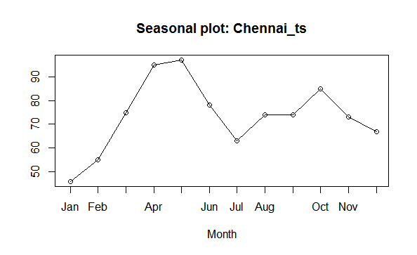
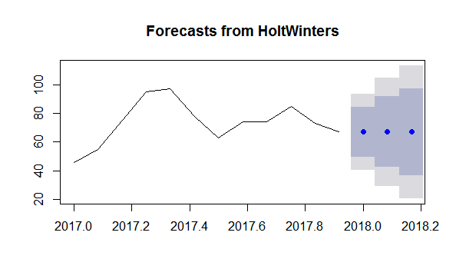
> forecast(fit1, 3)
Point Forecast Lo 80 Hi 80 Lo 95 Hi 95
Jan 2018 67.0004 49.55534 84.44545 40.32049 93.6803
Feb 2018 67.0004 42.33018 91.67061 29.27056 104.7302
Mar 2018 67.0004 36.78601 97.21478 20.79148 113.2093
For Bangalore Location:
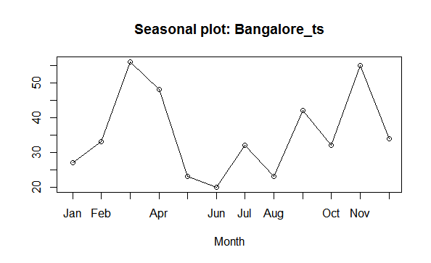

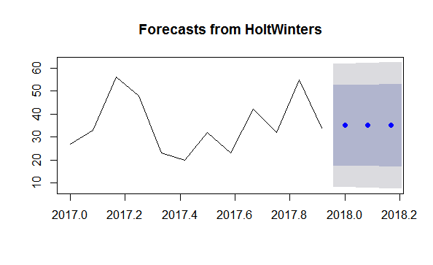
> forecast(fit2, 3)
Point Forecast Lo 80 Hi 80 Lo 95 Hi 95
Jan 2018 35.01909 17.48505 52.55314 8.203086 61.83510
Feb 2018 35.01909 17.28877 52.74942 7.902909 62.13528
Mar 2018 35.01909 17.09465 52.94354 7.606019 62.43217
For Delhi Location:
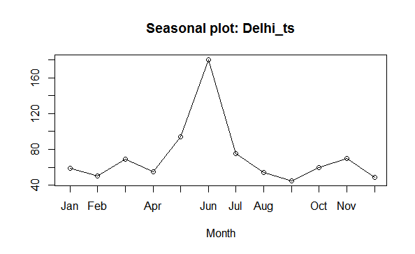

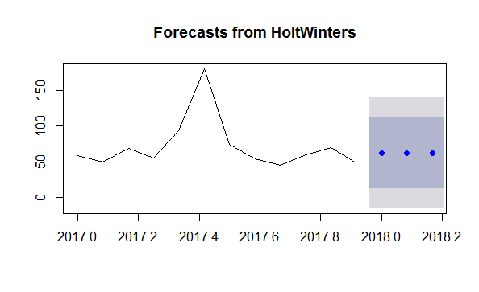
> forecast(fit3, 3)
Point Forecast Lo 80 Hi 80 Lo 95 Hi 95
Jan 2018 62.717 12.67375 112.7602 -13.81755 139.2515
Feb 2018 62.717 12.65174 112.7823 -13.85120 139.2852
Mar 2018 62.717 12.62975 112.8042 -13.88484 139.3188

Allsec Attrition as a whole:

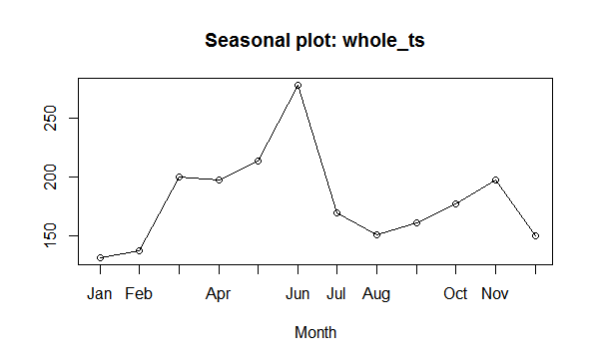

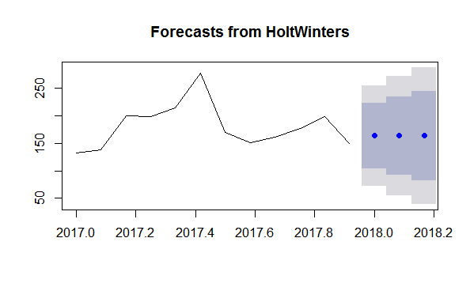

> forecast(fit4, 3)
Point Forecast Lo 80 Hi 80 Lo 95 Hi 95
Jan 2 163.5422 103.91038 223.1739 72.34322 254.7411
Feb 2 163.5422 92.30904 234.7753 54.60050 272.4838
Mar 2 163.5422 82.34877 244.7355 39.36759 287.7167

