**VIETNAM NATIONAL UNIVERSITY**

**HO CHI MINH UNIVERSITY OF SCIENCE**

**FACULTY INFORMATION TECHNOLOGY**

**PROJECT 02**

**WUMPUS WORLD**

TEAM MEMBERS

Phạm Ngọc Thùy Trang 18127022

Võ Trần Quang Tuấn 18127248

**Course: Introduction to Artificial Intelligence**

**Ho Chi Minh City – 2020**

**VIETNAM NATIONAL UNIVERSITY**

**HO CHI MINH UNIVERSITY OF SCIENCE**

**FACULTY INFORMATION TECHNOLOGY**

**PROJECT PACMAN GAME**

**| TOPIC |**

**| LECTURERS |**

Mr. Le Ngoc Thanh

Ms. Ho Thi Thanh Tuyen

Ms. Nguyen Ngoc Thao

# TABLE OF CONTENTS

REPORT’S TABLE OF CONTENTS

TABLE OF CONTENTS 3

ACKNOWLEDGEMENTS 4

ASSIGNMENT PLAN 5

ENVIRONMENT 6

ESTIMATE THE DEGREE OF COMPLETION LEVEL 8

REFERENCES 9

# ACKNOWLEDGEMENTS

We would like to express our deepest appreciation to all those who provided me the possibility to complete this report.  A special gratitude we give to our major Introduction to AI’s teacher, Ms. Nguyen Ngoc Thao, whose contribution in stimulating suggestions and encouragement, helped us to coordinate my project especially in writing this report.

Furthermore we would also like to acknowledge with much appreciation the crucial role of the staff of Mr. Le Ngoc Thanh and Ms. Ho Thi Thanh Tuyen, who gave the permission to use all required  equipment and the necessary material to complete the project “Searching”.

We have to appreciate the guidance given by other supervisor as well as the panels especially in our project presentation that has improved our presentation skills thanks to their comment and advices.

Regards,

Team Representative,

Trang

Pham Ngoc Thuy Trang

# ASSIGNMENT PLAN

* Preparation

**Sprites for Game**

|  |  |
| --- | --- |
| Name of sprites |  |
| Agent | **back** |
| **right** |
| **front** |
| **left** |
| Brick |  |
| Gold (Coin) |  |
| Pit |  |
| Wumpus |  |
| Breeze |  |
| Stench |  |
| Arrow |  |

**At least 5 maps with different structures such as position and number of Pit, Golds and Wumpus**

|  |  |
| --- | --- |
| ID | Map (*Default with size: 10x10*) |
| 1 |  |
| 2 |  |
| 3 |  |
| 4 |  |
| 5 |  |

* Ideas
* Planning UI and Workflow for game

**Workflow for game**:

* Explain some important classes and function.

# ENVIRONMENT

What we use for our project are:

* **IDEs**: Visual Code
* Programming language: Python
* Outsource Platform for Python: Anaconda
* **Libraries for Project**: PyQt5, pygame (for graphics), heapq (to use heap data structure in python), sys, re (Regular Expression - restrict the way how user input information), os
* **Version Control System:** Git (using GitHub to store projects and teamwork).
* The primary branch is branch “master” and parallel to this branch is another branch called “dev”.
* When the team’s source code in the “dev” branch reaches a stable point and is ready to be released, all of changes will be merged back into “master” branch.
* Members will also have their own branch which is named after their name. These branches are used for edit/delete/update their functions….

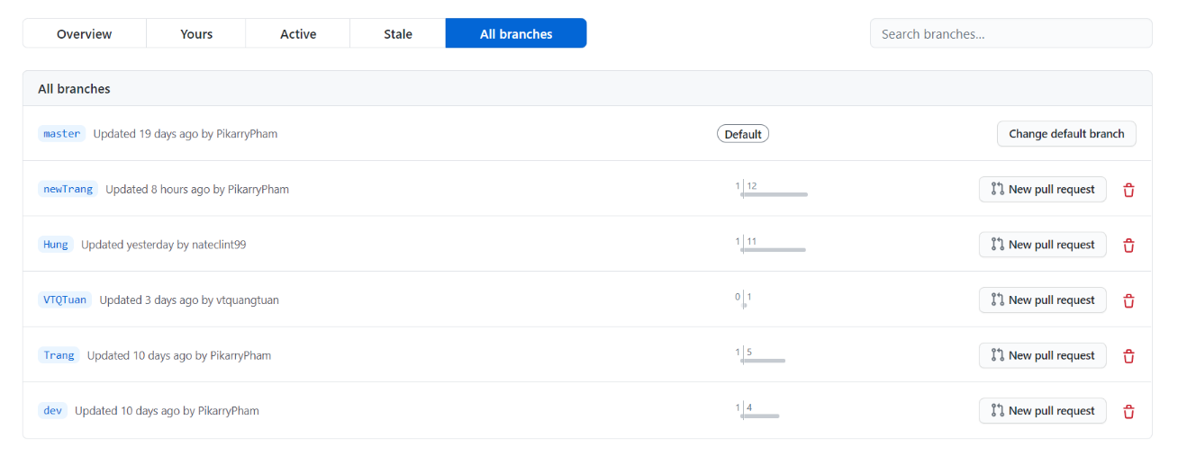

# ESTIMATE THE DEGREE OF COMPLETION LEVEL

ESTIMATE THE DEGREE OF COMPLETION FOR EACH LEVEL

OVERALL ESTIMATE

# REFERENCES

[1]: Artificial Intelligence – A Modern Approach 3rd Edition Russel and Peter Norvig

[2]:

[3]: