1-

find . -name getty\*

// After researching i found out that the target file might be a file named “getty”. So I searched all the files named getty in the system.

Result:

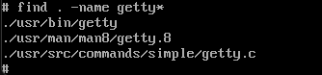

2-

cd usr/src/commands/simple

// Source of minix is located in usr/src. So I entered this path.

3-

vi getty.c

// I used vi editor to edit the file.

4-

/login:

// First i checked if there is "login:" in this file.

5-

:%s/login:/Giris:/g

// I changed "login:" text in the file to "Giris:".

6-

:wq

// I saved file and exited vi editor.

7-

cd //

cd usr/src

make clean install

reboot

// Compiling the source code and result:

