Answer to 14.8(a)

Number of factors = 2,

factor-1: age of child, factor-2: type of product

This is a 3x2 factorial design

Y_ijk = mu + alpha_i + beta_j + alpha_beta_ij + epsilon_ijk

Y_ijk = observed length of time to hold a child’s attention for age group i, product type j, of subject k .

i = 1, 2, 3 for age groups A1, A2, and A3

j=1, 2 for product type, P1 & P2

Alpha_i = effect of age group i on population mean response

Beta_j = effect of using product type j’s on population mean response

Alpha_beta_ij the joint effect of age group i, and product type j on population’s mean

epsilon_ijk = a random error associated with the kth response for the ith value of age of child, combined with the jth level of product type.

Answer to 14.11

(a)

Three factors: air, milk fat, sweetener.

This is a 3x3x2 factorial design

(b)

Model:

Y_ijkl = mu + alpha_i + beta_j + gamma_k + alpha_beta_ij + alpha_gamma+ik + beta_gamma_jk + alpha_beta_gamma_ijk + epsilon_ijkl

i =1, 2, 3 for air representing 5%, 10%, 15%, respectively

j= milk fat levels = 1, 2, 3 for representing 10%, 12%, and 15%, respectively

k = levels for sweetener = 1, 2 for 12%, and 16%, respectively

l = experimental unit, session rating

Y_ijkl = response from the lth experiemental unit, here sensory ratings, for the ith level of the air, jth level of milk fat, and kth level of sweetener

mu = overall mean

alpha_i = effect due to the ith level of air

beta_j = effect due to the jth level of milkfat

gamma_k = effect due to the kth level of sweetener

alpha_beta_ij = a two way interaction effect of the ith level of air, with jth level of milkfat

alpha_gamma_ik = a two way interaction effect of the ith level of air, with kth level of sweetener

beta_gamma_jk = a two way interaction effect of the jth level of milkfat, with kth level of sweetener

alpha_beta_gamma_ijk = a three way interaction effect of the ith level of the air, with jth level of milk fat, and kth level of sweetener

epsilon_ijkl = a random error associated with the lth response for the ith value of air, combined with the jth level of milk fat, and kth level of sweetener .

(c)

Figure-I

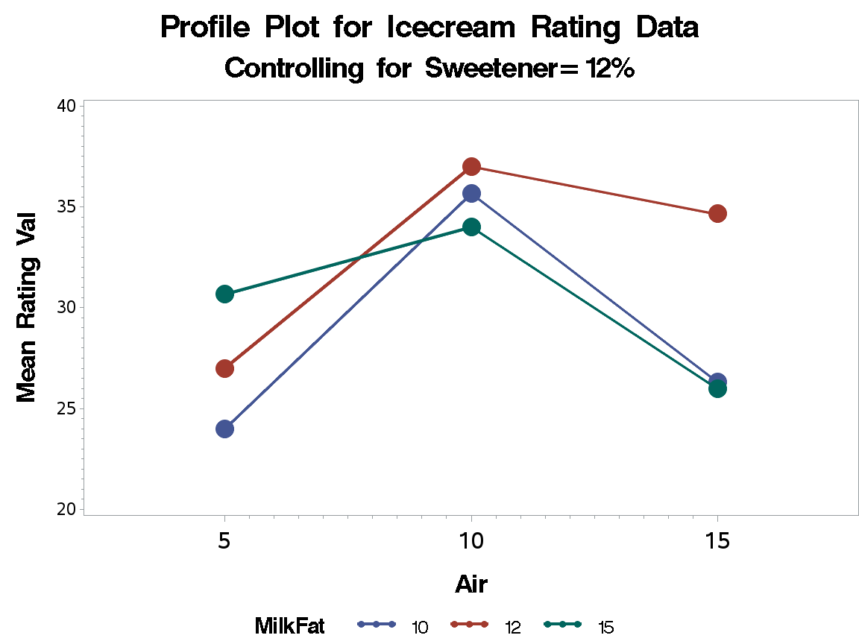

Figure-II

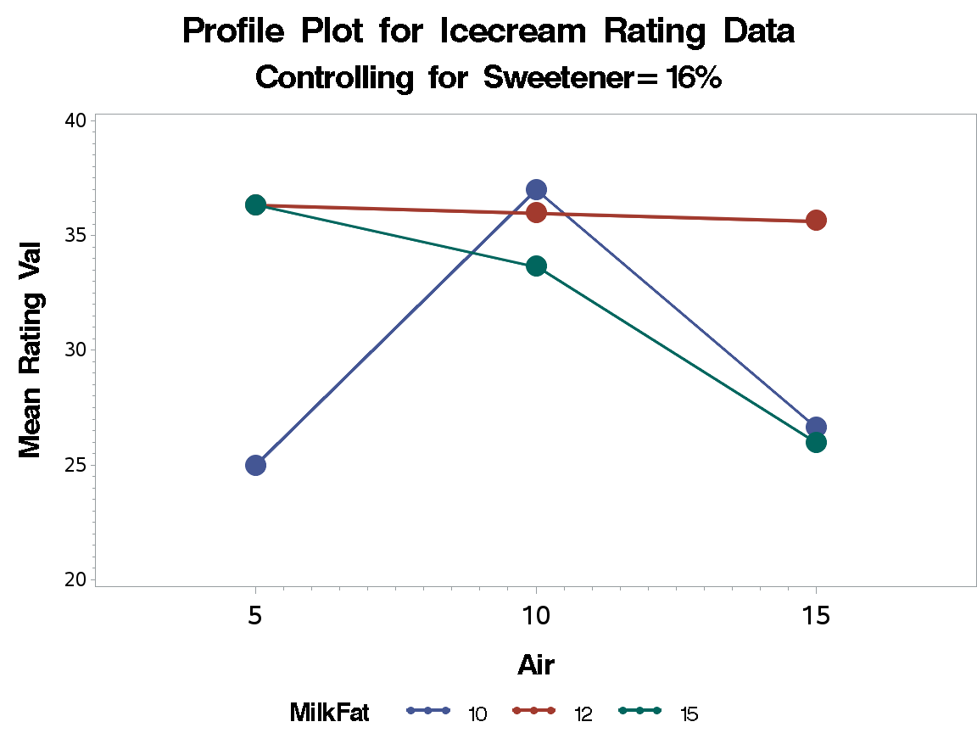

(d)

From Figure-I we observe that the Milkfat levels for 10 and 12 are almost similar for levels of Air 5, 10, and 15. However, Milkfat level 15 interacts between Air 5 and 10, and between Air 10 and 15 levels. Therefore, at 12% sweetener level there is interaction between Air and Milkfat.

From Figure-II we observe that the Milkfat levels for 10 and 15 are not similar for levels of Air 10 and 15. Also for level of Air = 5, we see all three levels of Milkfat interacting. Therefore, at 16% sweetener level there is interaction between Air and Milkfat when Air=5.

Figure I and II also states that we have a 3-way interaction between the factors as the plots are different.

14.12

(a)

Except for the combined factors of sweetener and milk indicated by sweetener*milk, that has a p-value of 0.194, we can state with 95% statistical confidence the factors have an effect on sensory ratings. The output also states that there is a 3-way interaction, which is also stated by Figures I and II.

(b)

Yes. As p-value for milkfat*air we have a p-value for < 0.05, and we have identified Milkfat and air to be interacting with two levels of sweetener from the two profile plots.

(c)

Overall test for ANOVA

1. H0_all = alpha_i = beta_j=gamma_k = alpha_beta_gamma_ijk = 0 for all i=1,2,3; j=1,2,3; and k=1,2.
2. HA_all = at least one model effect is non zero

F test for air*milkfat

1. H0_ air*milkfat = alpha_beta_ij = 0 for all i=1,2,3 and j=1,2,3
2. HA_ air*milkfat = at least one alpha_beta_ij is non zero

F test for air*sweetener

1. H0_ air*sweetener = alpha_gamma_ik = 0 for all i=1,2,3 and k=1,2
2. HA_ air*sweetener = at least one alpha_gamma_ik is non zero

F test for milkfat*sweetener

1. H0_ milkfat*sweetener = beta_gamma_jk = 0 for all j=1,2,3 and k=1,2
2. HA_ milkfat*sweetener = at least one beta_gamma_jk is non zero

F test for air

1. H0_ air = alpha_i = 0 for all i=1,2,3
2. HA_ air = at least one alpha_i is non zero

F test for milkfat

1. H0_ milkfat = beta_j = 0 for all j=1,2,3
2. HA_ milkfat = at least one beta _j is non zero

F test for sweetener

1. H0_ sweetener = gamma_k = 0 for all k=1,2
2. HA_ sweetener = at least one gamma _k is non zero

Assumptions:

1. SRS: Satisfied, as the samples are randomly assigned to treatments
2. Normality: Roughly satisfied as indicated in the ‘Percent-Residual’ plot
3. Constant Variances: Roughly satisfied as indicated in the ‘Residual-Fitted Value’ plot, three points do not follow
4. Samples are independent of each other so the condition of independence satisfied.