The 0/1 knapsack problem means that the items are either completely or no items are filled in a knapsack. For example, we have two items having weights 2kg and 3kg, respectively. If we pick the 2kg item then we cannot pick 1kg item from the 2kg item (**item is not divisible**); we have to pick the 2kg item completely. This is a 0/1 knapsack problem in which either **we pick the item completely or we will pick that item**. **The 0/1 knapsack problem is solved by the dynamic programming**.

Weights: {3, 4, 6, 5}

Profits: {2, 3, 1, 4}

The weight of the knapsack is 8 kg

The number of items is 4

The above problem can be solved by using the following method:

xi = {1, 0, 0, 1}

= {0, 0, 0, 1}

= {0, 1, 0, 1}

The above are the possible combinations. 1 denotes that the item is completely picked and 0 means that no item is picked. Since there are 4 items so possible combinations will be:

**24 = 16;** So. There are 16 possible combinations that can be made by using the above problem. Once all the combinations are made, we have to select the combination that provides the maximum profit.

Another approach to solve the problem is dynamic programming approach. In dynamic programming approach, the complicated problem is divided into sub-problems, then we find the solution of a sub-problem and the solution of the sub-problem will be used to find the solution of a complex problem

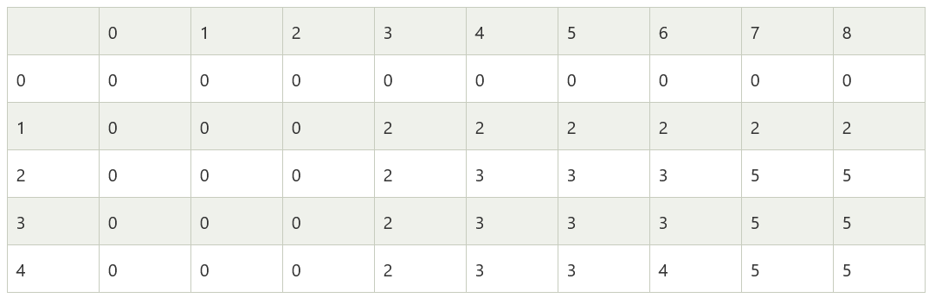

In the above matrix, columns represent the weight, i.e., 8. The rows represent the profits and weights of items. Here we have not taken the weight 8 directly, problem is divided into sub-problems, i.e., 0, 1, 2, 3, 4, 5, 6, 7, 8. The solution of the sub-problems would be saved in the cells and answer to the problem would be stored in the final cell. First, we write the weights in the ascending order and profits according to their weights shown as below:

**wi = {3, 4, 5, 6}**

**pi = {2, 3, 4, 1}**

**The first row and the first column would be 0 as there is no item for w=0**

**When i=1, W=1**

w1 = 3; Since we have only one item in the set having weight 3, but the capacity of the knapsack is 1. We cannot fill the item of 3kg in the knapsack of capacity 1 kg so add 0 at M[1][1] shown as below: