**INTRODUCTION**

**Data** can be defined as **a systematic record of a particular quantity**. It is the different values of that quantity represented together in a set. It is a collection of facts and figures to be used for a specific purpose such as a survey or analysis. When arranged in an organized form, can be called **information**.

Information = {data1, data2, data3}

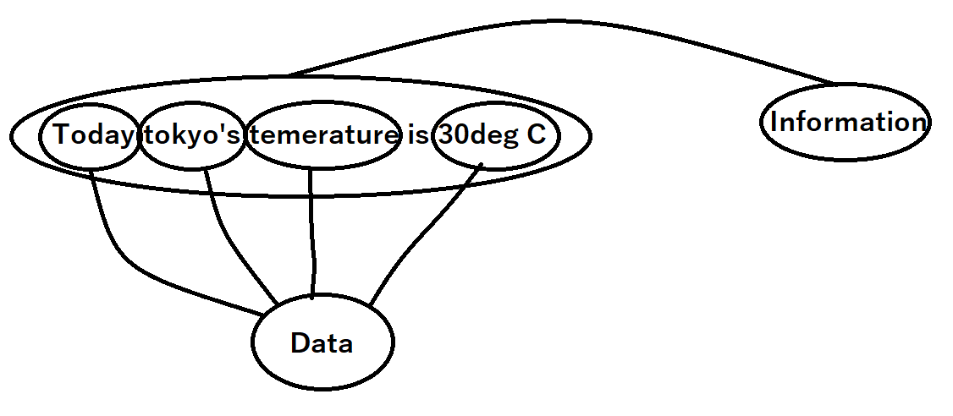

**Data model**

A data model is an abstract model that organizes elements of data and standardizes how they relate to one another and to the properties of real-world entities

**Database**

A **database** is a **collection** of **inter-related data** which helps in the efficient retrieval, insertion, and deletion of data from the database and organizes the data in the form of tables, views, schemas, reports, etc

A **DBMS (database management system)** consists a **database** and **set of programs** to access those data.

The software which is used to manage databases is called Database Management System (DBMS). For Example, MySQL, Oracle, etc. are popular commercial DBMS used in different applications.

**RDBMS**

A RDBMS (relational database management system) is a DBMS which uses **relations (or tabular form)** forshowing / storing data in DBMS

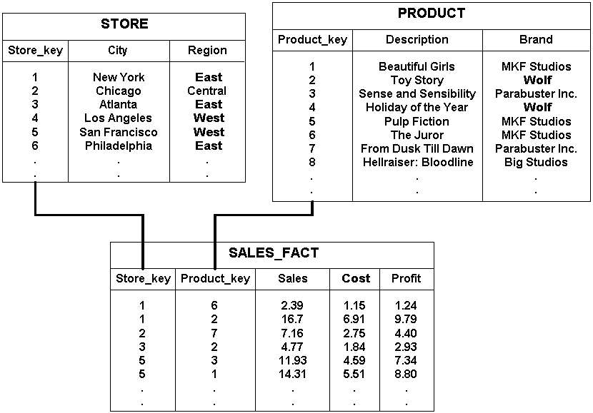

**Procedural language**

**specifies a series of well-structured steps and procedures within its programming context to compose a program**. It contains a systematic order of statements, functions and commands to complete a computational task or program

Language used in RDBMS is **Structured Query Language (SQL / pronounced as se-qu-el)** is a **non-procedural** language.