**What and Why Time delay**

In the 8085 microprocessor, a time delay is a pause in the execution of instructions for a specific amount of time. This time delay is typically introduced by instructions that perform input/output operations, such as reading from or writing to a device. These instructions require additional time to complete because they involve communication with an external device, which can be slower than the internal operations of the microprocessor.

To account for this time delay, the 8085 microprocessor includes a built-in clock generator, which produces a series of pulses at a constant frequency. The length of the time delay is specified in terms of the number of clock pulses that elapse during the delay. This allows the microprocessor to accurately measure the amount of time that has passed, and ensures that the time delay is consistent, regardless of the clock frequency.

Time delays are an important part of the operation of the 8085 microprocessor, because they allow the microprocessor to coordinate its operations with the slower speed of external devices. This enables the microprocessor to efficiently communicate with these devices, and ensures that the overall system operates smoothly.

**What Is clock**

a clock is a timing mechanism that is used to coordinate the operation of a system. It typically consists of a hardware circuit that produces a series of pulses at a constant frequency, which are used to synchronize the operations of the different components in the system.

in a microprocessor, the clock is used to synchronize the execution of instructions, and to ensure that the various components of the processor are working in unison

the clock is also used to measure the passage of time. By counting the number of clock pulses that occur over a given period, it is possible to determine the amount of time that has elapsed.

**What is T-state**

T-state is a unit of time used to measure the duration of an operation in a microprocessor. It is defined as the time it takes for one clock pulse to complete

the T-state is also used to measure the overall performance of a microprocessor. By counting the number of T-states that are required to complete a given task, it is possible to determine the speed at which the microprocessor is operating. This can be used to compare the performance of different microprocessors, and to determine which one is the fastest.

**T state is Fashionable name given to 1 complete clock cycle.**

**\***When a clock is said to be "2 MHz", it means that it produces a series of pulses at a frequency of 2 million cycles per second

“MHz” is a unit of frequency equal to one million cycles per second.

**The clock produces a pulse every 0.5 microseconds

**if an instruction in the microprocessor required 10 T-states to complete, it would take 5 microseconds to execute (10 * 0.5 microseconds = 5 microseconds)

**Types of delays**

**NOP**

A NOP (no operation) delay is a type of time delay that is used to introduce a pause in the execution of instructions. It is implemented using a NOP instruction, which is an instruction that does not perform any operation. When the microprocessor encounters a NOP instruction, it simply moves on to the next instruction, without performing any action.

The NOP delay is typically used to introduce a small, fixed amount of time delay, in order to allow other operations to complete or to synchronize the operation of different components in the system. For example, it might be used to wait for a device to become ready, or to allow a certain amount of time for a memory operation to complete.

**inserting too many NOP instructions can slow down the overall operation of the system.**

**OUT 01H**

**NOP Time delay = (4T+4T+4T+4T)**

**NOP = 16X0.5µsec**

**NOP = 8 µsec**

**NOP**

**OUT 02H**

**REGISTER-DELAY**

A register-delay is a type of time delay that is implemented using a register in a microprocessor. A register is a small amount of memory within the microprocessor that is used to store data temporarily, while it is being processed.

To implement a register-delay, the microprocessor would first load the desired delay time into the register. It would then perform a loop that repeatedly checks the value in the register, decrementing it by one each time through the loop. When the value in the register reaches zero, the loop would terminate and the microprocessor would continue with the next instruction.

The register-delay is typically used to introduce a fixed, known amount of time delay. It is an efficient way to implement a delay, because the microprocessor can perform the delay using only a single register, without having to use additional hardware circuits or complex software algorithms. However, it is important to use the register-delay carefully, because using too many registers for delays can limit the amount of data that the microprocessor can process at once.

; Load the desired delay time into register R1

MVI R1, 10

; Perform a loop that repeatedly decrements the value in R1

delay_loop:

DCR R1

JNZ delay_loop

; When the value in R1 reaches zero, continue with the next instruction

the register-delay is implemented using a loop that decrements the value in register R1 until it reaches zero. This introduces a delay of 10 clock cycles, because the loop is executed 10 times (once for each time the value in R1 is decremented) before the next instruction is executed.

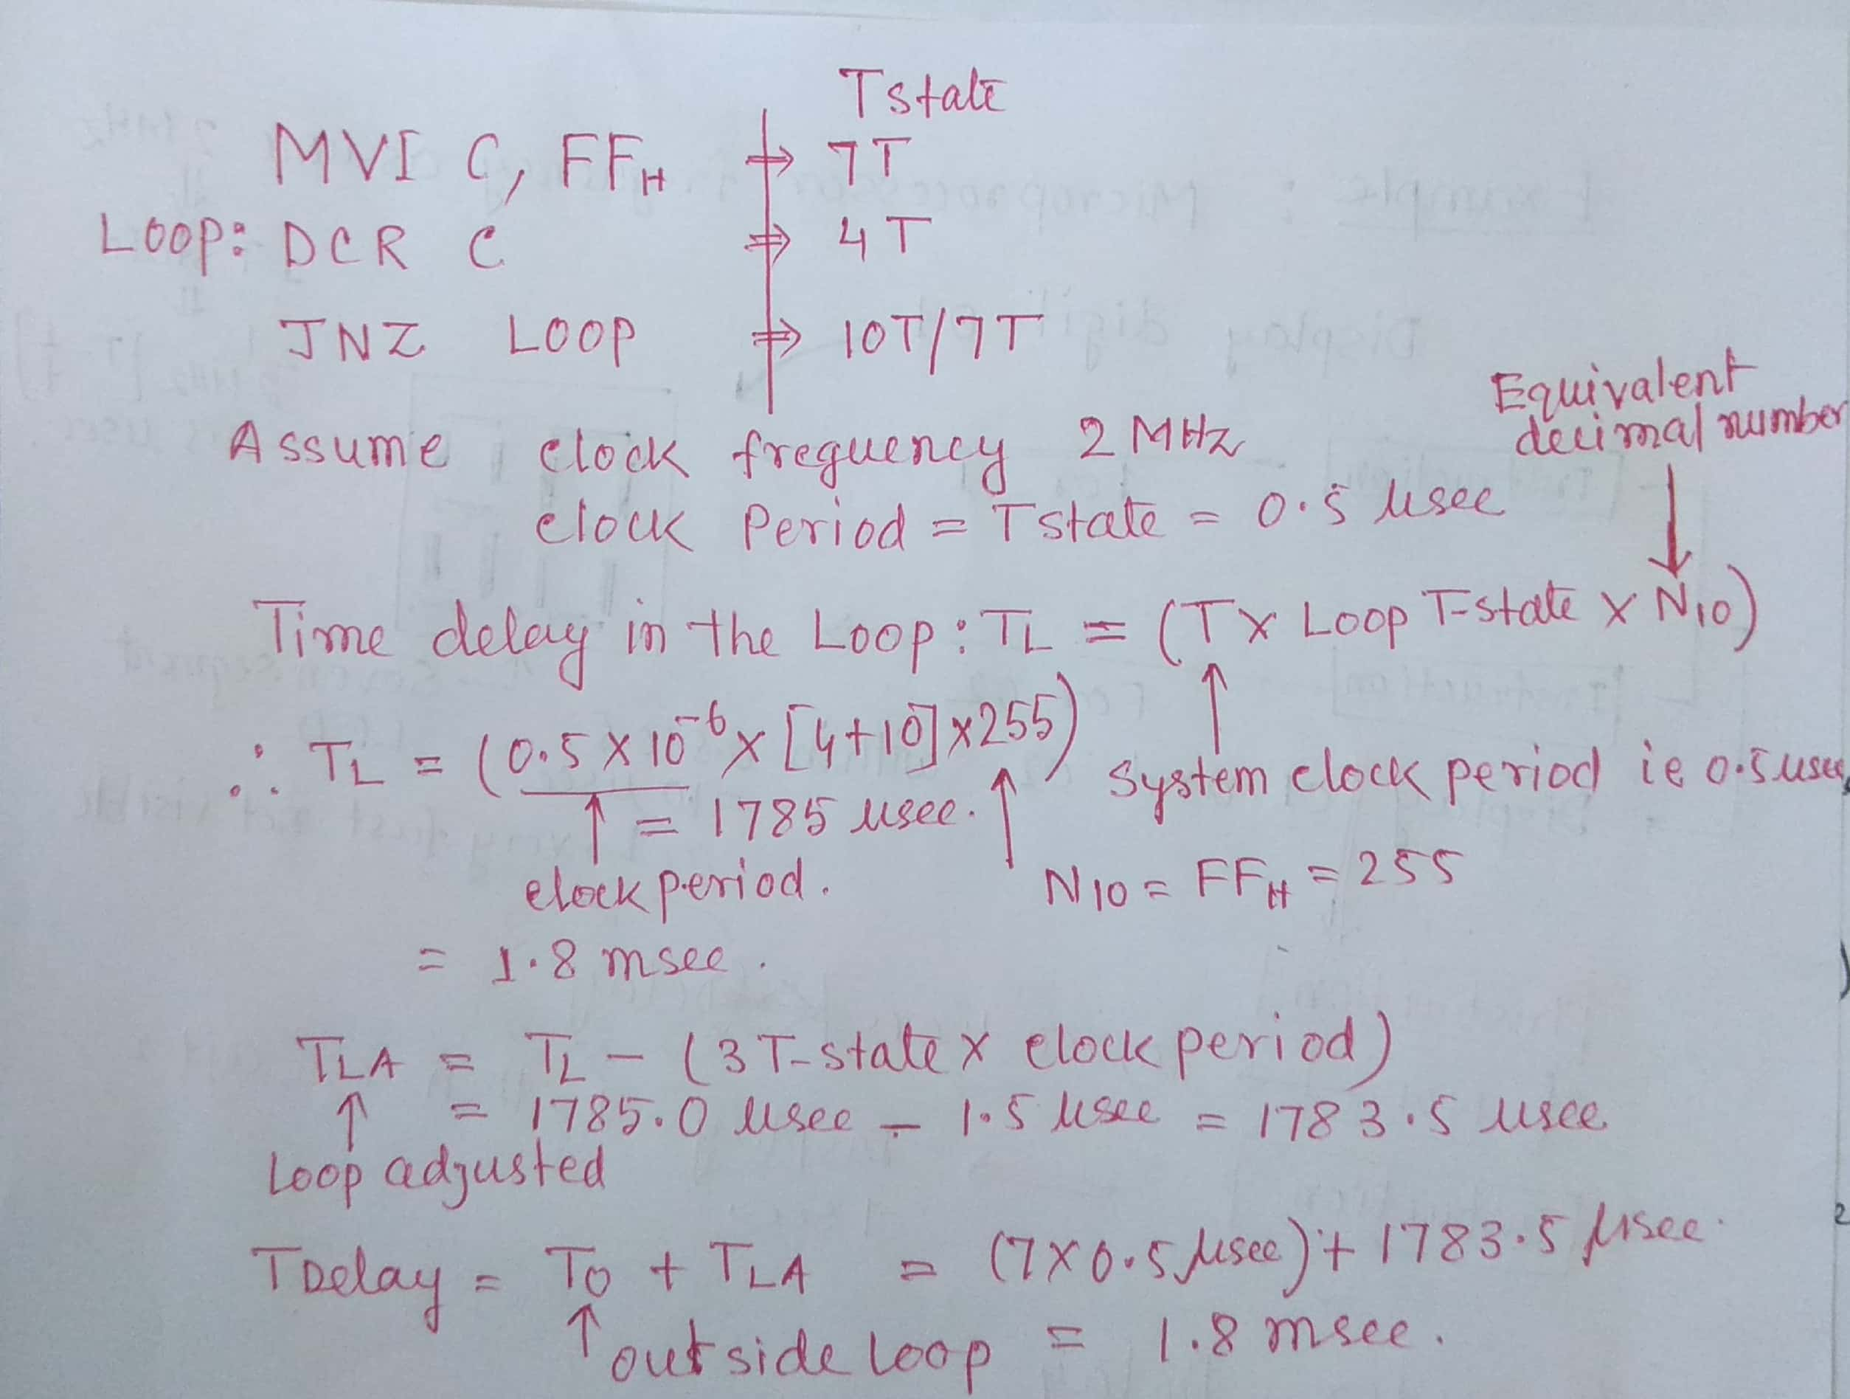

In this example, TLA is the adjusted time delay in a loop, and it is calculated by subtracting the delay caused by the "3T-state" from the previously calculated time delay (TL).

The "3T-state" refers to a type of delay that can occur in digital circuits when a signal is processed through multiple stages, each of which has a "setup time" and a "hold time" that must be satisfied in order for the signal to be correctly processed. This type of delay is called a "3T-state" because it is typically modeled using three "T" values: Tsetup, Thold, and Tprop.

In the equation "TLA = TL - (3T-state * clock period)", the "3T-state" is multiplied by the clock period, which is the time it takes for a single clock cycle to complete. This multiplication is necessary because the "3T-state" delay is typically expressed in terms of the clock period, so it must be converted to the same time unit as TL in order to be subtracted from it.

In summary, the equation "TLA = TL - (3T-state * clock period)" is used to calculate the adjusted time delay in a loop, taking into account the delay caused by the "3T-state" in the circuit.

**REGISTER PAIR DELAY**

The REGISTER PAIR DELAY in 8085 microprocessor is a delay that occurs when the microprocessor needs to access data from a register pair, such as the HL, BC, or DE register pair. This delay is caused by the fact that the 8085 microprocessor is an 8-bit microprocessor, and register pairs are 16-bit. To access the data from a register pair, the microprocessor must first read the low-order byte from the register pair, then the high-order byte. This causes a delay, as the microprocessor must wait for the data to be read from memory before it can continue processing.

MOV A, B ; Move the contents of register B into register A

MVI C, 10 ; Load the value 10 into register C

ADD C ; Add the contents of register C to the contents of register A

HLT ; Halt the program

In this example, the microprocessor would first move the contents of register B into register A. This operation would not cause a REGISTER PAIR DELAY, as only a single 8-bit register is being accessed.

Next, the microprocessor would load the value 10 into register C. Again, this operation would not cause a REGISTER PAIR DELAY, as only a single 8-bit register is being accessed.

Finally, the microprocessor would add the contents of register C to the contents of register A. This operation would cause a REGISTER PAIR DELAY, as the microprocessor must first read the low-order byte of the HL register pair, then the high-order byte, before it can perform the addition. This causes a delay in the execution of the program.

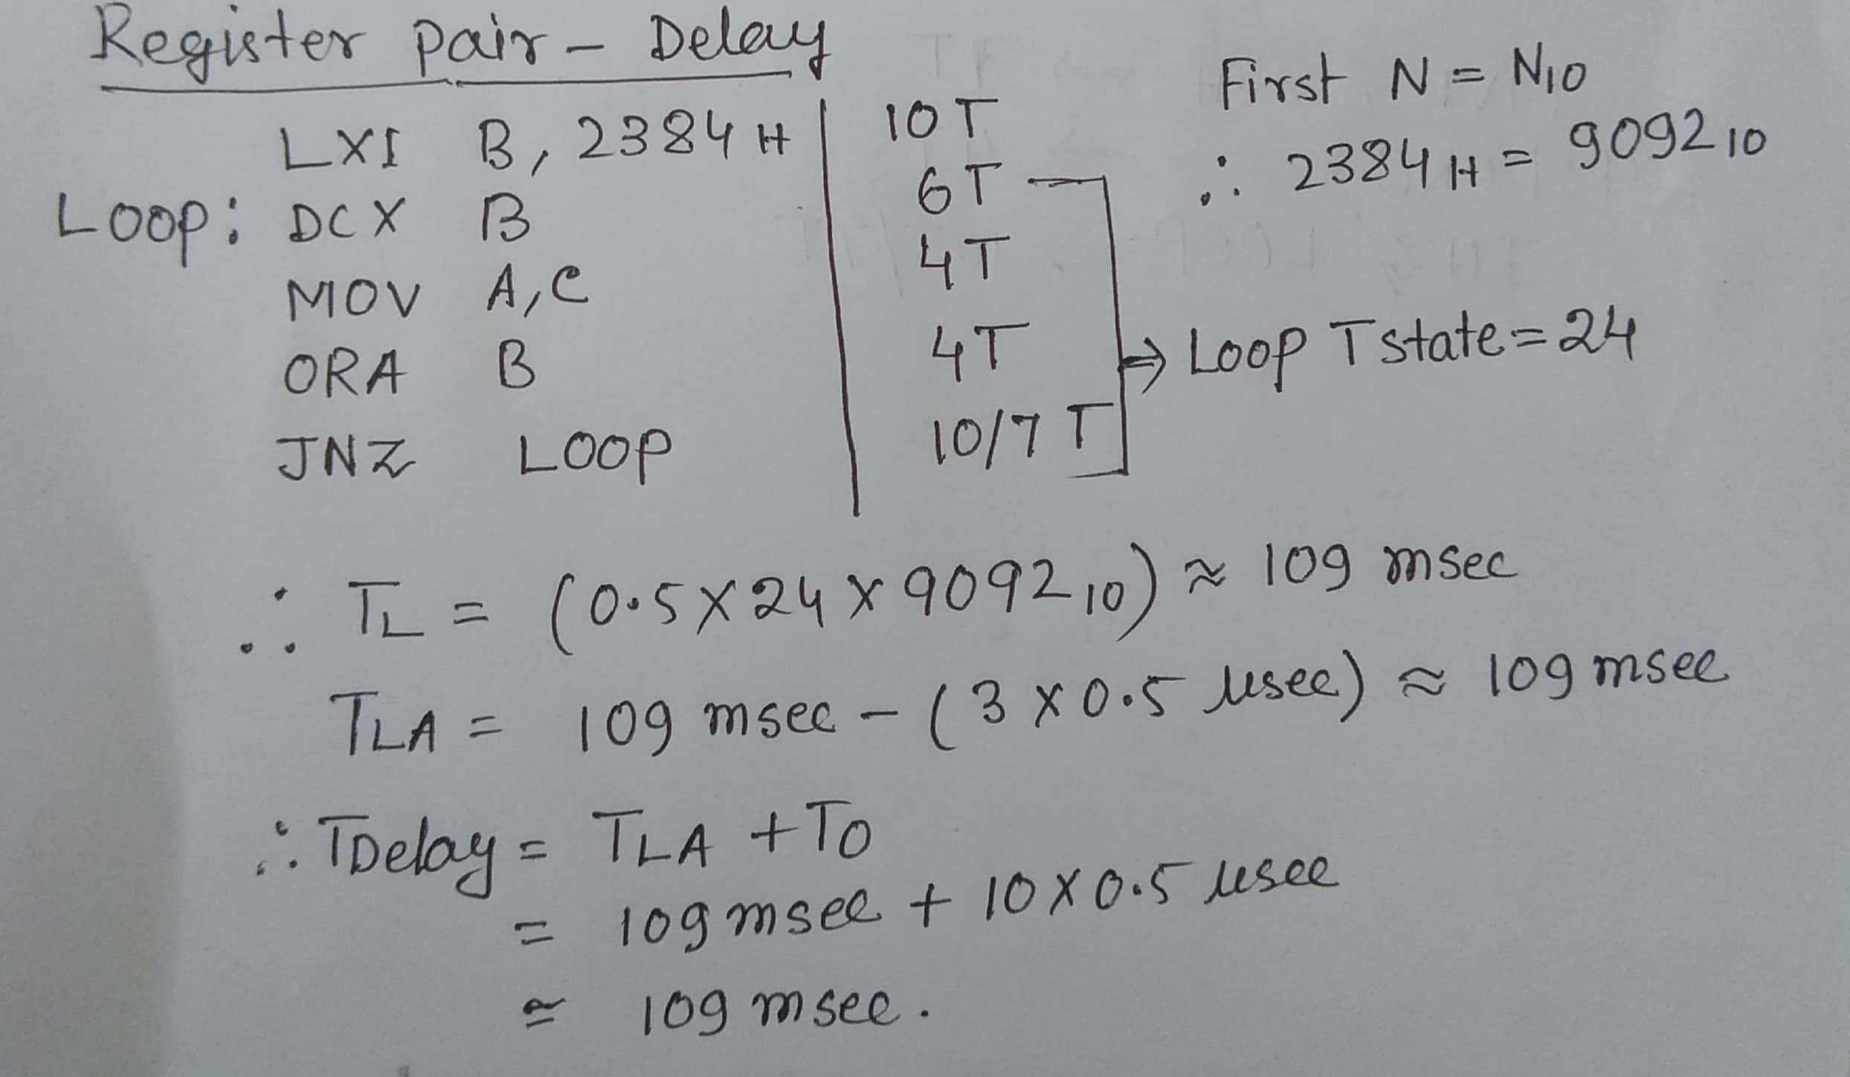

**LOOP-INSIDE DELAY**

A loop inside a delay can be used to create a timed delay in a program. For example, in the 8085 microprocessor, you could use the following code to create a delay of approximately 1 second:

MVI B, 250 ; Load the value 250 into register B

DELAY:

DCR B ; Decrement the value in register B

JNZ DELAY ; If the value in register B is not zero, jump back to the DELAY label

In this code, the microprocessor would first load the value 250 into register B. It would then enter a loop, where it would decrement the value in register B and check if it is zero. If the value in register B is not zero, the microprocessor would jump back to the start of the loop, repeating the process.

This would cause a delay of approximately 1 second, as the microprocessor would execute the loop 250 times, with each iteration taking approximately 4 microseconds (assuming a clock speed of 1 MHz).

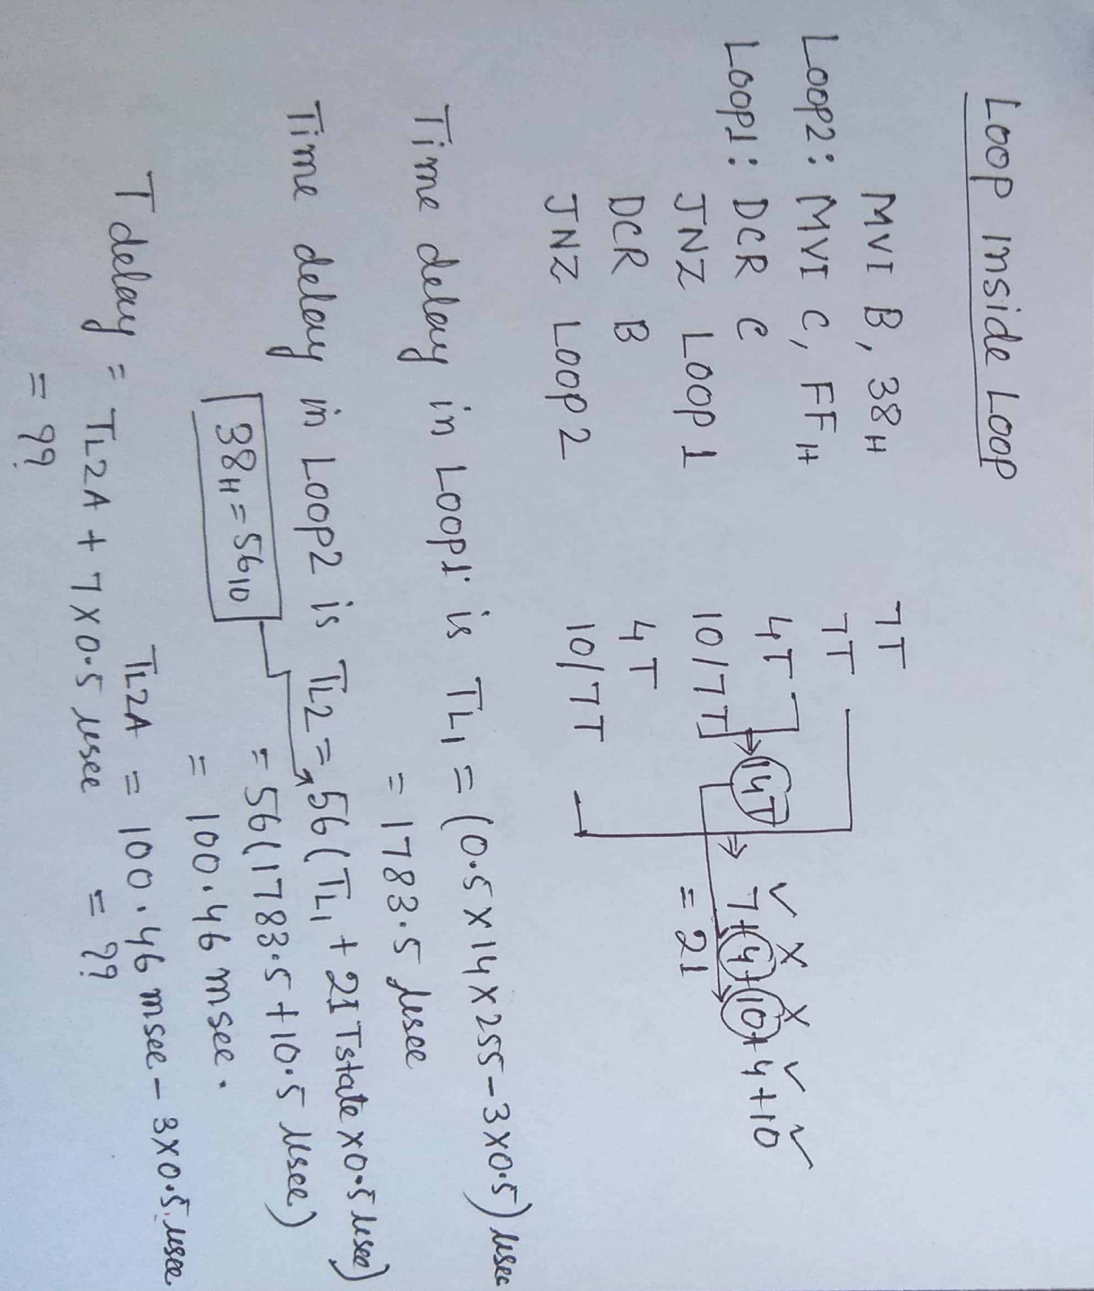

**MAKE IN TIME DELAY**

MAKE IN TIME delay is a type of delay that is used in digital circuits to ensure that a signal arrives at a certain point in time. This type of delay is often used in clock circuits, where the clock signal must be synchronized with other signals in the system in order to function correctly.

The MAKE IN TIME delay is implemented using a delay element, such as a delay line or a buffer, that delays the signal by a fixed amount of time. When the signal passes through the delay element, it is delayed by the desired amount, so that it arrives at the correct time. This ensures that the signal is correctly synchronized with other signals in the system.

Here is an example of how a MAKE IN TIME delay might be used in a digital circuit:

input signal -> delay element -> output signal

In this example, the input signal is passed through a delay element, which delays the signal by the desired amount. The output signal, which is the delayed version of the input signal, arrives at the correct time, and can be correctly synchronized with other signals in the system.