**19 / 07 / 22**

**UNIX FILE SYSTEM**

All data in Unix is organized into files. All files are organized into directories. These directories are organized into a tree-like structure called the file system.

**Everything is a file in UNIX

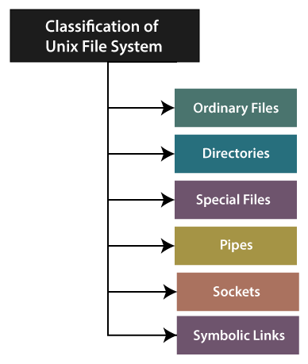

***Ordinary Files***

Contains only data.

* In ordinary files, there are no other files.
* Ordinary files are always placed under the directory file.
* Ordinary files are used to store our information like the text which we have to write or a picture which we have to draw. This is the kind of the file which we mainly work with.

**In the long-format output of ls -l, the "-" symbol is used to specified such kind of file.**

***Directory Files***

Act as a container, stores both special and ordinary files. **UNIX directories are equivalent to the folders in MAC and WINDOWS.**

• We use it to organize the collection of files.

• It contains special files, ordinary files or other directories.

• It does not contain "real" information that we would work with, like text. Mostly, only need for organizing files.

• Each file is descendant of the root directory (named /) located at the tree's top.

**In the long-format output of ls -l, we used the "d" symbol in order to specify this kind of file.**

***Special / Device Files***

Special files are used to represent the real physical device like terminal, tape drive, and printer. and also used for Input/Output(I/O) operations.

Mainly two kinds of special files for every device in the Unix system are there such as **block special files** and **character special files**.

If we use the block special file for the device input/output (I/O), the data is moved to the higher fixed-size blocks. This kind of access is known as **block device access**.

***Pipes***

Used for sending the output of a command as the input to another command. **we can link commands together** using pipes.

Pipes is like a temporary file that only exists to hold the data from one command till it is read by another. Pipes are created through the vertical bar character (‘|’)

Example – ls | sort (sorts all the files based on recent access time)

***Sockets***

These files are used for transferring information between two processes, that are running on different / same machines.

*Socket files are basically used as an interface between UNIX process and networking protocol.

**In the long-format output of ls -l, using the "s" symbol, Unix sockets are marked**

***Symbolic links***

Is a Special file that points to another existing file that points to another existing file on the system, this link contains the oath name of the file it is pointing to.

**“ln” command is used for creating links.**

***Organization of Filesystem***

The file system is organized as a tree, with a single root node (‘/’).

**Pathname is a sequence of component names that are separated by slashes.**

**A component is an arrangement of characters that designates a filename, that is unique.**

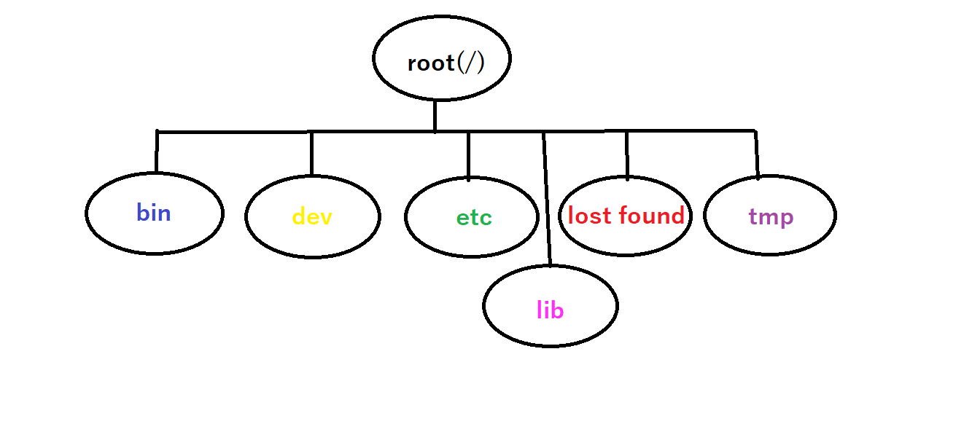

***bin***

Executable files are kept in this directory

***dev***

All the special files in the UNIX file systems, such as keyboard or terminal device drivers are kept in this directory

***etc***

All administrative files in UNIX are kept in this directory

***lib***

This is the central library storage for files that are commonly used by other programs. A library is the collection of the files that can be shared among many processes. The advantage of having a library is that it is a single source of data and each program can use it without needing a unique copy of this executable functions of itself.

***lost + found***

This is the most likely place where files can be found after the system crashes

***tmp***

Programs usually needs extra spaces to store data on a disk, the /tmp directory is a directory used by programs that need extra buffer area or space in order to be executed.

**UNIX COMMANDS**

1. Internal commands
2. External commands

**Internal commands**

Built in to shell, such as cd, echo

**External commands**

UNIX utilities and programs

***ls command***

Used for listing files in a directory. By default, the files and directories are ordered in alphabetic order.

**“ls -a”** Shows all the hidden files

**“ls -l”** Shows files in long listing format

**“ls -u”** Sorts files according to the last access time (starting with most recent time)

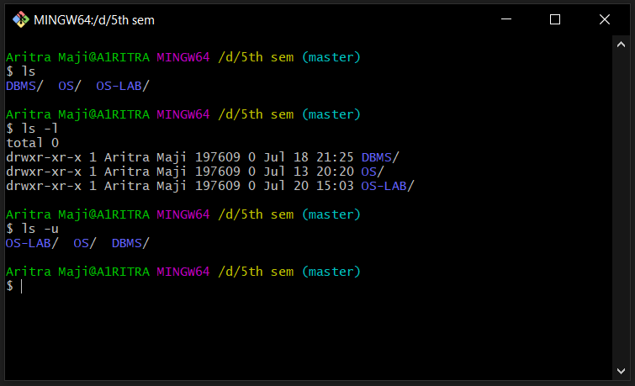

“mkdir” is used for creating new directory, mkdir “name”

“cd” is used for changing current working directory, cd “name”

“date” and “cal” can be used for seeing current date and calender

“cal jan 2022”