CAT command is used for

Creating file, concatenating files, display the file

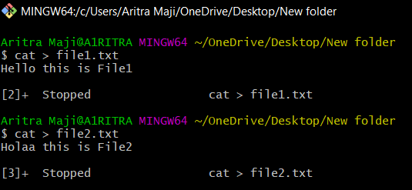

For appending to a file, we should use **cat >> filename**

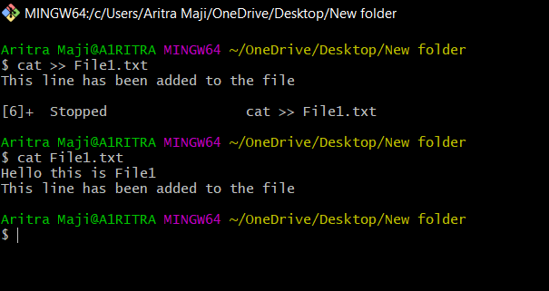

For concatenating two files -> **cat file1 file2**

For concatenating two files and store it in third file -> **cat file1 file2 > file3**

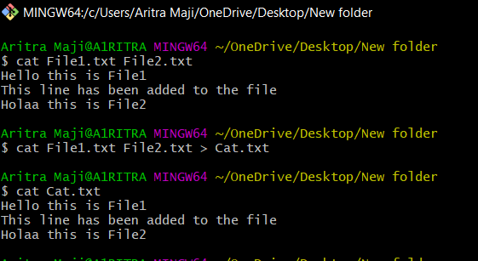

The **who** command displays all the users who are currently logged in the system,

It returns the user-id , terminal and the time at which the user logged in.

We can use **whoami** to know about our selves

**Remove files**

**rm** command can be used for removing files

**rm filename**

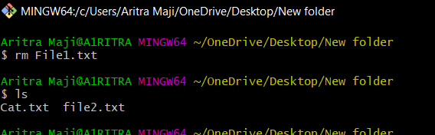

**Renaming files**

The mv (or move) command can be used for renaming a file or moving a file

For renaming **mv filename newfilename**

For moving **mv filename subdirectory/filename**

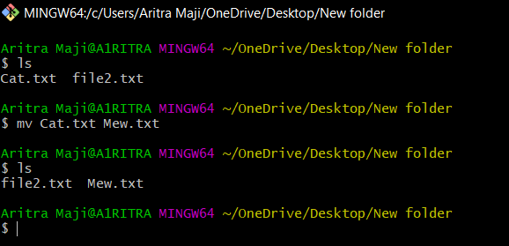

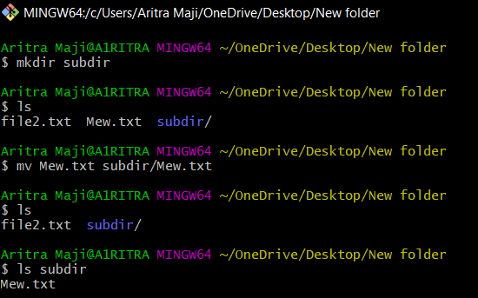

Basically using the mv command the file is removed from it’s current location and copied to another location

**Copying files**

cp command is used for copying a file

**cp filename1 filename2**

**cp filename1 subdir/filename2**

**Displaying message**

**echo message**

this command is used to display messages and the result of the computation on the screen

**Creating new files**

touch command can be used for creating files and changing timestamps

where timestamps means both the times , that is the time the file was last modified

**touch –[mk] time_expression filename**

here -m option is used for changing modification time

the -a option is used for changing the access time

the time expression that we would provide should be in the **MMDDhhmm** format (month-day-hour-minutes)

**Working with date command**

date +%m -> shows month

date +%I%p -> shows time

date +%y -> shows year

date +%a -> shows weekday

**File permission**

There are 3 classes of system users

User -> the user is usually the system user who created the file.

The user has full control over stricting or permitting access to the file at any time

Group ownership -> group refers one or more users who may access the file as a group

Other -> it refers to any other users of the system

There are several permissions for system uses.

Basically 3 types of access mode used by the user of the system

**Mode**  **description**

r or 4 read protection

w or 2 write protection

x or 1 execute protection

**Option**  **description**

u represents user or the owner of the file

g represents group

O represents other

A represents all (user , group , other)

+ adds access permission

- Removes access permission

= Assigns permission to u, g, o or A