**PROCESS STATE**

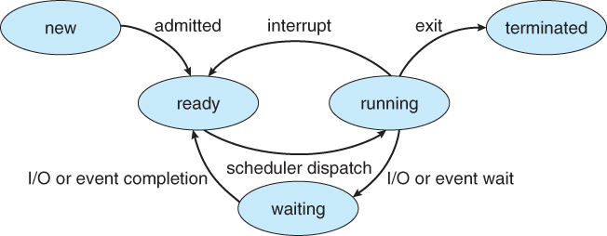

**As a process executes it changes states**

**New**

When a process is created.

**Ready**

The process then got pushed to the ready queue (that’s means it’s now ready to execute or in ready state)

**Running**

Instructions of the process are being executed.

The scheduler selects the process from the queue and executes it through the CPU.

The process can also come to ready queue again

*Only one process at a time can be at running state

**Waiting**

The process is waiting for some event to occur, like user should give an input.

Process in waiting state is not in the ready queue.

If the pending event got completed the process again comes to the ready queue

**Terminated**

The process has stopped executing

