Experiment No 1

Problem statement

Simulate a three nodes point-to-point network with duplex links between them. Set the queue size vary the bandwidth and find the number of packets dropped

Topology:
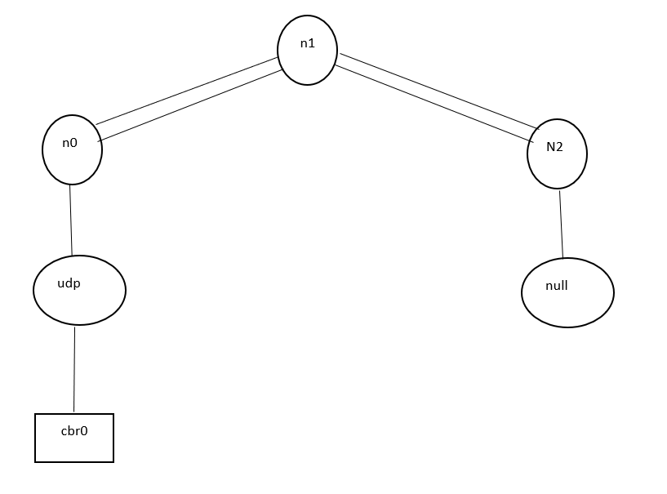

Program:
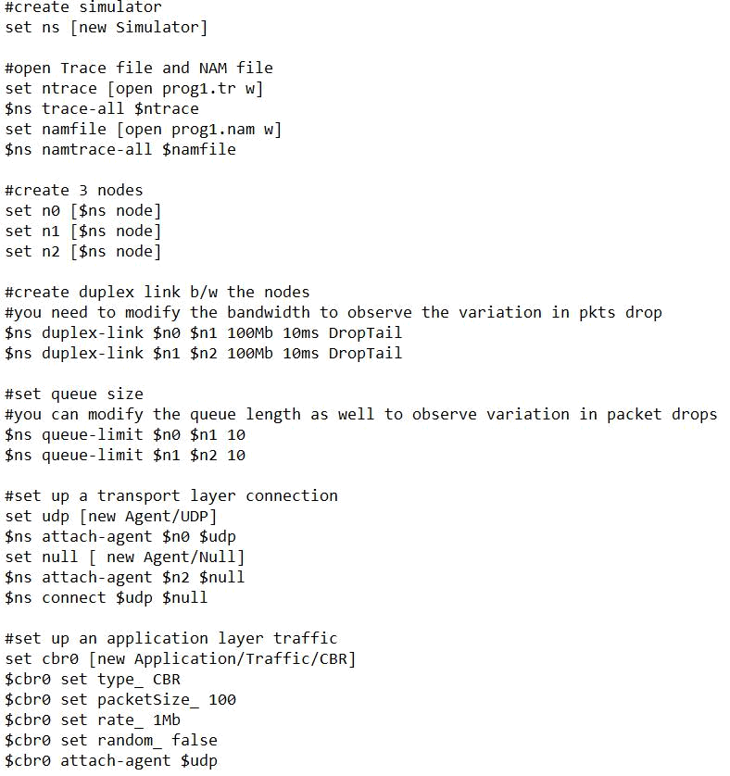
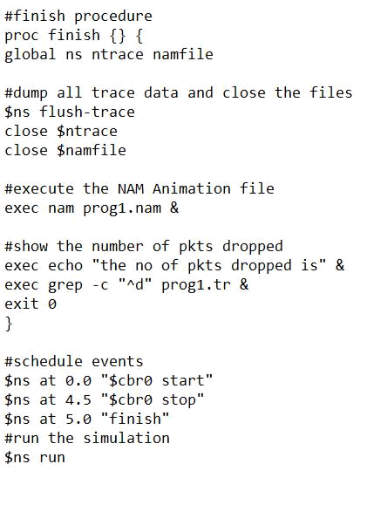

Output:
Experiment No 2

Problem statement

Simulate a four-node point-to-point network, and connect the links as follows: n0-n2, n1-n2 and n2-n3. Apply TCP agent between n0-n3 and UDP n1-n3. Apply relevant applications over TCP and UDP agents changing the parameter and determine the number of packets sent by TCP/UDP.

Topology:
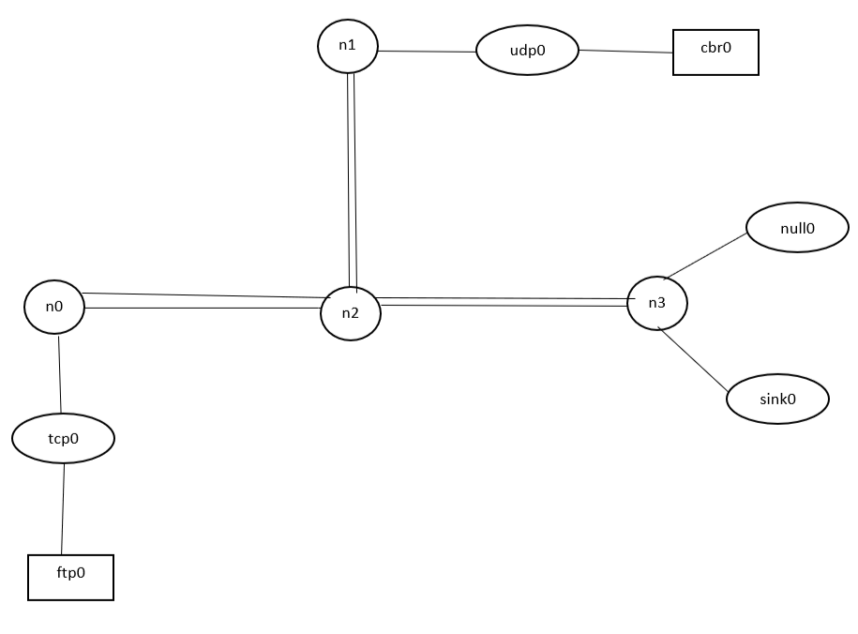

Program
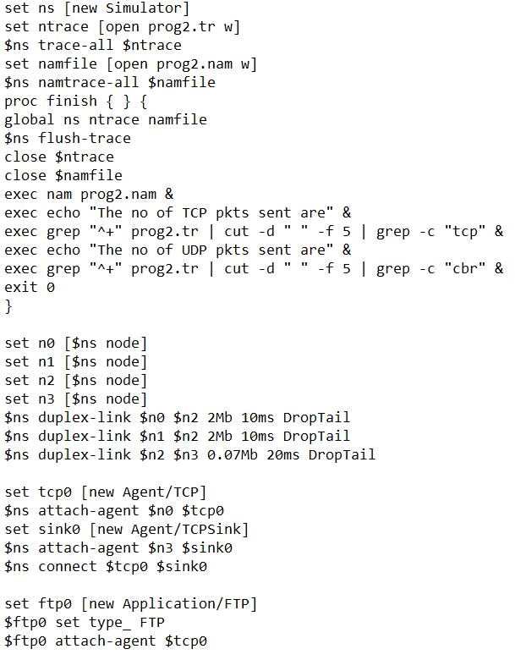
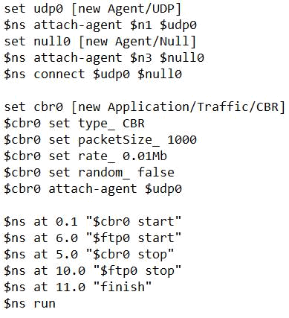

Output:

Experiment No 3

Problem statement

Simulate an Ethernet LAN using N nodes. Determine collision across different nodes

Topology
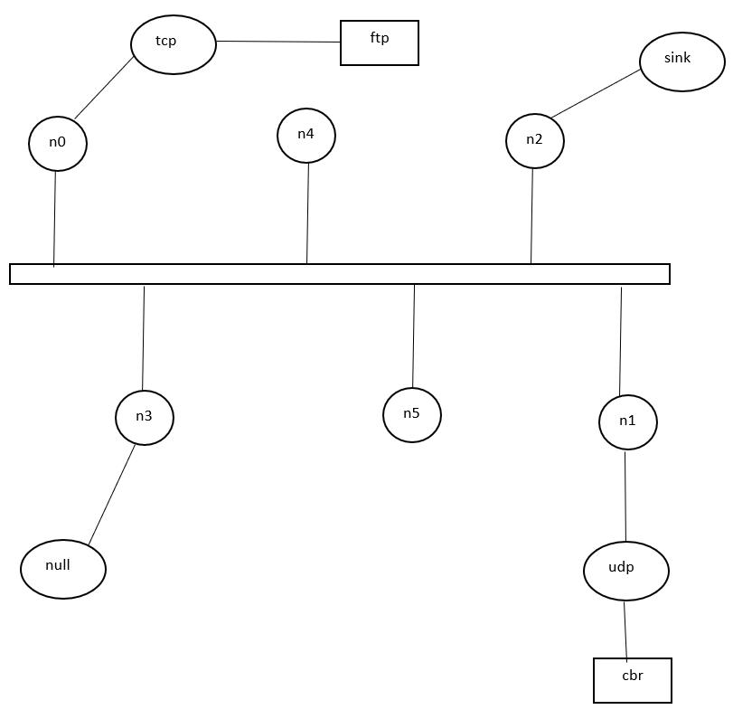

Program
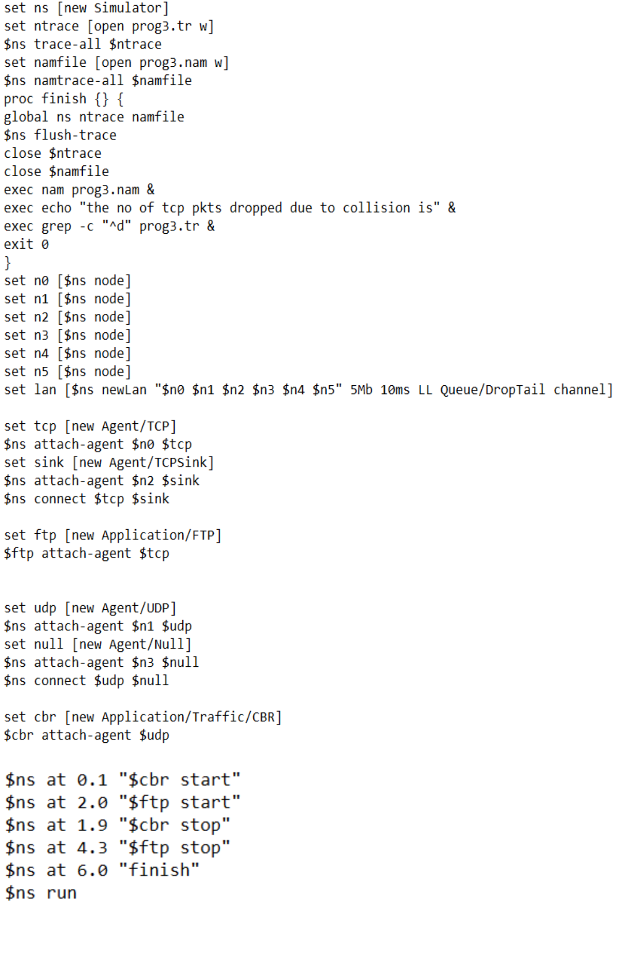
Experiment No 4

To Simulate transmission of ping messages over a network topology using ns-2
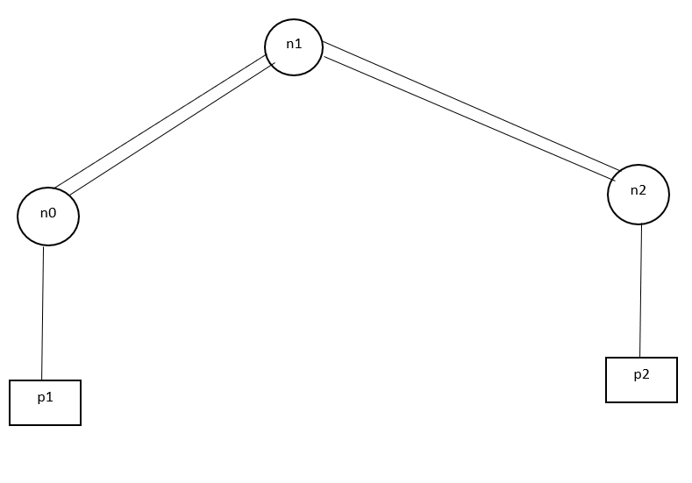
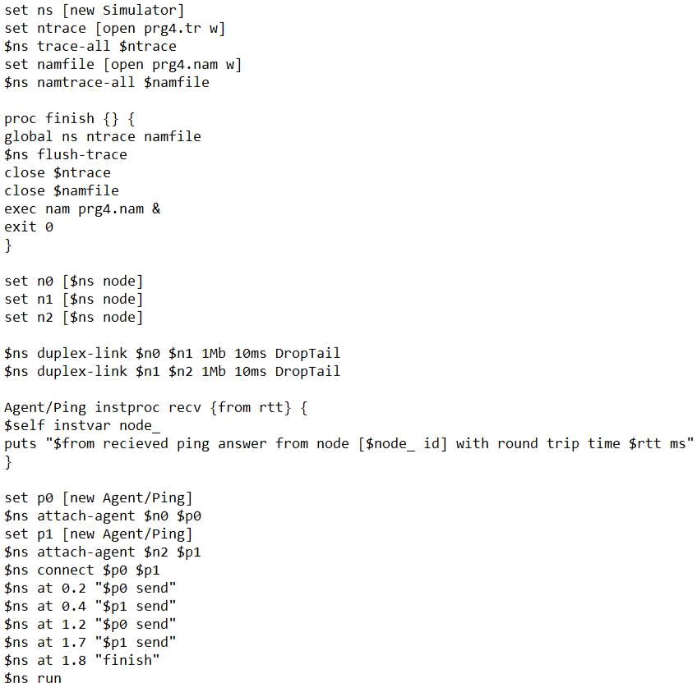
Experiment No 5

Implement the method of cyclic data transmission using UDP protocol

Topology:
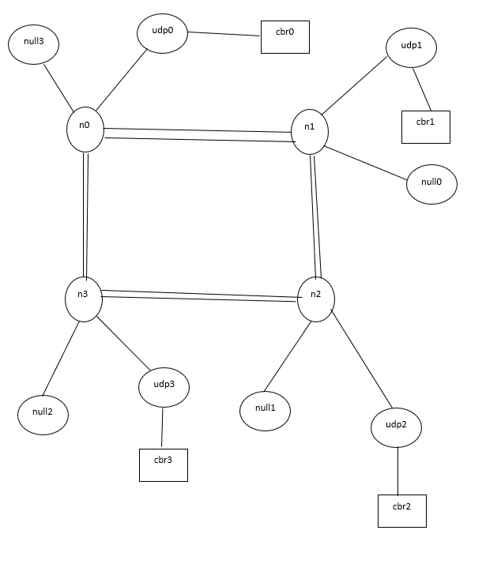
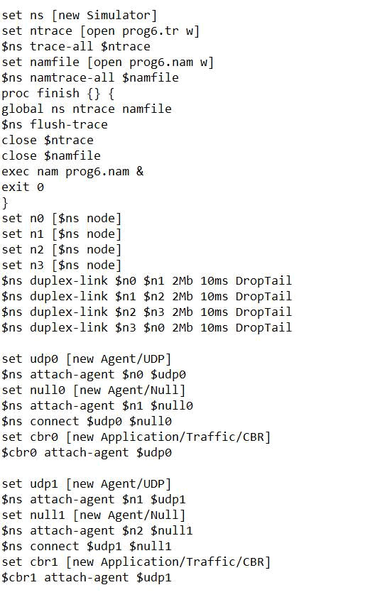
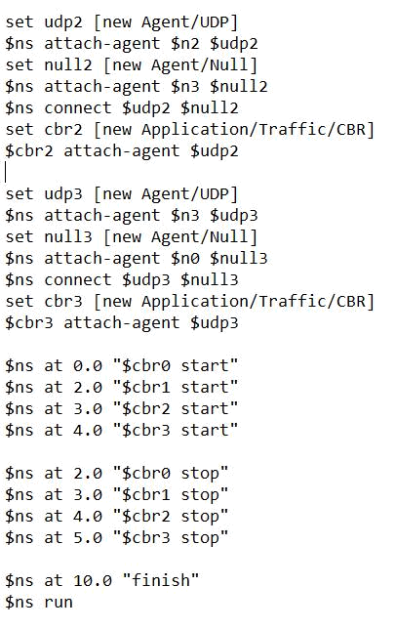
Experiment No 6

Develop a program that implements dynamic routing algorithm using 7 nodes

Topology
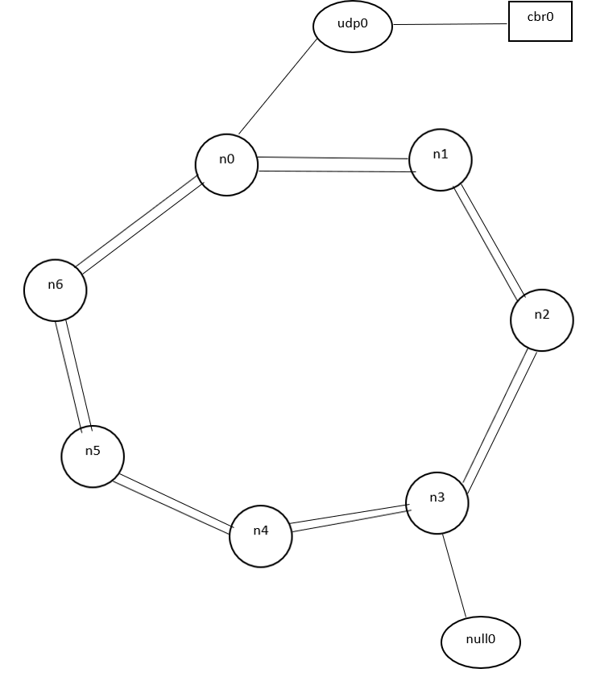
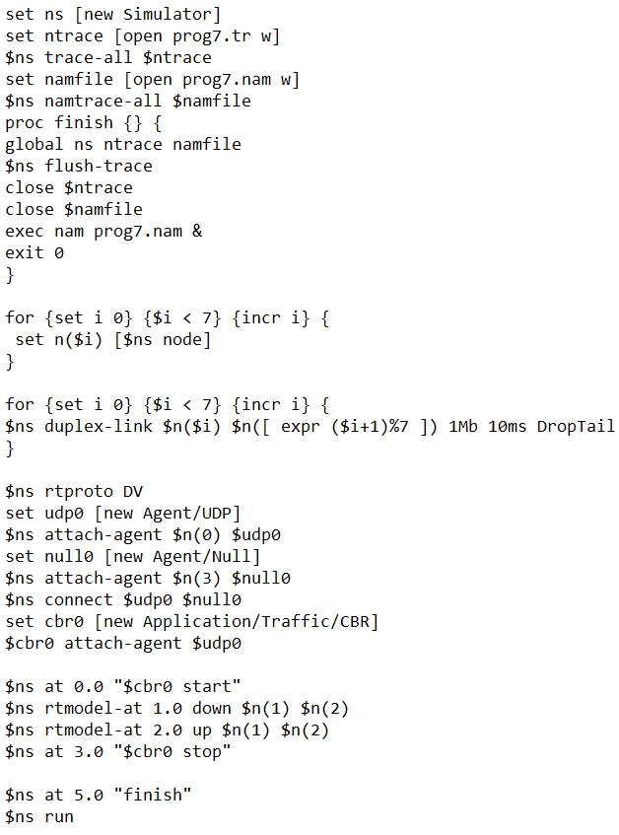
Experiment No 7

Develop a program that implements link state routing algorithm using 7 nodes

Topology
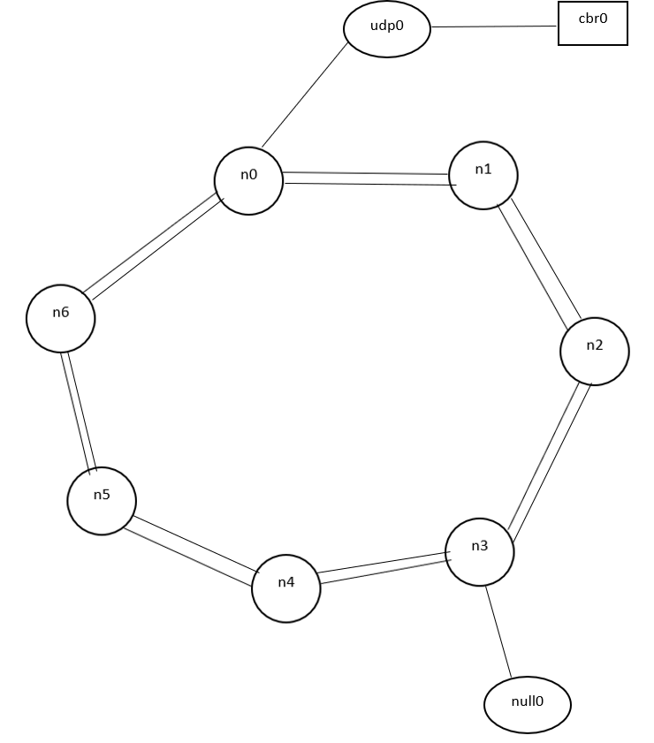
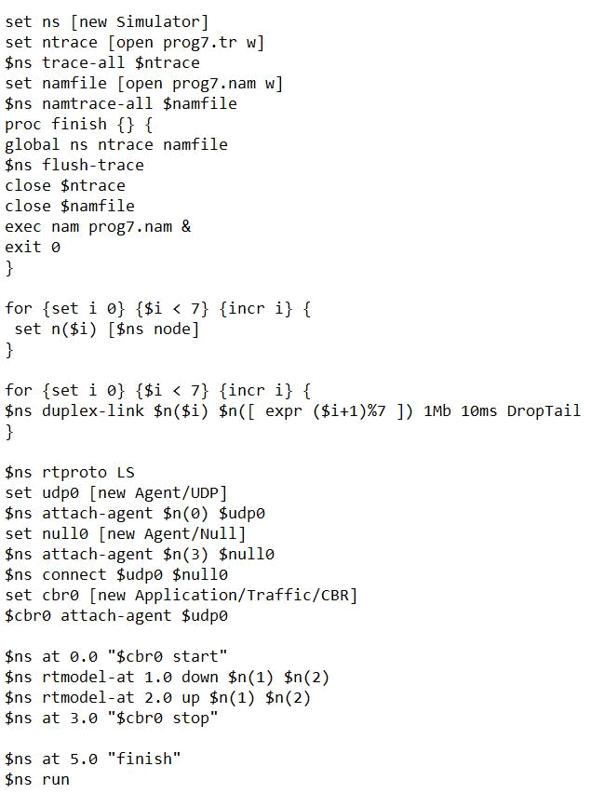

Experiment No 8

Problem Statement

Simulate an Ethernet LAN using N-nodes, and determine the throughput Topology: -
